FDE_USER_41
PRIYANKA KARUPPUSAMY
USE CASE NUMBER: UC007
Claims Workspace Architecture and Flowcharts
This document contains the architecture diagrams for the Claims Processing Workspace.
1. System Architecture
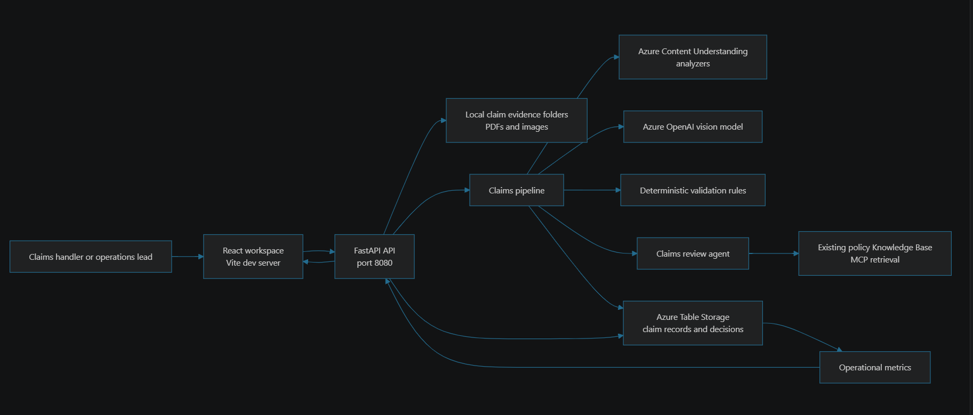
2. Original Claim-Preparation Flow

