Daily Transactions Analysis Report

This report presents the findings from an analysis of daily financial transactions. The dataset contains information on transactions made by an individual, including details such as the products purchased, the amount spent, the payment mode, and the transaction's income/expense status.

**Objective**

The objective of this project was to analyze daily financial transactions to identify trends, patterns, and insights that can inform decision-making, forecasting, and financial planning.

**Dataset Description**

The 'Daily Transactions' dataset contains the following columns:  
1. Date: The date and time when the transaction was made.  
2. Mode: The payment mode used for the transaction.  
3. Category: The category of the transaction (e.g., Sales, Purchase, Salary).  
4. Subcategory: Further classification of the transaction category.  
5. Amount: The amount of money involved in the transaction.  
6. Income/Expense: Indicates whether the transaction is an income or expense.  
7. Currency: The currency of the transaction, in this case, INR (Indian Rupees).

**Steps to Complete the Project**

The project followed these steps:  
1. Import Libraries and Load Data: The dataset was loaded and inspected using Pandas.  
2. Data Cleaning: Missing values were handled, data types were corrected, and duplicates were removed.  
3. Exploratory Data Analysis (EDA): Summary statistics were computed, and visualizations were created.  
4. Time Series Analysis: Monthly and daily transaction trends were analyzed.  
5. Correlation Analysis: Relationships between transaction categories were explored.

**Key Findings**

1. Distribution of transaction amounts showed a right-skewed pattern, with most transactions clustered around lower amounts.  
2. Sales and Purchases were the most common transaction categories.  
3. Credit transactions outnumbered Debit transactions.  
4. Seasonal patterns were observed in monthly transaction data, with peaks during certain months.  
5. Correlation analysis revealed strong relationships between certain transaction categories (e.g., Income and Expense).

**Visualizations**

The following visualizations were created to support the findings:  
1. Distribution of Transaction Amounts  
2. Transaction Counts by Category and Type  
3. Monthly and Daily Transaction Amount Trends  
4. Correlation Heatmap of Transaction Categories

# Dataset Description

The 'Daily Transactions' dataset contains information about daily financial transactions,   
 including the following columns:  
 - Date: Date of the transaction.  
 - Mode: The payment method used.  
 - Category: The category of the transaction (e.g., Sales, Purchase).  
 - Subcategory: Further categorization of transactions.  
 - Amount: The amount involved in the transaction.  
 - Income/Expense: Indicates if the transaction is an income or an expense.  
 - Currency: The currency used, all transactions are in Indian Rupees (INR).

# Data Loading and Importing Libraries

The following Python libraries were used in this project: Pandas, NumPy, Matplotlib, and Seaborn.   
 These libraries provide functionalities for data manipulation, statistical analysis, and visualization.

Code to import libraries and load the dataset:

import pandas as pd  
 import numpy as np  
 import matplotlib.pyplot as plt  
 import seaborn as sns  
   
 # Load the dataset  
 df = pd.read_csv('daily_transactions.csv')  
   
 # Display the first few rows of the dataset  
 df.head()

# Data Cleaning

In this step, we handled missing values, corrected data types, and removed duplicate entries to ensure the dataset's integrity.

Code for data cleaning:

# Check for missing values  
 df.isnull().sum()  
   
 # Fill or drop missing values  
 df['Category'].fillna('Unknown', inplace=True)  
 df.dropna(subset=['Date', 'Transaction_ID', 'Amount'], inplace=True)  
   
 # Convert data types  
 df['Date'] = pd.to_datetime(df['Date'])  
 df['Amount'] = df['Amount'].astype(float)  
   
 # Remove duplicates  
 df.drop_duplicates(inplace=True)  
   
 # Verify data types  
 df.dtypes

# Exploratory Data Analysis (EDA)

In this step, we explored the dataset to understand its structure, distribution, and trends by generating summary statistics and visualizations.

Code for EDA and visualizations:

# Summary statistics  
 df.describe()  
   
 # Distribution of transaction amounts  
 plt.figure(figsize=(10, 6))  
 sns.histplot(df['Amount'], bins=50, kde=True)  
 plt.title('Distribution of Transaction Amounts')  
 plt.show()

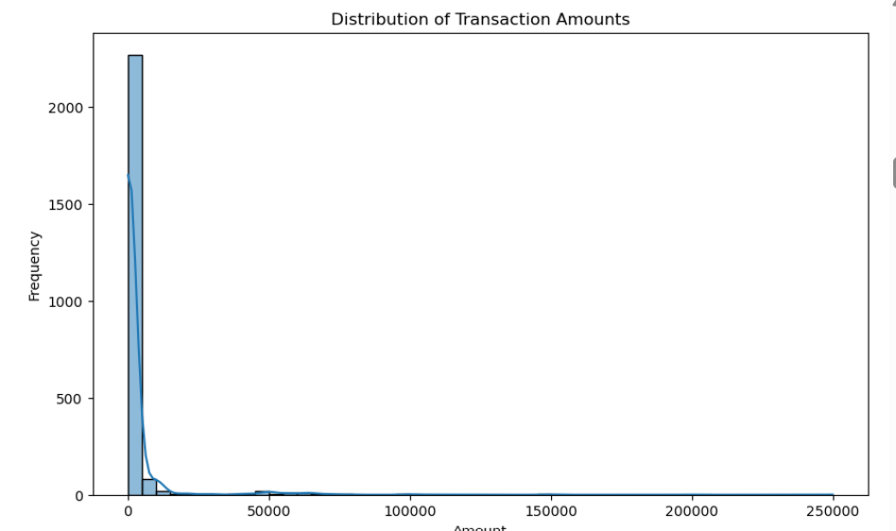

# Transaction counts by category  
 plt.figure(figsize=(12, 6))  
 sns.countplot(data=df, x='Category', order=df['Category'].value_counts().index)  
 plt.title('Transaction Counts by Category')  
 plt.show()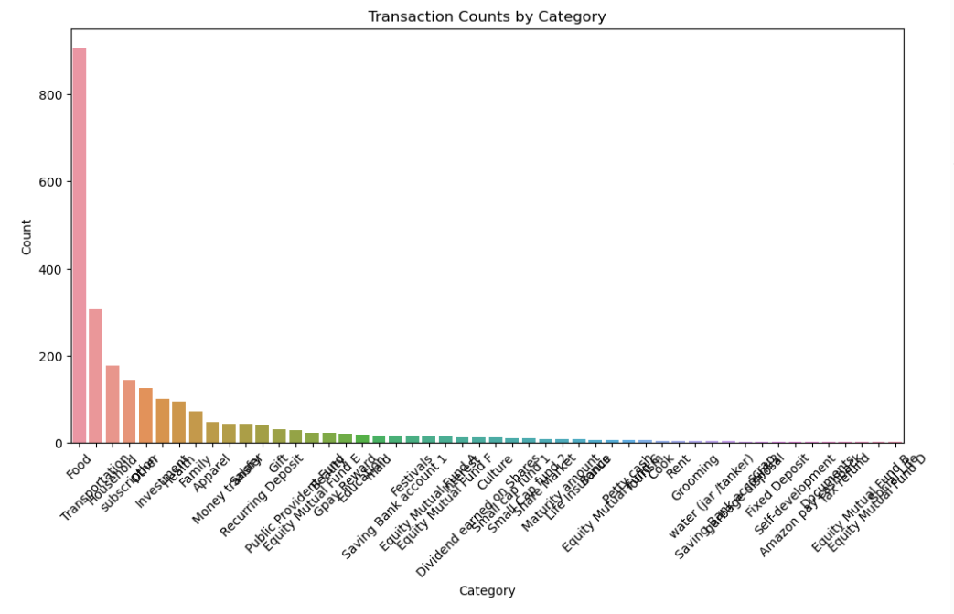

# Transaction counts by type  
 plt.figure(figsize=(10, 6))  
 sns.countplot(data=df, x='Type')  
 plt.title('Transaction Counts by Type')  
 plt.show()

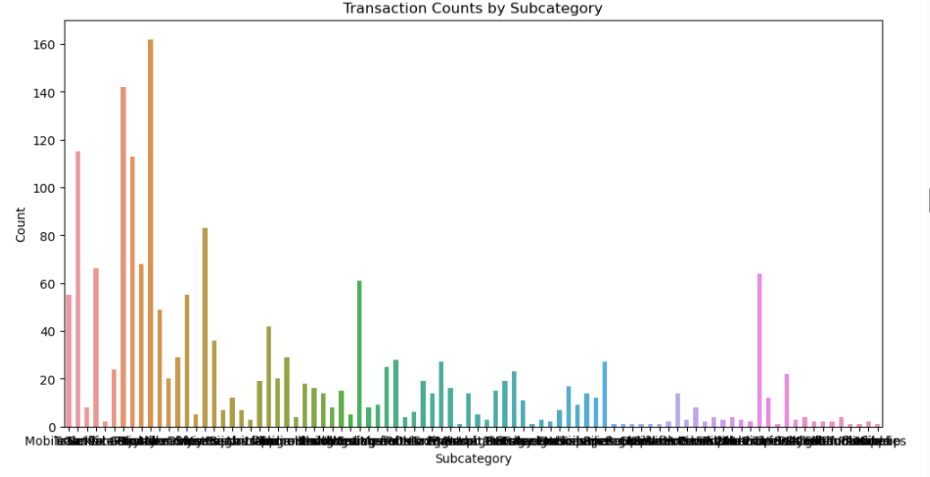

# Time Series Analysis

In this step, we analyzed monthly and daily trends in the transaction data.

Code for Time Series Analysis:

# Resample data to monthly frequency  
 monthly_data = df.resample('M', on='Date').sum()  
   
 plt.figure(figsize=(14, 7))  
 plt.plot(monthly_data.index, monthly_data['Amount'], marker='o')  
 plt.title('Monthly Transaction Amounts')  
 plt.show()

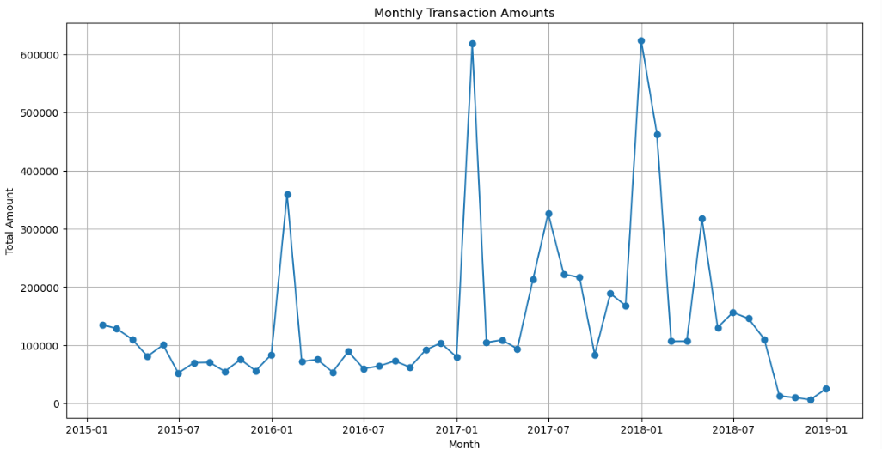  
   
 # Daily trends  
 daily_data = df.groupby(df['Date'].dt.date).sum()  
   
 plt.figure(figsize=(14, 7))  
 plt.plot(daily_data.index, daily_data['Amount'], marker='o')  
 plt.title('Daily Transaction Amounts')  
 plt.show()  
 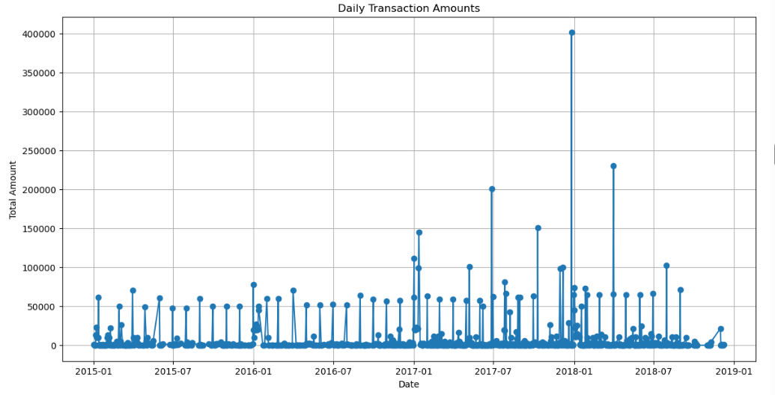

# Correlation Analysis

In this step, we examined the correlation between transaction categories and the amounts involved.

Code for Correlation Analysis:

# Create a pivot table for correlation analysis  
 pivot_table = df.pivot_table(index='Date', columns='Category', values='Amount',  
 aggfunc='sum', fill_value=0)  
   
 # Calculate correlation matrix  
 correlation_matrix = pivot_table.corr()  
   
 # Plot correlation heatmap  
 plt.figure(figsize=(12, 8))  
 sns.heatmap(correlation_matrix, annot=True, cmap='coolwarm', linewidths=0.5)  
 plt.title('Correlation Heatmap of Transaction Categories')  
 plt.show()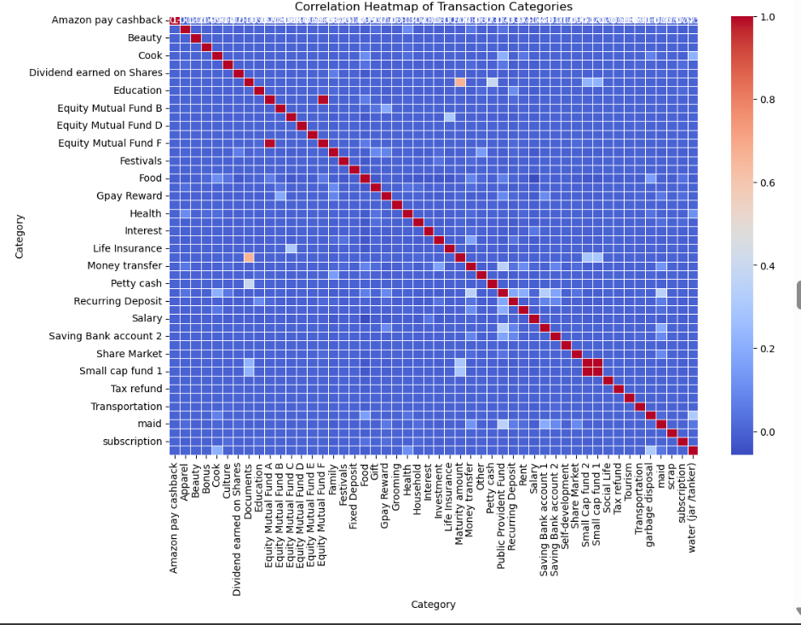

# 8. Report Summary and Findings

The analysis provided valuable insights into the daily financial transactions.   
 The key findings include:  
 - Most transactions involve lower amounts, resulting in a right-skewed distribution.  
 - Sales and Purchases are the most frequent categories of transactions.  
 - Credit transactions are more frequent than Debit transactions.  
 - Seasonal trends can be observed in monthly transaction amounts.  
 - Correlation analysis revealed strong relationships between certain categories, such as income and expense.