Q.1) Create a table named dmart_orders and insert values in it based on below criteria.
order_id, customer_id, customer_name, product_category, quantity, price_per_unit, order_date , payment_status.

Query:
USE JJBA;
DROP TABLE IF EXISTS dmart_orders; CREATE TABLE dmart_orders ( order_id INT PRIMARY KEY, customer_id VARCHAR(10), customer_name VARCHAR(100), product_category VARCHAR(50),
quantity INT, price_per_unit DECIMAL(10, 2), order_date DATE, payment_status VARCHAR(20)
);

Screenshot:
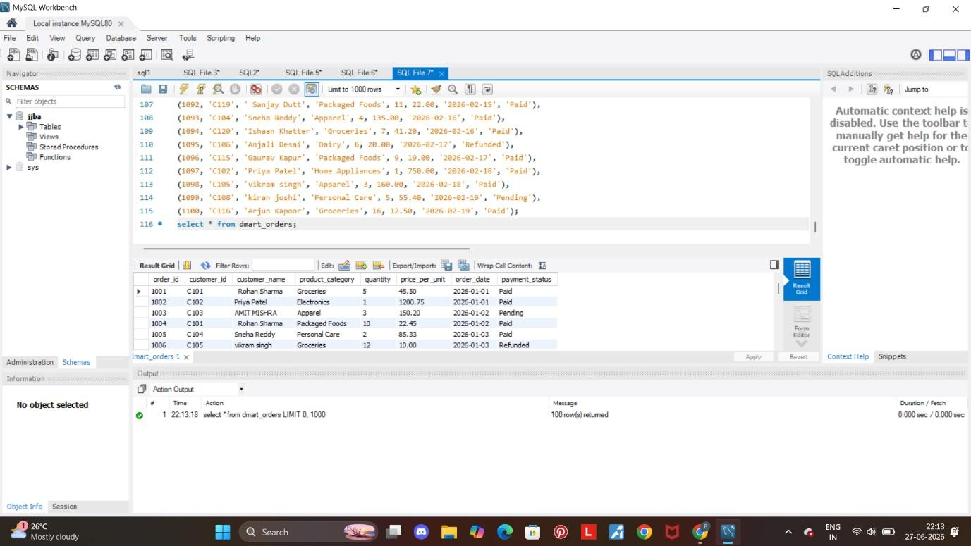
Q.2 Insert data of customers.

Query:
USE JJBA;
DROP TABLE IF EXISTS dmart_orders;

CREATE TABLE dmart_orders ( order_id INT PRIMARY KEY, customer_id VARCHAR(10), customer_name VARCHAR(100), product_category VARCHAR(50), quantity INT, price_per_unit DECIMAL(10, 2), order_date DATE, payment_status VARCHAR(20)
);
INSERT INTO dmart_orders (order_id, customer_id, customer_name, product_category, quantity, price_per_unit, order_date, payment_status)
VALUES
(1001, 'C101', ' Rohan Sharma ', 'Groceries', 5, 45.50, '2026-01-01', 'Paid'),
(1002, 'C102', 'Priya Patel', 'Electronics', 1, 1200.75, '2026-01-01', 'Paid'),
(1003, 'C103', 'AMIT MISHRA', 'Apparel', 3, 150.20, '2026-01-02', 'Pending'),
(1004, 'C101', ' Rohan Sharma ', 'Packaged Foods', 10, 22.45, '2026-01-02', 'Paid'),
(1005, 'C104', 'Sneha Reddy', 'Personal Care', 2, 85.33, '2026-01-03', 'Paid'),
(1006, 'C105', 'vikram singh', 'Groceries', 12, 10.00, '2026-01-03', 'Refunded'),
(1007, 'C102', 'Priya Patel', 'Home Appliances', 1, 450.00, '2026-01-04', 'Paid'),
(1008, 'C106', 'Anjali Desai', 'Apparel', 4, 99.99, '2026-01-04', 'Pending'),
(1009, 'C103', 'AMIT MISHRA', 'Electronics', 2, 300.50, '2026-01-05', 'Paid'),
(1010, 'C107', 'Raj Malhotra', 'Groceries', 8, 35.25, '2026-01-05', 'Paid'),
(1011, 'C108', 'kiran joshi', 'Dairy', 6, 15.80, '2026-01-06', 'Paid'),
(1012, 'C104', 'Sneha Reddy', 'Packaged Foods', 5, 40.00, '2026-01-06', 'Paid'),
(1013, 'C109', ' Nitin Verma ', 'Personal Care', 1, 120.00, '2026-01-07', 'Pending'),
(1014, 'C101', ' Rohan Sharma ', 'Groceries', 2, 65.40, '2026-01-07', 'Paid'),
(1015, 'C110', 'Pooja Hegde', 'Apparel', 5, 110.00, '2026-01-08', 'Paid'),
(1016, 'C105', 'vikram singh', 'Electronics', 1, 899.00, '2026-01-08', 'Paid'),
(1017, 'C106', 'Anjali Desai', 'Home Appliances', 2, 175.25, '2026-01-09', 'Refunded'),
(1018, 'C111', 'Sunil Shetty', 'Groceries', 20, 5.50, '2026-01-09', 'Paid'),
(1019, 'C102', 'Priya Patel', 'Personal Care', 3, 45.00, '2026-01-10', 'Paid'),
(1020, 'C107', 'Raj Malhotra', 'Apparel', 1, 250.00, '2026-01-10', 'Pending'),
(1021, 'C112', 'Meera Nair', 'Packaged Foods', 15, 12.20, '2026-01-11', 'Paid'),
(1022, 'C108', 'kiran joshi', 'Groceries', 4, 55.00, '2026-01-11', 'Paid'),
(1023, 'C113', 'deepak Gupta', 'Electronics', 1, 650.00, '2026-01-12', 'Paid'),
(1024, 'C109', ' Nitin Verma ', 'Dairy', 10, 18.00, '2026-01-12', 'Paid'),
(1025, 'C103', 'AMIT MISHRA', 'Groceries', 7, 42.10, '2026-01-13', 'Paid'),
(1026, 'C114', 'Ritu Phogat', 'Personal Care', 2, 95.50, '2026-01-13', 'Paid'),
(1027, 'C110', 'Pooja Hegde', 'Packaged Foods', 8, 25.00, '2026-01-14', 'Refunded'),
(1028, 'C101', ' Rohan Sharma ', 'Home Appliances', 1, 520.00, '2026-01-14', 'Paid'),
(1029, 'C115', 'Gaurav Kapur', 'Apparel', 3, 180.00, '2026-01-15', 'Paid'),
(1030, 'C106', 'Anjali Desai', 'Groceries', 11, 14.50, '2026-01-15', 'Pending'),
(1031, 'C112', 'Meera Nair', 'Dairy', 4, 22.00, '2026-01-16', 'Paid'),
(1032, 'C116', 'Arjun Kapoor', 'Electronics', 2, 410.00, '2026-01-16', 'Paid'),
(1033, 'C105', 'vikram singh', 'Packaged Foods', 6, 30.25, '2026-01-17', 'Paid'),
(1034, 'C113', 'deepak Gupta', 'Personal Care', 4, 60.00, '2026-01-17', 'Paid'),
(1035, 'C107', 'Raj Malhotra', 'Groceries', 9, 38.00, '2026-01-18', 'Paid'),
(1036, 'C117', 'Neha Kakkar', 'Apparel', 2, 299.99, '2026-01-18', 'Paid'),
(1037, 'C108', 'kiran joshi', 'Home Appliances', 1, 340.00, '2026-01-19', 'Refunded'),
(1038, 'C114', 'Ritu Phogat', 'Groceries', 5, 48.00, '2026-01-19', 'Paid'),
(1039, 'C118', 'Varun Dhawan', 'Packaged Foods', 12, 15.00, '2026-01-20', 'Pending'),
(1040, 'C102', 'Priya Patel', 'Dairy', 3, 28.50, '2026-01-20', 'Paid'),
(1041, 'C115', 'Gaurav Kapur', 'Electronics', 1, 999.00, '2026-01-21', 'Paid'),
(1042, 'C110', 'Pooja Hegde', 'Personal Care', 3, 75.20, '2026-01-21', 'Paid'),
(1043, 'C119', ' Sanjay Dutt', 'Groceries', 14, 12.00, '2026-01-22', 'Paid'),
(1044, 'C103', 'AMIT MISHRA', 'Packaged Foods', 4, 32.50, '2026-01-22', 'Paid'),
(1045, 'C106', 'Anjali Desai', 'Electronics', 1, 150.00, '2026-01-23', 'Paid'),
(1046, 'C120', 'Ishaan Khatter', 'Apparel', 6, 85.00, '2026-01-23', 'Pending'),
(1047, 'C112', 'Meera Nair', 'Home Appliances', 1, 680.00, '2026-01-24', 'Paid'),
(1048, 'C109', ' Nitin Verma ', 'Groceries', 10, 21.00, '2026-01-24', 'Paid'),
(1049, 'C116', 'Arjun Kapoor', 'Personal Care', 2, 110.50, '2026-01-25', 'Refunded'),
(1050, 'C113', 'deepak Gupta', 'Packaged Foods', 7, 24.00, '2026-01-25', 'Paid'),
(1051, 'C101', ' Rohan Sharma ', 'Electronics', 1, 1350.00, '2026-01-26', 'Paid'),
(1052, 'C117', 'Neha Kakkar', 'Groceries', 6, 52.30, '2026-01-26', 'Paid'),
(1053, 'C104', 'Sneha Reddy', 'Dairy', 5, 19.50, '2026-01-27', 'Paid'),
(1054, 'C118', 'Varun Dhawan', 'Apparel', 3, 195.00, '2026-01-27', 'Paid'),
(1055, 'C108', 'kiran joshi', 'Packaged Foods', 9, 18.50, '2026-01-28', 'Pending'),
(1056, 'C115', 'Gaurav Kapur', 'Home Appliances', 2, 210.00, '2026-01-28', 'Paid'),
(1057, 'C105', 'vikram singh', 'Personal Care', 4, 65.00, '2026-01-29', 'Paid'),
(1058, 'C119', ' Sanjay Dutt', 'Electronics', 1, 720.00, '2026-01-29', 'Paid'),
(1059, 'C102', 'Priya Patel', 'Groceries', 13, 11.20, '2026-01-30', 'Refunded'),
(1060, 'C120', 'Ishaan Khatter', 'Packaged Foods', 5, 33.00, '2026-01-30', 'Paid'),
(1061, 'C107', 'Raj Malhotra', 'Dairy', 8, 16.00, '2026-01-31', 'Paid'),
(1062, 'C114', 'Ritu Phogat', 'Apparel', 2, 320.00, '2026-01-31', 'Paid'),
(1063, 'C116', 'Arjun Kapoor', 'Groceries', 15, 9.50, '2026-02-01', 'Pending'),
(1064, 'C110', 'Pooja Hegde', 'Home Appliances', 1, 890.00, '2026-02-01', 'Paid'),
(1065, 'C103', 'AMIT MISHRA', 'Personal Care', 3, 88.00, '2026-02-02', 'Paid'),
(1066, 'C113', 'deepak Gupta', 'Groceries', 7, 44.00, '2026-02-02', 'Paid'),
(1067, 'C117', 'Neha Kakkar', 'Packaged Foods', 10, 20.00, '2026-02-03', 'Paid'),
(1068, 'C109', ' Nitin Verma ', 'Apparel', 4, 140.00, '2026-02-03', 'Refunded'),
(1069, 'C112', 'Meera Nair', 'Electronics', 1, 540.00, '2026-02-04', 'Paid'),
(1070, 'C118', 'Varun Dhawan', 'Groceries', 11, 16.50, '2026-02-04', 'Paid'),
(1071, 'C101', ' Rohan Sharma ', 'Dairy', 6, 21.50, '2026-02-05', 'Paid'),
(1072, 'C119', ' Sanjay Dutt', 'Home Appliances', 1, 430.00, '2026-02-05', 'Pending'),
(1073, 'C104', 'Sneha Reddy', 'Groceries', 8, 39.00, '2026-02-06', 'Paid'),
(1074, 'C120', 'Ishaan Khatter', 'Personal Care', 2, 105.00, '2026-02-06', 'Paid'), (1075, 'C106', 'Anjali Desai', 'Packaged Foods', 14, 14.00, '2026-02-07', 'Paid'),
(1076, 'C115', 'Gaurav Kapur', 'Groceries', 5, 58.20, '2026-02-07', 'Paid'),
(1077, 'C102', 'Priya Patel', 'Apparel', 3, 210.50, '2026-02-08', 'Refunded'),
(1078, 'C105', 'vikram singh', 'Dairy', 4, 24.00, '2026-02-08', 'Paid'),
(1079, 'C108', 'kiran joshi', 'Electronics', 1, 1150.00, '2026-02-09', 'Paid'),
(1080, 'C116', 'Arjun Kapoor', 'Packaged Foods', 8, 26.50, '2026-02-09', 'Paid'),
(1081, 'C107', 'Raj Malhotra', 'Home Appliances', 2, 199.00, '2026-02-10', 'Pending'),
(1082, 'C114', 'Ritu Phogat', 'Electronics', 1, 850.00, '2026-02-10', 'Paid'),
(1083, 'C111', 'Sunil Shetty', 'Packaged Foods', 25, 10.50, '2026-02-11', 'Paid'),
(1084, 'C110', 'Pooja Hegde', 'Groceries', 12, 18.00, '2026-02-11', 'Paid'),
(1085, 'C103', 'AMIT MISHRA', 'Dairy', 5, 23.00, '2026-02-12', 'Paid'),
(1086, 'C113', 'deepak Gupta', 'Apparel', 2, 185.00, '2026-02-12', 'Refunded'),
(1087, 'C117', 'Neha Kakkar', 'Personal Care', 4, 72.00, '2026-02-13', 'Paid'),
(1088, 'C109', ' Nitin Verma ', 'Home Appliances', 1, 620.00, '2026-02-13', 'Paid'),
(1089, 'C112', 'Meera Nair', 'Groceries', 10, 33.50, '2026-02-14', 'Paid'),
(1090, 'C118', 'Varun Dhawan', 'Electronics', 1, 499.00, '2026-02-14', 'Pending'),
(1091, 'C101', ' Rohan Sharma ', 'Personal Care', 3, 90.00, '2026-02-15', 'Paid'),
(1092, 'C119', ' Sanjay Dutt', 'Packaged Foods', 11, 22.00, '2026-02-15', 'Paid'),
(1093, 'C104', 'Sneha Reddy', 'Apparel', 4, 135.00, '2026-02-16', 'Paid'),
(1094, 'C120', 'Ishaan Khatter', 'Groceries', 7, 41.20, '2026-02-16', 'Paid'),
(1095, 'C106', 'Anjali Desai', 'Dairy', 6, 20.00, '2026-02-17', 'Refunded'),
(1096, 'C115', 'Gaurav Kapur', 'Packaged Foods', 9, 19.00, '2026-02-17', 'Paid'),
(1097, 'C102', 'Priya Patel', 'Home Appliances', 1, 750.00, '2026-02-18', 'Paid'),
(1098, 'C105', 'vikram singh', 'Apparel', 3, 160.00, '2026-02-18', 'Paid'),
(1099, 'C108', 'kiran joshi', 'Personal Care', 5, 55.40, '2026-02-19', 'Pending'), (1100, 'C116', 'Arjun Kapoor', 'Groceries', 16, 12.50, '2026-02-19', 'Paid'); select * from dmart_orders;

Screenshot:

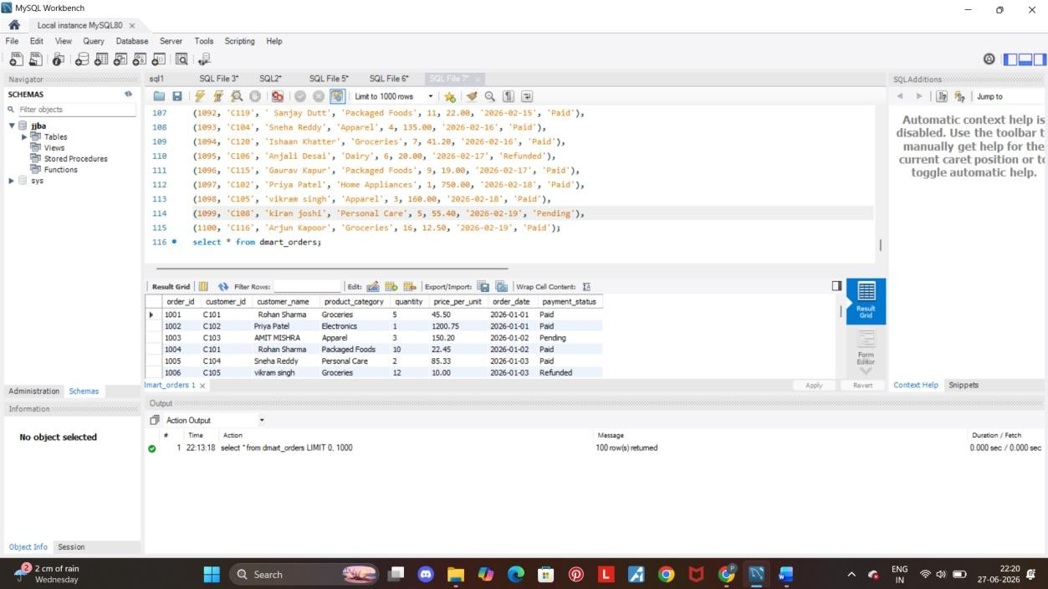

Q. 3 Calculate the total price of products and create a separate column for it.

Query:

select *,(price_per_unit*quantity) as total_price from dmart_orders where payment_status='Paid';

Screenshot:

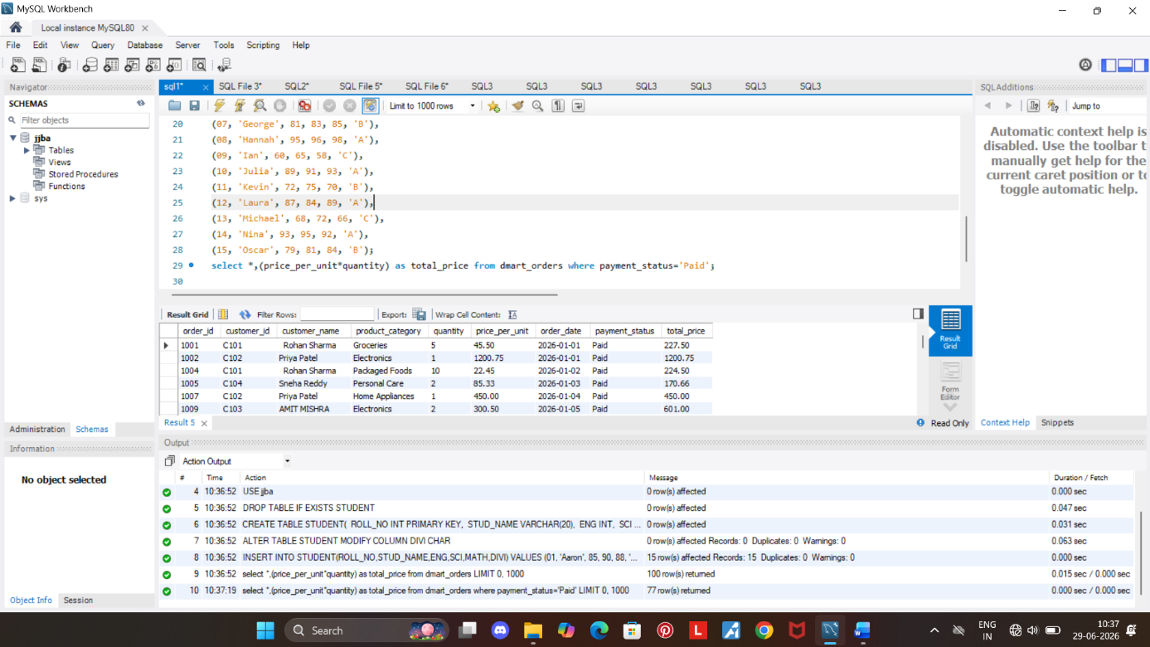

Insights:
- The total price of products sold as per the quantity is calculated .

Q. 4 Give 15% of discount to such customer who’s total spend is above 599 and the payment status if ‘paid’.

Query:
select*, (price_per_unit*quantity) as total_price, if(payment_status!='Paid',"-", if(price_per_unit*quantity>599,round((price_per_unit*quantity)*0.15,2),'-')) as discount_amount from dmart_orders;

Screenshot:

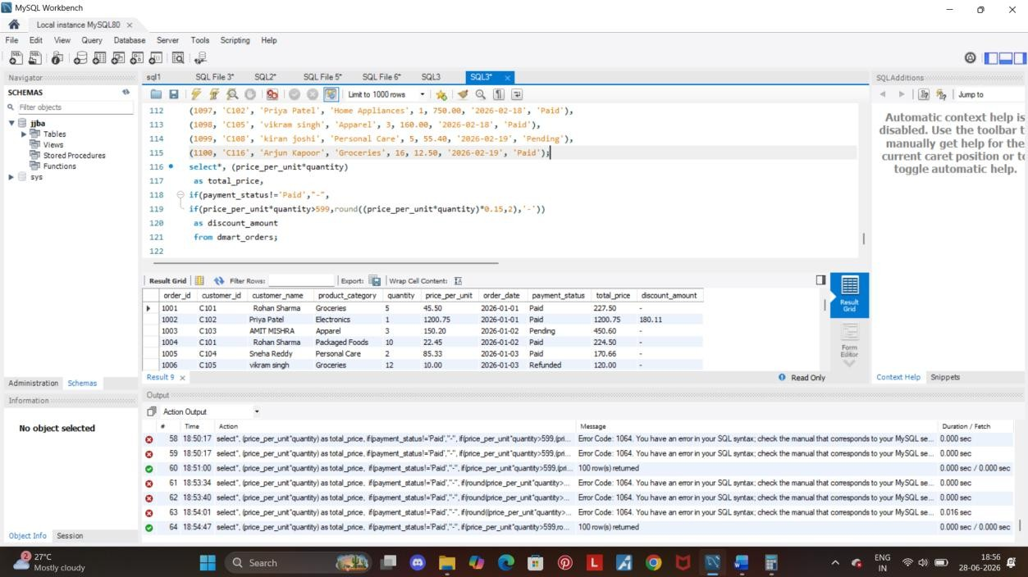

Q. 5 Calculate to total revenue generated across all the product categories.

Query:
select product_category, sum((price_per_unit*quantity)) as total_revenue
where payment_status=’Paid’
from dmart_orders
group by product_category
order by product_category desc;

Screenshot:

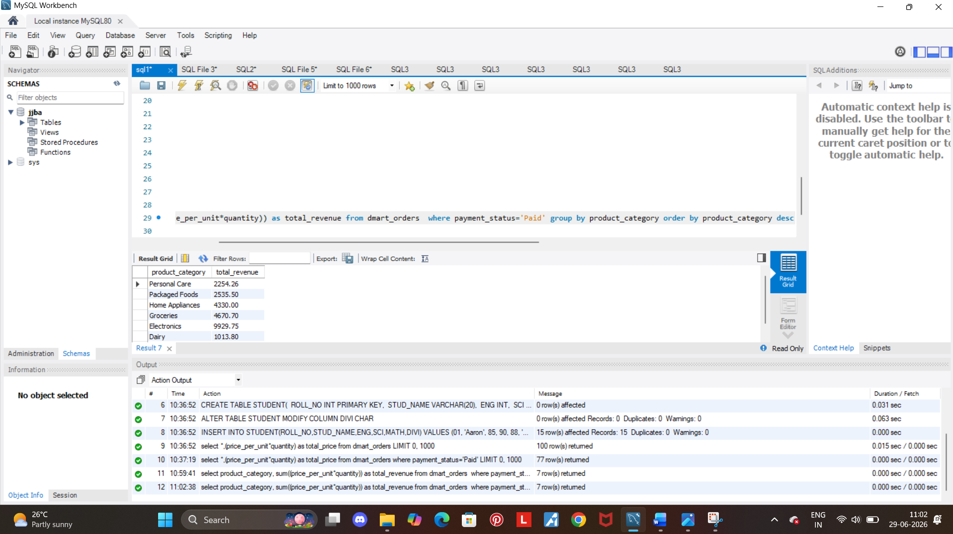

Insights:
- We calculated the total revenue generated across all the categories.
- With the highest being ‘Personal Care’ with 2254

Q. 6 Which product categories are lagging in pending status.

Query:
select product_category, payment_status, count(payment_status) as pay_status from dmart_orders where payment_status='Pending' group by product_category;

Screenshot:

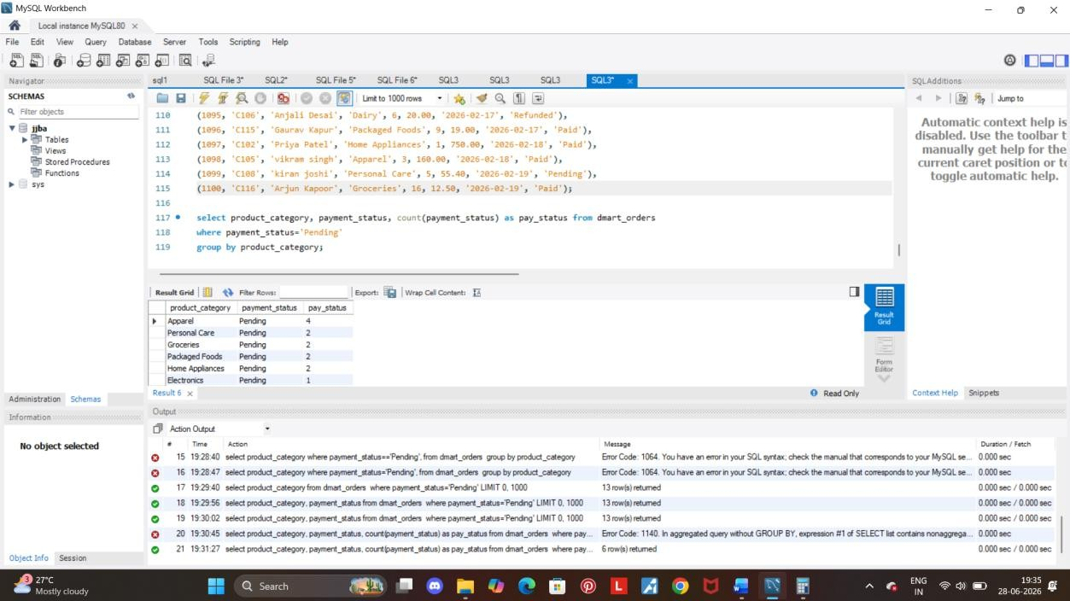

Q. 7 Calculate the total revenue lost due to refund transaction.

Query:
select sum(price_per_unit*quantity) as revenue_lost_due_to_refund from dmart_orders where payment_status='Refunded';

Screenshot:
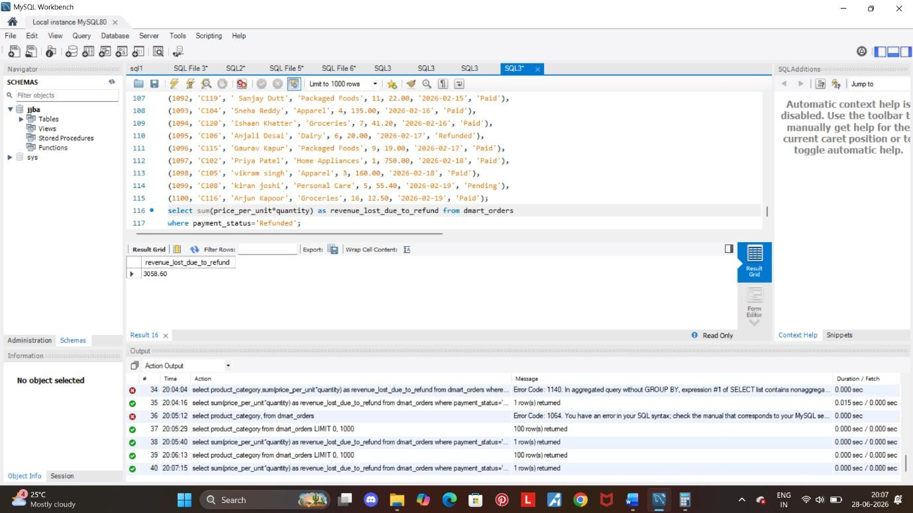

Q. 8 Print the details of top 10 customers with highest total spend.

Query:
select *,(price_per_unit*quantity) as total_revenue from dmart_orders order by total_revenue desc limit 10;

Screenshot:

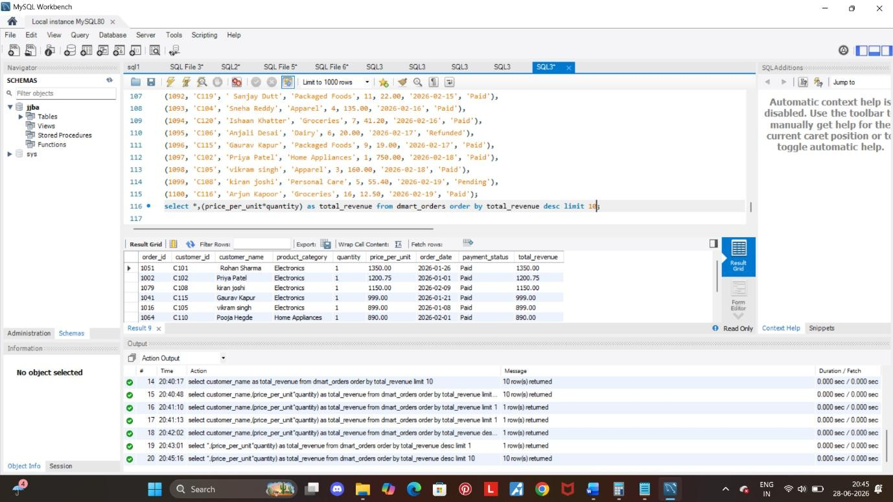

Q. 9 Calculate the total items sold across all transactions.

Query:
select payment_status, sum(quantity) as total_items_sold from dmart_orders group by payment_status;

Screenshot:

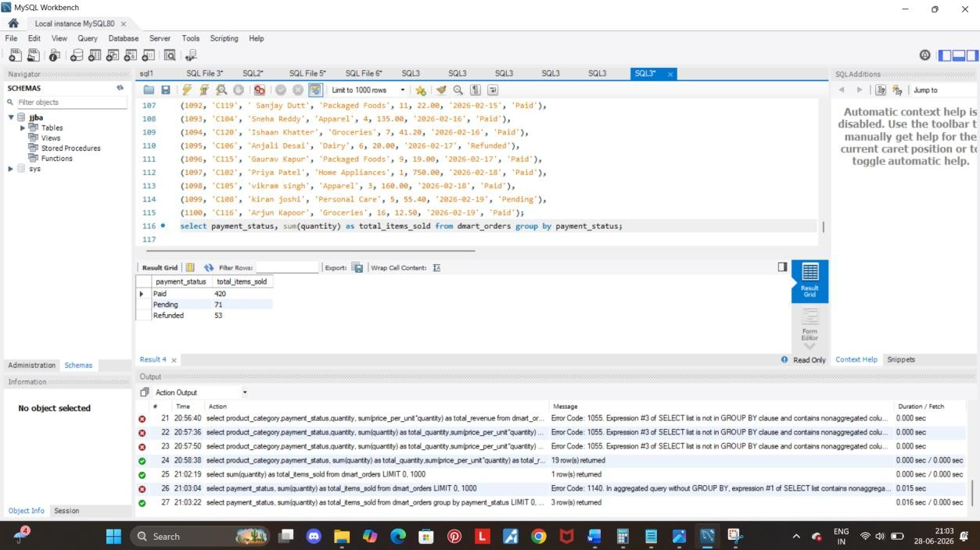

Q. 10 Total revenue generated across all the paid orders.

Query:

select sum(price_per_unit*quantity) as total_revenue from dmart_orders where payment_status='Paid';

Screenshot:
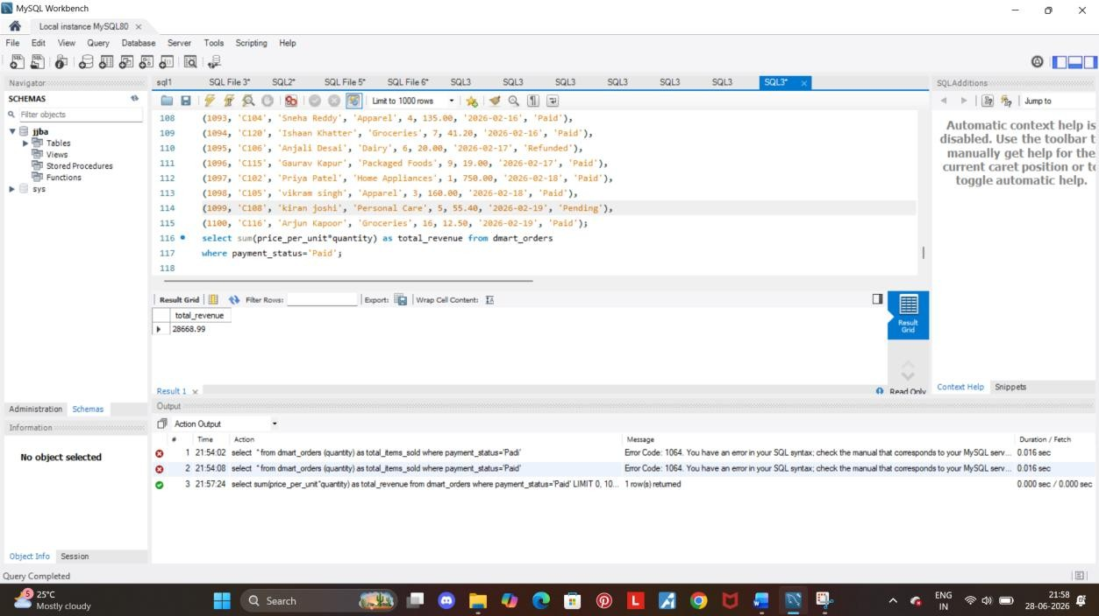

Q. 10 Calculate the average revenue generated per single unit item sold.

Query:
select product_category, avg(price_per_unit) as avg_price from dmart_orders group by product_category order by avg_price desc;

Screenshot:
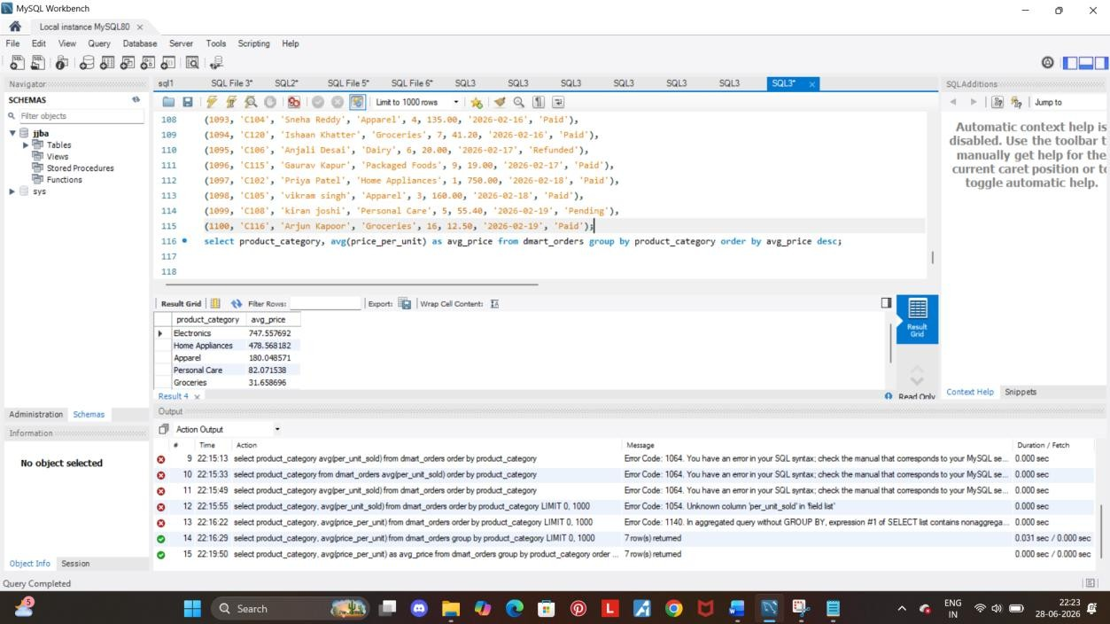

Q. 11 Fetch the data of all customers between ‘2026-02-01' and '2026-02-25'.

Query:
select *from dmart_orders where order_date between '2026-02-01' and '2026-02-25';

Screenshot:

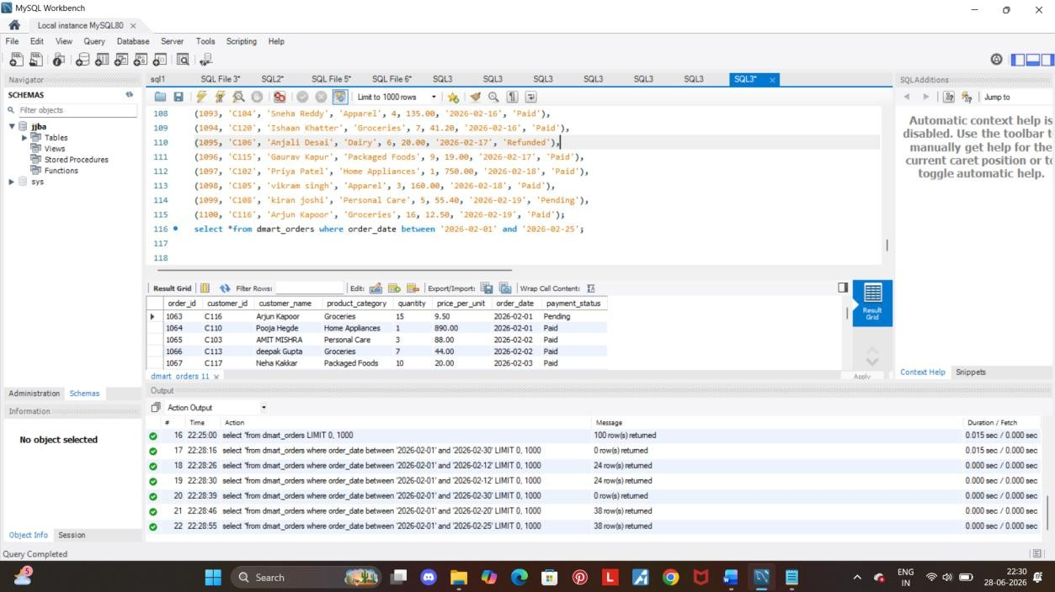

Q. 12 Fetch the data of customers who’s name starts with ‘R.

Query:
select *from dmart_orders where customer_name like 'r%';

Screenshot:

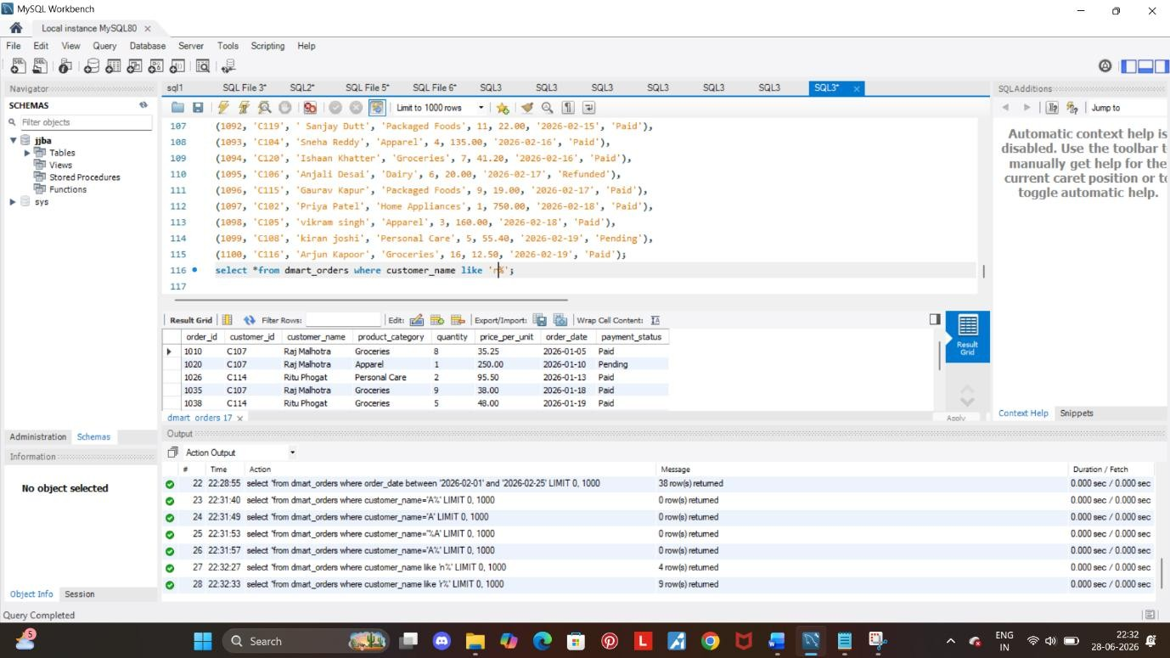

Q. 13 Create a new column order_tier labelling each customer as per the order quantity.

Query:
select *, if(quantity>10,'Bulk order', if(quantity >5 and quantity< 10, 'Regular order,','singel order')) as order_tier from dmart_orders;

Screenshot:

