Title:- write a Program to get the average marks of six subjects using the Multiple Inheritance.
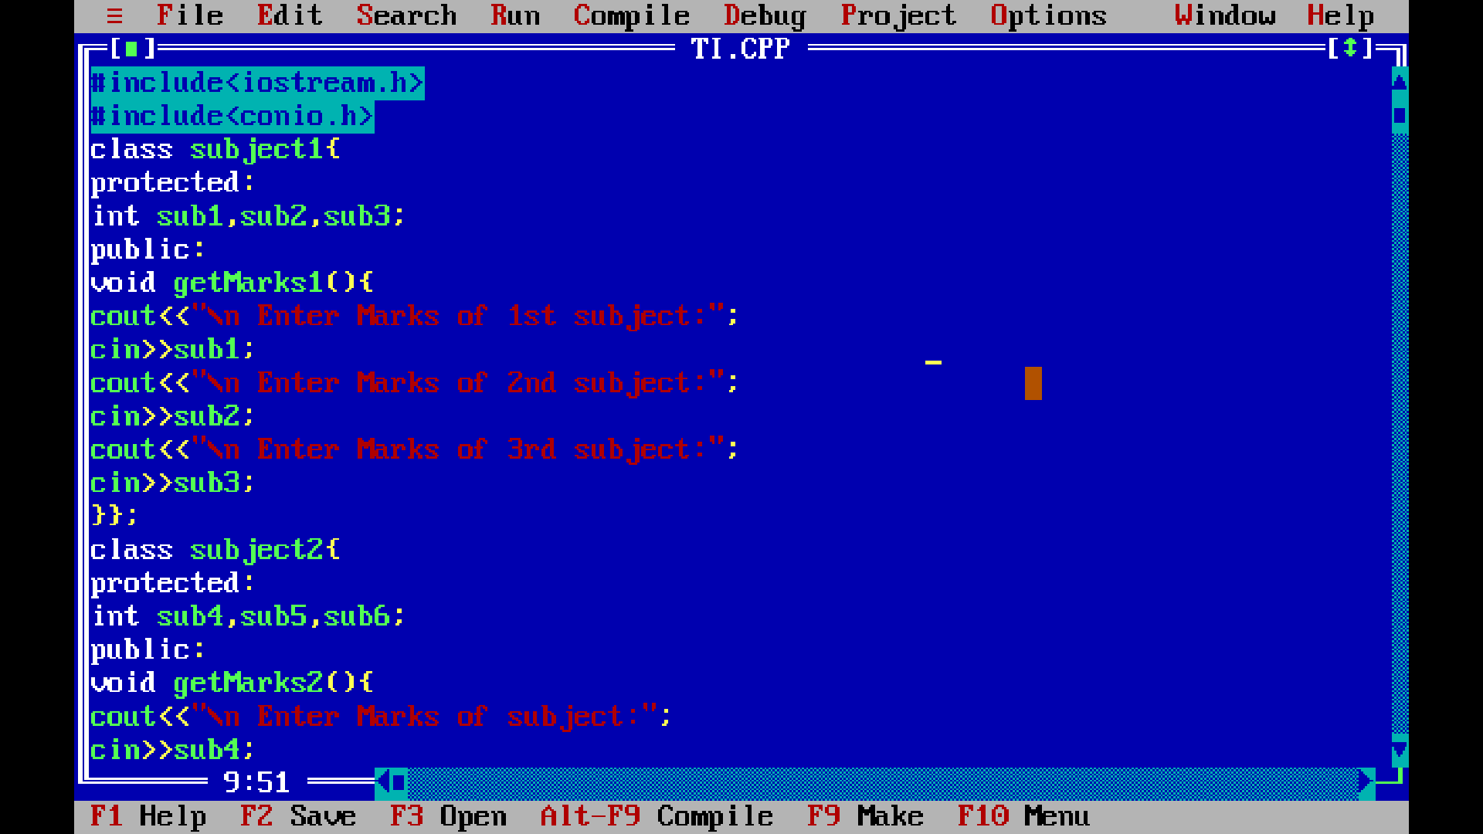
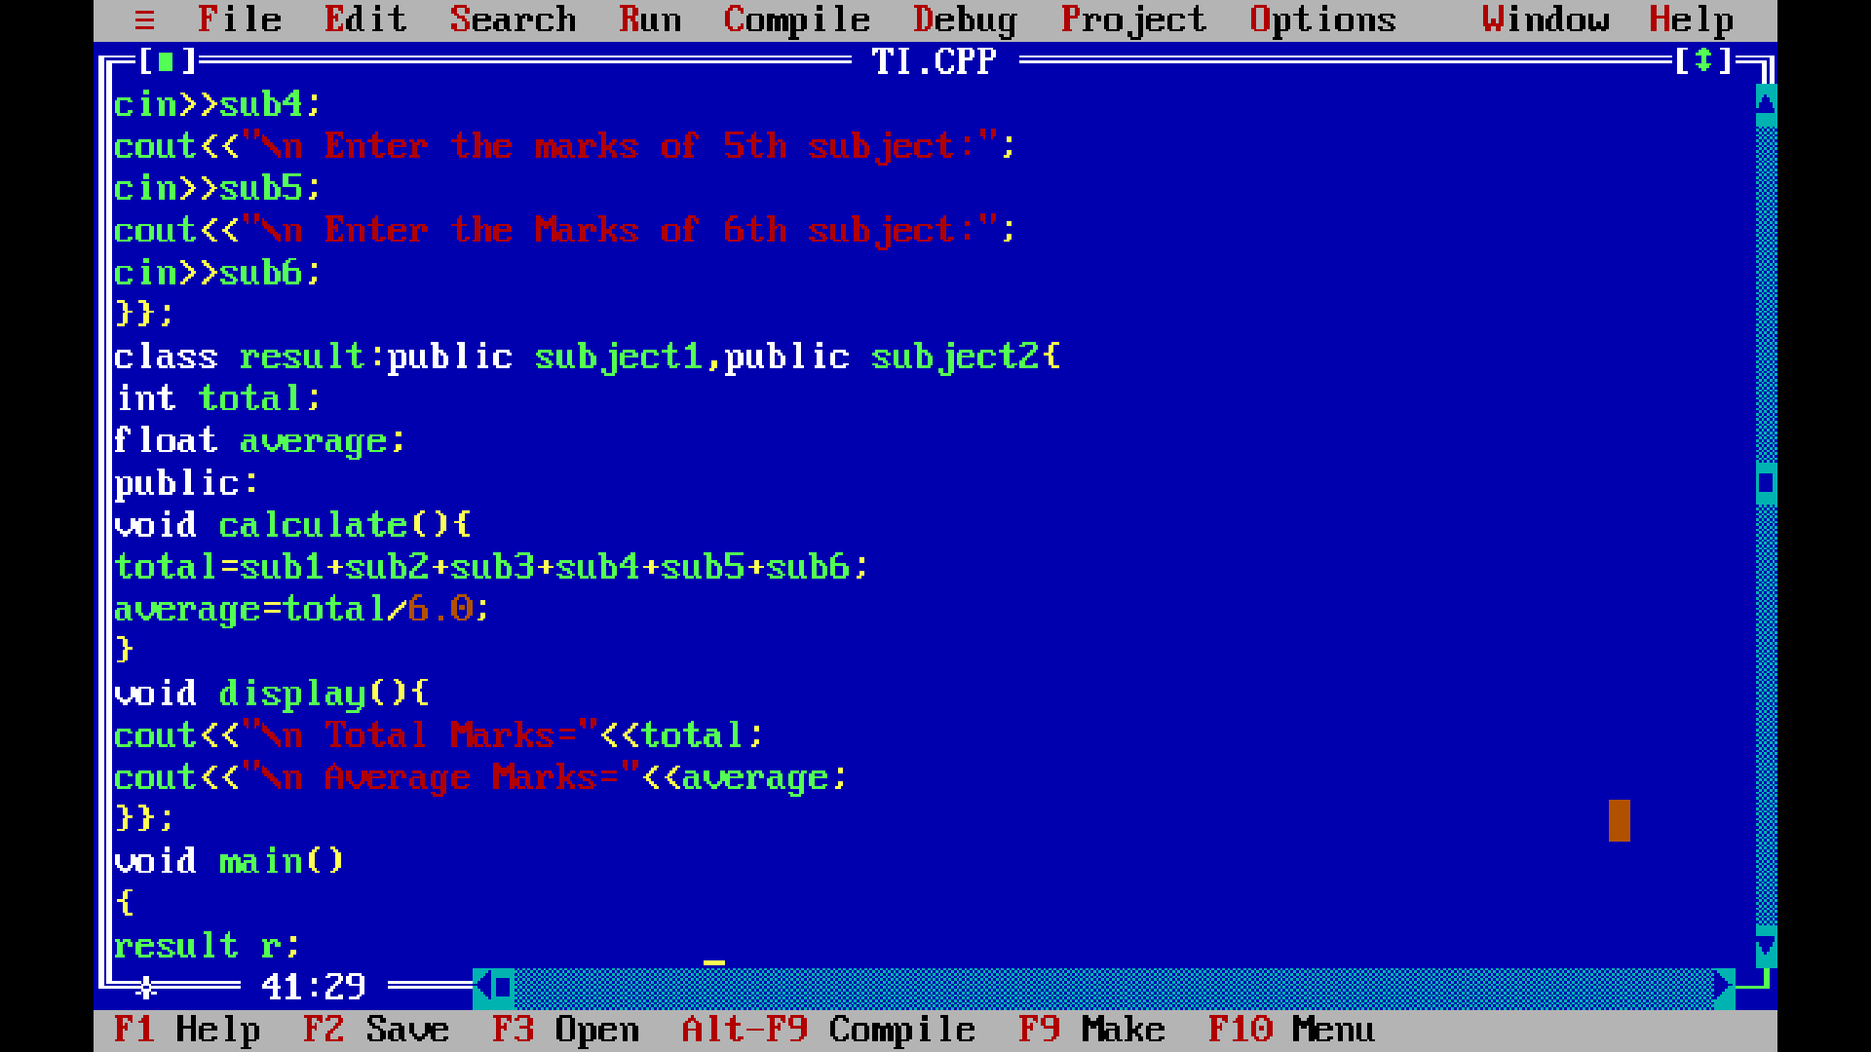

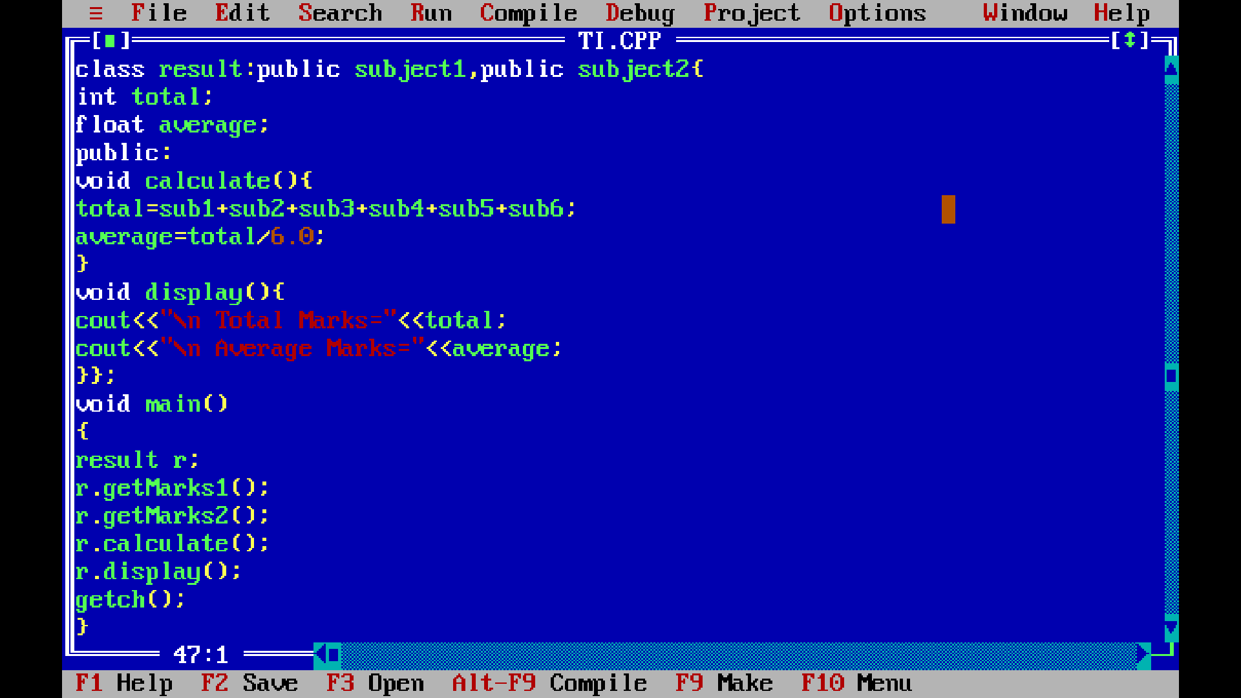
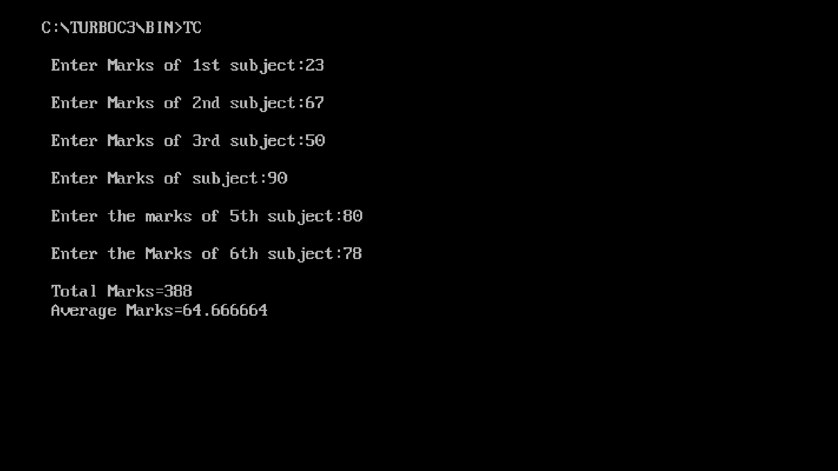

Title:- An Educational institute wishes to store the data of its employees. The Hierarchical relationship of its related classes are shown in the fig below. Define all the classes to represent hierarchy and define functions to retrive individual information as and when required.

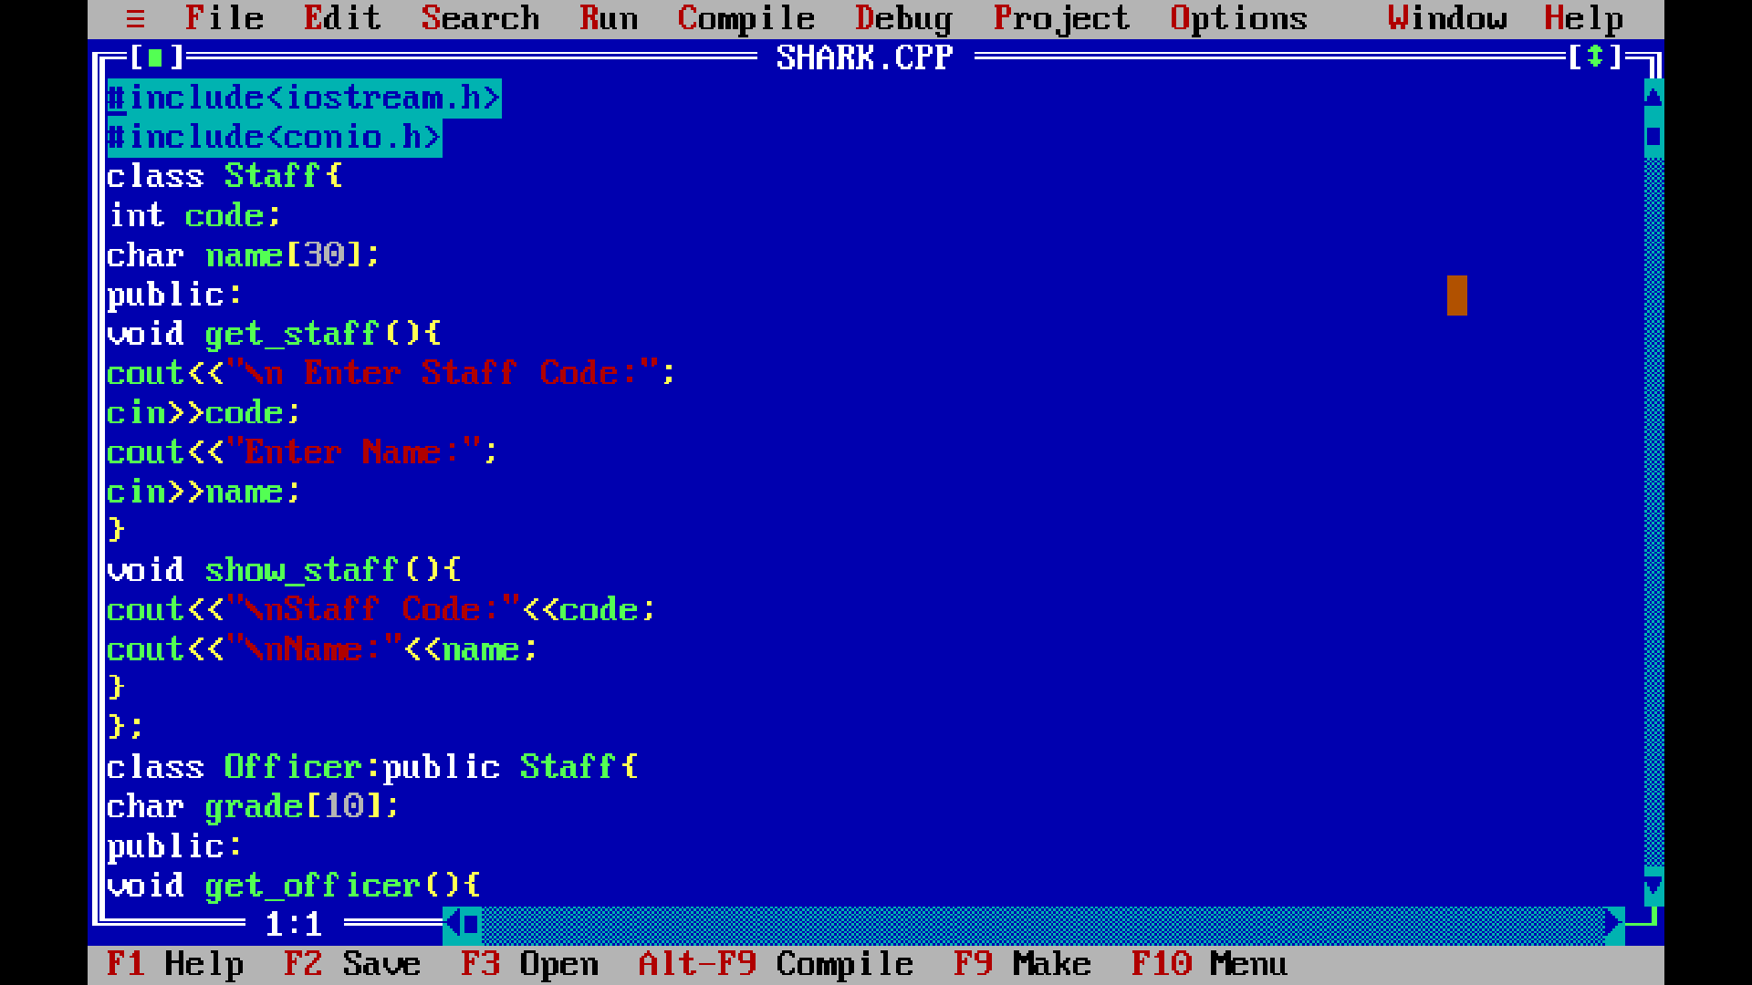
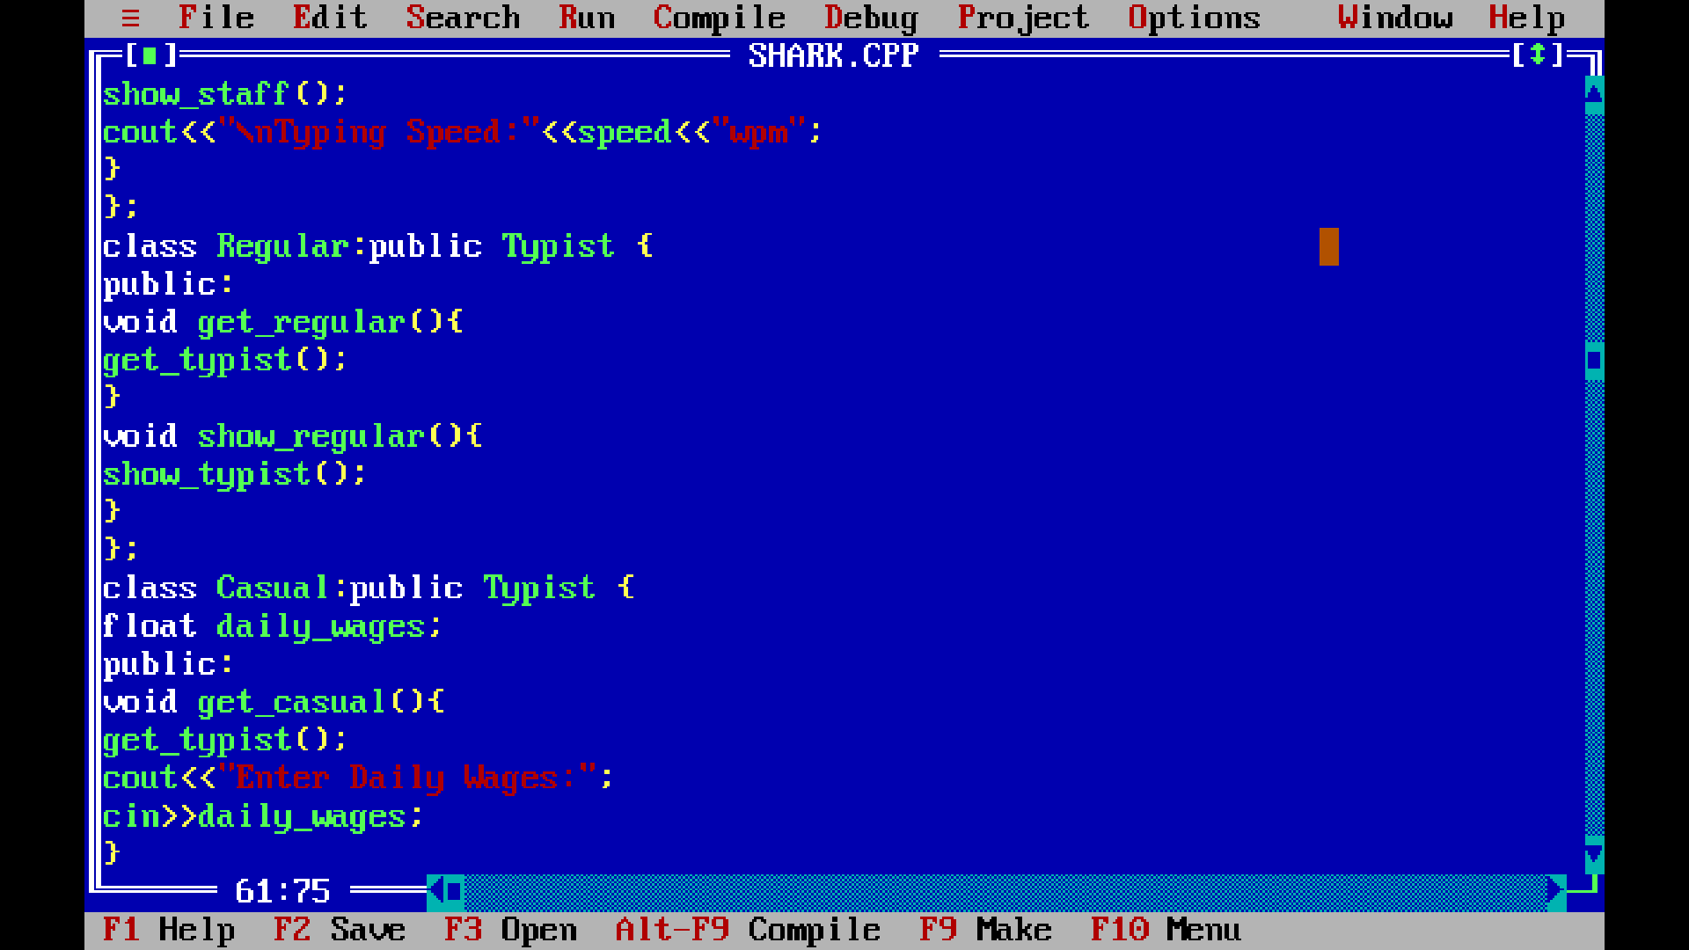

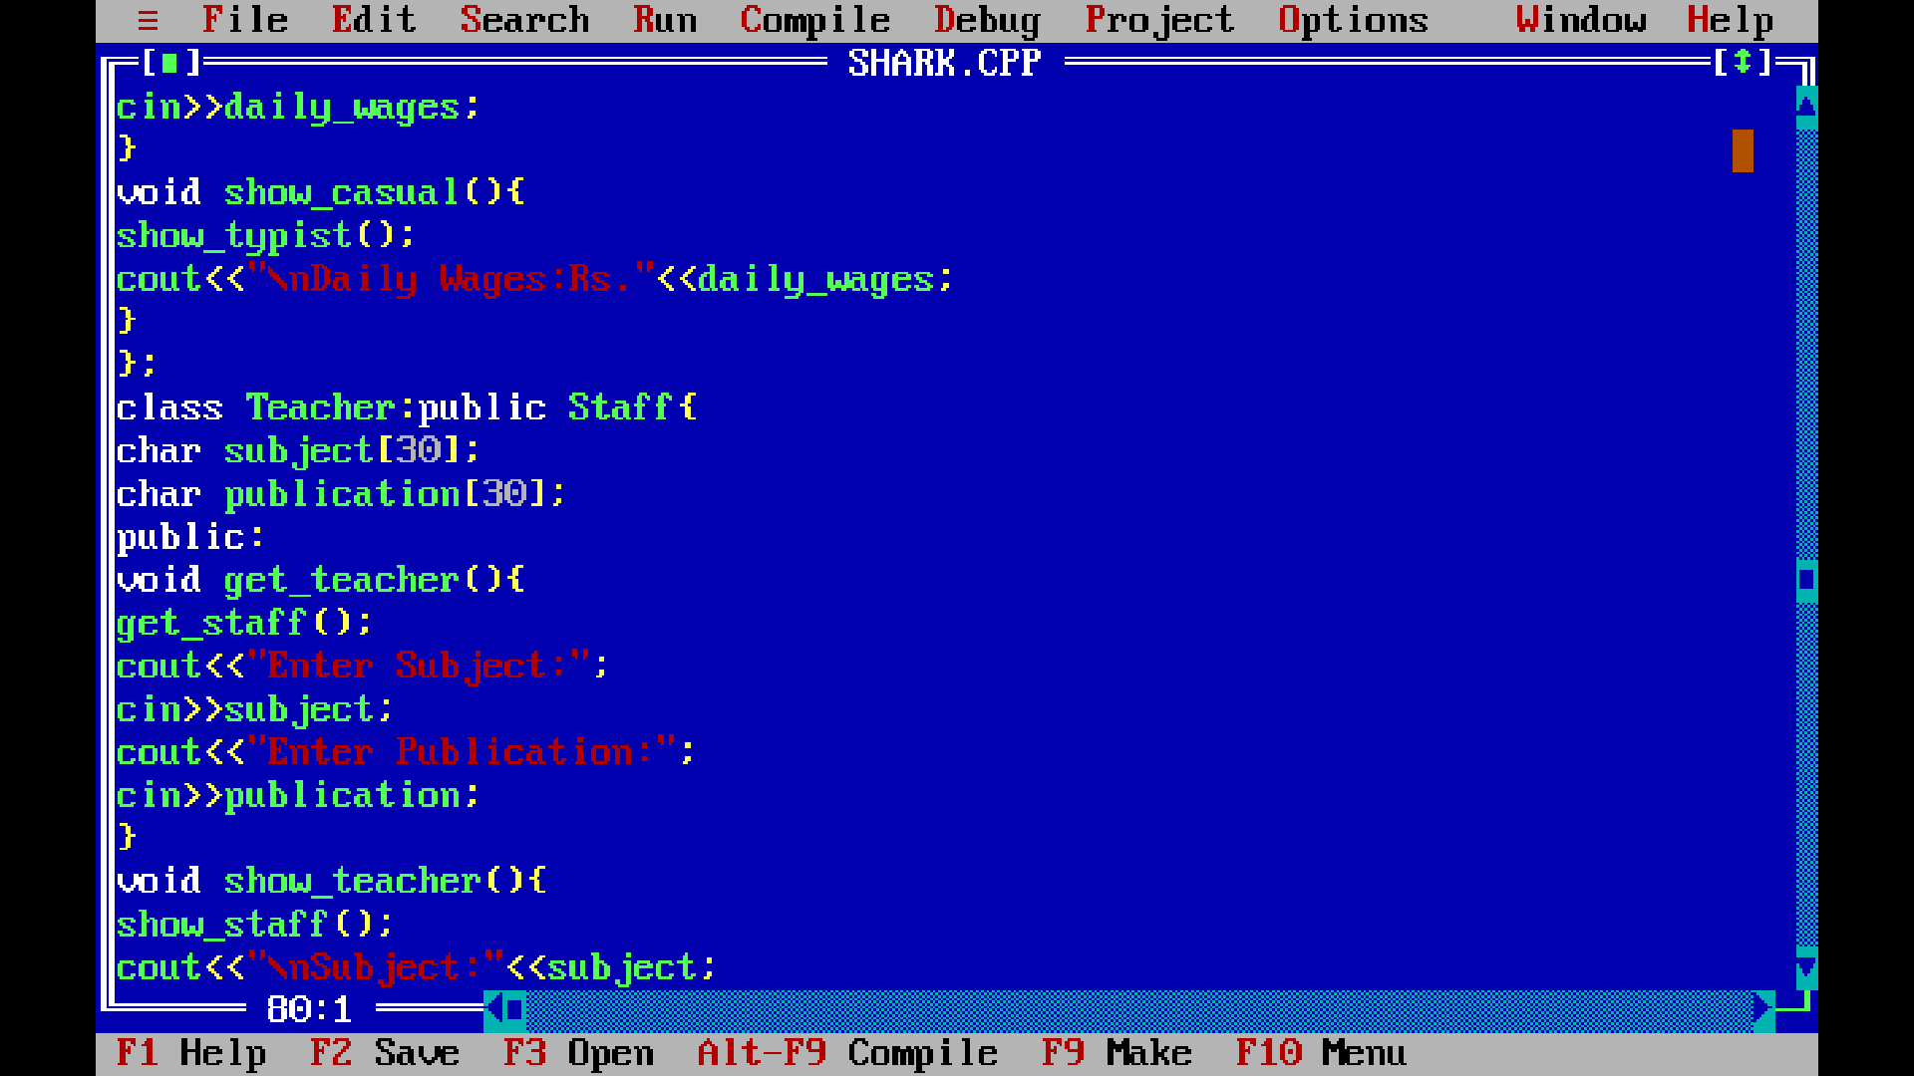
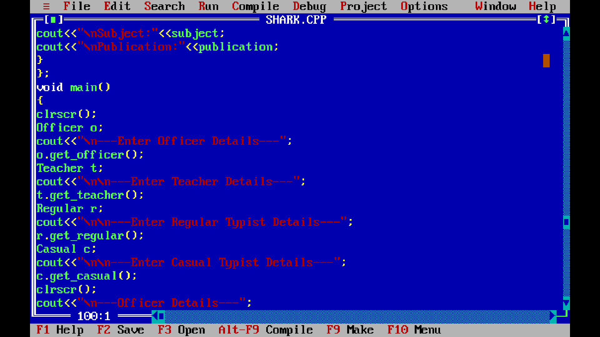

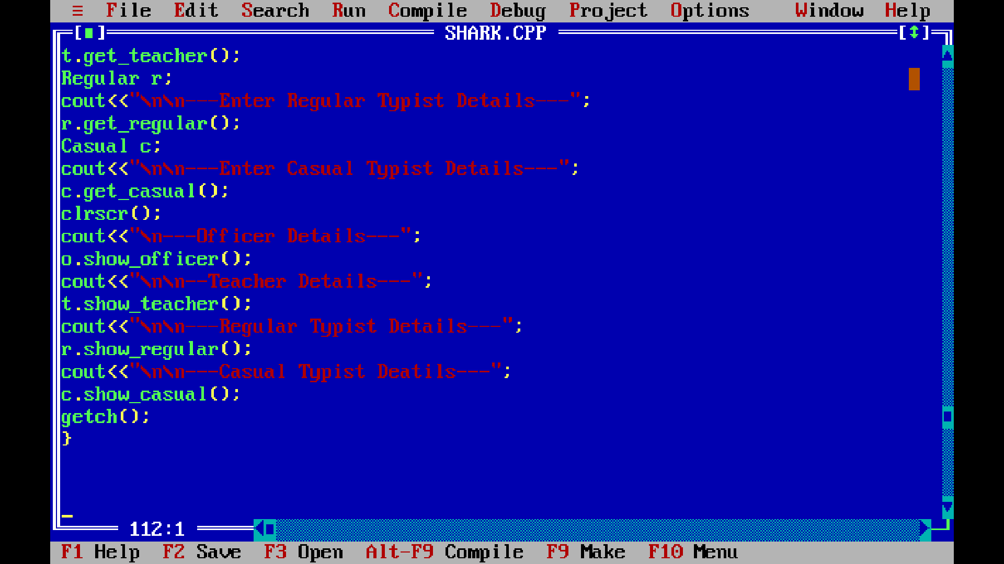
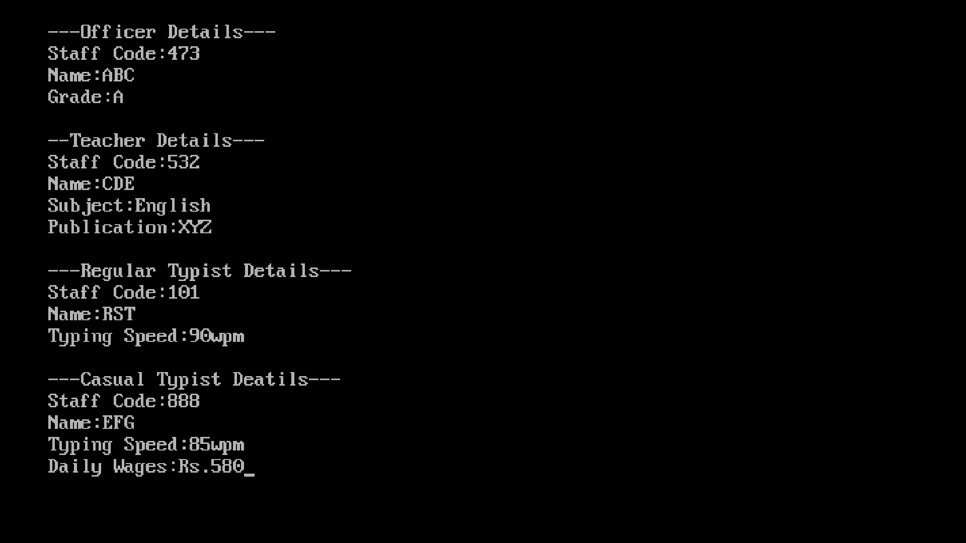

Title:- Write a C++ program to implement the following inheritance. Accept and display data for one programmer and one manager. Make display function virtual.
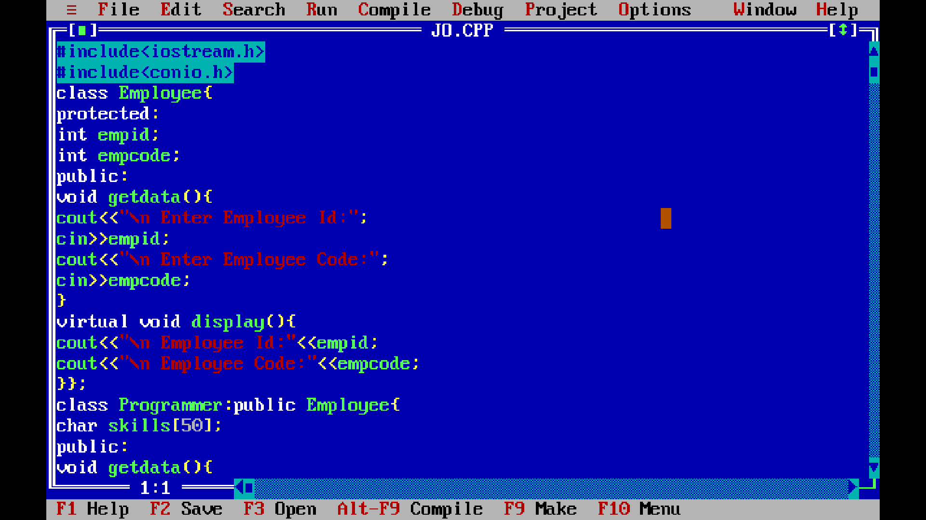
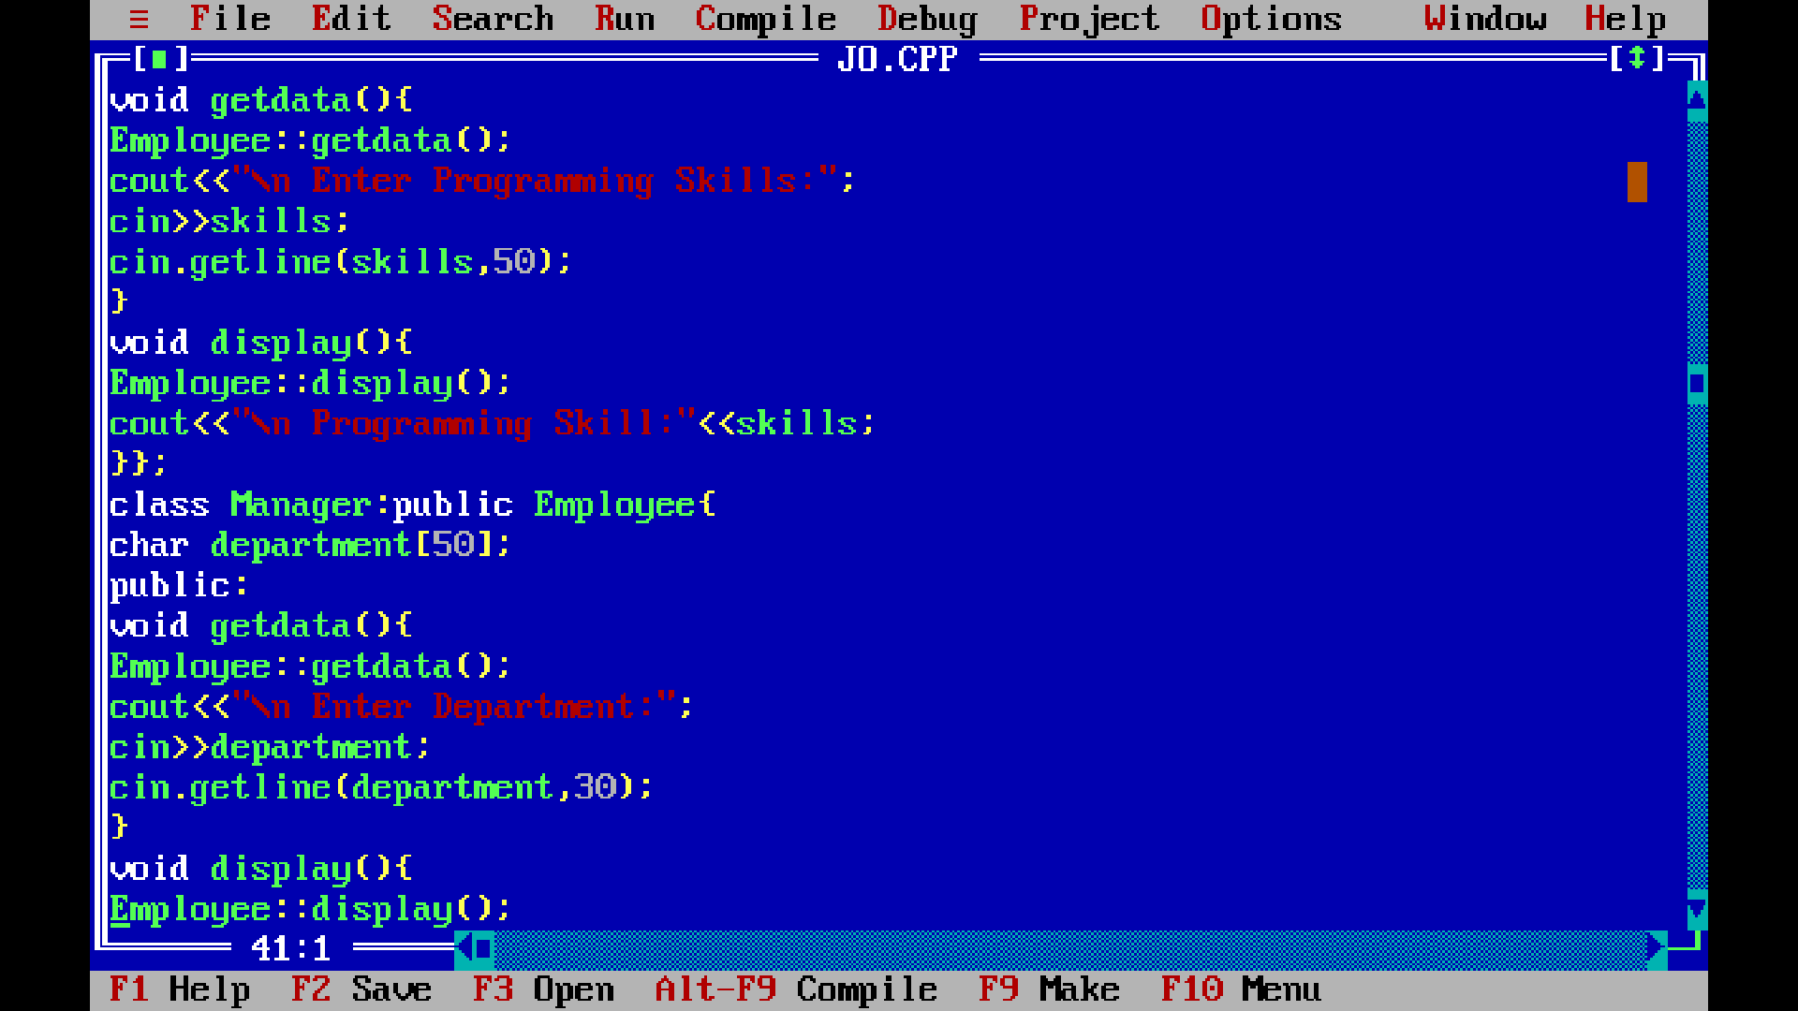

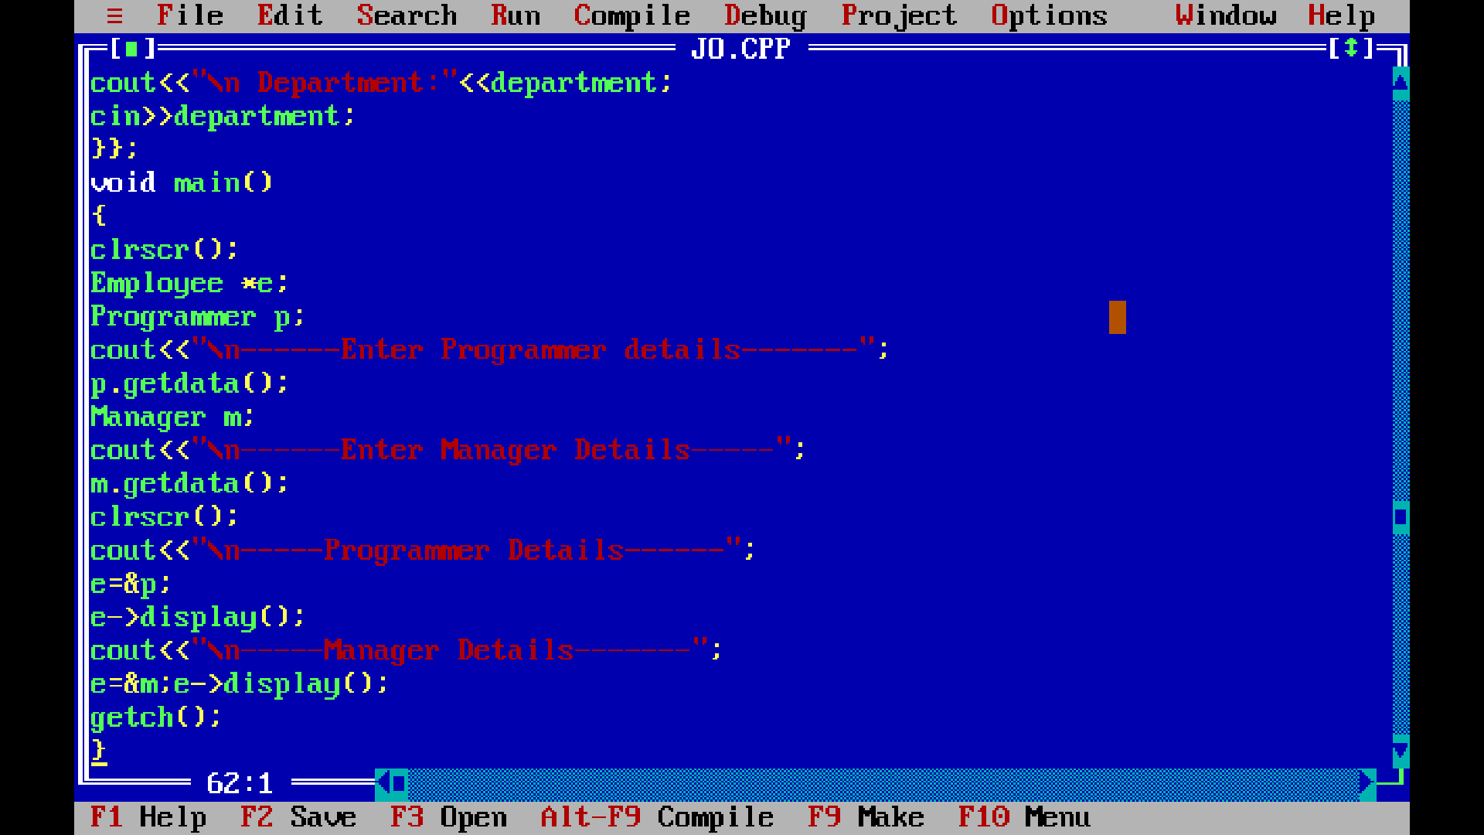
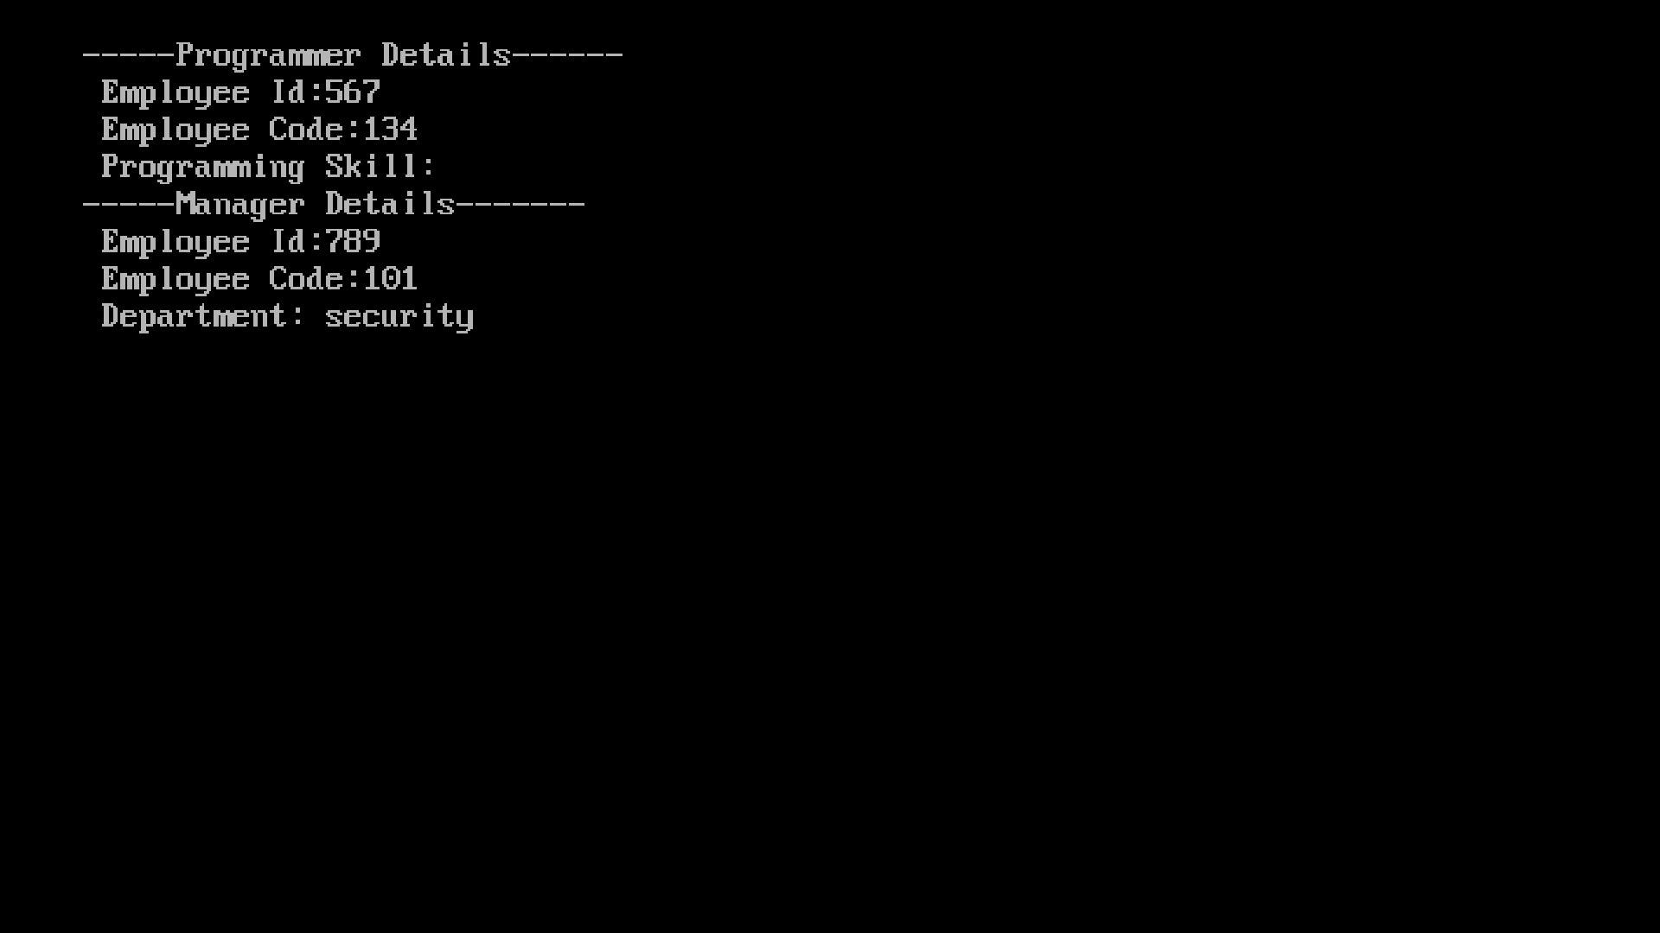

Title:- Write a program which show the use of implicit type casting to calculate the average of two numbers.

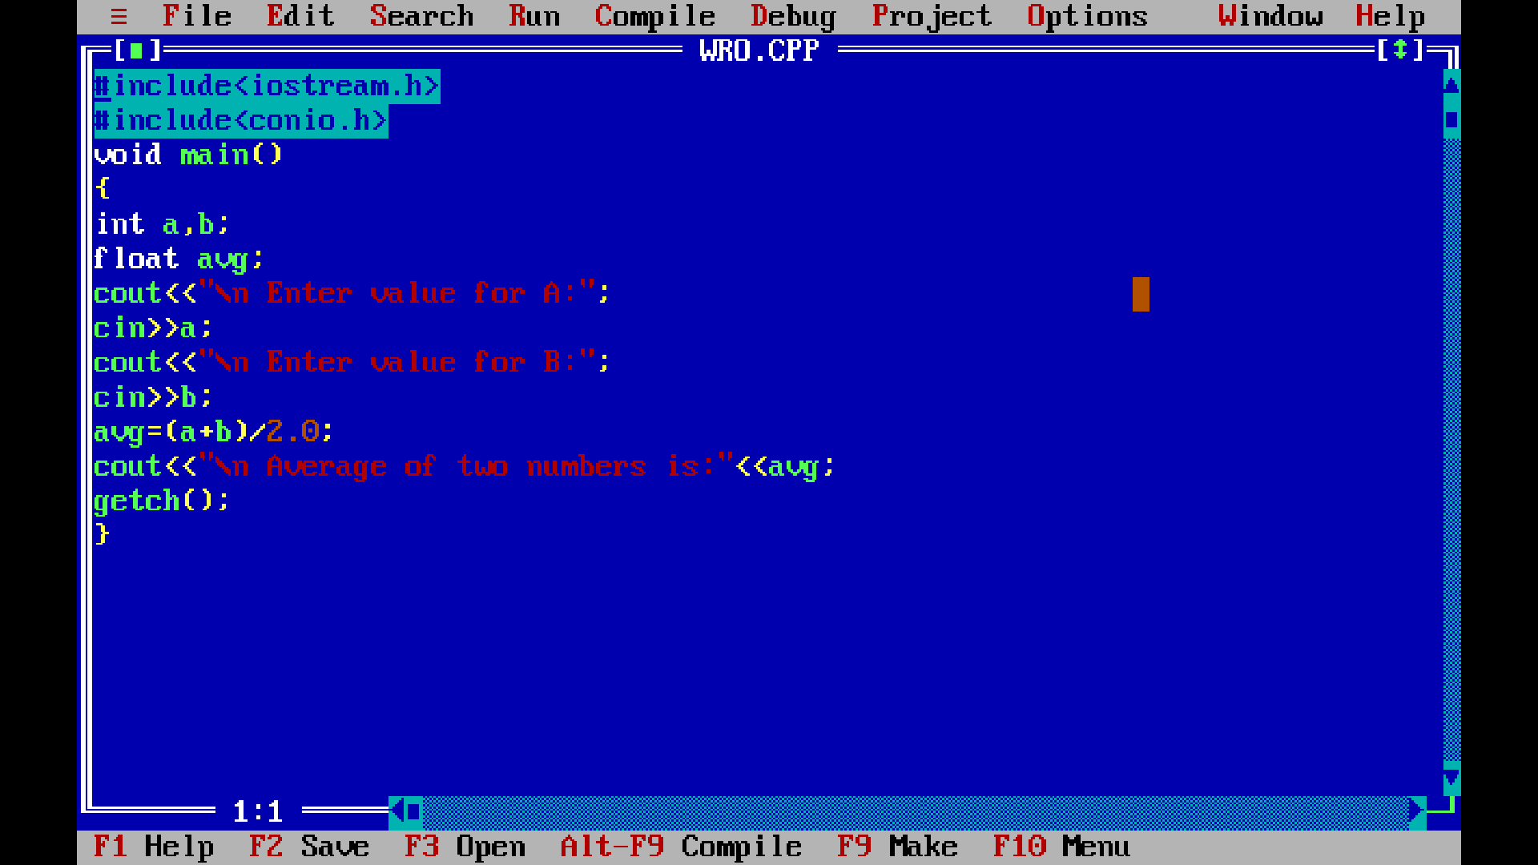

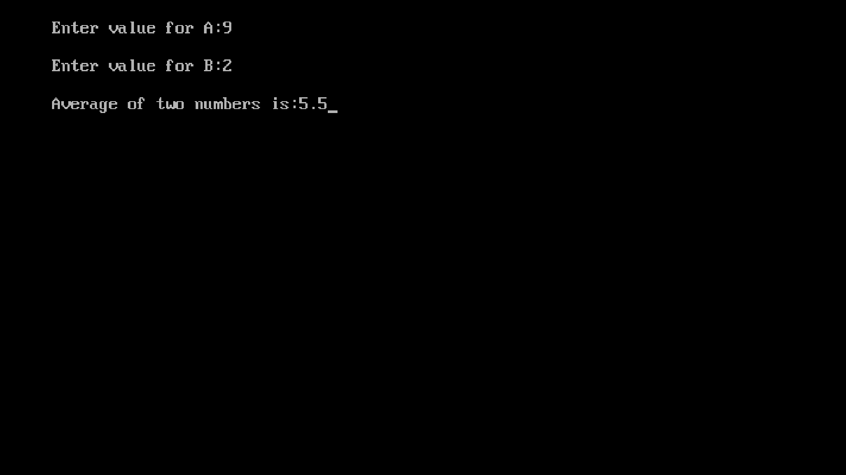

#include<conio.h>
#include<stdio.h>
#include<graphics.h>
void main()
{
int gd=DETECT,gm;
initgraph(&gd,&gm,”c:\\turboc3\\bgi”);
printf(“\n Roll No:-60”);
printf(“\n Name:-Priyanka Kolte”);
rectangle(100,100,300,300);
rectangle(150,150,250,250);
line(175,300,125,400);
line(225,300,270,400);
rectangle(100,400,300,450);
getch();
closegraph();
}

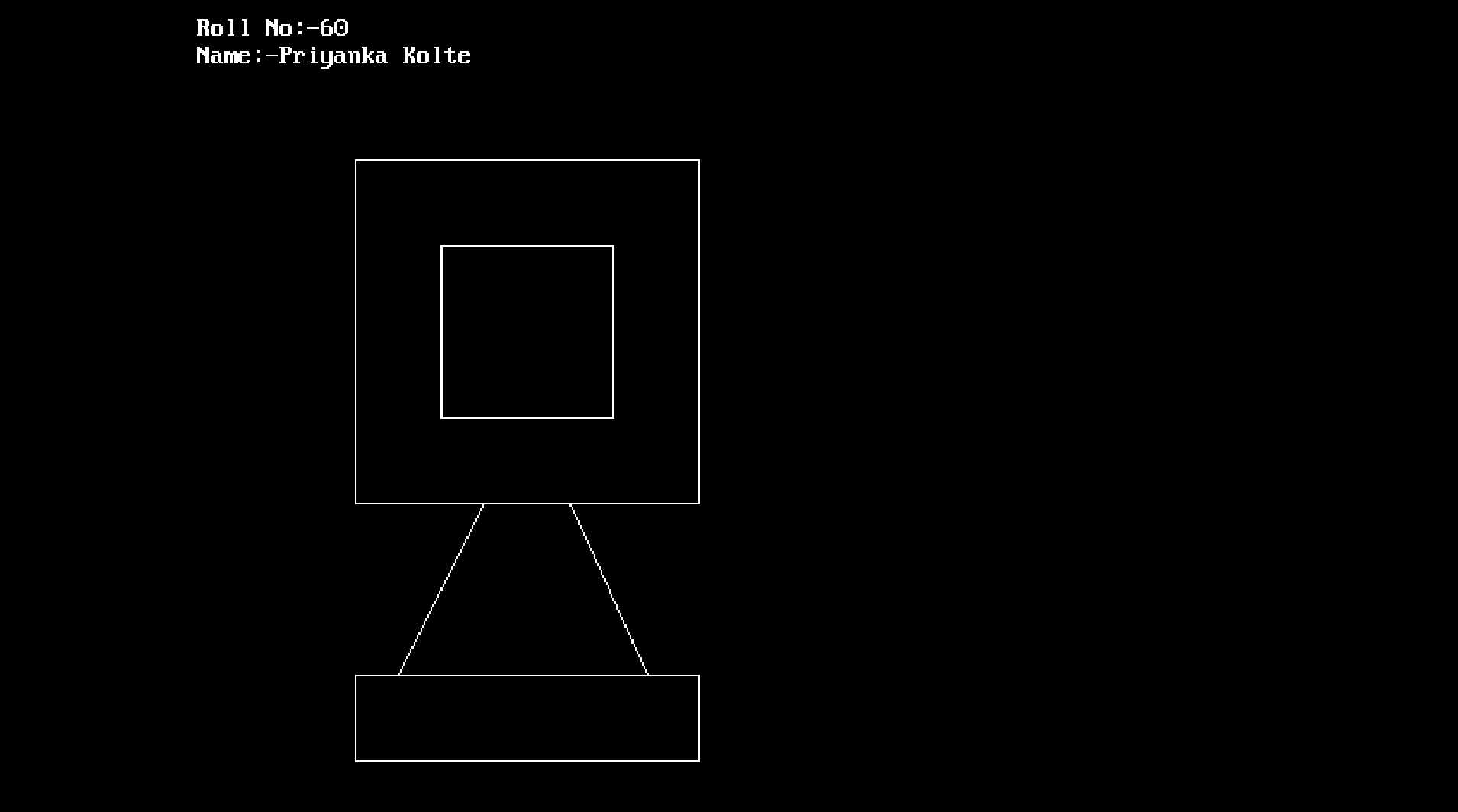

#include<stdio.h>
#include<conio.h>
#include<graphics.h>
void main()
{
int gd=DETECT,gm;
initgraph(&gd,&gm,”c:\\turboc3\\bgi”);
printf(“\n Priyanka Kolte”);
printf(“\n Roll No:- 60”),
rectangle(100,100,400,300);
circle(350,350,50);
circle(150,350,50);
getch();
closegraph();
}

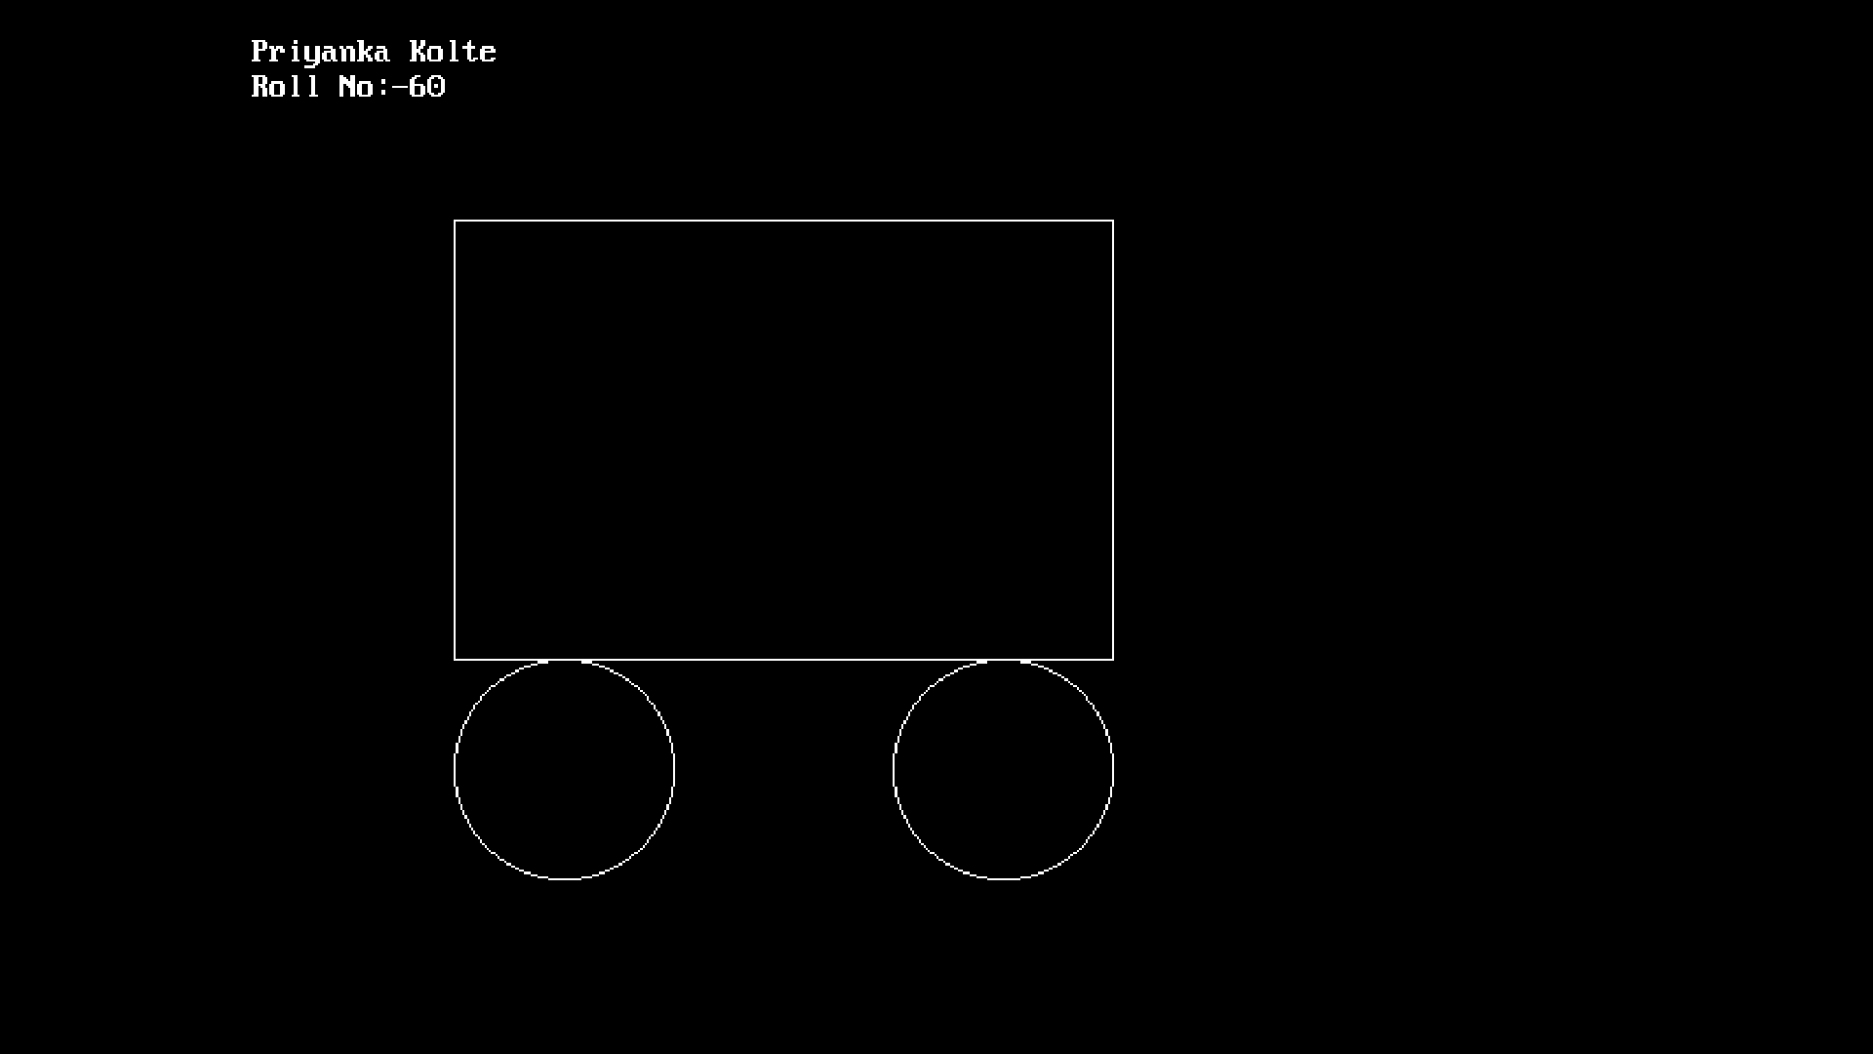

#include<stdio.h>
#include<conio.h>
#include<graphics.h>
void main()
{
int gd=DETECT,gm;
initgraph(&gd,&gm,”c:\\turboc3\\bgi”);
printf(“\n Priyanka Kolte”);
printf(“\n Roll No:- 60”);
line(100,100,200);
line(100,100,350,100);
line(100,200,350,200);
line(350,50,350,200);
line(350,200,350,200);
line(350,50,500,150);
line(350,200,500,150);
line(350,50,350,200);
getch();
closegraph();
}

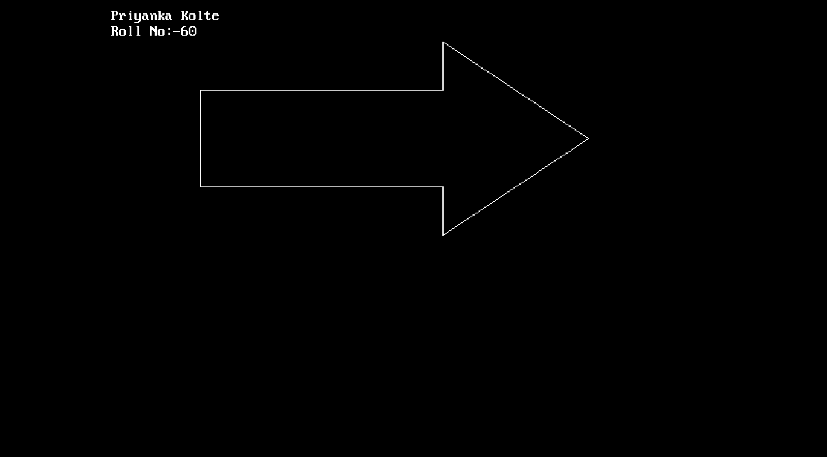

#include<stdio.h>
#include<conio.h>
#include<graphics.h>
void main()
{
int gd=DETECT,gm;
initgraph(&gd,&gm,”c:\\turboc3\\bgi”);
printf(“\n Priyanka Kolte”);
printf(“\n Roll No:- 60”);
line(100,100,100,200);
line(100,100,350,100);
line(100,200,350,200);
line(350,50,350,100);
line(350,200,350,200);
line(350,50,500,150);
line(350,250,500,150);
line(350,250,350,200);
getch();
closegraph();
}

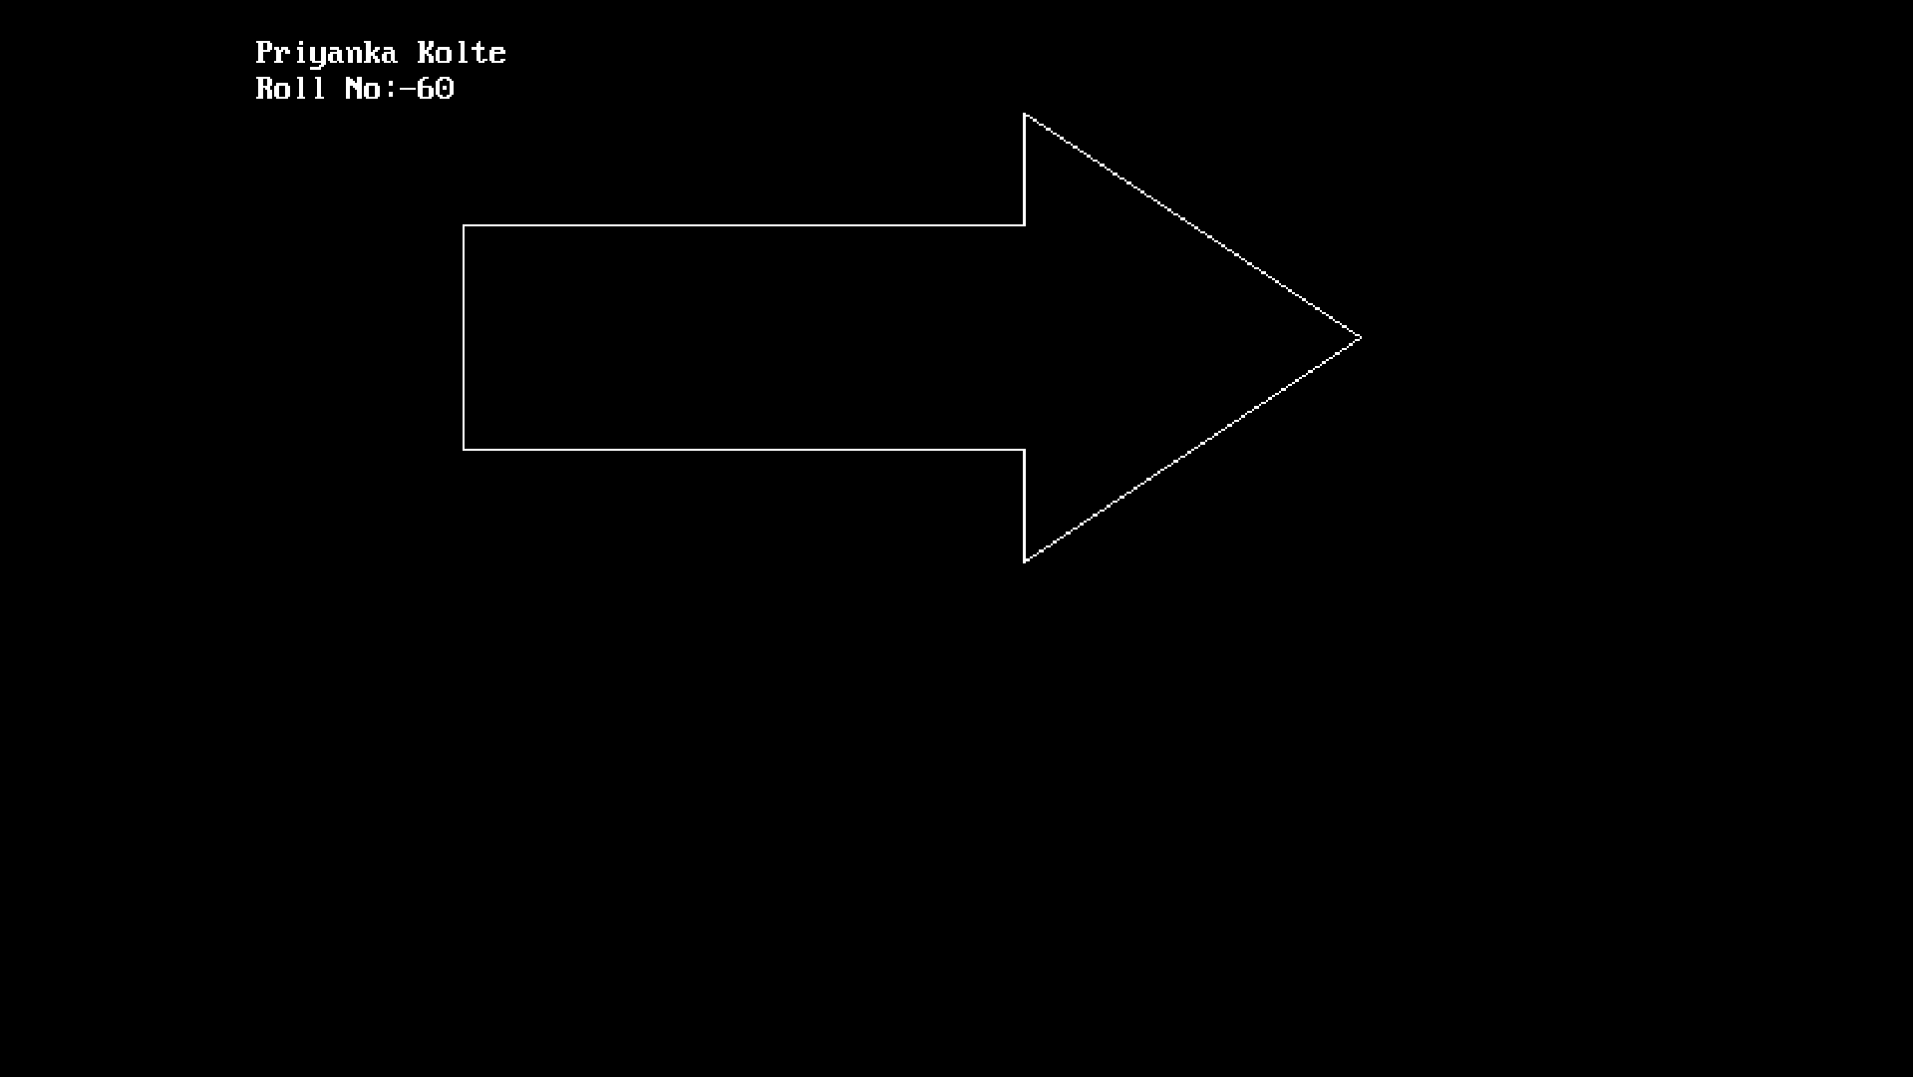

#include<stdio.h>
#include<conio.h>
#include<graphics.h>
void main()
{
int gd=DETECT,gm;
initgraph(&gd,&gm,”c:\\turboc3\\bgi”);
printf(“\n Priyanka Kolte”);
printf(“\n Roll No:- 60”);
circle(300,100,50);
circle(280,80,10);
circle(320,80,10);
ellipse(300,50,6,360,50,100);
line(350,240,400,300);
line(250,240,200,270);
getch();
closegraph();
}

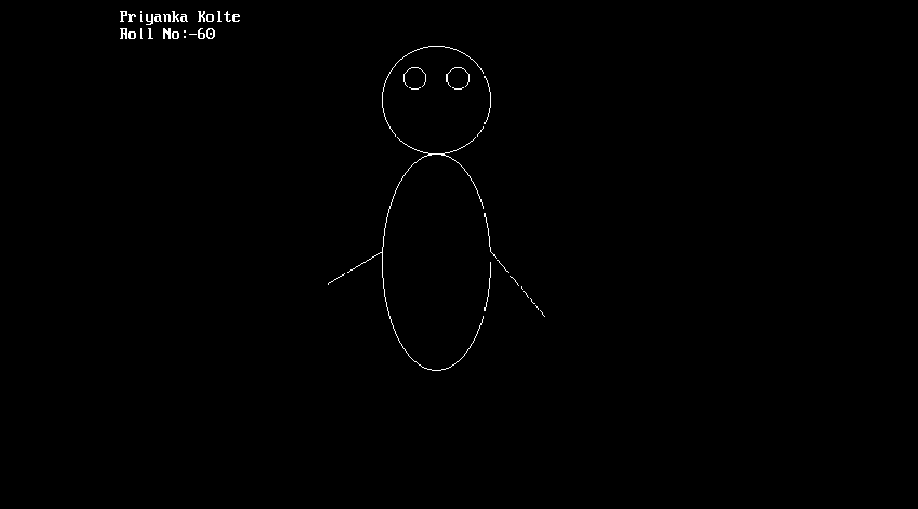

#include<stdio.h>
#include<conio.h>
#include<graphics.h>
void main()
{
int gd=DETECT,gm;
initgraph(&gd,&gm,”c:\\turboc3\\bgi”);
printf(“\n Priyanka Kolte”);
printf(“\n Roll No:- 60”);
circle(400,200,200);
circle(300,100,30);
circle(500,100,30);
line(400,200,350,250);
line(350,250,450,250);
line(400,200,450,250);
rectangle(300,300,500,350);
getch();
closegraph();
}

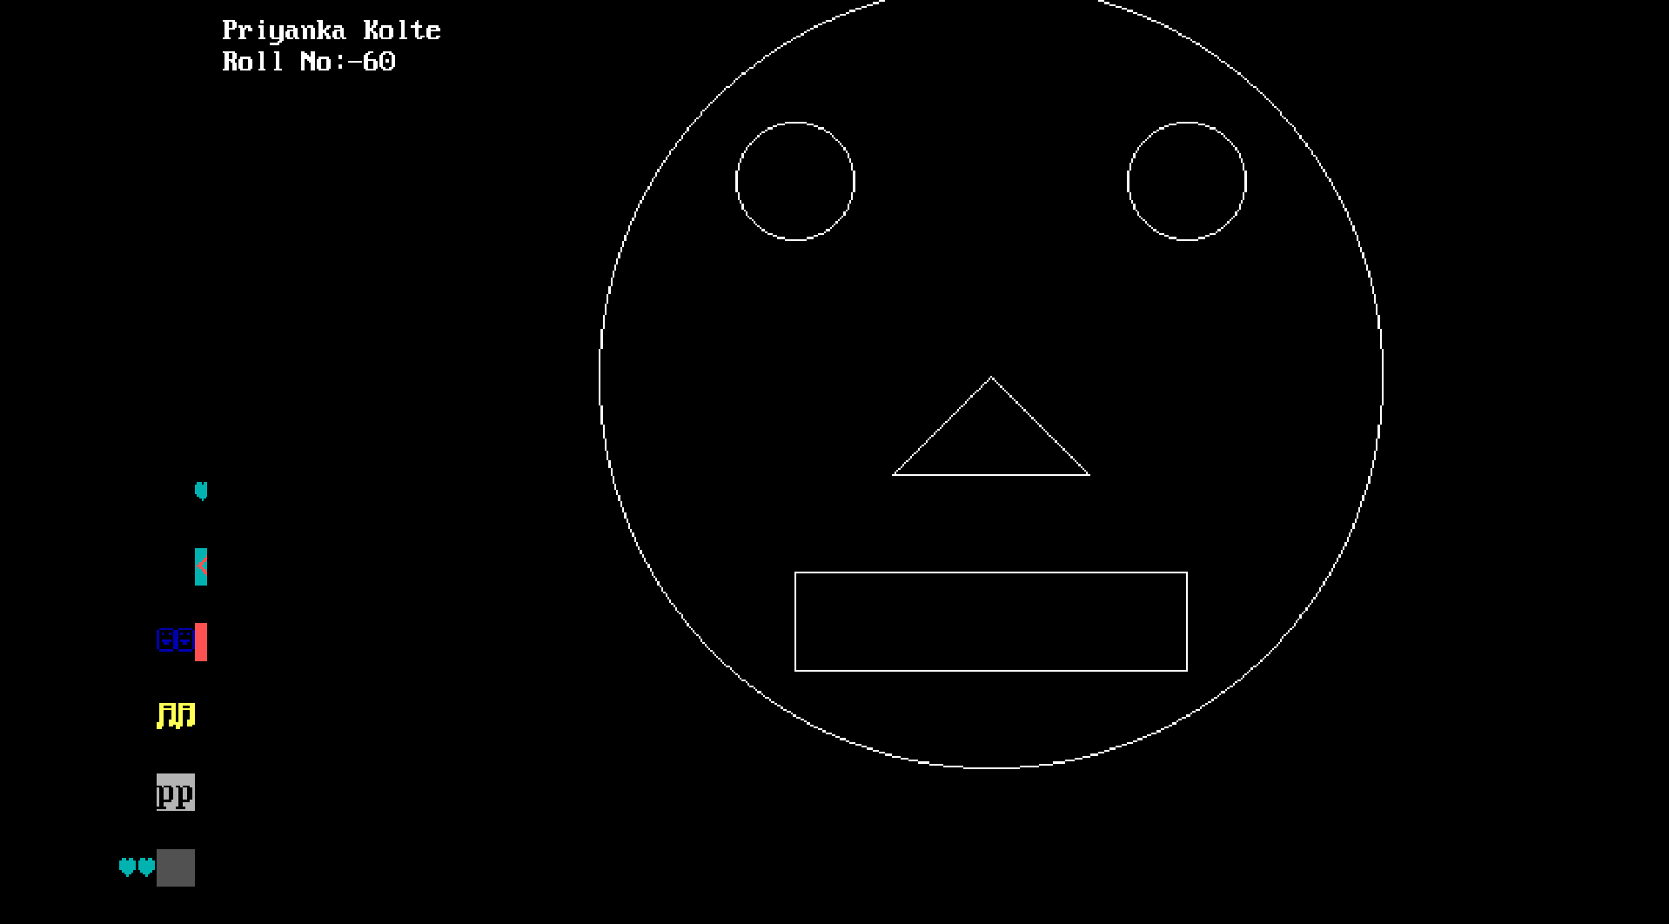

#include<stdio.h>
#include<conio.h>
#include<graphics.h>
void main()
{
int gd=DETECT,gm;
initgraph(&gd,&gm,”c:\\turboc3\\bgi”);
printf(“\n Priyanka Kolte”);
printf(“\n Roll No:- 60”);
line(175,125,150,250);
line(175,125,200,250);
line(150,250,200,250);
line(150,250,150,300);
line(150,300,200,300);
line(200,250,200,300);
line(175,125,275,125);
line(275,150,300,250);
line(200,250,300,250);
line(300,250,300,300);
line(200,300,300,300);
getch();
closegraph();
}

