#include<stdio.h>
#include<conio.h>
#include<graphics.h>
void main()
{
Int x1,y1,x2,y2,dx,dy,length,I;
Float x,y,xinc,yinc;
Int gd=DETECT,gm;
Initgraph(&gd,&gm,”c:\\turboc3\\bgi”);
pintf(“\n Name:- Priyanka Kolte”);
printf(“\n Roll No:- 60”);
printf(“\n Enter the strating coordinates:”);
scanf(“%d%d”,&x1,&y1);
printf(“\n Enter the ending coordinates:”);
scanf(“%d%d”,&x2,&y2);
dx=x2-x1;
dy=y2-y1;
if(abs(dx)>abs(dy))
length=abs(dx);
else
length=abs(dy);
xinc=dx(float)length;
yinc=dy(float)length;
x=x1;
y=y1;
putpixel(x,y,10);
for(i=0;i<length;i++)
{
x=x+xinc;
y=y+yinc;
putpixel(x,y,10);
delay(10);
}
getch();
closegraph();
}

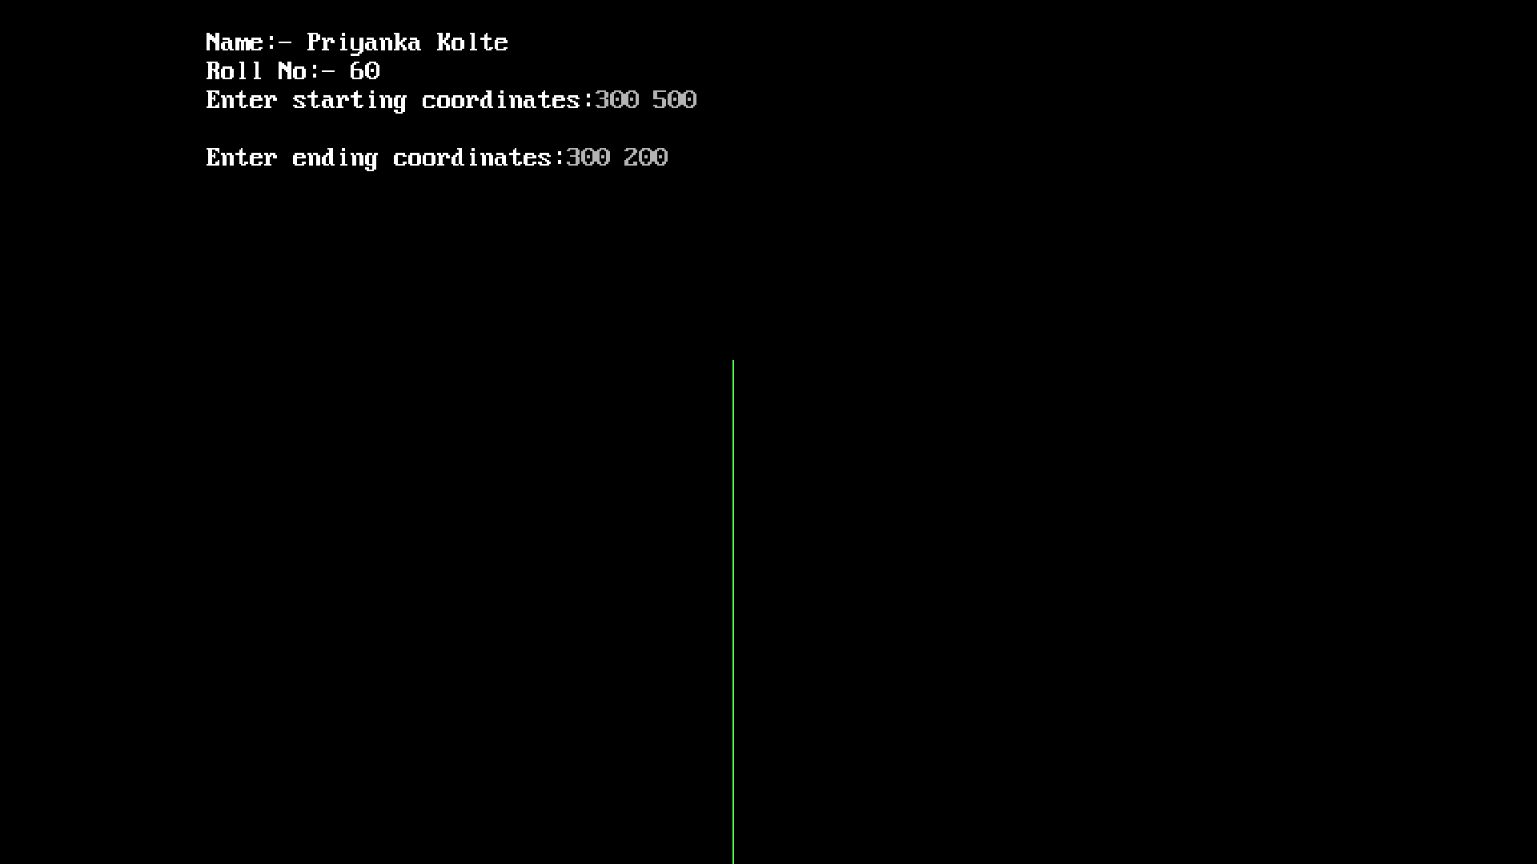

#include<stdio.h>
#include<conio.h>
#include<math.h>
#include<dos.h>
#include<graphics.h>
void bressn(int,int,int);
void plot(int,int,int,int);
void plot(int xc,int yc,int x,int y)
{
putpixel(xc+x,yc+y,WHITE);
putpixel(xc-x,yc+y,RED);
putpixel(xc-x,yc-y,GREEN);
putpixel(xc+x,yc-y,YELLOW);
putpixel(xc+y,yc+x,WHITE);
putpixel(xc-y,yc+x,GREEN);
putpixel(xc-y,yc-x,YELLOW);
putpixel(xc+y,yc-x,RED);
}
Void bressn(int xc,int yc,int r)
{
Int d,x,y;
d=3-(2*r);
x=0;
y=r;
while(x<y)
{
If(d<0)
{
D=d+(4*x)+6;
}
else
{
d=d+4*(x-y)+10;
y=y=1;
}
x=x+1;
plot(xc,yc,x,y);
}
}
void main()
{
int gd,gm;
int xc,yc,radius;
detectgraph(&gd,&gm);
initgraph(&gd,&gm,”c:\\turboc3\\bgi”);
printf(“\n Name:- Priyanka Kolte”);
printf(“\n Roll No:- 60);
printf(“\n Enter xc,yc,radius:”);
bressn(xc,yc,radius);
getch();
closegraph();
}

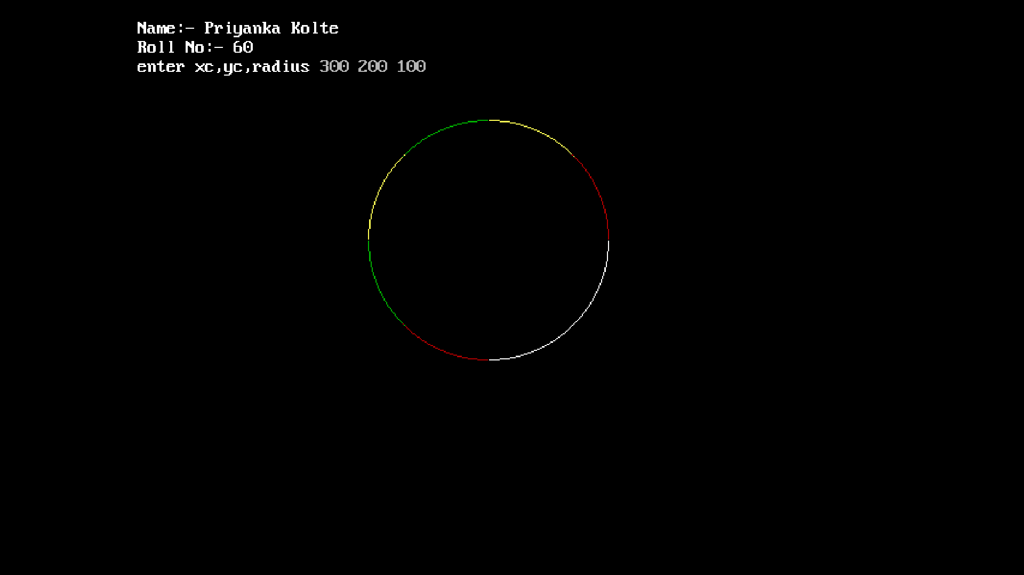

#include<stdio.h>
#include<conio.h>
#include<graphics.h>
#include<dos.h>
void fillcolor(int,int,int,int);
void main(){
Int gd,gm;
Detectgraph(&gd,&gm);
initgraph(&gd,&gm,”c:\\turboc3\\bgi”);
printf(“\n Name:- Priyanka Kolte”);
printf(“\n Roll No:- 60”);
rectangle(50,50,100,100);
fillcolor(55,55,0,11);
getch();
colsegraph();}
void fillcolor(int x,int y,int old_color,int new_color){
If(getpixel(x,y)==old_color){
delay(5);
putpixel(x,y,new_color);
fillcolor(x+1,y,old_color,new_color);
fillcolor(x-1,y,old_color,new_color);
fillcolor(x,y+1,old_color,new_color);
fillcolor(x,y-1,old_color,new_color);
fillcolor(x+1,y+1,old_color,new_color);
fillcolor(x+1,y-1,old_color,new_color);
fillcolor(x-1,y-1,old_color,new_color);
fillcolor(x-1,y+1,old_color,new_color);
}}
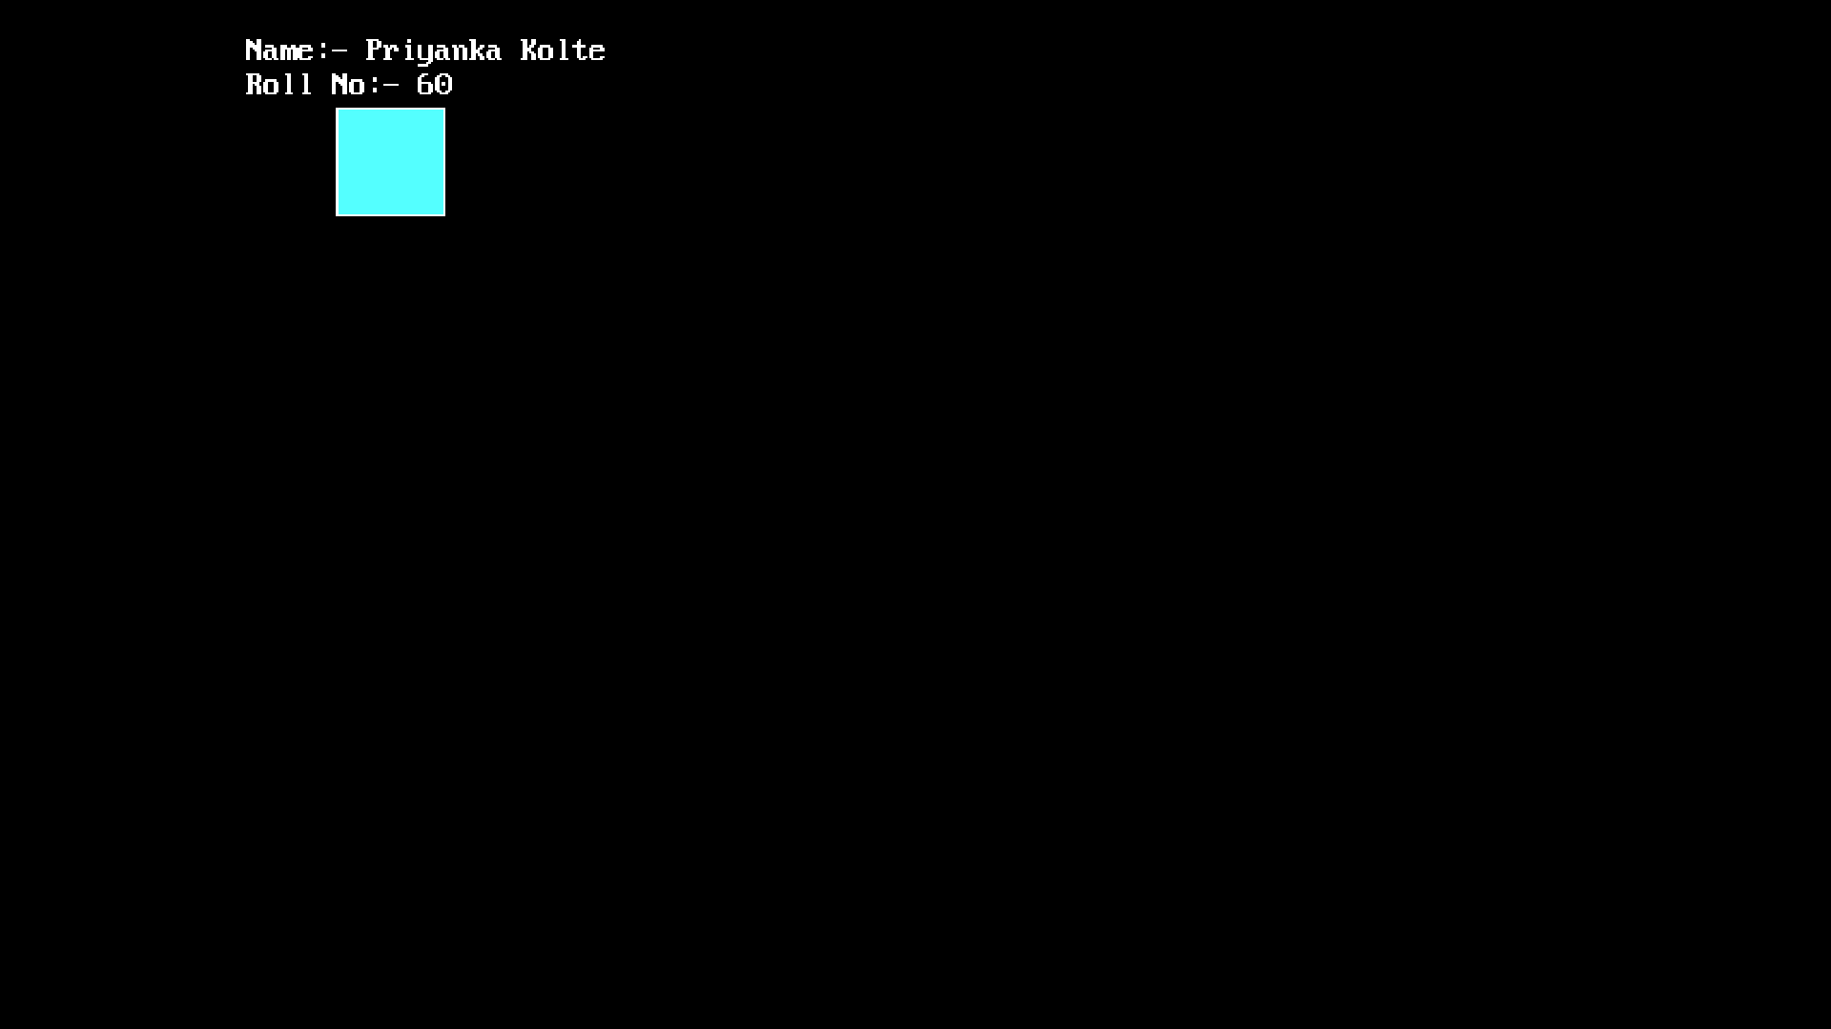

#include<stdio.h>
#include<conio.h>
#include<graphics.h>
#include<dos.h>
void boundary_fill(int,int,int,int);
void main(){
Int gd,gm;
detectgraph(&gd,&gm);
initgraph(&gd,&gm,”c:\\turboc3\\bgi”);
printf(“\n Name:- Priyanka Kolte”);
printf(“\n Roll No:- 60”);
rectangle(50,50,100,100);
boundary_fill(55,55,6,15);
getch();
closegraph();}
void fillcolor(int x,int y,int fcolor,int bcolor){
If((getpixel(x,y)!=bcolor)&&(getpixel(x,y)!=fcolor)){
delay(5);
putpixel(x,y,fcolor);
fillcolor(x+1,y,fcolor,bcolor);
fillcolor(x-1,y,fcolor,bcolor);
fillcolor(x,y+1,fcolor,bcolor);
fillcolor(x,y-1fcolor,bcolor);
fillcolor(x+1,y+1,fcolor,bcolor);
fillcolor(x-1,y+1,fcolor,bcolor);
fillcolor(x+1,y-1fcolor,bcolor);
fillcolor(x-1,y-1,fcolor,bcolor);
}}
