Roll No:- 60
Pr No 26
Q3:- Write a Python Program to read and write with CVS files using pandas.
Program:
import pandas as pd
data = {
"Name": ["Alice", "Bob", "Charlie"],
"Age": [25, 30, 35],
"City": ["New York", "London", "Paris"]
}
df = pd.DataFrame(data)
df.to_csv("sample_data.csv", index=False)
print("Data written to sample_data.csv successfully!\n")
read_df = pd.read_csv("sample_data.csv")
print("Data read from CSV file:")
print(read_df)

Output:
Data written to sample_data.csv successfully!
Data read from CSV file:
Name Age City
0 Alice 25 New York
1 Bob 30 London
2 Charlie 35 Paris

Roll No:- 60
Pr No 28
Q3:- Write a Python Program using Tkinter that creates a RadioButton.
Program:
from tkinter import *
root = Tk()
root.title("Radio Button Example")
var = StringVar()
Radiobutton(root, text="Option 1", variable=var, value="Option 1").pack()
Radiobutton(root, text="Option 2", variable=var, value="Option 2").pack()
Radiobutton(root, text="Option 3", variable=var, value="Option 3").pack()
root.mainloop()

Output:
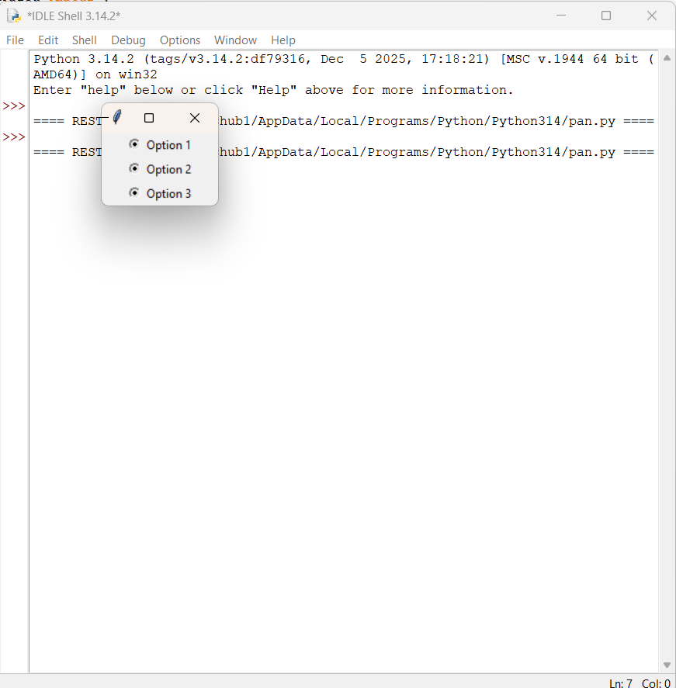

Q4:- Write a Python Program using Tkinter that creates a Menu.
Program:
from tkinter import *
root = Tk()
root.title("Menu Example")
menu_bar = Menu(root)
file_menu = Menu(menu_bar, tearoff=0)
file_menu.add_command(label="New")
file_menu.add_command(label="Open")
file_menu.add_command(label="Save")
file_menu.add_separator()
file_menu.add_command(label="Exit", command=root.quit)
edit_menu = Menu(menu_bar, tearoff=0)
edit_menu.add_command(label="Cut")
edit_menu.add_command(label="Copy")
edit_menu.add_command(label="Paste")
menu_bar.add_cascade(label="File", menu=file_menu)
menu_bar.add_cascade(label="Edit", menu=edit_menu)
root.config(menu=menu_bar)
root.mainloop()

Output:
