Q. 1 Print customer name with highest number of orders.

Query:
select customer_name,customer_id,
count(customer_id) as orders_placed
from dmart_orders
where payment_status=’Paid’
group by customer_id,customer_name
order by count(customer_id) desc limit 1;
Screenshot:

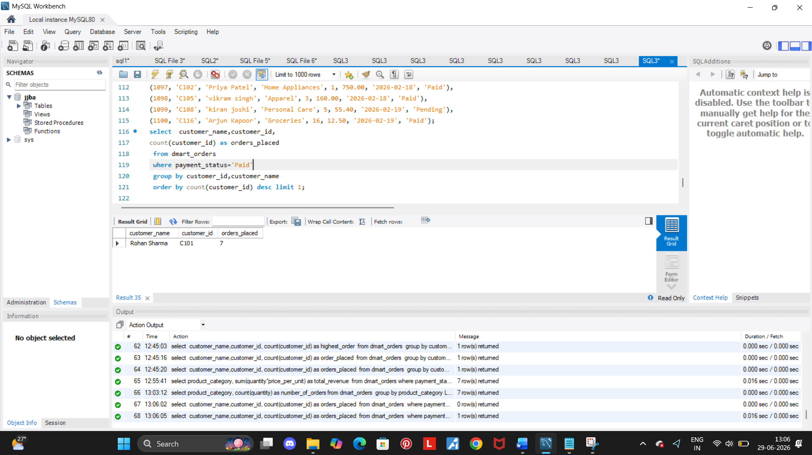

Insights:
- Calculating the customer who placed order the highest time.
- While ‘Rohan sharma’ being the most regular customer with most paid orders.

Q. 2 Find total number of orders per category.

Query:
select product_category,
count(quantity) as number_of_orders
from dmart_orders
group by product_category;

Screenshot:

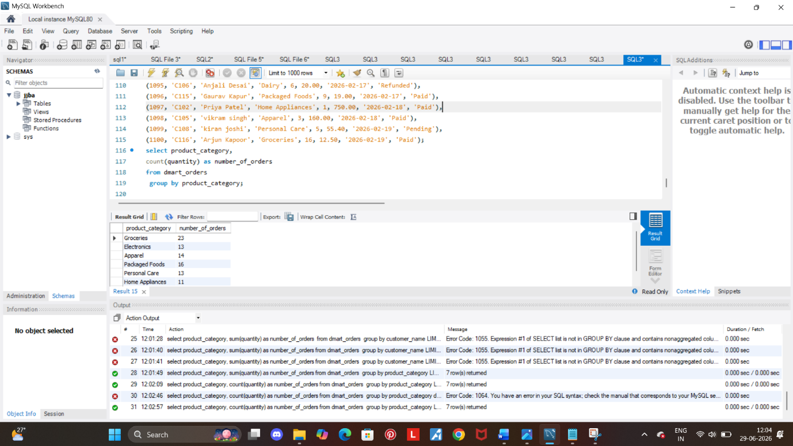

Insights:
- Total products sold from each category including all payment status.
- Where ‘Groceries’ being the highest bought category and ‘Dairy’ being the lowest bought category among users.

Q. 3 Print revenue per order category:

Query:

select product_category,
sum(quantity*price_per_unit) as total_revenue
from dmart_orders
where payment_status='Paid'
group by product_category
order by total_revenue desc;

Screenshot:

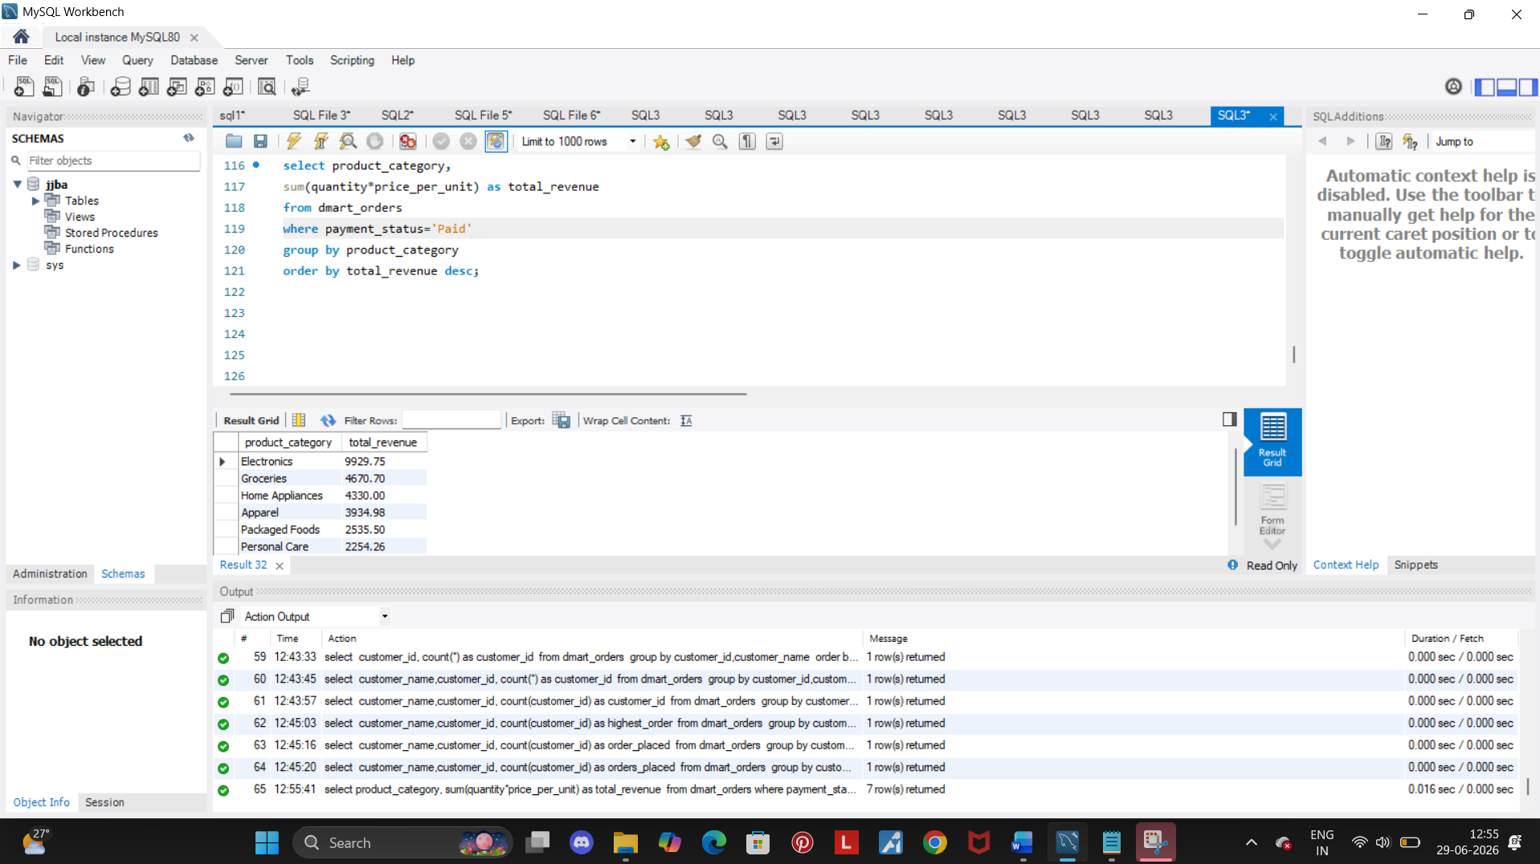

Insights:
- Here the highest revenue where the status is ‘Paid’ is of ‘Electronic’ Category.
- While the lowest being ‘Dairy’ Category.
- The rate of ‘Paid’ customers is more in ‘Electronic’ category.

Q. 4 Find credit amount.

Query:
select sum(price_per_unit*quantity) as credited_amount from dmart_orders where payment_status='Paid';

Screenshot:

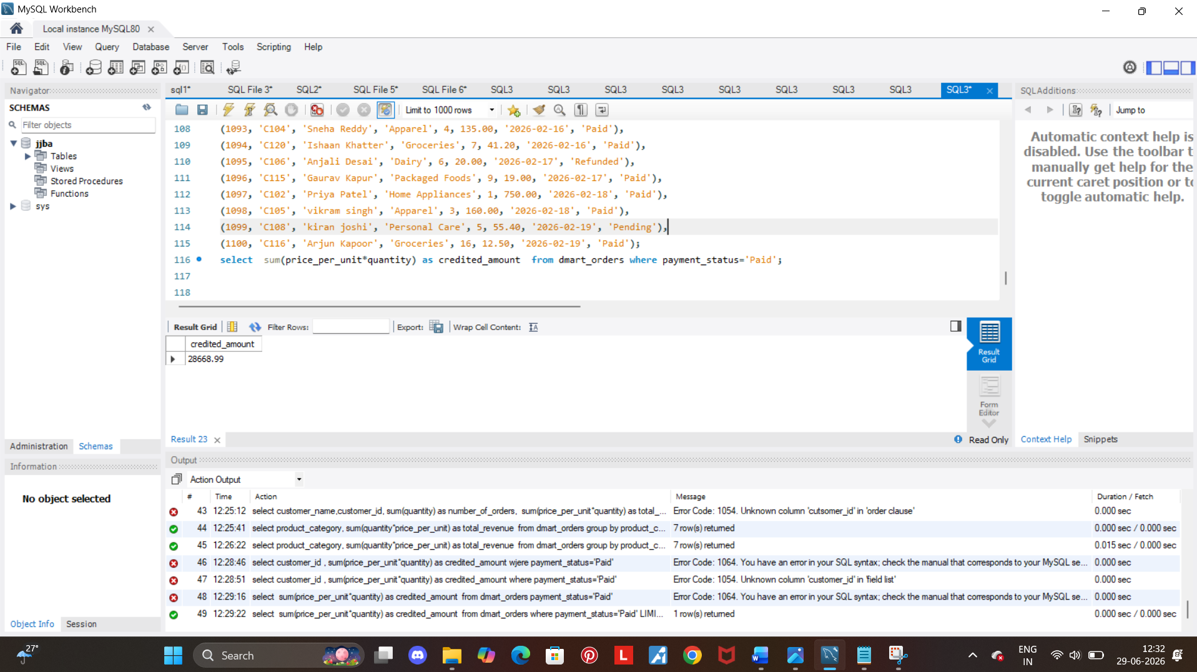

Insights:
- The product of quantity and price per unit gives the total price of the product.
- Among all 100 customers who shopped from dmart out of those some of them either refunded or the status is pending.
- So the total credited amount is 28668.

