Q.1 Ratio of “Paid” revenue.

Query:
select
paid_revenue,
total_revenue,
concat(round(((paid_revenue/total_revenue)*100),2),'%')
as revenue_ratio
from (
select
sum(price_per_unit*quantity) as total_revenue,
sum(case
when
payment_status='Paid' then price_per_unit*quantity
else 0 end)
as paid_revenue
from dmart_orders
)as sub_query;

Screenshot:
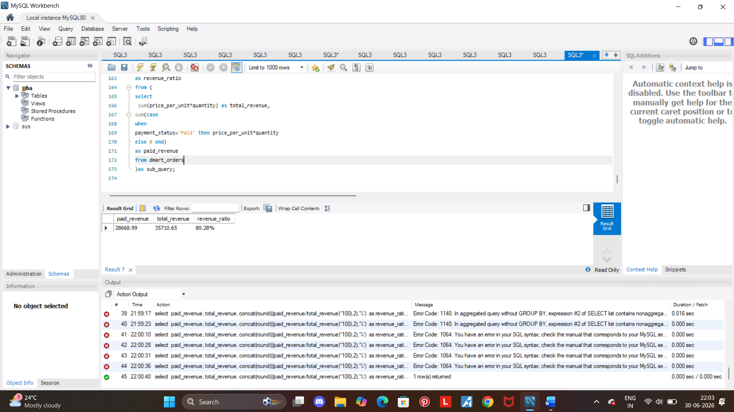

Insights:
- The above data shows total ratio of paid revenue which is 81.28%.
- The difference between total revenue and paid revenue is 7,042, this potential revenue is held by ‘Pending’ and ‘Refunded’ category.

Q.1 Ratio of “Pending” revenue.

Query:

select
pending_revenue,
total_revenue,
concat(round(((pending_revenue/total_revenue)*100),2),'%')
as revenue_ratio
from (
select
sum(price_per_unit*quantity) as total_revenue,
sum(case
when
payment_status='Pending' then price_per_unit*quantity
else 0 end)
as pending_revenue
from dmart_orders
)as sub_query;

Screenshot:

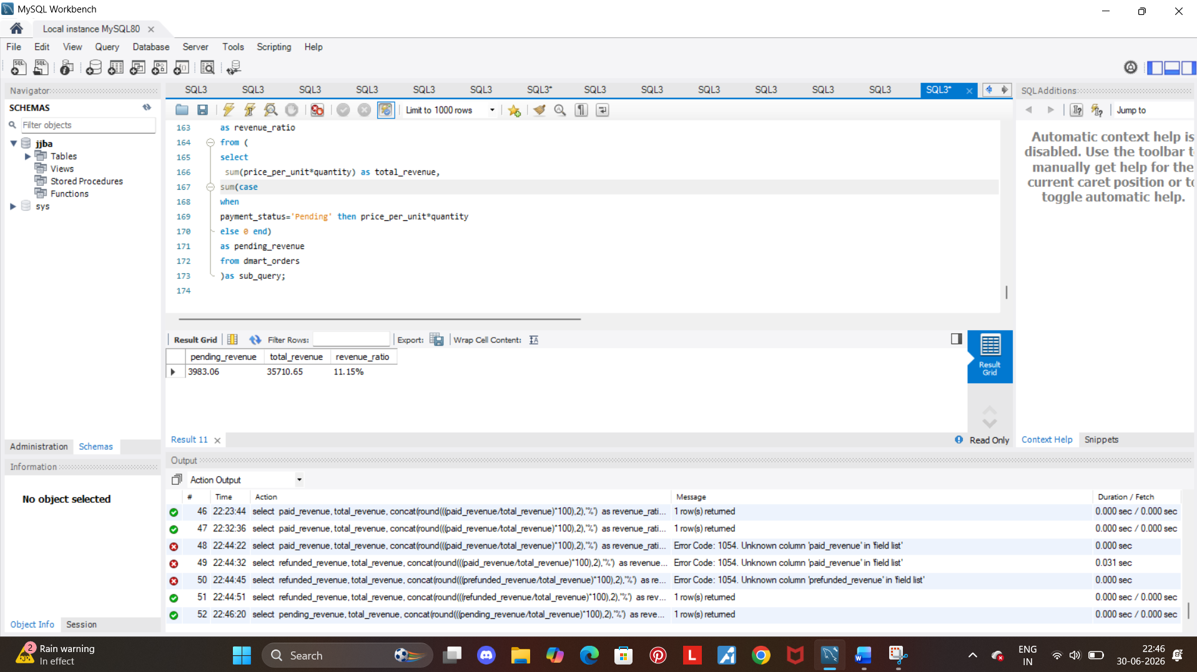

Insights:
- The total revenue ratio of pending category is 11.15%.
- The potential held amount being 3,983, which may conclude their might by obstacles in transaction process.

Q.1 Ratio of “Refunded” revenue.

Query:

select
refunded_revenue,
total_revenue,
concat(round(((refunded_revenue/total_revenue)*100),2),'%')
as revenue_ratio
from (
select
sum(price_per_unit*quantity) as total_revenue,
sum(case
when
payment_status='Refunded' then price_per_unit*quantity
else 0 end)
as refunded_revenue
from dmart_orders
)as sub_query;

Screenshot:

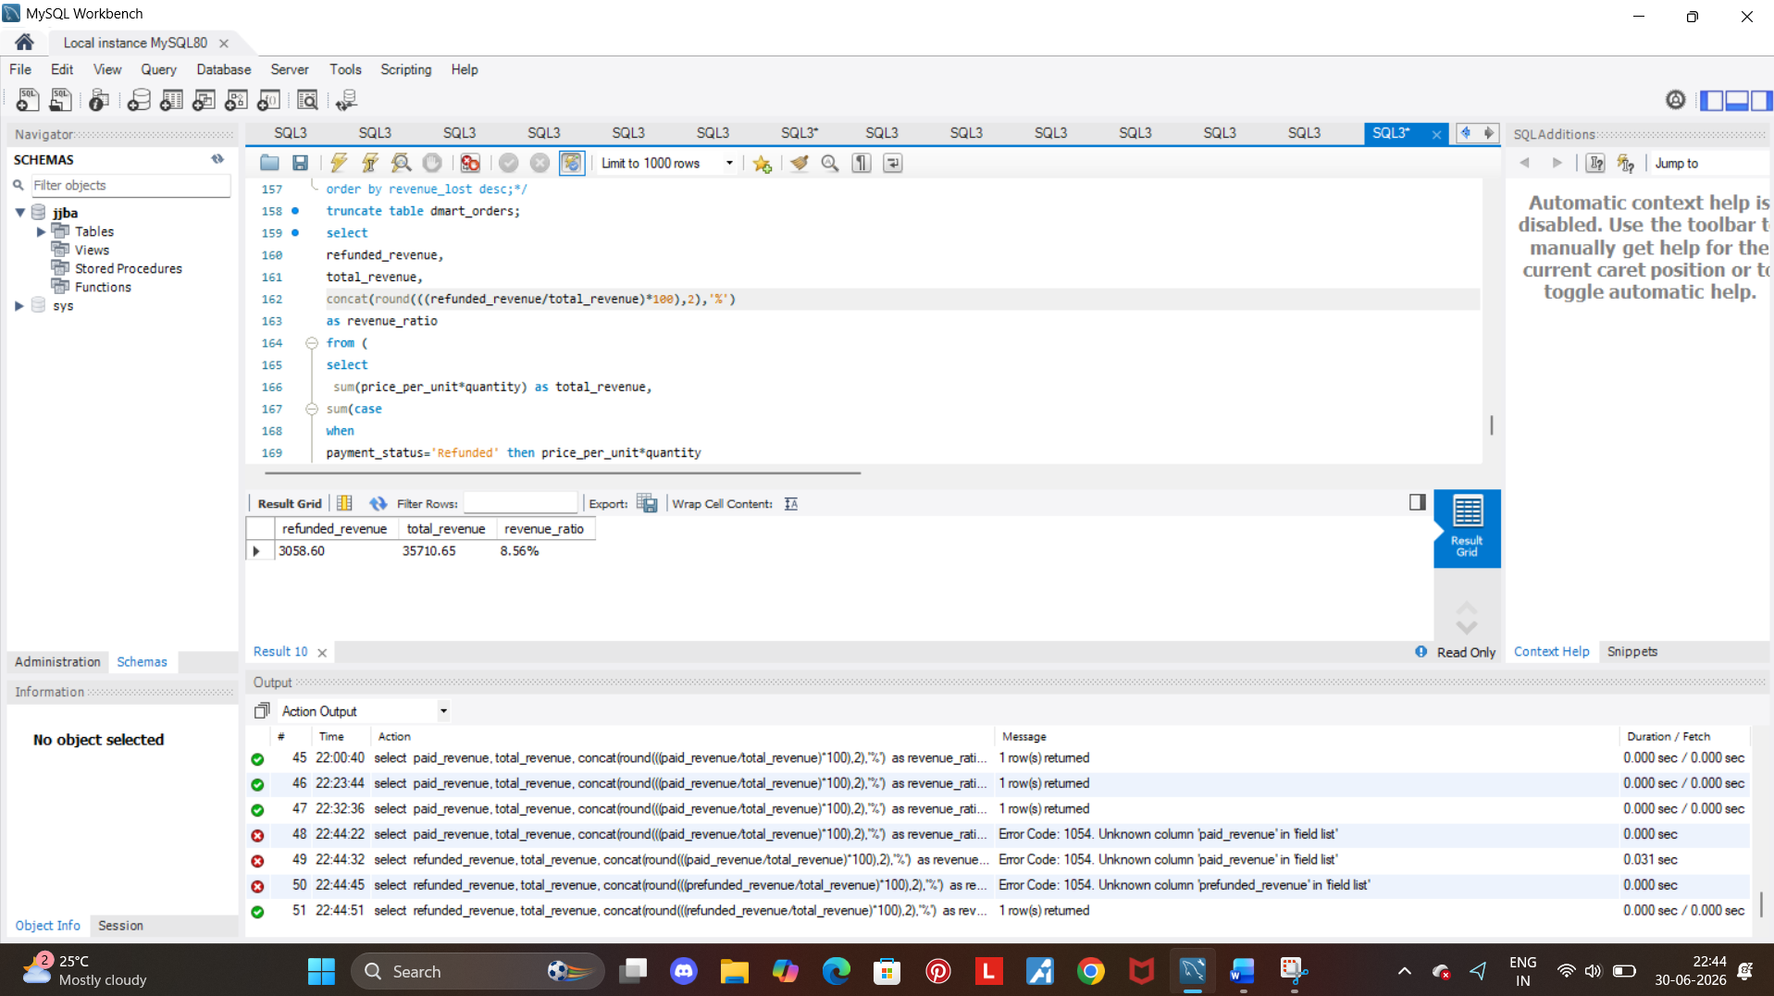

Insights:

- The total revenue ratio of refunded category is 8.56%.
- The total revenue amount which is 3,058 concludes the difference between the refunded category and pending category is 3% which is 925 rupees, means that majority of part is covered by the paid category.
- The rest of the 19% of the revenue that is lost might be due to specific product category lack of customer satisfaction and problems in payment transactions.

