Q. 1 INNER JOIN.

Query:

SELECT T1.TEACHER_ID,
T1.TEACHER_NAME,
D1.DEPT_NAME
FROM DEPARTMENT D1 INNER JOIN TEACHER T1
ON D1.DEPT_ID=T1.DEPT_ID;

Screenshot:

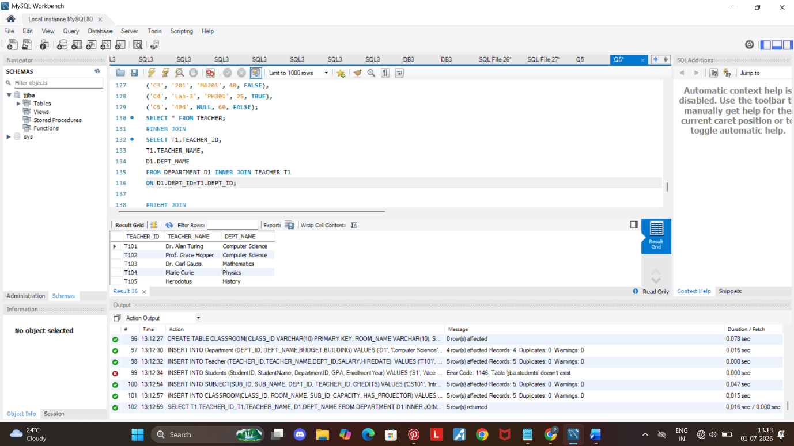

Insights:

- Fetched the data from teacher and department table with one common column ‘DEPT_ID’.
- Based on the DEPRT_ID connection we fetched all the common data from both the tables.

Q. 2 LEFT JOIN.

Query:

SELECT
C1.ROOM_NAME,
C1.CLASS_ID,
S1.SUB_NAME
FROM CLASSROOM C1 left JOIN SUBJECT S1
ON C1.SUB_ID=S1.SUB_ID;

Screenshot:
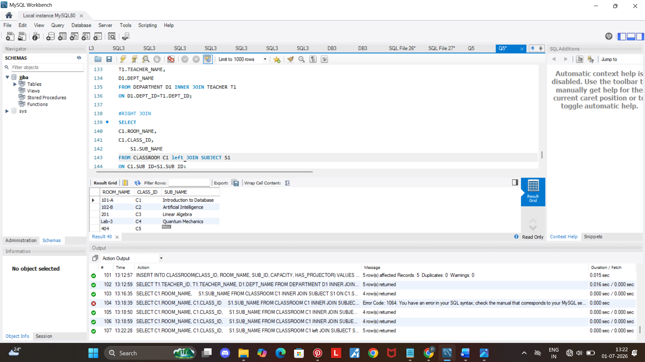

Insight:
- We fetched the common data from table classroom and subject name based on the common column ‘DEPT_ID’.
- The row of sub_name is null since it only has 4 subjects in it.

Q. 3 RIGHT JOIN.

Query:

SELECT
C1.ROOM_NAME,
C1.CLASS_ID,
S1.SUB_NAME
FROM CLASSROOM C1 Right join SUBJECT S1
on C1.SUB_ID=S1.SUB_ID;

Screenshot:
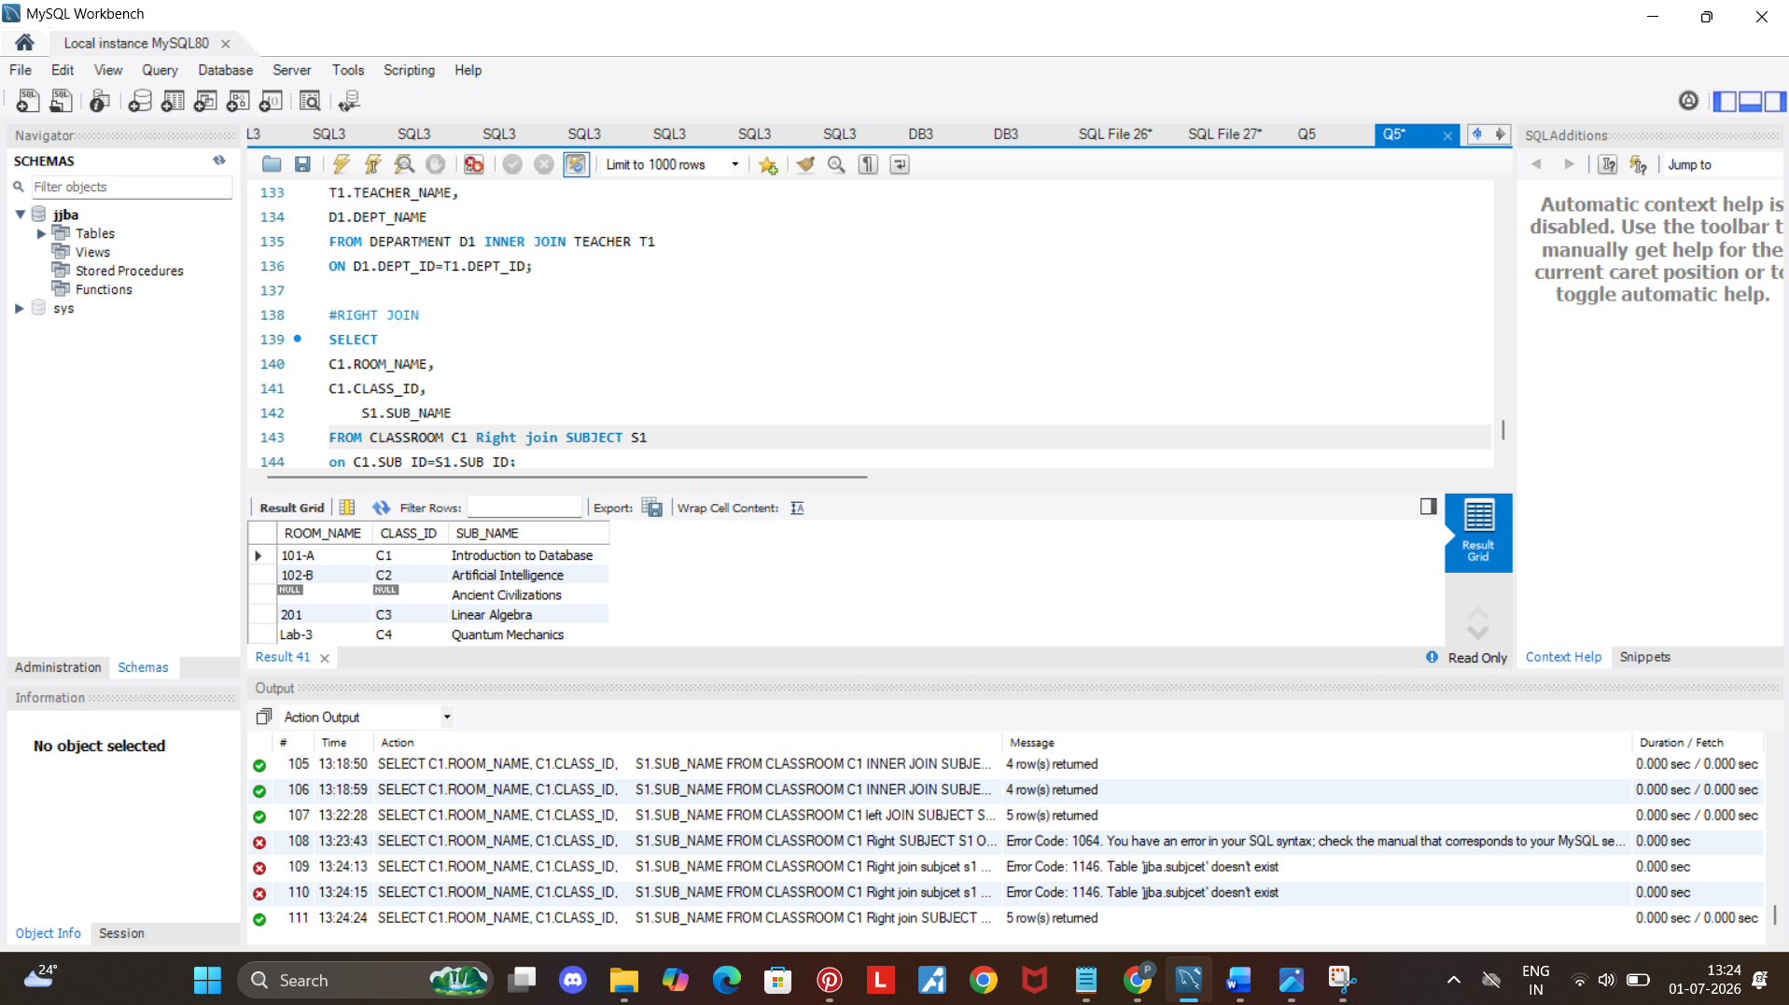

Insights:

- The rows which doesn’t have the subject name is empty.
- It only fetched the data that has common data at the right side.

