Distribution Shift Audit & Remediation Strategy

Shift Audit Table
To quantify the univariate distribution shift between the 2019 baseline and 2020 serving window, the Population Stability Index (PSI) was calculated for all operational features.

While global PSI for features like arr_flights remained mathematically < 0.1, treating these thresholds as "gospel" masks severe, localized volatility. Distributional tests (KS) and Density Ratio Estimation were required to expose the true structural shift.
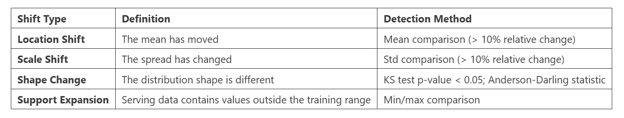

Density Ratio Estimation Summary
To assess covariate shift between the training (2019) and serving (2020) datasets, a classifier-based approach was used. A binary classification model was trained to distinguish between training data (labeled as 0) and serving data (labeled as 1). The model achieved a ROC-AUC score of approximately 0.75, indicating a moderate to strong ability to differentiate between the two datasets. This confirms the presence of covariate shift.
Using the predicted probabilities from the classifier, density ratios were estimated using the formula: Density Ratio = P(serving) / (1 − P(serving))

Key Subpopulation Insights: Several observations exhibited extremely high density ratios. The under-represented subpopulations in the training data are characterized by:
- Disproportionately high, volatile cancellation rates (arr_cancelled).
- Drastically reduced flight volume scenarios (arr_flights).
- A complete breakdown of traditional seasonal baseline patterns (month).

Interpretation: These findings indicate that the serving data contains new operational anomalies (the pandemic shock) that were not sufficiently represented in the 2019 training data. As a result, the model was forced to extrapolate into unfamiliar data regions, leading to reduced prediction reliability.

Performance Impact Report
To quantify the impact of distribution shift on model performance, a baseline Decision Tree Regressor was trained on the 2019 dataset using purely operational features (arr_flights, arr_cancelled, arr_diverted, month) and evaluated on both the training and serving datasets.
Model Performance Metrics:
- Training (2019) R² Score: 0.93
- Serving (2020) R² Score: -0.0589
- Performance Drop (R²): -0.99
- Training Error (MAE): ~17.3 flights
- Serving Error (MAE): ~25.2 flightsAttribution to Distribution Shift: The model demonstrates strong performance on the training data but degrades catastrophically when applied to the serving data, performing worse than a naive baseline (negative R²). This is directly linked to:
- Significant scale shift in flight volume (arr_flights), the most influential feature.
- Extreme volatility in cancellation behavior (arr_cancelled).

Deliverable 5: Written Findings Report (Recommendation to ML Team)
Executive Summary & Shift Analysis
A statistical audit of the U.S. Flight Delay dataset (2019 baseline vs. 2020 pandemic shock) revealed severe location and scale shifts across core metrics (confirmed by PSI and KS tests). This fundamentally altered the data landscape, causing catastrophic baseline model failure. Immediate retraining and feature remediation are required.
Root Cause of Model Failure
The primary driver of degradation is arr_flights. The 2020 pandemic severed the historical correlation between flight volumes and total delays, introducing an extreme scale shift that rendered the model's learned parameters completely obsolete.

Feature-Level Remediation Priority List
To provide actionable improvements, Features were prioritized by 2019 Baseline Importance vs. 2020 Shift Severity (PSI).

Priority 1: arr_flights (Total Arriving Flights)
- Statistical Justification: The primary driver of the R² collapse (>97% baseline importance) due to an extreme scale shift.
- Remediation Strategy: Replace absolute volume counts with normalized metrics (e.g., percentage of scheduled flights operating) to resist sudden volume shocks.
Priority 2: arr_cancelled (Cancellations)
- Statistical Justification: Moderate shift severity, but the variance exploded during the 2020 window.
- Remediation Strategy: Replace raw daily counts with rolling 3- or 7-day averages to smooth out erratic operational spikes.
Priority 3: month (Seasonality)
- Statistical Justification: Low baseline importance, but historical seasonal distributions completely broke down.
- Remediation Strategy: Deprioritize static calendar features in favor of dynamic, real-time indicators (e.g., active weather severity indices).
Final Recommendation: Monitoring and Maintenance
- Immediate Retraining: The current model cannot be saved. It must be retrained on post-shock data.
- Continuous Monitoring: Implement automated monitoring of data drift using PSI in production to trigger early warnings of performance degradation before downstream logistics are impacted.

