NeuroXAI: A Dual-Stream Explainable AI Framework Integrating MRI and Clinical Biomarkers for Cognitive Impairment Screening
[Author 1 Name]  [Department / Program]  [Institution Name]  [City, Country]  [Email Address] | [Author 2 Name]  [Department / Program]  [Institution Name]  [City, Country]  [Email Address] | [Author 3 Name]  [Department / Program]  [Institution Name]  [City, Country]  [Email Address]

Abstract—NeuroXAI is a deep learning system that uses a brain MRI image and six clinical values to classify cognitive impairment. The image branch uses ResNet-18, while a small neural network reads age, sex, education, MMSE, CDR Sum-of-Boxes, and FAQ scores. The two branches join their learned features before making a Normal or Impaired prediction. Real MRI scans and clinical records from the Alzheimer's Disease Neuroimaging Initiative (ADNI) were matched by subject identifier. This gave 403 subjects: 115 Cognitively Normal (CN), 198 with Mild Cognitive Impairment (MCI), and 90 with Alzheimer's disease (AD). One record with a missing FAQ score was removed, leaving 402 subjects. MCI and AD were grouped as Impaired. The model was trained for 15 epochs using an 80/20 subject-level split. The best recorded evaluation accuracy was 93.83%, with a weighted F1-score of 0.9387. The evaluation split was also used to choose the model checkpoint. Grad-CAM shows image areas that affect a prediction, and a mean-replacement method shows how changes to individual clinical inputs affect the output. A web dashboard presents the prediction and both explanations. This paper describes how the dataset, model, and dashboard were built and explains what the reported binary result measures.
Index Terms—Cognitive impairment, explainable artificial intelligence, multimodal fusion, ResNet-18, Grad-CAM, clinical feature attribution, ADNI, magnetic resonance imaging.
I. Introduction
NeuroXAI was built to use two types of information together: a brain MRI image and a short clinical record. These inputs have different forms. The image shows brain structure, while clinical scores describe cognitive and functional status [6], [7]. The aim of this project is to bring both into one model and show the information behind its prediction. The task is to separate cognitively normal subjects from subjects with MCI or AD using matched ADNI records [4].
A class label alone gives little information about how a model reached its answer. For this reason, the system includes an explanation for each input branch. Grad-CAM [2] highlights image areas that affect the selected class score. The clinical explanation changes one input at a time and measures the change in the output. These views help a user inspect the model. They are not a medical diagnosis or proof that an input caused the condition.
The project covers the steps from downloaded data to a working dashboard. MRI scans were matched with clinical records, prepared for training, and passed to a two-branch model. Training curves and classification scores were used to describe the experiment. The dashboard then brought the prediction and explanations into one place. The final labels are Normal and Impaired. In this paper, Impaired includes both MCI and AD; it does not mean that the model separates those two groups.
The two branches are needed because an image and a clinical row cannot be read in the same way. The image network learns patterns across pixels. The clinical network reads a short list of values. Each branch first turns its input into learned features. The features are then joined so the final part of the model can use both sources for one decision. This is the meaning of multimodal fusion in this project.
A key part of the work is keeping the inputs connected to the correct subject. The model should not receive one person's scan and another person's clinical values. Subject identifiers provide the link between the downloaded files. The same link also connects each example to its diagnosis label. Preparing this matched set is therefore part of the model pipeline, not a separate task with no effect on training.
II. Related Work
The system uses several established methods. ResNet introduced residual learning for image recognition [1]. Here, an ImageNet-pretrained ResNet-18 is used to read the MRI input. Grad-CAM gives a visual explanation for a convolutional network [2]. SHAP is related work on assigning contributions to input features [3], but the clinical method in this project is a simpler replacement test, not SHAP. MMSE, CDR, and FAQ provide the clinical assessment measures used in the model [6]–[8]. ADNI provides the source imaging and clinical records [4]. Other related work covers multimodal and follow-up data [9], explainable AI in brain imaging [10], AD detection methods [11], and ADNI-based work using language models [12]. A further review discusses MRI-based models and multimodal methods [13]. These studies provide background for combining image features, clinical values, and explanations.
The cited methods have different roles. ResNet-18 is the image encoder. The small clinical network is the second encoder. Grad-CAM is used after a prediction to inspect the image branch. Clinical replacement is also used after a prediction, but it changes an input rather than reading image gradients. The explanation methods do not add new diagnosis classes or change the Normal and Impaired label definitions.
The clinical method is kept separate from SHAP in this paper because the calculations are not the same. It asks a simple question: what happens to the chosen probability when one clinical value is replaced by its training mean? The answer applies to that input and that reference value. It does not claim to divide the entire prediction into exact SHAP contributions.
III. Materials and Methods
A. Dataset
MRI scans and clinical records were obtained from ADNI under an approved data use agreement. The clinical values came from the Subject-Level (ADSL) table. T1-weighted MPRAGE scans were downloaded separately. The image search was limited to Screening and Baseline visits and records marked as MPRAGE under MRI. Subject identifiers were used to link the images and clinical rows. A subject was kept when a usable scan and a diagnosis were available. The matched set had 403 subjects: 115 CN, 198 MCI, and 90 Dementia/AD. Figure 1(a) shows these groups.
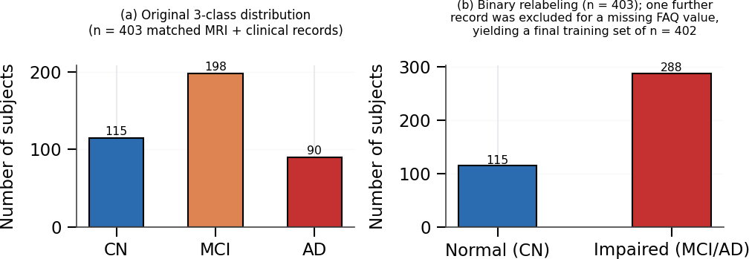
Fig. 1. Diagnostic class distribution of the matched ADNI cohort. (a) Original three-class distribution (CN/MCI/AD). (b) Binary relabeling used for model training, with one additional subject excluded during quality filtering for a missing FAQ value.
The final task used two labels. CN was assigned Normal, or label 0. MCI and AD were assigned Impaired, or label 1. Before the missing-value check, there were 115 Normal and 288 Impaired subjects, as shown in Fig. 1(b). Early three-class runs had variable validation results, so the final experiment used the binary task. One record was removed because its FAQ score was missing. The final dataset had 402 subjects. Every reported classification result refers to this two-class task.
A complete example needs an image, the selected clinical values, and a label. An unmatched image cannot be used in the same way as a complete paired record. Likewise, a clinical row without a usable scan does not provide both inputs required by this model. The matched cohort is the set of subjects for whom these sources could be joined. The initial count of 403 and the final count of 402 refer to different steps of this process.
Grouping the labels does not change the original ADNI diagnoses. CN remains the source for Normal. MCI and AD remain their original diagnoses in the source records, but share one output label during this experiment. The model therefore learns a two-class decision from three original groups. Figure 1 shows both views so that the dataset counts can be read together with the final prediction task.
B. Clinical Feature Selection
The clinical branch uses six values: age, sex, years of education, MMSE [6], CDR Sum-of-Boxes [7], and total FAQ [8]. The dashboard uses the same fields. An earlier plan considered normalized whole-brain volume (nWBV) and estimated total intracranial volume (eTIV). These were not used in the final model. The downloaded UCSFFSX51 table had regional measurements rather than the single whole-brain value expected by that plan. No whole-brain value was created from those regional fields.
The order of the six inputs matters. Each position in the clinical vector is connected to learned weights. A value entered as MMSE must therefore occupy the same position during prediction as it did during training. The dashboard and the training data use the same six field definitions. This keeps the input form consistent with the model instead of adding fields that the model was not trained to use.
Standardization puts the clinical values on a common numerical scale. For each feature, the training mean is subtracted from the observed value, and the result is divided by the training standard deviation. The training statistics are reused for evaluation. They are not recalculated from the evaluation records. After this step, zero represents the training mean, which also explains the reference used by the clinical replacement method.
C. Image Preprocessing
For each subject, the DICOM series with the most slices was selected. The middle slice was converted to grayscale and copied into three channels. The image was resized to 224 × 224 pixels and normalized using ImageNet statistics. This made it suitable for the pretrained ResNet-18 input. Each subject supplied one 2D image. The full 3D MRI volume was not passed to the model.
Copying the grayscale image into three channels changes its input format, not its medical content. The three channels contain the same grayscale information. This allows the selected slice to fit the input structure of the pretrained image network. Resizing also gives every image the same width and height so images can be processed in batches. These steps do not create additional subjects or independent scans.
The image shown to the model is the selected 2D slice after these steps. This is also the image to which its heatmap applies. A heatmap over that slice should not be described as an explanation of the whole MRI volume. Keeping the input and explanation descriptions aligned makes it clear what the image branch actually processed.
D. Model Architecture
Figure 2 shows how the branches join. The image branch uses an ImageNet-pretrained ResNet-18. Its original output layer was replaced with a block containing a linear layer, batch normalization, ReLU, and dropout. This branch produces 512 image features. The clinical branch passes six inputs through two layers with 64 units each and produces 64 clinical features. The outputs are joined into a vector with 576 values. A fusion block reduces this to 128 values using a linear layer, batch normalization, ReLU, and dropout of 0.3. The last linear layer produces the two class scores.
The feature sizes make the fusion step easy to follow. The image branch returns 512 values and the clinical branch returns 64. Joining them gives 576 values, which are passed to the fusion layer. The next layer reduces this joint representation to 128 values before the final two scores are produced. The branches are therefore joined after feature learning, rather than by placing the raw clinical numbers inside the MRI image.
A learned feature is a number produced by an encoder, not a clinical field entered by the user. The 512 image features are therefore different from the six clinical inputs. The clinical encoder also changes its six raw inputs into 64 learned features. The final classifier works with these learned representations. This distinction helps explain why the joined vector has 576 values even though the form contains only six clinical fields and one image.
The final scores use the same label order as the prepared dataset. One score belongs to Normal and the other to Impaired. The dashboard presents the selected class with a model probability. This number describes the model output for the supplied inputs. It is not a separate measurement of disease progression or a forecast of when a person may develop a condition.
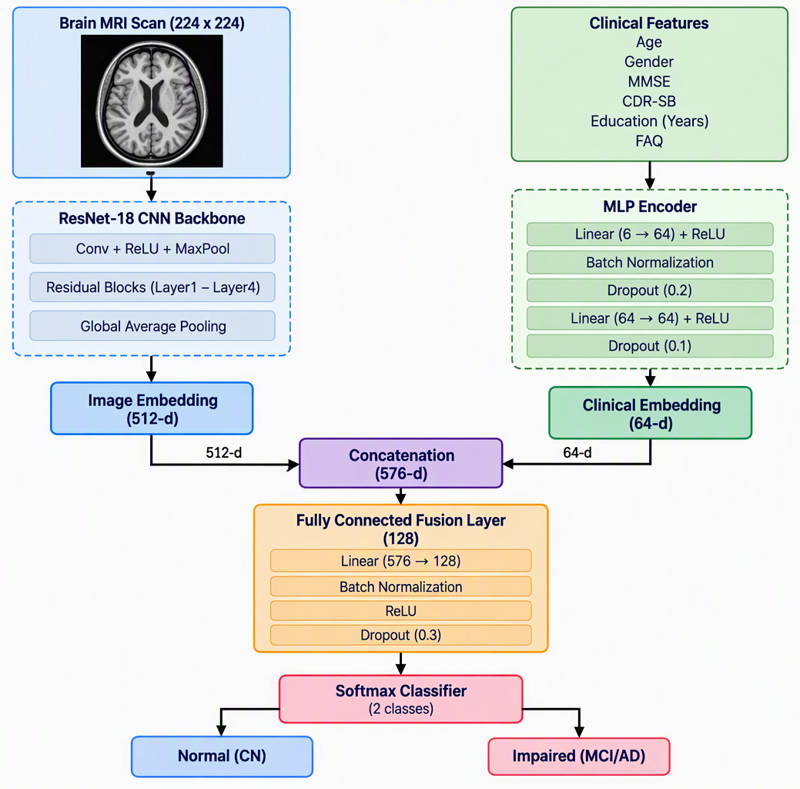
Fig. 2. Dual-stream multimodal fusion architecture combining a ResNet-18 imaging encoder and an MLP clinical encoder.
E. Training Configuration
The 402 subjects were divided into training and evaluation sets using an 80/20 stratified split at subject level. Clinical values were standardized using only the training-set mean and standard deviation. The same values were then used to transform the evaluation inputs. Training images were changed using random horizontal flips and rotations of up to ±10 degrees. The model was implemented in PyTorch [5]. Table I gives the training settings.
The split is made at subject level. This means the person represented by a record is the unit used to form the training and evaluation groups. Stratification keeps the label distribution in view when the groups are formed. The model is trained on the training group, while the evaluation group is used to follow its performance during the run. The same split is used across all 15 epochs.
Image augmentation changes the appearance of training images through flips and small rotations. It does not add new clinical records or new people to the dataset. The cohort still contains 402 subjects. Table I records the optimizer, learning rate, batch size, and network dimensions. These settings should be read with the data preparation steps, because the model configuration alone does not describe the whole experiment.
TABLE I TRAINING HYPERPARAMETERS
Hyperparameter | Value
Image stream backbone | ResNet-18 (ImageNet-pretrained)
Image embedding dimension | 512
Clinical embedding dimension | 64
Fusion hidden layer size | 128
Input image size | 224 × 224 × 3
Clinical input features | 6 (Age, Sex, MMSE, CDR-SB, Educ., FAQ)
Batch size | 16 (drop_last = True)
Optimizer | Adam (weight decay = 1e-4)
Learning rate | 0.001
Epochs | 15
Train / evaluation split | 80% / 20% (subject-level, stratified)
F. Explainability Modules
The image explanation uses Grad-CAM [2]. Gradients from the selected class score are taken at the last convolutional layer of ResNet-18 and used to form a heatmap. The clinical explanation works differently. One standardized clinical value is replaced with zero, which represents its training-set mean. The image and the other five values stay the same. The difference in the selected class probability is recorded. This is repeated for all six clinical values. A positive result means that replacement lowered the selected probability. A negative result means that replacement raised it. This method does not calculate SHAP values. Both explanations are shown with the prediction in the dashboard.
The clinical comparison starts with the original predicted probability. One feature is then set to its reference value, and the probability is calculated again. The original probability minus the replacement probability gives the displayed attribution. The process is repeated separately for each of the six features. The MRI stays fixed in every comparison, so the calculation tests changes in the clinical input rather than changes in the image.
The replacement value is a reference for comparison, not a claim that the training mean is the correct value for every person. For example, replacing a score with its mean asks how the model output differs from that chosen reference. It does not simulate a treatment or show what would happen if a person changed that score in real life. The calculation remains a test of the trained model with one changed input.
A value close to zero means that this replacement changed the selected probability only slightly. A larger positive value means that the observed input supported a higher probability than its reference replacement. A negative value means the replacement raised the probability. These are local effects for the current input. The same feature can have a different effect for another subject because the other inputs and the model response may differ.
IV. Experimental Results
A. Classification Performance
The model was trained for 15 epochs. The highest accuracy on the 20% evaluation set was 93.83%. This was first reached at epoch 10 and reached again at epochs 11 and 14. The weighted F1-score was 0.9387. Table II gives the reported values. The same evaluation set was used to choose the checkpoint, so this is not a result from a separate final test set that was left untouched during model selection.
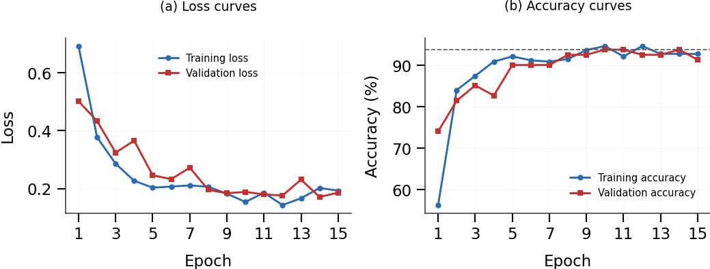
Fig. 3. Training and evaluation loss (a) and accuracy (b) over 15 epochs. The figure labels the evaluation curves as validation. The dashed line marks the highest recorded evaluation accuracy of 93.83%.
B. Training Dynamics
Figure 3 shows the training history. Training accuracy rose from 56.3% to a maximum of 94.7%. Evaluation accuracy started at 74.1% and reached 93.83%. The lowest reported evaluation loss was 0.1715 near epoch 14. The curves show how the model changed during this run, including differences between epochs. They describe the chosen data split, not performance on a new independent group of subjects.
Accuracy counts how often the predicted binary label matches the recorded binary label. The weighted F1-score combines class-specific F1 values using the number of examples in each class as weights. Both describe the same evaluation run. The value 0.939 is the rounded form of 0.9387, not a different score from another experiment. Keeping the full value in Table II avoids confusion about rounding.
The two classes are not equal in size before the final missing-value exclusion. This is one reason to report the label counts together with the accuracy. A single overall score does not show every type of mistake. The weighted F1-score adds another summary, but class-specific precision, recall, and a confusion matrix would provide further detail if those results were available. No additional class-specific values are introduced here because they are not part of the reported results.
The repeated best accuracy at epochs 10, 11, and 14 comes from one training run. These are not three independent tests. They show that the same highest recorded accuracy was reached at more than one checkpoint on the same split. The curves give the wider training history, while Table II gives the selected summary values. Neither adds an independent external evaluation.
TABLE II BEST-EPOCH CLASSIFICATION PERFORMANCE (BINARY: NORMAL vs. IMPAIRED)
Metric | Value
Best epoch | 10 (matched at 11, 14)
Evaluation accuracy | 93.83%
Weighted F1-score | 0.9387
Final cohort size (n) | 402
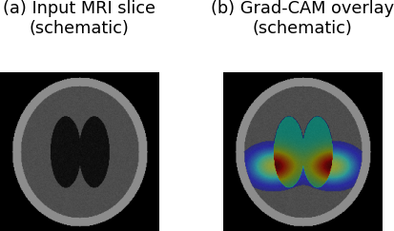
Fig. 4. Schematic illustration of an MRI slice and Grad-CAM-style overlay. This drawing explains the display format and is not a measured patient heatmap.
C. Qualitative Explainability Results
Figure 4 explains how an image heatmap can be placed over an MRI slice. It is a schematic drawing, not an actual patient heatmap from the trained model. Its purpose is to show the display format. It cannot be used as evidence that the model found a particular brain region in a patient.
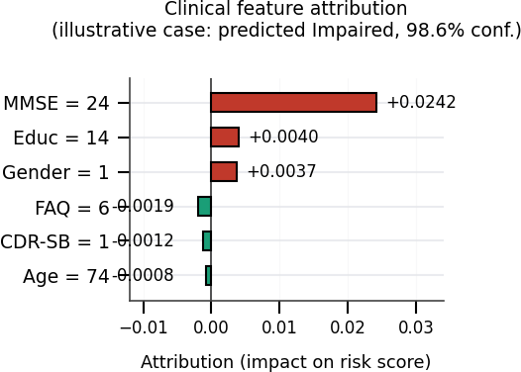
Fig. 5. Illustrative clinical feature attribution display for an Impaired prediction. Values show changes in the predicted score after individual features are replaced by their reference values.
Figure 5 gives an illustrative clinical explanation for an Impaired output of 98.6%. MMSE has the largest positive value, +0.0242. Education and sex have smaller positive values. FAQ, CDR Sum-of-Boxes, and age have small negative values. Each sign describes what happened when that input was replaced in the displayed example. The chart is not a general ranking of the six inputs. The displayed model probability is also not a measured or calibrated clinical risk.
The dashboard provides a practical way to review the inputs and outputs together. Its MRI input corresponds to the image branch, and its six clinical fields correspond to the clinical branch. The predicted class, image heatmap, and clinical attribution are then presented as parts of one result. The interface does not introduce a new label definition or a different set of clinical measurements.
The path from a prepared example to a displayed result follows the same two-branch design as training. The image is represented in the format expected by the image encoder, and the clinical values use the feature definitions and scaling described earlier. The encoders produce their features, the fusion layers produce class scores, and the explanation modules inspect the selected output. Presenting these stages together helps connect the visible result with the methods described in the paper.
The figures have different purposes. The class-distribution plot describes the records used to form the dataset. The architecture diagram shows how the branches join. The training curves show the experiment over 15 epochs. The schematic heatmap and illustrative attribution chart explain the output display. Reading these roles separately prevents a display example from being mistaken for a measured patient finding.
V. Discussion
The completed system combines MRI and clinical inputs in one working process. Its reported accuracy of 93.83% belongs to the Normal-versus-Impaired task in this ADNI dataset. It does not measure the ability to separate MCI from AD. The image branch uses one 2D slice per subject, and the experiment uses one subject-level split. Since the evaluation set also guided checkpoint selection, a separate final test group would be needed to assess the chosen model independently.
The dashboard connects the prediction with two ways to inspect it. Grad-CAM shows image influence, while the clinical method measures the effect of replacing one value. These tools explain model behaviour; they do not prove clinical validity. The schematic and illustrative figures show how explanations are presented. They should not be read as measured patient-level findings. Comparing the accuracy with another study would require checking its labels, dataset, and evaluation method first.
The reported result should be read together with the cohort, label grouping, and split. Changing any of these would define a different experiment. For example, separating CN, MCI, and AD would require three output labels and a new evaluation. The current binary accuracy cannot be carried over as the accuracy of that future three-class model. This does not change what the present system achieved; it defines the task that was completed.
A useful next comparison would train an image-only model and a clinical-only model on the same split. Their results could help show how much each source adds to the combined system. These comparisons are proposed work, not results reported here. A larger independent cohort would also allow the selected checkpoint to be assessed without reusing the data that guided its selection.
Reproducibility also depends on keeping the data preparation rules clear. The selected visits, subject matching, missing-value exclusion, label grouping, image size, clinical scaling, and training settings all affect the meaning of a repeated run. The tables and method descriptions record these choices for the present experiment. A future run with a different cohort or a different slice-selection rule should be described as a new experiment rather than assumed to reproduce the same numerical result.
VI. Conclusion and Future Work
NeuroXAI was built to classify cognitive impairment using an MRI slice and six clinical values. The work matched ADNI records, prepared a 402-subject dataset, trained a two-branch model, and connected the output with explanations in a web dashboard. The best checkpoint reached 93.83% accuracy and a weighted F1-score of 0.9387 on the set used for evaluation and checkpoint selection. The current system performs Normal-versus-Impaired classification. Further work can study separate CN, MCI, and AD labels, full MRI volumes, subject-level cross-validation, and an independent final test set. Clinical-only and image-only comparisons would also help measure the role of each branch.
ACKNOWLEDGMENT
The Alzheimer's Disease Neuroimaging Initiative (ADNI) database provided the MRI scans and clinical records used to build the dataset for this study. Dataset preparation, model development, training, evaluation, and dashboard implementation were carried out as part of this project.
REFERENCES
[1] K. He, X. Zhang, S. Ren, and J. Sun, “Deep residual learning for image recognition,” in Proc. IEEE Conf. Computer Vision and Pattern Recognition (CVPR), 2016, pp. 770–778.
[2] R. R. Selvaraju, M. Cogswell, A. Das, R. Vedantam, D. Parikh, and D. Batra, “Grad-CAM: Visual explanations from deep networks via gradient-based localization,” in Proc. IEEE Int. Conf. Computer Vision (ICCV), 2017, pp. 618–626.
[3] S. M. Lundberg and S.-I. Lee, “A unified approach to interpreting model predictions,” in Advances in Neural Information Processing Systems (NeurIPS), vol. 30, 2017.
[4] R. C. Petersen et al., “Alzheimer’s Disease Neuroimaging Initiative (ADNI): Clinical characterization,” Neurology, vol. 74, no. 3, pp. 201–209, 2010.
[5] A. Paszke et al., “PyTorch: An imperative style, high-performance deep learning library,” in Advances in Neural Information Processing Systems (NeurIPS), vol. 32, 2019.
[6] M. F. Folstein, S. E. Folstein, and P. R. McHugh, “‘Mini-mental state’: A practical method for grading the cognitive state of patients for the clinician,” J. Psychiatric Research, vol. 12, no. 3, pp. 189–198, 1975.
[7] J. C. Morris, “The Clinical Dementia Rating (CDR): Current version and scoring rules,” Neurology, vol. 43, no. 11, pp. 2412–2414, 1993.
[8] R. I. Pfeffer, T. T. Kurosaki, C. H. Harrah, J. M. Chance, and S. Filos, “Measurement of functional activities in older adults in the community,” J. Gerontology, vol. 37, no. 3, pp. 323–329, 1982.
[9] S. Muksimova, S. Umirzakova, J. Baltayev, and Y. I. Cho, “Multi-modal fusion and longitudinal analysis for Alzheimer’s disease classification using deep learning,” Diagnostics, vol. 15, no. 6, p. 717, 2025.
[10] M. T. Khosroshahi et al., “Explainable artificial intelligence in neuroimaging of Alzheimer’s disease,” Diagnostics, vol. 15, no. 5, p. 612, 2025.
[11] S. Mohsen, “Alzheimer’s disease detection using deep learning and machine learning: A review,” Artificial Intelligence Review, vol. 58, p. 262, 2025.
[12] H. Almalki, A. O. Khadidos, and N. Alhebaishi, “Enhancing Alzheimer’s detection: Leveraging ADNI data and large language models for high-accuracy diagnosis,” Int. J. Adv. Comput. Sci. Appl., vol. 15, no. 11, 2024.
[13] R. D. Resen, L. S. Alzubaidi, H. A. Alwzwazy, and M. I. Capel, “Review of deep learning models for Alzheimer’s disease detection: MRI-centric approaches and multimodal extensions,” Frontiers in Artificial Intelligence, vol. 9, 2026.

