AuthentiScan: A Full-Stack MobileNetV2-LSTM System for Deepfake Video Detection
S Ambika  School of Computing  Vel Tech Rangarajan Dr.Sagunthala R & D Institute of Science and Technology Avadi  Chennai  drambikas@veltech.edu.in | G Gowtham Sai  School of Computing  Vel Tech Rangarajan Dr.Sagunthala R & D Institute of Science and Technology Avadi  Chennai  vtu28790@veltech.edu.in | P Pragadeesh  School of Computing  Vel Tech Rangarajan Dr.Sagunthala R & D Institute of Science and Technology Avadi  Chennai  vtu28761@veltech.edu.in

Abstract—It is now possible to create realistic deepfake videos using freely available consumer tools. However, most published deepfake detection models only provide a highly accurate classifier on a benchmark. This means that these models are rarely implemented as a usable tool that someone can easily interact with. Furthermore, these models are seldom tested on unseen data. In this paper we present AuthentiScan, a complete system for detecting deepfake videos. We utilise a MobileNetV2-LSTM based classifier that extracts 20 frames, detects and crops the faces, before a MobileNetV2 feature extractor and an LSTM layer work together to decide whether the clip is REAL or FAKE. The model was trained on a combination of data from the FaceForensics++, DFDC and Celeb-DF datasets, and achieved 90.53% accuracy on the validation set with an AUC of 0.9444. We then deployed the model using a FastAPI backend, a SQLite database storing previous predictions, and a React frontend that displays analytics dashboards and exports reports in CSV/PDF formats. When deployed, the system was tested on 20 independently labelled clips and achieved 75% accuracy (15/20 clips; Wilson 95% confidence interval 0.53–0.89). A webcam clip that we recorded ourselves was also falsely classified as fake. Both results are shown to highlight the discrepancy between the accuracy figures.
Index Terms—deepfake detection, MobileNetV2, LSTM, video forensics, FastAPI, React, domain shift
I. Introduction
Tools for performing face swapping are now easily available. In a few minutes on an average laptop, a realistic deepfake video can be created. This technology can easily be misused to fabricate evidence, put words in a politician's mouth or forge endorsements. It is very difficult to know whether a video being watched is real or fake. Automated systems for detecting deepfake videos are no longer an academic pursuit and have become a necessity. A large amount of research has been conducted to achieve high accuracy on benchmarks such as FaceForensics++ [6], DFDC [7], and Celeb-DF [8].
However, a couple of issues are commonly raised regarding research in this area. Firstly, whilst a trained classifier in a notebook may achieve good results, we need to provide a tool that someone can use to verify whether a video they are concerned about is fake. This means providing a way to upload files and giving understandable results and confidence levels. These details are rarely provided in papers. Secondly, the reported accuracy figures are based on curated data splits. A video submitted by a real user will rarely look like that curated data, since compression level, lighting conditions and sensor noise can all differ substantially. Most existing studies concentrate heavily on the modelling side of the problem and largely leave the deployment side unaddressed, and this gap is what pushed us to take on this project.
Our architecture is inspired by the hybrid approach presented by Ambika et al. [1]. This uses a lightweight convolutional neural network alongside an LSTM to detect appearance-based frame features as well as inconsistencies between frames. Whilst [1] provides an example using a Streamlit frontend, we have developed a complete pipeline to produce a production-style client-server system. Importantly, we have also deployed the model and tested it on a small number of independently labelled examples. This paper provides:
1) A pre-processing pipeline to combine three very different public datasets. The raw video data, pre-cropped face images and third-party image mirror are converted into a standardised format of 20 frames of 224×224 face images.
2) A complete working application. This includes a FastAPI backend, a SQLite database and a React frontend, providing a system with previous predictions, analytics and report export. The model has a documented REST API.
3) An honest comparison between the validation accuracy and the accuracy achieved on 20 labelled examples and one out-of-distribution recording, explaining why there is a discrepancy between these figures.
II. Related Work
Using a sequence of CNN features extracted from each frame and passing them through an LSTM layer is becoming a common approach. One of the first papers to do this was by Güera and Delp [2], who used an LSTM to detect inconsistencies between frames. However, their model was only evaluated on one benchmark and they did not examine how well it would perform when deployed. Saikia et al. [3] improved on this idea by incorporating optical-flow features. This helps to detect unrealistic motion but increases the pre-processing required, making real-time use difficult. Tipper et al. [4] looked at a number of different CNN-LSTM approaches and found that accuracy varied significantly depending on the dataset. This is the same issue we are trying to address.
MobileNetV2 [5] was purpose-built with mobile and embedded use cases in mind, relying on inverted residual blocks and linear bottlenecks to keep both the parameter count and the latency down. This property suits our scenario well, since we need the model to produce results within a few seconds. Ambika et al. [1] used a hybrid MobileNet-LSTM approach and achieved 92% accuracy and an ROC-AUC of 0.96. They also provided a Streamlit example and explanations using Grad-CAM [9]. Our approach is very similar, but we have three key differences. Firstly, the model in [1] was not evaluated on any data outside its validation split, so there is no evidence of how well it generalises to clips collected after training. We have deployed our model and tested it on 20 clips (Section VI-C) to address this issue. Our validation accuracy is slightly lower (90.53%), but it is shown alongside the deployed accuracy. Secondly, [1] does not describe a backend with persistence, a REST API or any history/reporting; these are core requirements that we have included in our system (Section V). Lastly, we had to combine three very different datasets. We developed a pre-processing pipeline to convert the raw compressed video, pre-cropped frames and third-party image mirror into one training set. This was not required in [1]–[4], as each of those models was trained on a single source.
There are three main datasets used in this area, and we included all of them in our training set. FaceForensics++ [6] provides manipulated videos at different levels of compression. We only used the heavily compressed c40 tier, as this is the most challenging and the most representative of videos shared on social media. DFDC [7] is a large-scale dataset that was created for the Deepfake Detection Challenge. It is the largest contributor to our training data in terms of images (Table I). Celeb-DF [8] provides higher-quality manipulations with fewer visible artefacts. We included this dataset to help reduce the chance of the model learning from compression artefacts. As these datasets differ in subjects, compression levels and face extraction methods, no existing baseline uses the same combination that we train on.
III. Datasets and Preprocessing
A. Data sources
Our training set was created from three public sources, as detailed in Table I. The data from FaceForensics++ [6] included 100 original videos and 100 Deepfakes videos from the c40 (heavily compressed) tier. As the data was in raw video format, we performed our own face detection and cropping (Section III-B). The data from DFDC [7] was in pre-cropped 160×160 face image format, with 26,728 real images and 97,919 fake images. We resized and renormalised these images but did not perform detection. The data from Celeb-DF [8] was also in pre-cropped face image format. It was sourced from a Kaggle mirror, but we did not log how many images there were for each class; this needs to be confirmed from the build script. The individual frames and images were organised into sequences of 20 ordered frames (Section III-B). The total number of sequences was approximately 7,100.
TABLE I
DATA SOURCES, NATIVE UNITS AND HOW EACH WAS CONVERTED TO SEQUENCES
Source | Native unit | Real / Fake counts | Notes
FaceForensics++ [6] | Raw video, c40 compression | 100 videos / 100 videos | Faces detected and cropped locally (Sec. III-B)
DFDC [7] | Pre-cropped 160×160 face image | 26,728 images / 97,919 images | Regrouped into per-video sequences by file-name video ID
Celeb-DF [8] | Pre-cropped face image | Kaggle mirror, ≈ 1.46 GB | Per-class image counts not separately logged; to be confirmed against the build script
Combined | 20-frame face sequence | ≈ 7,100 sequences total | Split into training and validation sets (Sec. III-C)

B. Face extraction and sequence construction
All training examples are converted into 20 face crops of 224×224 pixels. This allows all three datasets to be used with the same network. The file names in the DFDC dataset include a video ID, so we organised frames from the same source video into one sequence. This ensures that all frames of a particular clip are on the same side of the split and reduces leakage. For the FaceForensics++ raw video, we extracted 20 evenly spaced frame positions. For each frame we used the YuNet detector [12] to detect the face, and used the highest-confidence detection if its score was at least 0.5. If no face could be detected at a certain position, we duplicated the nearest successfully detected frame, which keeps the sequence in order. The Celeb-DF images were already pre-cropped, so we organised them using the directory/subject naming convention from the Kaggle mirror. All pixel values were scaled to the range [-1, 1] using the standard MobileNetV2 pre-processing function.
C. Train/validation split and leakage protection
We divided the combined corpus into training and validation subsets at the sequence level, grouping samples by video ID so that no two frames belonging to the same DFDC source video end up on opposite sides of the split. However, we have not independently confirmed that the same applies to the FaceForensics++ and Celeb-DF data. This is an open item, discussed in Section VII, and could be one of the reasons for the discrepancy between validation and deployed accuracy. It should be confirmed from the build scripts that no frames from the same source video or subject appear on both sides.
D. Class imbalance
The fake images in DFDC outnumber the real images by roughly 3.5 to 4 times in both the training and validation sets. Rather than discarding data to balance this, we kept the whole dataset and applied a class-weighted binary cross-entropy loss (Section IV-A).

IV. Model and Methodology
A. Architecture
The network takes in 20 ordered face crops (224×224×3). A MobileNetV2 backbone, pretrained on ImageNet, is applied to each frame with shared weights. Global average pooling reduces each feature map to a 1280-dimensional vector f(t). The sequence of 20 vectors is then passed to an LSTM layer with 128 hidden units. At each time step t, the standard LSTM update [11] is as follows:
i_{t} = σ(W_{i}·[h_{t−1}, f_{t}] + b_{i}) f′_{t} = σ(W_{f}·[h_{t−1}, f_{t}] + b_{f})
o_{t} = σ(W_{o}·[h_{t−1}, f_{t}] + b_{o}) c̃_{t} = tanh(W_{c}·[h_{t−1}, f_{t}] + b_{c})
c_{t} = f′_{t} ⊙ c_{t−1} + i_{t} ⊙ c̃_{t} h_{t} = o_{t} ⊙ tanh(c_{t})
In these equations σ represents the sigmoid activation and ⊙ represents element-wise multiplication, with the three gate vectors corresponding to the input, forget and output gates respectively. Once the 20th time step has been processed, the hidden state passes through a dropout layer (rate 0.5), a dense layer (64 ReLU units), a second dropout layer (rate 0.3) and a dense sigmoid unit to output p = P(fake | sequence) (Table II, Fig. 1).
If p > 0.5 the clip is labelled FAKE, otherwise it is labelled REAL. The confidence displayed to the user is simply max(p, 1−p). Training minimises the class-weighted binary cross-entropy over a batch of N sequences:
L = −(1/N) Σ_{n} w_{yn} [y_{n} log(p_{n}) + (1−y_{n}) log(1−p_{n})]
using the Adam optimiser [10]. The class weights were inversely proportional to the class frequencies in the training set (Section III-D). The model was trained on a free-tier Google Colab GPU runtime. These runtimes can disconnect unexpectedly, so we saved the dataset archives and a model checkpoint for each epoch to Google Drive. The total number of trainable parameters is approximately 2.99 million; this should be double-checked against the model summary output. The system also provides Grad-CAM [9] heatmaps, calculated from the last convolutional activation of MobileNetV2. This is available in the interface but has not been quantitatively assessed in this paper.
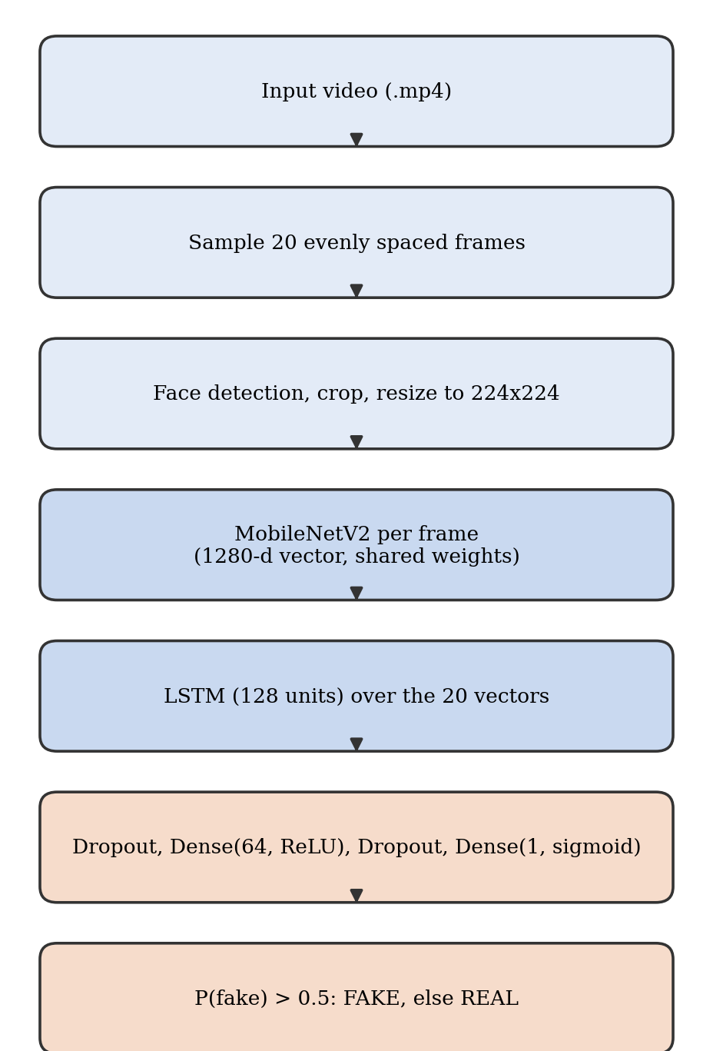
Fig. 1. Processing pipeline from uploaded video to verdict.

TABLE II
LAYERS OF THE CLASSIFIER
Layer | Output shape
Input (20 frames) | 20×224×224×3
TimeDistributed MobileNetV2, average pooling | 20×1280
LSTM, 128 units | 128
Dropout, rate 0.5 | 128
Dense, 64 units, ReLU | 64
Dropout, rate 0.3 | 64
Dense, 1 unit, sigmoid | 1

B. Evaluation metrics
Accuracy and AUC are reported on the validation set. Precision, recall and F1-score for each class were calculated for the 20 labelled examples using the confusion matrix (Fig. 3); a true positive here means a FAKE clip correctly identified as FAKE. The confidence interval for the 20-clip accuracy was computed using the Wilson score interval [13], chosen over the more commonly used normal/Wald interval because the Wald approximation is known to be unreliable at this sample size and can give values outside [0, 1].
V. System Implementation
A. Backend and model serving
The trained model is served via a FastAPI service that loads the model weights once on startup, which keeps steady-state inference latency low (Section VI-E). The service provides a health-check endpoint; an endpoint that uploads a video file and runs the complete pipeline from pre-processing to prediction; an endpoint that accepts pre-extracted NumPy sequences, skipping video decoding (useful for testing and batch processing); and endpoints for listing, retrieving and deleting stored predictions. Every prediction, including file name, fake probability, predicted label, confidence and timestamp, is saved into a SQLite table (Fig. 2). This is the single source of truth for the history, analytics and export views. One issue that took longer to debug than expected was enabling Cross-Origin Resource Sharing (CORS) so that the API could be accessed from the frontend. Without it, the browser would not expose the body of a cross-origin response, and the frontend showed only a generic error when fetching data.
B. Front end
The frontend is a React app built with Vite. It has five pages, all pulling data from the same prediction endpoint. The landing page explains the tool, and the dashboard shows overall scan data including total scans, the fake vs real split and average confidence. The analysis page lets a user upload a video and receive a verdict, with a confidence meter that makes low-confidence predictions easy to see. The history page allows searching, filtering and sorting by label, confidence and date. The analytics page calculates the fake vs real ratio, the confidence score distribution, the file type distribution and trends over time. All of this is calculated in the browser from the list response. The report page can download the currently filtered data as a CSV file or a formatted PDF table.
C. Data flow and persistence
As shown in Fig. 2, the frontend uploads either a video or an array to the FastAPI service. The service performs the pre-processing and inference and stores the result in the SQLite table. Any data retrieved for history, analytics or export is taken from this table. Because all pages retrieve data from the same endpoint, the dashboard statistics, analytics graphs and report stay consistent. The trade-off is that basic statistics are re-calculated in the browser.
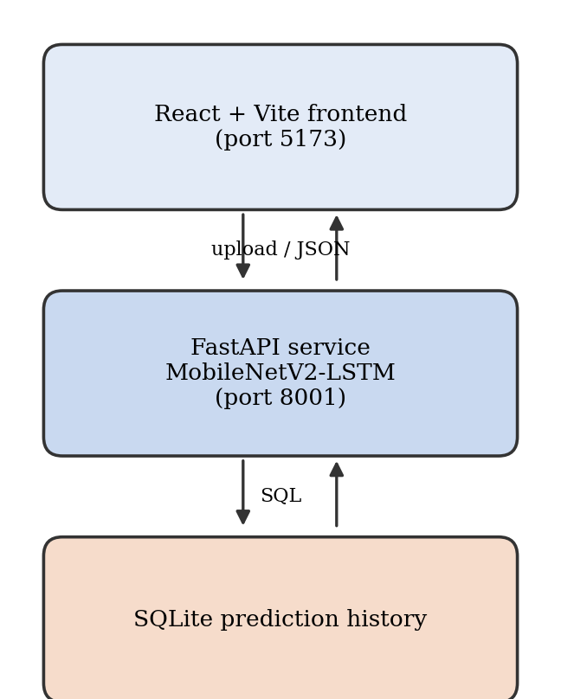
Fig. 2. System architecture: React front end, FastAPI model-serving backend and SQLite prediction history.
VI. Experiments and Results
A. Experimental setup
The model was trained on the combined corpus and split described in Section III, using a free-tier GPU in Google Colab. The inference times in Section VI-E were measured on a CPU-only Windows machine, to better mimic a low-cost deployment target. These should be treated as two separate measurements, as they show how well the model classifies versus how fast it can respond.
B. Validation performance
On the held-out validation split described in Section III-C, the model reached 90.53% accuracy with an AUC of 0.9444.
C. Deployment check on labelled clips
To understand how well the model performs on unseen clips, 20 videos were uploaded via the web interface. They were named real_1 to real_10 and fake_1 to fake_10, so the true label can be read from the file name. Given the small sample size this should be read as a sanity check rather than a formal benchmark, but it still offers a useful signal on how the model behaves once deployed. Fifteen of the 20 clips (75%) were predicted correctly (Fig. 3 and Table III). The Wilson 95% confidence interval for this result is 0.53 to 0.89 [13]. The clip-level AUC is 0.82, which is again lower than the validation result. However, as only 20 clips were tested, these results are indicative only.
There were five incorrect predictions. Three were real clips predicted as fake. Real_8 and real_9 were both just over the threshold (0.526 and 0.540), which suggests normal class overlap near the boundary. However, real_4 was predicted fake with high confidence (0.958), so no change of threshold would fix it. Two fake clips were incorrectly predicted as real: fake_6 and fake_9 were both below the threshold (0.438 and 0.333) (Fig. 4).
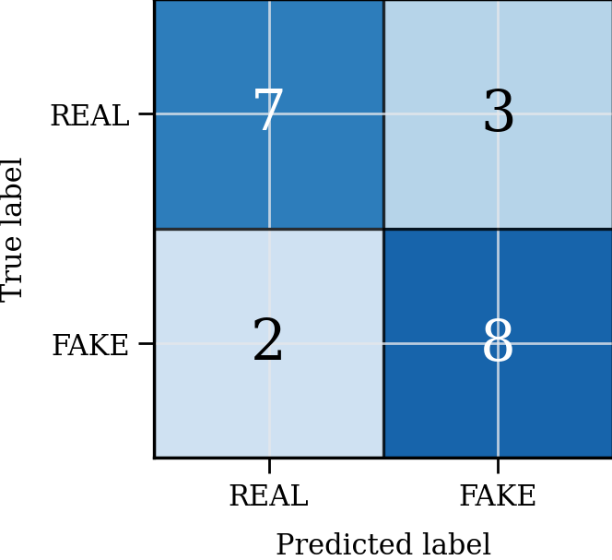
Fig. 3. Confusion matrix for the 20 labelled clips.
TABLE III
RESULTS ON THE 20 LABELLED CLIPS
Class | Precision | Recall | F1 | Clips
REAL | 0.78 | 0.70 | 0.74 | 10
FAKE | 0.73 | 0.80 | 0.76 | 10
Accuracy | 0.75 (15 of 20) |  |  | 20

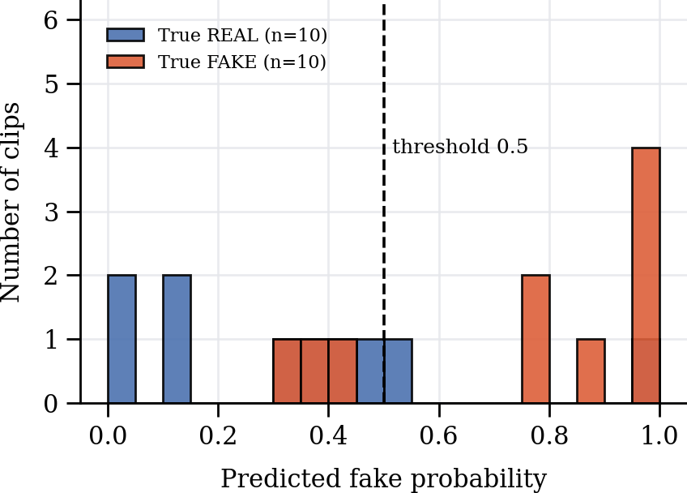
Fig. 4. Distribution of predicted fake probability for the 20 clips, with the 0.5 decision threshold marked.
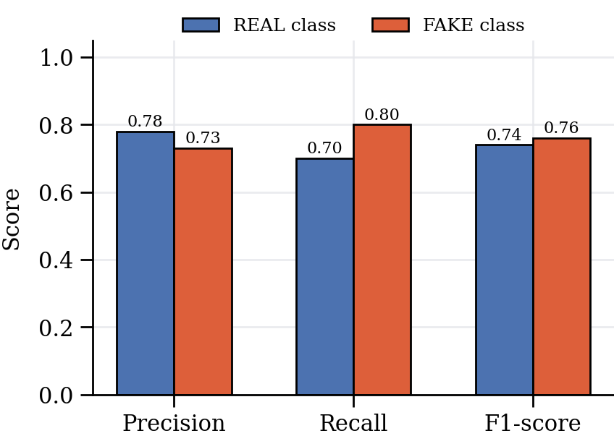
Fig. 5. Precision, recall and F1-score per class on the 20 clips.
D. Repeatability
Ten of the 20 files were analysed multiple times (between two and seven times each); real_1 was analysed seven times. Every time, the probability was the same to six decimal places. This means the deployed pipeline gives the same result for the same input. However, this applies only to these files and does not show whether the model can generalise (see Section VII).
E. Inference timing
After the model graph had initialised, each sequence of 20 frames took between 185 and 200 ms. The first request after starting the service took around 18 seconds because the computation graph was being built; this only happens once and does not affect later requests. The total time for the entire pipeline (upload, sampling, face detection and inference) was 22.1 seconds, for a 157.5 MB, 640×360 video with a stated duration of 133 minutes 58 seconds. This duration still needs to be verified against the metadata inside the file (using ffprobe). This has not been done for this draft, and we would not want to alter a measured value. The result seems low considering the length of the file, but only 20 frames were decoded, so the time depends on the number of frames sampled. It is unclear from the logs whether this figure includes container parsing and decoding time, which should be separated in the next version.
F. Behaviour outside the training distribution
A short webcam video that contained nothing from any of the three training datasets was labelled FAKE with a fake probability of 0.642. This is a false positive, and since a self-recorded webcam video is about as realistic an input as a non-expert user is likely to try, the result matters for deployment reliability.
VII. Discussion and Limitations
One question this work cannot avoid is why validation accuracy (90.53%) comes out so much higher than the 75% accuracy seen on the 20 deployed clips. Looking at the data we collected, three explanations stand out. Firstly, there is likely domain shift between the training data and the deployed data: consumer-recorded and web-sourced video is compressed differently and has different lighting and sensor noise, and there was no specific training to make the model invariant to these factors. Secondly, the sample size is small. With only 20 clips, the true deployed accuracy could plausibly lie anywhere between 0.53 and 0.89 (Wilson interval). Finally, there may be leakage in the validation split. As mentioned in Section III-C, grouping by video before splitting was verified for DFDC but has not been independently verified for FaceForensics++ and Celeb-DF. If sequences from the same source video were split across both sides in these two datasets, the validation accuracy will be overestimated. We are intentionally leaving the cause open. To resolve it, the split should be redone with each video/subject grouped in all three datasets, and the accuracy compared.
Another limitation is the lack of calibration. The model output is compared to a fixed threshold of 0.5, and no calibration (such as temperature scaling or Platt scaling) was performed, so a score of 0.54 receives the same label as 0.96. Most of the errors in Section VI-C were close to the threshold (within 0.1). The only clear exception was real_4, which was predicted incorrectly with high confidence. This is exactly the difference that a calibrated probability would highlight. Our confidence band is not fully calibrated, and max(p, 1−p) should not be read as a calibrated probability of being correct.
The 22.1-second total time (Section VI-E) has not been broken down between video decoding and inference, so it should not be seen as a pure inference time.
This detector was created and trained to detect face-swap style manipulations in single-face videos. It does not consider audio and has no defence against adversarial post-processing. The false positive on the out-of-distribution webcam video (Section VI-F) shows that it should never be used as the sole decision maker. The repeatability shown in Section VI-D means that a given file always produces the same output; this does not show whether the model can generalise. Having a public implementation does not make our results reproducible: the exact trained weights and knowledge of how the dataset was split would also be needed.
VIII. Conclusion and Future Work
We have created a deepfake video detector using MobileNetV2-LSTM, trained on a combined corpus of FaceForensics++, DFDC and Celeb-DF. It is wrapped in a full-stack solution containing a FastAPI backend, a SQLite database and a React frontend with history, analytics and report export. The model achieves a validation accuracy of 90.53% and an AUC of 0.9444, produces deterministic outputs when the same file is uploaded multiple times, and, once initialised, responds in a few hundred milliseconds per sequence. However, on a small set of 20 independently labelled clips and one self-recorded webcam clip, accuracy and reliability were lower (75% accuracy and one false positive). We have chosen to be transparent and show this difference.
There are three clear next steps based on the limitations in Section VII. Firstly, create a larger independent test set that groups by video/subject in all three source datasets. This will give a better idea of the deployed accuracy with a narrower confidence interval, and will help determine whether there was leakage in the split for FaceForensics++ and Celeb-DF. Secondly, the output probability should be calibrated (temperature scaling or Platt scaling) so that the interface can show uncertainty. Finally, the Grad-CAM explanation layer should be extended into a per-frame visualisation that the user can view, and we should test whether this helps a non-expert decide whether borderline clips (such as real_8 or real_9) are fake.
References
[1] S. Ambika, Y. Harini and B. R. Sumanth, “Real-time deepfake detection using a hybrid MobileNet-LSTM model for image and video analysis,” in Proc. 8th Int. Conf. Computing Methodologies and Communication (ICCMC), 2025, pp. 981–986, doi: 10.1109/ICCMC65190.2025.11140856.
[2] D. Güera and E. J. Delp, “Deepfake video detection using recurrent neural networks,” in Proc. IEEE Int. Conf. Advanced Video and Signal Based Surveillance (AVSS), 2018, pp. 1–6.
[3] P. Saikia, D. Dholaria, P. Yadav, V. Patel and M. Roy, “A hybrid CNN-LSTM model for video deepfake detection by leveraging optical flow features,” in Proc. Int. Joint Conf. Neural Networks (IJCNN), 2022, pp. 1–7.
[4] S. Tipper, H. F. Atlam and H. S. Lallie, “An investigation into the utilisation of CNN with LSTM for video deepfake detection,” Applied Sciences, vol. 14, no. 21, p. 9754, 2024.
[5] M. Sandler, A. Howard, M. Zhu, A. Zhmoginov and L.-C. Chen, “MobileNetV2: Inverted residuals and linear bottlenecks,” in Proc. IEEE/CVF Conf. Computer Vision and Pattern Recognition (CVPR), 2018, pp. 4510–4520.
[6] A. Rössler, D. Cozzolino, L. Verdoliva, C. Riess, J. Thies and M. Nießner, “FaceForensics++: Learning to detect manipulated facial images,” in Proc. IEEE/CVF Int. Conf. Computer Vision (ICCV), 2019, pp. 1–11.
[7] B. Dolhansky et al., “The DeepFake Detection Challenge (DFDC) dataset,” arXiv:2006.07397, 2020.
[8] Y. Li, X. Yang, P. Sun, H. Qi and S. Lyu, “Celeb-DF: A large-scale challenging dataset for DeepFake forensics,” in Proc. IEEE/CVF Conf. Computer Vision and Pattern Recognition (CVPR), 2020, pp. 3207–3216.
[9] R. R. Selvaraju et al., “Grad-CAM: Visual explanations from deep networks via gradient-based localization,” in Proc. IEEE Int. Conf. Computer Vision (ICCV), 2017, pp. 618–626.
[10] D. P. Kingma and J. Ba, “Adam: A method for stochastic optimization,” in Proc. Int. Conf. Learning Representations (ICLR), 2015.
[11] S. Hochreiter and J. Schmidhuber, “Long short-term memory,” Neural Computation, vol. 9, no. 8, pp. 1735–1780, 1997.
[12] W. Wu, H. Peng and S. Yu, “YuNet: A tiny millisecond-level face detector,” Machine Intelligence Research, vol. 20, no. 5, pp. 656–665, 2023, doi: 10.1007/s11633-023-1423-y.
[13] E. B. Wilson, “Probable inference, the law of succession, and statistical inference,” Journal of the American Statistical Association, vol. 22, no. 158, pp. 209–212, 1927.

