AuthentiScan: A Full-Stack MobileNetV2-LSTM System for Deepfake Video Detection
[1st Author Name]  [dept. name of organization]  [name of organization, Aff.]  [City, Country]  [email address or ORCID] | [2nd Author Name]  [dept. name of organization]  [name of organization, Aff.]  [City, Country]  [email address or ORCID] | [3rd Author Name]  [dept. name of organization]  [name of organization, Aff.]  [City, Country]  [email address or ORCID]

Abstract—Anyone can now generate a convincing deepfake video with free, consumer-grade tools, and the result is often impossible to tell apart from real footage just by watching it. Yet most published detectors stop at being accurate classifiers on a benchmark; they are rarely turned into something an ordinary person could actually open and use, and they are almost never tested on footage the model has never seen outside that benchmark. This paper describes AuthentiScan, a complete system built around a MobileNetV2-LSTM classifier: given an uploaded video, it samples 20 frames, finds and crops the face in each one, and passes the resulting sequence through a MobileNetV2 feature extractor followed by an LSTM to decide REAL or FAKE. The model was trained on a combined dataset drawn from FaceForensics++, the DFDC challenge dataset, and Celeb-DF, and reached 90.53% validation accuracy with an AUC of 0.9444. Around that model we built a FastAPI backend, a SQLite database for prediction history, and a React front end with analytics dashboards and CSV/PDF report export. To see how the system performs once it leaves the validation split, we ran 20 independently labelled clips through the live application and got 75% accuracy (15 of 20, Wilson 95% confidence interval 0.53–0.89); a short webcam clip we recorded ourselves, outside any training data, was also misclassified as fake. We report both numbers side by side rather than only the more flattering one, because the gap between them says something real about how far benchmark accuracy can be trusted once a model is actually deployed.
Index Terms—deepfake detection, MobileNetV2, LSTM, video forensics, FastAPI, React, domain shift
I. Introduction
Face-swapping tools that once needed a research lab's worth of infrastructure are now one download away, and they can produce a believable fake video in a few minutes on an ordinary laptop. The same technology that powers a harmless entertainment filter can just as easily be used to put words in a politician's mouth, fabricate an endorsement, or manufacture evidence that never existed, and a person watching the video has almost no reliable way to tell the difference just by looking. This is why automated deepfake detection has stopped being a purely academic exercise and has become something people genuinely need, and it is why a large body of research now reports strong classification numbers on benchmarks such as FaceForensics++ [6], DFDC [7], and Celeb-DF [8].
Two things, however, keep coming up as gaps in this literature. First, a trained classifier sitting in a notebook is not actually a tool: someone who wants to check a suspicious video — a journalist, a teacher, a moderator — needs a place to upload the file, a result they can understand, a confidence figure, and ideally a record of what they checked before. Papers rarely describe this part at all. Second, the accuracy numbers that get reported come from curated validation splits, and footage an ordinary user submits will differ from that in compression, lighting, and camera noise, so a high validation score does not by itself tell you much about how the system will behave in the real world. Most existing work solves the modelling problem without ever touching the deployment problem or being honest about the second gap, and that combination is really what motivated this project.
The architecture here builds on the hybrid design proposed by Ambika et al. [1], who pair a lightweight convolutional backbone with a recurrent layer so the network can pick up both per-frame appearance cues and the subtler inconsistencies that only show up across frames. Where [1] demonstrates the idea mainly through a Streamlit interface, we carried the pipeline all the way through to a production-style client-server system, and — more importantly — we did not stop at the validation split. We put the deployed system itself in front of a small, independently labelled test and reported what actually happened. Concretely, this paper contributes:
1) A preprocessing pipeline that reconciles three very differently shaped public datasets — raw compressed video, pre-cropped face images, and a third-party image mirror — into one common format of 20-frame, 224×224 face sequences that the same network can consume.
2) A working full-stack application — FastAPI backend, SQLite persistence, React front end — that turns the model into something with prediction history, analytics, and report export, through a documented REST API.
3) An honest side-by-side comparison of validation accuracy against the system's behaviour on 20 labelled clips and one out-of-distribution recording, with an attempt to explain where and why the two disagree, rather than quoting only the better of the two numbers.

II. Related Work
Feeding a sequence of per-frame CNN features into a recurrent layer is by now a fairly standard move in video deepfake detection. Güera and Delp [2] were among the first to do this, using an LSTM to catch inter-frame inconsistencies that a single-frame classifier would simply miss, though their evaluation is limited to one now-ageing benchmark and never looks at how the model behaves once deployed. Saikia et al. [3] took a similar idea further by adding optical-flow features alongside the CNN features, which helps with unnatural motion but adds a heavier preprocessing step that makes real-time use harder. Tipper et al. [4], in a broader survey of CNN-LSTM combinations for this problem, found that reported accuracies swing quite a bit from one dataset to another — which is really the same benchmark-generalisation concern this paper tries to address directly.
On the backbone side, MobileNetV2 [5] was built specifically for mobile and embedded inference, using inverted residual blocks with linear bottlenecks to keep both the parameter count and the latency down, which is exactly what you want in something that has to respond within a few seconds over the web. Ambika et al. [1] combined a MobileNet backbone with an LSTM and reported 92% accuracy and an ROC-AUC of 0.96 on their own validation split, alongside a Streamlit demo and Grad-CAM [9] explanations. Our design closely follows theirs, but three things set this work apart. First, [1] reports no evaluation beyond its own validation split, so there is no evidence of how that 92% transfers to clips collected after training; our 20-clip deployment check (Section VI-C) is specifically meant to close that gap, and our own validation number (90.53%) is a little lower but is reported next to the deployment figure instead of in place of it. Second, [1] does not describe any persistent backend, REST API, or history/reporting layer — in AuthentiScan these are treated as core requirements, not an afterthought (Section V). Third, we had to combine three structurally different datasets — compressed raw video, pre-cropped frames, and a third-party image mirror — into a single training corpus, which meant building a cross-dataset preprocessing pipeline that [1]–[4] simply did not need, since each of them trains on one more uniform source.
Three datasets dominate this space and all three went into our training set. FaceForensics++ [6] offers manipulated videos at several compression levels; we deliberately used only the heavily compressed c40 tier, since it is the hardest setting and the closest to what actually gets shared on social platforms. DFDC [7] is the large-scale corpus built for the Deepfake Detection Challenge, and by image count it is the single biggest contributor to our training data (Table I). Celeb-DF [8] contains higher-quality manipulations with fewer visible artefacts than the original Deepfake dataset it replaced, and we included it mainly to reduce the risk of the model latching onto compression artefacts instead of genuine manipulation cues. Because these three datasets differ in subjects, compression, and face-extraction conventions, no existing baseline uses quite the same combination we train on here, which does limit how directly our validation number can be compared to [1]–[4].
III. Datasets and Preprocessing
A. Data sources
Table I lays out the three public sources we used for training, each reported in whatever unit it is natively distributed in, so we are not pretending videos, images, and sequences are the same kind of count. From FaceForensics++ [6] we took 100 original and 100 Deepfakes videos at the c40 (heavy) compression tier; since this comes as raw video, our own pipeline handled face detection and cropping (Section III-B). The DFDC portion [7] arrived as a pre-cropped, already face-aligned 160×160 image archive mirrored on Kaggle, with 26,728 real and 97,919 fake images; we resized and renormalised these but did not re-run detection on them. The Celeb-DF portion [8] likewise came as pre-cropped face images from a Kaggle mirror (roughly 1.46 GB of image data); we did not separately log the per-class image counts for this source at preprocessing time, and that figure needs to be checked against the dataset-build script rather than guessed at here. Once individual frames and images were grouped into ordered 20-frame sequences (Section III-B), the combined corpus came to about 7,100 sequences, split into training and validation sets.
TABLE I
DATA SOURCES, NATIVE UNITS AND HOW EACH WAS CONVERTED TO SEQUENCES
Source | Native unit | Real / Fake counts | Notes
FaceForensics++ [6] | Raw video, c40 compression | 100 videos / 100 videos | Faces detected and cropped locally (Sec. III-B)
DFDC [7] | Pre-cropped 160×160 face image | 26,728 images / 97,919 images | Regrouped into per-video sequences by file-name video ID
Celeb-DF [8] | Pre-cropped face image | Kaggle mirror, ≈ 1.46 GB | Per-class image counts not separately logged; to be confirmed against the build script
Combined | 20-frame face sequence | ≈ 7,100 sequences total | Split into training and validation sets (Sec. III-C)

B. Face extraction and sequence construction
Every training example, no matter which dataset it came from, ends up as 20 face crops of 224×224 pixels — that standardisation is what lets FaceForensics++, DFDC, and Celeb-DF all feed the same network. DFDC file names happen to encode a video identifier, so we grouped frames from the same source video into one ordered sequence instead of treating them as independent images; this keeps every frame of a given clip on one side of the split and cuts down on frame-level leakage, at least for that dataset. For the raw FaceForensics++ video, we sampled 20 frame positions at even intervals across the clip and ran each through the YuNet detector [12], keeping the highest-confidence detection as long as its score was at least 0.5; if detection failed at a given position, we copied the nearest successful frame in time so the sequence's temporal order never gets disturbed. Celeb-DF images arrived pre-cropped already, and we grouped them using the directory/subject naming convention from the Kaggle mirror. In every case, pixel values were scaled to [-1, 1] using the standard MobileNetV2 preprocessing function.
C. Train/validation split and leakage protection
We split the combined corpus into training and validation subsets at the sequence level. Grouping by video identifier before splitting, as described above, guarantees that no two frames from the same DFDC source video end up on opposite sides of the split. What we have not done yet is independently re-verify an equivalent subject- or video-level separation for FaceForensics++ and Celeb-DF, and rather than quietly assume it is fine, we are flagging it here as an open item. Section VII comes back to this as one possible explanation for the gap between validation and deployment accuracy, and it is something that should be checked against the dataset-build scripts — confirming no frames from the same source video or subject appear on both sides — before the validation figure is treated as a safe, conservative estimate.
D. Class imbalance
Within DFDC specifically, fake images outnumber real ones by roughly 3.5 to 4 times in both splits. Instead of throwing away data to force balance, we kept the full corpus and weighted the binary cross-entropy loss by class frequency (Section IV-A).
IV. Model and Methodology
A. Architecture
The network takes in a tensor of 20 ordered face crops, each 224×224×3. A MobileNetV2 backbone, pretrained on ImageNet with its classification head removed, runs over every frame with shared weights; global average pooling then turns each frame's feature map into a 1280-dimensional vector f(t). That sequence of 20 vectors is what the LSTM layer, with 128 hidden units, actually reads. At each time step t, the standard LSTM update [11] looks like this:
i_{t} = σ(W_{i}·[h_{t−1}, f_{t}] + b_{i}) f′_{t} = σ(W_{f}·[h_{t−1}, f_{t}] + b_{f})
o_{t} = σ(W_{o}·[h_{t−1}, f_{t}] + b_{o}) c̃_{t} = tanh(W_{c}·[h_{t−1}, f_{t}] + b_{c})
c_{t} = f′_{t} ⊙ c_{t−1} + i_{t} ⊙ c̃_{t} h_{t} = o_{t} ⊙ tanh(c_{t})
Here σ is the sigmoid function, ⊙ denotes element-wise multiplication, and the three gate vectors above are the input, forget, and output gates respectively. After the 20th step, the final hidden state goes through a dropout layer (rate 0.5), a dense layer of 64 ReLU units, a second dropout layer (rate 0.3), and finally a dense sigmoid unit producing p = P(fake | sequence) (Table II, Fig. 1).
A clip gets labelled FAKE whenever p > 0.5 and REAL otherwise, and the confidence we surface to the user is simply max(p, 1−p). Training minimises class-weighted binary cross-entropy over a batch of N sequences:
L = −(1/N) Σ_{n} w_{yn} [y_{n} log(p_{n}) + (1−y_{n}) log(1−p_{n})]
using the Adam optimiser [10], with class weights set inversely proportional to class frequency in the training split (Section III-D). Training itself ran on a free-tier Google Colab GPU runtime, and because those runtimes can disconnect without warning and wipe local storage, we persisted dataset archives and a checkpoint from every epoch to Google Drive as a precaution. The full model comes to roughly 2.99 million trainable parameters; that number still needs to be cross-checked directly against the printed model-summary output before anything is finalised, in line with the verification already requested for Table II — we are not simply restating it here as settled. The system also supports a Grad-CAM [9] heatmap computed from MobileNetV2's last convolutional activation for the primary detected face; it is available in the interface, but we have not evaluated it quantitatively in this paper.
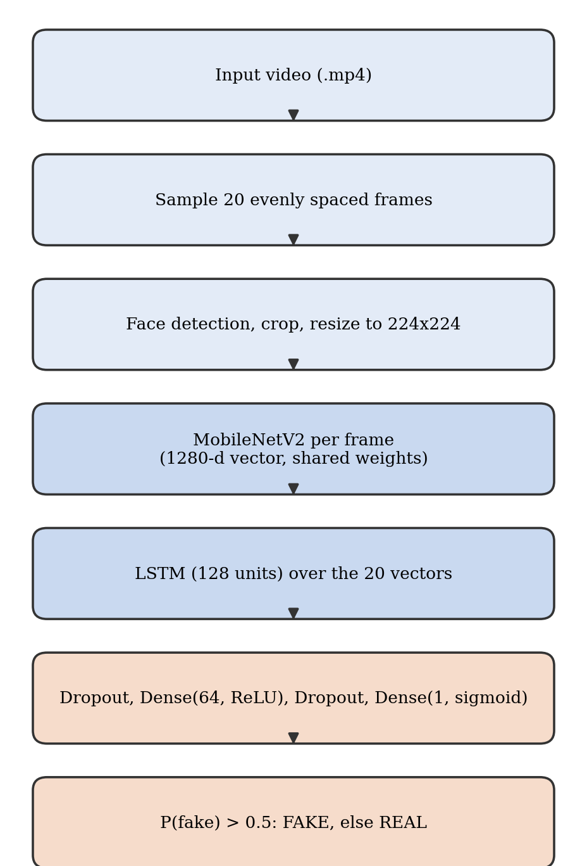
Fig. 1. Processing pipeline from uploaded video to verdict.
TABLE II
LAYERS OF THE CLASSIFIER
Layer | Output shape
Input (20 frames) | 20×224×224×3
TimeDistributed MobileNetV2, average pooling | 20×1280
LSTM, 128 units | 128
Dropout, rate 0.5 | 128
Dense, 64 units, ReLU | 64
Dropout, rate 0.3 | 64
Dense, 1 unit, sigmoid | 1

B. Evaluation metrics
We report accuracy and AUC on the held-out validation split, and for the 20 labelled deployment clips we compute per-class precision, recall, and F1-score from the confusion matrix in Fig. 3 (a true positive here means a FAKE clip correctly identified as FAKE). For the 20-clip accuracy, we used a Wilson score interval [13] rather than the more familiar normal/Wald interval, since the Wald approximation is known to be unreliable at this sample size and can even stray outside [0, 1].
V. System Implementation
A. Backend and model serving
The trained model is served through a FastAPI application that loads its weights once at start-up rather than on every request, which keeps steady-state inference latency low (Section VI-E). The service exposes a health-check endpoint; an endpoint that takes an uploaded video file and runs the whole preprocessing-to-prediction pipeline; a second endpoint that accepts a pre-extracted NumPy sequence directly, skipping video decoding, which is handy for testing and batch runs; and list/retrieve/delete endpoints over everything that has been predicted so far. Every prediction — file name, fake probability, predicted label, confidence, timestamp — gets written into a SQLite table (Fig. 2), which ends up being the single source of truth behind the history, analytics, and export views described below. One thing that took longer than expected to debug: cross-origin resource sharing had to be explicitly enabled on the API, because without it the browser silently refused to expose the response body of cross-origin requests, and all the front end showed was a generic fetch failure until we traced it back to CORS.
B. Front end
The client is a React application built with Vite, organised around five views that all read from the same prediction-list endpoint so the database stays the single source of truth: a landing page introducing the tool; a dashboard showing total scans, the real/fake split, and average confidence; an analysis view where a user uploads a video and gets back a verdict along with a confidence meter that visually flags low-confidence results; a history view with search plus label/confidence/date filters and sorting; and an analytics view that works out the real-vs-fake split, a confidence-score histogram, a file-type breakdown, and a predictions-over-time trend — all computed in the browser from that same list response rather than from separate backend aggregation endpoints. A report view exports whatever is currently filtered as CSV or as a formatted PDF table.
C. Data flow and persistence
Fig. 2 lays out the end-to-end data flow: the front end sends a video or array upload to the FastAPI service, which runs preprocessing and inference and writes the result into the SQLite table; every later read for history, analytics, or export comes from that same table. Because every view is backed by a single list endpoint, the dashboard counts, the analytics charts, and the exported report all stay consistent with each other — the trade-off being that simple aggregates get recomputed in the browser on every page load instead of being cached server-side.
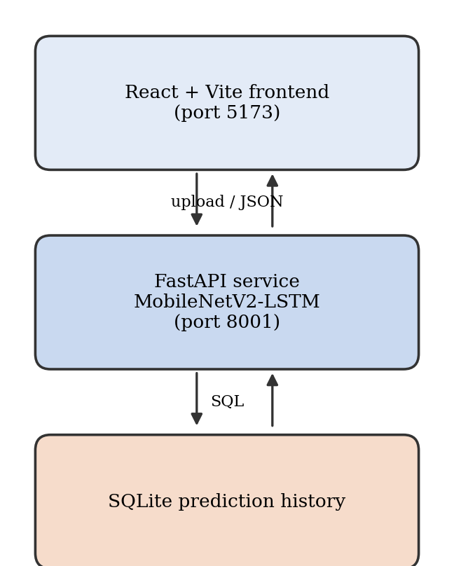
Fig. 2. System architecture: React front end, FastAPI model-serving backend and SQLite prediction history.
VI. Experiments and Results
A. Experimental setup
Training ran on a free-tier Google Colab GPU using the combined corpus and split described in Section III. The inference-timing measurements in Section VI-E, by contrast, were collected on a CPU-only Windows machine — a more realistic stand-in for a low-cost deployment target than the training hardware. It is worth keeping these two apart: one measures how well the model classifies, the other how quickly it responds, and conflating them would be misleading.
B. Validation performance
On the held-out validation split from Section III-C, the model reached 90.53% accuracy with an AUC of 0.9444.
C. Deployment check on labelled clips
To get a sense of how the deployed system behaves on clips it never saw during training or validation, we uploaded 20 videos through the web interface — ten named real_1 through real_10 and ten named fake_1 through fake_10, so the ground truth is encoded directly in the file name. We treat this as a sanity check rather than a formal benchmark, given how small the sample is. Fig. 3 and Table III summarise what happened: 15 of 20 clips (75%) came back correct. The Wilson 95% interval for 15/20 runs from 0.53 to 0.89 [13], and the clip-level AUC from the logged probabilities works out to 0.82 — both numbers sit below the validation figures, though with only 20 clips this is suggestive rather than conclusive.
The five mistakes were not all the same kind of mistake. Three real clips got flagged as fake: real_8 and real_9 scored just above the decision threshold (0.526 and 0.540), which looks like ordinary class overlap near the boundary, but real_4 scored 0.958 — a confident, clearly wrong prediction that no amount of threshold tuning would fix. Two fake clips slipped through as real: fake_6 at 0.438 and fake_9 at 0.333, both sitting on the uncertain side of the line (Fig. 4).
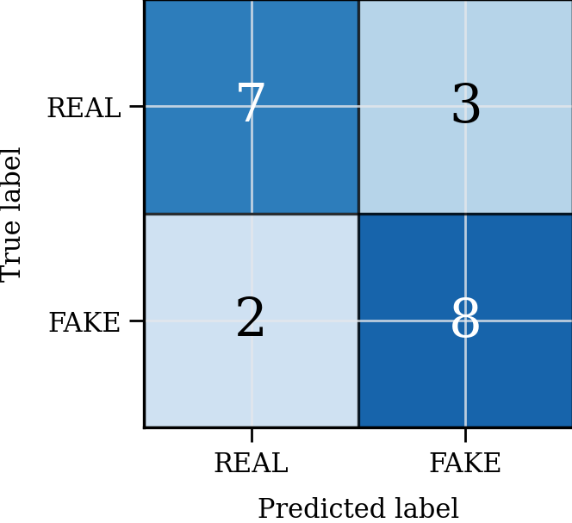
Fig. 3. Confusion matrix for the 20 labelled clips.
TABLE III
RESULTS ON THE 20 LABELLED CLIPS
Class | Precision | Recall | F1 | Clips
REAL | 0.78 | 0.70 | 0.74 | 10
FAKE | 0.73 | 0.80 | 0.76 | 10
Accuracy | 0.75 (15 of 20) |  |  | 20

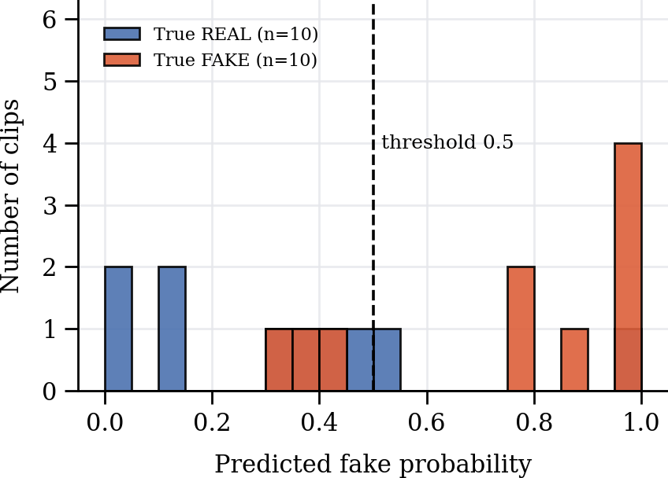
Fig. 4. Distribution of predicted fake probability for the 20 clips, with the 0.5 decision threshold marked.
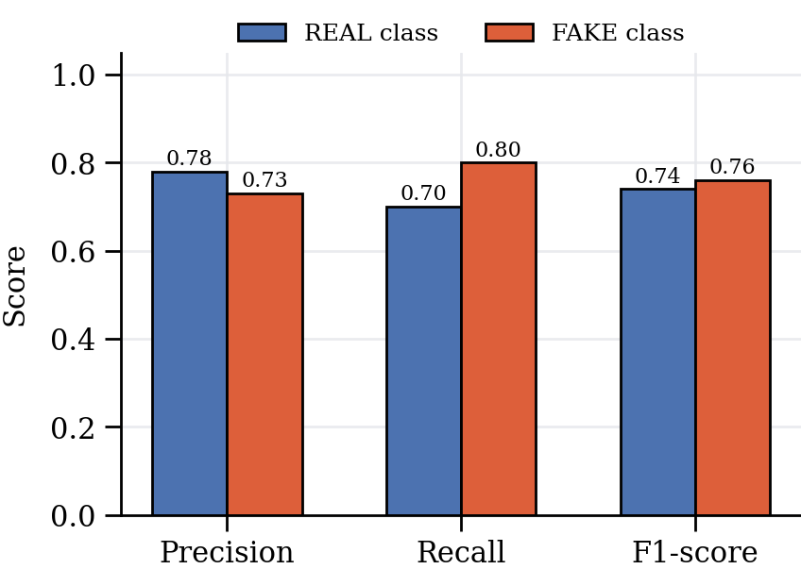
Fig. 5. Precision, recall and F1-score per class on the 20 clips.
D. Repeatability
Ten of the twenty files were analysed more than once — between two and seven repeats each, with real_1 run through seven times — and every repeat came back with the same probability to six decimal places. So the deployed pipeline is deterministic for a fixed input: re-uploading the same file is never going to flip the verdict. That is repeatability for the specific files we tried, nothing more; it does not, on its own, say anything about whether the model generalises, a point we come back to in Section VII.

E. Inference timing
Once the model graph had warmed up, a single forward pass over a 20-frame sequence took 185–200 ms on our CPU-only test machine. The very first request after the service started took about 18 seconds while the computation graph was being built, but that cost only happens once per deployment, not on every request. End to end — upload, frame sampling, face detection, and inference together — the interface reported 22.1 seconds for a 157.5 MB, 640×360 video with a stated duration of 133 minutes 58 seconds. That duration figure still needs to be checked against the file's actual container metadata (ffprobe would do it) before we treat it as final — we have not independently re-verified it for this draft, and we are not willing to change a measured number without that check. The 22.1-second figure looks short next to the file's nominal length mainly because only 20 frames get decoded rather than the whole video, so timing tracks the number of sampled frames rather than video length; it is also not currently clear from our logs whether that 22.1 s includes container parsing and decoding overhead on top of model inference, which is something the next revision should break out separately.
F. Behaviour outside the training distribution
A short webcam clip we recorded ourselves, with nothing from any of the three training datasets in it, came back labelled FAKE at a fake probability of 0.642. That is a false positive, and since a self-recorded webcam clip is about as realistic a first input as a non-expert user is likely to try, this result matters for deployment reliability — it is not an edge case we can set aside.
VII. Discussion and Limitations
The question this paper really can't avoid is why validation accuracy (90.53%) comes out noticeably higher than deployment accuracy on the 20 labelled clips (75%). We cannot pin down a single cause from the data we collected, but three explanations are all consistent with what we observed. One is domain shift: consumer-recorded and web-sourced video differs from benchmark footage in compression, lighting, and sensor noise, and nothing in training specifically pushed the model to be invariant to those factors. Another is simply sample size — 20 clips is small enough that the true deployment accuracy could plausibly sit anywhere in the Wilson interval (0.53–0.89), so part of the gap might just be noise rather than a real effect. A third, and the one we are least able to rule out, is possible leakage in the validation split: as noted in Section III-C, video-level grouping before splitting was verified for DFDC but not independently confirmed for FaceForensics++ or Celeb-DF, and if sequences from the same source video ended up on both sides of the split for those two datasets, our validation accuracy would be optimistic relative to a strictly subject-disjoint evaluation. We are deliberately leaving this open rather than picking whichever explanation sounds best. Settling it means rerunning the split with enforced per-video/per-subject grouping across all three datasets and comparing the resulting accuracy against what we have now.
A second limitation is calibration. The sigmoid output gets compared against a fixed 0.5 threshold with no post-hoc calibration — no temperature scaling, no Platt scaling — so a score of 0.54 and a score of 0.96 receive exactly the same binary label even though they mean very different things in terms of certainty. Most of the deployment errors in Section VI-C were in fact borderline, within about 0.1 of the threshold, with the clear exception of real_4, which was both wrong and confident; that difference between a close, miscalibrated error and a confidently wrong one is precisely what a calibrated probability would surface, and our current confidence band is only a partial, uncalibrated stand-in for it. It is also worth being explicit that the confidence we report (max(p, 1−p)) is not the same thing as a calibrated probability of being correct, and the two should not be read as interchangeable, especially by a non-technical user.
The 22.1-second end-to-end timing figure from Section VI-E is a wall-clock measurement that, as logged right now, does not cleanly separate video decoding from model inference, so it should not be read as a pure inference benchmark until that breakdown exists.
Finally, this detector was built and trained for face-swap-style manipulation in single-face video. It does not look at audio, makes no attempt to resist adversarial post-processing such as re-compression or a perturbation deliberately designed to flip the prediction, and its false positive on an out-of-distribution webcam clip (Section VI-F) is a reminder that it should never be the sole basis for a decision that actually matters. The “repeatability” we demonstrated in Section VI-D is about deterministic output for a fixed file, nothing more — it says nothing about whether the model generalises and should not be mistaken for evidence of general reliability. In the same spirit, having a public implementation is a statement about the code repository, not about the validation results, and it does not on its own make our numbers reproducible by someone else without the exact trained weights and dataset split we used.
VIII. Conclusion and Future Work
We built a MobileNetV2-LSTM deepfake video detector, trained it on a combined corpus pulled from FaceForensics++, DFDC, and Celeb-DF, and wrapped it in a full-stack application — a FastAPI backend, a SQLite persistence layer, and a React front end with history, analytics, and report export. The model reaches 90.53% validation accuracy and an AUC of 0.9444, gives deterministic outputs on repeated uploads of the same file, and responds in a few hundred milliseconds per sequence once warmed up. On a small set of 20 independently labelled clips and one self-recorded webcam clip, though, both accuracy and reliability came in measurably lower — 75% and one false positive — and we have chosen to report that gap plainly rather than lead with only the more favourable validation number.
Three next steps follow fairly directly from the limitations in Section VII. First, build a larger, independent test set split at the video/subject level across all three source datasets, both to get a deployment-accuracy estimate with a tighter confidence interval and to settle the split-leakage question for FaceForensics++ and Celeb-DF. Second, calibrate the output probability — temperature scaling or Platt scaling would both work — so the interface can express genuine uncertainty instead of a single binary label. Third, take the explanation layer we already have (Grad-CAM) and turn it into a per-frame, user-facing visualisation, then actually test whether it helps a non-expert judge borderline cases like real_8 or real_9 rather than just trusting a bare threshold.
References
[1] S. Ambika, Y. Harini and B. R. Sumanth, “Real-time deepfake detection using a hybrid MobileNet-LSTM model for image and video analysis,” in Proc. 8th Int. Conf. Computing Methodologies and Communication (ICCMC), 2025, pp. 981–986, doi: 10.1109/ICCMC65190.2025.11140856.
[2] D. Güera and E. J. Delp, “Deepfake video detection using recurrent neural networks,” in Proc. IEEE Int. Conf. Advanced Video and Signal Based Surveillance (AVSS), 2018, pp. 1–6.
[3] P. Saikia, D. Dholaria, P. Yadav, V. Patel and M. Roy, “A hybrid CNN-LSTM model for video deepfake detection by leveraging optical flow features,” in Proc. Int. Joint Conf. Neural Networks (IJCNN), 2022, pp. 1–7.
[4] S. Tipper, H. F. Atlam and H. S. Lallie, “An investigation into the utilisation of CNN with LSTM for video deepfake detection,” Applied Sciences, vol. 14, no. 21, p. 9754, 2024.
[5] M. Sandler, A. Howard, M. Zhu, A. Zhmoginov and L.-C. Chen, “MobileNetV2: Inverted residuals and linear bottlenecks,” in Proc. IEEE/CVF Conf. Computer Vision and Pattern Recognition (CVPR), 2018, pp. 4510–4520.
[6] A. Rössler, D. Cozzolino, L. Verdoliva, C. Riess, J. Thies and M. Nießner, “FaceForensics++: Learning to detect manipulated facial images,” in Proc. IEEE/CVF Int. Conf. Computer Vision (ICCV), 2019, pp. 1–11.
[7] B. Dolhansky et al., “The DeepFake Detection Challenge (DFDC) dataset,” arXiv:2006.07397, 2020.
[8] Y. Li, X. Yang, P. Sun, H. Qi and S. Lyu, “Celeb-DF: A large-scale challenging dataset for DeepFake forensics,” in Proc. IEEE/CVF Conf. Computer Vision and Pattern Recognition (CVPR), 2020, pp. 3207–3216.
[9] R. R. Selvaraju et al., “Grad-CAM: Visual explanations from deep networks via gradient-based localization,” in Proc. IEEE Int. Conf. Computer Vision (ICCV), 2017, pp. 618–626.
[10] D. P. Kingma and J. Ba, “Adam: A method for stochastic optimization,” in Proc. Int. Conf. Learning Representations (ICLR), 2015.
[11] S. Hochreiter and J. Schmidhuber, “Long short-term memory,” Neural Computation, vol. 9, no. 8, pp. 1735–1780, 1997.
[12] W. Wu, H. Peng and S. Yu, “YuNet: A tiny millisecond-level face detector,” Machine Intelligence Research, vol. 20, no. 5, pp. 656–665, 2023, doi: 10.1007/s11633-023-1423-y.
[13] E. B. Wilson, “Probable inference, the law of succession, and statistical inference,” Journal of the American Statistical Association, vol. 22, no. 158, pp. 209–212, 1927.

