Feature-Engineered Fault Classification of Robot Execution Failures with a Deployed Predictive-Maintenance Web Application
Logambigai R  Computer Science and Engineering  Vel Tech Rangarajan Dr. Sagunthala R&D  Institute of Science and Technology  Chennai, India  drlogambigair@veltech.edu.in | Kalla Shiva Charan Reddy  Computer Science and Engineering  Vel Tech Rangarajan Dr. Sagunthala R&D  Institute of Science and Technology  Chennai, India  shivacharanr431@gmail.com | M.Siddu  Computer Science and Engineering  Vel Tech Rangarajan Dr. Sagunthala R&D  Institute of Science and Technology  Chennai, India  vtu30379@veltech.edu.in

Abstract: This work classifies faults in robotic tasks using force and torque sensor data. In addition, there is a web application which allows users to input data and view results. The Robot Execution Failures dataset consists of five subsets of data (LP1-5). Each sample contains 15 sensor readings from 6 force and torque channels. The models were tested using different feature engineering techniques, the raw data (90 features), statistical features per channel (48 features) and magnitude features (14 features). The Random Forest and XGBoost classifiers were tested using stratified cross-validation methods per subset. The models used had varying accuracies depending on the subset. LP1 had an accuracy of 96.59%, LP2 72.34%, LP3 82.98%, LP4 95.73%, and LP5 76.83%. LP1 and LP4 had good performance using statistical features. LP3 and LP5 used magnitude features. Further experiments were undertaken to test fused data, parameter tuning, and oversampling using SMOTE. A model was chosen per task depending on the results. The models were used with FastAPI services and a React interface to classify data, store previous classifications, analyse the data, and create reports. This produced a working prototype that allows sensor input, classification and storage of data.
Index Terms: Robot Execution Failures, Fault Classification, Feature Engineering, Random Forest, XGBoost, Force/Torque Sensor, Maintenance Support.

I. INTRODUCTION
Robotic arms are used to perform repetitive tasks in manufacturing and assembly. During operations, the robot could have a collision, get stuck, or drop a part. Using force and torque sensor readings this can be identified. A model can be trained to look at a short sequence of sensor data to determine if the task was completed normally or what fault occurred.
This project used the Robot Execution Failures dataset. There are five subsets of data (LP1-5) relating to different tasks. Each subset has different target labels. The input features of all subsets have the same shape and so the features and models were compared for each task separately.
This project was separated into two parts. Firstly the models were trained with the sensor data. This involves preparing the data, feature engineering and measuring the performance of the Random Forest and XGBoost models. A model was chosen per subset. Secondly, a web interface was created to allow the user to input sensor data, receive a predicted class, see previous classifications and create reports.
Different feature engineering approaches were compared.
A model was chosen for each task. The importance of the features used was looked at. The chosen models were then connected to the application. An observation was made that the input features of the models for LP2 and LP3 were the same. This project was independently implemented and experimented with. Information on the dataset and methods used have been referenced.

II. RELATED WORK
Recent research has been done on diagnosing faults in robots. Different levels have been looked at from end to end, to individual drives/joints. Savas [1] looked at force and torque features for robot executions. Bogue [2] looked at maintenance strategies for industrial robots.
Savas [1] looked at comparing raw data with statistical features on the LP1 subset. This achieved 93.85% accuracy with a Naive Bayes classifier. In this project LP1 achieved 96.59% accuracy with a Random Forest classifier using a different set of features.
Eang and Lee [3] used CNN-RNN observers for detecting faults in robot motors. Bilal et al [4] looked at online fault diagnosis for robots using IoRT and hybrid deep learning. Raouf et al [5] looked at transfer learning for robots in different operating conditions. These projects looked at monitoring individual components and different operating conditions, whereas this project looks at full 15 by 6 force/torque windows.
Other work has been done on machinery. CNN and LSTM models have been used for bearing diagnosis [6]. CNN-LSTM-GRU networks have been used to learn spatial and temporal features [7]. Jeon et al [8] used SHAP and LIME for diagnosis of wafer transfer robots. Maged et al [9] looked at methods for explainable fault detection. Amaliah et al [10] looked at human in the loop explainable maintenance systems. These projects inspired looking at feature importance and providing understandable results.
Anđelić et al [11] used symbolic expressions and Random Forest meta-ensembles for maintenance of machines. Zhong et al [12] looked at domain adversarial transfer learning with structural adaptation. Zhao et al [13] looked at cross machine diagnosis with small, imbalanced data. Other methods have been looked at in the literature.
Kim [14] looked at diagnosing robot drive faults with learnt dynamics and SHAP representations. Azeta et al [15] looked at using more AI, sensors and robotics for predictive maintenance. This shows that this project is part of a wider movement towards using sensor data to create usable diagnostic tools.
In this project Random Forest and XGBoost were used for classification. Feature importance was looked at using SHAP. In addition, SMOTE was used in extra experiments. The research done recently is related to the application and is not the original sources of these well known methods.

III. METHODOLOGY

A. Data and Preprocessing
Data was taken from the UCI Robot Execution Failures dataset created by L. Seabra Lopes and L. M. Camarinha-Matos. Each sample consisted of a 15 by 6 matrix. There are 6 channels, Fx, Fy, Fz, Tx, Ty, and Tz. The first three are force, the last three are torque. There are categorical labels for the outcome of the recorded execution. See table I for sample count per subset and class counts.
TABLE I
DATASET CONTENT AND CLASS COUNT
Dataset | Samples | Classes | Class counts
LP1 | 88 | 4 | obstruction 34, normal 21, collision 17, fr_collision 16
LP2 | 47 | 5 | normal 20, left_col 9, back_col 7, front_col 6, right_col 5
LP3 | 47 | 4 | ok 20, moved 15, slightly_moved 9, lost 3
LP4 | 117 | 3 | collision 72, normal 24, obstruction 21
LP5 | 164 | 5 | collision_in_part 47, normal 44, collision_in_tool 26, bottom_collision 26, bottom_obstruction 21
There are 88 samples for LP1, 47 for LP2 and LP3, 117 samples for LP4, and 164 samples for LP5. There are between 3 and 5 classes. As there are a different amount of samples per class, the models were evaluated using macro F1. This accounts for each class having the same weight.
By analysing the data directly it was found that the sensor matrices for LP2 and LP3 (the 47 samples) were identical. LP2 had collision direction labels and LP3 had displacement labels. This means that the inputs have been prepared correctly. However, it would need to be checked that the original files and preprocessing steps to see why this was the case.
Figure 1 shows a normal sample for LP1. Figure 2 shows how the sensor channels relate to each other for LP1. Below describes how the data was preprocessed to create inputs for the models.
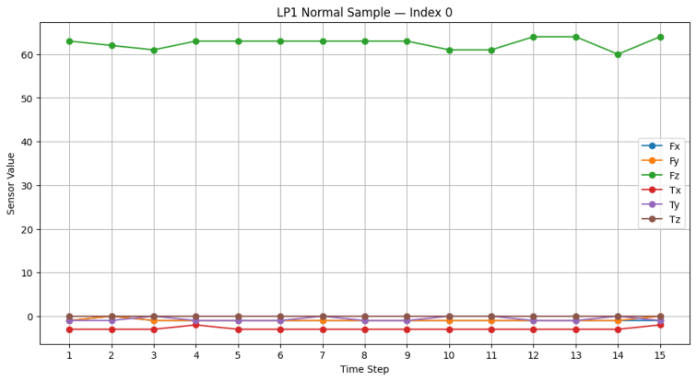
Fig. 1. Six-channel trace for a normal LP1 sample over 15 timesteps.

B. Feature Engineering
Raw-90: Each sample was reshaped to produce one vector containing all 15 samples from each channel. A total of 90

features per sample.
Engineered-48: For each channel, 8 statistical features were calculated. This includes mean, standard deviation, minimum, maximum, range, root-mean-square, mean absolute first difference, and maximum absolute first difference. With 6 channels this produces 48 features. These features describe the magnitude, variance and difference between consecutive samples.
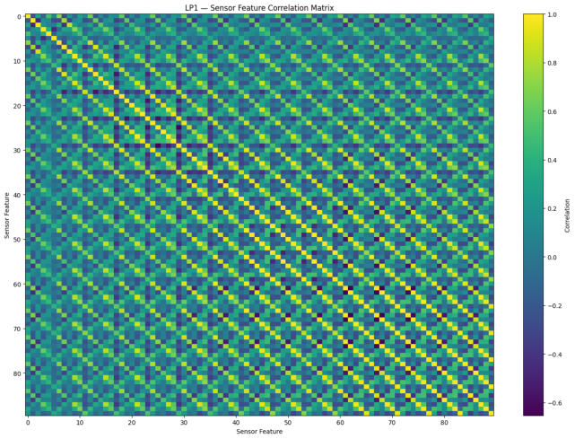

Fig. 2. LP1 correlation plot.
Root-mean-square for channel c:
RMS(c) = sqrt[(1/15) sum(t=1..15) x(c,t)²] (1)
Where x(c,t) is the value of channel c at a given time step. First difference features look at the difference between consecutive time steps.
L2-14: One L2 norm was calculated for each channel. This produces 6 features. The magnitude of force and torque was calculated for each time step. For force this was sqrt(Fx² + Fy² + Fz²). For torque this was sqrt(Tx² + Ty² + Tz²). The mean, standard deviation, maximum, and root-mean-square was calculated for each magnitude. Producing 8 additional features. A total of 14 features.
Fusion-62: The 48 statistical features and 14 magnitude features were concatenated to create a 62 feature vector. An additional experiment was performed to see if combining the two features would provide any useful information.

C. Classification and Model Selection
The models were tested using different features for each subset. Stratified cross-validation was used to ensure the classes were balanced within the folds. 5-fold cross-validation was used if the smallest class had at least 5 samples. 3-fold was used for LP3 as the smallest class only had 3 samples.
The metrics recorded were accuracy, macro precision, macro recall, macro F1 and weighted F1. The main metric used for choosing a model was macro F1 due to the imbalance of the classes. Accuracy and weighted F1 show other ways to look at the predictions.
RandomisedSearchCV was used with 40 iterations. The model was optimised for macro F1. The chosen parameters for Random Forest can be seen in table II. The models were tuned using 5-fold. LP3 was evaluated using 3-fold. To ensure this experiment can be reproduced the number of tuning folds for LP3 should be checked in the training code.
TABLE II
TUNED RANDOM FOREST HYPERPARAMETERS
Parameter | LP1 | LP3 | LP4
n_estimators | 300 | 200 | 800
max_depth | 10 | 20 | 15
min_samples_split | 2 | 6 | 6
min_samples_leaf | 2 | 2 | 2
max_features | sqrt | None | log2
For LP2 and LP5 the chosen models to deploy were XGBoost with default parameters. Optimisation and oversampling with SMOTE was also looked at. For LP2 with SMOTE the model achieved 70.21% accuracy and 0.630 macro F1. Without oversampling this increased to 72.34% and 0.647. For LP5 the best results using SMOTE were 74.39% accuracy and 0.742 macro F1. The chosen model achieved better results with 76.83% and 0.760. This is why it wasn’t used in the final models.

D. Severity
Once the class was predicted, this was mapped to severity. This added a new variable to the results with the options being None, Low, Medium, and High. This was an application rule that wasn’t learnt by the classifier. It helps organise the predictions. This can be changed to suit the application. This is not an verified threshold for safety.
TABLE III
SEVERITY MAPPING BY DATASET AND PREDICTED CLASS
Dataset | Predicted class | Severity
LP1 | normal  obstruction  collision, fr_collision | none  medium  high
LP2 | normal  front/back/left/right_col | none  high
LP3 | ok  slightly_moved  moved  lost | none  low  medium  high
LP4 | normal  obstruction  collision | none  medium  high
LP5 | normal  bottom_obstruction  collision_in_part/tool, bottom_collision | none  medium  high

Service Architecture
The application has FastAPI services behind an API Gateway. The services are running on port 8000. The Prediction Service runs on port 8080, the History Service runs on port 8081, the Analytics Service on port 8082 and Report Service on port 8083. Requests are sent to the gateway.
The Prediction Service chooses which model to use based on the subset requested. The History Service stores previous predictions. The Analytics Service creates summaries from the stored data. The Report Service creates a structured report. Within the gateway there is an endpoint for checking the health of the services.

This shows the status of each service to the dashboard.

IV. EXPERIMENTAL SETUP

A. Software Setup
The models were trained using Python, scikit-learn 1.6.1, and XGBoost 3.4.1. The backend services were running using FastAPI and Uvicorn. The frontend was a React application created using Vite. JSON messages were used to communicate between the interface and backend.

B. Metrics
Accuracy measures the percentage of samples that were correctly classified. Macro F1 looks at the F1 per class and averages them equally. Weighted F1 weighs each class by the number of samples. Both have been included to show how the model performs on different sized classes.
F1(macro) = (1/C) sum(i=1..C) [2P(i)R(i)/(P(i)+R(i))] (2)
Where C is the number of classes. P(i) is the precision for class i. R(i) is the recall for class i. Below shows the results from the experiments.

V. RESULTS AND DISCUSSION

A. Feature Comparison
TABLE IV
RANDOM FOREST ACCURACY/MACRO F1
Dataset | Raw-90 | Eng.-48 | L2-14 | Fusion-62
LP1 | .808/.794 | .966/.965 | .933/.924 | .966/.965
LP2 | .571/.366 | .678/.539 | .636/.443 | .636/.447
LP3 | .681/.451 | .786/.727 | .831/.767 | .808/.738
LP4 | .907/.867 | .957/.949 | .949/.935 | .957/.943
LP5 | .737/.654 | .737/.698 | .719/.700 | .743/.702
From table IV it can be seen that the Engineered-48 features achieved much higher accuracies than the raw data for LP1 and LP4. LP1 had an accuracy of ~96.6%, compared to 80.8% for raw data. LP4 had an accuracy of 95.7% compared to 90.7%. This means that statistical features per channel perform well on these tasks.
The magnitude features performed well on LP3. The L2-14 features had an accuracy of 83.1% and a macro F1 of 0.767. Whereas the Engineered-48 features had an accuracy of 78.6% and a macro F1 of 0.727. The Engineered-48 features provided a lower accuracy and macro F1. On LP2 the Engineered-48 features achieved an accuracy of 67.8% and a macro F1 of 0.539. The accuracy was similar for LP5. However, the Engineered-48 features provided a better macro F1 than the raw data.
The fused features (fusion-62) provided varying results. They performed the same as the statistical features for LP1. For LP5 they provided a slight increase from 73.7% to 74.3%. Overall they didn’t provide an improvement across all tasks. The best features were chosen for each task. Increasing the number of features did not always improve the results.

B. Chosen Models
TABLE V
DEPLOYED MODELS
Ds. | Model / Features | Acc. | Macro F1 | Wtd. F1
LP1 | RF (tuned) / Eng.-48 | 96.59% | 0.966 | 0.966
LP2 | XGBoost (default) / Raw-90 | 72.34% | 0.647 | 0.701
LP3 | RF (tuned) / L2-14 | 82.98% | 0.801 | 0.829
LP4 | RF (tuned) / Eng.-48 | 95.73% | 0.950 | 0.957
LP5 | XGBoost (default) / L2-14 | 76.83% | 0.760 | 0.767
From table V it can be seen that for LP1 a tuned Random Forest was used with the Engineered-48 features. This achieved an accuracy of 96.59% with a macro F1 of 0.966 and a weighted F1 of 0.966. LP4 used the same model family and features. This achieved an accuracy of 95.73% with a macro F1 of 0.950 and a weighted F1 of 0.957.
LP3 used a tuned Random Forest with L2-14 features. This achieved an accuracy of 82.98% with a macro F1 of 0.801 and a weighted F1 of 0.829. LP2 used an untuned XGBoost with raw data. This achieved an accuracy of 72.34% with a macro F1 of 0.647 and a weighted F1 of 0.701. LP5 used an untuned XGBoost with L2-14 features. This achieved an accuracy of 76.83% with a macro F1 of 0.760 and a weighted F1 of 0.767.
All models were chosen due to the results. LP1 and LP4 used statistical features, LP3 and LP5 used magnitude features, and LP2 used raw data.

C. Confusion Matrices
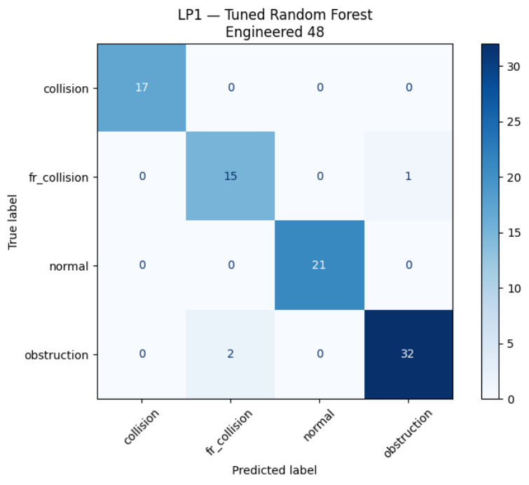
Fig. 3. LP1 confusion matrix for tuned Random Forest with Engineered-48.

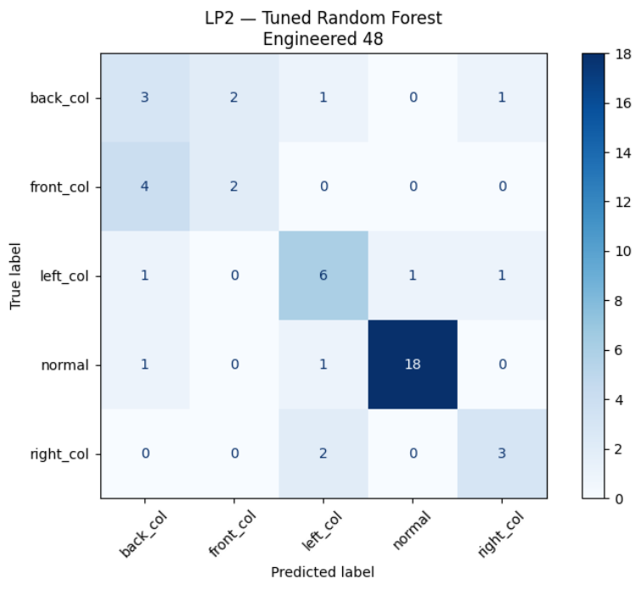
Fig. 4. Confusion Matrix for LP2 using the tuned Random Forest with Engineered-48 features. This was not the model chosen for deployment.
Figure 3 shows that the model correctly classified the examples shown. One sample from the fr_collision class was misclassified as obstruction. Two samples from the obstruction class were misclassified as fr_collision. This shows which classes were misclassified.
Figure 4 shows a different model to what was chosen for deployment. It is from the tuned Random Forest with Engineered-48 features. The deployed model uses XGBoost with raw data. This shows where the model was misclassifying collision directions.

D. Feature Importance
The feature importance from the Random Forest for LP1 was compared to the SHAP values using TreeExplainer. The top 6 features from SHAP can be seen in figure 5. This includes Fz_mean, Fz_min, Fy_diff_max, Fx_rms, Fz_std and Fz_rms. A lot of the most important features are from the Fz channel. Some features are also from the Fy and Fx channels.
The built-in feature importance showed Fz_diff_mean, Fz_range, Fz_rms, Fz_std, Fz_min, and Fz_mean. Both methods show that features from the Fz channel are important. This suggests these features are useful to the model. However this doesn’t show what caused the fault physically.
The previous study on LP1 highlighted the skewness of Fx and Fy [1]. Skewness was not used in the Engineered-48 features. This means the features are different. For a fair comparison the evaluation should use the same data and splits. This analysis shows what features are used by the chosen model.
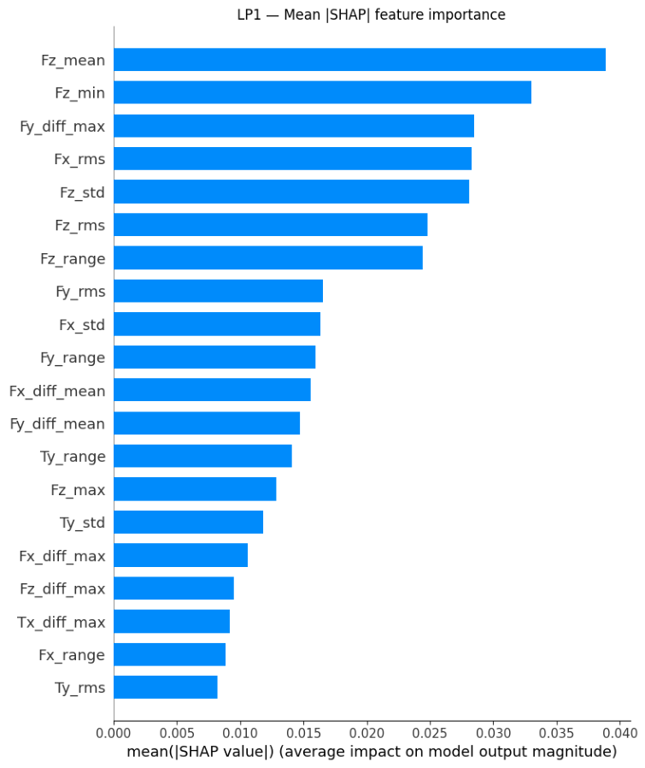
Fig. 5. Mean absolute SHAP feature-importance plot for the LP1 Random Forest model.

VI. SYSTEM IMPLEMENTATION
The application was created (RoboFault AI) to connect the 5 models together. The application was created with data processing, model testing, backend services, and frontend interface. The application allows sensor data to be entered, predictions made, and previous predictions viewed. Reports can be created.
The homepage shows the status of the system. Summary values are shown from the backend. These are based on the predictions made during testing.

Fig. 6. Application landing page with system status and summary statistics.
The Analyse page allows the user to choose which subset they want to analyse. They enter a 15 by 6 window of sensor data into an editable table. The data is validated for the expected shape. The correct model is run. The results show what class was predicted, confidence, severity label, and breakdown of the class probabilities.

This allows the prediction to be reviewed. Confidence does not guarantee the result is correct.
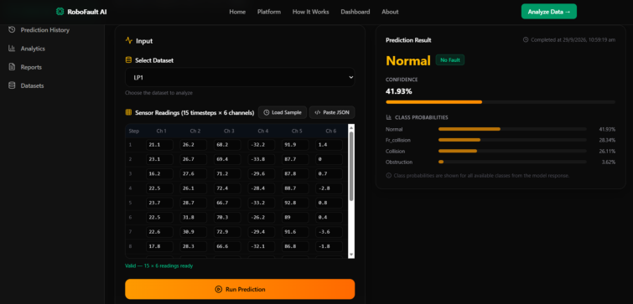
Fig. 7. Analyze page with sensor input and a prediction result.
The dashboard shows summary information from the stored predictions. This includes how many predictions have been made, how many had a fault, average confidence, activity over time, and severity. This information is calculated from the stored data using the Analytics Service. This ensures the dashboard is using the same data.
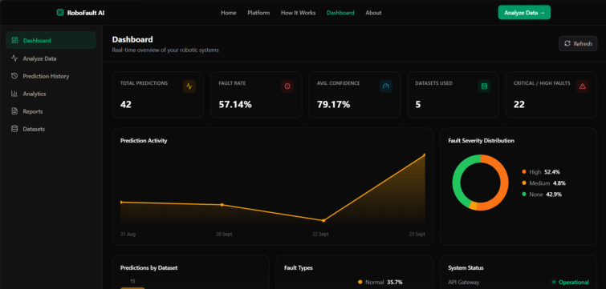
Fig. 8. Dashboard showing prediction summaries, activity, and severity distribution.
The History page provides a list of previous predictions. Filters can be applied for subset and severity. This allows the user to review specific data without requesting predictions. The history and analytics page are connected via the stored data.
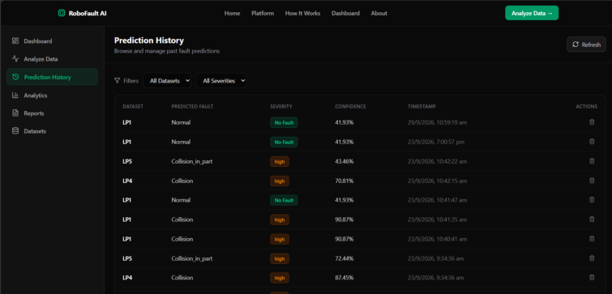
Fig. 9. Prediction-history page with dataset and severity filters.
The Report Service creates a report from the prediction history. This includes summary information on the faults, and high severity cases. The interface and services provide a full workflow from entering a sensor window to saving the results and creating a downloadable report.
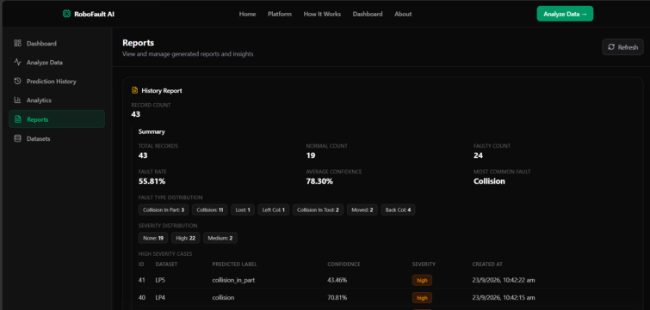
Fig. 10. Generated history report with fault summaries and high-severity cases.

VII. SCOPE AND FUTURE WORK
The data used in this study were LP1-LP5. LP2 and LP3 only had 47 samples. Some classes had very few samples. This means the results don’t guarantee the model will perform as well on new robots or operating conditions. More labelled examples would allow for a wider evaluation.
The input for LP2 and LP3 should be checked against the original data and preprocessing code to ensure they match. This would need to be done before combining the subsets or using them to augment each other. The exact number of tuning folds for LP3 should also be confirmed. The paper does not specify what type of hardware was used for the sensors or what units were used. This shouldn’t be assumed.
The severity is a configurable rule mapping classes to labels. This hasn’t been independently verified for safety. The storage and database configuration should also be documented further. This defines the scope of the prototype.
Further work can be done to stream data in directly from a physical robot. More labelled examples can be tested. Feature engineering methods can be compared using the same data splits. The application currently takes sensor windows to make predictions. Integration with a physical robot in real time is a future extension.

VIII. CONCLUSION
A workflow was created and tested to classify faults in robots. This was connected to a working web application. The experiments showed that the features and classifier should be chosen separately for each task. Tuned Random Forest were used for LP1, LP3, and LP4. Untuned XGBoost were used for LP2 and LP5.
The models achieved accuracies of 96.59%, 72.34%, 82.98%, 95.73%, and 76.83% for LP1-LP5 respectively. LP1 and LP4 used statistical features. LP3 and LP5 used magnitude features. LP2 used raw data. Further experiments were performed to decide that it would be best to use the models without fusion or oversampling.
The models are connected together with FastAPI services and a React interface. This allows sensor windows to be classified, previous predictions viewed, data analysed, and reports created. The prototype is complete and allows the user to enter sensor data, receive a prediction of a fault, and view/export results.

REFERENCES
[1] S. Savaş, “Statistical Feature Engineering for Robot Failure Detection: A Comparative Study of Machine Learning and Deep Learning Classifiers,” Sensors, vol. 26, no. 5, Art. no. 1649, 2026, doi: 10.3390/s26051649.
[2] R. Bogue, “Predictive maintenance for industrial robots,” Industrial Robot, vol. 52, no. 3, pp. 305–311, 2025, doi: 10.1108/IR-03-2025-0081.
[3] C. Eang and S. Lee, “Predictive Maintenance and Fault Detection for Motor Drive Control Systems in Industrial Robots Using CNN-RNN-Based Observers,” Sensors, vol. 25, no. 1, Art. no. 25, 2025, doi: 10.3390/s25010025.
[4] H. Bilal, M. S. Obaidat, M. S. Aslam, J. Zhang, B. Yin, and K. Mahmood, “Online Fault Diagnosis of Industrial Robot Using IoRT and Hybrid Deep Learning Techniques: An Experimental Approach,” IEEE Internet of Things Journal, vol. 11, pp. 31422–31437, 2024, doi: 10.1109/JIOT.2024.3418352.
[5] I. Raouf, P. Kumar, H. Lee, and H. S. Kim, “Transfer Learning-Based Intelligent Fault Detection Approach for the Industrial Robotic System,” Mathematics, vol. 11, no. 4, Art. no. 945, 2023, doi: 10.3390/math11040945.
[6] G. Fu, Q. Wei, and Y. Yang, “Bearing fault diagnosis with parallel CNN and LSTM,” Mathematical Biosciences and Engineering, vol. 21, pp. 2385–2406, 2024, doi: 10.3934/mbe.2024105.
[7] K. Han, W. Wang, and J. Guo, “Research on a Bearing Fault Diagnosis Method Based on a CNN-LSTM-GRU Model,” Machines, vol. 12, no. 12, Art. no. 927, 2024, doi: 10.3390/machines12120927.
[8] J. E. Jeon, S. J. Hong, and S.-S. Han, “Utilization of Machine Learning and Explainable Artificial Intelligence (XAI) for Fault Prediction and Diagnosis in Wafer Transfer Robot,” Electronics, vol. 13, no. 22, Art. no. 4471, 2024, doi: 10.3390/electronics13224471.
[9] A. Maged, S. Haridy, and H. Shen, “Explainable Artificial Intelligence Techniques for Accurate Fault Detection and Diagnosis: A Review,” arXiv preprint arXiv:2404.11597, 2024, doi: 10.48550/arXiv.2404.11597.
[10] N. R. Amaliah, B. Tjahjono, and V. Palade, “Human-in-the-Loop XAI for Predictive Maintenance: A Systematic Review of Interactive Systems and Their Effectiveness in Maintenance Decision-Making,” Electronics, vol. 14, no. 17, Art. no. 3384, 2025, doi: 10.3390/electronics14173384.
[11] N. Anđelić, S. B. Šegota, and V. Mrzljak, “Hybrid Explainable AI for Machine Predictive Maintenance: From Symbolic Expressions to Meta-Ensembles,” Processes, vol. 13, no. 7, Art. no. 2180, 2025, doi: 10.3390/pr13072180.
[12] Z. Zhong, H. Xie, Z. Wang, and Z. Zhang, “Domain Adversarial Transfer Learning Bearing Fault Diagnosis Model Incorporating Structural Adjustment Modules,” Sensors, vol. 25, no. 6, Art. no. 1851, 2025, doi: 10.3390/s25061851.
[13] J. Zhao, M. Yuan, Y. Cui, and J. Cui, “A Cross-Machine Intelligent Fault Diagnosis Method with Small and Imbalanced Data Based on the ResFCN Deep Transfer Learning Model,” Sensors, vol. 25, no. 4, Art. no. 1189, 2025, doi: 10.3390/s25041189.
[14] H. Kim, “Fault Diagnosis in Robot Drive Systems Using Data-Driven Dynamics Learning,” Actuators, vol. 14, no. 12, Art. no. 583, 2025, doi: 10.3390/act14120583.
[15] J. Azeta et al., “Artificial intelligence and robotics in predictive maintenance: a comprehensive review,” Frontiers in Mechanical Engineering, vol. 11, Art. no. 1722114, published Jan. 2026, doi: 10.3389/fmech.2025.1722114.

