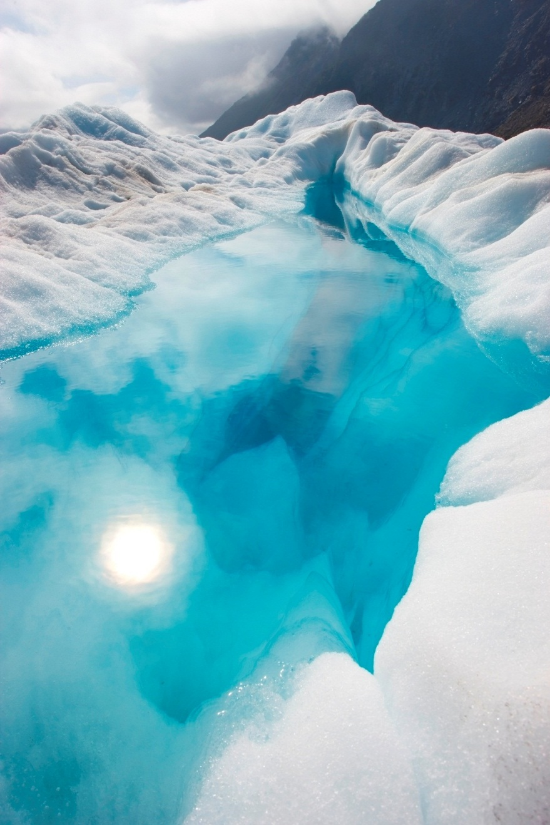

**Priyanka saraf**

**Task-7**

Level 0:

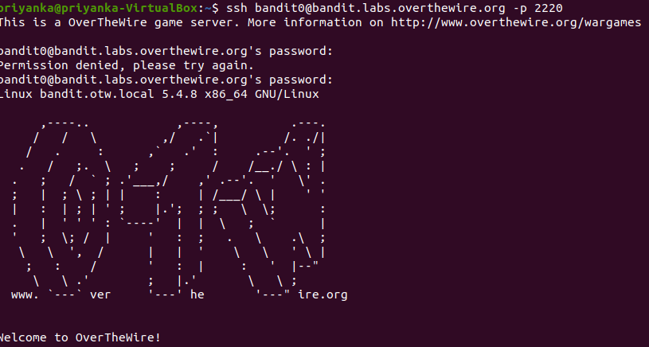password: boj9jbbUNNfktd7800psq0ltutMc3MY1

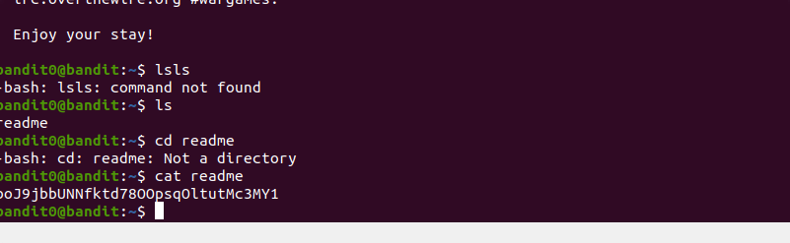

LEVEL 1:

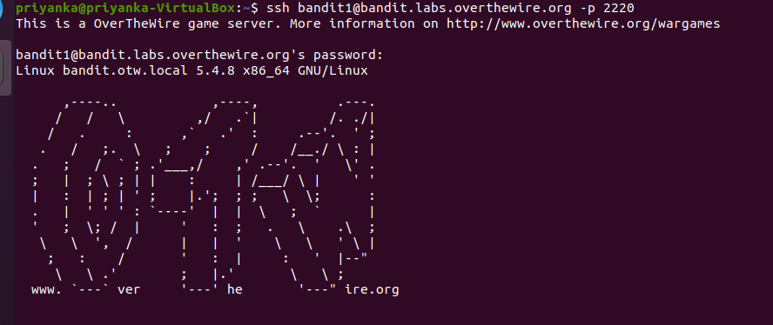

Password: CV1DtqXWVFXTvM2F0K09SHz0YwRINYA9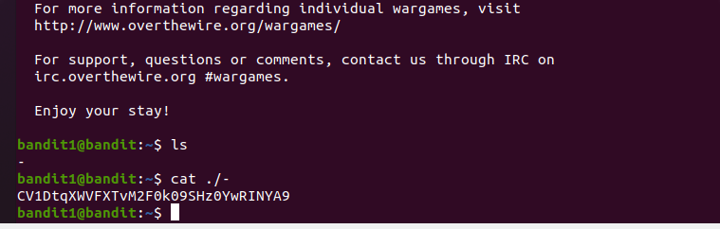

LEVEL 2: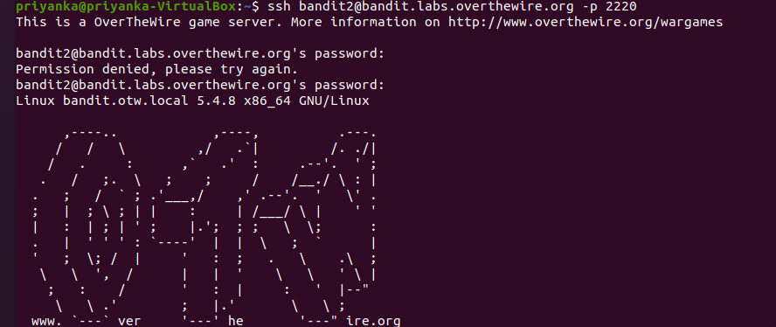

Password: UmHadQclWmgdLOKQ3YNGjWxGoRmb5luk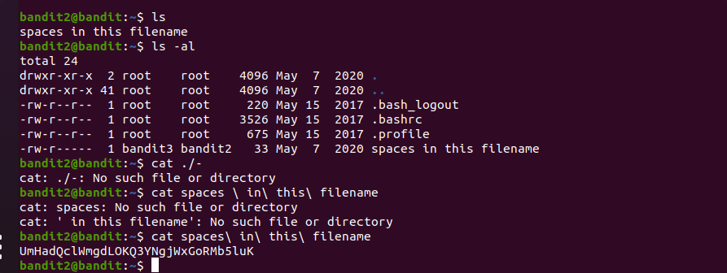

Level3:

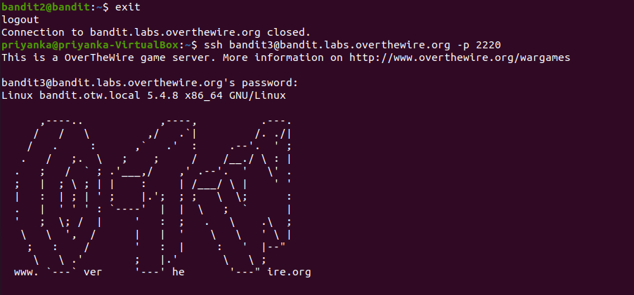

Password: pIwrPrtPN36QITsp3Eqaw936yaFoFgAB

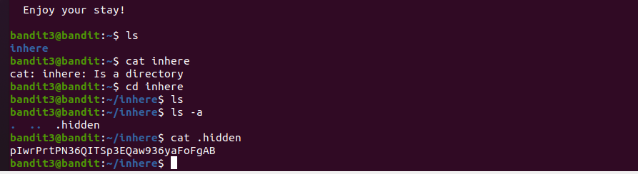

Level 4:

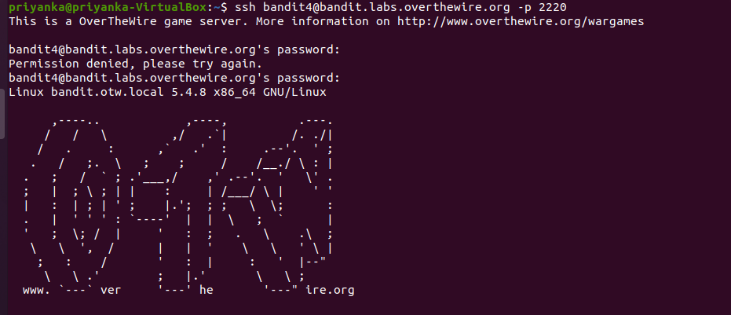

Password: koReBoKulDDepwhWk7jZC0RTdopnAYKh

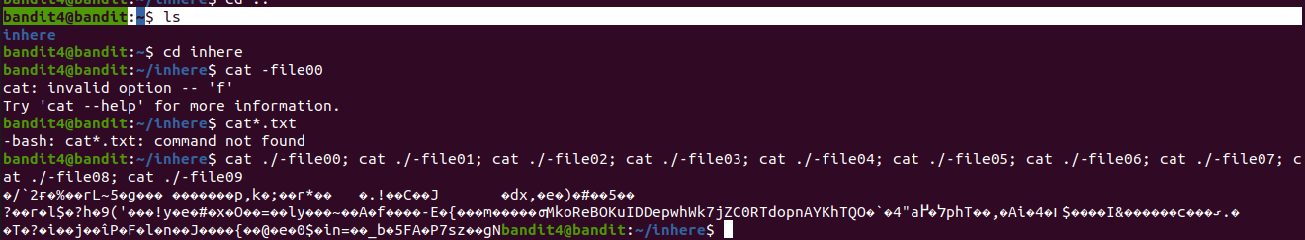

Level 5:

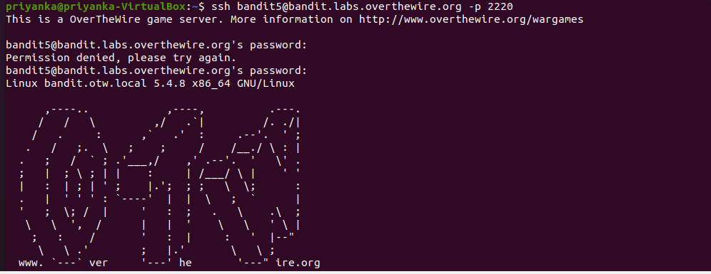

 DXjZPULLxYr17uwoI01bNLQbtFemEgo7

Password:

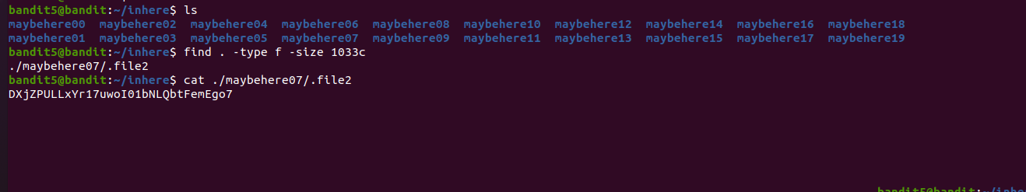

Level 6:

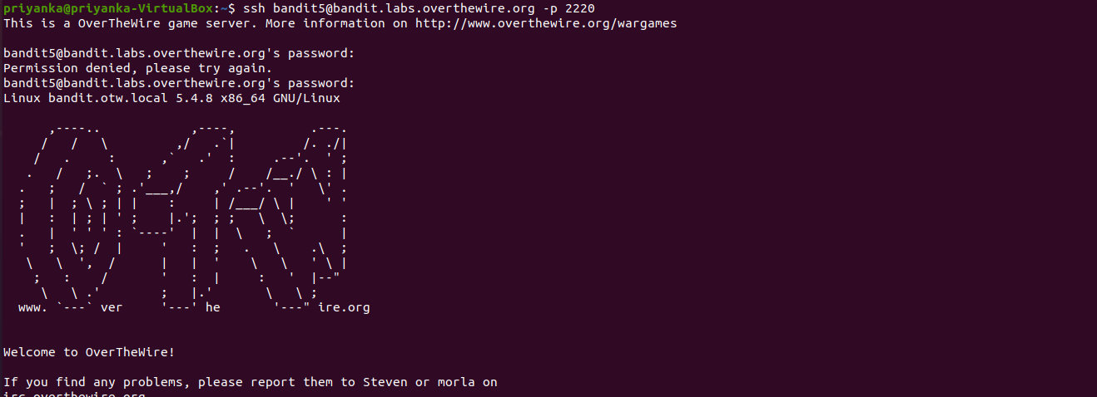

Password: HKBPTKQnIay4Fw76bEy8PVxKEDQRKTzs

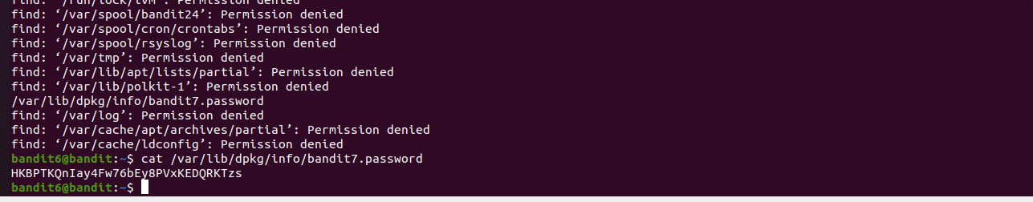

Level 7:

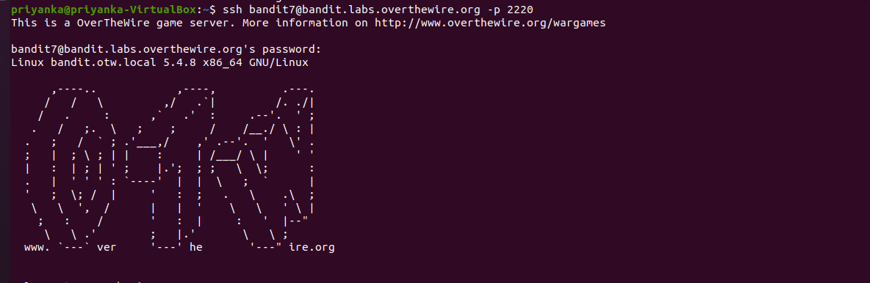

Password: cvX2JJa4CFALtqS87jk27qwqGhBM9plV

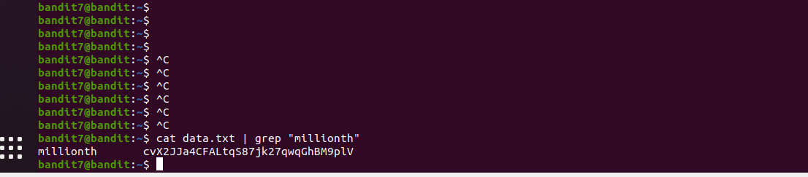

Level 8:

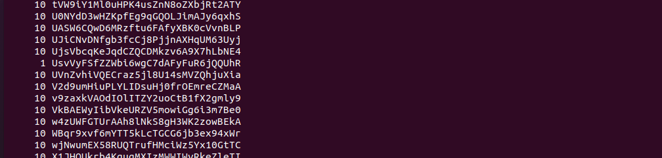

Password: UsvVyFSfZZWbi6wgC7dAFyFuR6jQQUhR



Level 9:

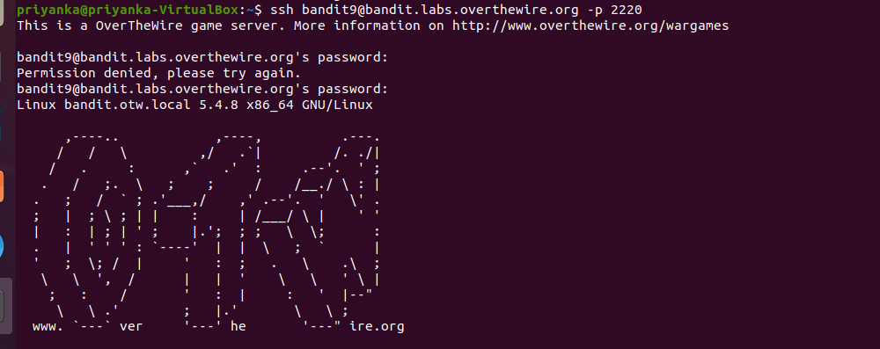

Password: truKLdjsbJ5g7yyJ2X2R0o3a5HQJFuLk

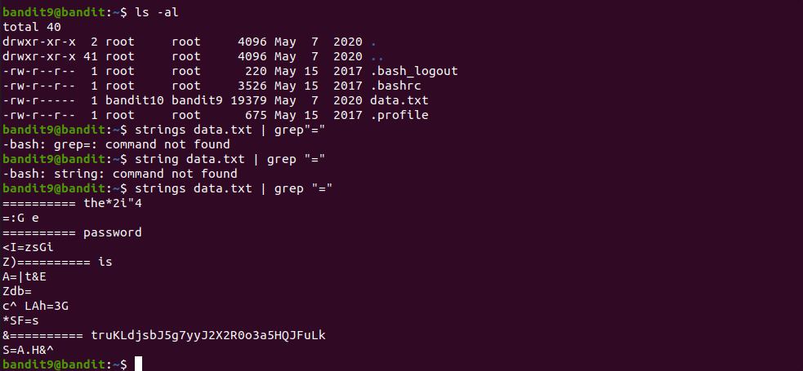

Level 10:

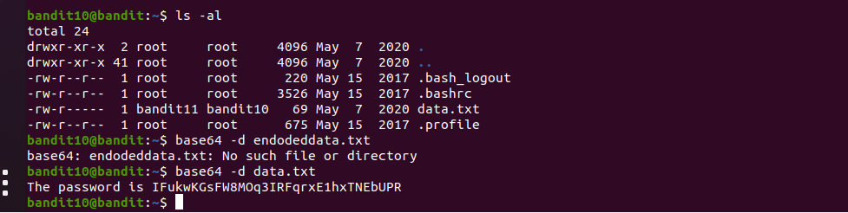

Password:  IFukwKGsFW8MOq3IRFqrxE1hxTNEbUPR



Level 11:

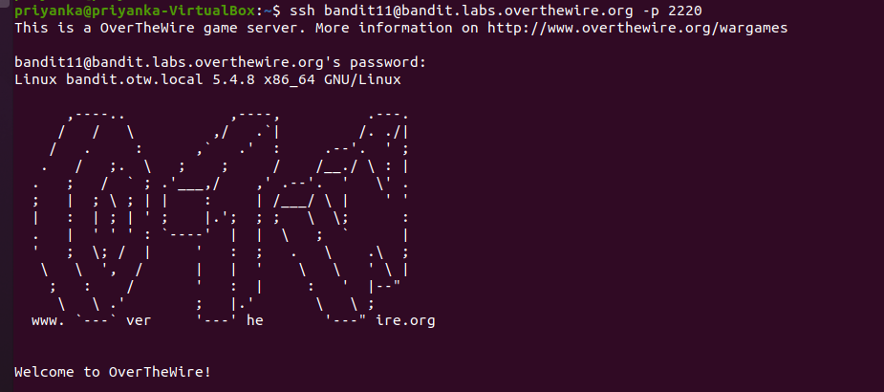

Password: 5Te8Y4drgCRfCx8ugdwuEX8KFC6k2EUu

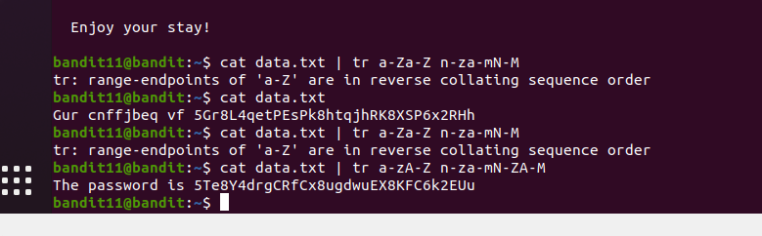

Level 12:

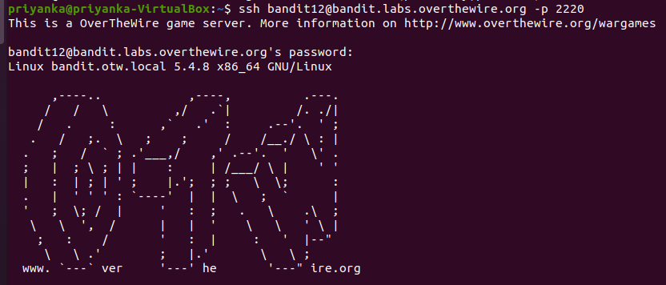

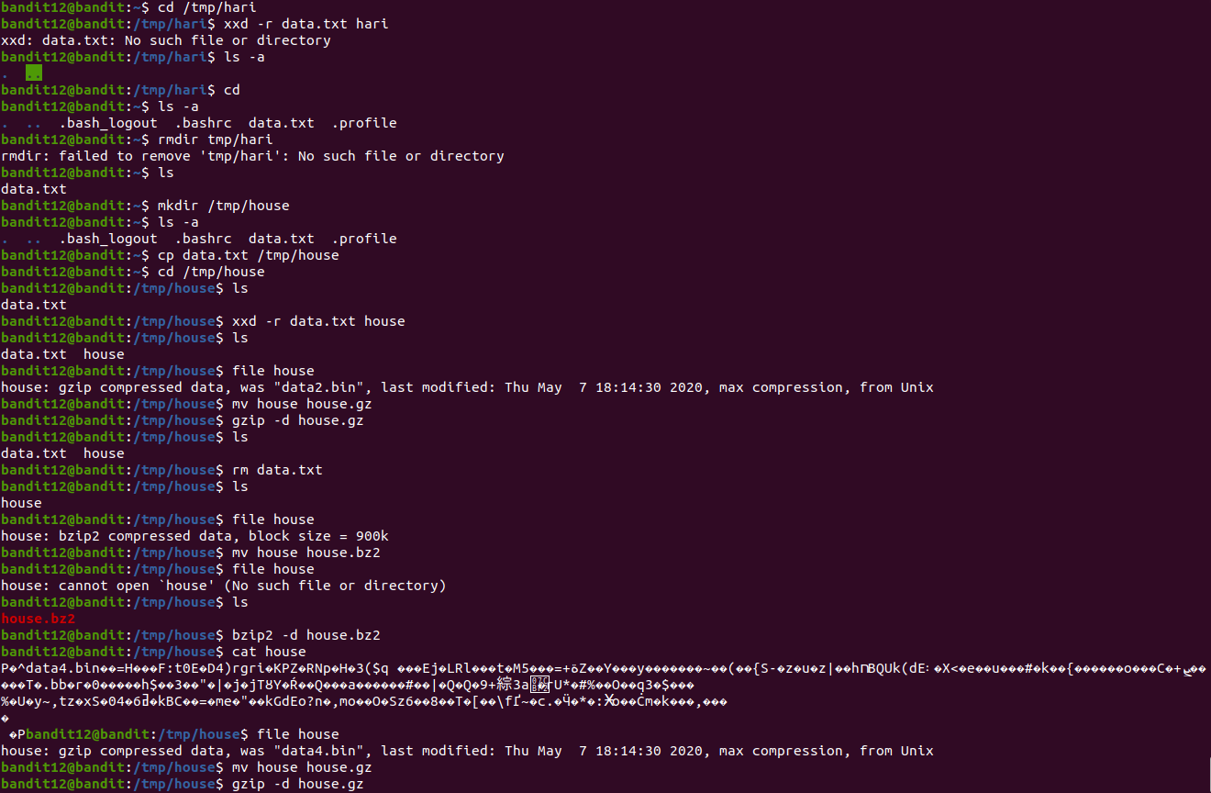

Password: 8ZjyCRiBWFYKneahHwxCv3wb2a1ORpYL

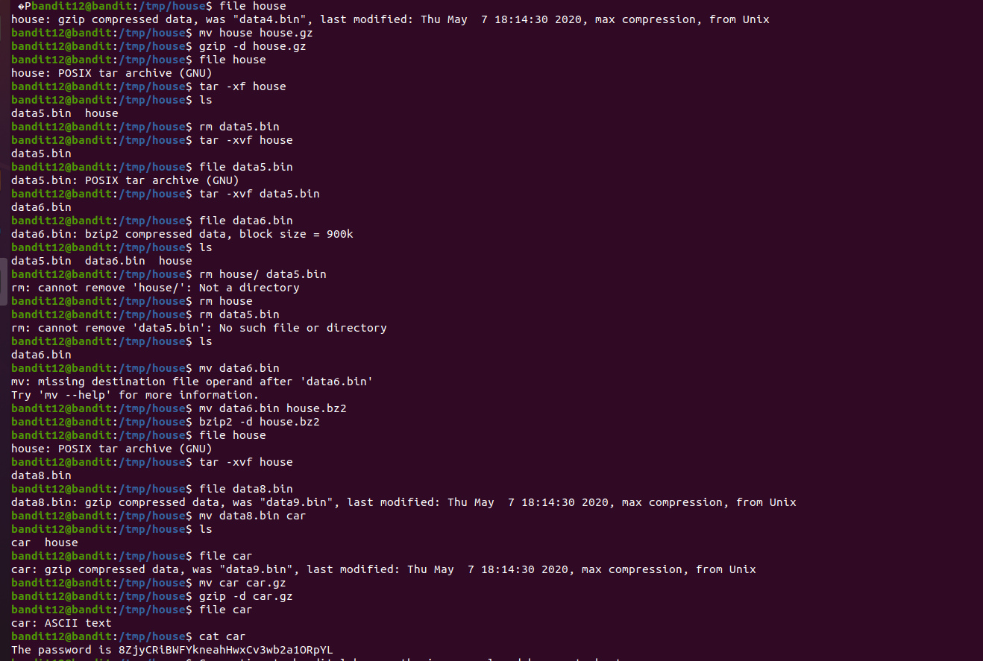

Level13:



Password: 4wcYUJFw0K0XLShlDzztnTBHiqxU3b3e

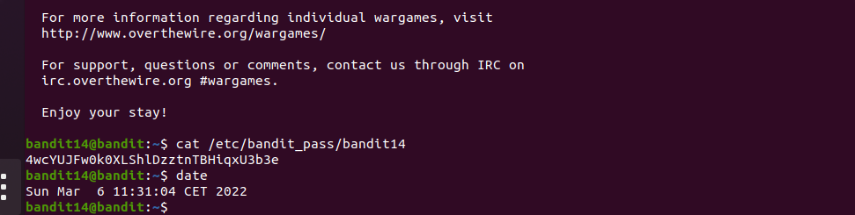

Level 14:

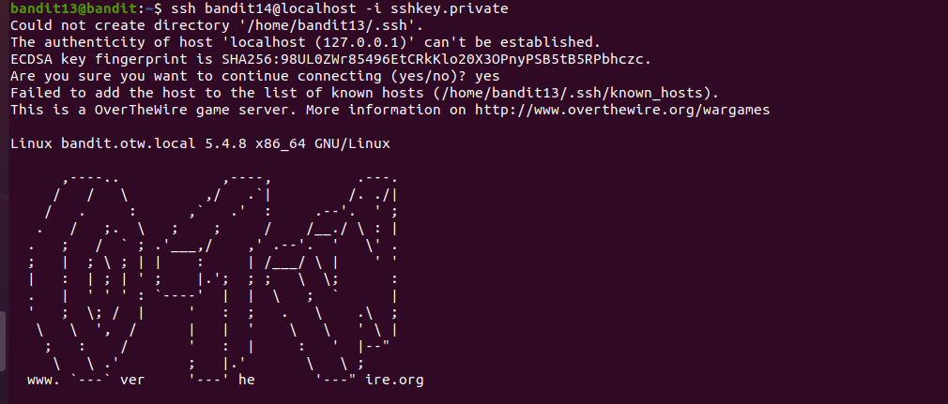

Password: BfMYroe26WYalil77FoDi9qh59eK5xNr

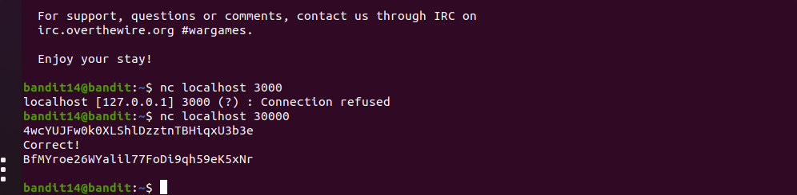

Level15:

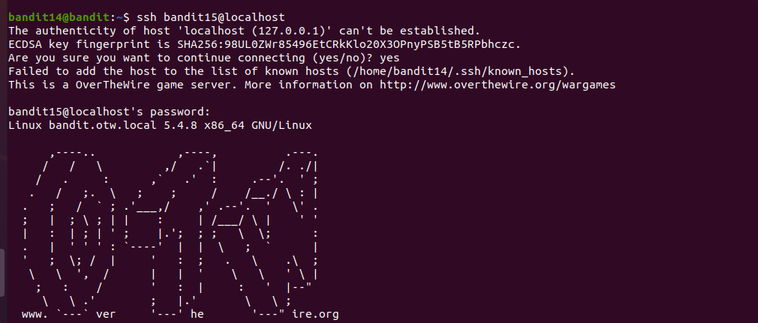

Password: cluFn7wTiGryunymYou4RcffSXQluehd

