A **single-channel relay** is an electronic switch that can be controlled by a low-power electrical signal, such as the output from an [Arduino microcontroller](https://circuitdigest.com/tags/arduino). By using an **Arduino Uno** and a single-channel [relay](https://circuitdigest.com/tags/relay) module, you can control high-voltage or high-power devices, such as lights, motors, and appliances, from your computer or mobile device. In this blog, we will explore [how a relay works](https://circuitdigest.com/article/relay-working-types-operation-applications), how to interface a **single-channel relay with an Arduino Uno**, and demonstrate a simple example of how to use the **5v relay module** to control a lamp.

**Single Channel Relay Module Pinout**

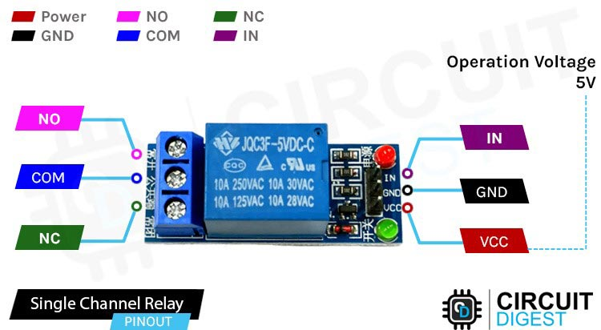

VCC - this pin provides power to the module

GND - this is the common ground

IN - This pin is also called the control pin because it is used to control the output of the relay.

COM - is connected to the device you intend to connect.

NC - terminal is connected to the COM terminal by default unless you activate the relay which breaks the connection

NO is normally open unless you activate the relay which then connects it to the COM terminal

**NOTE**: - In a few generic versions of the relays, the pin sequence could be different. Remember to check the annotations on the **PCB** or the **datasheet**before making the connections

**Single Channel Relay Module Parts**

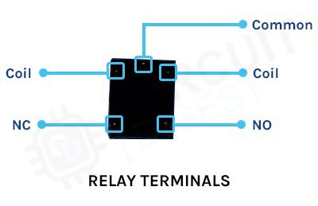

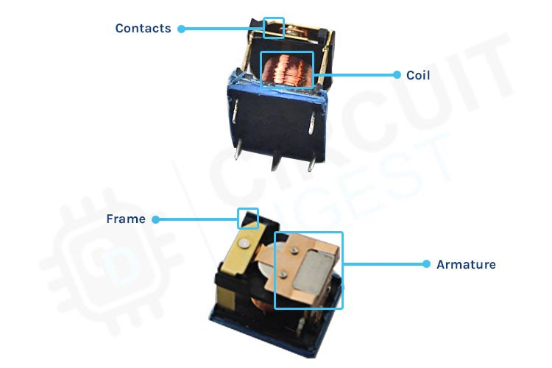

The construction of a single-channel relay typically consists of the following components:

1. Coil: The coil generates a magnetic field when an electrical current is passed through it, which is used to open or close the switch contacts.

2. Contacts: The contacts are the switching elements of the relay and can be **normally open (NO) or normally closed (NC)**. When the coil is energized, the magnetic field attracts a movable armature, which opens or closes the contacts.

3. Armature: The armature is a movable component that is attracted by the magnetic field generated by the coil. It opens or closes the contacts, depending on the state of the coil.

4. Frame: The frame provides mechanical support for the relay components and protects the relay from external damage.

5. Terminals: The terminals provide a means of connecting the relay to external circuits. The coil is connected to a control circuit, while the contacts are connected to the load.

In addition to these basic components, some relays may also include additional features, such as LED indicators, protection diodes, snubber circuits, or other components to enhance their performance and reliability.

**Common questions about Single Channel Relay Module**

**What is the difference between 1 channel and a 2-channel relay?**

A 1-channel relay has a single switch or channel, which means it can only control one load or circuit at a time. This type of relay is typically used in simple applications where only one load needs to be switched, such as turning a single light on or off.

A 2-channel relay, on the other hand, has two switches or channels, which means it can control two separate loads or circuits independently. This type of relay is often used in more complex applications where multiple loads need to be switched, such as controlling two separate lights or motors.

**Why are relays used?**

Relays are used to switch high power loads using a low power control signal, providing electrical isolation between the control circuit and the load. They are often used to control lights, motors, and other **high-power devices**, and can be controlled by a variety of signals, such as switches, sensors, or microcontrollers. Relays are also used to switch different loads independently, and to protect sensitive electronic components from high voltages and currents.