**Pulse Oximeter MAX30100**

## **What is Pulse Oximeter?**

#### Pulse Oximeters are low cost non-Invasive medical sensors used to continuously measure the Oxygen saturation (SPO2) of haemoglobin in blood. It displays the percentage of blood that is loaded with oxygen.

## **Principle of Pulse oximeter**

#### The principle of pulse oximetry is based on the differential absorption characteristics of oxygenated and the de-oxygenated hemoglobin. Oxygenated hemoglobin absorbs more infrared light and allows more red light to pass through. Whereas Deoxygenated hemoglobin absorbs more red light and allowing more infrared light to pass through.

## **What’s inside the Sensor?**

#### Each [pulse oximeter sensor](https://www.dnatechindia.com/max-30100-pulse-oximeter-heart-beat-sensor.html) probe contains two light emitting diode one emitting red light  and the other emitting near infrared light, it also has a photo-detector. The photo-detector measures the intensity of transmitted light at each wavelength. And using the differences in the reading the blood oxygen content is calculated. The probe is placed on a suitable part of the body, usually a fingertip or ear lobe.

Pulse Oximeter MAX30100 / MAX30102 is a cheap one and quite popular among hobbyists. Unfortunately, the cheapest module boards (which are sold by thousands on Aliexpress) contain a fatal error. I’ll tell you how to fix it.  
Everything I said below applies equally to the new MAX30102 modules and old modules with discontinued MAX30100 chip since they are assembled on the same boards.

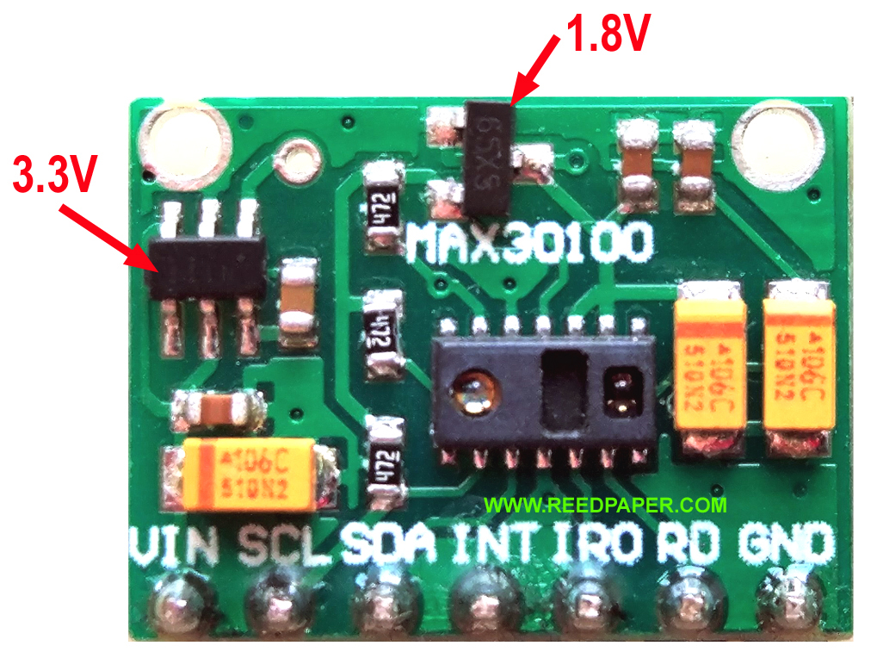Fig. 1. Module board MAX30100 / MAX30102 from Aliexpress

If you ordered the board shown in Fig. 1 – my congratulations, you have problems with power circuits. The sensor chip requires two separated supply voltages:

* **1,8V** for ADC and sensor logic (1,7V – 2,0V)
* **3,3V** for green and IR LEDs of sensor (3,1V – 5,25V)

Carefully look at the circuit of the module (Fig. 2). It involves two linear voltage regulators – U2 and U3. The first one make a + 3.3V from + 5V (or simply passes through the power supply + 3.3V). The second regulator is connected to the output of the first and generates supply voltage + 1.8V. It would seem that everything is correct? Really?

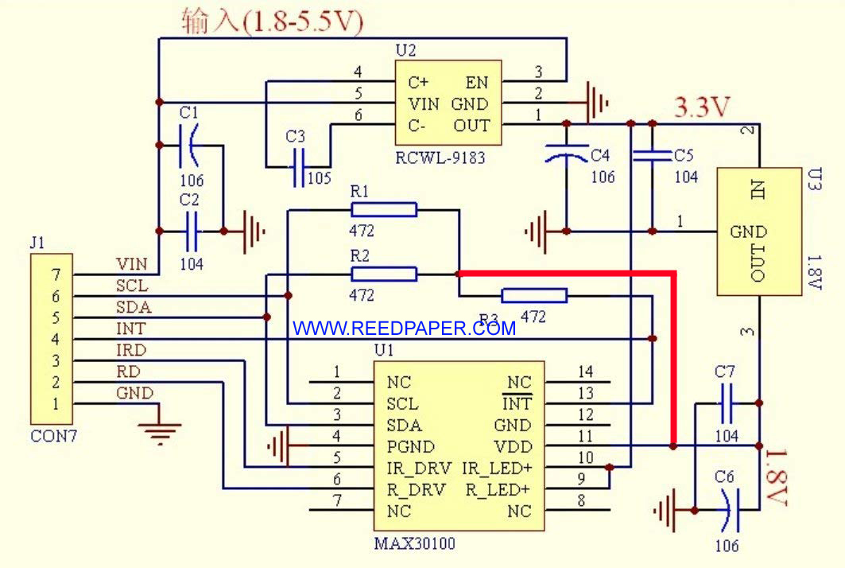Fig. 2. Schematic diagram of MAX30100 / MAX30102

Now take a closer look at the pull-up resistors 4.7k for SCL, SDA and INT signal lines (a thick red line). They are connected to the supply + 1.8V!!! If such a module is connected to a 5V logic of Arduino board – it will not be visible on the I2C bus because the logic levels are too low. However, even with a 3V logic board the I2C bus will work unstably.

This error can easily be fixed as shown in Fig. 3. It is enough to cut the path in the place of the red cross and make a jumper as shown by the yellow line. The jumper does not need an insulated wire. You can take a tinned strand from a stranded wire. The board is covered with a protective mask and there is no short circuit to the copper pour.

### **How does Pulse Oximeter Works?**

**Oxygen** enters the lungs and then is passed on into blood. The blood carries oxygen to the various organs in our body. The main way oxygen is carried in our blood is by means of **hemoglobin**. During a pulse oximetry reading, a small clamp-like device is placed on a finger, earlobe, or toe.

[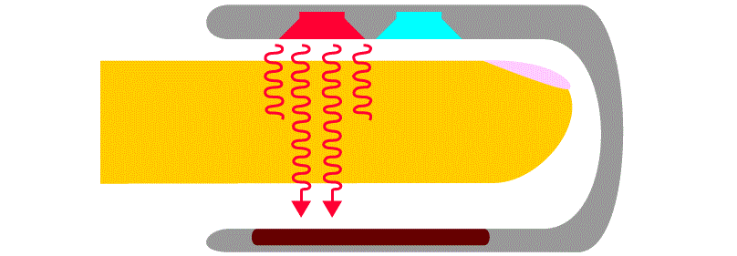](https://how2electronics.com/wp-content/uploads/2019/06/1.gif)

Small beams of light pass through the blood in the finger, measuring the amount of oxygen. It does this by measuring changes in **light absorption** in **oxygenated** or **deoxygenated blood**.

[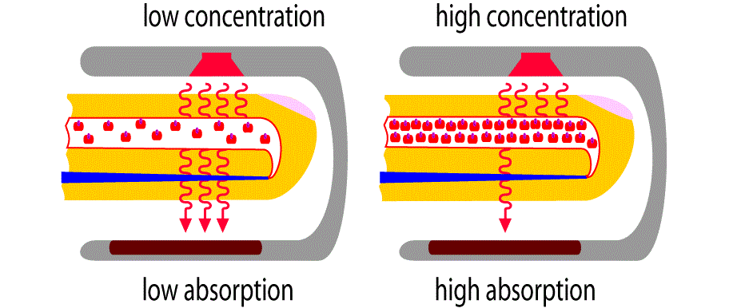](https://how2electronics.com/wp-content/uploads/2019/06/2.gif)

### **MAX30100 Pulse Oximeter**

[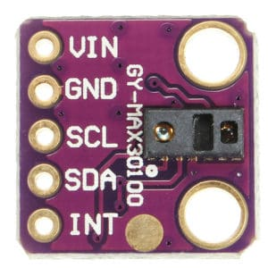](https://how2electronics.com/wp-content/uploads/2019/06/MAX30100.jpg)

The sensor is **integrated pulse oximetry** and heart-rate monitor sensor solution. It combines two LED’s, a photodetector, optimized optics, and low-noise analog signal processing to detect pulse and heart-rate signals. It operates from **1.8V** and **3.3V** power supplies and can be powered down through software with negligible **standby current**, permitting the power supply to remain connected at all times.

#### **Features**

1. Consumes very low power (operates from 1.8V and 3.3V)  
   2. Ultra-Low Shutdown Current (0.7µA, typ)  
   3. Fast Data Output Capability  
   4. Interface Type: I2C

#### **Working of MAX30100 Pulse Oximeter and Heart-Rate Sensor**

The device has **two LEDs**, one **emitting red light**, another emitting **infrared light**. For pulse rate, only infrared light is needed. Both red light and infrared light are used to measure **oxygen levels** in the blood. When the heart pumps blood, there is an increase in **oxygenated blood** as a result of having more blood. As the heart relaxes, the volume of oxygenated blood also decreases. By knowing the time between the increase and decrease of oxygenated blood, the **pulse rate** is determined. It turns out, oxygenated blood absorbs more **infrared light** and passes more red light while deoxygenated blood absorbs red light and passes more infrared light. This is the main function of the MAX30100: it reads the absorption levels for both light sources and stores them in a buffer that can be read via **I2C** communication protocol.