Problem Statement 1

Write a Java program to display the content of a file in HDFS on screen.

PROGRAM:

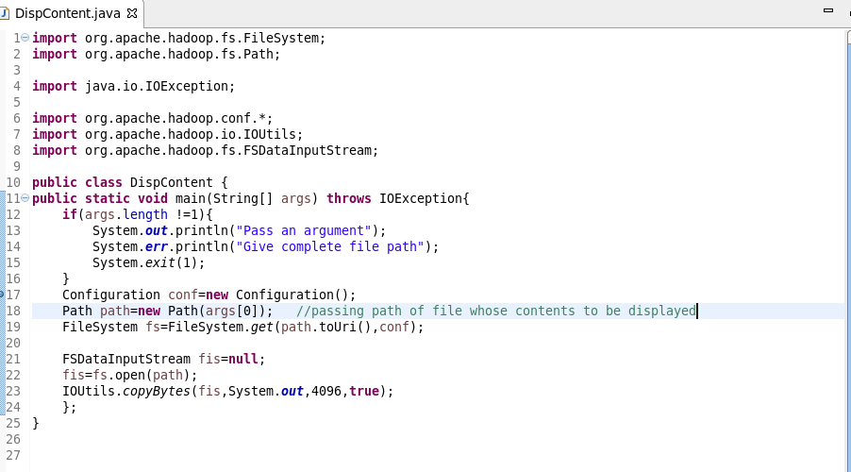

OUTPUT:

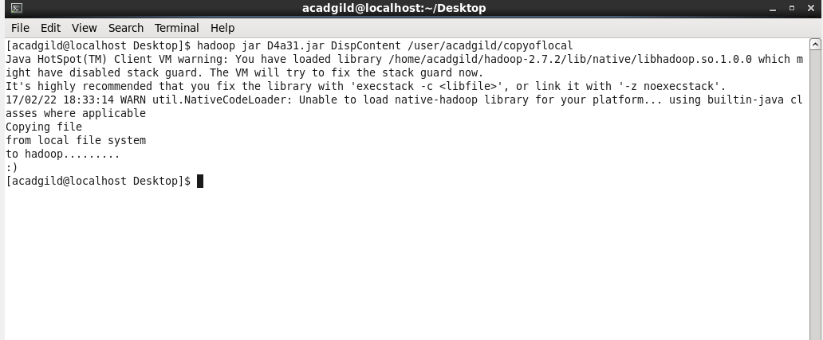

Problem Statement 2

Write a Java program to copy a file from local file system to HDFS.PROGRAM: 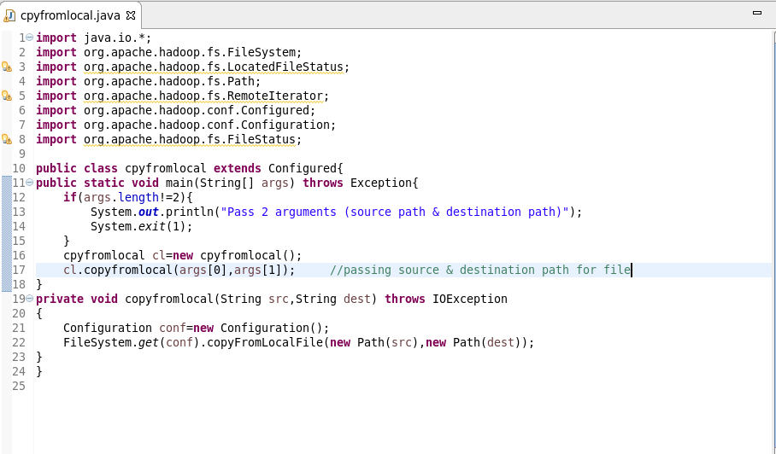

OUTPUT: 