Blue Origin Project: Technical Documentation & Interview Prep
Nov 1, 2026 · @User

1. Project overview
Blue Origin is a Sales & Retailer Growth Management Platform: a web dashboard that turns quarterly distributor sales files into retailer tiers, tier movements and business reports.
The problem it solves. The BO team's sales data lives in distributor sheets and cleaned CSV files in Dropbox. Answering "which retailers moved up or down a tier this quarter?" otherwise means working through spreadsheets by hand. The platform does that calculation automatically, applies one set of tier rules, and shows the result behind a login.
Who uses it. Three roles, enforced by the backend:
Role | Can do
Admin | Everything, plus managing user accounts
Editor | View and change data
Viewer | Read only; any non-GET request returns 403
What it does.
- Shows a retailer network dashboard, plus sales, retailers, distributors and tiers pages.
- Places each retailer in a tier by quarterly net sales: Yellow, Green, Silver, Gold or Platinum.
- Tracks how each retailer moved between quarters, such as Upgraded, Downgraded or Dropped from the tier.
- Syncs automatically when new files appear in Dropbox.
- Produces Excel reports, including the BO_Data workbook and the distributor counter report.
The 30-second pitch. "I worked on a sales analytics platform for a retailer network. A React and TypeScript frontend calls a FastAPI backend, which uses Dropbox as its data store. When cleaned quarterly files land in Dropbox, a background job detects them, runs a pandas pipeline, and rebuilds the dashboard data. Users sign in with role-based access and see tiers, movements and downloadable reports."
Open question: the code never expands "BO" or explains the name "Blue Origin". Confirm the meaning before presenting, because interviewers may assume the aerospace company.

2. Tech stack
The app is a React and TypeScript single-page app on Vercel, calling a Python FastAPI service on Render, with Dropbox used as the database. The "why" column is the reasoning you can give; it is inferred from how the code uses each tool, so adjust it if the real history differs.
Frontend
Technology | Used for | Why it fits
React 18 | Component-based UI | Many pages share tables, filters and charts
TypeScript 5 | Types for API responses and the data model | Catches field-name mistakes at build time; npm run build runs tsc first
Vite 5 | Dev server, proxy and production build | Fast reloads; /api is proxied to the backend in development
React Router 6 | Client-side routes, including /dashboard/:tab | Page changes without a full reload
Recharts 2 | Line and bar charts | Declarative React chart components
TanStack Virtual 3 | Virtualised long tables | Renders only visible rows, so thousands of retailers stay smooth
ExcelJS 4 | Excel export in the browser | Loaded on demand with a dynamic import(), which keeps the first load smaller
Plain CSS | styles.css, network.css | No UI framework dependency
Backend
Technology | Used for | Why it fits
Python 3.10+ | Backend language | Same language as the existing notebook pipeline
FastAPI | REST API, dependency injection, Swagger at /docs | Typed requests and automatic API docs
Uvicorn | ASGI server | Standard way to run FastAPI
Pydantic 2 and pydantic-settings | Response schemas and .env configuration | Validates data and settings in one style
pandas and NumPy | Cleaning, joining and summing sales data | Tabular work on CSV and Excel files
openpyxl, xlrd | Reading .xlsx and legacy .xls | BO data arrives as Excel
XlsxWriter | Writing formatted Excel reports | Reproduces the business's report layouts
python-multipart | File uploads | Required by FastAPI for form uploads
hashlib, hmac, secrets (standard library) | Password hashing and login tokens | No extra security dependency
Data, hosting and testing
Technology | Used for | Note
Dropbox (Python SDK) | Primary data store and source of input files | The business already keeps its files there
Jupyter (BO_data.ipynb) | Upstream cleaning, run by hand | Lives in Dropbox, not in this repository
Vercel | Hosts the frontend | vercel.json rewrites every route to index.html
Render | Hosts the backend | URL configured in frontend/.env.production
pytest and httpx | Backend tests | TestClient for API tests, with a fake Dropbox client for storage tests
Git and GitHub | Version control | 4 commits on master so far
There is no SQL database, Redis, Docker image or CI pipeline in this repository. Be ready to explain the Dropbox decision; section 12 has an answer.

3. System architecture
The system has three tiers (React frontend, FastAPI backend, Dropbox storage) plus an upstream notebook that supplies the data.
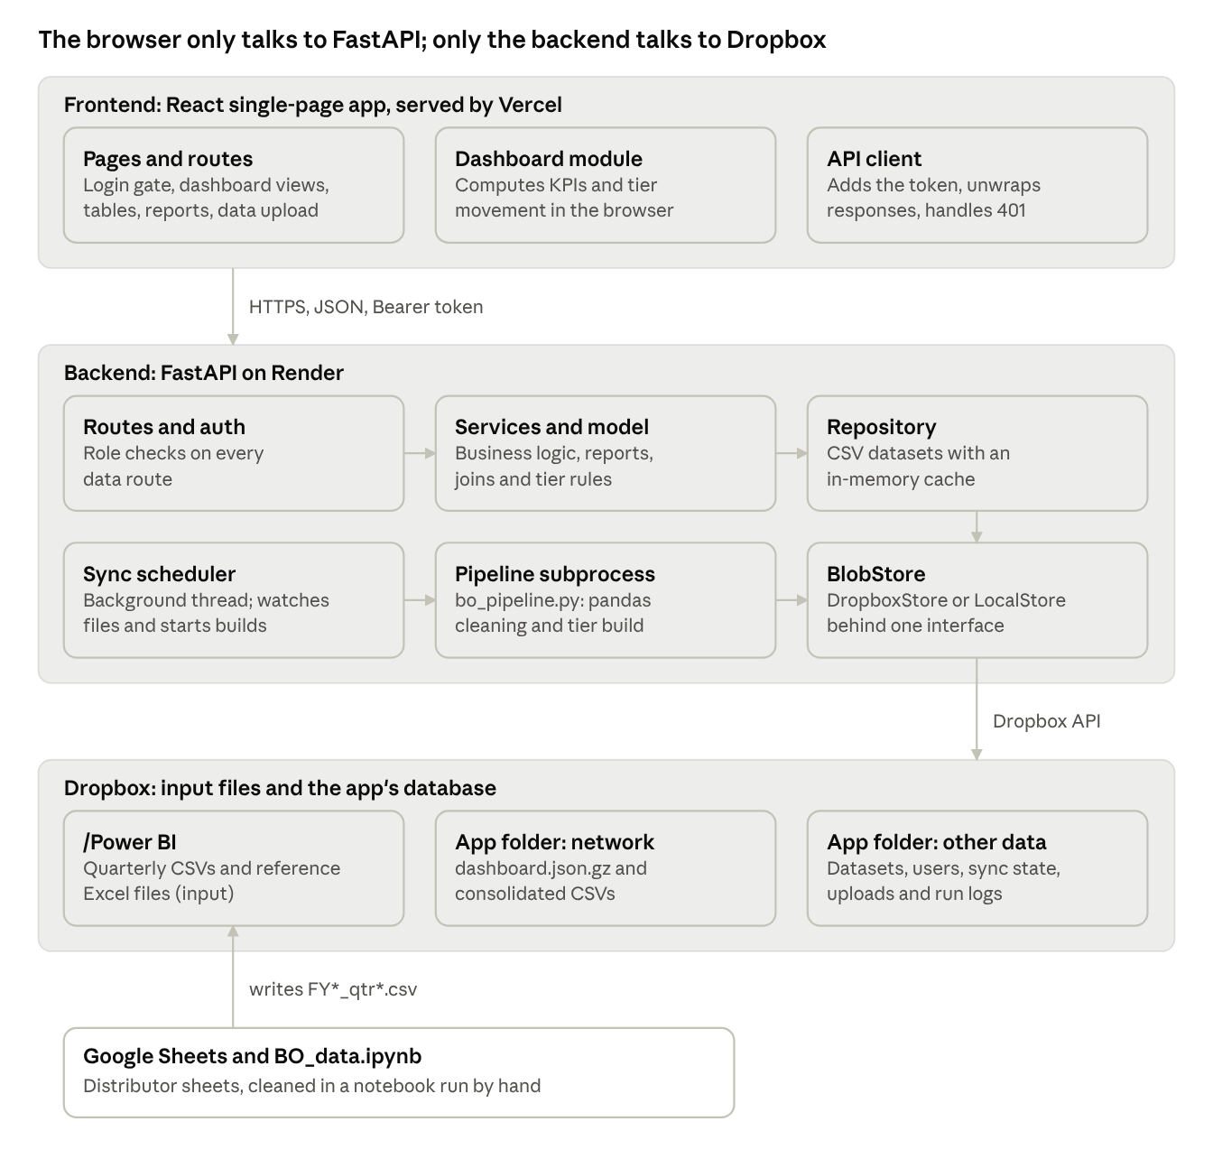
system architecture · 3 tiers and the upstream notebook
Read it from the top for a user request, and from the bottom for new data arriving. The two paths meet in Dropbox.
Key design decisions
Decision | Reason | Trade-off
Dropbox as the data store | The source files already live there | No queries or transactions; one backend instance
Storage behind an interface | Tests and offline work use a local folder | One extra layer of code
Dashboard computed in the browser | Filter changes are instant | Large first download; all data reaches every signed-in user
Precomputed, gzipped payload | Requests are served without re-running pandas | Data is only as fresh as the last build
Pipeline in a subprocess | Heavy work stays outside the API process | Progress and errors must be read from process output
Tier rules in JSON | A rule change needs no logic change | The frontend and pipeline must read the same values

4. Repository structure
The repository has two independently deployed apps, backend/ and frontend/, with the backend split into clear layers.
BLUE ORIGIN/
├── backend/
│ ├── app/
│ │ ├── main.py App factory, CORS, gzip, startup of the sync scheduler
│ │ ├── api/ HTTP routes only: one file per feature, plus router.py and deps.py
│ │ ├── core/ Settings (config.py), constants, error classes and handlers
│ │ ├── services/ Business logic: one service per page, plus sync, auth and reports
│ │ ├── pipeline/ bo_pipeline.py and consolidated_prep.py, run as subprocesses
│ │ ├── processing/ Read, normalise, clean, validate and transform uploaded files
│ │ ├── repositories/ StoreRepository: datasets as CSV, with an in-memory cache
│ │ ├── storage/ BlobStore interface; DropboxStore and LocalStore
│ │ ├── rules/ Tier, benefit and geography rules, with config/*.json
│ │ └── schemas/ Pydantic response and request models
│ ├── tests/ pytest suite (160 tests)
│ ├── scripts/dropbox_auth.py One-time Dropbox token setup
│ └── requirements.txt
├── frontend/
│ ├── src/
│ │ ├── App.tsx Route table and the login gate
│ │ ├── pages/ One component per route
│ │ ├── components/ Shared UI: Layout, DataTable, FilterBar, charts
│ │ ├── network/ Dashboard module: model, reports, context, export
│ │ ├── services/ ApiClient interface, fetch implementation, session
│ │ ├── hooks/ useAsync, useListQuery, useTheme
│ │ ├── types/, utils/, config/
│ │ └── styles.css
│ ├── vercel.json Sends every route to index.html
│ ├── vite.config.ts `@` alias and the /api dev proxy
│ └── .env.development, .env.remote, .env.production
├── Blue_Origin_API_Reference.md
├── BO_Consolidate_Final.xlsx Original workbook the BO_Data report reproduces
└── Distributor_Counter_Report.xlsx Layout reference for the counter report
The dependency rule to mention in an interview: routes call services, services call the repository, the repository calls a BlobStore. Routes hold no business logic, and only the storage layer knows about Dropbox.

5. Data layer
Dropbox is both the input source and the database: there are 8 quarterly input files today (Q3 FY 25 to Q2 FY 27), and each build produces a single compressed payload for the dashboard.
Input files in /Power BI
File | Role
FY25_qtr3.csv to FY27_qtr2.csv | Main data: cleaned quarterly sales written by BO_data.ipynb
Dist-state.xlsx | Maps each distributor to a state
Tier_scheme.xlsx | Benefits required per tier
BO_Consolidate_Final.xlsx (in the info folder) | Fills blank city, pincode and phone values
A new file such as FY27_qtr3.csv is picked up automatically; its month columns are read from the header.
What the app stores in its own Dropbox folder
<DROPBOX_ROOT>/
├── network/ dashboard.json.gz, retailers.csv, retailer_month.csv,
│ retailer_quarter.csv, code_names.csv
├── datasets/ sales, retailers, distributors, benefits, fulfillments, targets (CSV)
├── uploads/ Original uploaded files and _upload_history.json
├── inbox/ Optional drop folder, one subfolder per dataset
├── meta/ users.json, users_log.json, auth_secret.json, sync_state.json, network_build.json
└── Users/ BO_User_Register.xlsx
What bo_pipeline.py does, in order
- Loads each quarter file and converts messy values, such as (1,200) to -1200 and - to 0.
- Extracts valid 10-digit Indian mobile numbers from messy phone cells.
- Drops subtotal lines (TOTAL, GRAND TOTAL) so that sales are not counted twice.
- Creates one retailer per Code name, which is shop name plus distributor. There is deliberately no duplicate merging.
- Sums revenue per retailer by month and quarter, then computes each quarter's tier.
- Maps distributor to state to region (North, South, East, West).
- Writes the CSVs and a compact JSON payload, and prints a revenue check of source total against consolidated total.
Quarter convention. The financial year runs April to March and is named after the year it ends in, so Q1 FY 27 is Apr–Jun 2026 and Q4 FY 27 is Jan–Mar 2027.
def quarter_key(year, month):
return f"Q{(month - 4) % 12 // 3 + 1}_FY{(year + (month >= 4)) % 100:02d}"
One exception: a month goes to its calendar quarter only if that quarter has its own file. Sept_24 sits in FY25_qtr3.csv and no Q2 FY 25 file exists, so it counts in Q3 FY 25.
Tier rules. Tiers are set per quarter, and the lower boundary is inclusive, so exactly ₹1,50,000 is Green. All thresholds live in rules/config/tiers.json.
Tier | Up to Q1 FY 27 | From Q2 FY 27 (Jul 2026)
Untiered | Below ₹50K | Below ₹50K
Yellow | ₹50K to ₹1.5L | ₹50K to ₹1.5L
Green | ₹1.5L to ₹2.5L | ₹1.5L to ₹3L
Silver | ₹2.5L to ₹5L | ₹3L to ₹5L
Gold | ₹5L to ₹10L; no upper limit before Q1 FY 27 | ₹5L to ₹10L
Platinum | ₹10L and above, only from Q1 FY 27 (Apr 2026) | ₹10L and above
Three worked examples you can quote:
- ₹2.8L in Q1 FY 27 is Silver, but the same ₹2.8L in Q2 FY 27 is Green.
- ₹12L in Q4 FY 26 is Gold, because Platinum did not exist yet.
- ₹12L in Q1 FY 27 is Platinum.
The amount that decides the tier. The pipeline uses the larger of the sheet's Last 3 Months figure and the sum of the quarter's months (Tier_Basis). So a tier can differ from the quarter's displayed revenue. Say this if asked, because it is easy to assume the tier is revenue alone.
Tier movement. Each retailer gets one category per quarter, compared with the previous quarter. The first matching rule wins:
Order | Category | Rule
1 | New | First purchase ever is in this quarter
2 | No sales | Bought last quarter, nothing this quarter
3 | Upgraded, Downgraded or Stayed in same tier | On a tier now, compared with last quarter's tier
4 | Dropped from the tier | Below the lowest tier now, but on a tier in an earlier quarter
5 | Never been on tier but some sales | Everything else with sales
The same rules exist in the backend and in frontend/src/network/model.ts (moveOf), and they must be kept in sync.
Uploaded files take a different route. Excel or CSV files from the Data page or inbox go through run_pipeline: read, normalise headers, clean, validate, transform. Rows are never deleted. Each gets a _row_status of valid, invalid, missing, duplicate or needs_review, and only valid sales count in figures.
Code and documentation disagree on blank names. The backend README says every rupee is kept, but bo_pipeline.py:357 drops rows whose retailer name is truly blank. Only names like . become (Name missing). The revenue check runs after that filter, so it would not reveal those rows. Earlier project notes put the gap between the notebook files and the raw sheets at ₹1.41 Cr, with a decision pending, so confirm the current status before quoting a figure.

6. Backend
The backend is a layered FastAPI app: thin routes, a service per feature, a repository for data, and a storage interface that hides Dropbox.
Startup (app/main.py). create_app() builds the app, then adds CORS and gzip middleware, error handlers and the router under /api. A lifespan handler starts the background sync scheduler at startup and stops it at shutdown.
The layers
Layer | Key file | Job
Routes | api/*.py | Parse parameters, call a service, wrap the response
Dependencies | api/deps.py | Current user, role checks, repository, list parameters
Services | services/*.py | Business logic and report generation
Analytics model | services/model.py | Joins datasets into quarters, tiers and links; cached per data version
Repository | repositories/store_repository.py | One CSV per dataset, processed on read, cached in memory
Storage | storage/base.py | BlobStore abstract class with read, write, delete and list
Rules | rules/tier_rules.py | The only place tier boundaries are interpreted
Design patterns you can name
- Repository and Strategy: DropboxStore and LocalStore implement one BlobStore interface, so tests run with no Dropbox account.
- Dependency injection: routes receive the repository and settings through FastAPI Depends.
- Singleton through lru_cache: get_settings() and the repository are created once per process.
- Configuration over code: tier thresholds live in JSON rather than in logic.
API conventions
{ "success": true, "data": { }, "meta": { } }
{ "success": false, "error": { "code": "NOT_FOUND", "message": "...", "details": { } } }
List endpoints share search, sort_by, sort_dir, page and page_size (default 15, maximum 500). Errors are subclasses of AppError, each with its own status code and error code. Unexpected exceptions return a generic 500, and the stack trace goes only to the server logs.
Main endpoints (all under /api)
Area | Endpoints | Access
Health | GET /health | Open
Sign-in | POST /auth/login | Open
Own account | GET /auth/me, POST /auth/change-password | Signed in
Users | GET, POST /users; PUT, DELETE /users/{id}; GET /users/register | Admin
Dashboard data | GET /network/data, GET /network/status, GET /network/download | Signed in
Rebuild | POST /network/rebuild | Editor or admin
Sales and parties | GET /sales, /retailers, /retailers/{id}, /distributors | Signed in
Tiers | GET /tiers, /tiers/classify, /tiers/definitions, /tiers/movements | Signed in
Benefits | /benefits, /benefits/fulfillments: read, plus create, update, delete | Writes need editor or admin
Reports | GET /reports, /reports/{id}/preview, /reports/{id}/download, /reports/bo-data/summary, /reports/bo-data/download | Signed in
Counter report | GET /counter-report, /counter-report/download | Signed in
Data management | /datasets, /uploads, /uploads/{id}/activate | Writes need editor or admin
Sync | GET /sync, POST /sync | POST needs editor or admin
Filters | GET /meta/filters, GET /geography/states | Signed in
Live documentation is at /docs (Swagger) and /redoc.
Authentication. Auth is custom-built on the Python standard library rather than a package such as PyJWT.
- Passwords: PBKDF2-SHA256 with 390,000 iterations and a random 16-byte salt, compared in constant time with hmac.compare_digest. The minimum length is 8 characters.
- Tokens: a JWT-like body.signature, where the body holds user id, expiry and password version, signed with HMAC-SHA256. Tokens last 12 hours by default.
- Revocation: every request re-checks that the user exists and is active, and that the password version matches. Changing a password therefore invalidates older tokens, which plain JWTs do not do on their own.
- Brute-force limit: 8 failed logins per email pause that email for 15 minutes.
- Lockout protection: you cannot demote or delete yourself, and one active admin must always remain.
Authorisation is applied once in api/router.py, so a new router cannot forget it:
for module in (meta, network, sales, retailers, ...):
api_router.include_router(module.router, dependencies=[Depends(require_access)])
require_access lets GET, HEAD and OPTIONS through for any signed-in user, and requires editor or admin for everything else.
Concurrency. Routes are plain def functions, which FastAPI runs in a thread pool, and the scheduler runs in its own thread. That is why the code uses locks:
- _RUN_LOCK allows one sync at a time; a second attempt gets 409 SYNC_RUNNING.
- _BUILD_LOCK allows one dashboard build at a time.
- The repository's RLock protects its cache.
Testing. All 160 pytest tests passed when run for this document on 1 Nov 2026, taking about 70 seconds. They cover the API, auth, tier rules, cleaning, validation, sync and the Dropbox store (through a fake client).
Stale documents to avoid quoting. Blue_Origin_API_Reference.md lists GET /dashboard, but no such route exists; the dashboard uses /network/data. That file also omits /network, /sync and /counter-report. The backend README still says there is no access control, which is out of date.

7. Frontend
The frontend is a React single-page app with two data strategies: the dashboard loads all retailer data once and computes in the browser, while the other pages request one page of results at a time from the API.
Pages and routes
Route | Page | Data strategy
/dashboard/overview | KPIs and charts for the network | Client-side
/dashboard/new-retailers | Retailers buying for the first time | Client-side
/dashboard/tier-movement | Upgrades, downgrades and other movement | Client-side
/dashboard/retention | Retained and lost retailers | Client-side
/dashboard/upgrade-pipeline | Retailers close to the next tier | Client-side
/dashboard/retailer-lookup | Search one retailer, with a detail panel | Client-side
/dashboard/deliverables, /dashboard/benefits-history | Show "Under construction" | None
/sales, /retailers, /distributors | Filterable tables | Server-side paging
/tiers | Tier definitions and movement | API
/reports | Report previews and Excel downloads, including BO_Data | API
/data | Uploads, sync status and pipeline status | API
/users | Account management, admin only | API
/benefits | Kept empty for now through config/pages.ts | None
Login gate. App.tsx renders LoginPage until a session exists. It also redirects non-admins away from /users. This is for user experience only; the backend is what enforces access.
State management. There is no Redux. Each kind of state has a small dedicated home:
State | Where it lives | Mechanism
Session and token | services/session.ts, localStorage | useSyncExternalStore; also syncs sign-out across browser tabs
Dashboard data and filters | network/NetworkContext.tsx | React Context, with a module-level cache
List pages | hooks/useListQuery.ts | Search with a 250 ms debounce, filters, sort and page
Fetching | hooks/useAsync.ts | Loading and error state; a sequence number ignores out-of-date responses
Theme | hooks/useTheme.ts | Light or dark preference
API layer. Pages depend on the ApiClient interface in services/api.ts, and services/httpApi.ts implements it with fetch. That one file adds the Bearer token, unwraps the { success, data } envelope, turns error responses into an ApiError, and clears the session on any 401.
The dashboard module (src/network/)
File | Job
model.ts | buildModel expands the compact payload; also holds moveOf, applyFilters and money formatting
reports.ts | One function per dashboard view, returning KPIs, charts and tables
NetworkContext.tsx | Shared data and filters; saves filters and repairs invalid ones
components.tsx | KpiGrid, ChartCard, the virtualised NetTable, RetailerPanel
export.ts | CSV and Excel export in the TechnoSport report format
Why compute in the browser? Once the payload is loaded, changing a region, state, distributor, quarter or tier filter needs no server call, so results appear immediately. The payload is compact to make this workable: short keys (n, d, m, t) and arrays by position.
Performance techniques to mention
- Virtualised tables: NetTable uses useVirtualizer, which renders only the visible rows plus 12 extra.
- Memoisation: useMemo recalculates a view only when the data, filters or search change.
- Lazy loading: ExcelJS is imported only when someone downloads a file.
- Module-level cache: returning to the dashboard does not refetch the data.
- Debounced search: list pages wait 250 ms after typing before sending a request.
Resilience. fitFilters resets a remembered filter that no longer matches the data, so an old saved value cannot break a page. The quarter is remembered by its key (Q2_FY27) rather than its list position. An ErrorBoundary catches rendering errors, and Layout shows setup guidance when the API or Dropbox is unreachable.
Money format. Values use Indian units through fmtINR: ₹ K, L and Cr.

8. End-to-end workflows
Four workflows explain almost everything in the system: data refresh, sign-in, loading the dashboard, and uploading a file.

Workflow 1: From sales sheets to the dashboard
- Distributor sales live in Google Sheets.
- The team runs BO_data.ipynb by hand, which writes cleaned FY*_qtr*.csv files to Dropbox /Power BI.
- The backend notices the change and rebuilds the data, as drawn below.
- The next dashboard request returns the new payload.
The app also has a built-in Google Sheets download (sheets_download.py), but project notes say it was switched off on 23 Oct 2026 in favour of the manual notebook.
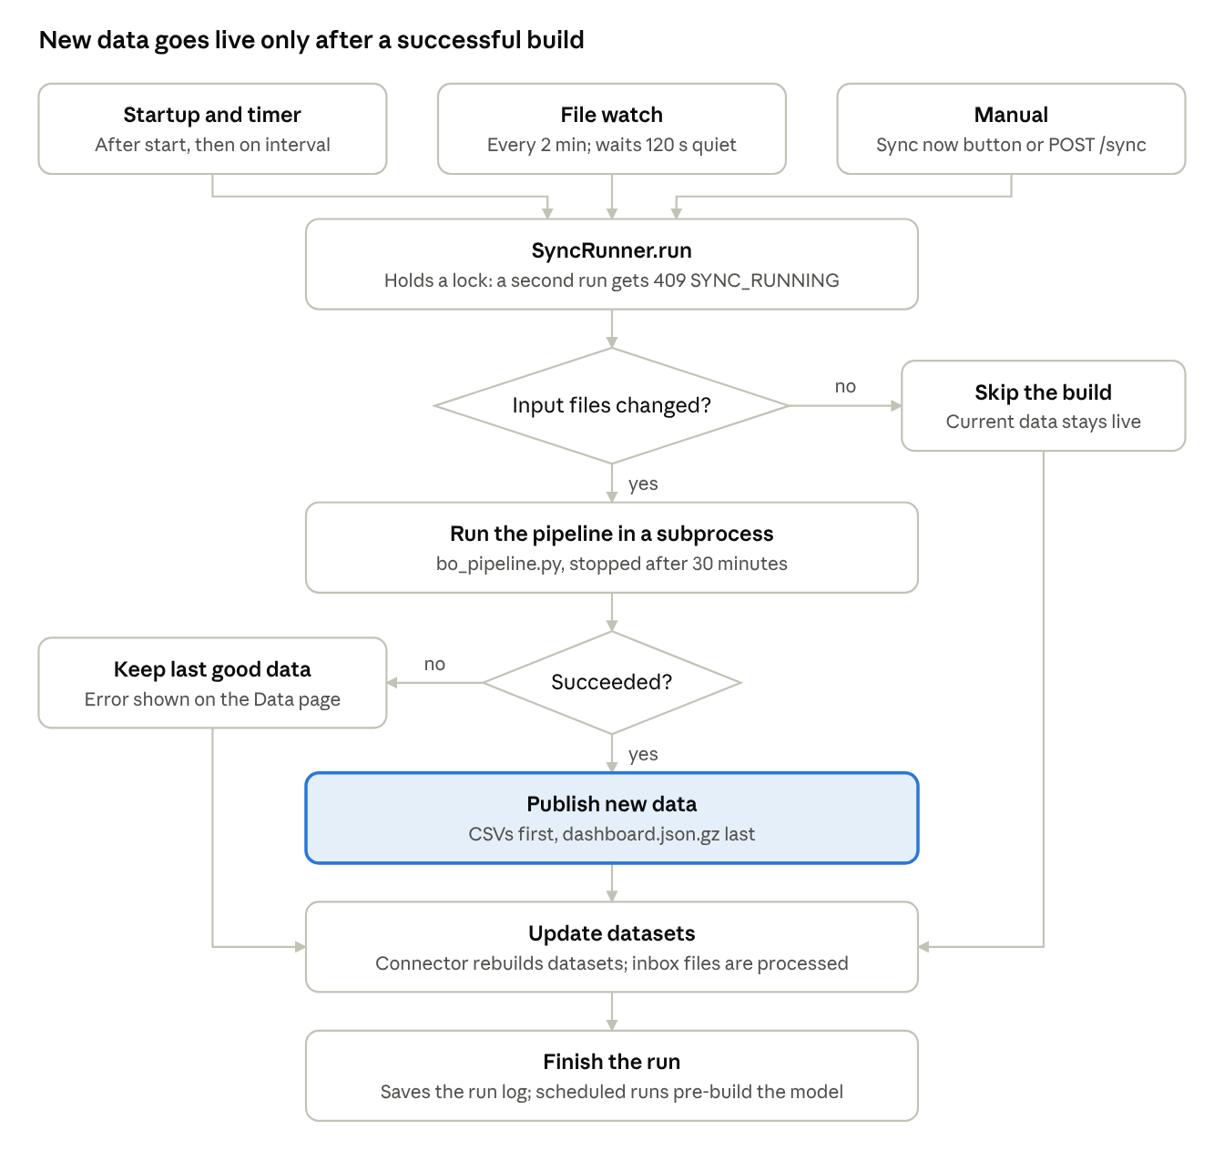
data refresh flow · 3 triggers, 2 decisions
The payload is written last, so a reader never sees new data alongside old CSVs. Every path ends with a saved run log.

Workflow 2: Signing in
- LoginPage calls api.login, which sends POST /api/auth/login.
- auth_service.login checks the failed-attempt limit, then verifies the password against its PBKDF2 hash.
- The backend records the login time and returns a signed token, its expiry and the user.
- setSession saves these to localStorage, and App.tsx re-renders from the login page into the app.
- Every later request carries Authorization: Bearer <token>.
- On each request, current_user checks the signature, expiry, active status and password version.
- If the API answers 401, httpApi clears the session and the login page shows the reason.

Workflow 3: Loading the dashboard
- Opening /dashboard/overview mounts NetworkProvider.
- If no model is cached, it calls GET /api/network/data.
- require_access confirms the user is signed in.
- network_service.payload returns its in-memory copy if it checked Dropbox within the last 30 seconds. Otherwise it lists the file and re-reads it only if the version changed.
- The route returns the already-gzipped bytes with an ETag. If the browser's If-None-Match matches, the answer is 304 with no body.
- The browser decompresses the response, httpApi unwraps it, and buildModel expands it into retailer objects.
- applyFilters and the view function in reports.ts produce KPIs, charts and tables.
- Changing a filter re-runs step 7 only, with no network call.

Workflow 4: Uploading a file
- An editor picks a dataset and an Excel or CSV file on the Data page.
- Validate only calls POST /uploads/validate, which returns a report and stores nothing.
- Upload calls POST /uploads, which keeps the original in uploads/ and validates it. An identical file for the same dataset returns 409 DUPLICATE_UPLOAD.
- Activate calls POST /uploads/{id}/activate with replace or append, which writes datasets/<dataset>.csv.
- The repository clears that dataset's cache, so the change shows immediately.

9. Deployment and configuration
The frontend deploys to Vercel at blue-originfrontend.vercel.app and the backend to Render at blue-origin-2.onrender.com; the two are separate origins, which is why CORS matters.
Part | Host | How it is configured
Frontend | Vercel | npm run build produces static files; the API URL comes from .env.production
Backend | Render | uvicorn app.main:app, with settings in environment variables; the repository has no render.yaml, so the rest of the setup lives in Render's dashboard
Data | Dropbox | Refresh token, app key and app secret, generated with scripts/dropbox_auth.py
Two deployment fixes from the git history, both good stories to tell:
- Page refresh returned 404 on Vercel. The router runs in the browser, but Vercel looked for a real file at paths like /sales. Commit c9b4e9d added a vercel.json rewrite that sends every path to index.html.
- The browser blocked API calls. The Vercel site is a different origin from the Render API. Commit abcae88 added the Vercel URL to the default CORS_ORIGINS.
Frontend environments
Command | Env file | Backend used
npm run dev | .env.development | Local, through the Vite proxy
npm run dev:remote | .env.remote | Render, through the Vite proxy
npm run build | .env.production | Render, called directly
VITE_ variables are written into the JavaScript at build time and anyone can read them, so they must never hold secrets. These files hold only URLs.
Key backend settings
Variable | Purpose | Local value or default
DATA_SOURCE | dropbox or local | dropbox
DROPBOX_ROOT | The app's own data folder | /TECHNOSPORT/BO_Platform
BO_PIPELINE_INPUT | Folder with the quarter files | /Power BI
BO_INFO_FOLDER | Folder with the contact-details workbook | /INFORMATION
SYNC_INTERVAL_MINUTES | Full sync interval | 60 locally; code default 1440
DATA_WATCH_MINUTES | How often to check for changed files | 2
DATA_SETTLE_SECONDS | Quiet time required before building | 120 (default)
CACHE_TTL_SECONDS | Dataset cache lifetime | 300 (default)
AUTH_SECRET | Token signing key; generated and stored in Dropbox if empty | Secret
AUTH_TOKEN_HOURS | Token lifetime | 12 (default)
ADMIN_EMAIL, ADMIN_PASSWORD | First admin, created only while no users exist | Secret
CORS_ORIGINS | Allowed frontend origins; a value here replaces the default list | Vercel URL and localhost
MAX_UPLOAD_MB | Upload size limit | 25
These are the values on this PC. Check Render's own settings before quoting them for production.
Running locally (PowerShell)
# Terminal 1: backend, http://localhost:8000/docs
cd backend
python -m venv .venv
.venv\Scripts\Activate.ps1
pip install -r requirements.txt
copy .env.example .env # then fill in the values
uvicorn app.main:app --reload --port 8000
# Terminal 2: frontend, http://localhost:5173
cd frontend
npm install
npm run dev
# Backend tests
cd backend
pytest -q
To work without Dropbox, set DATA_SOURCE=local, which keeps the same folder layout under backend/app/data/store/.
Operational rule. Run one backend instance per Dropbox folder. Caches, locks and the failed-login counter all live in that process's memory, so a second instance would not share them.

10. Security, performance, limitations and improvements
The app has solid sign-in and role checks, but it has two security issues to resolve or be ready to explain, and its file-based storage limits how far it can scale.

Fix or prepare for these first
Issue | Where | Why it matters | Suggested fix
Real business data is committed to git | BO_Consolidate_Final.xlsx is tracked; its columns include retailer names and phone numbers | Anyone with repository access can read it, and it stays in git history even after deletion | Confirm the GitHub repository is private, remove the file, and clean the history if needed
An optional feature stores plaintext passwords | services/account_book.py writes passwords to secrets/account_book.json and an Excel file when ACCOUNT_BOOK_FILE is set | It defeats the password hashing and contradicts the "never passwords" register | It is off on this PC, so check Render's settings too; removing the feature is the safest choice

Security already in place
- Salted PBKDF2 password hashes, with 390,000 iterations and constant-time comparison.
- Signed, expiring tokens that are revoked when a password changes.
- Role checks on the backend, applied centrally in the router.
- A limit on failed logins per email.
- Secrets kept out of the code: .env and secrets/ are gitignored.
- Errors that never send stack traces to the client.
- Upload checks on file size (25 MB), file type and duplicates.

Remaining security risks
Risk | Detail | Improvement
Token in localStorage | A cross-site scripting bug could steal it | Use an HttpOnly cookie, with CSRF protection
Custom token code | Security code is harder to get right than a vetted library | Move to a maintained JWT library
Login limit held in memory | It resets on restart and does not limit by IP address | Store attempts centrally and add an IP limit
Full data sent to every role | Any signed-in viewer's browser receives all retailers, including phone numbers | Remove phone numbers from the payload, or filter it by role

Performance decisions
Decision | Benefit
Rebuild only when file versions change | Avoids a build that the code describes as taking about 5 minutes
Gzip the payload once at build time | The roughly 9 MB JSON (per a code comment) is not re-compressed or re-parsed on each request
ETag with 304 responses | Unchanged data is not downloaded again
In-memory caches with short re-checks | Fewer Dropbox calls
Pipeline in a subprocess | Heavy pandas work runs outside the API process, and its memory is released when it exits
Pre-build the model after scheduled syncs | The first page load after a sync is faster
Chunked Dropbox uploads with retries | Files over 4 MB upload in pieces, and a dropped connection retries only that piece

Known limitations
- Dropbox as a database: there are no transactions or queries, and every change rewrites a whole file.
- One instance only: in-memory state prevents horizontal scaling.
- Duplicated logic: tier-movement rules and name cleaning exist in both Python and TypeScript.
- Hard-coded data: the distributor-to-state and state-to-region maps live inside bo_pipeline.py.
- Manual step: the notebook is run by hand, and its quarters are hard-coded for each quarter.
- Testing gaps: there are no frontend tests and no CI pipeline.
- Unfinished pages: Benefits, Deliverables tracker and Benefits history are empty or under construction.

Small defects found while writing this
- Layout.tsx:82 splits names with /s+/ instead of /\s+/, so avatar initials split on the letter "s" rather than on spaces.
- rapidfuzz is in requirements.txt but nothing imports it.
- sheets_download.py imports google.auth, which requirements.txt does not list. This has no effect while the download is off, but it would fail on a fresh install if switched on.
- The DSU class in bo_pipeline.py appears to be left over from the removed duplicate merging.

Future improvements, in priority order
- Resolve the two issues at the top of this section.
- Add a GitHub Actions pipeline that runs tests and a type check on every push.
- Move users and sign-in state to a managed database such as PostgreSQL.
- Move sales data to the database too, keeping Dropbox as the file input only.
- Run the pipeline as a scheduled job instead of a notebook run by hand.
- Add frontend tests with Vitest and React Testing Library.
- Finish the Benefits and Deliverables pages.

11. Presentation guide
A 15-minute talk works best in this order: start with the business problem, then the architecture, then a live demo, and finish on one hard decision and what you would improve.
Minutes | Topic | What to say | Show
0–2 | Problem | Sales data is spread across distributor sheets, and tier analysis is manual | Section 1 pitch
2–4 | Solution | One login, one set of tier rules, automatic refresh | Dashboard overview
4–7 | Architecture | React to FastAPI to Dropbox, and why each layer exists | Section 3 diagram
7–11 | Live demo | Follow the demo script below | The running app
11–13 | Hard decision | Pick one: Dropbox as the store, or computing in the browser | Section 12 answers
13–15 | Improvements | Database, CI, frontend tests, removing the manual step | Section 10 list
Demo script
- Sign in. Mention hashed passwords and the 12-hour token.
- Overview page. Point out the KPIs and charts, and the quarter label in the form "Q2 FY 27 (Jul–Sep 2026)".
- Change a filter. Show the instant update, and explain that no server call happens.
- Tier movement. Explain one category, then the rule that Platinum starts in Q1 FY 27.
- Retailer lookup. Search for a shop and open its detail panel.
- Reports. Download the BO_Data workbook and open it in Excel.
- Data page. Show the sync status and pipeline panel, and explain how a new file is detected.
- Swagger at /docs. Show that the API documents itself.
Before you present
- ☐ Open the Render URL a few minutes early, in case the service needs time to wake up.
- ☐ Record a backup video of the demo in case the network fails.
- ☐ Use a viewer account for most of the demo, and blur real retailer names and phone numbers if outsiders are present.
- ☐ Confirm you are allowed to show company data outside the organisation.
- ☐ Be clear about which parts you built yourself and which you worked on with others.
- ☐ Read section 10 so that no limitation catches you by surprise.

12. Interview questions and answers
These answers are written to be said aloud and are based on the code; the "why" parts are reasoned from it, so reword them to match what actually happened and what you personally did.

Project and architecture
What does this project do? It turns quarterly distributor sales files into a retailer analytics dashboard. It places each retailer in a tier by quarterly purchases, tracks tier movement between quarters, and produces Excel reports, all behind role-based sign-in.
Walk me through the architecture. A React app on Vercel calls a FastAPI service on Render over HTTPS, with a Bearer token. The backend stores everything in Dropbox through a storage interface. A background thread watches for changed input files and runs a pandas pipeline, which publishes a compressed payload for the dashboard.
Why Dropbox instead of a database? The business already keeps its source files in Dropbox, and the notebook writes there, so there was no separate system to feed or maintain. Data changes in quarterly batches and has few writers, so whole-file updates are acceptable. The trade-offs are no transactions, no queries and a single backend instance. If it grew, I would move to PostgreSQL. The BlobStore and repository layers would limit how much code that touches.
What was the hardest part? A strong candidate is applying business rules that changed over time while keeping history correct. Tier thresholds differ by quarter, Platinum only exists from April 2026, and Silver's range changed in July 2026. I kept those as dated values in one JSON file, so each quarter uses the rules in force at that time.
How would you scale this to 100 times the users? First, move the data and sign-in state into a database, and caches into Redis, so that several backend instances can run. Then move the pipeline to a separate worker, and replace the full-data download with paginated, server-side queries.

Backend
Why FastAPI? It gives typed request validation, dependency injection and automatic Swagger documentation. It is also Python, which matches the pandas pipeline.
How is the backend organised? In layers: routes, services, repository, storage. Routes only handle HTTP, services hold logic, the repository handles caching and CSV datasets, and storage hides Dropbox. This let the tests run against a local store and a fake Dropbox client.
How does dependency injection help here? Routes declare what they need with Depends, such as the current user, repository or settings. FastAPI supplies them, and the shared repository is created once with lru_cache.
Why run the pipeline in a subprocess? It is a long-running pandas script, adapted from a standalone script. A subprocess keeps its memory use and any crash away from the API process, and it can be given a timeout. The timeout here is 30 minutes.
How do you avoid building half-written files? The watcher checks every 2 minutes but only starts when no input file has changed for 120 seconds. During publishing, the dashboard payload is written last, so a reader does not get new data alongside old CSVs.
How do you detect that files changed? Each stored file has a version: Dropbox's content_hash, or rev as a fallback. A build saves the list of versions it used, and comparing lists needs only a folder listing, without downloading any file.
What happens if a build fails? The last good payload stays live, and the error is recorded and shown on the Data page. The file watcher doesn't retry a failed build for the same files, which prevents a tight retry loop; the next scheduled sync tries again. One bad file in an inbox dataset is skipped and reported while the others still load.
How do you handle errors in the API? There is one response shape, with a code, message and details. Custom exceptions subclass AppError and global handlers convert them. Unexpected errors return a generic 500, and the stack trace goes only to the logs.
How is concurrency handled? FastAPI runs plain def routes in a thread pool, and the scheduler has its own thread, so shared state needs locks. Sync and build each use a non-blocking lock, so a second attempt gets a 409 rather than waiting.

Security
How does sign-in work? The password is checked against a salted PBKDF2-SHA256 hash. The server then issues an HMAC-signed token with the user id, expiry and a password version. Each request verifies it, and also checks that the account is still active.
Why not use a standard JWT library? The token follows the same idea, using only the standard library, and the password version allows revocation. The honest trade-off is that hand-written security code carries more risk, so I would move to a maintained library.
How do you revoke a token? The token includes a short hash of the stored password hash. When the password changes, that value no longer matches, so older tokens fail. Deactivated accounts fail as well, because the account is checked on each request.
How are roles enforced? On the backend, through a dependency attached centrally to the routers. Viewers can use read methods only, and user management requires admin. Hiding things in the frontend is only for convenience.
What security issue would you fix first? A workbook with real retailer data is committed to the repository, so I would remove it and clean the history. I would also remove the optional account book feature, because it stores plaintext passwords.

Frontend
Why no Redux? The shared state is small. Context handles the dashboard, a small external store handles the session, and hooks handle list pages. Redux would add code without solving a problem here.
Why compute the dashboard in the browser? Filters are used constantly, and running them locally makes them instant, with no server load per click. The costs are a large first download, and every signed-in user receives the full data.
How do you render so many rows smoothly? With virtualisation through TanStack Virtual. Only visible rows plus a small buffer are in the DOM, however long the list is.
What does useSyncExternalStore do in your session code? It lets React subscribe safely to state held outside React. Combined with the browser's storage event, signing out in one tab also signs out the others.
How do you stop an old response overwriting a new one? useAsync numbers each request and ignores any response that isn't from the latest one.
Why does vercel.json rewrite everything to index.html? Routing happens in the browser, so /sales isn't a real file. Without the rewrite, refreshing that page returns a 404.

Data and business rules
Explain the financial-year convention. The year runs April to March and is named after the year it ends in. So Q1 FY 27 is April to June 2026.
How is a tier decided? By the larger of the sheet's Last 3 Months figure and the sum of that quarter's months, compared against the thresholds in force that quarter. The lower boundary is inclusive, so exactly ₹1.5 lakh is Green.
How do you make sure the totals are right? The pipeline prints a revenue check comparing the source total with the consolidated total, excluding subtotal lines, and the Data page shows it. Tests also cover the tier rules and cleaning. One known gap is that rows with a truly blank retailer name are removed before that check runs.
Why no duplicate retailer merging? It was built and then removed at the business's request. One retailer is now one Code name, which is shop name plus distributor. This keeps the dashboard matching the notebook's output exactly.

Deployment and testing
What is CORS, and how did it affect you? Browsers block a page from reading responses from another origin unless the server allows it. The Vercel frontend and Render API are different origins, so the Vercel URL had to be added to the allowed list.
How do you test this? With 160 pytest tests covering the API, auth, rules, cleaning, validation and sync. They use a temporary local store and a fake Dropbox client, so they need no network. There are no frontend tests or CI yet, and I would add those next.

Questions about you
These depend on your own experience, so prepare your own answers:
- Which part did you personally build, and which decision are you proudest of?
- Tell me about a requirement that changed. The Silver range and the removal of duplicate merging are real examples.
- Tell me about a bug you fixed. The Vercel 404 and the CORS block are real examples.
- What would you do differently if you started again?

