**NOTE: please run “npm install --force” before run “frontend & backend” project in your local system.**

**Video Link:** <https://www.loom.com/share/20fc67a5f32c4222a5e67689210ee287>

Description:

Dashboard with sidebar and navbar routing:  
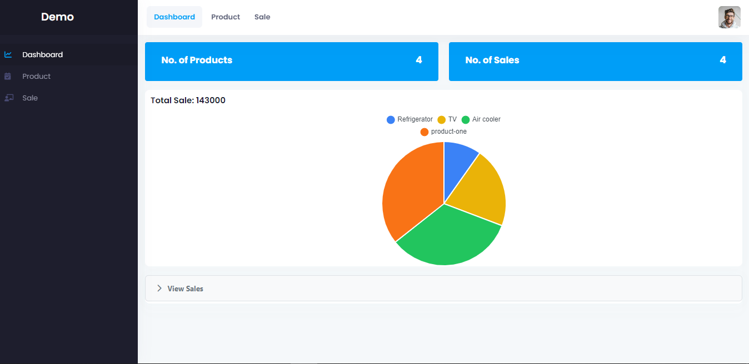

Sales per product list in accordion in dashboard

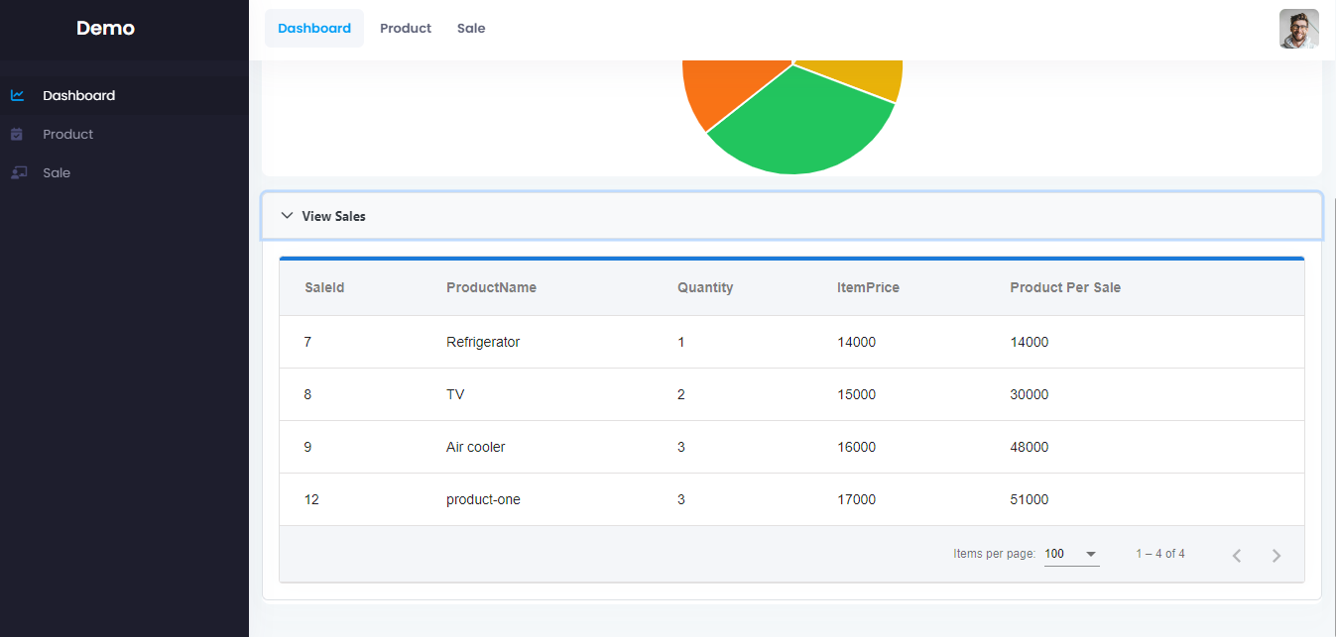

Product data listing:  
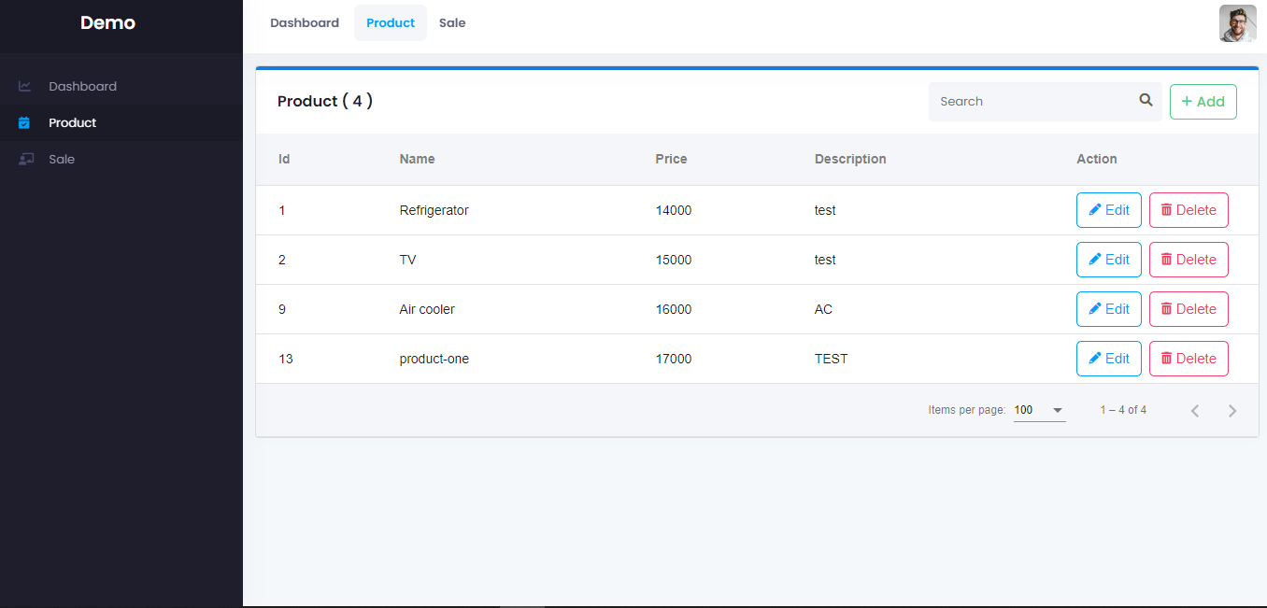

Product: create  
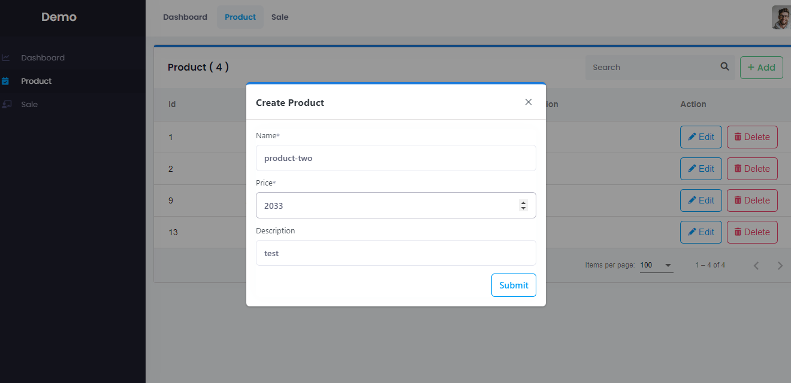

Product: update

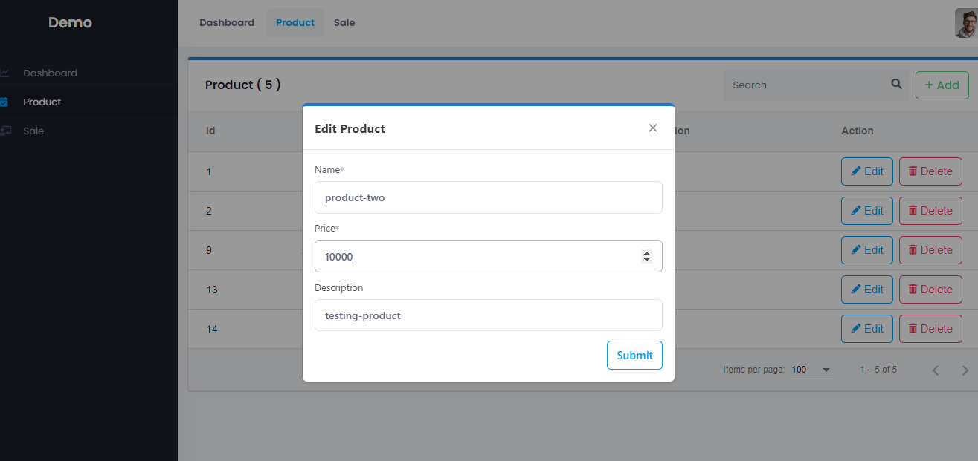

Product: delete

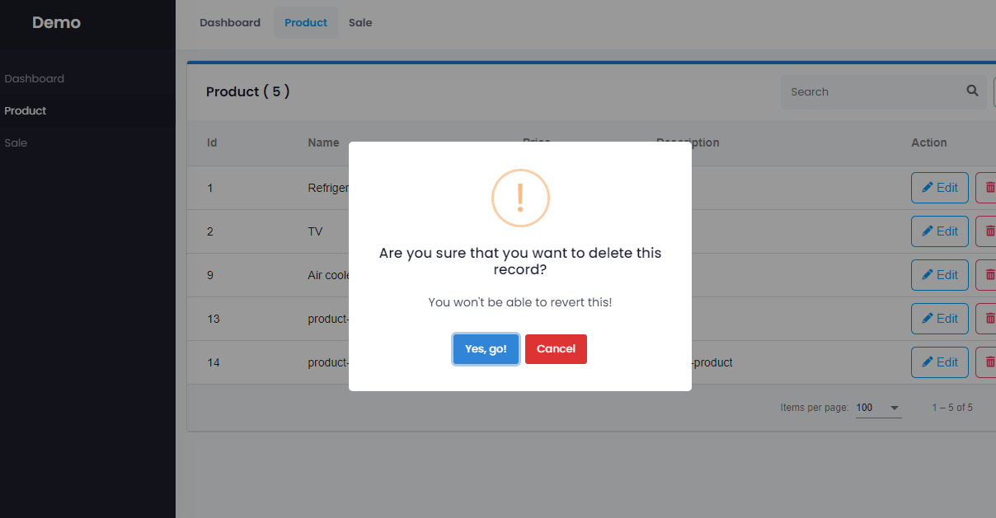

Product filter:

Product: filter

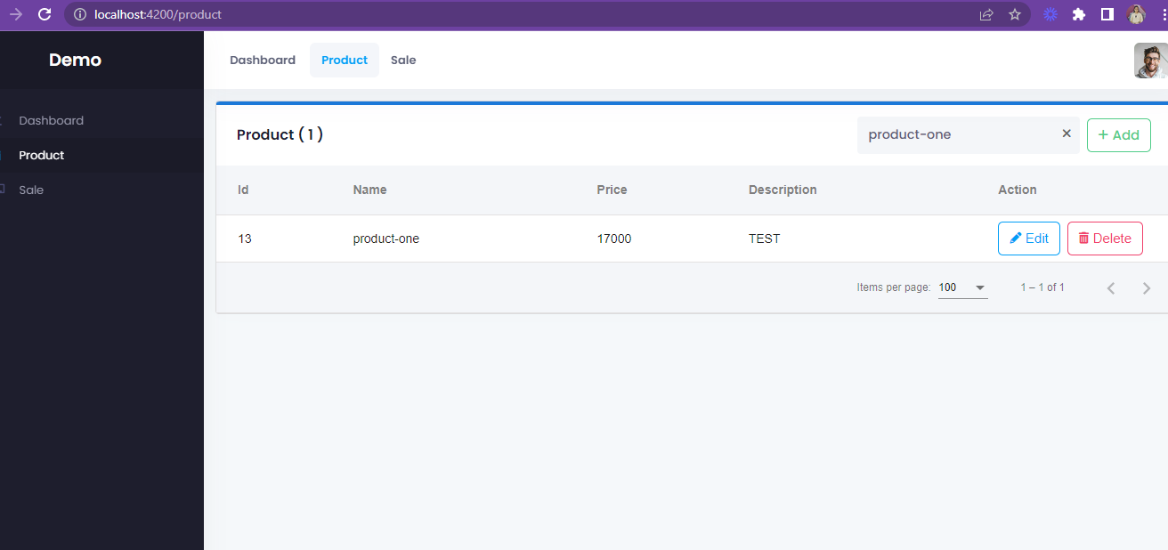

Sale: view List

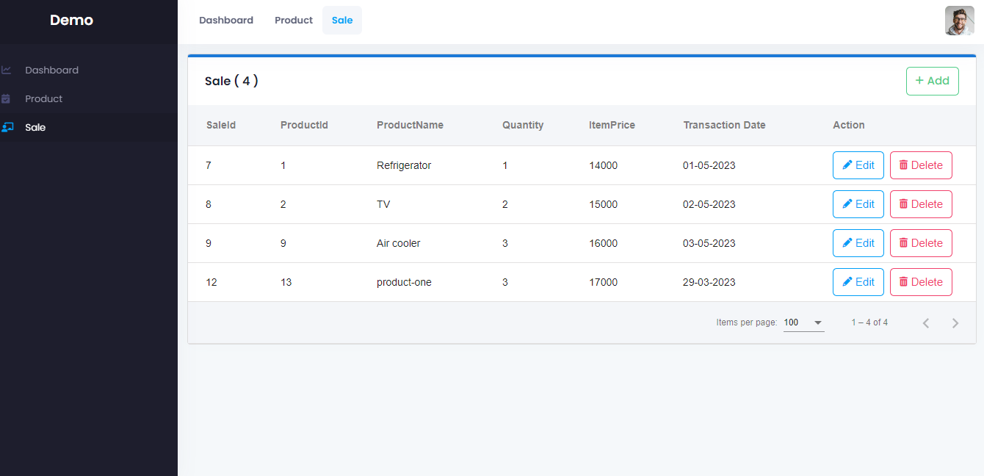

Sale: create model

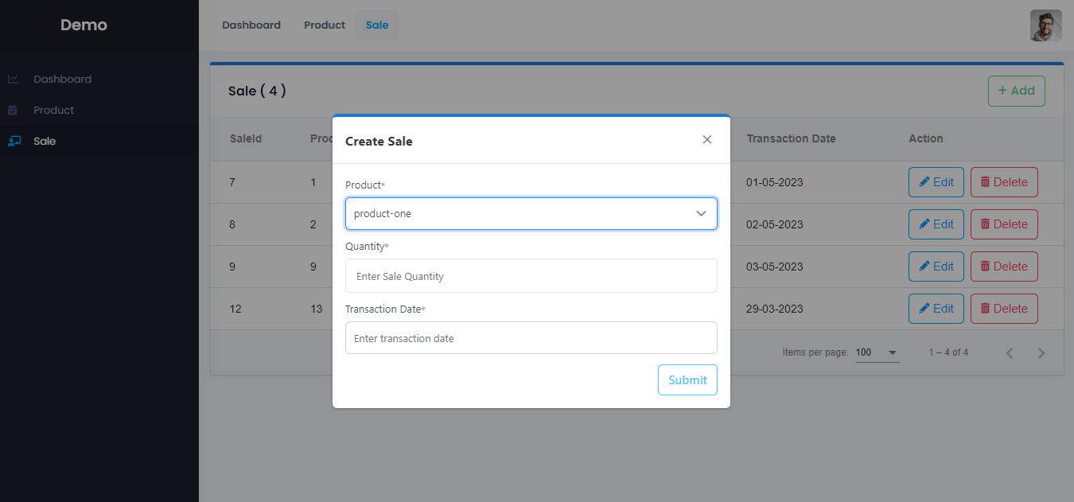

Sale: update model

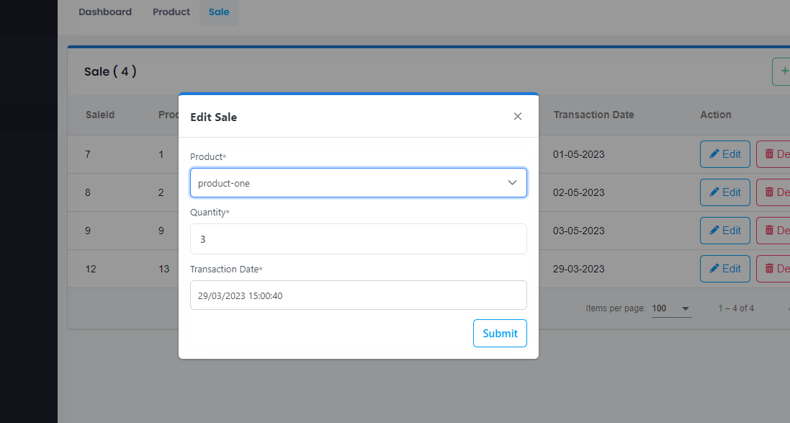

New added sale is “product-two” updated in dashboard with chart:

