Name:Priyanka.E RollNo:231901038

EX NO:1a BASIC NETWORKING COMMANDS IN WINDOWS OPERATING

DATE:27.7.24 SYSTEM

Aim:

To study the basic networking operating system in window operating system.

1.IPCONFIG

The IPCONFIG network command provides a comprehensive view of information regarding the [IP address](https://www.simplilearn.com/tutorials/cyber-security-tutorial/what-is-an-ip-address) configuration of the device we are currently working on.

The IPConfig command also provides us with some variation in the primary command that targets specific system settings or data, which are:

* IPConfig/all - Provides primary output with additional information about network adapters.
* IPConfig/renew - Used to renew the system’s IP address.
* IPConfig/release - Removes the system’s current IP address.

SYNTAX- ipconfig

EXAMPLE : ipconfig

OUTPUT:

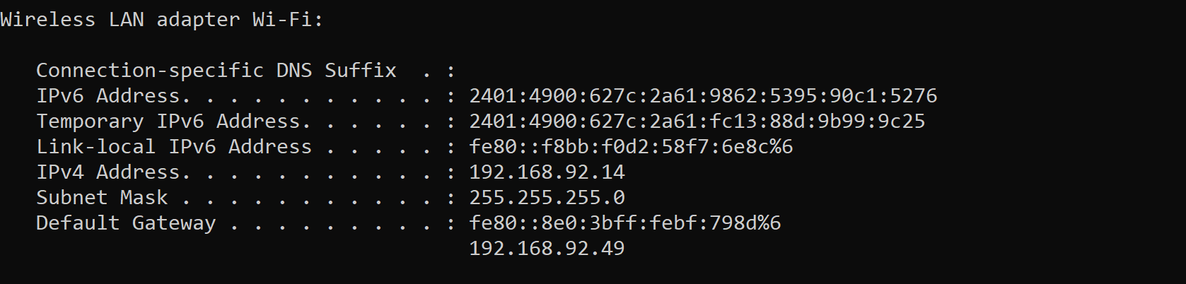

2. NSLOOKUP

 The NSLOOKUP command is used to troubleshoot network connectivity issues in the system. Using the nslookup command, we can access the information related to our system’s DNS server, i.e., domain name and IP address.

Syntax– nslookup

Example : nslookup [www.google.com](http://www.google.com)

OUTPUT:

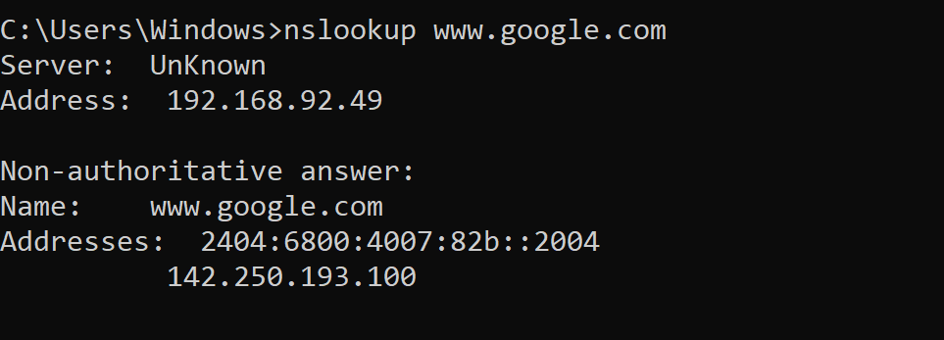

3. HOSTNAME

The HOSTNAME command displays the hostname of the system. The hostname command is much easier to use than going into the system settings to search for it.

SYNTAX- hostname

EXAMPLE : hostname

OUTPUT:

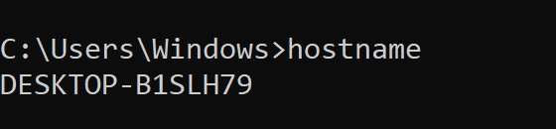

4. PING

The Ping command is one of the most widely used commands in the prompt tool, as it allows the user to check the connectivity of our system to another host.

This command sends four experimental packets to the destination host to check whether it receives them successfully, if so, then, we can communicate with the destination host. But in case the packets have not been received, that means, no communication can be established with the destination host.

SYNTAX- ping [www.destination_host_name.com](http://www.destination_host_name.com)

EXAMPLE : ping [www.facebook.com](http://www.facebook.com)

OUTPUT:

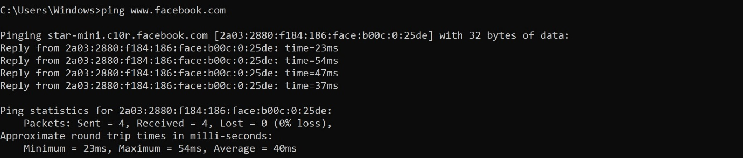

5. TRACERT

The TRACERT command is used to trace the route during the transmission of the data packet over to the destination host and also provides us with the “hop” count during transmission.

Using the number of hops and the hop IP address, we can troubleshoot network issues and identify the point of the problem during the transmission of the data packet.

SYNTAX- tracert IP-address OR tracert [www.destination_host_name.com](http://www.destination_host_name.com)

EXAMPLE : tracert [www.facebook.com](http://www.facebook.com)

OUTPUT:

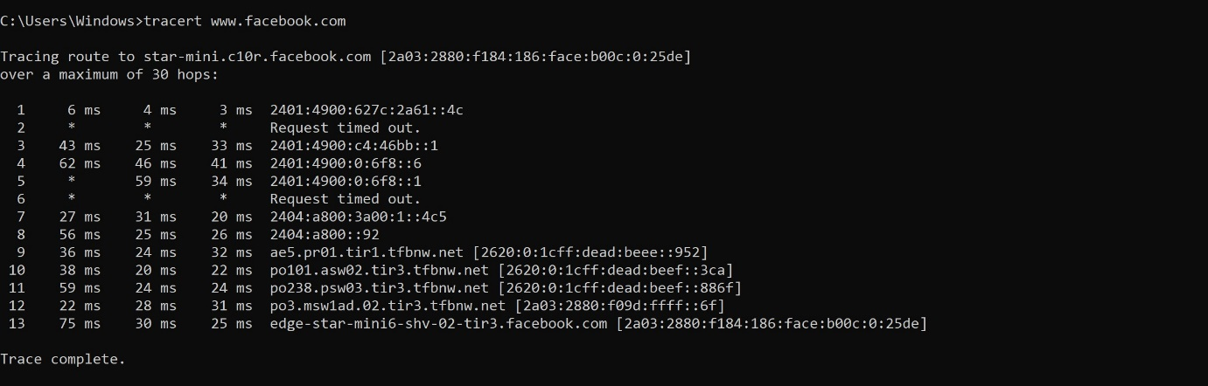

6. NETSTAT

The Netstat command as the name suggests displays an overview of all the network connections in the device. The table shows detail about the connection protocol, address, and the current state of the network.

SYNTAX- netstat

EXAMPLE : netstat

OUTPUT:

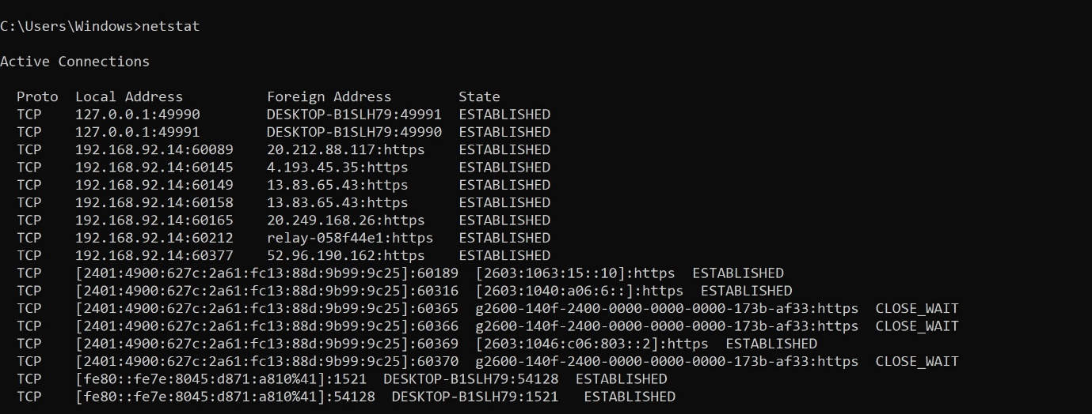

7. ARP(Address Resolution Protocol)

The ARP command is used to access the mapping structure of IP addresses to the MAC address. This provides us with a better understanding of the transmission of packets in the network channel.

SYNTAX- arp

EXAMPLE : arp -a

OUTPUT:

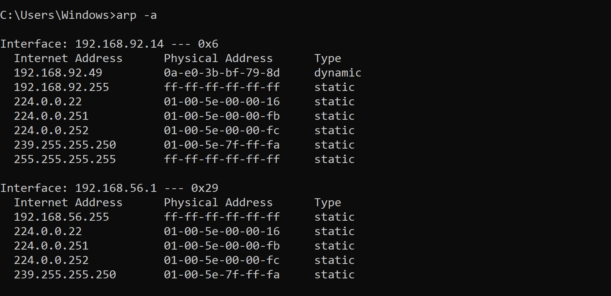

8. SYSTEMINFO

Using the SYSTEMINFO command, we can access the system’s hardware and software details, such as processor data, booting data, Windows version, etc.

SYNTAX– systeminfo

EXAMPLE : systeminfo

OUTPUT; 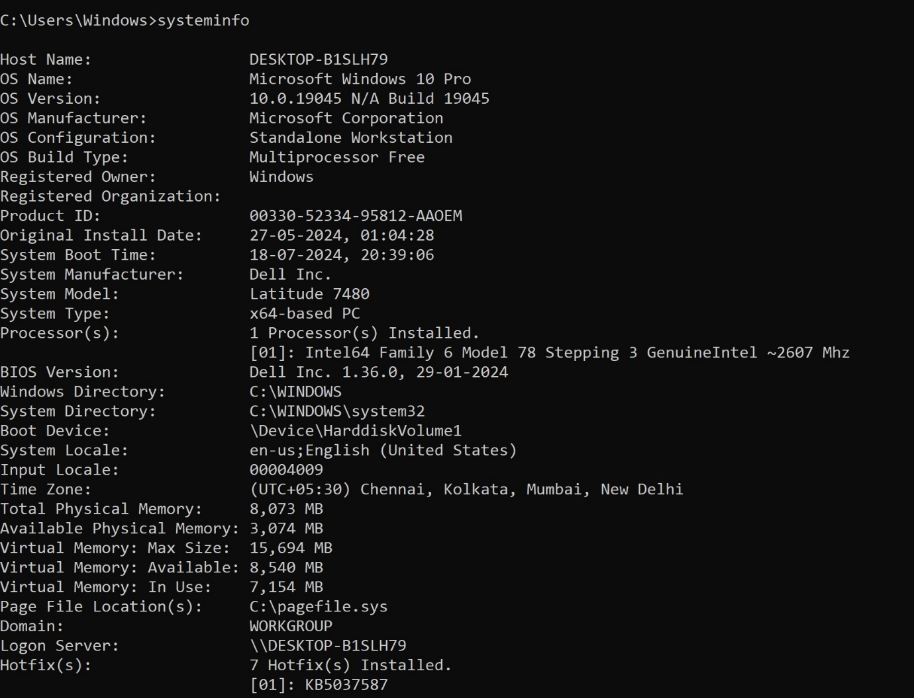

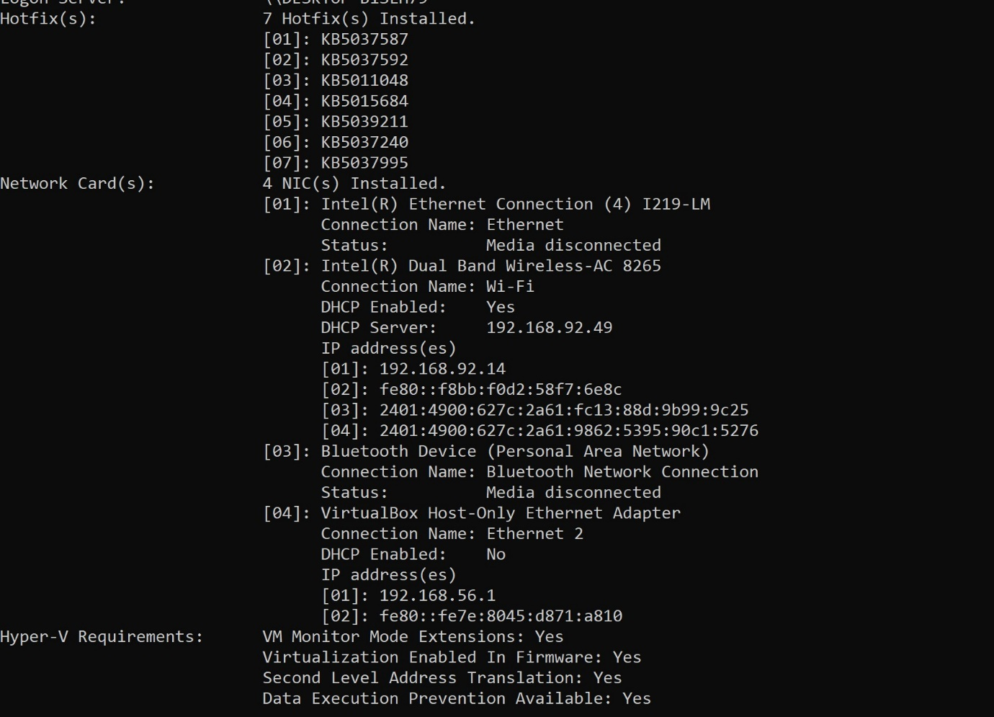

9. ROUTE

Provides the data of routing data packets in the system over the communication channel.

SYNTAX – route print

EXAMPLE : route print

OUTPUT:

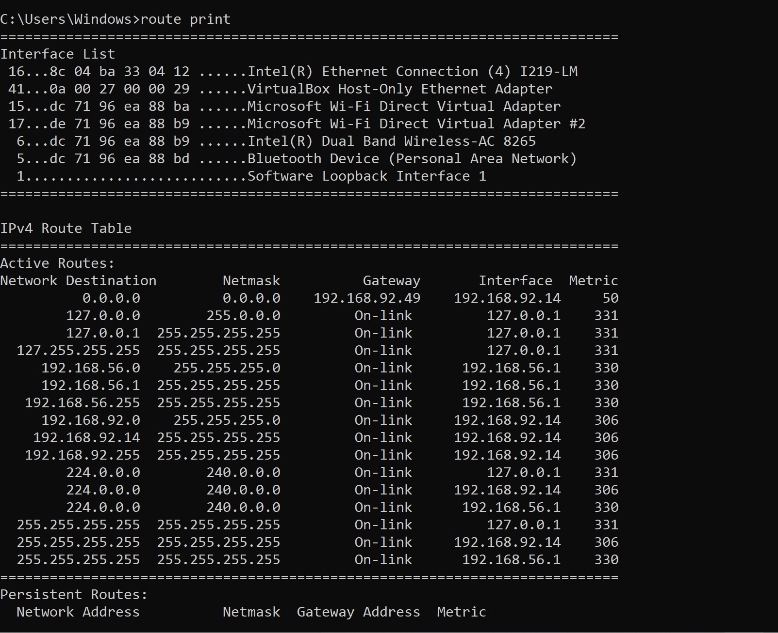

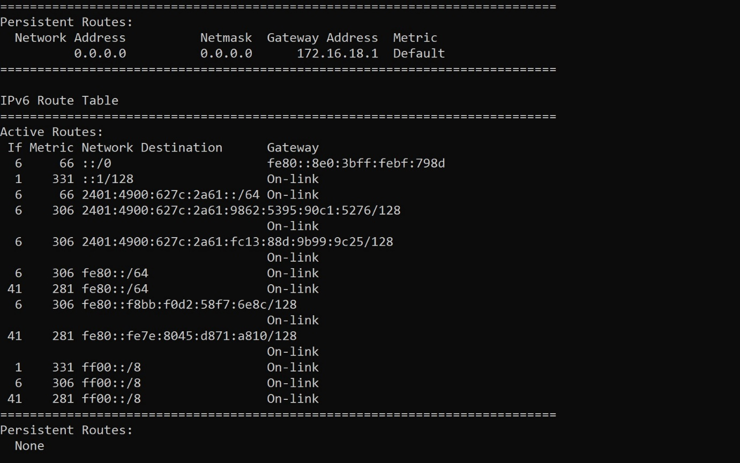

RESULT :

Hence,the study of basic networking commands in window operating system is studied.