PRIYANKA GOENKA

MACHINE LEARNING- CSE847

Solutions for Homework- 5

1)

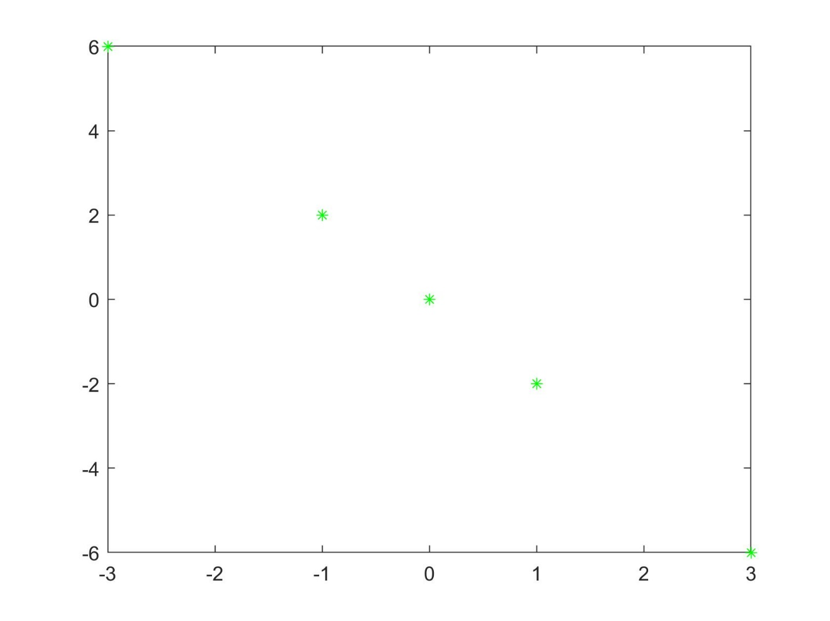

* First Principle Component Analysis (PCA): The first PCA is the best line which we can fit to the data, so it is the line which connects all the ploted points.
* Second Principle Component Analysis: Second PCA is orthogonal to the first PCA, and it is capturing the left over variance from the first PCA. So in this case the second PCA will not add anything, as the first PCA didn’t have any error.

**Link** : <https://github.com/PriyankaGoenka/MachineLearning_HW5/blob/master/Hw5_Q1.m>

2) Original Images:

Image 1(img1):  Image 2(img2): 

Image 1 and Image 2 with different Principle Components:

|  |  |  |  |  |
| --- | --- | --- | --- | --- |
| Principle Component | 10 | 50 | 100 | 200 |
| Image 1 |  |  |  |  |
| Image 2 |  |  |  |  |

**Link for the code:** <https://github.com/PriyankaGoenka/MachineLearning_HW5/blob/master/HW5_Q2.m>

2) Matrix Completion

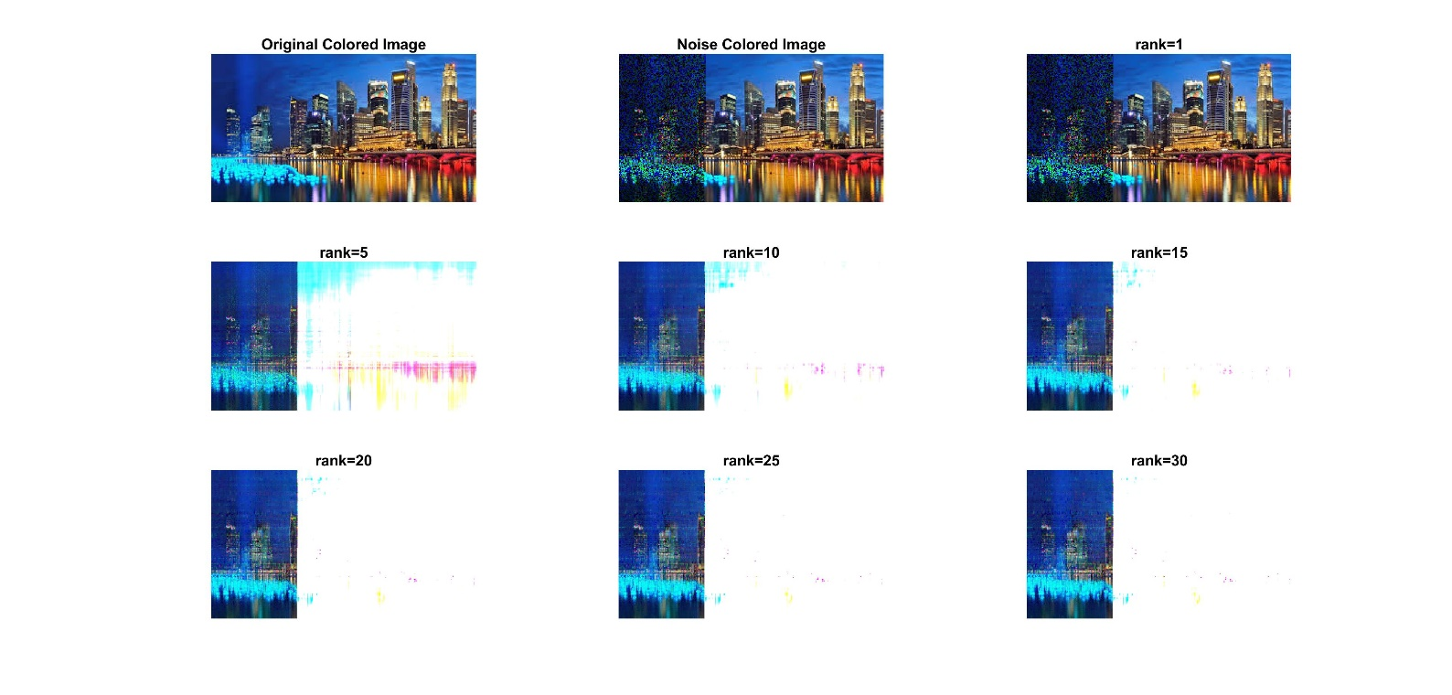

Graph for error recovery for different rank

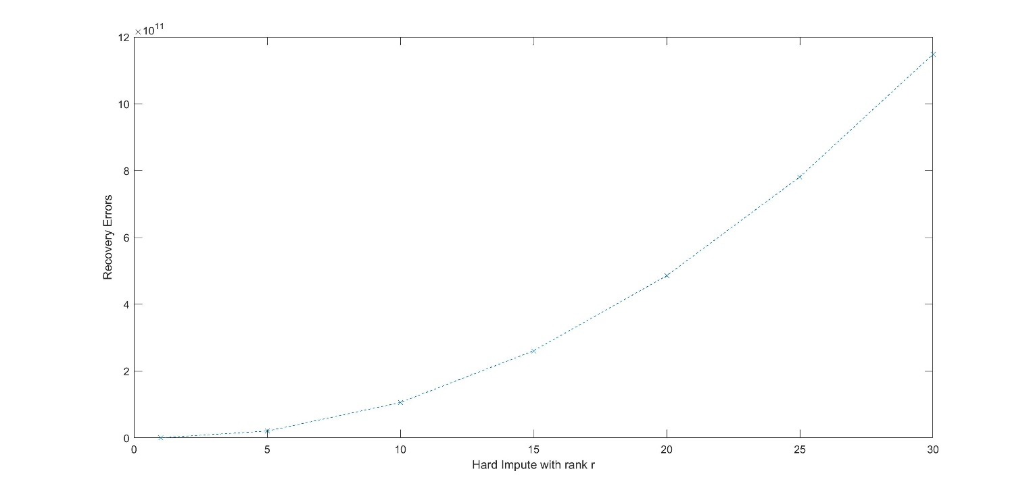

Please run the code and check all the answers.

**Link for the Matlab code:**

<https://github.com/PriyankaGoenka/MachineLearning_HW5/blob/master/HardImpute.m>

<https://github.com/PriyankaGoenka/MachineLearning_HW5/blob/master/MatrixCompletion.m>

All the codes and output images are uploaded on github. Please go through it.

Thank you!