DATE: 28-06-2022

NAME: SUCHITHRA RAJ M

USN: 1NT19IS162

**BDLAB**

Execrcise-5: Extract facts using Hive:

1)Create and Drop Databases

2)Create, Alter, Drop Table

3)Built-in Operators

4)Built-in function

5)Views and Index

6)HIVEQL (select where, Select Order by, Select group by, Select Joins)

**Starting hive shell**

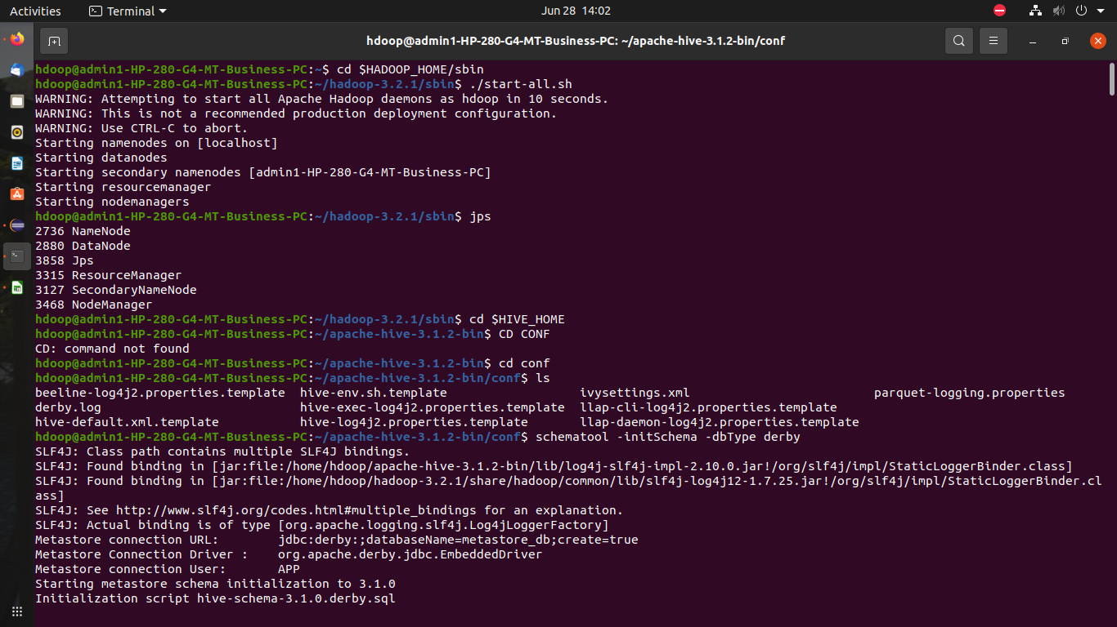

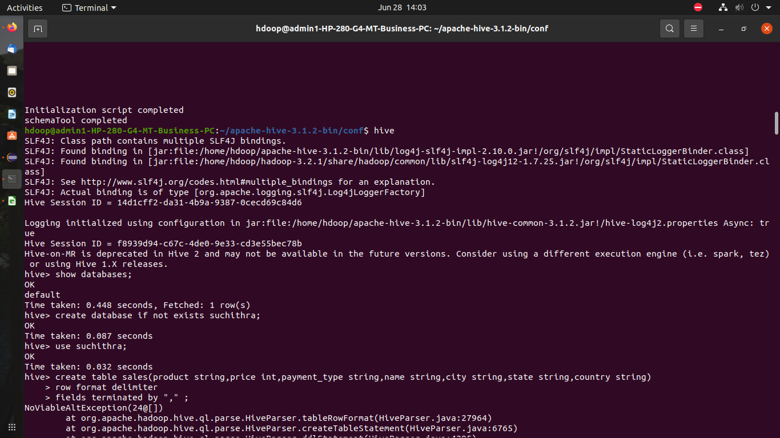

1. **Create database**

create database if not exists suchithra ;



1. **Creating table**

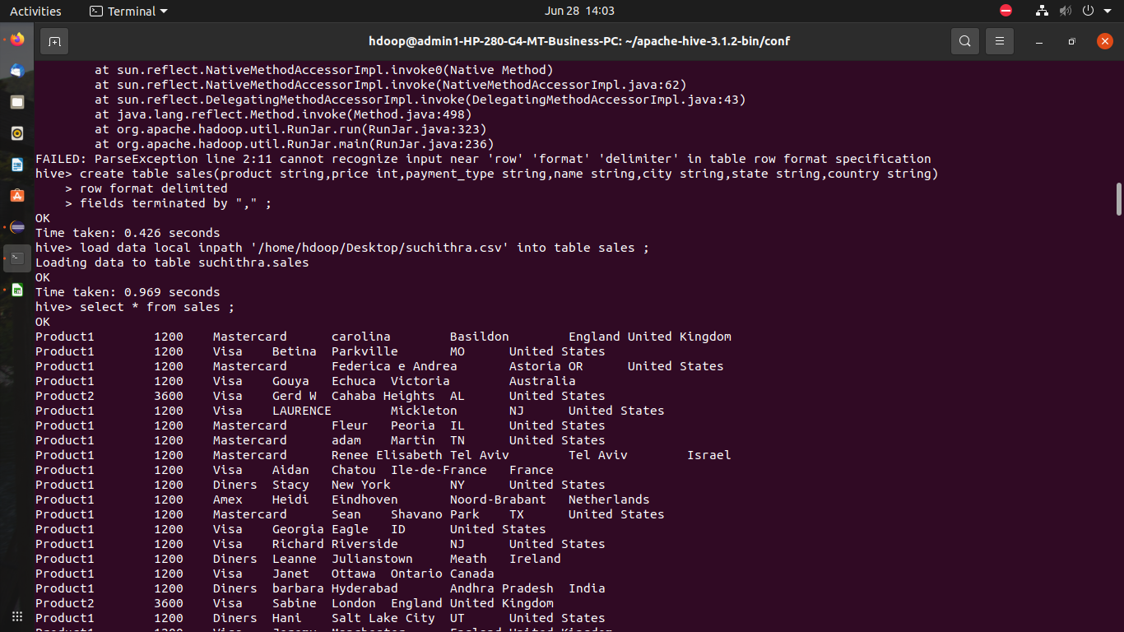

**Loading values into table**

load data local inpath ‘/home/hdoop/Desktop/suchithra.csv’ into table sales ;



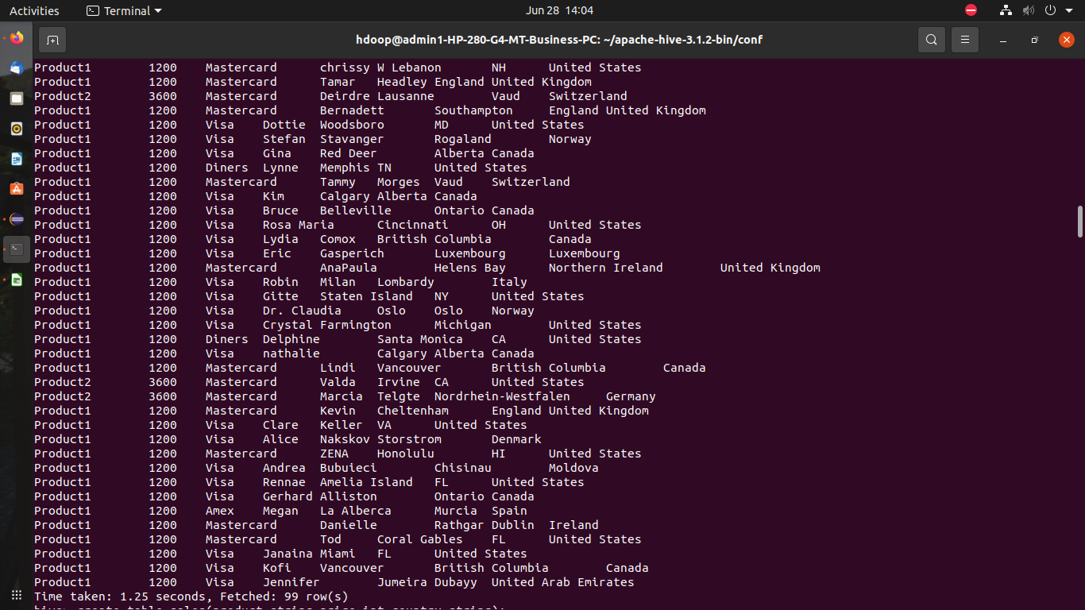

**Dropping a table**

drop table sales_suchi ;

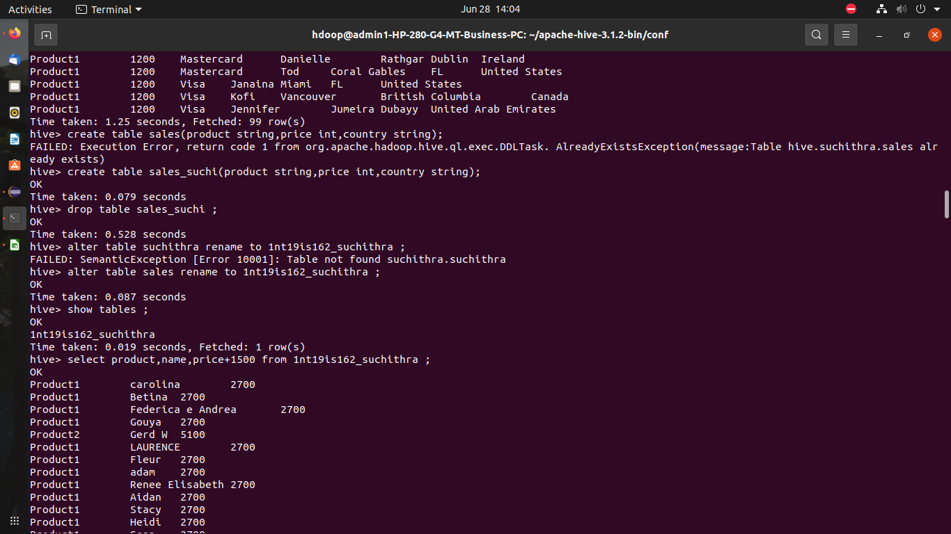

**Alter command:**

Altering the table name

alter table sales rename to 1nt19is162_suchithra ;



1. **Built in operations**

Arithmetic operator in hive

Select product,name,price+1500 from 1nt19is162_suchithra ;

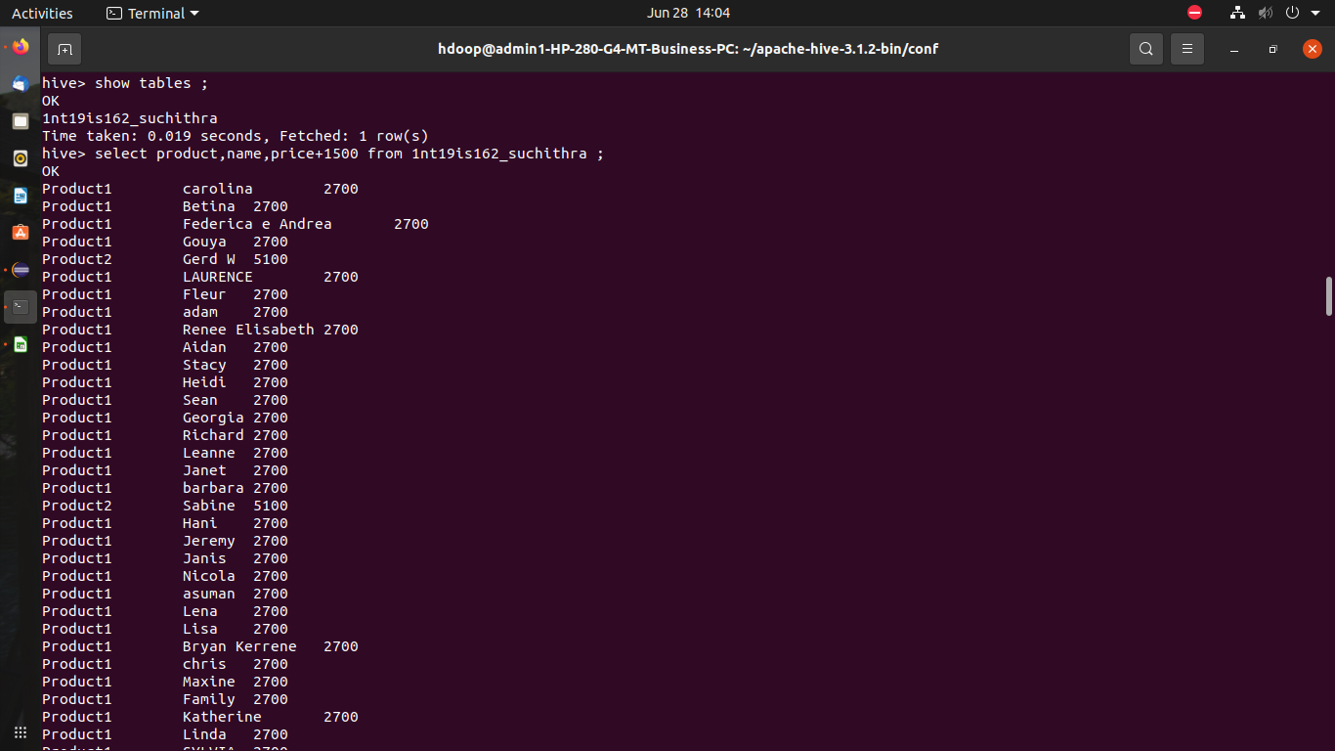

Select product,name,(price*10)/2 from 1nt19is162_suchithra ;

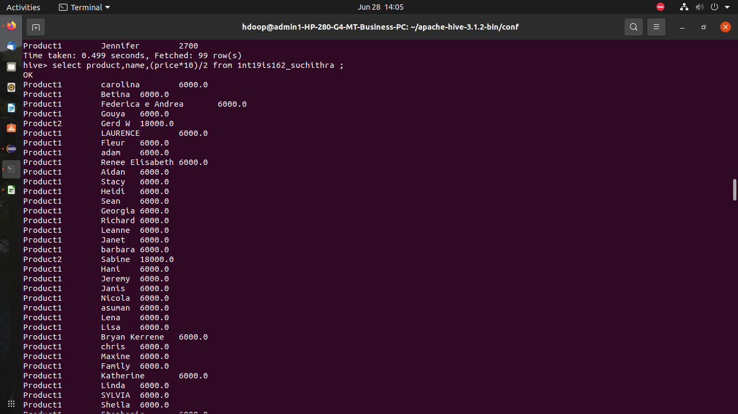

**Relational operators in hive**

Select * from 1nt19is162_suchithra where price>1200 ;

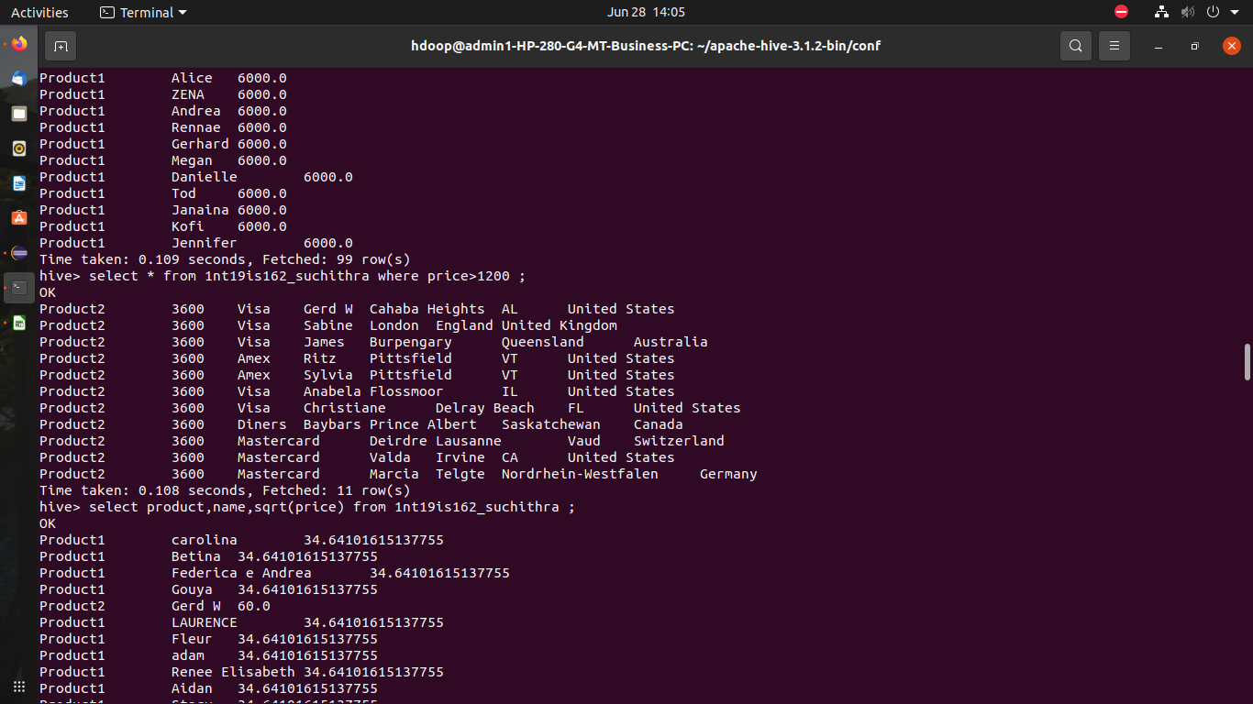

1. **Built in functions:**

Mathematical functions in hive

Select product,name,sqrt(price) from 1nt19is162_suchithra ;

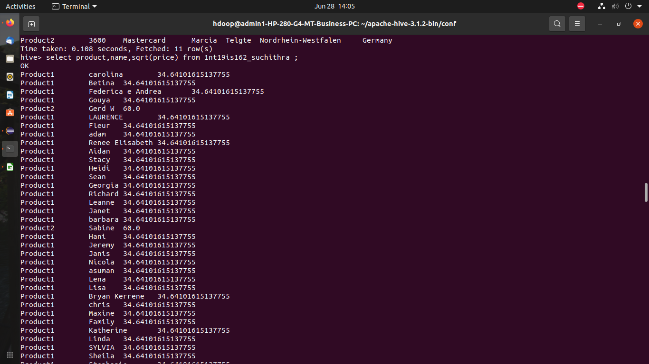

Select product,name,floor(price) from 1nt19is162_suchithra ;

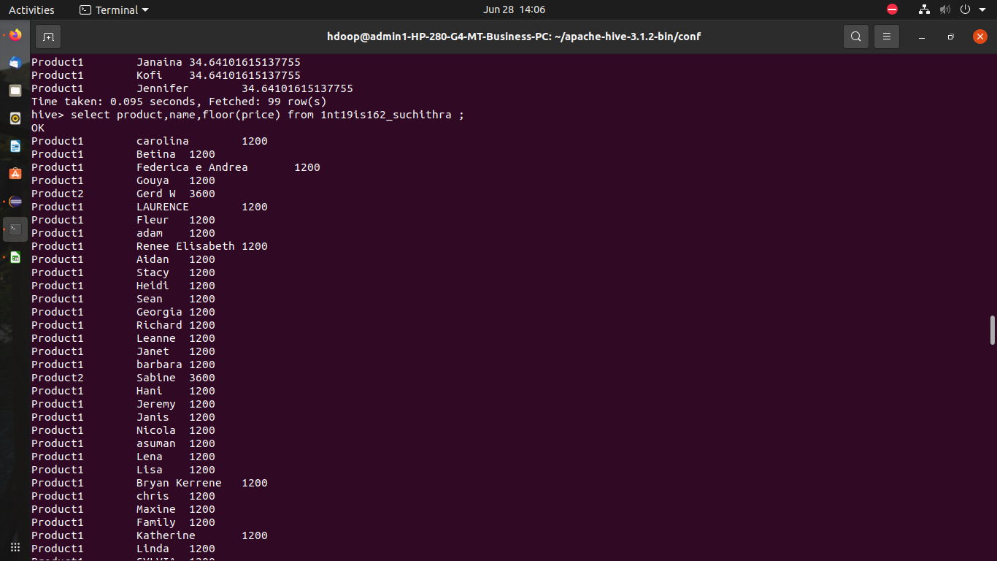

Select product,name,cos(price) from 1nt19is162_suchithra ;

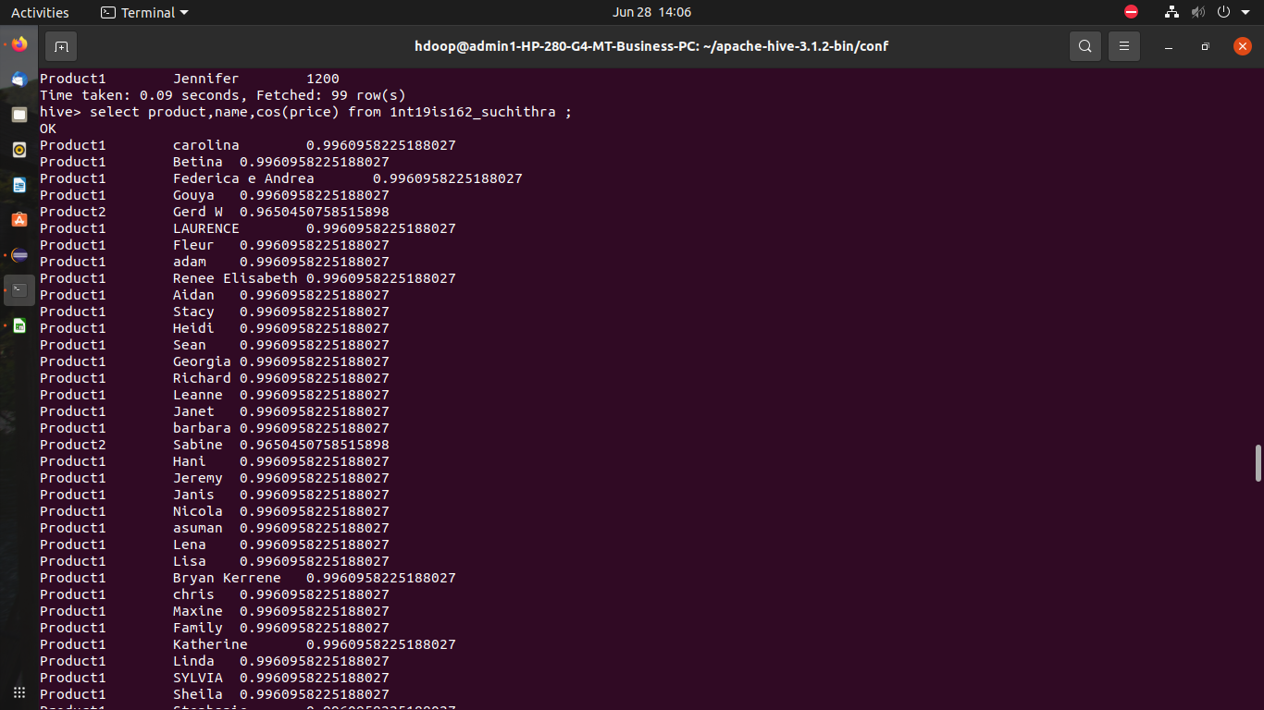

**Aggregate functions in hive**

Select max(price) from 1nt19is162_suchithra where country=”United States” ;

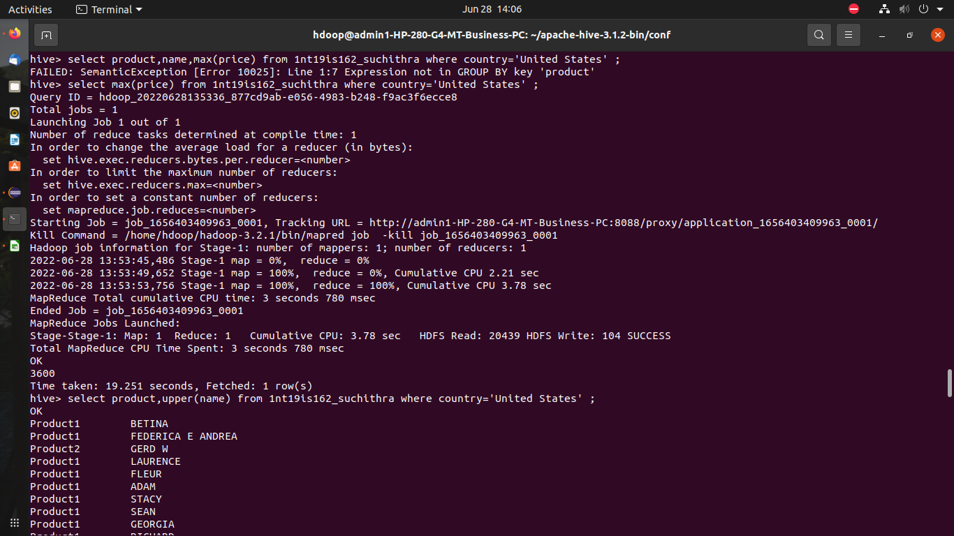

Select product,reverse(name) from 1nt19is162_suchithra where country=”United States” ;

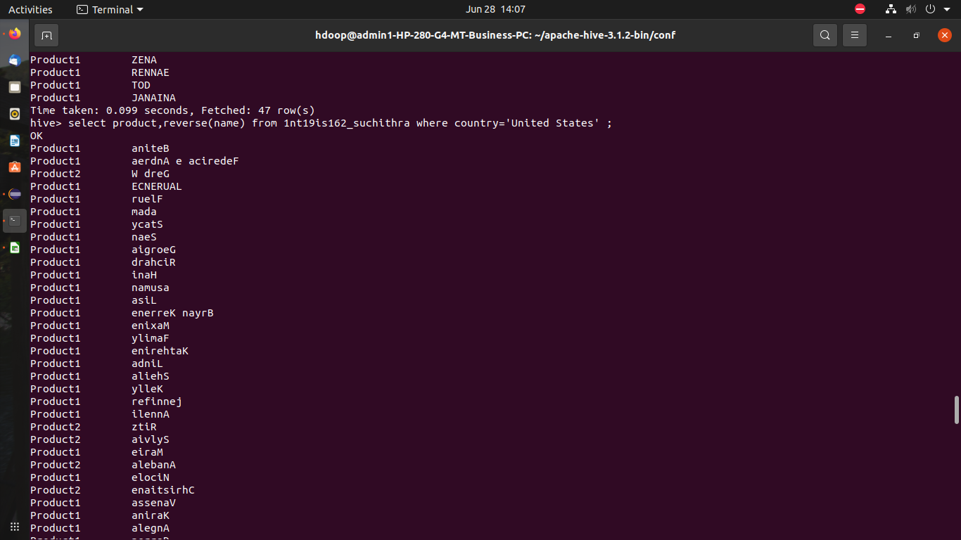

Select product,concat(name,state) from 1nt19is162_suchithra where country=”United States”;

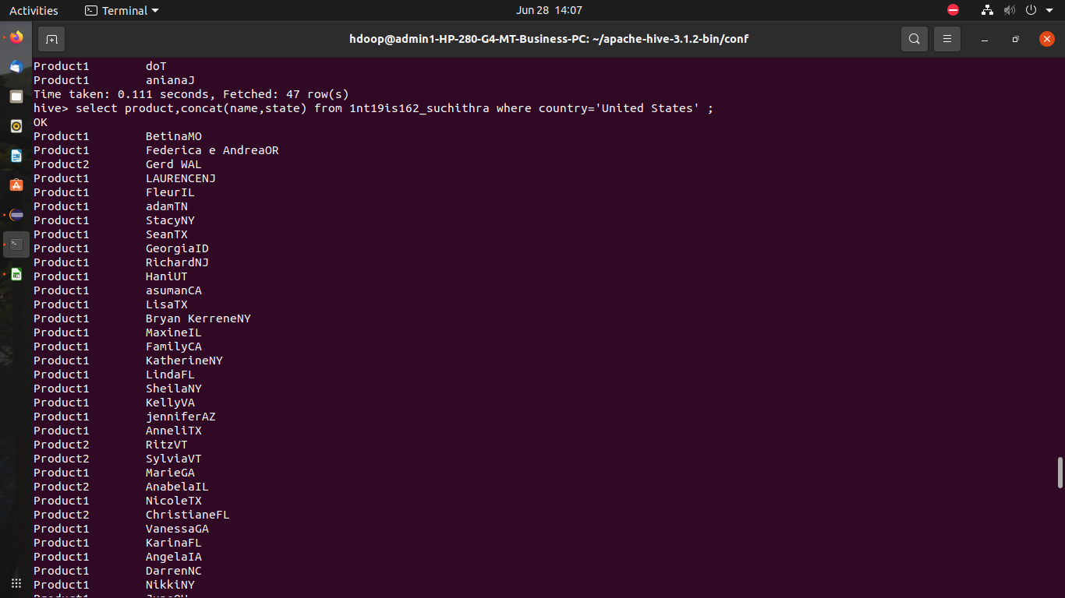

**Views**

Create view diners as select * from 1nt19is162_suchithra where payment_type=”Diners”;

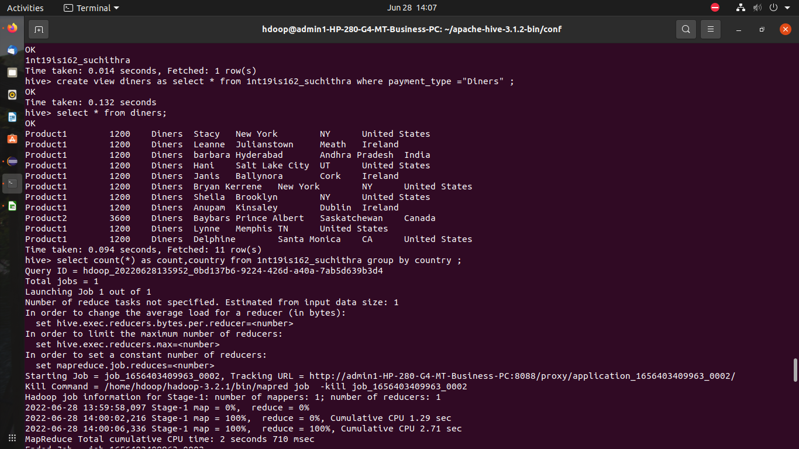

**HIVEQL**

**Group by:**

Select count(*) as count,country from 1nt19is162_suchithra group by country ;

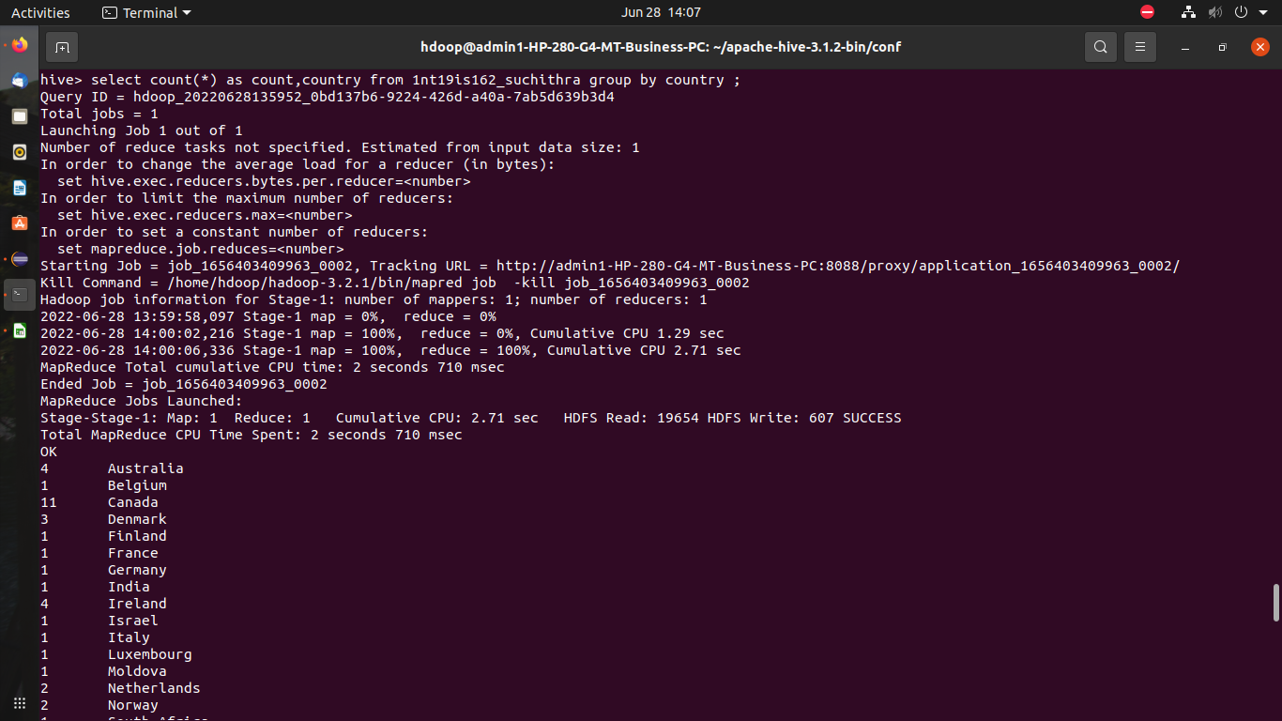

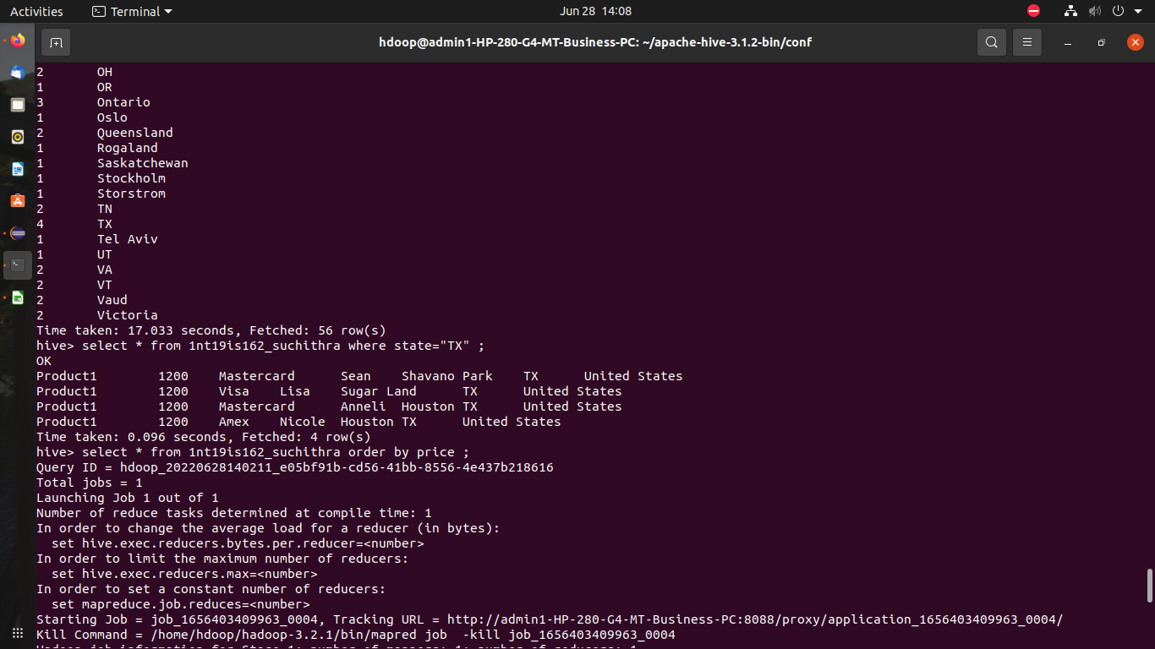

**Where**

Select * from 1nt19is162_suchithra where state=”TX” ;



**Order by**

Select * from 1nt19is162_suchithra order by price ;

