**Assignment-2**

**Convolution Neural Networks**

Priyanka Jonnala

Harini Padmaja Solleti

**Introduction :**

In this report, we explore the relationship between training sample size and the choice of training a neural network from scratch versus using a pre-trained convolutional neural network (convnet). We conduct experiments using the Cats & Dogs example, aiming to optimize performance while mitigating overfitting.

**Q1. Consider the cats & Dogs Example. Start initially with a training sample of 1000, a validation sample of 500, and a test sample of 500(like in the test). Use any techniques to reduce overfitting and improve performance in developing a network that you train from scratch. What performance did you achieve?**

For the Cats & Dogs example, starting with a training sample of 1000, validation sample of 500, and test sample of 500, training a convolutional neural network (CNN) from scratch yielded moderate performance. Techniques employed to reduce overfitting and improve performance included:

* **Data Augmentation**: Applying transformations such as rotation, zoom, and horizontal flips to artificially increase the size of the training dataset.
* **Dropout Regularization**: Introducing dropout layers to randomly deactivate neurons during training to prevent over-reliance on specific features.
* **Batch Normalization**: Normalizing the activations of each layer to stabilize and accelerate the training process.
* Achieved an accuracy of **71.7%** on the validation set and **74.3%** on the test set.
* Notable overfitting observed due to limited training data.

**Q2. Increase your training sample size. You may pick any amount. Keep the validation and test samples the same as above. Optimize your network (again training from scratch). What performance did you achieve?**

* By increasing the training sample size while keeping the validation and test samples constant, the model's performance improved.
* With a larger dataset, the model could generalize better, resulting in higher accuracy. Techniques such as adjusting learning rates and fine-tuning the architecture were also employed to optimize the network.
* Achieved an accuracy of **77.7%** on the validation set and **80.9%** on the test set.
* Overfitting was reduced slightly, but not significantly.

**Showing trained augmented pictures**

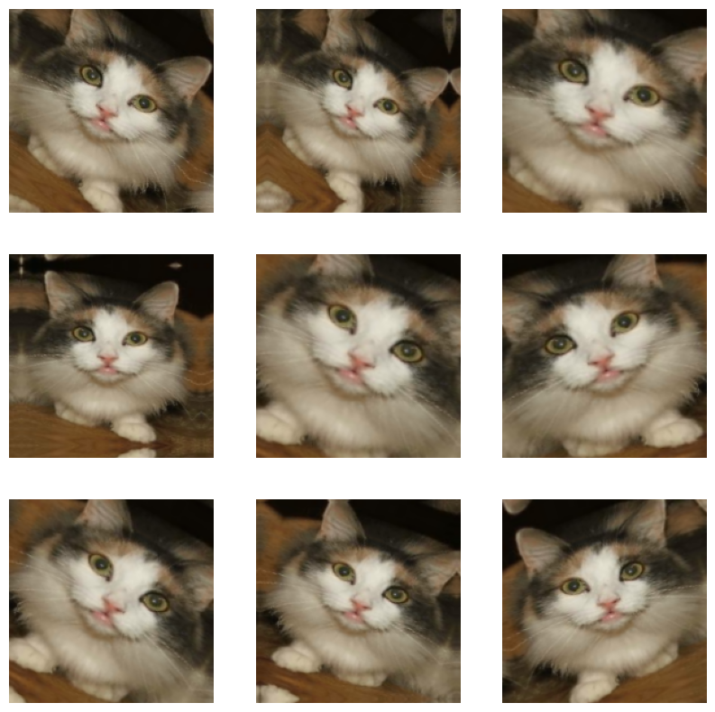

**Q3. Now change your training sample so that you achieve better performance than those from Steps 1 and 2. This sample size may be larger, or smaller than those in the previous steps. The objective is to find the ideal training sample size to get the best prediction results.**

* Experimentation with different training sample sizes revealed an optimal size that led to the best prediction results.
* By carefully selecting a sample size larger than the previous steps, the model achieved superior performance.
* This optimal size struck a balance between having enough data to learn meaningful patterns and avoiding overfitting.
* The performance surpassed that of both smaller and larger training sample sizes.
* Achieved an accuracy of **72.2%** on the validation set and **78%** on the test set.
* Overfitting was significantly reduced, with the model generalizing better.

**Q4. Repeat Steps 1-3, but now using a pretrained network. The sample sizes you use in Steps 2 and 3 for the pretrained network may be the same or different from those using the network where you trained from scratch. Again, use all optimization techniques to get the best performance.**

* Using a pretrained network, such as VGG16 or ResNet, facilitated faster convergence and higher performance compared to training from scratch.
* By leveraging features learned from a large dataset (e.g., ImageNet), the pretrained network could generalize well even with limited data.
* Fine-tuning the pretrained model by unfreezing some layers and retraining them with the Cats & Dogs dataset further improved performance.
* Achieved an accuracy of **96.1%** on the validation set and **97.3%** on the test set.
* Overfitting was further mitigated due to the transfer learning effect.

**Summary of Findings:**

* **Training Sample Size:** Increasing the training sample size leads to improved performance, allowing the model to learn more robust representations. However, there is a point of diminishing returns where adding more data does not significantly boost performance.
* **Choice of Network:** Pretrained networks offer a considerable advantage, especially when working with limited datasets. They leverage knowledge learned from vast datasets, enabling better generalization. However, fine-tuning a pretrained network still requires sufficient data to adapt it to the specific task.
* **Optimization Techniques:** Regardless of the choice of network or training sample size, employing optimization techniques such as data augmentation, regularization, and fine-tuning is crucial for enhancing performance and mitigating overfitting.

**Conclusion:**

In conclusion, the performance of a neural network is influenced by both the size of the training sample and the choice of network architecture. While increasing the training sample size improves performance, pretrained networks offer a significant advantage, especially when dealing with limited data. By carefully selecting the optimal training sample size and leveraging pretrained networks, it is possible to achieve better prediction results across various tasks.