**React - Virtual DOM, Reconciliation, Diffing Algorithm, Keys and DOM**

✔ DOM (Document Object Model)  
◼ It is the representation of HTML elements/nodes in tree format in the browser.

✔ Virtual DOM  
◼ It is the representation of actual DOM in memory.  
◼ It is nothing but a Javascript object.  
◼ It acts as middle layer between react components and actual DOM.  
◽ React components ➖ Virtual DOM ➖ Actual DOM  
◼ Virtual DOM is a old concept but React uses it effectively to make reconciliation process more powerful.

🙄 Sort an array of objects based on a specific property of the objects.  
🙄 Implement a function to reverse the order of words in a sentence without using the built-in `split` or `reverse` functions.  
🙄 Given two strings, find the longest common subsequence (not necessarily contiguous) between them.  
🙄 Implement a function to find the first non-repeating character in a string.  
🙄 Implement a function to check if a string is a valid parentheses sequence.  
🙄 Given a matrix, rotate it by 90 degrees clockwise (in-place or by returning a new matrix).  
🙄 Implement a function to flatten a nested object and convert it into a flat key-value pair.  
🙄 Find the missing number in an array containing consecutive numbers from a given range.  
🙄 Given an array of integers, rearrange the elements in such a way that all the even numbers appear before the odd numbers.  
🙄 Given a sorted array with duplicate elements, remove the duplicates in-place (without using extra space).  
🙄 Implement a function to generate all possible subsets of a given set.  
🙄 Implement a function to find the largest sum of a contiguous subarray within an array (Kadane's algorithm).  
🙄 Given an array of intervals, merge overlapping intervals.  
🙄 Implement a function to calculate the square root of a number without using built-in functions.  
🙄 Implement a function to find the kth smallest element in an unsorted array.  
🙄 Given a string, find the longest substring without repeating characters.  
🙄 Given an array of integers, rearrange the elements such that all negative numbers appear before the positive numbers, without changing the relative order of the elements.  
🙄 Implement a function to calculate the number of trailing zeros in the factorial of a given number.  
🙄 Given a string, find the longest palindromic substring.  
🙄 Given a string, check if it is a valid parentheses sequence considering multiple types of parentheses (e.g., (), [], {}).  
🙄 Implement a function to calculate the maximum sum of non-adjacent elements in an array.  
🙄 Given a sorted array, remove all occurrences of a specific value in-place.  
🙄 Given a string, find the length of the longest palindromic subsequence (not necessarily contiguous).  
🙄 Given an array of integers, find the maximum product of three numbers.  
🙄 Given a string, find the length of the longest substring with at most k distinct characters.

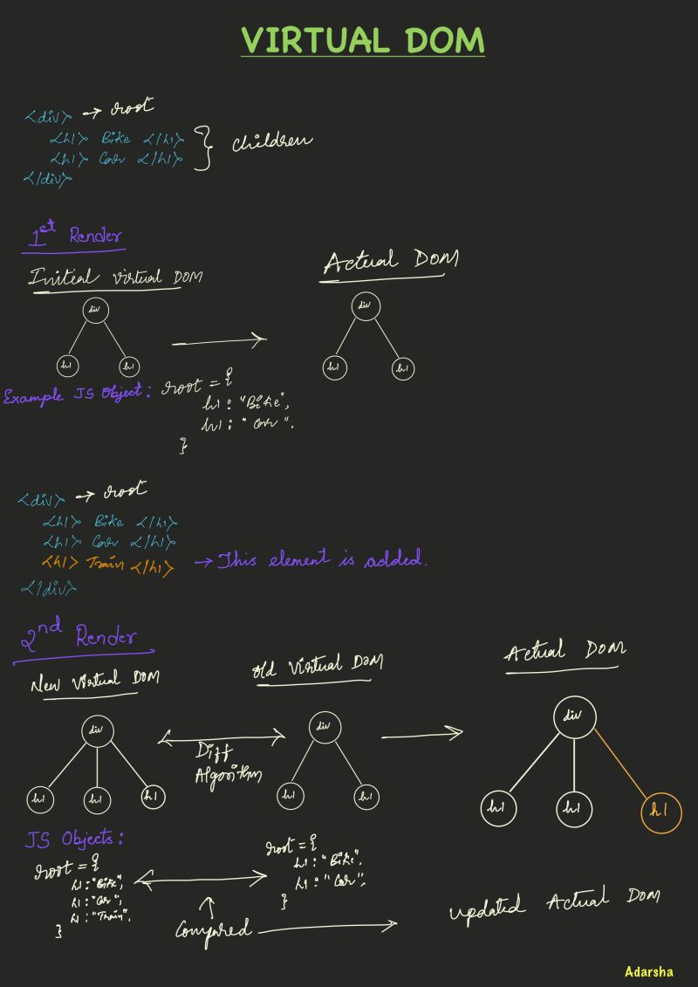

 Reconciliation ↔ Diffing Algorithm ↔ React Fiber  
◼ These are the core of React 🚀  
◼ Reconciliation is a process which uses "diffing algorithm" to compare two virtual DOMs (initial and updated) to find the difference between the HTML elements/nodes and updates the actual DOM using "only the updated nodes".  
◼ Behind the scene it actually compares two Javascript objects {👴} - {🧑}  
◼ React Fiber : It is the new reconciliation algorithm in React, it was released in React 16.

 Key property  
◼ Always provide a "unique value" to key whenever looping on any "list items". We usually use "map" method to loop over list items.  
◼ Providing keys to list items will make reconciliation process more efficient to render the HTML elements/nodes on to DOM.  
◼ Reconciliation process will come to know easily what was there (old virtual dom) and what has changed (new virtual dom) between the two renders and update the DOM elements quickly.  
◼ Try to get the unique values from the back-end data and avoid giving array index as key (suggested by React team).  
◼ Index will create issues if the sort operation performed on data (Index will be altered) and data will not displayed on the UI as expected.  
◼ Keep this (index) as last option if there are no unique values available.