1. **git version**
2. **git update**-**git**-for-**windows**
3. **pwd -🡪 to check current folder in gitbash**
4. **mkdir projects**
5. **cd projects**
6. **cloning a repository in github to local:**
   1. **git clone** [**https://github.com/PriyankaM-Hexaware/github-learning-29July.git**](https://github.com/PriyankaM-Hexaware/github-learning-29July.git)
   2. **status ----🡪 shows the current branch and also used to compare files between working directory,stating area,local repo and remote repo**

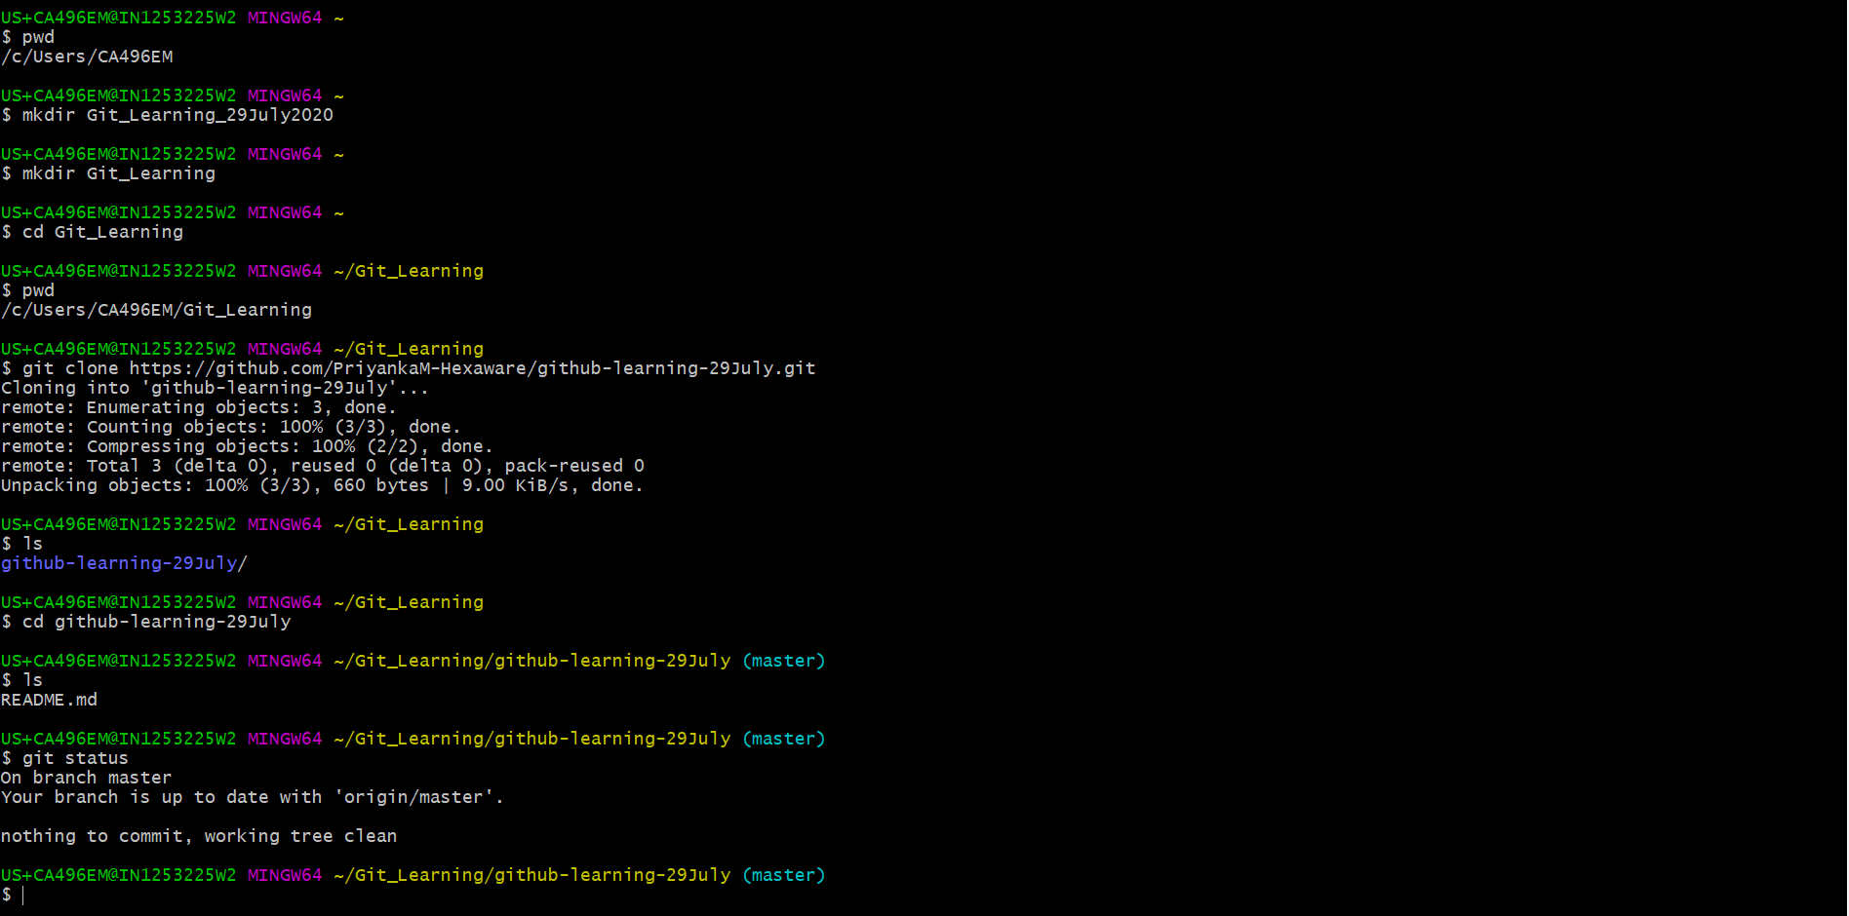

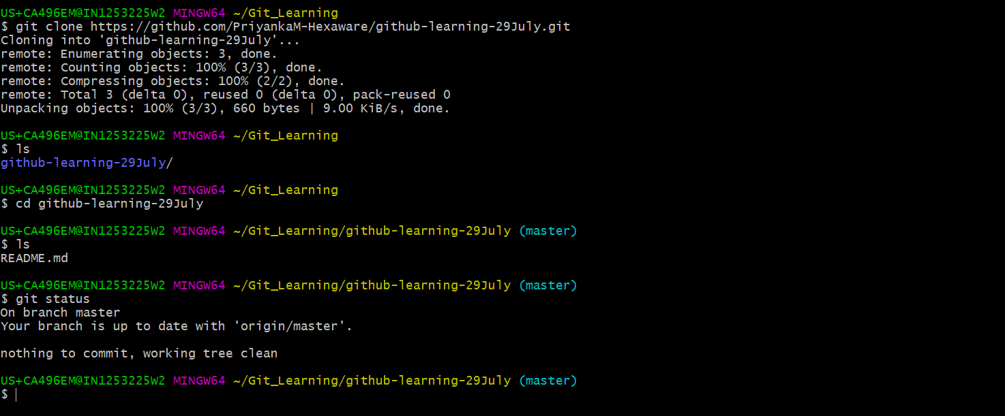

1. **Clear – to clean the screen in Git bash**
2. **echo "Test Git quick start excercise part 1" >> start.txt --🡪 to create a new file**
3. **ls --------🡪 to check the files in folder**
4. **cat start.txt --------🡪 to see content inside the file**

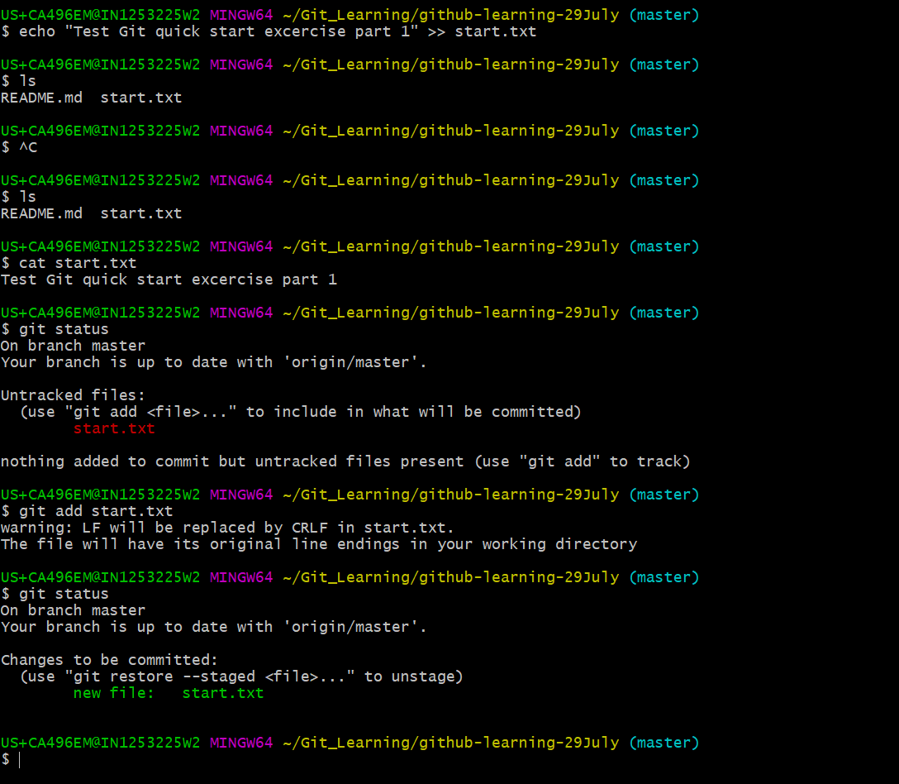

1. **git status ----- untracked files --------🡪 file in WD**
2. **git add start.txt “filename” -----------🡪 will help you to add file to staging area which is ready to e committed and if necessary can be altered numerous times before commiting to git local repo**
3. **Changes to be committed ---------🡪 file in staging area**
4. **git commit -m “Adding/Committing start textfile” --🡪 to save it in git local repo i.e. /.git in WD**

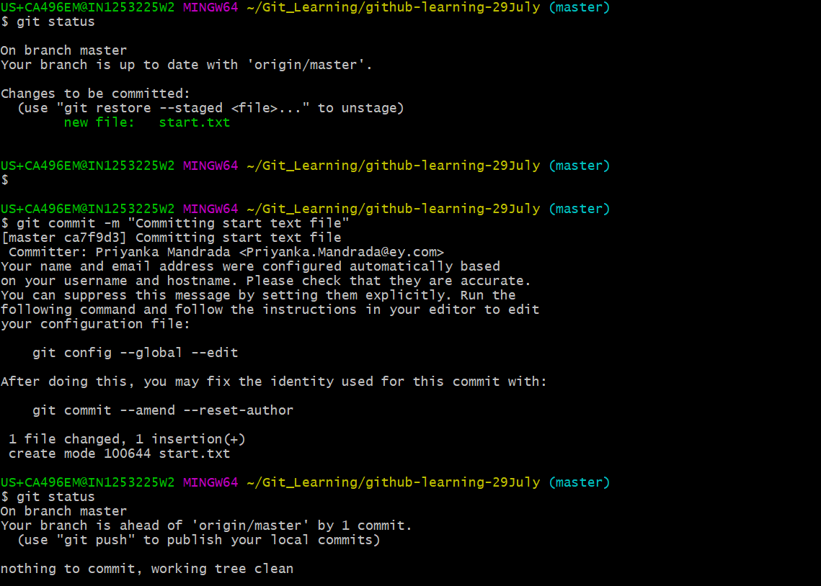

1. **Not file is in .git folder**
2. **Before git push:**

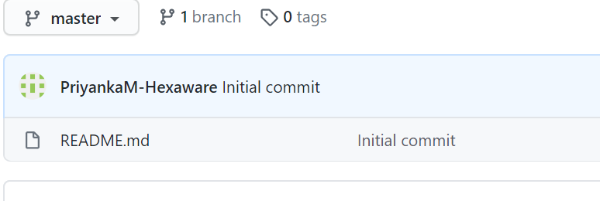

1. **Git push origin(github copy of out repo while creating new repo) master(default branch in github repo) ---------🡪 used to commit the changes to remote repo(github)**

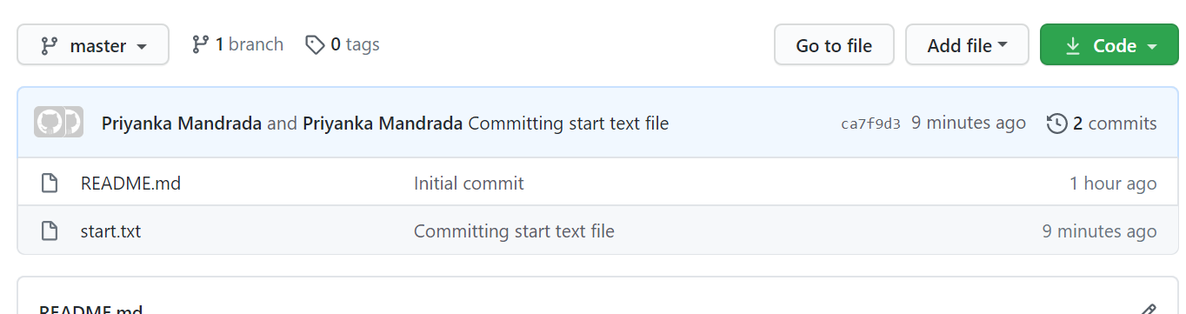

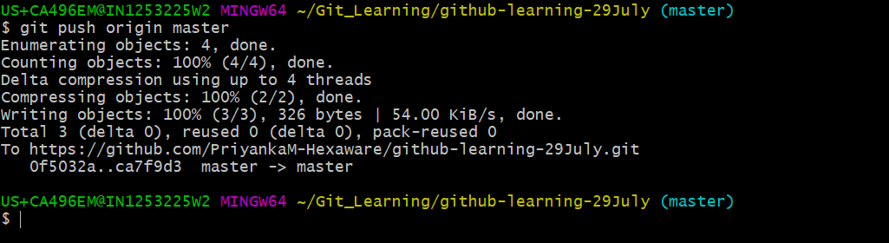

**Texteditor installation and configuring with git:**

1. **Install Notepad++**
2. **Add installed path of notepad++ in path of system – controlpaanel 🡪system🡪advance setting 🡪 environment variable, add path at the last and save it**
3. **Open git bash and type notepad++ -🡪 it will open up text editor**
4. **Alt+f4 – exit notepad++**
5. **Ctrl+w to close the file**

**Start Fresh project:**

1. **To create a new git project -🡪 git init Fresh-Project( project name)**
2. **Rm -rf project Fresh-Project (FreshProject) --------🡪 delets the git project**

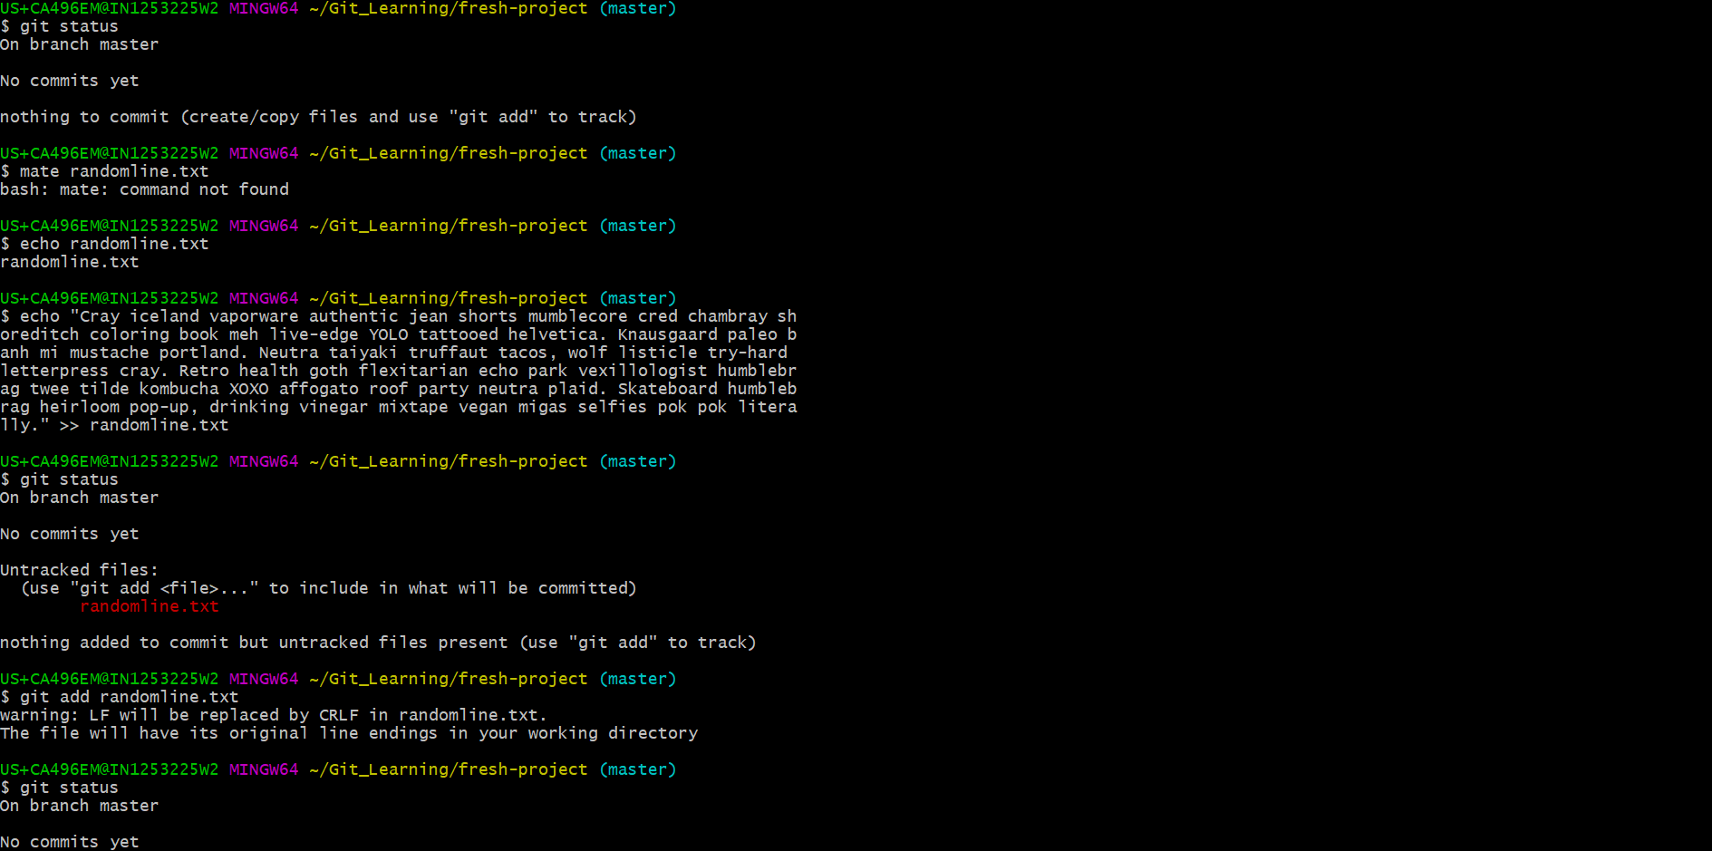

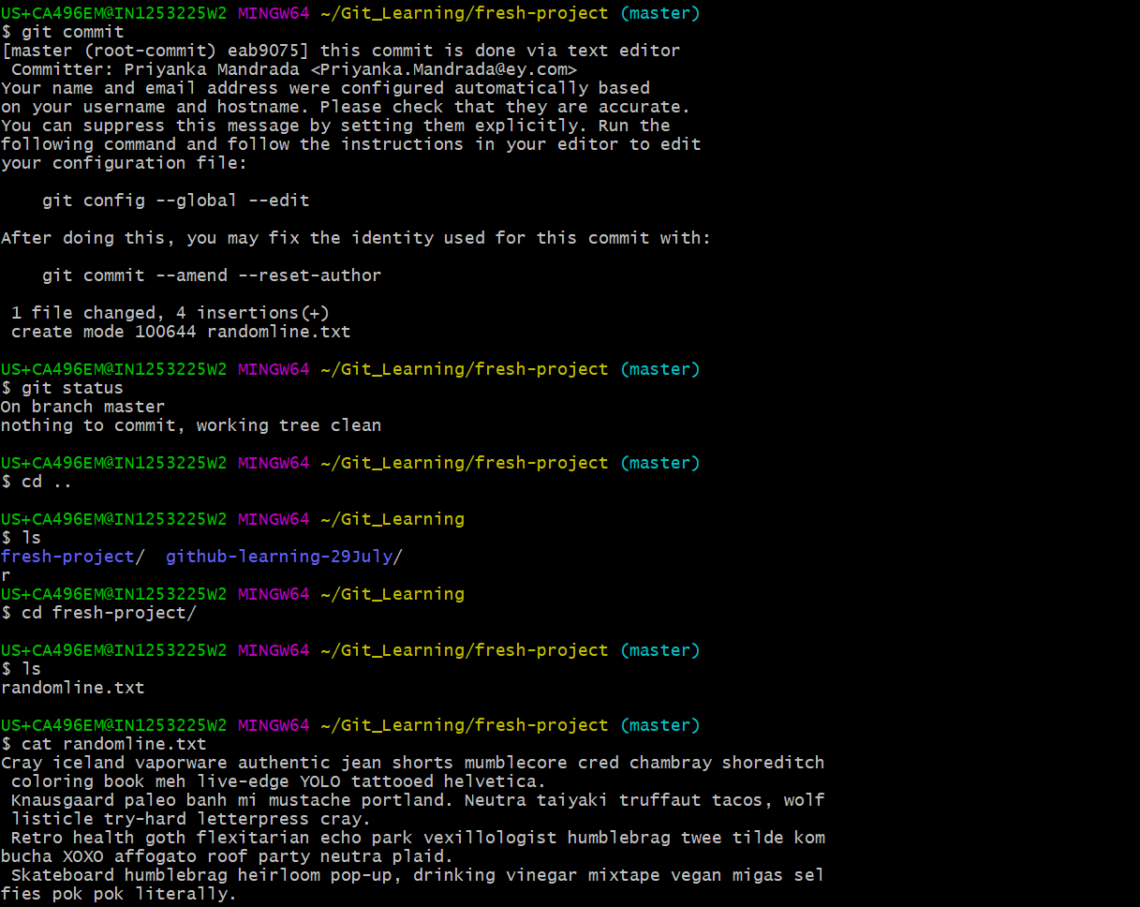

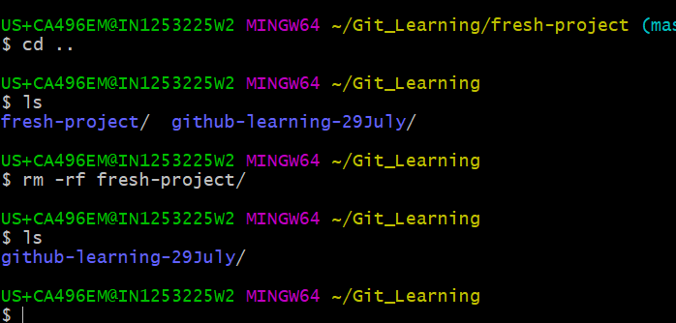

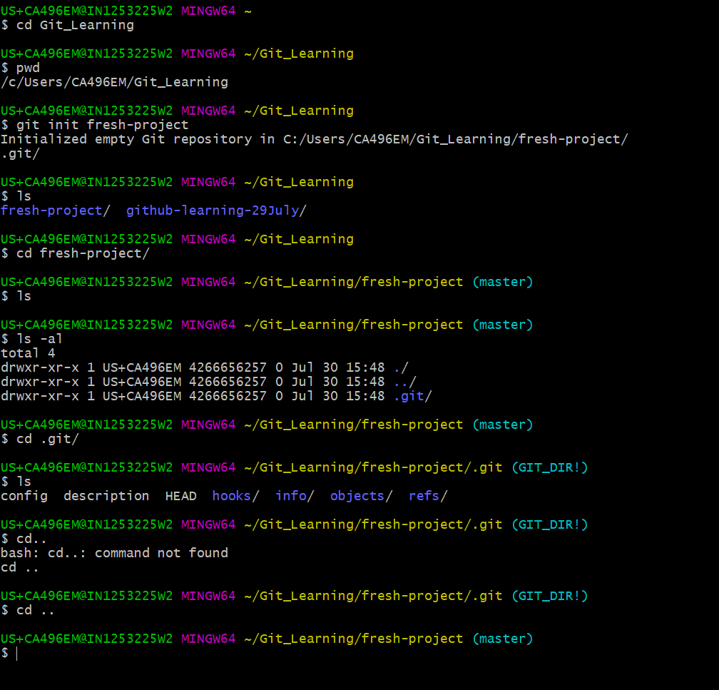

1. **Ls -al ---------🡪 shows all the files in folder including dot files**