**Ansible Assignment**

CPME-272 Section 49

Enterprise Software Platform

Submitted by

**Team Data Marvels**

Priyanka Math 015240134

Jithesh Kurungote Balakrishnan 014654679

Rajvi Shah 015523313

Tharun Mukka 014640496



**GitHub Repository link:** <https://github.com/PriyankaMath/DataMarvels>

**Instructor:** Andrew Bond

Created 3 CentOS Virtual Machines on Oracle VirtualBox

1. Ansible vm1 (Host)
2. Vm2 Clone (Client)
3. Vm3 (Client)

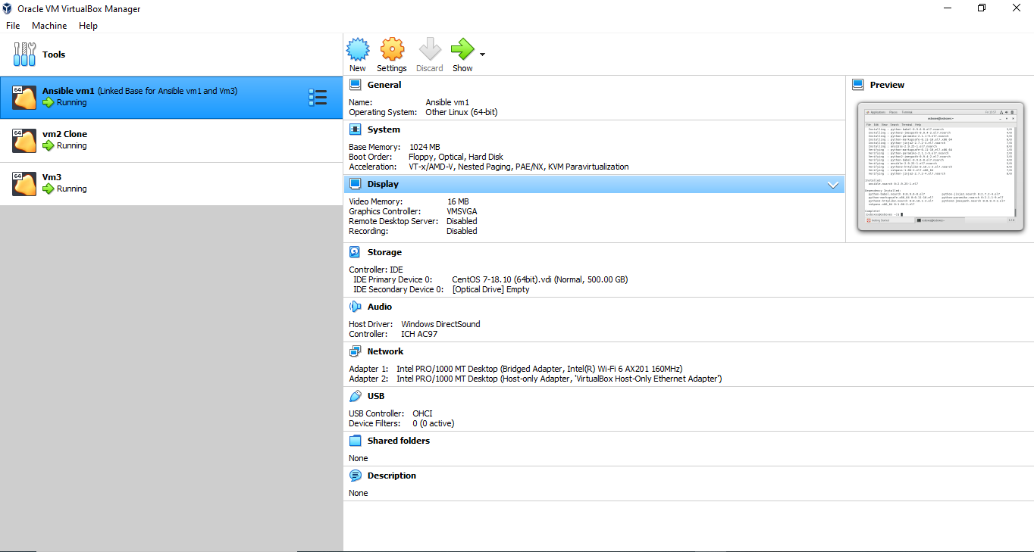

Network settings on each of the Virtual Machines

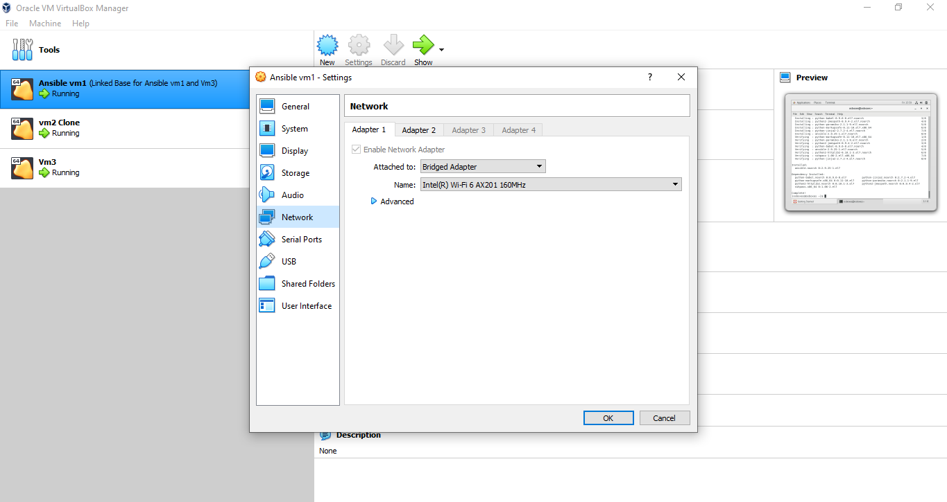

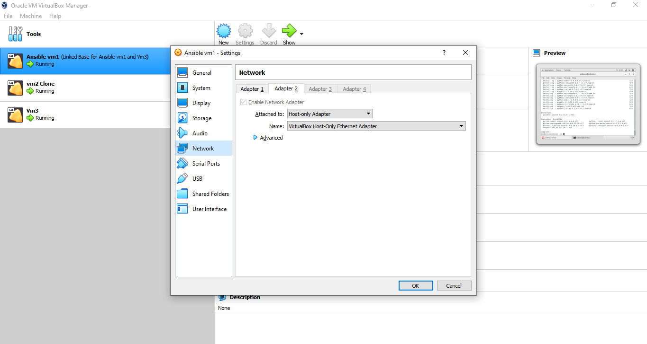

Installing Ansible on CentOS Ansible vm1

Commands:

$ sudo yum install epel-release

$ sudo yum install ansible

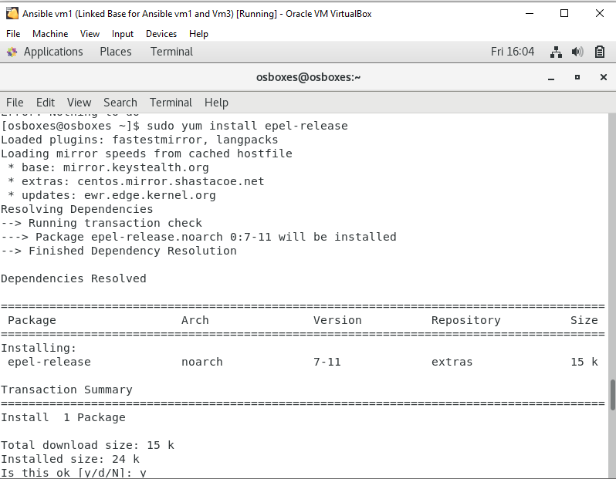

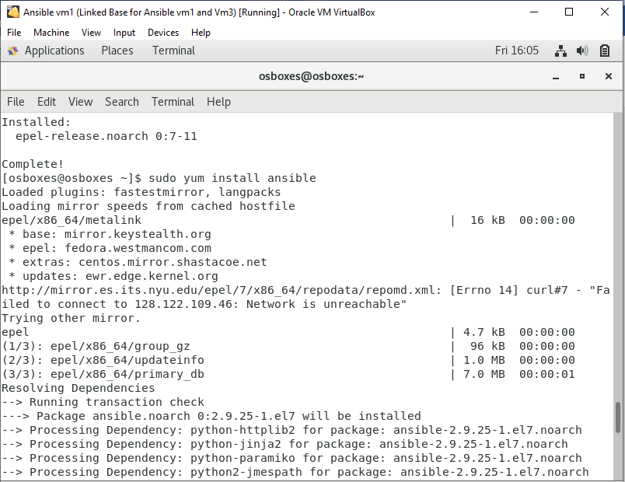

Creating the RSA key pair on Host Ansible vm1

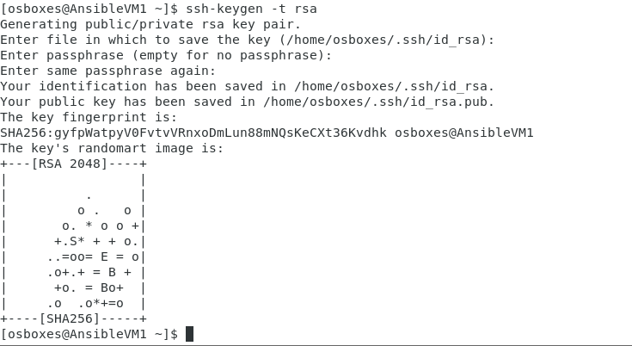

Ansible communicates with remote machines over the [SSH protocol](https://www.ssh.com/ssh/protocol/).

Confirming the connection using SSH to all the nodes in the inventory using the same username.

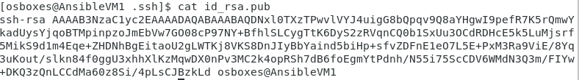

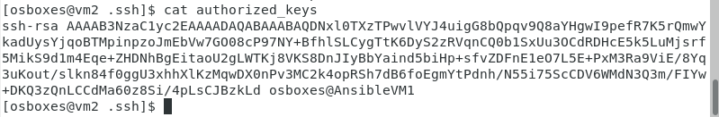

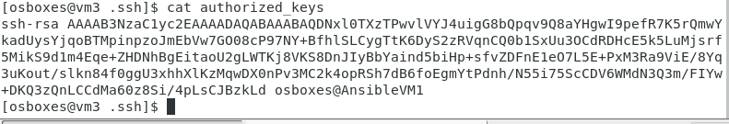

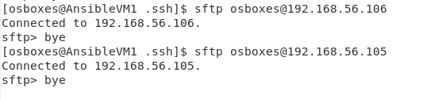

Setup of connectivity between host VM Ansible vm1 and other two client VMs without any password.

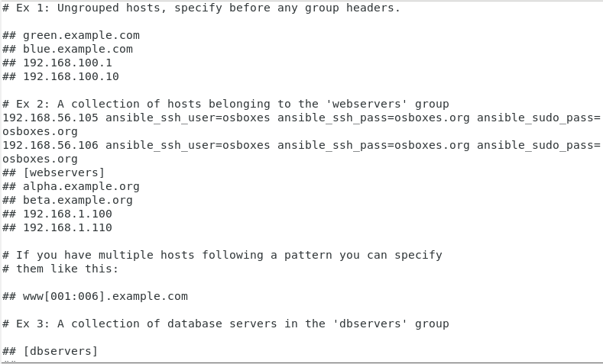

Validating Ansible install

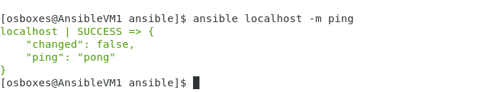

Ping to all the client VMs

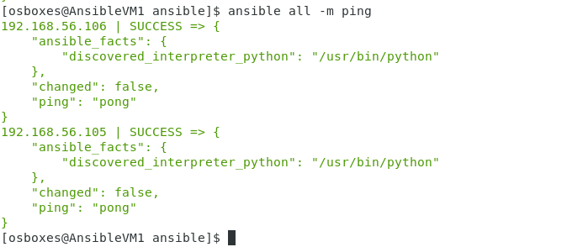

Playbook to deploy a web server to Client VMs on port 8080 that displays the message: “Hello World from SJSU”

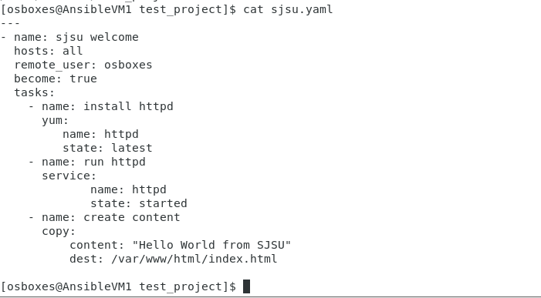

Configuring the web server ports of Client VMs from default 80 to 8080

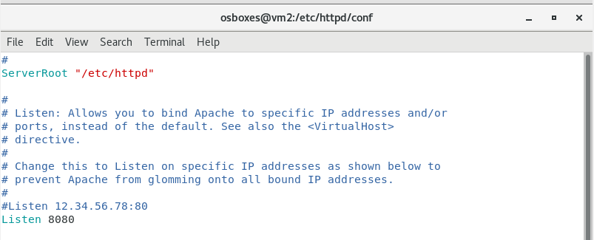

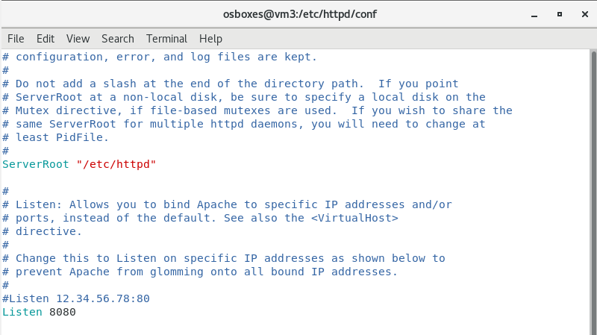

Output after running the playbook

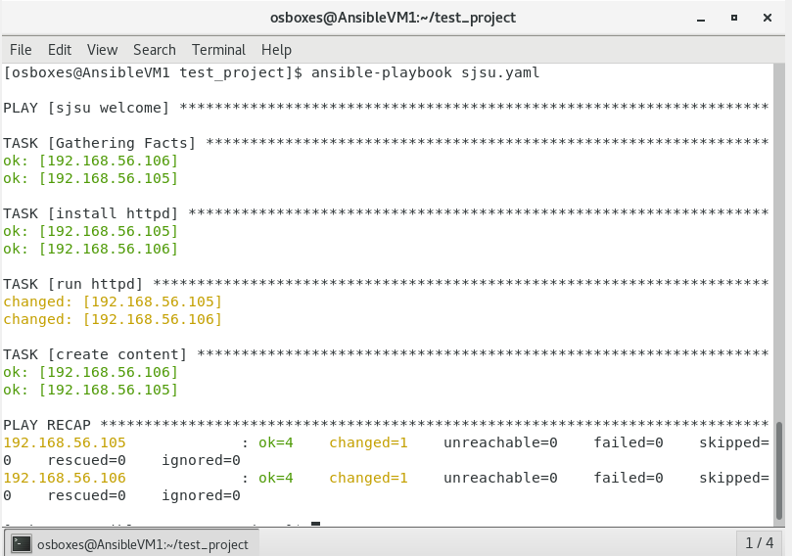

Web server displaying the message on Client VMs

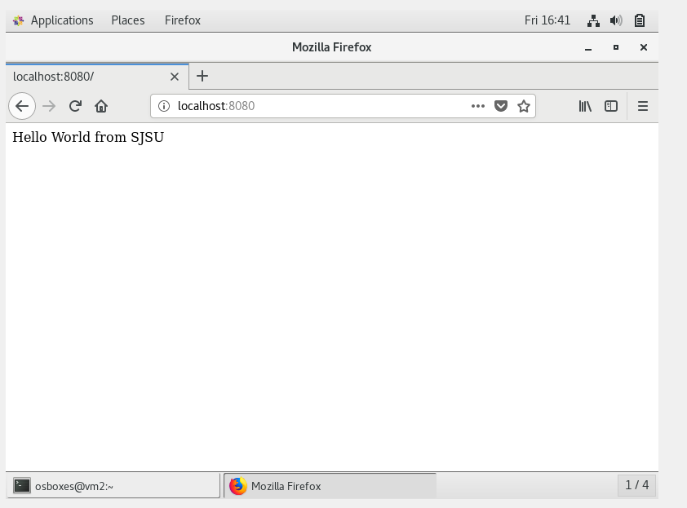

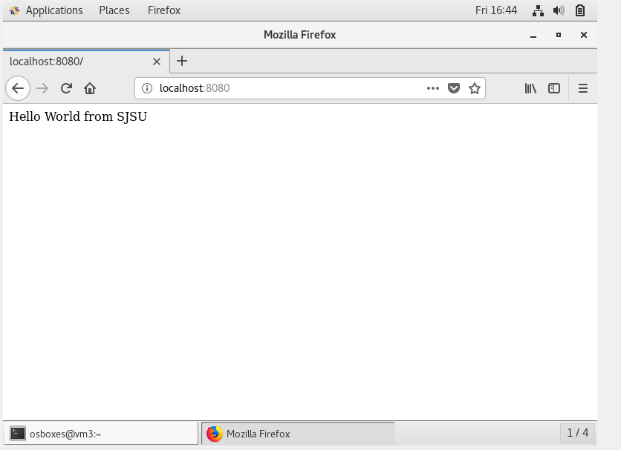

Playbook to un-deploy the web server

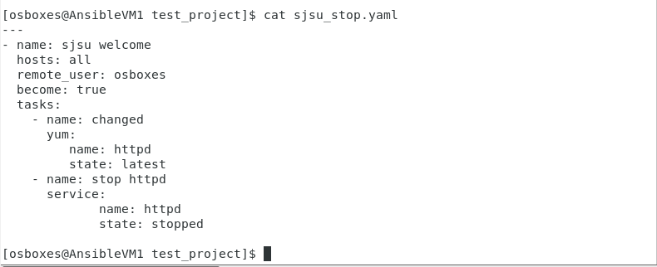

Output after running the playbook to un-deploy web servers on Client VMs

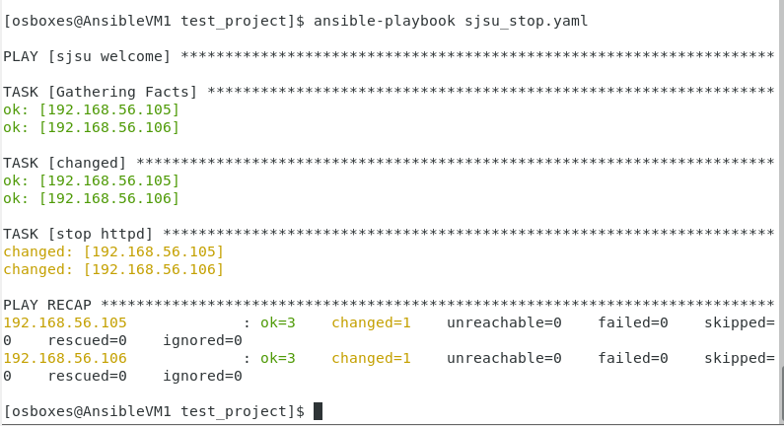

Verifying the un-deployed web server on Client VMs

