Linux Basic commands:

To check current directory(folder): > pwd

To list all files/folder under current directory: > ls (list of files)

Change current directory: cd <name of folder / path of folder>

Create new folder/directory : mkdir <folder_name>

create empty file: touch <filename>

print content of file: cat <filename>

Rename a file :mv oldfilename newfilename (mv:move)

copy one file to new : cp old_file_name new_file_name

to show file size :ls -al (list all)

delete the file : rm file_name

What is Git:

> Git is source control managment tool (Version control system)

> Git is used to track history of code changes

> Git tracks the changes you make to files, so you have a record of what has been done,

and you can revert to specific versions should you ever need to.

Benefits of using git:

> It maintains history of code changes

> We can go to any date in past and check the code at that point

> Used to collaborate efficiently in team

> allows multiple developers to work on feature parallely(indenpendently)

> Lost files can be easily recovered using history available

Types of Version Control System

> LocalVCS

> Centralized VCS

> Distributed VSC

GIT Services:

> Git: Software/Commandline Tool

> Github: Git website (microsoft)

> Gitlab: Git website

What is repository?

> Repository is directory/folder which stores all project files online

> It also has all past versions of all files

What is gitclone?

> Git clone command is used to make copy of repository from existing url

What is git pull?

> Git pull is used to fetch the changes from online repository

What is Branch?

> Branch is separate copy created by each developer for their independent work on new feature

How the branch is merged to main branch?

> Developers creates pull request from his feature branch to main branch

> Then other developers review the pull request and merge it into main branch

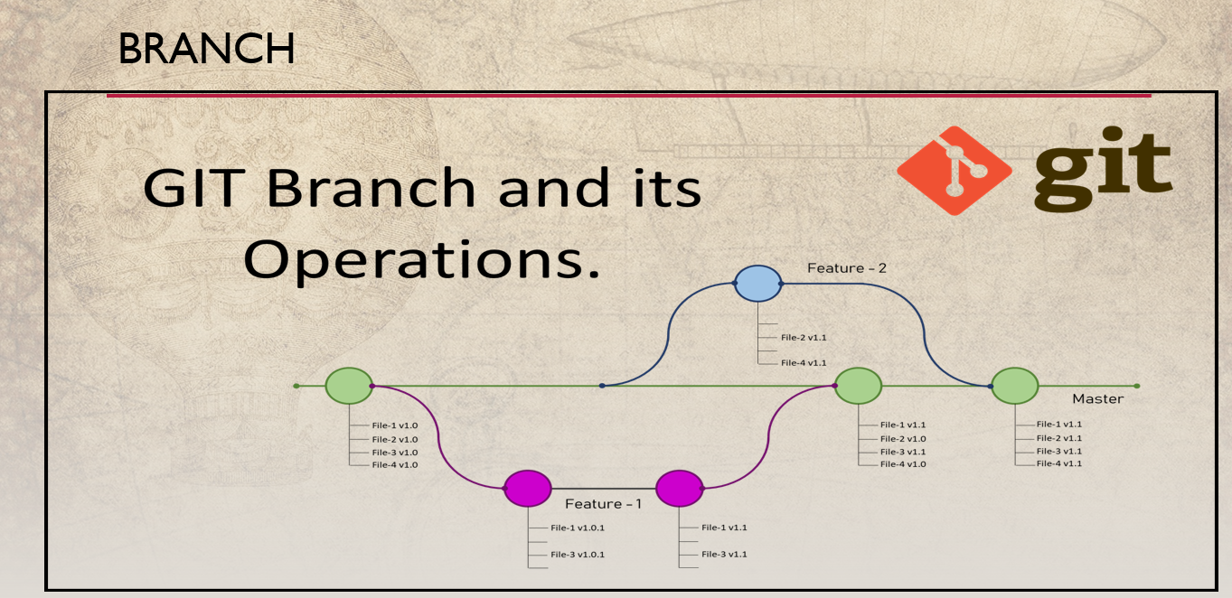

Git Commands:

1) Clone existing Repository from Githu

> git clone <repo_url> (https://github.com/PriyankaMetkar/GitTest.git)

2) check status of files changed

> git status

3) Add file to stagging area

> git add <file_name>

4) Commit the staged changes using message

> git commit -m <"commit message">

5) Upload/push the latest commit changes to the central or online repository

> git push

6) to check what is changed in file

> git diff <filename>

7) To check history of commits

> git log --graph

8)Remove File

>git rm <filename>

9) Pull the changes from online repo

> git pull

10) list all existing branches (show all branch names)

> git branch -a

11) change git branch

> git checkout <new_branch_name>

Git Workflow:

Step 1: git add (add changes to stagging area)

Step 2: git commit (tags current changes using message)

Step 3: git push (upload/push the latest commit changes to central repo/ online repo)