High Level Architechture
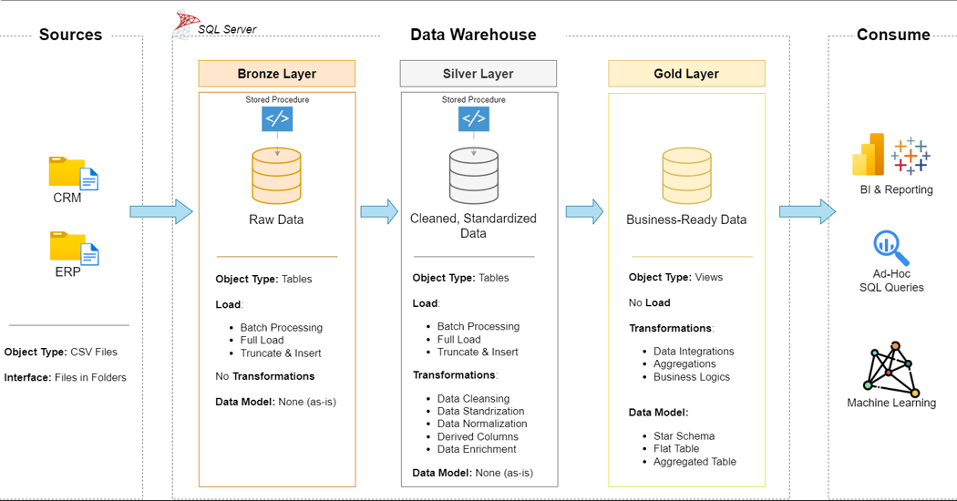

Data Flow(Data Lineage)
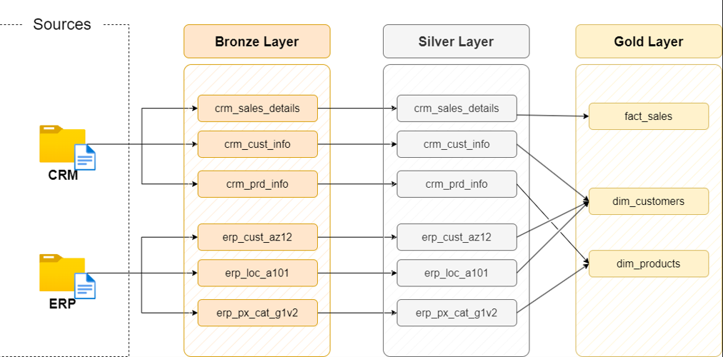

Bronze Layer Data Model
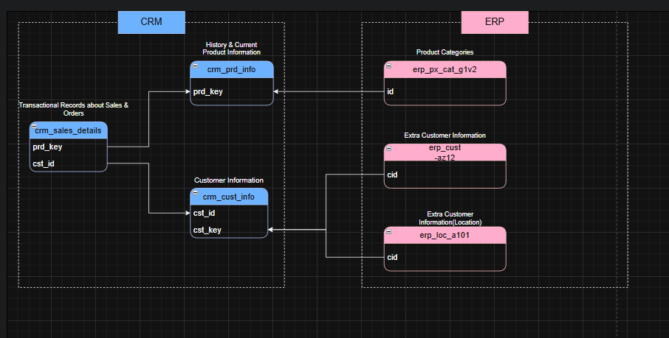

Silver Layer Data Model
Data Integration(How the tables are related)
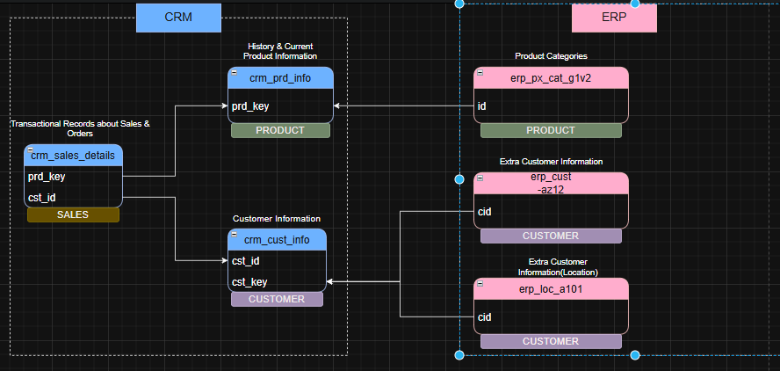

Gold Layer Data Model
Sales Data Mart (Star Schema)
