MANAGEGURU: Real Time Restaurant Monitoring System

Software engineering project 2017

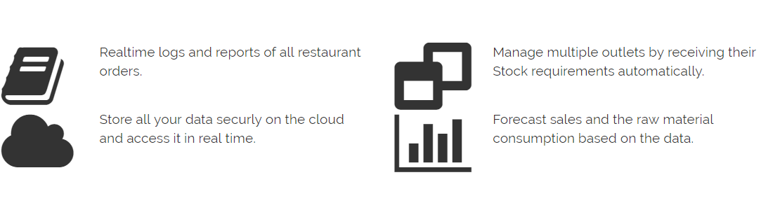

Team c8

N L Ramya 01FB14ECS124

Nachiketa Ramesh 01FB14ECS126

Nirmit Shetty 01FB14ECS134

Prerana Mehta          01FB14ECS164

Priyanka Narendra 01FB14ECS166

R Hariharan 01FB14ECS172

Rahul M 01FB14ECS176

Madhusudan H 01FB15ECS429

Nagaveni N K 01FB14ECS43

# Summary of the Project:

Mangeguru is an application for managing and monitoring data of restaurants. The real-time monitoring system has a high importance in the field of hotel management. With real time updates to the manager who need not be at the hotel’s location, can help him monitor its working at any time of the day. The manager has access to all the data generated and also concise reports on them. These reports help him to do his job better. With the application, the owner is well informed about what is going on in his outlets remotely. Not only does it keep him updated, it would also reduce potential fraud as the owner would get updates regularly. Analytics would provide trends and anything varying from these trends would be an indication for the owner to take caution.

Our system contains three main subsystems, the management end (hotel staff), the cloud computing system (analytics end) and the monitoring end (Real time updates/Reports).

The management end forms the data aggregation end of our system. The system is designed to provide an easy hotel management. The system is divided into more simpler components, 1) a simple web interface for the waiters to take in orders based on the current menu prepared by the head chef, 2) web interface for the billing staff to get all the orders placed by a particular table, 3) web interface for Inventory management and menu management for the head chef and 4) web interface for a local manager to administrate the whole system.

ManageGuru’s Cloud system form the central core system of our product. The updates from the management system is stored our cloud where analytics is performed on the gathered data. The cloud also runs a MySQL database server.

Based on the analytics reports on the functioning of the franchises management system is provided to the owner/manager who might not be present at the location. The system is a centralised system, so the owner/manager uses a mobile application to get real time updates by connecting to our Azure cloud.

Real-time application will provide the user with a mobile application that renders different real time stats management system, any time, any place. The system has a user authentication page at start and then the application renders the updates by invoking API’s designed at the cloud end.