***ASSIGNMENT 4***

1. Create collections “flights” inside database “airline_delayDB”

db = client['airline_delayDB']

#collection

collection = db['flights']

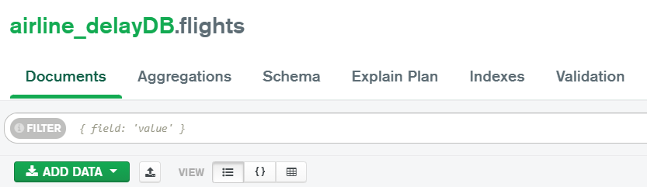

b. Average arrival delay caused by airlines



c. Arrange weekdays with respect to the average arrival delays caused. [Create a suitable plot using matplotlib/seaborn]

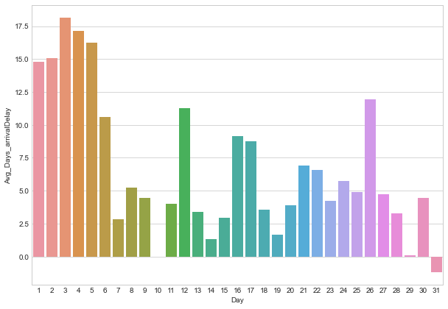

d. Arrange weekdays with respect to the average arrival delays caused. [Create a suitable plot using matplotlib/seaborn]

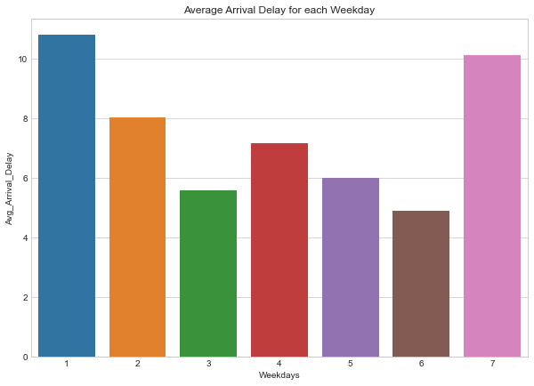

e. Arrange Days of month as per cancellations done in descending order.  [Create a suitable plot using matplotlib/seaborn]

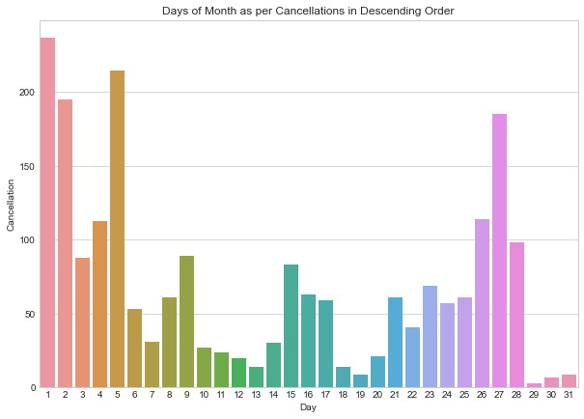

g. Find top 10 Airlines of US. Create a suitable plot using matplotlib/seaborn.

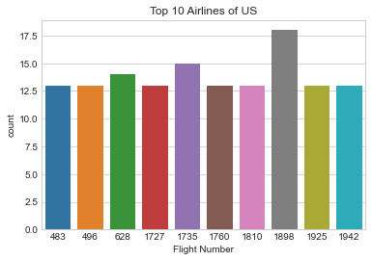

h. Finding airlines that make the maximum, minimum number of cancellations.



i. Find and show airlines names in descending that make the most number of diversions made. [Create a suitable plot using matplotlib/seaborn]

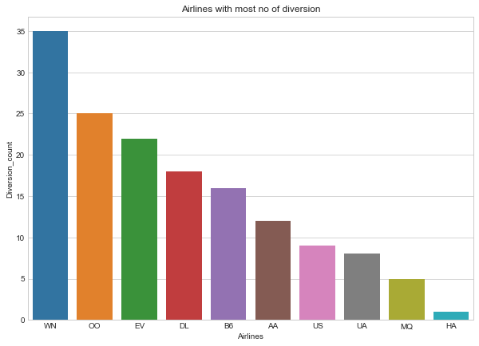

J. Finding days of month that see the most number of diversion

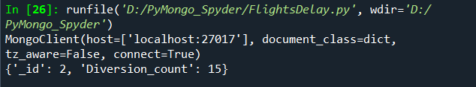

k. Calculating mean and standard deviation of departure delay for all flights in minutes

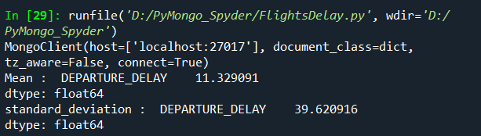

l. Calculating mean and standard deviation of arrival delay for all flights in minutes

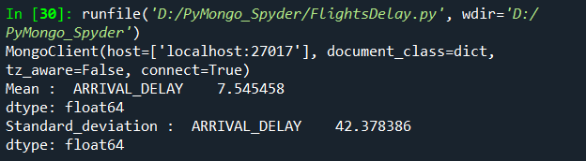

n. Finding all diverted Route from a source to destination Airport & which route is the most diverted route.

