CUT COMMAND
cut -b 1,2,3 file.txt = List without ranges
cut -b 1-3,5-7 state.txt = List with ranges
cut -b 1- state.txt = from 1st byte to end byte
cut -b -3 state.txt = from 1st byte to 3rd byte
cut -c4 file.txt = to print characters in a line by specifying the position of the characters.
cut -c4,6 file.txt = more than one character at a time
cut -c4-7 file.txt = print a range of characters in a line by specifying the start and end position of the characters.
cut -c-6 file.txt = first six characters in a line, omit the start position and specify only the end position.
cut -c10- file.txt = To print the characters from tenth position to the end, specify only the start position and omit the end position.
cut -c- file.txt = If you omit the start and end positions, then the cut command prints the entire line.
cut --complement -c 5 state.txt = except 5th char all will be there
cut -d- -f2 marks.txt - it shows only the 2nd field.
cut -d- -f2,3 marks.txt - it shows only the 2nd and 3rd fields.
cut -d- -f1- marks.txt - it shows only fields from 1st field to the last.
cut -d- -f-3 marks.txt - it shows only fields from starting field to the 3rd field.
cut -d- -f1-3 marks.txt - it shows only fields from 1st field to the 3rd field.
complement
cut -complement -d- -f2 marks.txt - it shows all the fields except field 2.
cut -complement -d- -f2,3 marks.txt - it shows all the fields except field 2 and 3.
cut -complement -d- -f1- marks.txt - it does'nt shows the fields from field 1 to the end.
cut -complement -d- -f-3 marks.txt - it shows all the fields except field from starting field to 3.
cut -complement -d- -f1-3 marks.txt - it shows all the fields except field from 1st field to 3rd field.
output-delimiter
cut -d- -f2 marks.txt --output-delimiter="%" - it changes the delimiter '-' to '%'
cut -d% -f2 marks.txt --output-delimiter="*" - it changes the delimiter '%' to '*'
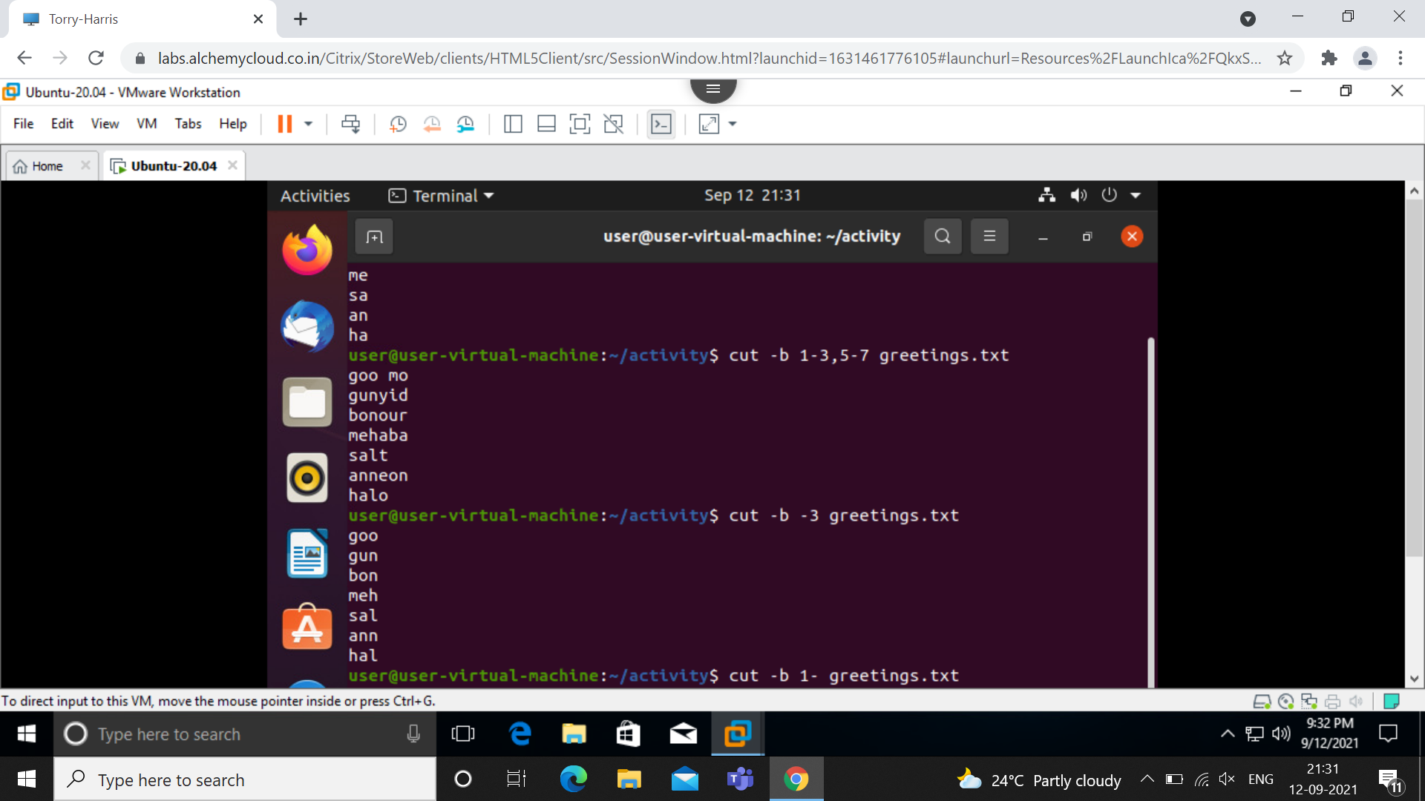
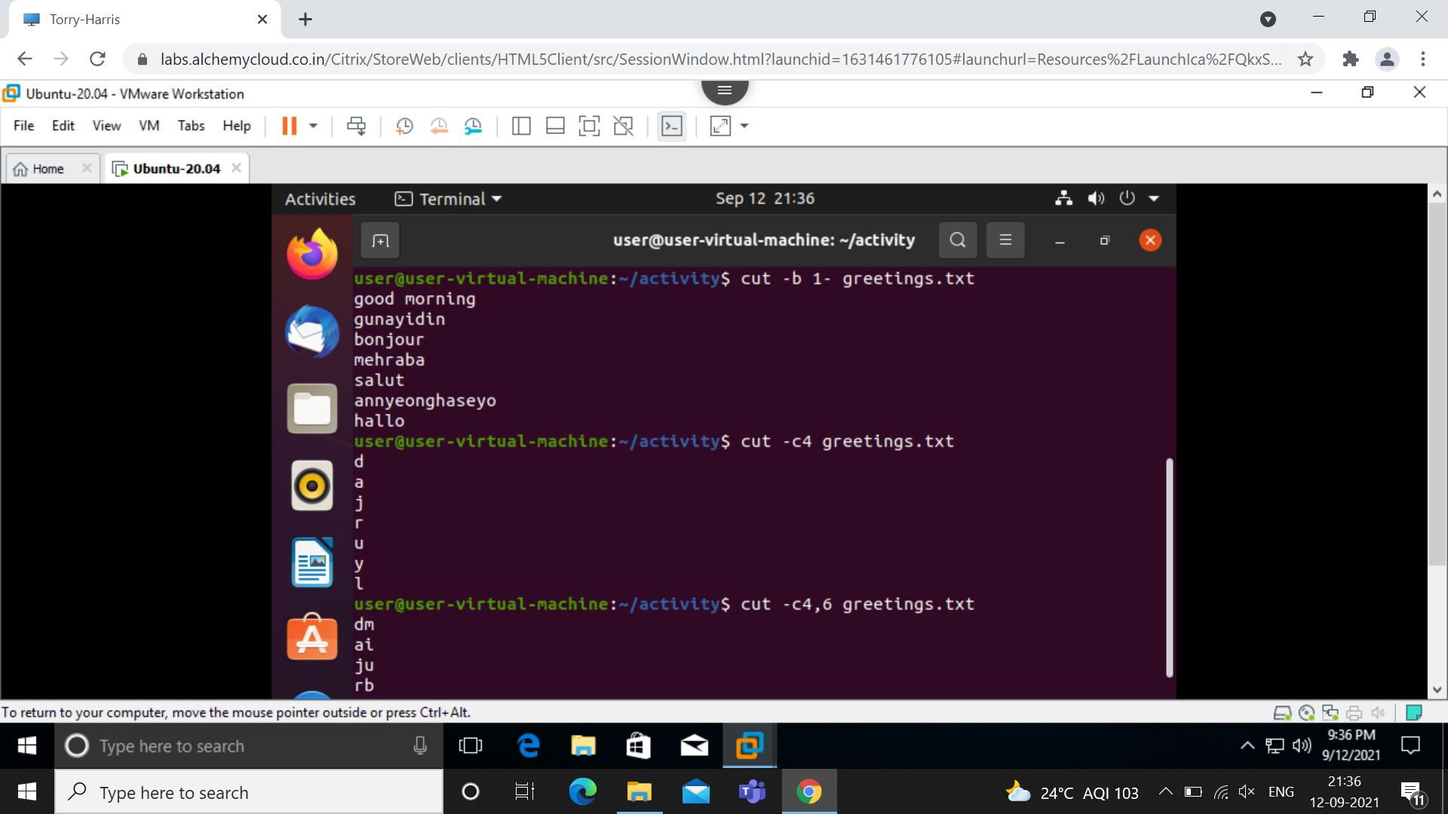
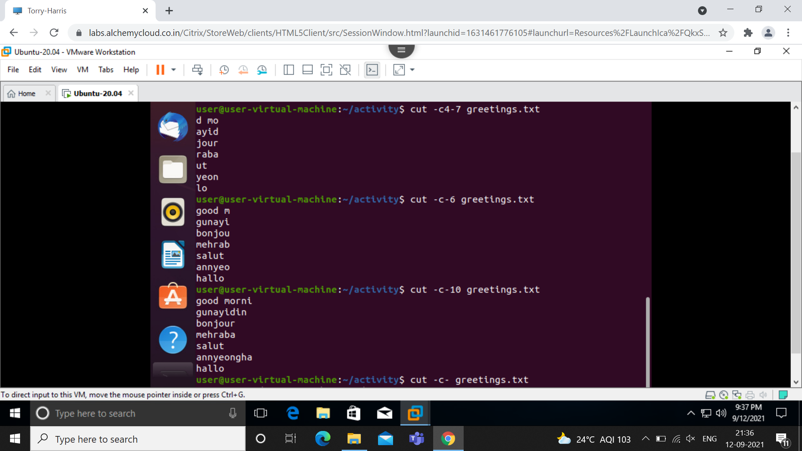

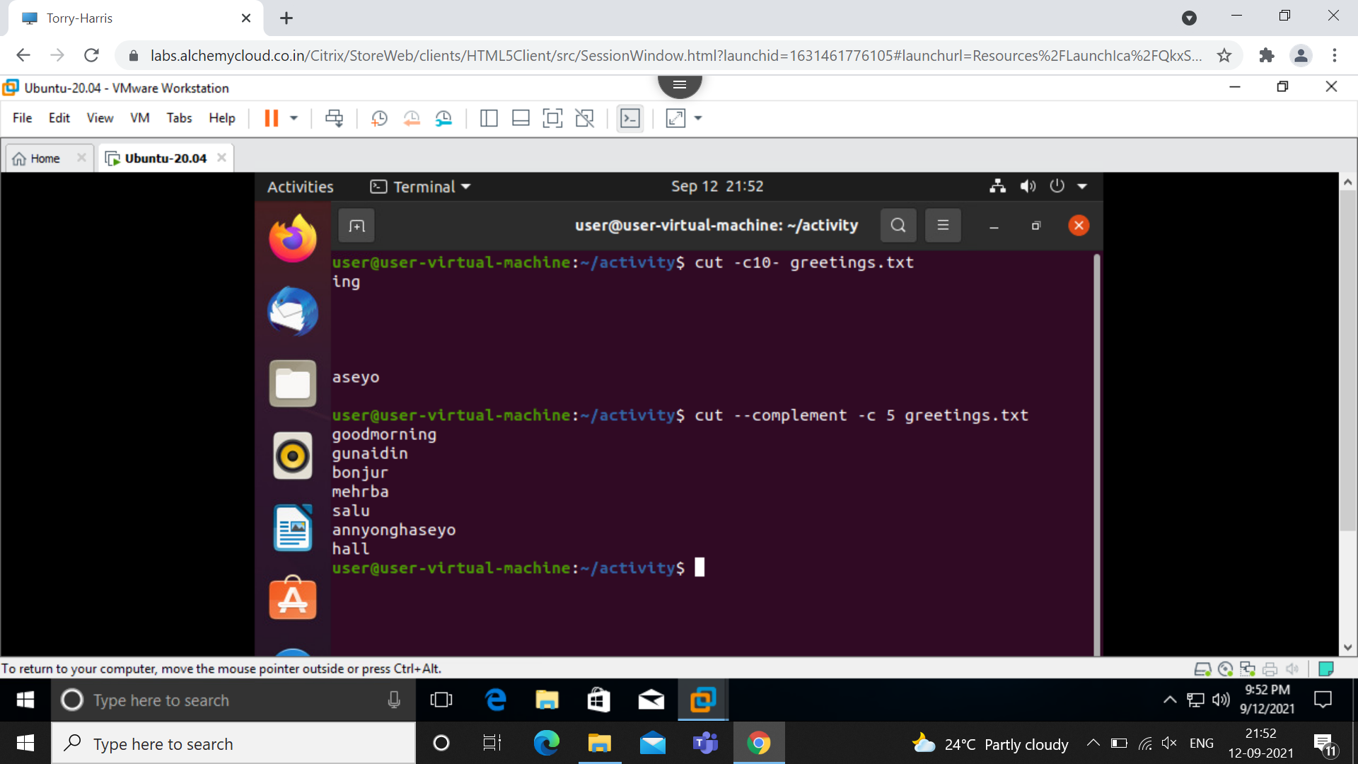

Sort Command
Sort file.txt-Sort the content in ascending order
Sort –r file.txt-display the sort in reverse
Sort –k 2 file.txt-Sort with respect to 2nd field
Sort –c file.txt-check the content in the file is sorted
Sort –u file.txt-sort and removes duplicate
Sort –n file.txt-sort the number
Sort –nu file.txt-sort the number and removes duplicate
Sort –M file.txt-sort the months
Sort –o output.txt file.txt-sorts and saves the output in output file
Sort –t “,” –k 1 file.txt-sort in 1st field for delimiter in the content
Sort –t “,” –k2nr file.txt-sort in 2st field for delimiter in the content and reverse it
