Online Second-Hand Book Selling System

Team members:

01fm19mca025: Kavya Goudar

01fm19mca024: Prarthana Charankar

01fm19mca014: Priyanka Goudar

Level 0 DFD

DB

Product details

Purchase details

Payment details

Sold book details

Customer

Admin

Admin

details

Processed

Customer details

details

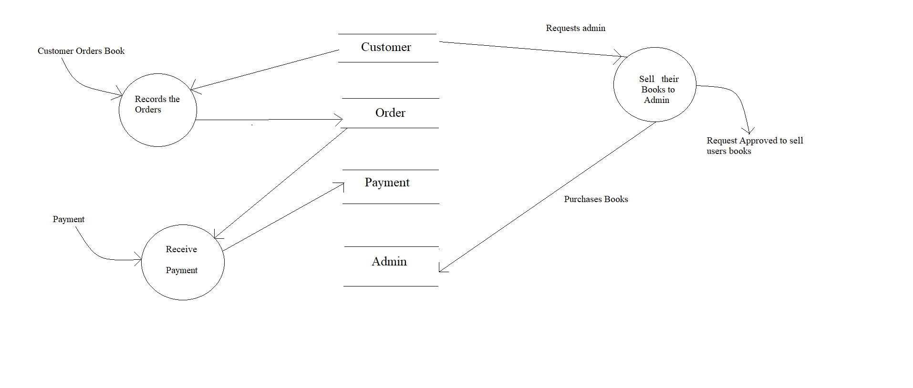Detailed DFD