**Design**

Project - Sign Language Recognition using Machine Learning

Name – Priyanka Rokhade

USN – 01FM19MCA014

**Block Diagram**

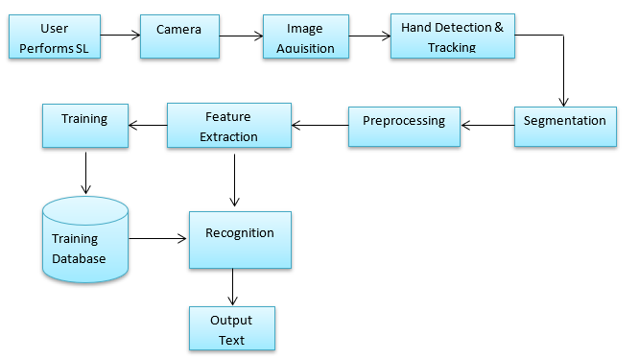

**Use Case Diagram**

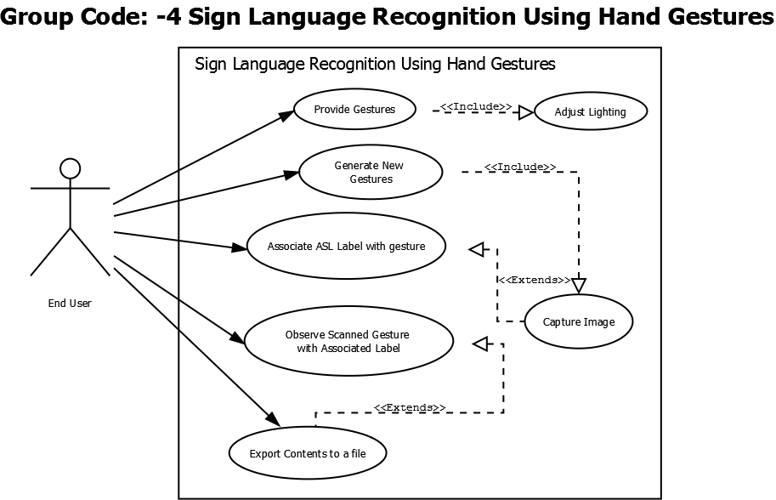

**Architecture Diagram**

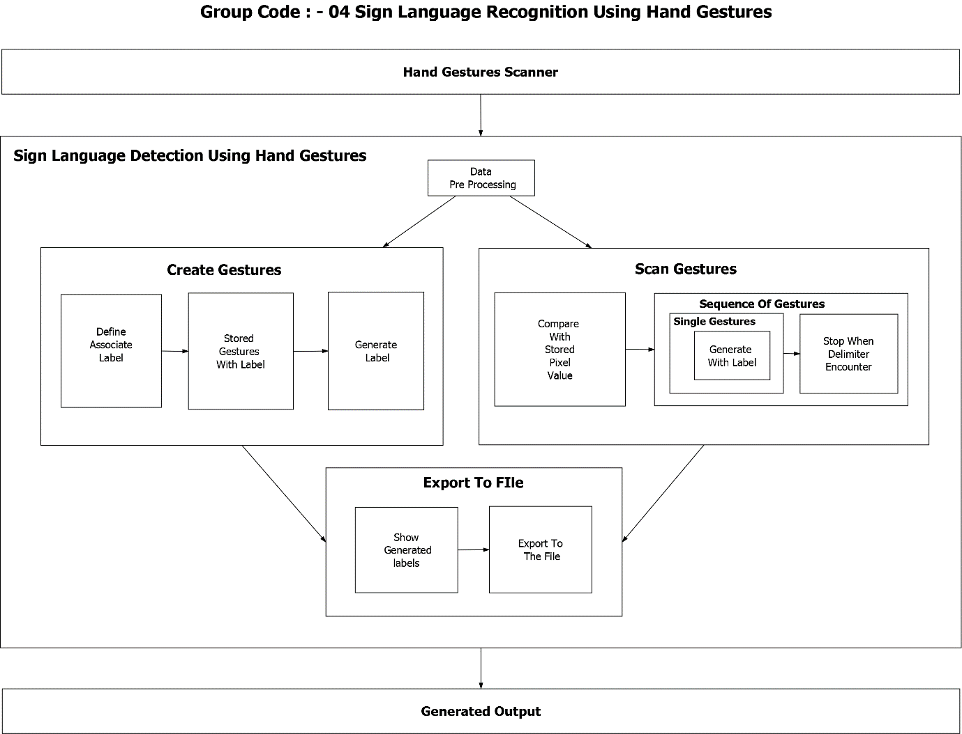

**Level 0 DFD**

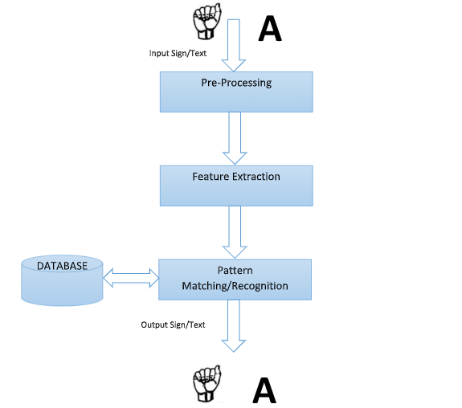

**Detailed DFD**

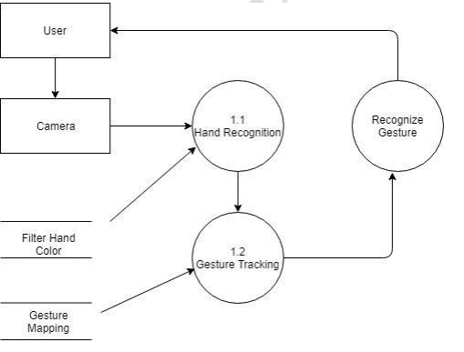

**Sequence Diagram**

