**Answer Sheet - SQL**

Name : Priyanka Arora

Phone No. : 9149113191

Email : [arora09011987@gmail.com](mailto:arora09011987@gmail.com)

**Major Question 1**

1. List the salary of all the employees.

Select ENAME, salary from Employee;

Insert Image-

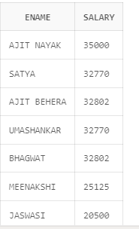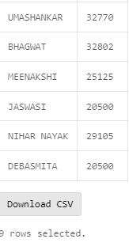

1. Display the names of all employees with any “A” at any place of the name.

or

select ENAME from Employee

where ENAME like '%A%';

*Select ENAME from Employee*

*where INSTR(ENAME,'A') is not null*

Insert Image – 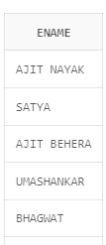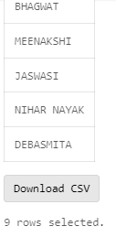

1. Show all employees who were hired in the first half of the month (Before the 16th of the month).

select * from department, employee

where department.DNUMBER = employee.DNO

and Extract (Day from MGRSTARTD) < 16

Insert Image –

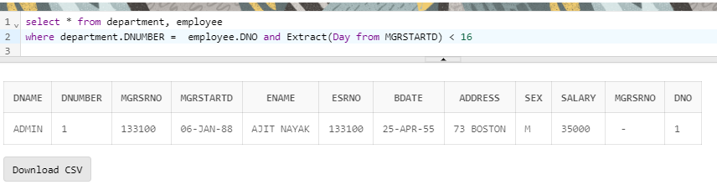

OR

SELECT ENAME, MGRSTARTD,Employee.MGRSRNO

FROM Employee

JOIN Department

ON Employee.ESRNO = Department.MGRSRNO

Where EXTRACT(DAY FROM MGRSTARTD) < 15

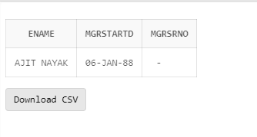

1. Display the name of all female employees.

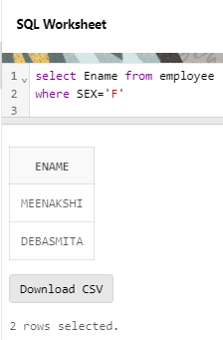

select Ename from employee

where SEX='F'

1. Display the employee who is paid most in the company.

select * from Employee

where salary = (select max(Salary) from Employee)

OR

select ENAME, salary from Employee

where salary=(select Max(salary) from Employee)

Insert Image –

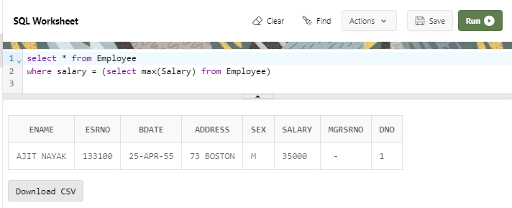

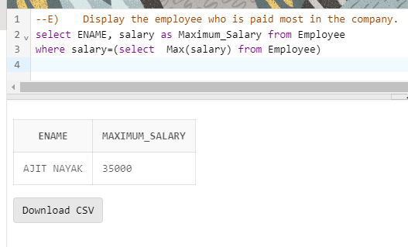

**Major Question 2**

1. Display employee name, address, department no and department name.

select ENAME, ADDRESS, DNUMBER, DNAME

from Employee,Department

where Department.DNUMBER = Employee.DNO

order by DNUMBER;

OR

select * from department, employee

where department.DNUMBER = employee.DNO

ORDER BY DNAME;

Insert Image –

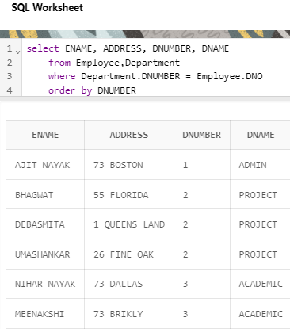

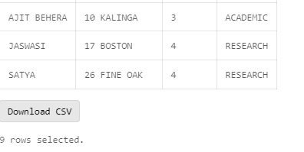

OR

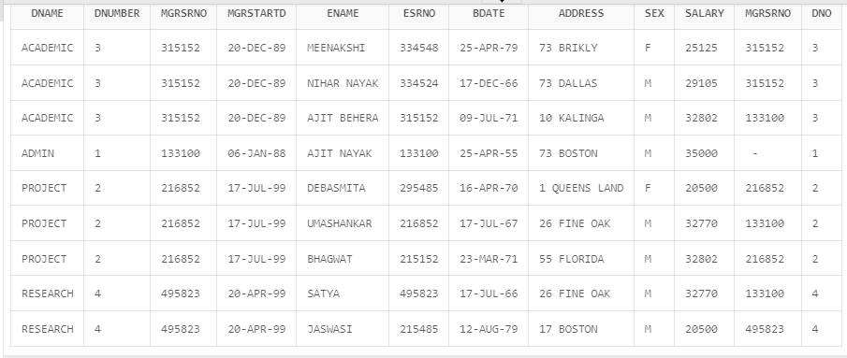

1. Display all the employees who are *not in* ACADEMIC department

select ENAME, ADDRESS, DNUMBER, DNAME

from Employee,Department

where Department.DNUMBER = Employee.DNO

and DNAME Not in 'ACADEMIC'

order by DNUMBER

Insert Image –

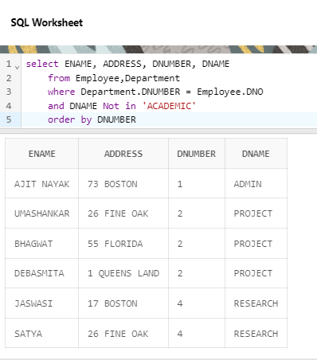

1. Display SATYAS’ project location.

SELECT ENAME,Project.PLOCATION

FROM Employee

INNER JOIN Project

ON Employee.DNO = Project.DNUM

where ENAME='SATYA'

OR

SELECT * FROM PROJECT,EMPLOYEE

WHERE DNUM =4 AND ENAME ='SATYA'

Insert Image –

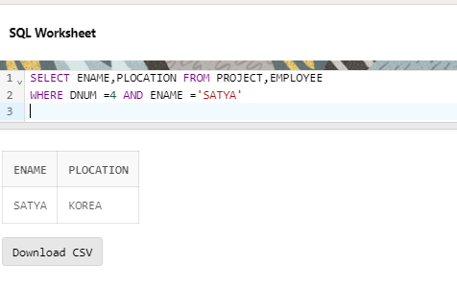

OR

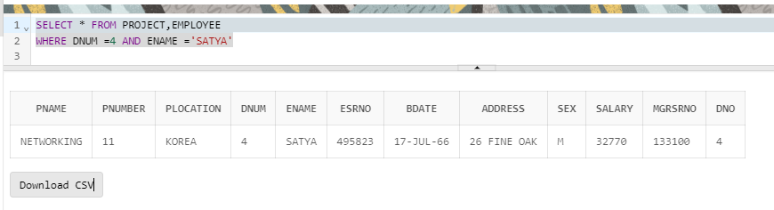

1. Find the total working hours of *each* female employee.

SELECT e.ESRNO, SUM(w.hours), e.ENAME

FROM works_on w

JOIN Employee e ON w.ESRNO = e.ESRNO

WHERE e.sex = 'F'

GROUP BY e.ESRNO, e.ENAME;

Insert Image –

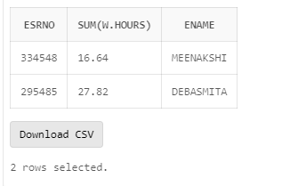

1. Display the details of the people whose projects are located at SOUTH AFRICA.

select p.PNAME,p.PNUMBER,p.PLOCATION,p. DNUM,e.ENAME,e.ESRNO,e.BDATE,e.ADDRESS,e.SEX,e.SALARY,e.MGRSRNO

from Employee e

join Project p

on e.DNO = p.DNUM

where PLOCATION='SOUTH AFRICA'

Insert Image –

