**Answer Sheet - SQL**

Name : Priyanka Arora

Phone No. : 9149113191

Email : [arora09011987@gmail.com](mailto:arora09011987@gmail.com)

**Major Question 1**

1. List the salary of all the employees.

*Select ENAME, SALARY from Employee*

Insert Image-

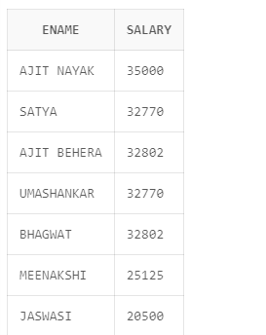 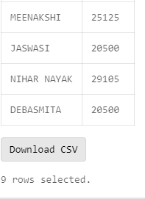

1. Display the names of all employees with any “A” at any place of the name.

*Select ENAME from Employee*

*where INSTR(ENAME,'A') is not null*

Insert Image –

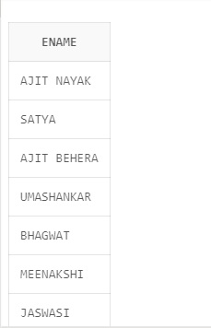 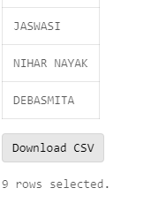

1. Show all employees who were hired in the first half of the month (Before the 16th of the month).

SELECT ENAME, MGRSTARTD,Employee.MGRSRNO

FROM Employee

INNER JOIN Department

ON Employee.MGRSRNO = Department.MGRSRNO

Where EXTRACT(DAY FROM MGRSTARTD) < 15

Insert Image –

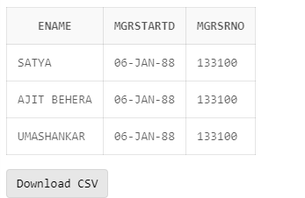

1. Display the name of all female employees.

--D) Display the name of all female employees.

select * from Employee

where sex='F'

Insert Image –

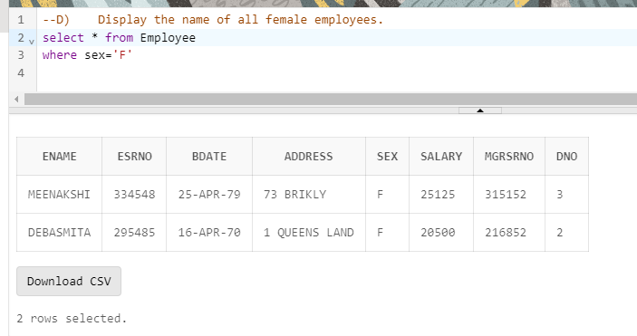

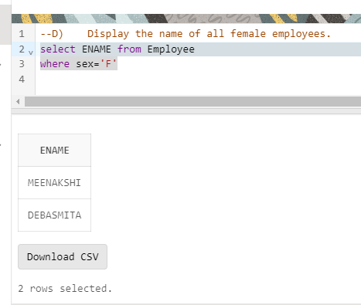

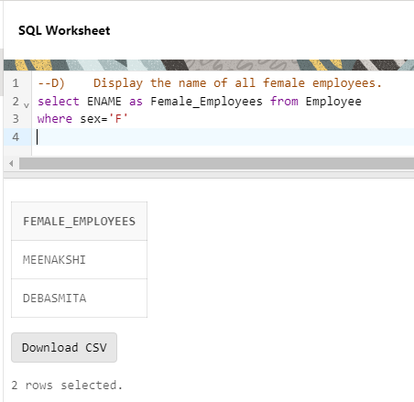

1. Display the employee who is paid most in the company.

--E) Display the employee who is paid most in the company.

select ENAME, salary from Employee

where salary=(select Max(salary) from Employee)

Insert Image –

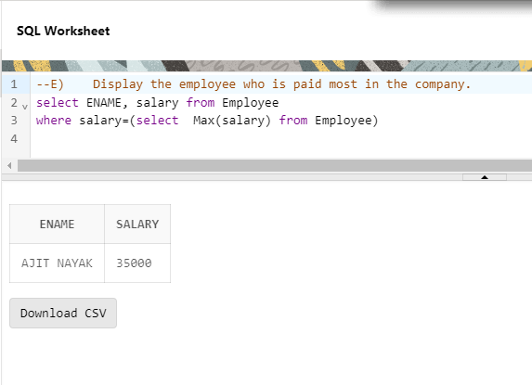

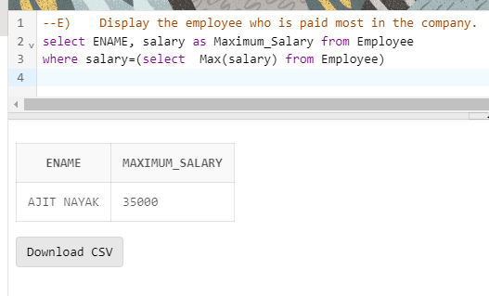

**Major Question 2**

1. Display employee name, address, department no and department name.

SELECT ENAME, ADDRESS,Department.DNAME,Department.DNUMBER

FROM Employee

LEFT JOIN Department

ON Employee.MGRSRNO = Department.MGRSRNOLEFT JOIN Department

ON Employee.MGRSRNO = Department.MGRSRNO

Insert Image –

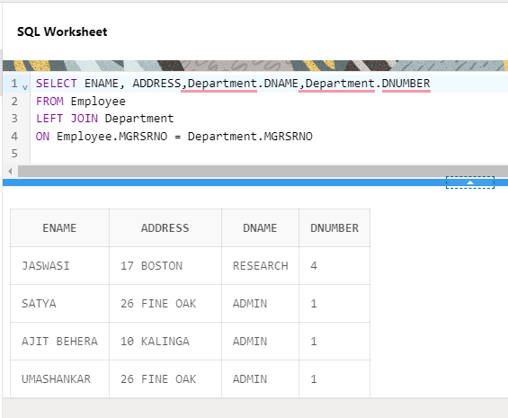

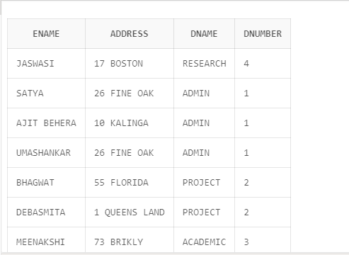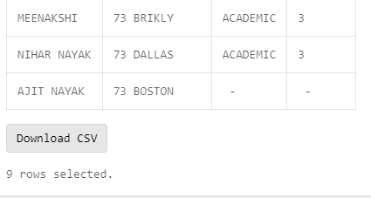

NOTE:- I have applied “left join” as I want the detail of all “employees” whether they have “dno and dname” or not ;

if we want the name of only those “employees” whose “dno and dname” is mentioned we can use inner join.

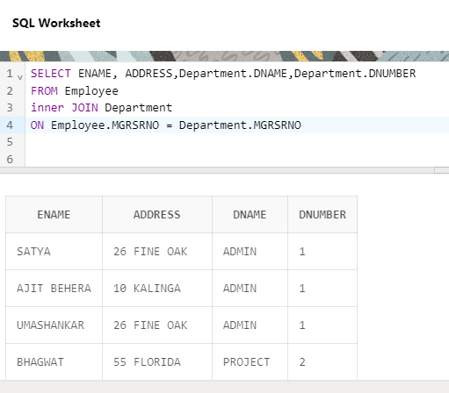 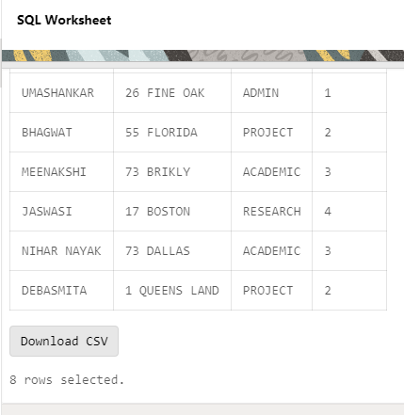

1. Display all the employees who are *not in* ACADEMIC department

SELECT ENAME,Department.DNAME

FROM Employee

inner JOIN Department

ON Employee.MGRSRNO = Department.MGRSRNO

where DNAME !='ACADEMIC'

Insert Image –

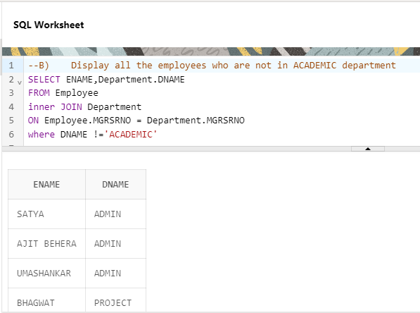 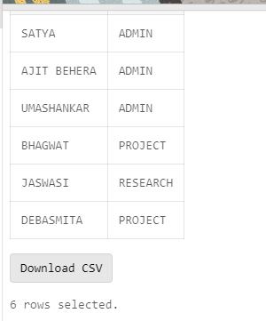

1. Display SATYAS’ project location.

SELECT ENAME,Project.PLOCATION

FROM Employee

INNER JOIN Project

ON Employee.DNO = Project.DNUM

where ENAME='SATYA'

Insert Image –

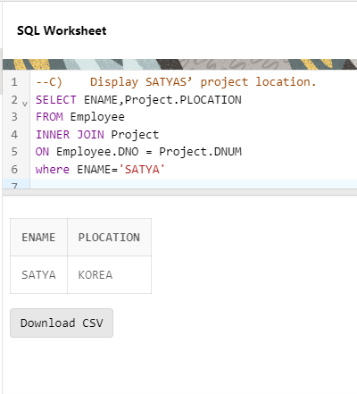

1. Find the total working hours of *each* female employee.

select ENAME , Sex, Works_on.HOURS

from Employee

INNER JOIN Works_on

ON Employee.ESRNO = Works_on.ESRNO

where sex='F'

Insert Image –

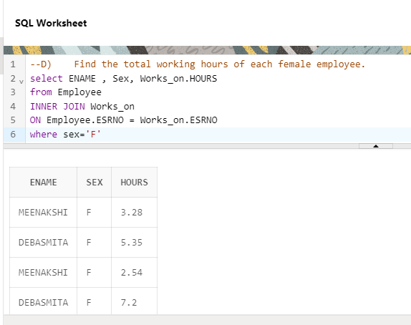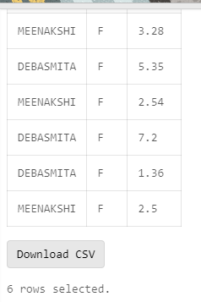

1. Display the details of the people whose projects are located at SOUTH AFRICA.

SELECT *

FROM Employee

inner join Project

ON Employee.DNO = Project.DNUM

WHERE PLOCATION ='SOUTH AFRICA'

Insert Image –

