**Question 1**

**GAMMA = 0.001 and C =0.3**

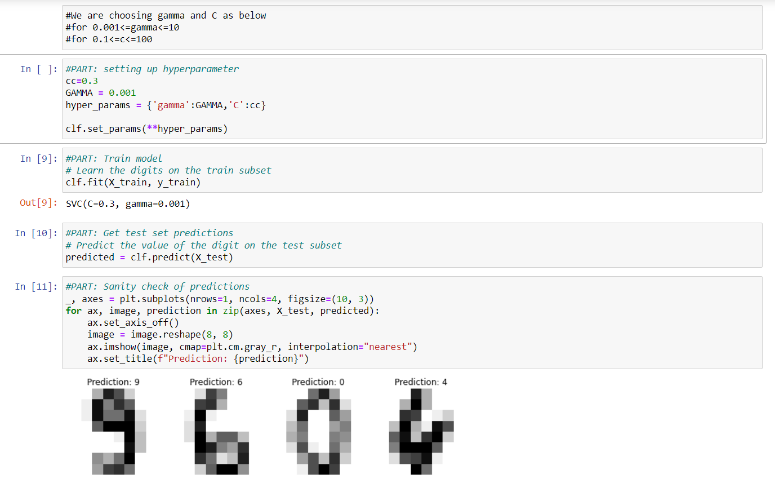

**Accuracy 99 percent**

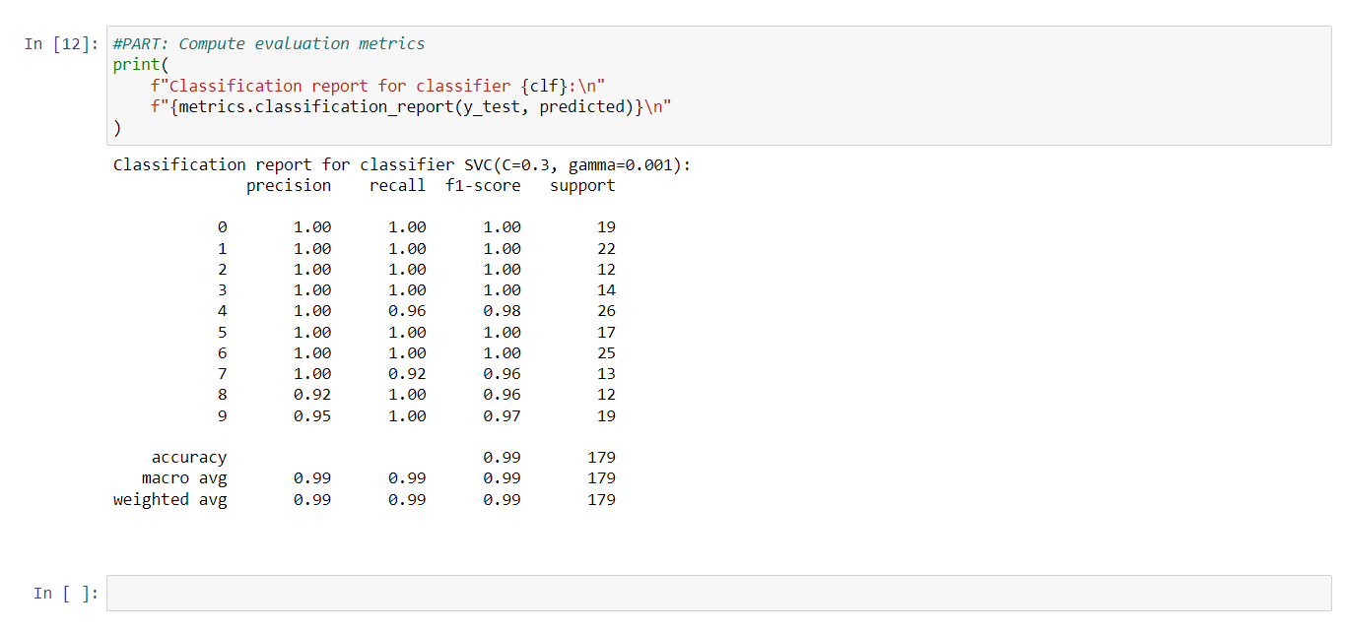

**GAMMA = 0.001 and C =0.1**

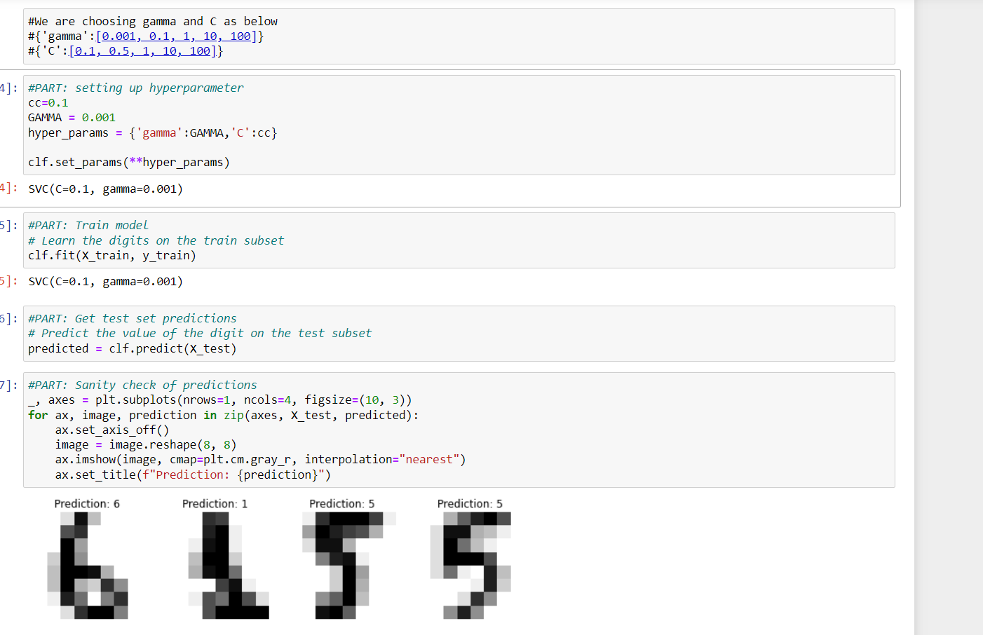

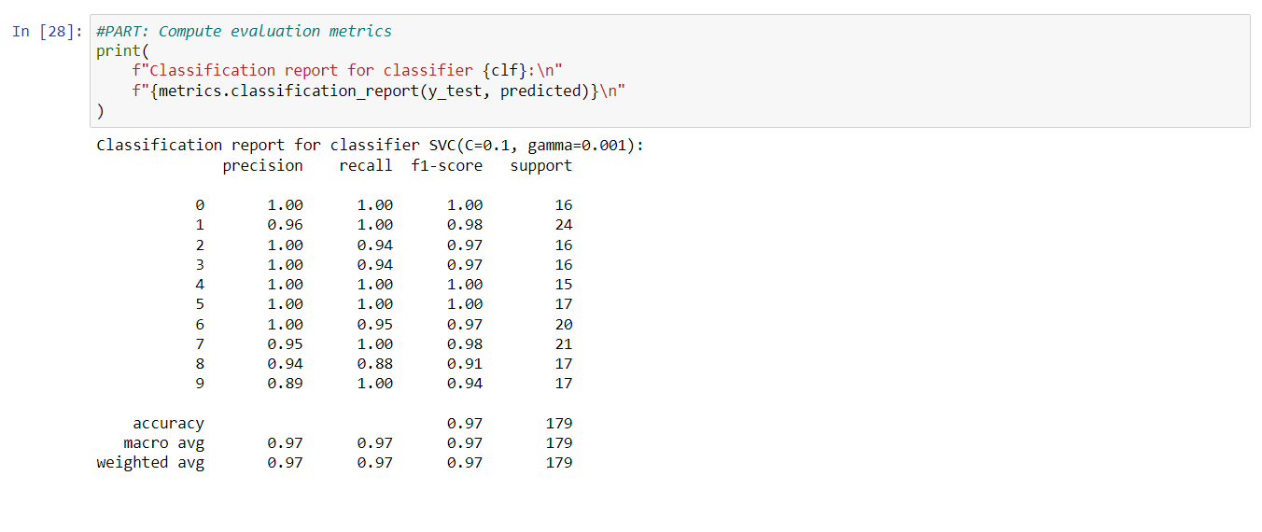

**GAMMA = 0.01 and C =0.5**

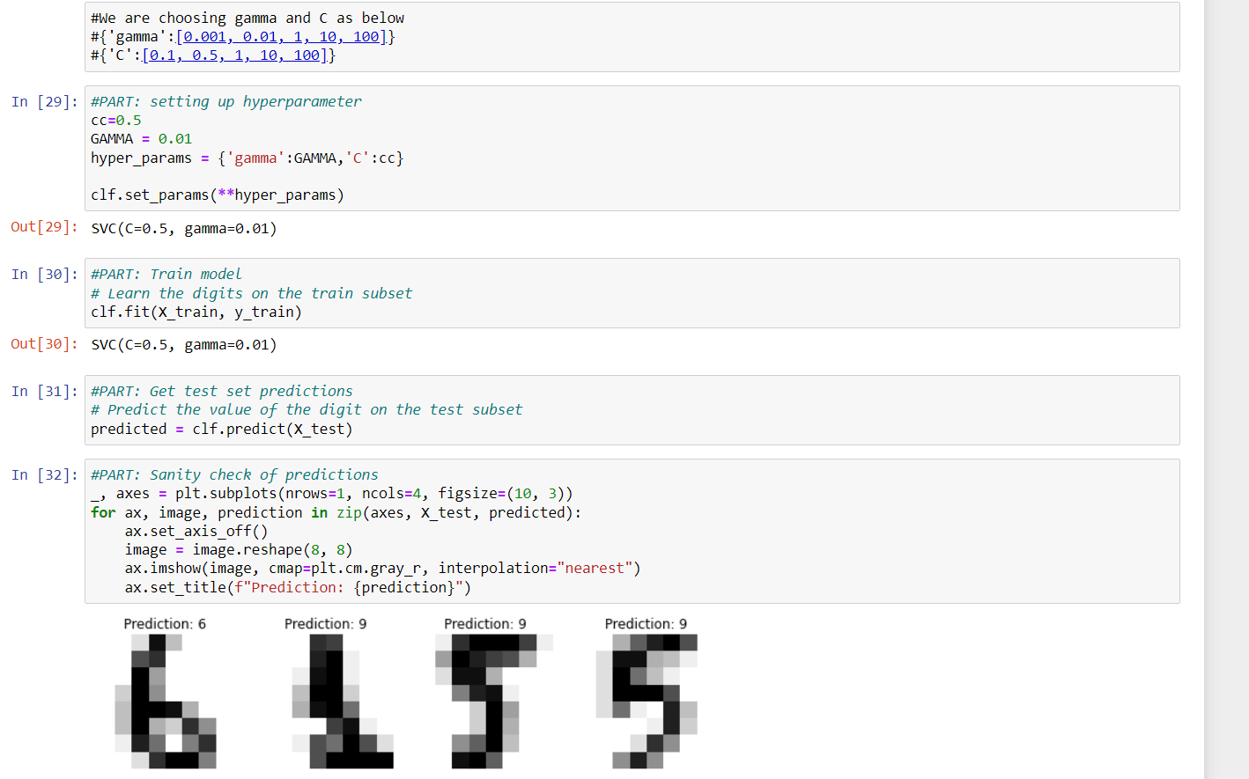

Accuracy 26 percent

