**Question 2**

**Resolution 1**

**Original image = (1797, 8, 8)**

**Resized Image = (1797, 79, 79)**

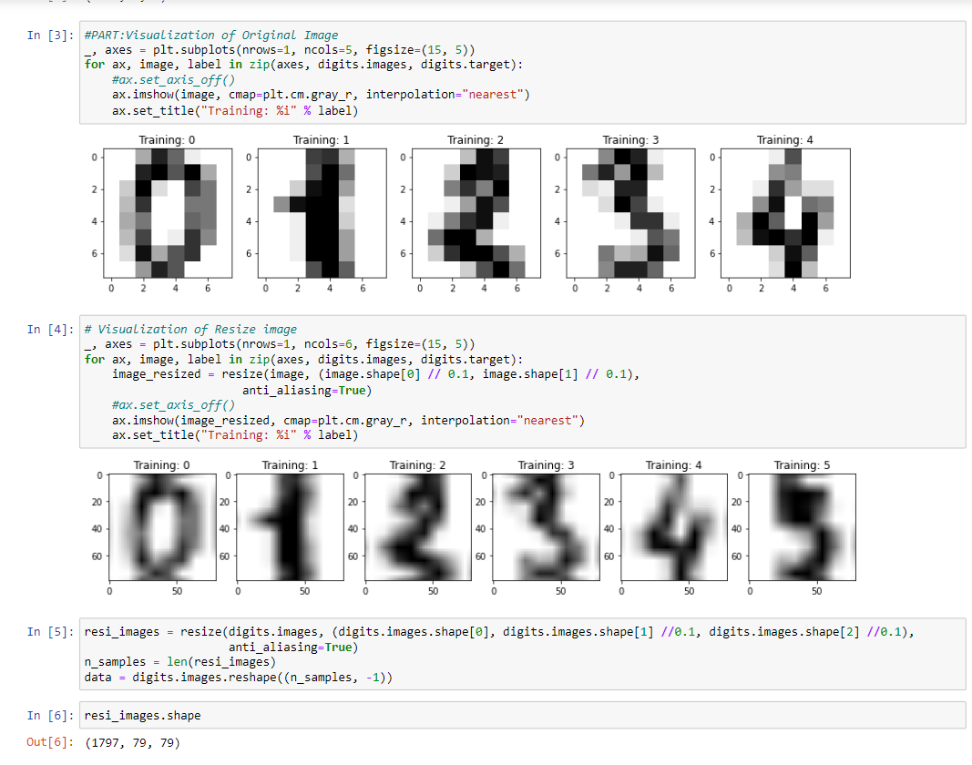

Accuracy 96 percent

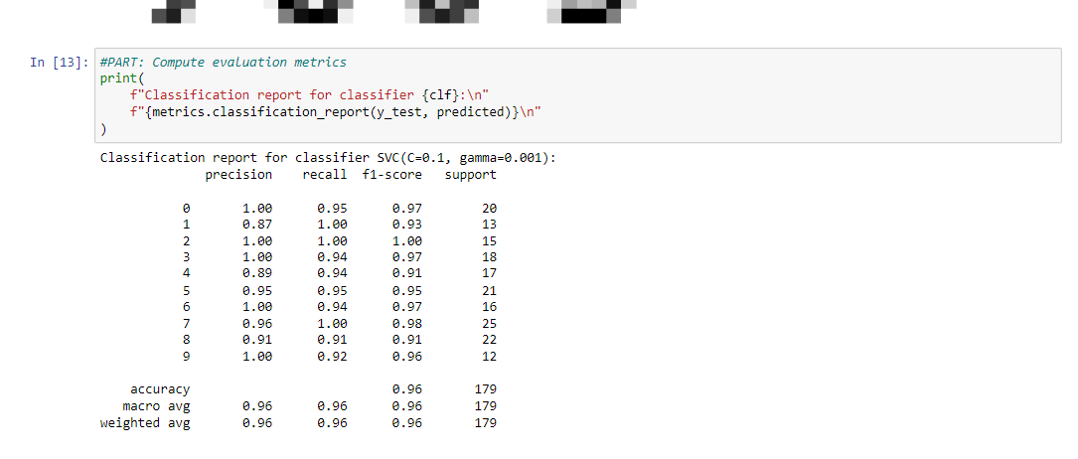

**Resolution 2**

**Original image = (1797, 8, 8)**

**Resized Image = (1797, 19, 19)**

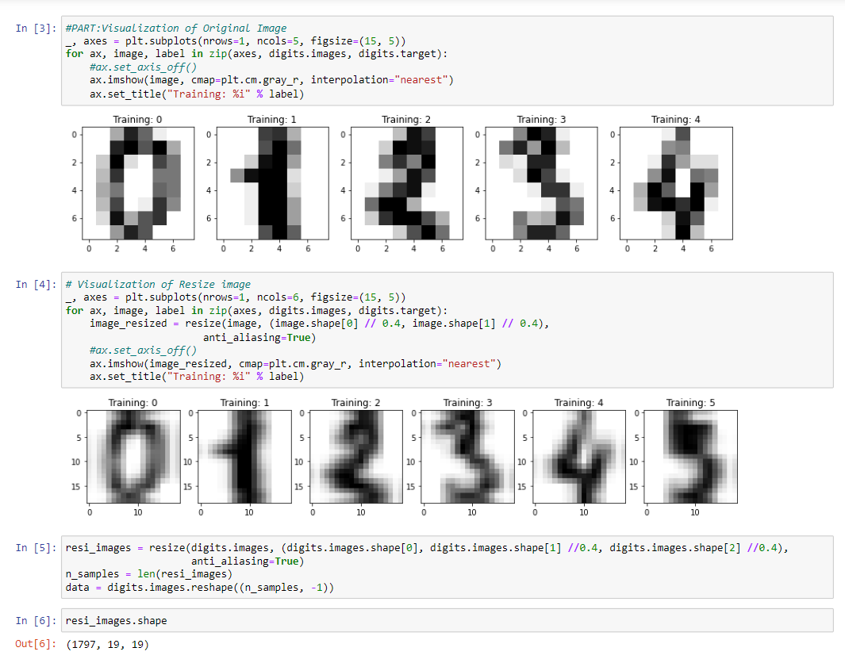

Accuracy 93 percent

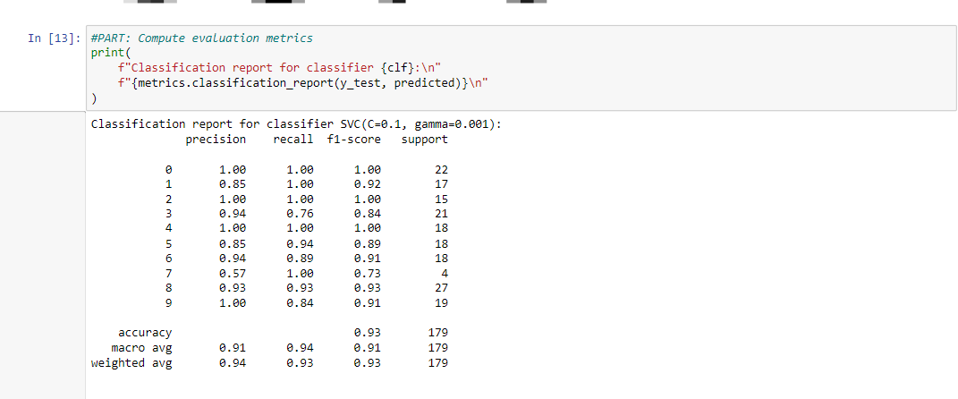

**Resolution 3**

**Original image = (1797, 8, 8)**

**Resized Image = (1797, 39, 39**)

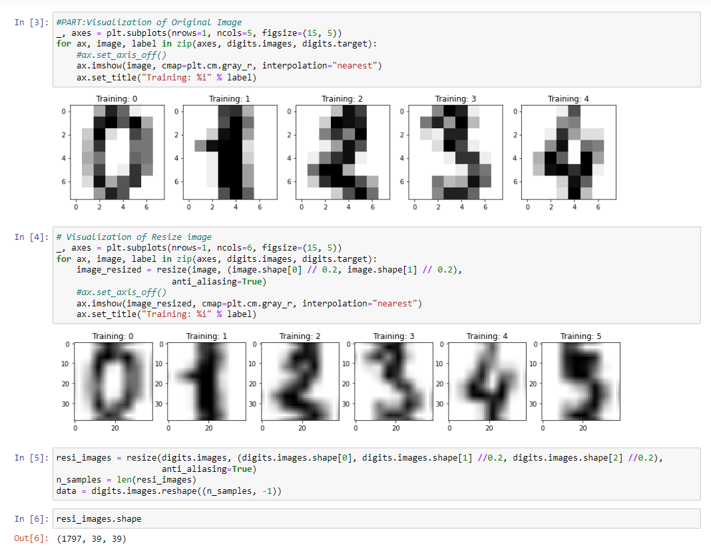

Accuracy 97 percent

