RETAIL SALES ANALYTICS
Power BI Project Documentation
End-to-End Documentation: Data → Model → DAX → Dashboard → Business Insights

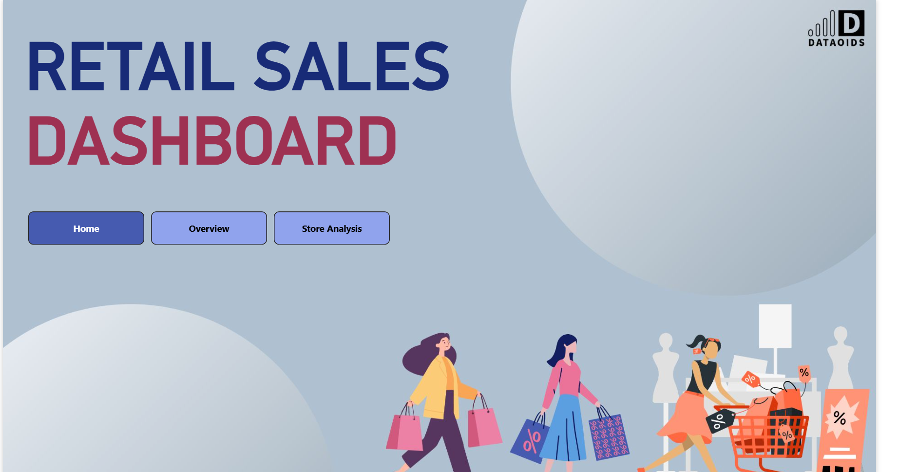

Source files: Retail_data.xlsx and Retail_Sales.pbix

1. Executive Summary
The Retail Sales Analytics project is an interactive Power BI solution designed to convert transaction-level retail sales data into a business-friendly reporting layer. The report focuses on revenue, profit, quantity, customer activity, product and brand performance, store performance, customer ratings, and time-based analysis.
The solution combines a retail sales fact table with customer, product, store, and calendar dimensions. The dashboard uses reusable DAX measures and a time-period selector to allow users to switch between MTD, QTD, and YTD views without maintaining separate visuals for every time period.
- Provide a single view of retail sales performance.
- Identify high- and low-performing products, brands, categories, and stores.
- Track revenue and profitability instead of relying only on sales volume.
- Understand customer activity and customer-rating patterns.
- Support MTD, QTD, and YTD performance analysis.
- Allow business users to slice results by year, month, day, category, sub-category, brand, product, and store.
- Support top/bottom analysis through report controls and dynamic filtering.

2. Business Problem Statement
Retail transaction data is detailed but difficult to use directly for management decisions. A raw sales file contains individual transactions, prices, quantities, customer identifiers, product attributes, and store identifiers, but it does not immediately answer questions such as:
- How much revenue is being generated?
- How profitable are the sales?
- Which brands and products are driving performance?
- Which stores are contributing the most revenue?
- How does performance change from month to month or year to date?
- What is the average customer rating?
- How much revenue is generated per customer?
- Which products/categories require additional attention?
- How can management move from raw transactions to an interactive decision-making view?
The Power BI report addresses this gap by creating a semantic model, standardizing calculations in DAX, and presenting the results through interactive pages and slicers.

3. Business Objectives
- Create a reliable analytical model from the retail source data.
- Build reusable KPIs for revenue, profit, quantity, ratings, and customer economics.
- Enable flexible time-period analysis using MTD, QTD, and YTD.
- Compare product, brand, category, and store performance.
- Expose top and bottom performers quickly.
- Create a dashboard that business users can filter without modifying the underlying data.
- Provide a foundation that can be extended with additional profitability, customer, inventory, or forecasting metrics.

4. Source Data and Data Understanding
The source workbook is Retail_data.xlsx. It contains five main sheets: Customer, Calender, Fact_sales, Store, and Product. The Power BI model uses corresponding analytical tables, including Customer, Date, Product, Sales_Fact, and Store.
Source Sheet | Approx. Data Rows | Columns
Customer | 39999 | Customer ID, Customer Name, Age, Gender, Location, Feedback (Stars), Acquisition Cost (₹)
Calender | 1461 | Date, Year, Quarter, Month, Day, Month Start Date, isWeekend, Day name, Day Number
Fact_sales | 819519 | Date, Product ID, Customer ID, Store ID, Sales Quantity, Cost Price, Selling Price, Profit/Loss, Customer Rating, Total CP, Total SP, Total prof/loss
Store | 55 | Store ID, Store Location, Store Name, Store Size, Conversion Rate, Area (Sq. Ft.)
Product | 350 | Product ID, Product Name, Category, Size, Brand, Price, Sub Category

The fact table is the transactional center of the solution. Dimension tables provide descriptive attributes used to filter, group, and analyze the transactions.

4.1 Customer Table
Column | Purpose
Customer ID | Unique customer identifier used to connect customer activity to sales.
Customer Name | Customer descriptive attribute.
Age | Customer demographic attribute.
Gender | Customer demographic segmentation.
Location | Customer geographic attribute.
Feedback (Stars) | Customer feedback/rating stored at customer level.
Acquisition Cost (₹) | Cost associated with acquiring the customer.

4.2 Calendar / Date Table
Column | Purpose
Date | Primary date field used for time intelligence.
Year | Year-level analysis and filtering.
Quarter | Quarter-level analysis.
Month | Numeric month used for sorting/grouping.
Day | Day component.
Month Start Date | Standardized month-level date.
isWeekend | Weekend flag.
Day name | Day-of-week label.
Day Number | Numeric day-of-week ordering/support field.

4.3 Sales Fact Table
Column | Purpose
Date | Transaction date.
Product ID | Foreign key to Product.
Customer ID | Foreign key to Customer.
Store ID | Foreign key to Store.
Sales Quantity | Units sold.
Cost Price | Unit cost.
Selling Price | Unit selling price.
Profit/Loss | Profit or loss at transaction/unit level.
Customer Rating | Rating associated with the transaction/customer interaction.
Total CP | Total cost price/value for the transaction.
Total SP | Total selling price/revenue value for the transaction.
Total prof/loss | Total profit/loss value for the transaction.

4.4 Product Table
Column | Purpose
Product ID | Unique product identifier.
Product Name | Product description.
Category | High-level product grouping.
Size | Product size/variant.
Brand | Brand-level analysis.
Price | Product price attribute.
Sub Category | Detailed product grouping.

4.5 Store Table
Column | Purpose
Store ID | Unique store identifier.
Store Location | Geographic store location.
Store Name | Business-facing store name.
Store Size | Small/Medium/Large store classification.
Conversion Rate | Store conversion metric available in the source.
Area (Sq. Ft.) | Store physical area used for store-level analysis.

5. How the Project Was Started
- Collected and reviewed the retail source workbook.
- Checked the logical separation of transaction data and descriptive/master data.
- Imported the workbook into Power BI Desktop.
- Reviewed data types, especially Date, numeric sales fields, identifiers, and categorical attributes.
- Created/used a dedicated date dimension for time intelligence.
- Built relationships between the fact table and dimensions.
- Created helper/parameter tables for dynamic reporting behavior.
- Created base measures first, then layered MTD/QTD/YTD logic over those measures.
- Built the dashboard pages around business questions rather than around individual raw columns.
- Added slicers, dynamic controls, and visual interactions so business users can investigate performance.

6. Data Preparation and Transformation
The preparation stage is focused on making the data suitable for analytical modeling. The source workbook already contains several business-ready fields, including Total CP, Total SP, Total profit/loss, calendar attributes, and product/store/customer attributes.
- Validate that identifiers are treated consistently as keys rather than numerical measures.
- Set Date as a true date type.
- Set Sales Quantity as a numeric field.
- Set Cost Price, Selling Price, Total CP, Total SP, and Total profit/loss as numeric/currency fields.
- Set ratings as numeric values so averages can be calculated.
- Use descriptive fields such as Category, Brand, Sub Category, Store Name, and Location for slicing/grouping.
- Use the calendar table for time intelligence rather than calculating time periods directly from the transaction date in every visual.

7. Data Model
The PBIX model contains the core analytical tables Customer, Date, Product, Sales_Fact, and Store. The model also contains helper/parameter objects used to support dynamic measures and report controls.
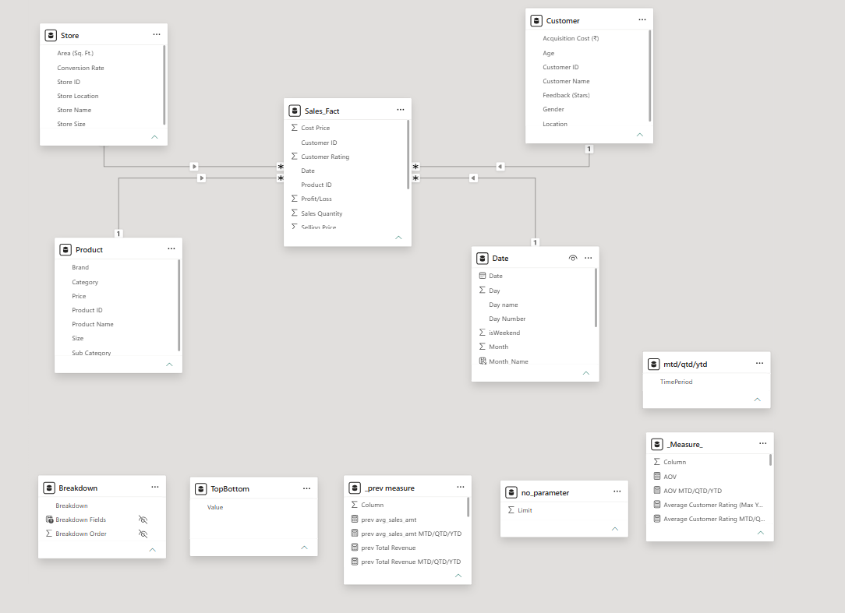

7.1 Model Components
Model Object | Role | Typical Usage
Sales_Fact | Fact / transaction table | Revenue, quantity, profit, ratings and transactional analysis.
Customer | Dimension | Customer segmentation and customer-level analysis.
Date | Dimension | Year, month, day and MTD/QTD/YTD time intelligence.
Product | Dimension | Category, sub-category, product, brand and size analysis.
Store | Dimension | Store performance and physical-store attributes.
mtd/qtd/ytd | Parameter/helper table | Controls the selected time period.
TopBottom | Parameter/helper table | Controls top/bottom analysis behavior.
no_parameter | Parameter/helper table | Provides a numeric limit/control used by the report.
_Measure_ | Measure table | Central location for reusable business measures.
_prev measure | Measure table | Stores previous-period/previous-year comparison measures.
Breakdown | Helper/model object | Supports analytical breakdown behavior in the report.

7.2 Modeling Approach
The model follows a fact-and-dimension design. Sales_Fact holds repeated transactional records, while Customer, Product, Store, and Date provide the descriptive context. This reduces duplication in the reporting layer and allows slicers to propagate filters into the fact table through relationships.
- Sales_Fact is the central table.
- Product filters sales through Product ID.
- Customer filters sales through Customer ID.
- Store filters sales through Store ID.
- Date filters sales through Date.
- Measures are evaluated in the current filter context, which is what makes the dashboard interactive.

7.3 Why a Star-Style Model Matters
A clean dimensional model makes DAX easier to reason about, improves consistency between visuals, and allows a single measure to respond to many different slicers. For example, the same Total Revenue measure can be evaluated by year, store, category, brand, or product without creating a separate formula for every combination.

8. New / Helper Fields and Tables
The source workbook already contains a prepared calendar structure and transaction totals. In the Power BI model, the most important additional modeling elements are helper/parameter tables and reusable measures rather than a large number of manually duplicated calculated columns.
Element | Purpose | Business Benefit
Year / Quarter / Month fields | Time slicing and grouping | Allows users to move from daily detail to management-level trends.
Month Start Date | Month-level standardization | Useful for consistent monthly analysis.
isWeekend | Day-type analysis | Allows weekday/weekend comparisons if required.
mtd/qtd/ytd TimePeriod | Disconnected time-period selector | One visual can show MTD, QTD or YTD.
TopBottom Value | Top/Bottom selector | Supports ranking-focused analysis.
no_parameter Limit | Numeric control | Controls how many records/performers are shown.
_Measure_ table | Dedicated measure organization | Keeps business logic separate from raw fields.
_prev measure table | Previous-period logic | Supports comparison to prior periods/years.

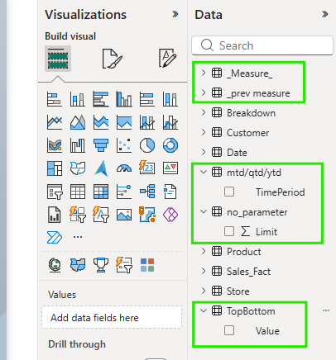

9. KPI Framework
The dashboard is organized around a compact KPI layer. The core KPI family visible in the PBIX includes revenue, profit percentage, average order/value metrics, average sales per person, selling-brand indicators, quantity, and customer ratings.
KPI | Definition | Business Question
Total Revenue | Revenue generated from sales. | Answers how much business is being generated.
Profit Percentage | Profit as a percentage of revenue. | Shows profitability rather than sales volume alone.
AOV | Average value per sales transaction/order basis used by the model. | Shows the typical monetary value of sales.
Avg Sales/Person | Average sales contribution per customer/person. | Shows customer-level revenue productivity.
Top Selling Brand | Brand with strongest performance under the selected logic. | Identifies leading brands.
Least Selling Brand | Brand with weakest performance under the selected logic. | Highlights brands requiring investigation.
Total Quantity | Total units sold. | Measures volume performance.
Total Profit | Total profit/loss. | Shows absolute profitability.
Average Customer Rating | Average customer rating. | Provides a customer-experience indicator.

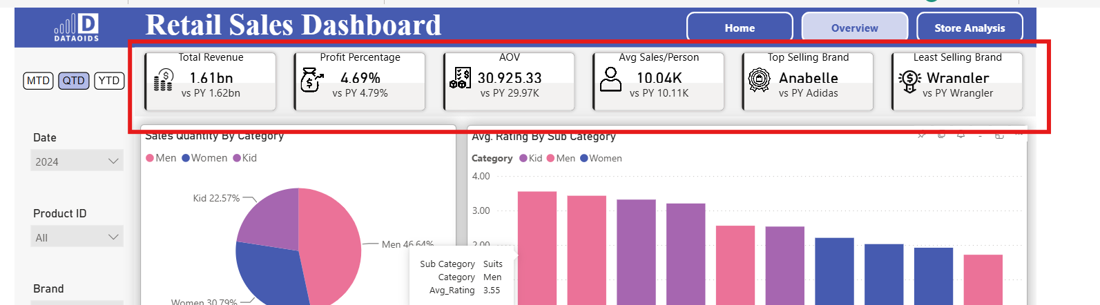

10. DAX Measures
The report uses a layered DAX approach. Base measures should be kept simple and reusable, while time intelligence and dynamic selectors are applied on top. The formulas below document the calculation logic represented by the report and the underlying fields.

10.1 Base Revenue
Total Revenue =
SUM ( Sales_Fact[Total SP] )

Calculates the total sales value/revenue.

10.2 Total Quantity
Total Quantity =
SUM ( Sales_Fact[Sales Quantity] )

Calculates units sold.

10.3 Total Profit
Total Profit =
SUM ( Sales_Fact[Total prof/loss] )

Calculates absolute profit/loss.

10.4 Profit Percentage
Profit Percentage =
DIVIDE (
[Total Profit],
[Total Revenue],
0
)

Calculates profit as a percentage of revenue.

10.5 Average Rating
Average Customer Rating =
AVERAGE ( Sales_Fact[Customer Rating] )

Calculates the average customer rating in the current filter context.

10.6 Average Sales per Person
Avg Sales/Person =
DIVIDE (
[Total Revenue],
DISTINCTCOUNT ( Sales_Fact[Customer ID] ),
0
)

Calculates revenue generated per distinct customer in the current context.

10.7 AOV
AOV =
DIVIDE (
[Total Revenue],
COUNTROWS ( Sales_Fact ),
0
)

Provides an average transaction-level sales value when each fact row represents a sales transaction.

10.8 Dynamic MTD / QTD / YTD Revenue
Total Revenue MTD/QTD/YTD =
SWITCH (
SELECTEDVALUE ( 'mtd/qtd/ytd'[TimePeriod], "MTD" ),
"MTD", CALCULATE ( [Total Revenue], DATESMTD ( 'Date'[Date] ) ),
"QTD", CALCULATE ( [Total Revenue], DATESQTD ( 'Date'[Date] ) ),
"YTD", CALCULATE ( [Total Revenue], DATESYTD ( 'Date'[Date] ) ),
[Total Revenue]
)

Allows one KPI to respond to the selected time period.

10.9 Dynamic Quantity
Sum Sales Quantity MTD/QTD/YTD =
SWITCH (
SELECTEDVALUE ( 'mtd/qtd/ytd'[TimePeriod], "MTD" ),
"MTD", CALCULATE ( [Total Quantity], DATESMTD ( 'Date'[Date] ) ),
"QTD", CALCULATE ( [Total Quantity], DATESQTD ( 'Date'[Date] ) ),
"YTD", CALCULATE ( [Total Quantity], DATESYTD ( 'Date'[Date] ) ),
[Total Quantity]
)

Applies the same time-period selector to sales volume.

10.10 Dynamic Profit
Total Profit MTD/QTD/YTD =
SWITCH (
SELECTEDVALUE ( 'mtd/qtd/ytd'[TimePeriod], "MTD" ),
"MTD", CALCULATE ( [Total Profit], DATESMTD ( 'Date'[Date] ) ),
"QTD", CALCULATE ( [Total Profit], DATESQTD ( 'Date'[Date] ) ),
"YTD", CALCULATE ( [Total Profit], DATESYTD ( 'Date'[Date] ) ),
[Total Profit]
)

Shows profitability for the selected period.

10.11 Dynamic Average Rating
Avg_Rating MTD/QTD/YTD =
SWITCH (
SELECTEDVALUE ( 'mtd/qtd/ytd'[TimePeriod], "MTD" ),
"MTD", CALCULATE ( [Average Customer Rating], DATESMTD ( 'Date'[Date] ) ),
"QTD", CALCULATE ( [Average Customer Rating], DATESQTD ( 'Date'[Date] ) ),
"YTD", CALCULATE ( [Average Customer Rating], DATESYTD ( 'Date'[Date] ) ),
[Average Customer Rating]
)

Provides a time-aware customer rating KPI.

10.12 Top Selling Brand Pattern
Top Selling Brand =
VAR BrandTable =
ADDCOLUMNS (
VALUES ( Product[Brand] ),
"@Revenue", [Total Revenue]
)
VAR TopBrand =
TOPN ( 1, BrandTable, [@Revenue], DESC )
RETURN
CONCATENATEX ( TopBrand, Product[Brand], ", " )

This pattern returns the brand with the highest revenue in the current filter context. If the project defines 'selling' using quantity instead, replace [Total Revenue] with [Total Quantity].

10.13 Least Selling Brand Pattern
Least Selling Brand =
VAR BrandTable =
ADDCOLUMNS (
VALUES ( Product[Brand] ),
"@Revenue", [Total Revenue]
)
VAR BottomBrand =
TOPN ( 1, BrandTable, [@Revenue], ASC )
RETURN
CONCATENATEX ( BottomBrand, Product[Brand], ", " )

This pattern identifies the lowest-performing brand under the selected metric. The report should be interpreted together with category, product, store, and time filters rather than treating the brand indicator as an explanation by itself.

10.14 Previous-Period / Previous-Year Pattern
Previous Year Revenue =
CALCULATE (
[Total Revenue],
SAMEPERIODLASTYEAR ( 'Date'[Date] )
)

The PBIX includes a dedicated '_prev measure' area for previous-period comparison. This structure allows the report to compare current and prior performance while keeping comparison logic organized separately from the base KPI layer.

10.15 Ranking / Top-N Pattern
Revenue Rank =
RANKX (
ALLSELECTED ( Store[Store Name] ),
[Total Revenue],
,
DESC,
DENSE
)

This ranking pattern can be applied to stores, brands, products, or categories. ALLSELECTED is useful when the report should respect the user's external slicers while ranking the remaining visible members.
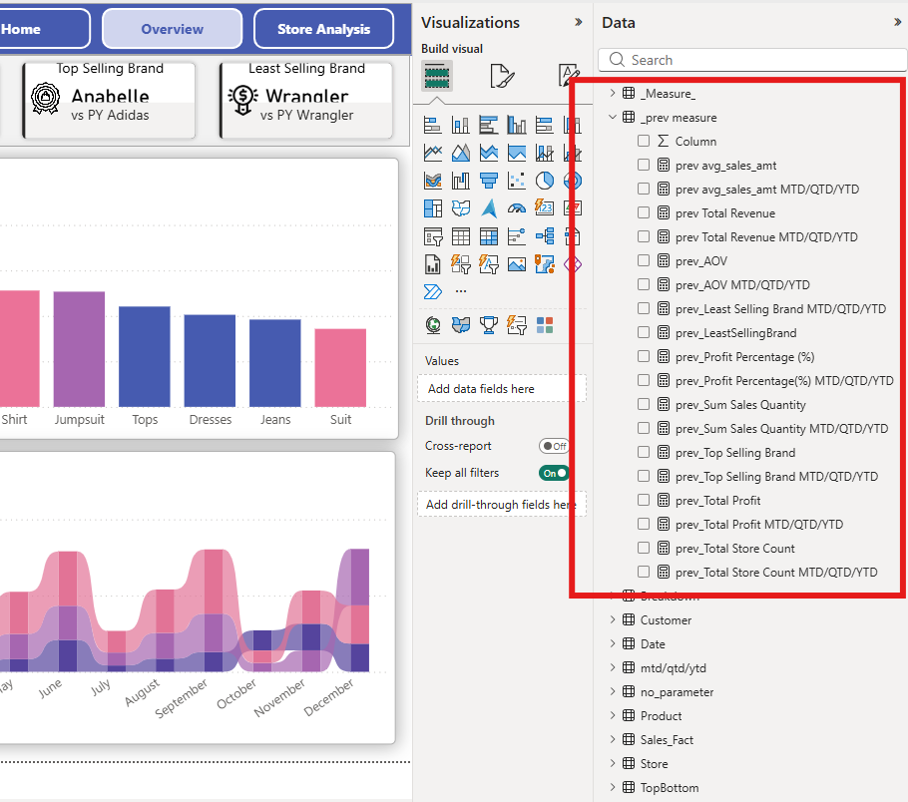

11. Dynamic Time Analysis: MTD, QTD and YTD
One of the key design choices in the report is the use of a TimePeriod selector. Instead of creating separate visuals for MTD, QTD, and YTD, the report can reuse a single visual and change the calculation through DAX.
Selection | Meaning | Typical Management Use
MTD | Month-to-date | Monitor current-month progress.
QTD | Quarter-to-date | Review quarter performance.
YTD | Year-to-date | Track annual progress against the broader business plan.

The selector is a disconnected parameter table. Because it is not intended to filter Sales_Fact directly, the selected value is read inside a SWITCH expression and used to choose the appropriate time-intelligence calculation.
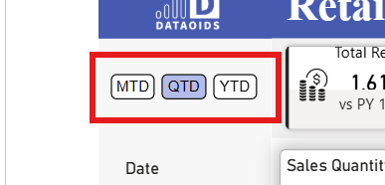

12. Dashboard Pages and Visual Design
The PBIX contains six pages in the report definition. Three are the main visible analytical pages, while the remaining pages are hidden/duplicate/support pages.
Page | Status | Purpose / Key Content
Home | Visible | Landing/navigation page.
Overview | Visible | Executive KPI and overall retail performance view.
Store Analysis | Visible | Store/product performance analysis and decomposition.
Page 1 | Hidden in view mode | Supporting comparison/analysis page.
Duplicate of Home | Hidden in view mode | Duplicate/support page.
Home1 | Hidden in view mode | Additional hidden/support page.

12.1 Home Page
The Home page acts as the report landing/navigation experience. It provides a clean entry point and page navigation rather than overloading the user with detailed analysis.

12.2 Overview Page
The Overview page is the executive monitoring layer. It contains KPI cards and visual analysis covering revenue, profit percentage, AOV, average sales per person, top/least selling brand, category trends, store revenue, and customer ratings. It also provides slicers for time and product/store attributes.
Visual | Business Purpose
KPI Card Group | Fast executive summary of core metrics.
Ribbon chart | Compare revenue/category performance across months and categories.
Pie chart | Show category-level contribution using revenue/profit/quantity context.
Store bar chart | Compare revenue by store.
Category/Sub-category rating chart | Understand rating patterns across product groups.
Product/brand slicers | Drill into specific products and brands.
Date slicer | Filter by year/month/day.
Store slicer | Focus the dashboard on selected stores.

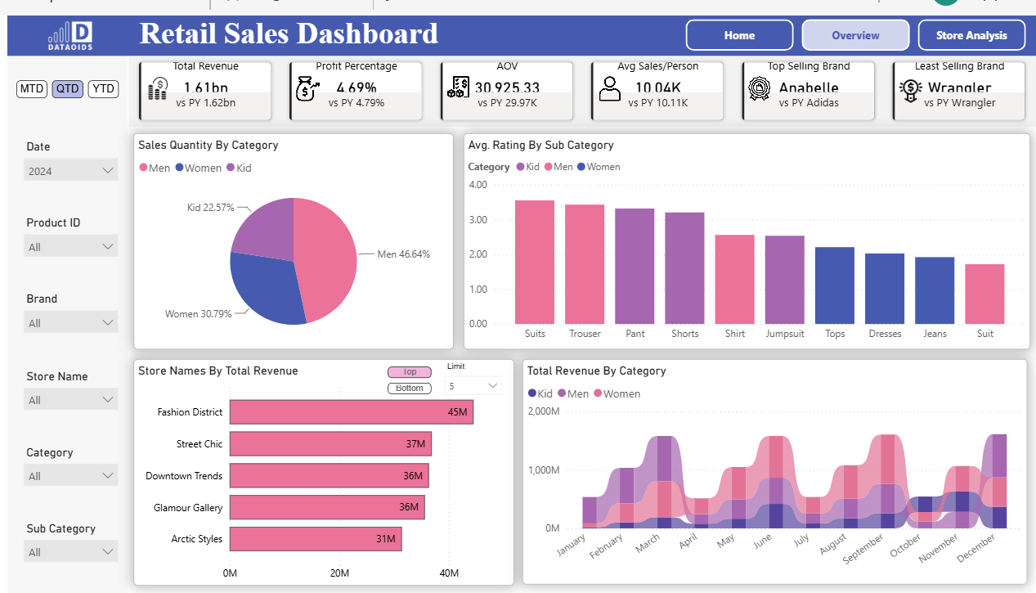

12.3 Store Analysis Page
The Store Analysis page is designed for deeper investigation. It includes a decomposition tree, product/category analysis, quantity and rating treemaps, KPI cards, and a scatter plot using store area. This page helps move from 'what happened?' to 'where and within which product structure did it happen?'
Visual | Purpose
Decomposition Tree | Break revenue down by category, sub-category, size and other dimensions.
Rating Treemap | Compare average customer rating across products/categories.
Quantity Treemap | Compare quantity contribution by brand/product/category.
Scatter Plot | Explore the relationship between store area, revenue, and profit.
KPI Cards | Maintain the executive KPI context while drilling into store analysis.
Slicers | Filter by category, sub-category, brand, product, store, and date.

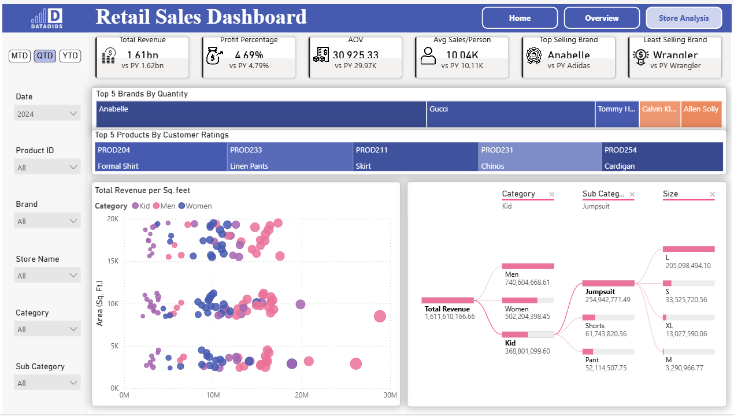

12.4 Hidden / Support Pages
The PBIX also contains hidden pages used for supporting analysis or alternative views. Keeping experimental, comparison, or duplicate pages hidden can reduce navigation clutter for business users while preserving the work inside the PBIX.

13. Slicers and User Interaction
The report exposes business-friendly controls instead of requiring users to interact with the data model directly.
Filter / Control | Why It Matters
Year | Analyze annual performance.
Month | Focus on a particular month.
Day | Investigate specific dates/day-level behavior.
TimePeriod | Switch between MTD, QTD, and YTD.
Category | Compare major product groups.
Sub Category | Drill into product group detail.
Product ID | Investigate an individual product.
Brand | Analyze brand performance.
Store Name | Analyze an individual store.
Top / Bottom | Focus analysis on leading or lower-performing entities.
Limit | Control the number of records/entities shown where applicable.

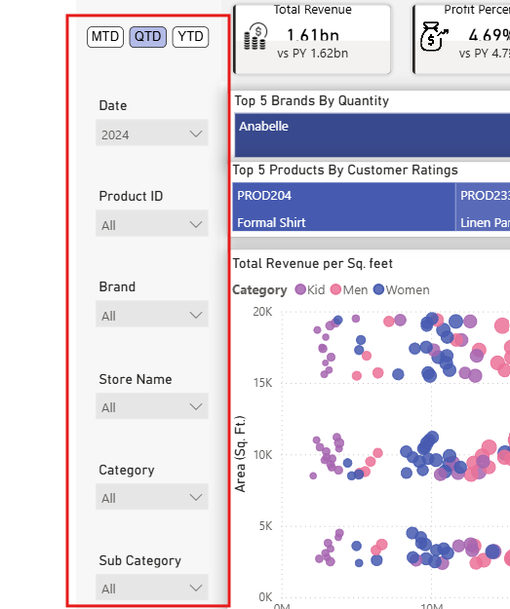

14. Business Questions Answered
Business Question | Dashboard Answer
What is the current sales performance? | Revenue and quantity KPIs provide the high-level view.
Is sales growth translating into profit? | Profit and profit percentage provide the profitability view.
Which brands are strongest? | Top Selling Brand and brand-level visuals identify leading performers.
Which brands need attention? | Least Selling Brand and lower-performing segments highlight candidates for investigation.
Which stores generate the most revenue? | Store revenue visual and ranking patterns provide store comparison.
Which categories drive the business? | Category-level visuals show revenue/quantity contribution.
How are customers responding? | Average customer rating provides a customer-experience indicator.
What is the customer-level revenue productivity? | Avg Sales/Person provides revenue per distinct customer.
How does performance look within a selected period? | MTD/QTD/YTD selector changes the time horizon dynamically.
Where should management drill deeper? | Decomposition tree and slicers support root-level exploration.

15. Business Use Cases
- Management review: quickly understand revenue, profitability and volume.
- Sales review: compare stores, categories, brands and products.
- Merchandising review: identify strong and weak brands/products.
- Customer review: monitor customer ratings and customer-level sales productivity.
- Store review: compare revenue against store area and other store attributes.
- Period review: monitor MTD/QTD/YTD performance.
- Drill-down investigation: move from a high-level KPI to category, sub-category, product, size or store detail.

16. Example Business Interpretation Framework
The dashboard should be used as a decision-support layer. A KPI by itself is a signal, not a diagnosis. For example, a low-performing brand should be investigated by checking its category, product mix, store distribution, quantity, revenue, profit, ratings, and time trend.
Signal | Follow-up Analysis
Revenue is high but profit percentage is low | Check selling price, cost price, product mix, and store mix.
Quantity is high but revenue is low | Check lower-priced products and category mix.
A brand ranks low | Check product assortment, store presence, ratings and time trend.
Store revenue is low | Check store area, product assortment, category mix and customer activity.
Customer rating is low | Drill into product/category/store and investigate customer feedback.
MTD differs materially from YTD | Check whether recent performance is changing the annual trend.

17. Data Quality Checks
- Check that Sales_Fact keys match Product, Customer and Store keys.
- Confirm the Date field is a true date and is connected to the fact date.
- Check for blank Product ID, Customer ID, Store ID and Date values.
- Validate that Total SP is consistent with Sales Quantity and Selling Price where that business rule applies.
- Validate Total CP and Total profit/loss against the intended business formula.
- Check that ratings are within the intended rating scale.
- Confirm that the Date table covers the required reporting period.
- Check that MTD/QTD/YTD selections return expected values at month, quarter and year boundaries.
- Check that slicers affect all intended visuals and do not unintentionally change unrelated visuals.

18. Performance and Maintainability Recommendations
- Keep business logic in measures rather than duplicating calculations across visuals.
- Use a proper continuous Date table for time intelligence and mark it as the model's date table when appropriate.
- Hide technical/helper tables from report users where they are not meant to be directly selected.
- Keep measure names business-friendly and organize them in dedicated measure tables.
- Avoid unnecessary calculated columns when the same logic can be evaluated efficiently as a measure.
- Use explicit numeric/currency formats for revenue, profit and price measures.
- Use consistent naming conventions for current-period and previous-period measures.
- Review unused visuals, duplicate pages, and unused helper objects before production deployment.

19. Testing and Validation Checklist
Test Area | Validation
Data Load | All expected sheets/tables load without errors.
Relationships | Dimension filters correctly propagate to Sales_Fact.
Revenue | Revenue matches the source Total SP under the same filter context.
Profit | Profit matches source Total prof/loss.
Quantity | Quantity matches source Sales Quantity.
Ratings | Average rating behaves correctly by product/category/store.
Time Intelligence | MTD/QTD/YTD changes correctly.
Slicers | All required slicers filter the intended visuals.
Top/Bottom | Top/bottom controls return the expected number of members.
Drill-down | Decomposition tree and detail visuals respond to selections.
Formatting | Currency, percentage, quantity and rating formats are consistent.
Performance | Pages load within an acceptable time and visuals are not unnecessarily duplicated.

20. Deployment / Refresh Considerations
For a production deployment, the workbook source should be stored in a controlled location and the Power BI dataset/report should have a documented refresh process. If the Excel source remains the input, the refresh location and access permissions must be stable. If the project later moves to SQL Server or another warehouse, the same dimensional model and measure layer can be retained with the data-source connection changed.
- Document the source file/location.
- Document refresh frequency.
- Validate credentials and gateway requirements if the source is on-premises.
- Validate refresh after publishing.
- Use Power BI Service workspace permissions appropriate to the audience.
- Monitor refresh failures and data-quality exceptions.

21. Project Architecture Summary
Architecture narrative: Retail_data.xlsx → Power BI data preparation/model → Sales_Fact + dimensions → helper/parameter tables → base DAX measures → MTD/QTD/YTD and comparison logic → interactive report pages → business analysis.

22. End-to-End Project Flow
- Understand the business requirement and key retail questions.
- Inspect the source workbook and identify fact/dimension candidates.
- Import the source into Power BI.
- Clean and type the fields.
- Create/validate the Date dimension.
- Build relationships between Sales_Fact and descriptive dimensions.
- Create helper tables for dynamic controls.
- Create base measures for revenue, quantity, profit and ratings.
- Create MTD/QTD/YTD versions of the measures.
- Create brand/store/product comparison logic.
- Build the Overview page for executive monitoring.
- Build Store Analysis for deeper investigation.
- Add slicers and interactive navigation.
- Validate calculations against the source data.
- Format the report for business users.
- Publish and configure refresh/security as required.

23. Conclusion
The Retail Sales Analytics project transforms a large transactional sales dataset into an interactive analytical product. Its main value comes from combining a structured dimensional model, reusable DAX measures, dynamic MTD/QTD/YTD logic, and business-focused visuals. The result is a reporting layer that helps management move from a headline KPI to the underlying store, product, category, brand, customer, and time dimensions behind that KPI.
The solution can be extended further with targets/budgets, year-over-year growth, customer lifetime value, cohort analysis, inventory metrics, store productivity, forecasting, anomaly detection, or automated alerts.

Appendix A: Measure Inventory Identified in the PBIX
Measure Name | Role
Total Revenue MTD/QTD/YTD | Dynamic revenue KPI
Sum Sales Quantity MTD/QTD/YTD | Dynamic quantity KPI
Profit Percentage MTD/QTD/YTD | Dynamic profitability percentage
AOV MTD/QTD/YTD | Dynamic average value KPI
Avg Sales/Person MTD/QTD/YTD | Dynamic customer-level sales KPI
Top Selling Brand MTD/QTD/YTD | Dynamic top-brand KPI
Least Selling Brand MTD/QTD/YTD | Dynamic least-brand KPI
Avg_Rating MTD/QTD/YTD | Dynamic rating KPI
Average Customer Rating MTD/QTD/YTD | Dynamic rating KPI
Total Quantity MTD/QTD/YTD | Dynamic quantity measure
Total Profit MTD/QTD/YTD | Dynamic profit measure
Top Selling Brand | Base top-brand measure
prev_Top Selling Brand | Previous comparison brand measure
prev_Top Selling Brand MTD/QTD/YTD | Dynamic previous comparison brand measure

Appendix B: Important Interpretation Notes
- The PBIX contains the visible report logic, page structure, visual fields, helper tables and measure names used in this documentation.
- The source workbook contains prepared transaction totals and calendar attributes; these should be treated as source/business fields unless the model explicitly replaces them with calculated logic.
- AOV should be aligned with the organization's definition of an order. The source model does not expose a separate Order ID in the documented fact columns, so the exact business definition should be confirmed before using AOV for formal commercial reporting.
- Top/least-selling logic should use the metric agreed by the business, such as revenue or quantity. The example formulas in this document use revenue as the default interpretation.
- Before production sign-off, validate every KPI against an independently calculated sample because the exact internal DAX expression can differ while producing the same visible report behavior.

