SAI VIDYA INSTITUTE OF TECHNOLOGY
(AFFILIATED TO VTU)


PROJECT DOCUMENTATION ON

INTEREST BASED FRIEND FINDER

SUBMITTED BY
POOJA M H
LINGALA KRISHNASREE
PRIYANKA C
J BINDU

INTEREST BASED FRIEND FINDER

INDEX
Chapter No. Title

- Introduction
- Objectives of the Project
- Scope of the Project
- Feasibility Study
- System Design
- Existing application
- Proposed application
8. ER Diagram
9. Screenshots of database
10. Coding and your application screenshots
11. Conclusion

ABSTRACT:

The Friend Finder Application is a Spring Boot-based web application developed to connect users based on their shared interests. In today’s digital world, finding like-minded individuals can be challenging, and this system aims to simplify that process through an efficient and scalable backend solution.
The application provides core functionalities such as user registration, secure login authentication, interest management, friend matching, and messaging. Users can create profiles, add or update their interests, and the system intelligently suggests potential friends by comparing common interests. Additionally, users can communicate with each other through a built-in messaging feature.
The system is developed using Java, Spring Boot, Hibernate (JPA), and MySQL, following a layered architecture consisting of Controller, Service, and Repository layers. This architecture ensures separation of concerns, maintainability, and scalability of the application.

Overall, the Friend Finder Application demonstrates the practical implementation of modern backend technologies and provides an efficient platform for interest-based social networking. It serves as a strong foundation for further enhancements such as real-time communication, AI-based recommendations, and mobile integration.

INTRODUCTION:

The Friend Finder Application is a web-based system developed using Spring Boot that helps users connect with others who share similar interests. In today’s digital world, people are increasingly looking for meaningful and relevant connections rather than random interactions. This application provides a platform where users can discover like-minded individuals efficiently through interest-based matching.

With the rapid growth of social networking platforms, there is a need for systems that offer personalized and accurate connections. Most existing platforms focus on general networking and do not prioritize user interests in a precise manner. This often makes it difficult for users to find people with similar hobbies, goals, or preferences.

The main problem addressed by this project is the lack of efficient interest-based matching in existing systems. Users often receive irrelevant suggestions, which reduces engagement and overall user experience. Therefore, this application aims to provide a better solution by analyzing user interests and suggesting suitable matches.

The Friend Finder Application allows users to register, create profiles, add or update their interests, and find potential friends based on shared preferences. It also includes a messaging feature that enables communication between users. The system is built using modern technologies like Spring Boot and Hibernate, ensuring scalability, maintainability, and efficient data handling.

OBJECTIVE OF THE PROJECT:
1. Primary Objective
The primary objective of the Friend Finder Application is to develop a system that enables users to find and connect with other individuals based on shared interests. The application aims to provide accurate and meaningful friend suggestions by analyzing user preferences, thereby improving the overall user experience. Additionally, it focuses on creating a simple, secure, and scalable platform that facilitates communication and interaction among users.

2. Secondary Objectives
The secondary objectives of the Friend Finder Application are:
- To provide a secure user registration and login system
- To allow users to add, update, and manage their interests
- To develop an efficient interest-based matching mechanism
- To enable users to send and receive messages
- To ensure proper data storage and management using a database
- To design a scalable and maintainable system using Spring Boot and Hibernate
- To improve user engagement by providing relevant and personalized connections

3. To Implement Interest-Based User Matching System:
The Friend Finder Application aims to provide an intelligent matching mechanism that connects users based on their shared interests. Instead of random suggestions, the system analyzes user preferences and identifies compatible profiles.
Examples include:
• Users with common hobbies (e.g., music, sports, coding)
• Matching based on multiple shared interests
• Suggesting users with similar profiles
• Improving relevance of friend recommendations
The objective is to ensure that users find meaningful and relevant connections rather than random matches.

4. To Enhance User Interaction Through Communication Features:
The application focuses on improving user engagement by enabling communication between matched users. It provides a messaging system that allows users to interact and build connections.
This includes:
• Sending and receiving messages
• Real-time or stored communication
• Easy user-to-user interaction
• Improving overall user engagement
By doing so, the system creates an interactive platform rather than just a matching system.

5. To Develop a Scalable and Maintainable Backend System:
Another key objective is to design a robust backend architecture using Spring Boot and Hibernate that ensures scalability, flexibility, and ease of maintenance.
This ensures:
• Efficient handling of user data
• Proper database management using MySQL
• Clean architecture (Controller, Service, Repository)
• Easy future enhancements and updates
The system avoids complexity and ensures that the application remains stable, maintainable, and adaptable to future requirements.

6. To Ensure Efficient Data Management and Storage
The Friend Finder Application aims to manage user data effectively using a structured database system. Proper data handling is essential for storing user profiles, interests, friendships, and messages securely and efficiently.
This includes:
•Storing user details such as name, email, and interests
•Managing relationships between users (friends, matches)
•Maintaining message history between users
• Ensuring quick data retrieval and updates
By doing so, the system ensures reliable data storage, consistency, and smooth performance of the application.

7. To Improve User Experience Through a Simple and User-Friendly System:
Another important objective is to design the application in a way that is easy to use and understand. A simple and intuitive system helps users interact with the application without difficulty.
This ensures:
• Easy navigation and usability
• Clear and simple user operations (register, login, match, message)
• Faster response and smooth interaction
• Better overall user satisfaction

SCOPE OF THE PROJECT:
1. Introduction to Project Scope:
The scope of the Friend Finder Application defines the boundaries, capabilities, and limitations of the system. It outlines what the application includes, how it operates, and the extent to which it supports user interaction and connectivity.
This project is designed to function as a social networking backend system, focusing on connecting users based on shared interests. It acts as a platform for interaction and communication rather than a full-scale social media system.

2. Functional Scope:
1. User Data Collection and Management:
The application includes the ability to collect and manage user-related data such as:
• User registration details (name, email, password)
• Profile information
• User interests and preferences
• Friend connections
• Messaging data
All data is stored in a structured database to ensure efficient retrieval and management.

2. Interest-Based Matching System:
Within its scope, the system provides:
• Matching users based on common interests
• Suggesting potential friends
• Filtering users with similar preferences
• Improving relevance of connections
This helps users find meaningful and relevant friendships.

3 Friend Management System:
The application includes:
• Sending friend requests
• Accepting or rejecting requests
• Managing friend lists
• Removing friends
This ensures proper handling of user relationships within the system

4. Messaging and Communication:
One of the core functionalities includes:
• Sending messages between users
• Receiving messages
• Storing communication history
• Enabling interaction between matched users
This feature enhances user engagement and connectivity.

5. Reporting and User Interaction Insights:
The system provides:
• Display of matched users
• User profile viewing
• Basic interaction tracking
• Simple feedback through system responses
This ensures a smooth and interactive user experience.

3. User-Based Scope:
1.Users:
Users can:
• Register and log in
• Add and manage interests
• Find and connect with friends
• Send and receive messages

2. Admin (Optional)
Admin users can:
• Monitor user data
• Manage system activities
• Maintain application data

4. Technical Scope
1. System Architecture
The project includes:
• Layered architecture (Controller, Service, Repository)
• Secure data handling
• Scalable backend design
• RESTful API development

2. Integration Capabilities
The project includes:
• Layered architecture (Controller, Service, Repository)
• Secure data handling
• Scalable backend design
• RESTful API development

3. Backend and Database Management
The project uses:
• Spring Boot for backend development
• Hibernate (JPA) for ORM
• MySQL for database management
Advanced AI-based recommendation systems are outside the current scope but can be added in future.

5. Security and Ethical Scope
The project ensures:
• Secure user authentication
• Protection of user data
• Controlled access to system resources
• Ethical use of user information
The system does not misuse or expose personal data.

6. Operational Scope
1. Platforms Covered
The application is applicable to:
• Web-based platforms
• Educational/demo environments
• Social networking prototypes

2. Usage Scope
The system supports:
• General users seeking connections
• Interest-based networking
• Basic communication features

7. Limitations and Exclusions (Out of Scope)
The following are outside the scope of this project:
• Real-time chat using WebSockets
• Mobile application (native apps)
• AI-based recommendation engine
• Video/audio calling features
• Advanced security features like biometric authentication

8. Scalability and Future Expansion Scope
Although not part of the current implementation, the system supports future enhancements such as:
• AI-based friend recommendations
• Real-time chat system
• Mobile app integration
• Notification system
• Advanced analytics

9. Institutional and Academic Impact Scope
The project contributes to:
• Better social connectivity
• Improved user engagement
• Learning modern backend technologies
• Real-world application development experience

10. Summary of Project Scope
In summary, the scope of the Friend Finder Application includes:
• User registration and authentication
• Interest-based matching
• Friend and messaging system
• Scalable backend architecture
• Secure and efficient data management
The project provides a simple, efficient, and scalable platform for connecting users based on shared interests and serves as a strong foundation for future enhancements.

FEASIBILITY STUDY OF THE PROJECT:
1. Introduction to Feasibility Study
A feasibility study is conducted to determine whether the Friend Finder Application can be designed, developed, implemented, and maintained effectively within the constraints of time, cost, technology, and user requirements.
This study evaluates the project from multiple perspectives to ensure that it is:
• Practically achievable
• Economically viable
• Technically feasible
• Operationally acceptable
• Secure and ethically compliant

2. Technical Feasibility
1.Availability of Technology
The project is technically feasible because it uses well-established and widely available technologies, including:
• Java for application development
• Spring Boot framework for backend development
• Hibernate (JPA) for database interaction
• MySQL for data storage
These technologies are stable, widely supported, and commonly used in real-world applications.

2.System Complexity
The system follows a layered architecture (Controller, Service, Repository), which:
• Reduces development complexity
• Allows modular development
• Supports easy testing and debugging
• Improves maintainability
The application logic is straightforward and does not require complex algorithms, making it suitable for academic-level implementation.

3. Integration Feasibility
The Friend Finder Application can be integrated with:
• Frontend web applications
• Mobile applications (future scope)
• External APIs (optional extensions)
The use of REST APIs ensures flexibility and compatibility with different platforms.

4. Performance and Scalability
The system supports:
• Efficient handling of user data
• Scalable database design
• Multiple user interactions
This ensures smooth performance even as the number of users increases.

3. Economic Feasibility
1. Development Cost
The project is economically feasible due to:
• Use of open-source technologies
• No licensing cost for tools
• Availability of free development environments

2. Operational Cost
Operational costs are minimal because:
• No specialized hardware is required
• Can run on local systems or cloud platforms
• Maintenance cost is low.

3. Cost-Benefit Analysis
The benefits of the project outweigh the costs by:
- Reducing manual integrity investigations
- Improving academic governance efficiency
- Preventing long-term reputational damage to institutions

4. Operational Feasibility
1. User Acceptance
The system is designed to be:
• Simple and user-friendly
• Easy to navigate
• Efficient in functionality
This ensures acceptance among users.

2. Training Requirements
Minimal training is required since:
• The interface is simple
• Features are easy to understand
• Operations are straightforward

3. Workflow Compatibility
The system fits well into general user workflows and does not require major changes in usage behavior.

5. Schedule Feasibility
1. Development Timeline
The project can be completed within a standard academic timeline due to:
• Clearly defined modules
• Availability of resources
• Simple implementation approach

2. Risk Management
Potential risks such as bugs or data issues can be handled through:
• Proper testing
• Debugging
• Incremental development

6. Legal and Ethical Feasibility
1. Data Privacy Compliance
The system ensures:
• Protection of user data
• Secure authentication
• Controlled access to information

2. Ethical Evaluation Framework
The application avoids:
• Misuse of user data
• Unauthorized access
• Privacy violations
All user data is handled responsibly.

7. Social Feasibility
The project promotes:
• Social connectivity
• Meaningful interactions
• Better communication between users
It helps users build connections based on shared interests.

8. Resource Feasibility
1. Human Resources
The project can be developed by:
• A student developer
• With guidance from faculty.

2. Hardware and Software Resources
Required resources include:
• Personal computer
• Java development tools
• Database software (MySQL)
• Spring Boot framework
All resources are easily available.

9. Feasibility Conclusion
Based on technical, economic, operational, and social analysis, the Friend Finder Application is highly feasible.
The project:
• Uses proven technologies
• Requires minimal cost
• Is easy to implement
• Provides practical benefits

10. Summary
The feasibility study confirms that the project is:
• Technically implementable
• Economically affordable
• Operationally practical
• Secure and reliable
• Academically valuable
Thus, the Friend Finder Application is a viable and effective solution for connecting users based on shared interests.

SYSTEM DESIGN:
1. Introduction to System Design
System Design defines how the Friend Finder Application works internally and explains its architecture, components, data flow, and interaction between modules.
The system is designed as a modular, scalable, and user-friendly backend platform that connects users based on shared interests and enables communication between them.
The design focuses on:
• Efficient user matching
• Secure data handling
• Scalability
• Ease of use and integration

2. Overall System Architecture
The system follows a multi-tier (layered) architecture, ensuring separation of concerns and easy maintenance.
Architecture Type:
Layered / Modular Architecture
Major Layers:
- Presentation Layer
- Application (Business Logic) Layer
- Matching & Interaction Engine
- Data Management Layer
- Security & Access Control Layer

3. High-Level Architecture Diagram (Conceptual):

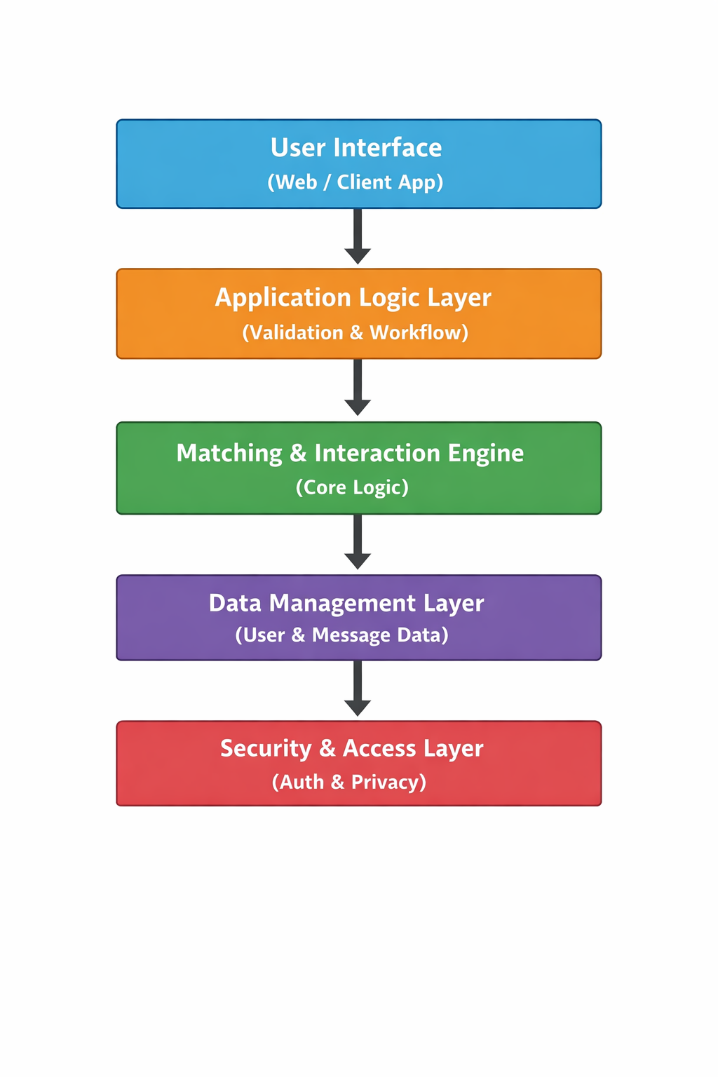

4. Module-Wise System Design:
1. Presentation Layer (User Interface Module)
Purpose:
Provides interaction between users and the system.
Users:
• Application Users
Functions:
• User registration and login
• Profile management
• Viewing matches
• Sending messages
Characteristics:
• Simple and user-friendly interface
• Easy navigation
• Responsive design

2.Application Logic Layer
Purpose:
Acts as a bridge between the user interface and backend processing.
Responsibilities:
• Request validation
• Workflow management
• Data processing
• Communication with backend modules
Functions:
• Handling user requests
• Managing sessions
• Processing inputs and outputs
• Error handling

3. Matching & Interaction Engine (Core Module)
1. Interest Matching Module
• Compares user interests
• Identifies common preferences
• Suggests potential friends

2. Friend Management Module
• Sends friend requests
• Accepts/rejects requests
• Maintains friend lists

3. Messaging Module
• Enables communication between users
• Stores message history
• Handles message sending and receiving

4. Recommendation Logic (Basic)
• Suggests users based on shared interests
• Improves connection relevance

4. Data Management Layer
Purpose:
Stores and manages all application data.
Data Types:
• User profiles
• Interests
• Friend relationships
• Messages
Database Characteristics:
• Relational database (MySQL)
• Normalized tables
• Efficient data retrieval
• Secure storage

5. Security & Access Control Layer
Purpose:
Ensures data security and privacy.
Security Features:
• User authentication (login system)
• Authorization control
• Data protection
• Secure access
Controls:
• Only authorized users can access data
• Secure password handling

5. Data Flow Design
Step-by-Step Data Flow:
- User registers or logs into the system
- User data is stored/retrieved from database
- Interests are processed
- Matching engine finds similar users
- Results are displayed to the user
- User sends/receives messages
- Data is updated in database

6. Control Flow Design
• Input validation → Processing → Matching → Output generation
• User actions trigger backend processes
• System ensures proper request handling

7. System Design Characteristics
1. Modularity
• Each module works independently
• Easy testing and debugging
• Supports future upgrades

2. Scalability
• Supports increasing number of users
• Can be extended with new features
• Ready for mobile/web expansion

3. Reliability
• Error handling mechanisms
• Data validation
• Stable performance

4. Simplicity
• Easy to understand
• User-friendly design
• Efficient workflow

8. Hardware & Software Design Requirements
Hardware Requirements:
• Standard computer system
• Minimum 4GB RAM
• Internet connectivity

Software Requirements:
• Operating System: Windows/Linux
• Backend: Java (Spring Boot)
• Database: MySQL
• Tools: Eclipse/STS, Postman

9. Limitations in System Design
• No real-time chat (basic messaging only)
• No AI-based recommendation system
• Limited frontend interface
• Depends on user-provided data accuracy

10. System Design Summary
The system design of the Friend Finder Application provides:
• A modular and layered architecture
• Efficient interest-based matching
• Secure and scalable backend system
• Simple and user-friendly interaction
This design ensures the application is practical, maintainable, and ready for future enhancements.

EXISTING APPLICATION (EXISTING SYSTEM):
1. Introduction to Existing System
The existing systems for social networking and friend connections are mostly generalized platforms that focus on broad user interaction rather than meaningful, interest-based connections. These systems are widely used but lack precise mechanisms to match users based on shared preferences.
Most existing applications provide basic features such as profile creation, friend suggestions, and messaging. However, they do not deeply analyze user interests or provide accurate matching, resulting in less relevant connections and reduced user satisfaction.

2. Overview of Existing Applications
1. Social Networking Platforms
Existing social networking applications are primarily used for:
• Connecting with friends and family
• Sharing posts, images, and updates
• Basic friend suggestions
• Messaging and communication
Limitations:
• Friend suggestions are often random or based on mutual connections
• No accurate interest-based matching
• Overloaded with unnecessary features
• Not focused on meaningful connections

2. Online Community Platforms
These platforms focus on:
• Group-based interactions
• Topic-based discussions
• Community building
Limitations:
• Connections are limited to specific groups
• No personalized friend recommendations
• Lack of one-to-one meaningful connections
• Not suitable for general friend finding

3. Basic Messaging Applications
Current messaging applications provide:
• Text communication
• Media sharing
• Group chats
Limitations:
• No friend discovery feature
• No matching mechanism
• Only supports communication after connection is established.

4 . Manual Friend Searching
Users often:
• Search for people manually
• Connect based on known contacts
• Use trial-and-error methods
Limitations:
• Time-consuming
• Inefficient process
• No guarantee of finding like-minded individuals
• Not scalable for large user bases

Limitations of Existing System
The major drawbacks of existing systems include:
• Lack of interest-based matching
• Irrelevant friend suggestions
• Limited personalization
• No proper analysis of user preferences
• Poor user experience in finding meaningful connections.

Need for Proposed System
Due to the above limitations, there is a need for a system that:
• Matches users based on shared interests
• Provides accurate and meaningful friend suggestions
• Enhances user interaction and engagement
• Offers a simple and efficient platform for connection.

Summary of Existing System
In summary, existing systems focus mainly on general networking and communication but fail to provide intelligent and personalized friend matching. They lack efficient mechanisms to analyze user interests and suggest relevant connections.
The Friend Finder Application addresses these limitation.

PROPOSED APPLICATION (PROPOSED SYSTEM):
1. Introduction to the Proposed System
The proposed application, Friend Finder Application, is an intelligent web-based platform designed to overcome the limitations of existing social networking systems. Unlike traditional platforms that provide random or generalized friend suggestions, this system focuses on connecting users based on shared interests.
The application aims to provide meaningful and relevant connections by analyzing user preferences and suggesting compatible users. It ensures a simple, efficient, and user-friendly environment for communication and interaction.

2. Overview of the Proposed Application
The proposed system functions as a user interaction platform that:
• Connects users based on shared interests
• Provides personalized friend suggestions
• Enables communication through messaging
• Manages user profiles and relationships
The system focuses on enhancing user experience by providing accurate and relevant connections rather than random networking.

3. Key Features of the Proposed System
1. Integrated User Data Management
The application centralizes user data such as:
• User registration details
• Profile information
• Interests and preferences
• Friend connections
• Messaging history
This creates a complete user profile for efficient matching and interaction.

2. Interest-Based Matching Module
The system evaluates:
• Common interests between users
• Similar preferences and hobbies
• Compatibility of user profiles
This helps in suggesting meaningful and relevant friend connections.

3. Friend Management Module
The system provides:
• Sending friend requests
• Accepting/rejecting requests
• Managing friend lists
• Removing connections
This ensures proper handling of user relationships.

4. Messaging Module
The application includes:
• Sending and receiving messages
• Storing communication history
• Enabling user interaction
This feature enhances engagement between users.

5. Recommendation and Interaction System
The system provides:
• Suggested user profiles
• Easy profile viewing
• Smooth interaction flow
• Improved user engagement
This ensures better connectivity and user satisfaction.

4. User Roles in the Proposed Application
1. Users
Users can:
• Register and log in
• Create and manage profiles
• Add and update interests
• Find and connect with friends
• Send and receive messages

2. Admin (Optional)
Admin users can:
• Monitor user data
• Manage system operations
• Maintain application integrity

6. Security and Privacy Considerations
The proposed application ensures:
• Secure user authentication
• Protection of user data
• Controlled access to information
• Safe communication environment
User data is handled securely without unauthorized access.

- System Workflow of Proposed Application
- User registers and logs into the system
- User adds and manages interests
- Data is stored securely in the database
- Matching engine analyzes user interests
- Suggested users are displayed
- User sends/accepts friend requests
- Messaging is enabled between connected users
8. Implementation Environment
Software Environment
• Backend: Java (Spring Boot)
• Frontend: HTML, CSS, JavaScript
• Database: MySQL
Hardware Environment
• Standard computer or server
• Minimum 4GB RAM
• Internet connectivity

9. Limitations of the Proposed Application
• Depends on user-provided data accuracy
• No real-time chat (basic messaging only)
• No AI-based recommendation system
• Limited frontend features
10. Future Enhancement Support
The system supports future enhancements such as:
• AI-based friend recommendations
• Real-time chat system
• Mobile application development
• Notification system
• Advanced user analytics

11. Summary of Proposed Application

The proposed Friend Finder Application provides a simple, efficient, and scalable platform for connecting users based on shared interests. It improves user experience by offering meaningful connections, secure communication, and a structured backend system.

ER DIAGRAM:
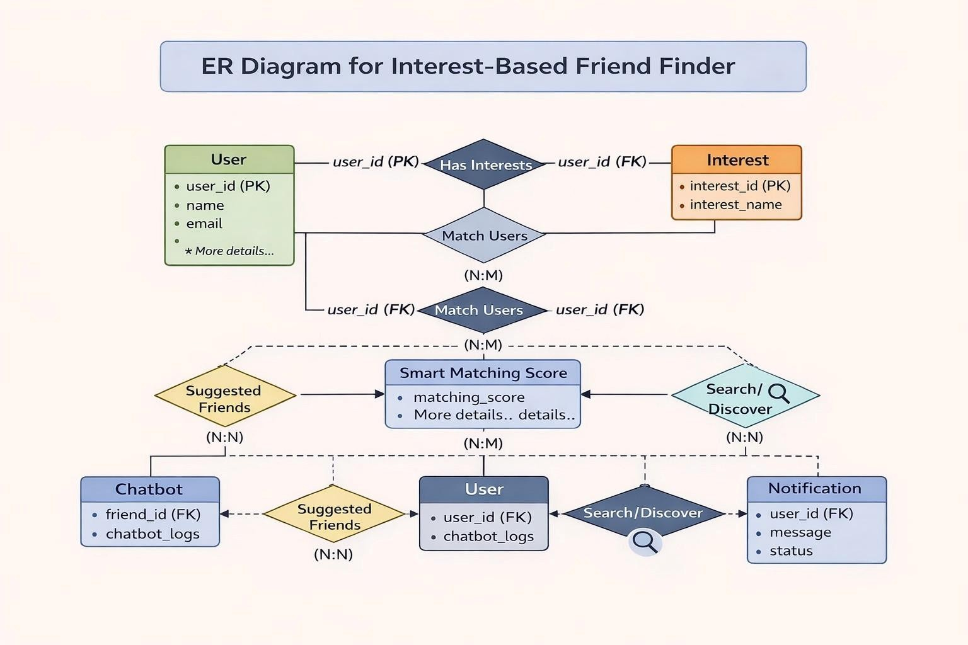

SQL DATABASE CODE:
- Create Users Table CREATE TABLE users (
id BIGINT AUTO_INCREMENT PRIMARY KEY, name VARCHAR(255) NOT NULL,
email VARCHAR(255) NOT NULL UNIQUE, password VARCHAR(255) NOT NULL,
otp VARCHAR(255),
is_verified BOOLEAN NOT NULL DEFAULT FALSE,
profile_picture LONGTEXT, last_login DATETIME,
activity_score INT NOT NULL DEFAULT 0, report_count INT NOT NULL DEFAULT 0
);

- Create Interests Table CREATE TABLE interests (
id BIGINT AUTO_INCREMENT PRIMARY KEY, name VARCHAR(255) NOT NULL UNIQUE
);

- Create Friend Requests Table CREATE TABLE friend_requests (
id BIGINT AUTO_INCREMENT PRIMARY KEY,
sender_id BIGINT NOT NULL, receiver_id BIGINT NOT NULL,
status VARCHAR(50) NOT NULL, -- e.g., 'PENDING', 'ACCEPTED', 'REJECTED' created_at DATETIME NOT NULL DEFAULT CURRENT_TIMESTAMP,
FOREIGN KEY (sender_id) REFERENCES users(id) ON DELETE CASCADE
FOREIGN KEY (receiver_id) REFERENCES users(id) ON DELETE CASCADE
);

- Create Messages Table CREATE TABLE messages (
id BIGINT AUTO_INCREMENT PRIMARY KEY,
sender_id BIGINT NOT NULL, receiver_id BIGINT NOT NULL, content LONGTEXT NOT NULL,
timestamp DATETIME NOT NULL DEFAULT CURRENT_TIMESTAMP,
FOREIGN KEY (sender_id) REFERENCES users(id) ON DELETE CASCADE,
FOREIGN KEY (receiver_id) REFERENCES users(id) ON DELETE CASCADE
);

- Create Join Table: User Interests (Many-to-Many) CREATE TABLE user_interests (
user_id BIGINT NOT NULL, interest_id BIGINT NOT NULL,
PRIMARY KEY (user_id, interest_id),
FOREIGN KEY (user_id) REFERENCES users(id) ON DELETE CASCADE,
FOREIGN KEY (interest_id) REFERENCES interests(id) ON DELETE CASCADE
);

- Create Join Table: User Friends (Many-to-Many) CREATE TABLE user_friends (
user_id BIGINT NOT NULL, friend_id BIGINT NOT NULL,
PRIMARY KEY (user_id, friend_id),
FOREIGN KEY (user_id) REFERENCES users(id) ON DELETE CASCADE,
FOREIGN KEY (friend_id) REFERENCES users(id) ON DELETE CASCADE
);

- Create Join Table: User Blocked (Many-to-Many) CREATE TABLE user_blocked (
user_id BIGINT NOT NULL,
blocked_id BIGINT NOT NULL,
PRIMARY KEY (user_id, blocked_id),
FOREIGN KEY (user_id) REFERENCES users(id) ON DELETE CASCADE,
FOREIGN KEY (blocked_id) REFERENCES users(id) ON DELETE CASCADE
);

coding and application screenshots:
package com.friendfinder.config;
import org.springframework.context.annotation.Bean;
import org.springframework.context.annotation.Configuration; import
org.springframework.security.crypto.bcrypt.BCryptPasswordEncoder;
import
org.springframework.security.crypto.password.PasswordEncoder;

@Configuration
public class AppConfig { @Bean

public PasswordEncoder passwordEncoder() { return new BCryptPasswordEncoder();
}
}

Controller File Codes:
package com.friendfinder.controller; import com.friendfinder.model.User;
import com.friendfinder.repository.UserRepository; import com.friendfinder.service.AdminService;
import org.springframework.http.ResponseEntity; import org.springframework.web.bind.annotation.*;

import java.util.List; import java.util.Map;
import java.util.stream.Collectors;

@RestController
@RequestMapping("/api/admin") public class AdminController {

private final AdminService adminService;
private final UserRepository userRepository;

public AdminController(AdminService adminService, UserRepository userRepository) {
this.adminService = adminService;
this.userRepository = userRepository;
}

@GetMapping("/users")
public ResponseEntity<List<Map<String, Object>>> getAllUsers() { List<Map<String, Object>> users =
userRepository.findAll().stream()
.map(u -> Map.<String, Object>of( "id", u.getId(),
"name", u.getName(),
"email", u.getEmail(),
"profilePicture", u.getProfilePicture() == null ? "" : u.getProfilePicture(),
"reportCount", u.getReportCount()
))
.collect(Collectors.toList());

return ResponseEntity.ok(users);
}

@DeleteMapping("/users/{id}")
public ResponseEntity<String> deleteUser(@PathVariable Long id) {

adminService.deleteUser(id);
return ResponseEntity.ok("User deleted successfully");
}

@DeleteMapping("/users/{id}/image")
public ResponseEntity<String> deleteUserImage(@PathVariable Long id) {
adminService.deleteUserImage(id);
return ResponseEntity.ok("Image deleted successfully") package com.friendfinder.controller;
import com.friendfinder.dto.LoginRequest; import com.friendfinder.dto.RegisterRequest; import com.friendfinder.dto.UserDto;
import com.friendfinder.dto.VerifyOtpRequest; import com.friendfinder.service.UserService;
import org.springframework.http.ResponseEntity; import org.springframework.web.bind.annotation.*;

@RestController
@RequestMapping("/api/auth") public class AuthController {

private final UserService userService;

public AuthController(UserService userService) { this.userService = userService;
}

@PostMapping("/register")
public ResponseEntity<String> register(@RequestBody RegisterRequest request) {
return ResponseEntity.ok(userService.registerUser(request));
}

@PostMapping("/verify-otp")
public ResponseEntity<String> verifyOtp(@RequestBody VerifyOtpRequest request) {
return
ResponseEntity.ok(userService.verifyOtp(request.getEmail(), request.getOtp()));
}

@PostMapping("/login")
public ResponseEntity<UserDto> login(@RequestBody LoginRequest request) {
return ResponseEntity.ok(userService.login(request));
}
}

package com.friendfinder.controller;
import com.friendfinder.model.FriendRequest; import com.friendfinder.model.User;
import com.friendfinder.service.FriendRequestService; import com.friendfinder.service.UserService;
import org.springframework.http.ResponseEntity; import org.springframework.web.bind.annotation.*;

import java.util.List;
import java.util.stream.Collectors;

@RestController
@RequestMapping("/api/friends") public class FriendController {

private final FriendRequestService friendRequestService; private final UserService userService;

public FriendController(FriendRequestService friendRequestService, UserService userService) {
this.friendRequestService = friendRequestService; this.userService = userService;
}

@PostMapping("/request")
public ResponseEntity<String> sendRequest(@RequestParam Long senderId, @RequestParam Long receiverId) {
return
ResponseEntity.ok(friendRequestService.sendRequest(senderId, receiverId));
}

@PostMapping("/accept")
public ResponseEntity<String> acceptRequest(@RequestParam Long requestId, @RequestParam Long receiverId) {
return
ResponseEntity.ok(friendRequestService.acceptRequest(requestId, receiverId));
}

@PostMapping("/reject")
public ResponseEntity<String> rejectRequest(@RequestParam Long requestId, @RequestParam Long receiverId) {
return
ResponseEntity.ok(friendRequestService.rejectRequest(requestId, receiverId));
}

@GetMapping("/pending")
public ResponseEntity<List<java.util.Map<String, Object>>> getPendingRequests(@RequestParam Long userId) {

List<FriendRequest> requests =
friendRequestService.getPendingRequestsForUser(userId);
List<java.util.Map<String, Object>> safeRequests = requests.stream()
.map(r -> java.util.Map.<String, Object>of( "id", r.getId(),
"sender", java.util.Map.of("id", r.getSender().getId(), "name", r.getSender().getName())
))
.collect(Collectors.toList());
return ResponseEntity.ok(safeRequests);
}

@GetMapping("/list")
public ResponseEntity<List<java.util.Map<String, Object>>> listFriends(@RequestParam Long userId) {
User user = userService.getUserById(userId);
List<java.util.Map<String, Object>> friends = user.getFriends().stream()
.map(f -> java.util.Map.<String, Object>of("id", f.getId(), "name", f.getName()))
.collect(Collectors.toList()); return ResponseEntity.ok(friends);
}

@DeleteMapping("/remove")
public ResponseEntity<String> removeFriend(@RequestParam Long userId, @RequestParam Long friendId) {
userService.removeFriend(userId, friendId);
return ResponseEntity.ok("Friend removed successfully");
}
}

package com.friendfinder.controller; import com.friendfinder.dto.UserDto;
import com.friendfinder.service.UserService;
import org.springframework.http.ResponseEntity; import org.springframework.web.bind.annotation.*;

@RestController
@RequestMapping("/api/interests") public class InterestController {

private final UserService userService;

public InterestController(UserService userService) { this.userService = userService;
}

@PostMapping("/add")
public ResponseEntity<UserDto> addInterest(@RequestParam Long userId, @RequestParam String interestName) {
return ResponseEntity.ok(userService.addInterestToUser(userId, interestName));
}

@DeleteMapping("/remove")
public ResponseEntity<UserDto> removeInterest(@RequestParam Long userId, @RequestParam String interestName) {
return
ResponseEntity.ok(userService.removeInterestFromUser(userId, interestName));
}
}

package com.friendfinder.controller; import com.friendfinder.dto.UserDto;
import com.friendfinder.service.MatchingService; import org.springframework.http.ResponseEntity; import org.springframework.web.bind.annotation.*;

import java.util.List;

@RestController
@RequestMapping("/api/matches") public class MatchController {

private final MatchingService matchingService;

public MatchController(MatchingService matchingService) { this.matchingService = matchingService;
}

@GetMapping("/suggest")
public ResponseEntity<List<UserDto>>
suggestFriends(@RequestParam Long userId) {
return
ResponseEntity.ok(matchingService.suggestFriends(userId));
}

@GetMapping("/search")
public ResponseEntity<List<UserDto>>
searchUsers(@RequestParam Long userId, @RequestParam String keyword) {
return ResponseEntity.ok(matchingService.searchUsers(userId, keyword));
}
}

package com.friendfinder.controller;

import com.friendfinder.model.Message; import com.friendfinder.model.User;
import com.friendfinder.repository.MessageRepository; import com.friendfinder.service.UserService;
import org.springframework.http.ResponseEntity; import org.springframework.web.bind.annotation.*;

import java.util.List; import java.util.Map;
import java.util.stream.Collectors;

@RestController
@RequestMapping("/api/messages") public class MessageController {

private final MessageRepository messageRepository; private final UserService userService;
private final com.friendfinder.repository.UserRepository userRepository;

public MessageController(MessageRepository messageRepository, UserService userService, com.friendfinder.repository.UserRepository userRepository) {
this.messageRepository = messageRepository; this.userService = userService;
this.userRepository = userRepository;
}

@PostMapping("/send")
public ResponseEntity<String> sendMessage(@RequestParam Long senderId, @RequestParam Long receiverId, @RequestBody Map<String, String> payload) {
User sender = userService.getUserById(senderId);
User receiver = userService.getUserById(receiverId);

String content = payload.get("content");
if (content == null || content.trim().isEmpty()) {
return ResponseEntity.badRequest().body("Message content cannot be empty.");
}

Message message = new Message(sender, receiver, content); messageRepository.save(message);

sender.setActivityScore(sender.getActivityScore() + 5); // Boost for sending msg
userRepository.save(sender);

return ResponseEntity.ok("Message sent successfully!");
}

@GetMapping("/history")
public ResponseEntity<List<Map<String, Object>>>
getHistory(@RequestParam Long user1Id, @RequestParam Long user2Id) {
User user1 = userService.getUserById(user1Id); User user2 = userService.getUserById(user2Id);

List<Message> messages =
messageRepository.findConversation(user1, user2);

List<Map<String, Object>> response = messages.stream()
.map(m -> Map.<String, Object>of( "id", m.getId(),
"senderId", m.getSender().getId(),
"receiverId", m.getReceiver().getId(), "content", m.getContent(),
"timestamp", m.getTimestamp().toString()
))

.collect(Collectors.toList());

return ResponseEntity.ok(response);
}
}

package com.friendfinder.controller;

import com.friendfinder.dto.UserDto; import com.friendfinder.model.User;
import com.friendfinder.repository.UserRepository; import com.friendfinder.service.UserService;
import org.springframework.http.ResponseEntity; import org.springframework.web.bind.annotation.*;

import java.util.Comparator; import java.util.List;
import java.util.Map;
import java.util.stream.Collectors;

@RestController
@RequestMapping("/api/users") public class UserController {

private final UserRepository userRepository; private final UserService userService;

public UserController(UserRepository userRepository, UserService userService) {
this.userRepository = userRepository; this.userService = userService;
}

@PostMapping("/{userId}/upload-pfp")
public ResponseEntity<?> uploadProfilePicture(@PathVariable Long userId, @RequestBody Map<String, String> payload) {
User user = userService.getUserById(userId);
user.setProfilePicture(payload.get("profilePicture"));
user.setActivityScore(user.getActivityScore() + 10); // Reward for uploading PFP
userRepository.save(user);
return ResponseEntity.ok().build();
}

@PostMapping("/{userId}/block/{blockId}")
public ResponseEntity<?> blockUser(@PathVariable Long userId, @PathVariable Long blockId) {
User user = userService.getUserById(userId);
User userToBlock = userService.getUserById(blockId);

.ok().build();
}
@GetMapping("/{userId}")
public ResponseEntity<UserDto> getUserInfo(@PathVariable Long userId) {
User user = userService.getUserById(userId); return ResponseEntity.ok(convertToDto(user));
}

private UserDto convertToDto(User user) { UserDto dto = new UserDto();
dto.setId(user.getId());
dto.setName(user.getName()); dto.setEmail(user.getEmail());
dto.setProfilePicture(user.getProfilePicture()); dto.setActivityScore(user.getActivityScore()); dto.setLastLogin(user.getLastLogin());
return dto;

}
}

Dto File Codes:
package com.friendfinder.dto; public class InterestDto {
private String name;

public String getName() { return name; }
public void setName(String name) { this.name = name; }
}

package com.friendfinder.dto; public class LoginRequest {
private String email;
private String password;

public String getEmail() { return email; }
public void setEmail(String email) { this.email = email; } public String getPassword() { return password; }
public void setPassword(String password) { this.password = password; }
}

package com.friendfinder.dto; public class RegisterRequest {
private String name; private String email;
private String password;

public String getName() { return name; }
public void setName(String name) { this.name = name; } public String getEmail() { return email; }
public void setEmail(String email) { this.email = email; } public String getPassword() { return password; }
public void setPassword(String password) { this.password = password; }
}

package com.friendfinder.dto; import java.util.Set;
public class UserDto { private Long id;
private String name; private String email;
private Set<String> interests;

private Set<String> sharedInterests; private int matchScore;
private int mutualConnections; private String profilePicture;
private java.time.LocalDateTime lastLogin; private int activityScore;

public Long getId() { return id; }
public void setId(Long id) { this.id = id; } public String getName() { return name; }
public void setName(String name) { this.name = name; } public String getEmail() { return email; }
public void setEmail(String email) { this.email = email; } public Set<String> getInterests() { return interests; }
public void setInterests(Set<String> interests) { this.interests = interests; }
public Set<String> getSharedInterests() { return sharedInterests; }
public void setSharedInterests(Set<String> sharedInterests) { this.sharedInterests = sharedInterests; }
public int getMatchScore() { return matchScore; }
public void setMatchScore(int matchScore) { this.matchScore = matchScore; }
public int getMutualConnections() { return mutualConnections; }
public void setMutualConnections(int mutualConnections) { this.mutualConnections = mutualConnections; }

public String getProfilePicture() { return profilePicture; }
public void setProfilePicture(String profilePicture) { this.profilePicture = profilePicture; }
public java.time.LocalDateTime getLastLogin() { return lastLogin; }
public void setLastLogin(java.time.LocalDateTime lastLogin) { this.lastLogin = lastLogin; }
public int getActivityScore() { return activityScore; }
public void setActivityScore(int activityScore) { this.activityScore = activityScore; }
}
package com.friendfinder.dto;

public class VerifyOtpRequest { private String email;
private String otp;

public String getEmail() { return email; }
public void setEmail(String email) { this.email = email; } public String getOtp() { return otp; }
public void setOtp(String otp) { this.otp = otp; }
}

Model File Codes:
package com.friendfinder.model;

import jakarta.persistence.*;
import java.time.LocalDateTime;

@Entity
@Table(name = "friend_requests") public class FriendRequest {
@Id
@GeneratedValue(strategy = GenerationType.IDENTITY) private Long id;

@ManyToOne(fetch = FetchType.LAZY)
@JoinColumn(name = "sender_id", nullable = false) private User sender;

@ManyToOne(fetch = FetchType.LAZY)
@JoinColumn(name = "receiver_id", nullable = false) private User receiver;

@Enumerated(EnumType.STRING) @Column(nullable = false)
private FriendRequestStatus status;

@Column(nullable = false, updatable = false)
private LocalDateTime createdAt = LocalDateTime.now();

public FriendRequest() {}

public Long getId() { return id; }
public void setId(Long id) { this.id = id; } public User getSender() { return sender; }
public void setSender(User sender) { this.sender = sender; } public User getReceiver() { return receiver; }
public void setReceiver(User receiver) { this.receiver = receiver; } public FriendRequestStatus getStatus() { return status; }
public void setStatus(FriendRequestStatus status) { this.status = status; }
public LocalDateTime getCreatedAt() { return createdAt; }
public void setCreatedAt(LocalDateTime createdAt) { this.createdAt
= createdAt; }
}

package com.friendfinder.model;

public enum FriendRequestStatus { PENDING,
ACCEPTED, REJECTED
}

package com.friendfinder.model;

import jakarta.persistence.*; import java.util.HashSet;
import java.util.Set;

@Entity
@Table(name = "interests") public class Interest {
@Id
@GeneratedValue(strategy = GenerationType.IDENTITY) private Long id;

@Column(nullable = false, unique = true) private String name;

public Interest() {}
public Interest(Long id, String name) { this.id = id;
this.name = name;
}

public Long getId() { return id; }

public void setId(Long id) { this.id = id; } public String getName() { return name; }
public void setName(String name) { this.name = name; }
}

package com.friendfinder.model;

import com.fasterxml.jackson.annotation.JsonIgnoreProperties; import jakarta.persistence.*;
import java.time.LocalDateTime;

@Entity
@Table(name = "messages") public class Message {

@Id
@GeneratedValue(strategy = GenerationType.IDENTITY) private Long id;

@ManyToOne(fetch = FetchType.EAGER)
@JoinColumn(name = "sender_id", nullable = false)
@JsonIgnoreProperties({"friends", "interests", "sentRequests", "receivedRequests", "password"})
private User sender;

@ManyToOne(fetch = FetchType.EAGER)
@JoinColumn(name = "receiver_id", nullable = false)
@JsonIgnoreProperties({"friends", "interests", "sentRequests", "receivedRequests", "password"})
private User receiver;

@Lob
@Column(nullable = false, columnDefinition = "LONGTEXT") private String content;

@Column(nullable = false)
private LocalDateTime timestamp;

public Message() {
}

public Message(User sender, User receiver, String content) { this.sender = sender;
this.receiver = receiver; this.content = content;
this.timestamp = LocalDateTime.now();
}

public Long getId() { return id;
}

public void setId(Long id) { this.id = id;
}

public User getSender() { return sender;
}

public void setSender(User sender) { this.sender = sender;
}

public User getReceiver() { return receiver;
}

public void setReceiver(User receiver) { this.receiver = receiver;
}

public String getContent() { return content;
}

public void setContent(String content) { this.content = content;
}

public LocalDateTime getTimestamp() { return timestamp;
}

public void setTimestamp(LocalDateTime timestamp) { this.timestamp = timestamp;
}
}

package com.friendfinder.model;

import jakarta.persistence.*; import java.util.HashSet;
import java.util.Set; @Entity

@Table(name = "users") public class User {
@Id
@GeneratedValue(strategy = GenerationType.IDENTITY) private Long id;

@Column(nullable = false) private String name;

@Column(nullable = false, unique = true) private String email;

@Column(nullable = false) private String password;

private String otp;

@Column(nullable = false) private boolean isVerified;

@ManyToMany(fetch = FetchType.LAZY) @JoinTable(
name = "user_interests",
joinColumns = @JoinColumn(name = "user_id"),

inverseJoinColumns = @JoinColumn(name = "interest_id")
)
private Set<Interest> interests = new HashSet<>();

@ManyToMany(fetch = FetchType.LAZY) @JoinTable(
name = "user_friends",
joinColumns = @JoinColumn(name = "user_id"),
inverseJoinColumns = @JoinColumn(name = "friend_id")
)
private Set<User> friends = new HashSet<>();

@Lob
@Column(columnDefinition = "LONGTEXT") private String profilePicture;

private java.time.LocalDateTime lastLogin;

@Column(nullable = false, columnDefinition = "int default 0") private int activityScore = 0;

@ManyToMany(fetch = FetchType.LAZY) @JoinTable(
name = "user_blocked",

joinColumns = @JoinColumn(name = "user_id"),
inverseJoinColumns = @JoinColumn(name = "blocked_id")
)
private Set<User> blockedUsers = new HashSet<>(); public User() {}
public Long getId() { return id; }
public void setId(Long id) { this.id = id; } public String getName() { return name; }
public void setName(String name) { this.name = name; } public String getEmail() { return email; }
public void setEmail(String email) { this.email = email; } public String getPassword() { return password; }
public void setPassword(String password) { this.password = password; }
public String getOtp() { return otp; }
public void setOtp(String otp) { this.otp = otp; } public boolean isVerified() { return isVerified; }
public void setVerified(boolean verified) { isVerified = verified; } public Set<Interest> getInterests() { return interests; }
public void setInterests(Set<Interest> interests) { this.interests = interests; }
public Set<User> getFriends() { return friends; }

public void setFriends(Set<User> friends) { this.friends = friends; }

public String getProfilePicture() { return profilePicture; } public void setProfilePicture(String profilePicture) {
this.profilePicture = profilePicture; }
public java.time.LocalDateTime getLastLogin() { return lastLogin; } public void setLastLogin(java.time.LocalDateTime lastLogin) {
this.lastLogin = lastLogin; }
public int getActivityScore() { return activityScore; }
public void setActivityScore(int activityScore) { this.activityScore = activityScore; }
public Set<User> getBlockedUsers() { return blockedUsers; }
public void setBlockedUsers(Set<User> blockedUsers) { this.blockedUsers = blockedUsers; }

@Column(nullable = false, columnDefinition = "int default 0") private int reportCount = 0;

public int getReportCount() { return reportCount; }
public void setReportCount(int reportCount) { this.reportCount = reportCount; }
}

Repository File Codes:
package com.friendfinder.repository;

import com.friendfinder.model.FriendRequest;
import com.friendfinder.model.FriendRequestStatus; import com.friendfinder.model.User;
import org.springframework.data.jpa.repository.JpaRepository; import org.springframework.stereotype.Repository;

import java.util.List;
import java.util.Optional;

@Repository
public interface FriendRequestRepository extends JpaRepository<FriendRequest, Long> {
List<FriendRequest> findByReceiverAndStatus(User receiver, FriendRequestStatus status);
List<FriendRequest> findBySenderAndStatus(User sender, FriendRequestStatus status);
Optional<FriendRequest> findBySenderAndReceiver(User sender, User receiver);
void deleteBySenderOrReceiver(User sender, User receiver);
}

package com.friendfinder.repository;

import com.friendfinder.model.Interest;

import org.springframework.data.jpa.repository.JpaRepository; import org.springframework.stereotype.Repository;

import java.util.Optional;

@Repository
public interface InterestRepository extends JpaRepository<Interest, Long> {
Optional<Interest> findByName(String name);
}

package com.friendfinder.repository;

import com.friendfinder.model.Message; import com.friendfinder.model.User;
import org.springframework.data.jpa.repository.JpaRepository; import org.springframework.data.jpa.repository.Query;
import org.springframework.stereotype.Repository; import java.util.List;
@Repository
public interface MessageRepository extends JpaRepository<Message, Long> {

@Query("SELECT m FROM Message m WHERE (m.sender = :user1 AND m.receiver = :user2) OR (m.sender = :user2 AND m.receiver =
:user1) ORDER BY m.timestamp ASC")
List<Message> findConversation(User user1, User user2); void deleteBySenderOrReceiver(User sender, User receiver);
}

package com.friendfinder.repository;

import com.friendfinder.model.User;
import org.springframework.data.jpa.repository.JpaRepository; import org.springframework.stereotype.Repository;

import java.util.Optional;

@Repository
public interface UserRepository extends JpaRepository<User, Long> { Optional<User> findByEmail(String email);
boolean existsByEmail(String email);
}

Service File Codes:
package com.friendfinder.service;

import com.friendfinder.model.User;
import com.friendfinder.repository.FriendRequestRepository; import com.friendfinder.repository.MessageRepository;
import com.friendfinder.repository.UserRepository; import org.springframework.stereotype.Service;
import org.springframework.transaction.annotation.Transactional; import java.util.List;
@Service
public class AdminService {

private final UserRepository userRepository;
private final MessageRepository messageRepository;
private final FriendRequestRepository friendRequestRepository;

public AdminService(UserRepository userRepository,
MessageRepository messageRepository, FriendRequestRepository friendRequestRepository) {
this.userRepository = userRepository;
this.messageRepository = messageRepository;

this.friendRequestRepository = friendRequestRepository;
}

@Transactional
public void deleteUser(Long userId) {
User user = userRepository.findById(userId)
.orElseThrow(() -> new RuntimeException("User not found"));

// 1. Delete all messages sent or received by the user
messageRepository.deleteBySenderOrReceiver(user, user);

// 2. Delete all friend requests sent or received by the user
friendRequestRepository.deleteBySenderOrReceiver(user, user);

// 3. Remove user from all other users' friends and blocked lists safely
List<User> allUsers = userRepository.findAll(); for (User other : allUsers) {
if (!other.getId().equals(user.getId())) { other.getFriends().remove(user);
other.getBlockedUsers().remove(user); userRepository.save(other);
}

}

row

}
// 4. Clear the user's own mappings so JPA can delete the base

user.getFriends().clear();
user.getBlockedUsers().clear(); user.getInterests().clear();
userRepository.save(user); // Flush clearing

// 5. Delete the user
userRepository.delete(user);

@Transactional
public void deleteUserImage(Long userId) {
User user = userRepository.findById(userId)
.orElseThrow(() -> new RuntimeException("User not found"));
user.setProfilePicture(null); userRepository.save(user);
}
}

package com.friendfinder.service;

import org.slf4j.Logger;
import org.slf4j.LoggerFactory;
import org.springframework.mail.SimpleMailMessage;
import org.springframework.mail.javamail.JavaMailSender; import org.springframework.stereotype.Service;

@Service
public class EmailService {

private final JavaMailSender emailSender; private static final Logger logger =
LoggerFactory.getLogger(EmailService.class);

public EmailService(JavaMailSender emailSender) { this.emailSender = emailSender;
}

public void sendOtpEmail(String to, String otp) {
String subject = "Verify your Friend Finder account"; String text = "Your OTP for verification is: " + otp;
sendEmail(to, subject, text);
}

public void sendNotification(String to, String subject, String text) { sendEmail(to, subject, text);
}

private void sendEmail(String to, String subject, String text) { try {
SimpleMailMessage message = new SimpleMailMessage(); message.setFrom("noreply@friendfinder.com");
message.setTo(to);
message.setSubject(subject); message.setText(text);
emailSender.send(message);
logger.info("Email sent successfully to {}", to);
} catch (Exception e) {
// Mock behavior if mail server is not configured
logger.error("Failed to send email. Mail Server may not be configured. Mocking email sending.");
logger.info("MOCK EMAIL TO: {}, SUBJECT: {}, TEXT: {}", to,
subject, text);
}
}
}

package com.friendfinder.service;

import com.friendfinder.model.FriendRequest;
import com.friendfinder.model.FriendRequestStatus; import com.friendfinder.model.User;
import com.friendfinder.repository.FriendRequestRepository; import org.springframework.stereotype.Service;
import org.springframework.transaction.annotation.Transactional;

import java.util.List;
import java.util.Optional;

@Service
public class FriendRequestService {

private final FriendRequestRepository friendRequestRepository; private final UserService userService;
private final EmailService emailService;

public FriendRequestService(FriendRequestRepository
friendRequestRepository, UserService userService, EmailService emailService) {
this.friendRequestRepository = friendRequestRepository; this.userService = userService;
this.emailService = emailService;

}

@Transactional
public String sendRequest(Long senderId, Long receiverId) { if (senderId.equals(receiverId)) {
throw new RuntimeException("Cannot send friend request to yourself");
}
User sender = userService.getUserById(senderId);
User receiver = userService.getUserById(receiverId);

if (sender.getFriends().contains(receiver)) {
throw new RuntimeException("Already friends");
}

Optional<FriendRequest> existingRequest =
friendRequestRepository.findBySenderAndReceiver(sender, receiver); if (existingRequest.isPresent()) {
throw new RuntimeException("Friend request already sent");
}

FriendRequest request = new FriendRequest(); request.setSender(sender);
request.setReceiver(receiver);

request.setStatus(FriendRequestStatus.PENDING); friendRequestRepository.save(request);
emailService.sendNotification(receiver.getEmail(), "New Friend Request",
sender.getName() + " has sent you a friend request!");

return "Friend request sent successfully";
}

@Transactional
public String acceptRequest(Long requestId, Long receiverId) { FriendRequest request =
friendRequestRepository.findById(requestId)
.orElseThrow(() -> new RuntimeException("Friend request not found"));

if (!request.getReceiver().getId().equals(receiverId)) {
throw new RuntimeException("Unauthorized to accept this request");
}

if (request.getStatus() != FriendRequestStatus.PENDING) {

throw new RuntimeException("Request is not pending it is " + request.getStatus());
}

request.setStatus(FriendRequestStatus.ACCEPTED); friendRequestRepository.save(request);

userService.addFriend(request.getSender(), request.getReceiver());

emailService.sendNotification(request.getSender().getEmail(), "Friend Request Accepted",
request.getReceiver().getName() + " accepted your friend request!");

return "Friend request accepted";
}

@Transactional
public String rejectRequest(Long requestId, Long receiverId) { FriendRequest request =
friendRequestRepository.findById(requestId)
.orElseThrow(() -> new RuntimeException("Friend request not found"));

if (!request.getReceiver().getId().equals(receiverId)) {
throw new RuntimeException("Unauthorized to reject this request");
}

request.setStatus(FriendRequestStatus.REJECTED); friendRequestRepository.save(request);

return "Friend request rejected";
}

public List<FriendRequest> getPendingRequestsForUser(Long userId) {
User user = userService.getUserById(userId);
return friendRequestRepository.findByReceiverAndStatus(user, FriendRequestStatus.PENDING);
}
}

package com.friendfinder.service;

import com.friendfinder.dto.UserDto; import com.friendfinder.model.Interest; import com.friendfinder.model.User;
import com.friendfinder.repository.UserRepository;

import org.springframework.stereotype.Service;

import java.util.*;
import java.util.stream.Collectors;

@Service
public class MatchingService {

private final UserRepository userRepository; private final UserService userService;

public MatchingService(UserRepository userRepository, UserService userService) {
this.userRepository = userRepository; this.userService = userService;
}

public List<UserDto> suggestFriends(Long userId) {
User currentUser = userService.getUserById(userId); List<User> allUsers = userRepository.findAll();

return rankAndConvertUsers(currentUser, allUsers);
}

public List<UserDto> searchUsers(Long userId, String keyword) { User currentUser = userService.getUserById(userId);

if (keyword == null || keyword.trim().isEmpty()) { return suggestFriends(userId);
}

String lowerKeyword = keyword.toLowerCase();

List<User> searchResults = userRepository.findAll().stream()
.filter(user ->
user.getName().toLowerCase().contains(lowerKeyword) || user.getInterests().stream().anyMatch(i ->
i.getName().toLowerCase().contains(lowerKeyword))
)
.collect(Collectors.toList());

return rankAndConvertUsers(currentUser, searchResults);
}

private List<UserDto> rankAndConvertUsers(User currentUser, List<User> usersToRank) {
Set<Interest> currentInterests = currentUser.getInterests(); Set<User> currentFriends = currentUser.getFriends();

List<UserDto> rankedUsers = new ArrayList<>();

for (User user : usersToRank) {
// Skip the current user, their existing friends, and blocked
users
if (user.getId().equals(currentUser.getId()) ||
currentFriends.contains(user) ||
currentUser.getBlockedUsers().contains(user)) { continue;
}

// Calculate intersection of interests Set<Interest> commonInterests = new
HashSet<>(user.getInterests());
commonInterests.retainAll(currentInterests);

// Calculate mutual friends
Set<User> mutualFriends = new HashSet<>(user.getFriends()); mutualFriends.retainAll(currentFriends);

int interestScore = commonInterests.size(); int mutualFriendScore = mutualFriends.size();
int totalScore = interestScore + mutualFriendScore;

// If we are suggesting, we require at least 1 score point. If searching, we show them anyway.
if (totalScore > 0 || usersToRank.size() < userRepository.count() - 1) {
UserDto dto = convertToDto(user);

Set<String> sharedInterestNames = commonInterests.stream()
.map(Interest::getName)
.collect(Collectors.toSet());

dto.setSharedInterests(sharedInterestNames); dto.setMutualConnections(mutualFriendScore); dto.setMatchScore(totalScore);

rankedUsers.add(dto);
}
}

// Sort by highest score first
rankedUsers.sort(Comparator.comparingInt(UserDto::getMatchS core).reversed());
return rankedUsers;
}

private UserDto convertToDto(User user) { UserDto dto = new UserDto();
dto.setId(user.getId());
dto.setName(user.getName()); dto.setEmail(user.getEmail());
Set<String> interestNames = user.getInterests().stream()
.map(Interest::getName)
.collect(Collectors.toSet()); dto.setInterests(interestNames); return dto;
}
}

package com.friendfinder.service;

import com.friendfinder.dto.LoginRequest; import com.friendfinder.dto.RegisterRequest; import com.friendfinder.dto.UserDto;
import com.friendfinder.model.Interest; import com.friendfinder.model.User;
import com.friendfinder.repository.InterestRepository; import com.friendfinder.repository.UserRepository;
import
org.springframework.security.crypto.password.PasswordEncoder;

import org.springframework.stereotype.Service;
import org.springframework.transaction.annotation.Transactional;

import java.util.Optional; import java.util.Random; import java.util.Set;
import java.util.stream.Collectors;

@Service
public class UserService {

private final UserRepository userRepository;
private final InterestRepository interestRepository; private final EmailService emailService;
private final PasswordEncoder passwordEncoder;

public UserService(UserRepository userRepository,
InterestRepository interestRepository, EmailService emailService, PasswordEncoder passwordEncoder) {
this.userRepository = userRepository;
this.interestRepository = interestRepository; this.emailService = emailService;
this.passwordEncoder = passwordEncoder;
}

@Transactional
public String registerUser(RegisterRequest request) {
if (userRepository.existsByEmail(request.getEmail())) { throw new RuntimeException("Email already exists");
}

User user = new User();
user.setName(request.getName()); user.setEmail(request.getEmail());
user.setPassword(passwordEncoder.encode(request.getPasswor d()));
user.setVerified(true); // Automatically verify userRepository.save(user);
return "Registration successful. You can now log in!";
}

@Transactional
public String verifyOtp(String email, String otp) { return "Email verified successfully"; // Stubbed out
}

public UserDto login(LoginRequest request) {
User user = userRepository.findByEmail(request.getEmail())
.orElseThrow(() -> new RuntimeException("Invalid credentials"));

if (passwordEncoder.matches(request.getPassword(), user.getPassword())) {
user.setLastLogin(java.time.LocalDateTime.now());
user.setActivityScore(user.getActivityScore() + 1); // 1 point for logging in
userRepository.save(user); return convertToDto(user);
}

throw new RuntimeException("Invalid credentials");
}

public UserDto getUserDto(Long userId) { User user = getUserById(userId); return convertToDto(user);
}

public User getUserById(Long userId) { return userRepository.findById(userId)

.orElseThrow(() -> new RuntimeException("User not found with id: " + userId));
}

@Transactional
public UserDto addInterestToUser(Long userId, String interestName) {
User user = getUserById(userId);

Interest interest = interestRepository.findByName(interestName)
.orElseGet(() -> interestRepository.save(new Interest(null, interestName)));

user.getInterests().add(interest); userRepository.save(user);

return convertToDto(user);
}

@Transactional
public UserDto removeInterestFromUser(Long userId, String interestName) {
User user = getUserById(userId);

Interest interest = interestRepository.findByName(interestName)

.orElseThrow(() -> new RuntimeException("Interest not found"));

user.getInterests().remove(interest); userRepository.save(user);

return convertToDto(user);
}

@Transactional
public void addFriend(User user1, User user2) { user1.getFriends().add(user2); user2.getFriends().add(user1);
userRepository.save(user1); userRepository.save(user2);
}

@Transactional
public void removeFriend(Long userId, Long friendId) { User user1 = getUserById(userId);
User user2 = getUserById(friendId);

user1.getFriends().remove(user2); user2.getFriends().remove(user1);

userRepository.save(user1); userRepository.save(user2);
}

private UserDto convertToDto(User user) { UserDto dto = new UserDto();
dto.setId(user.getId());
dto.setName(user.getName()); dto.setEmail(user.getEmail());
dto.setProfilePicture(user.getProfilePicture()); dto.setActivityScore(user.getActivityScore()); dto.setLastLogin(user.getLastLogin());
Set<String> interestNames = user.getInterests().stream()
.map(Interest::getName)
.collect(Collectors.toSet()); dto.setInterests(interestNames); return dto;
}
}

FriendFinderApplication.java:

package com.friendfinder;

import com.friendfinder.dto.RegisterRequest; import com.friendfinder.model.User;
import com.friendfinder.repository.UserRepository; import com.friendfinder.service.UserService;
import org.springframework.boot.CommandLineRunner; import org.springframework.boot.SpringApplication;
import
org.springframework.boot.autoconfigure.SpringBootApplication; import org.springframework.context.annotation.Bean;

@SpringBootApplication
public class FriendFinderApplication {

public static void main(String[] args) {
SpringApplication.run(FriendFinderApplication.class, args);
}

@Bean
public CommandLineRunner loadData(UserService userService, UserRepository userRepository) {
return args -> {
if (userRepository.count() == 0) {
// Seed Dummy Account 1

RegisterRequest req1 = new RegisterRequest(); req1.setName("tejuuuu");
req1.setEmail("tejuuuu@test.com"); req1.setPassword("123");
userService.registerUser(req1);
User tejuuuu =
userRepository.findByEmail("tejuuuu@test.com").get();
userService.addInterestToUser(tejuuuu.getId(), "dance"); userService.addInterestToUser(tejuuuu.getId(), "music");
userService.addInterestToUser(tejuuuu.getId(), "traveling");

// Seed Dummy Account 2
RegisterRequest req2 = new RegisterRequest(); req2.setName("usha");
req2.setEmail("usha@test.com"); req2.setPassword("123");
userService.registerUser(req2);
User usha =
userRepository.findByEmail("usha@test.com").get();
userService.addInterestToUser(usha.getId(), "painting"); userService.addInterestToUser(usha.getId(), "coding"); userService.addInterestToUser(usha.getId(), "reading");

// Seed Dummy Account 3

RegisterRequest req3 = new RegisterRequest(); req3.setName("nehaa");
req3.setEmail("nehaa@test.com"); req3.setPassword("123");
userService.registerUser(req3);
User nehaa =
userRepository.findByEmail("nehaa@test.com").get();
userService.addInterestToUser(nehaa.getId(), "music"); userService.addInterestToUser(nehaa.getId(), "movies"); userService.addInterestToUser(nehaa.getId(), "cooking");

// Seed Dummy Account 4 (NEW)
RegisterRequest req4 = new RegisterRequest(); req4.setName("Alex");
req4.setEmail("alex@test.com"); req4.setPassword("123");
userService.registerUser(req4);
User alex =
userRepository.findByEmail("alex@test.com").get();
userService.addInterestToUser(alex.getId(), "sports"); userService.addInterestToUser(alex.getId(), "gaming"); userService.addInterestToUser(alex.getId(), "traveling");

// Seed Dummy Account 5 (NEW)

RegisterRequest req5 = new RegisterRequest(); req5.setName("Jordan");
req5.setEmail("jordan@test.com"); req5.setPassword("123");
userService.registerUser(req5);
User jordan =
userRepository.findByEmail("jordan@test.com").get();
userService.addInterestToUser(jordan.getId(), "photography");
userService.addInterestToUser(jordan.getId(), "coding"); userService.addInterestToUser(jordan.getId(), "tech");

// Seed Dummy Account 6 (NEW)
RegisterRequest req6 = new RegisterRequest(); req6.setName("Sam");
req6.setEmail("sam@test.com"); req6.setPassword("123");
userService.registerUser(req6);
User sam =
userRepository.findByEmail("sam@test.com").get();
userService.addInterestToUser(sam.getId(), "sports"); userService.addInterestToUser(sam.getId(), "fitness");

// Seed Dummy Account 7 (NEW)
RegisterRequest req7 = new RegisterRequest();

req7.setName("Taylor");
req7.setEmail("taylor@test.com"); req7.setPassword("123");
userService.registerUser(req7);
User taylor =
userRepository.findByEmail("taylor@test.com").get();
userService.addInterestToUser(taylor.getId(), "music"); userService.addInterestToUser(taylor.getId(), "fashion"); userService.addInterestToUser(taylor.getId(), "reading");

// Seed Dummy Account 8 (NEW)
RegisterRequest req8 = new RegisterRequest(); req8.setName("Casey");
req8.setEmail("casey@test.com"); req8.setPassword("123");
userService.registerUser(req8);
User casey =
userRepository.findByEmail("casey@test.com").get();
userService.addInterestToUser(casey.getId(), "gaming"); userService.addInterestToUser(casey.getId(), "tech");

// Seed Dummy Account 9
RegisterRequest req9 = new RegisterRequest(); req9.setName("krishnasree");

req9.setEmail("krishnasree@test.com"); req9.setPassword("123");
userService.registerUser(req9);
User krishnasree =
userRepository.findByEmail("krishnasree@test.com").get();
userService.addInterestToUser(krishnasree.getId(), "dance");
userService.addInterestToUser(krishnasree.getId(), "music"); userService.addInterestToUser(krishnasree.getId(),
"traveling");

// Seed Dummy Account 10 (NEW)
RegisterRequest req10 = new RegisterRequest(); req10.setName("bindu");
req10.setEmail("bindu@test.com"); req10.setPassword("123");
userService.registerUser(req10);
User bindu =
userRepository.findByEmail("bindu@test.com").get();
userService.addInterestToUser(bindu.getId(), "adventure"); userService.addInterestToUser(bindu.getId(), "movies");
userService.addInterestToUser(bindu.getId(), "gym");

// Seed Dummy Account 11 (NEW)
RegisterRequest req11 = new RegisterRequest();

req11.setName("pooja");
req11.setEmail("pooja@test.com"); req11.setPassword("123");
userService.registerUser(req11);
User pooja =
userRepository.findByEmail("pooja@test.com").get();
userService.addInterestToUser(pooja.getId(), "blogging");
userService.addInterestToUser(pooja.getId(), "technology"); userService.addInterestToUser(pooja.getId(),
"socialmedia");

// Seed Dummy Account 12 (NEW)
RegisterRequest req12 = new RegisterRequest(); req12.setName("priyanka");
req12.setEmail("priyanka@test.com"); req12.setPassword("123");
userService.registerUser(req12);
User priyanka =
userRepository.findByEmail("priyanka@test.com").get();
userService.addInterestToUser(priyanka.getId(), "baking"); userService.addInterestToUser(priyanka.getId(), "gaming"); userService.addInterestToUser(priyanka.getId(), "singing");

System.out.println(

"Dummy Users (tejuuuu, usha, nehaa, Alex, Jordan, Sam, Taylor, Casey, krishnasree, bindu, pooja, priyanka) have been auto-created!");
}
};
}
}

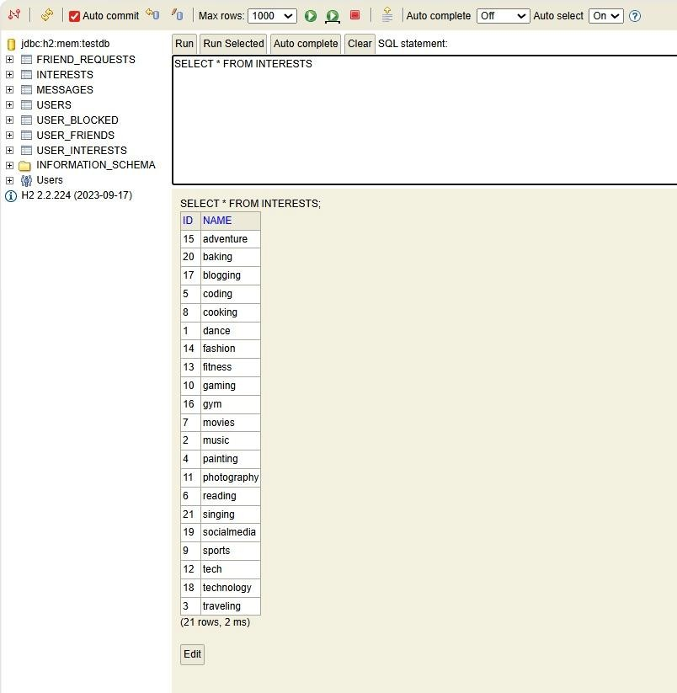
Output:

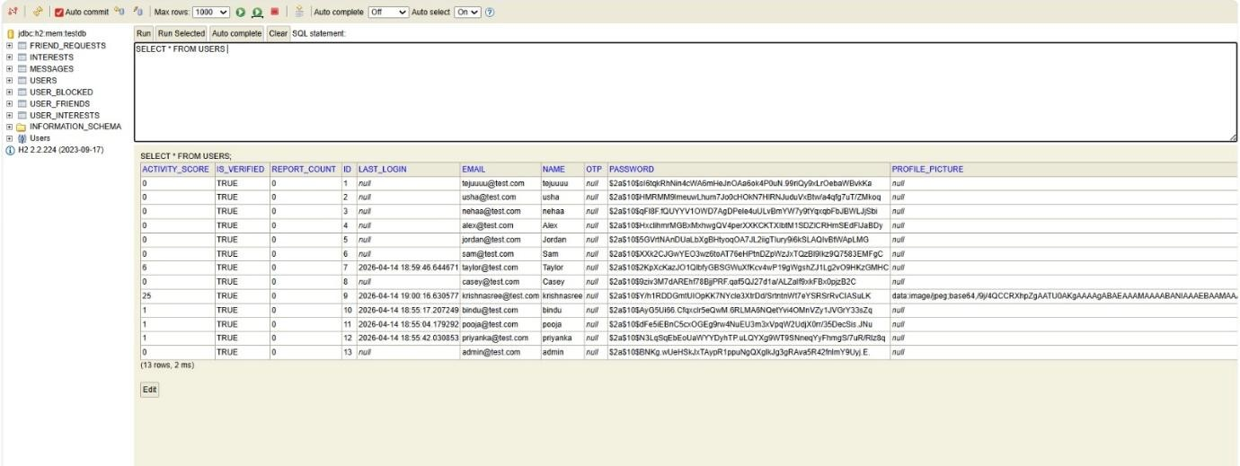

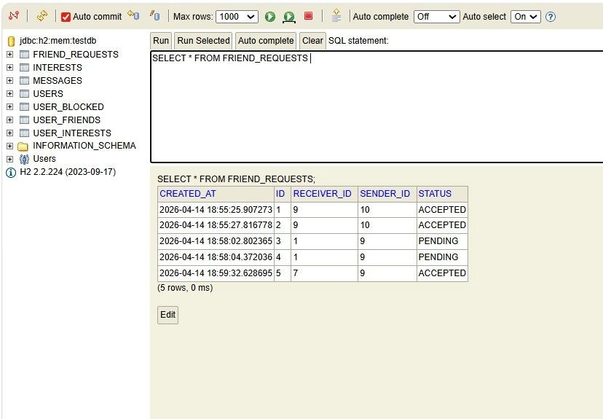

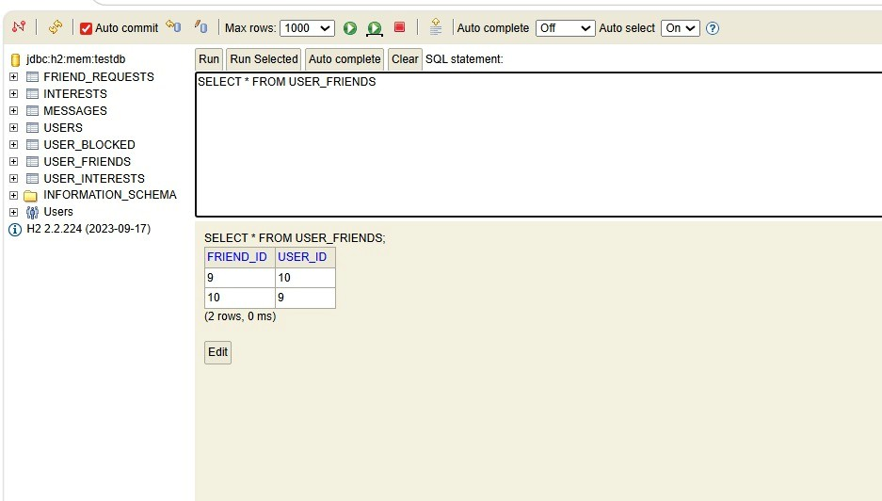

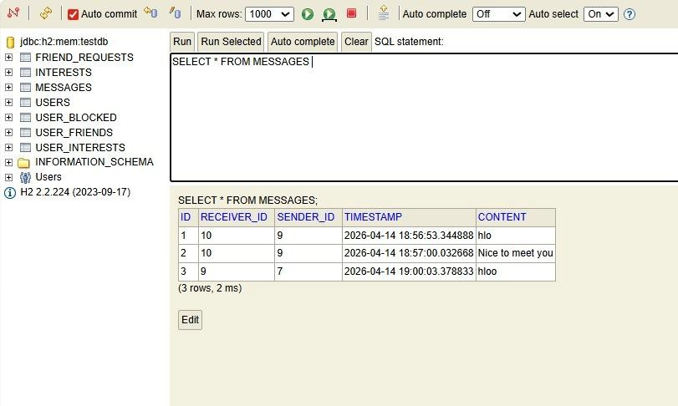

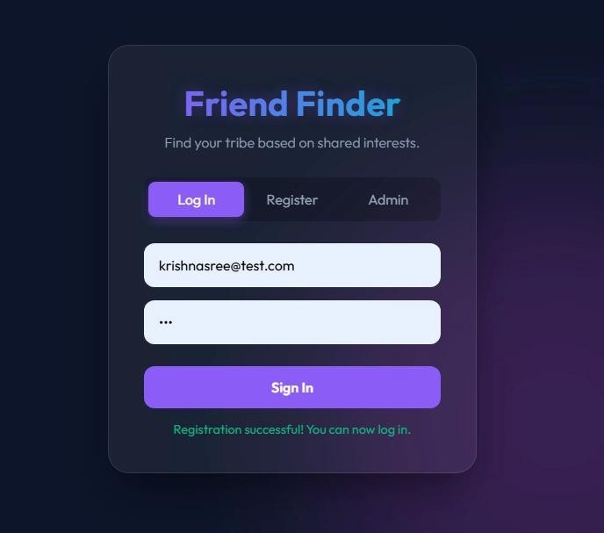

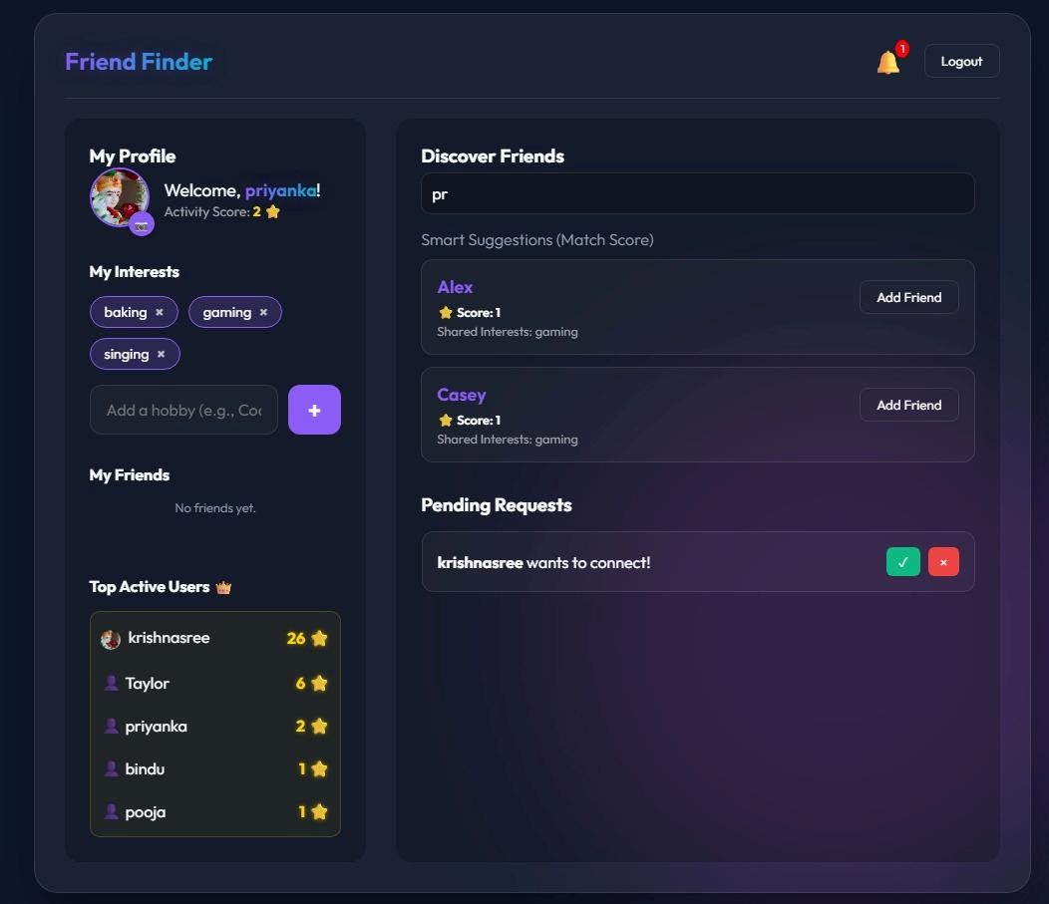

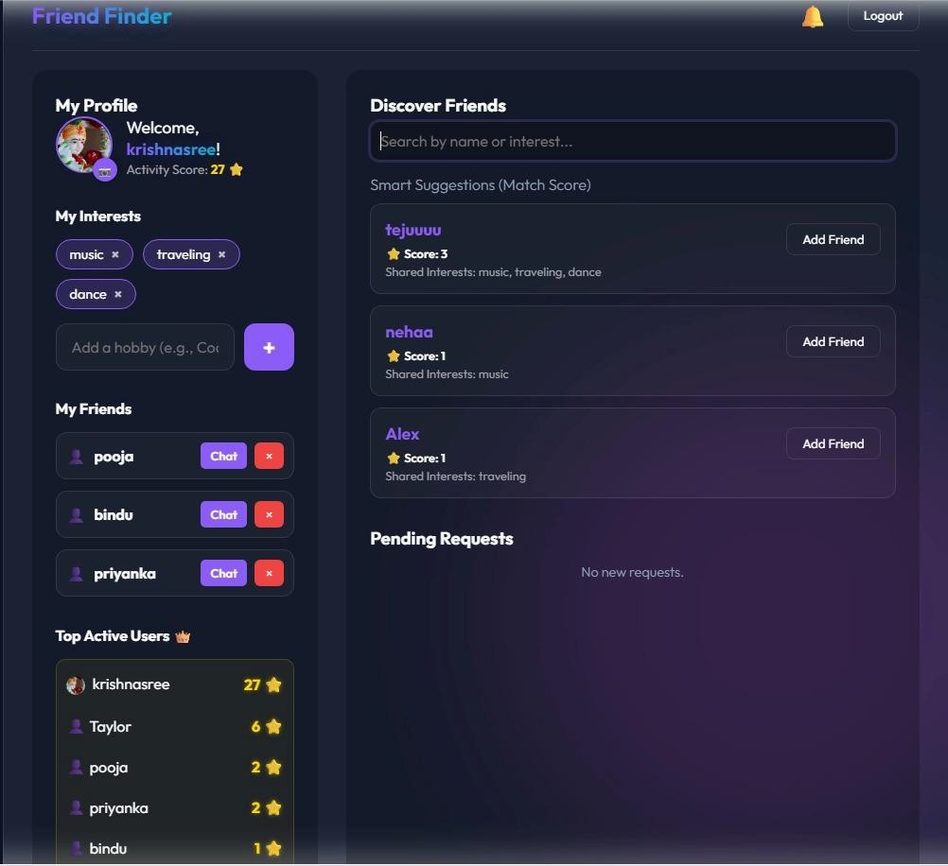

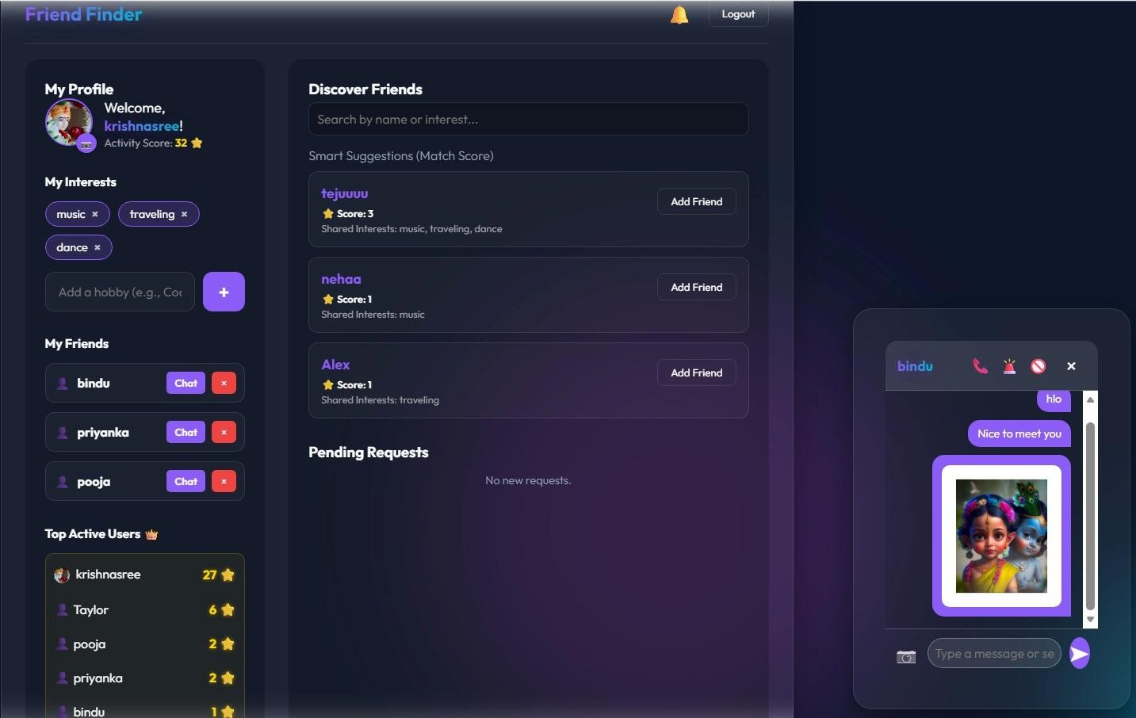

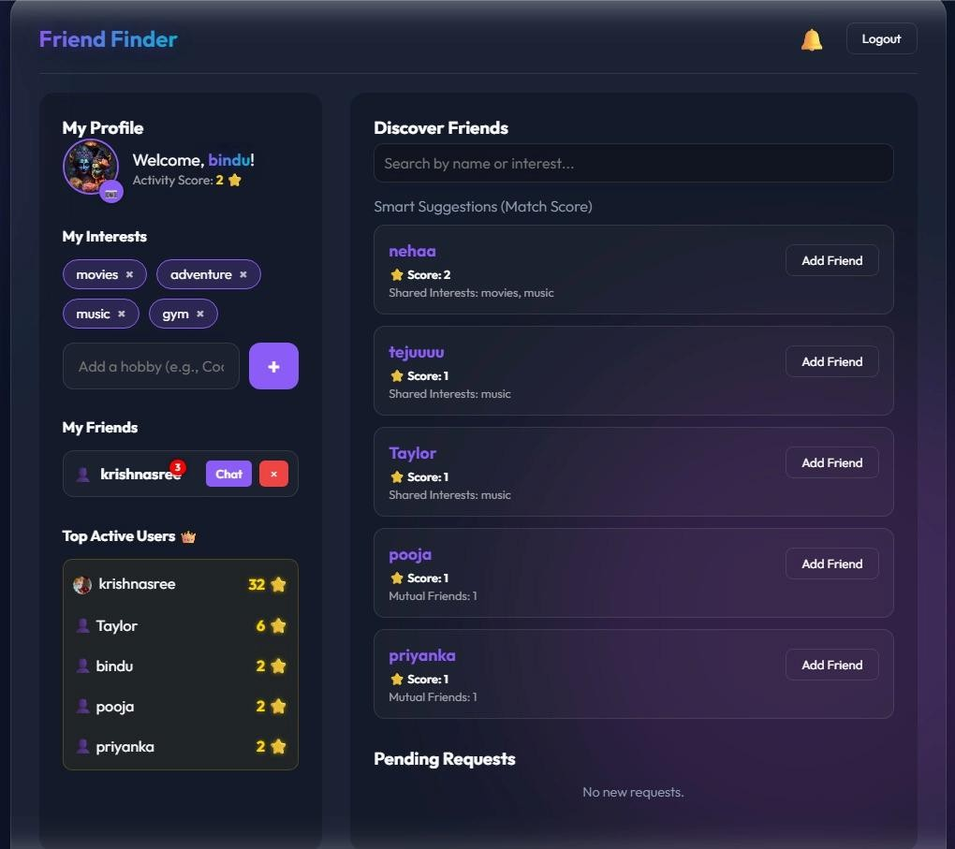

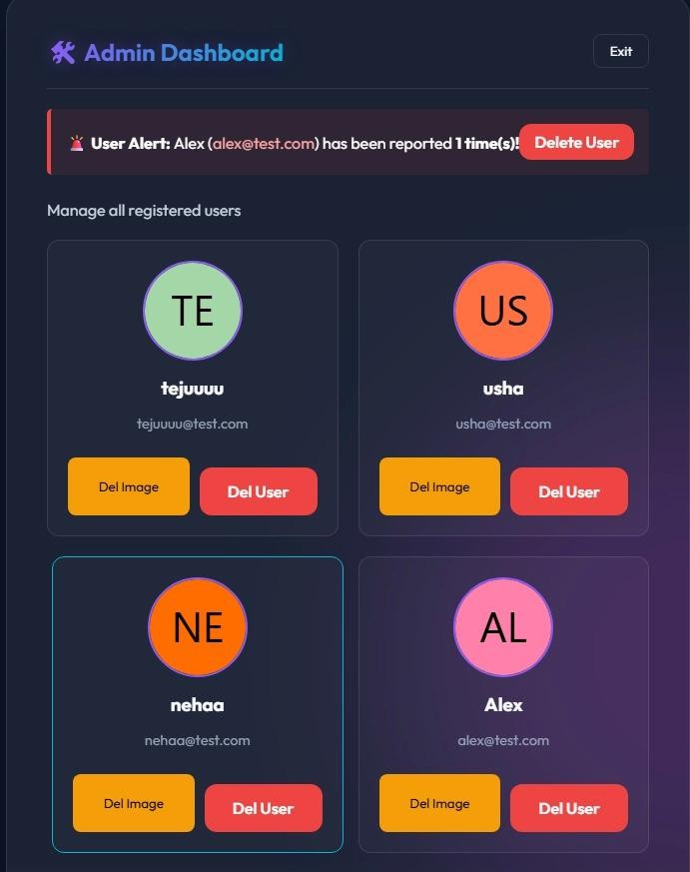

CONCLUSION:
The Friend Finder Application successfully demonstrates the development of a web-based system that connects users based on shared interests. The project addresses the limitations of existing social networking platforms by providing a more focused and meaningful approach to user interaction. Through features such as user registration, interest management, friend matching, and messaging, the system enables users to build relevant and personalized connections.
The application is implemented using modern technologies such as Spring Boot, Hibernate, and MySQL, following a layered architecture that ensures scalability, maintainability, and efficient data handling. The use of interest-based matching improves the accuracy of friend suggestions, thereby enhancing user engagement and overall experience.

