**Walchand Institute of Technology, Solapur**

**Computer Science and Engineering**

**2022-23**

**In Semester Examination - III**

Class: BTech Div- A

Roll No.: 43

Problem Statement 1

Problem Statement:

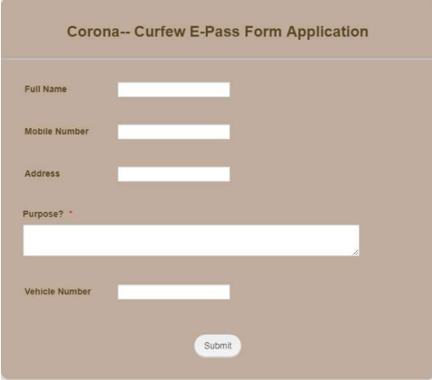

Assume this is the reg.html.

Admin wants to store these values in database table.

Complete this web side scripting technology

a. Write HTML and

b. Assume Database Name: DB and Table name :users

Code:

index.php

<!DOCTYPE html>

<html lang="en">

<head>

<title>Corona -Curfew E-Pass Form Application</title>

</head>

<style>

input {

padding: 12px 20px;

margin: 10px 0;

display: flex;

border: 1px solid #ccc;

border-radius: 4px;

box-sizing: border-box;

}

div {

background-color: #C4A484;

height: 500px;

padding: 20px;

width: 400px;

box-sizing: border-box;

align-content: center;

margin: 100px;

}

input[type=submit] {

border-radius: 12px;

border: 0;

box-sizing: border-box;

cursor: pointer;

font-size: 14px;

height: 50px;

margin-top: 25px;

text-align: center;

width: 25%;

}

label{

float: left;

margin:10px;

font-family: sans-serif;

color:#4c3228;

font-style: bold;

}

</style>

<body>

<center>

<div>

<h2 style="color:#4c3228">Corona -- Curfew E-Pass Form Application</h2>

<hr>

<form method="POST" action="insert.php">

<label>Full Name :</label>

<input type="text" name="full_name" id="full_name">

<label>Mobile No. :</label>

<input type="number" name="mobno" id="mobno">

<label>Address :&nbsp;&nbsp;&nbsp;&nbsp;&nbsp;</label>

<input type="text" name="addr" id="addr">

<label>Purpose :&nbsp;&nbsp;&nbsp;&nbsp;&nbsp;</label>

<input type="text" name="purpose" id="purpose">

<label>Vehicle No. :</label>

<input type="text" name="vehno" id="vehno">

<input type="submit" value="submit">

</form>

</div>

</center>

</body>

</html>

insert.php

<!DOCTYPE html>

<html>

<head>

<title>Insert Page page</title>

</head>

<body>

<center>

<?php

$conn = mysqli_connect("localhost", "root", "", "DB",3307);

// Check connection

if($conn === false){

die("ERROR: Could not connect. ". mysqli_connect_error());

}

$full_name = $_REQUEST['full_name'];

$mobno = $_REQUEST['mobno'];

$address = $_REQUEST['addr'];

$purpose = $_REQUEST['purpose'];

$vehno = $_REQUEST['vehno'];

$sql_query="INSERT INTO users VALUES('$full_name','$mobno','$address','$purpose','$vehno')";

if(mysqli_query($conn,$sql_query)){

echo "<h3>data stored in a database successfully."

. " Please browse your localhost php my admin"

. " to view the updated data</h3>";

}

else{

echo "ERROR: Hush! Sorry $sql. "

. mysqli_error($conn);

}

mysqli_close($conn);

?>

</center>

</body>

</html>

Screenshot:

