

**Business Intelligence and Data Warehousing**



# Introduction

In this project the Data visualizations are performed using the BI Power tool and data analysis concepts. To complete this task Business Intelligence concept is used to recognize the working purposes of the industry. Primarily, it has been familiarized that how the data analytics provides significance to business. According to the dataset selected visualizations are accomplished to assess the business processes in for long time. And built on those visualizations, this report is made. The dataset chosen for this valuation is from world data bank. Through this valuation numerous data visualization ideas, its effect on the industry and in what way the industry is functioning etc. is acknowledged. The analysis is based on the main domain selected that is development. This report brings valued visualizations made with the support of the designated dataset on the selected domain that is development. This data is the significant element for numerous businesses connected with development or with any domain because it is their main asset (Pandey, 2019).

# Development Domain

In present situation of digital economy, each business operates on information. As per the IBM report the world generates 2.5 quintillion bytes of information each day. In that viewpoint, this is correspondent of saying that 90% of the information, which occurs nowadays, has been produced in the previous one or two years. This is for the reason that the IT industry remains to quickly grow as well as capacity of the analytical data is also growing radically. In the world, 47% of industry specialists report dealing with deliberate or early access to data which obstructs their business to create appropriate choices at correct time. It might be accomplished by applying Business Intelligence. Researching into predictive analysis can provide a modest advantage by going past the basic analysis. Not just responding to varying market circumstances but forecasting them will be an enormous competitive benefit. 22% large-sized industries need business intelligence competence to report planning, development, and predicting their business and upcoming progress. Through this analysis, the development as of now and in future will be analyzed and predicted according to the dataset and source selected (Goel, 2020).

## Impact of BI and Data Analysis on Development

In today‟s ultra-competitive world, it is vital that businesses

In today‟s ultra-competitive world, it is vital that businesses

In today’s extreme competitive domain, it is important that companies prosper in discovering methods to stand out from the opposition. Business intelligence is the important aspect to gain this benefit and has developed progressively significant to the achievement of businesses in each industry. Business intelligence signifies the tools and systems that are significant for the deliberate planning procedures of a business. As a complete point, it is critical for the effective execution of a business (Laxmi, & Pranathi, 2015).

## Data set

The dataset selected for this domain is of source Data World Bank and it depicts the development of various things in the world. Based on this dataset, data analysis is performed and visualization for that is created. The analysis completed is built on this dataset using the BI power tool software (Pandey, 2019).

## Dashboard of Data World Bank Dataset

In the Data worldbank dashboard several graphs are utilized which portrays facts and figures of several effects and indications of development areas and zones. The very initial graph shows the data sources used as per the locations, in the next graph a map is portrayed which displays the world development indications and like this the entire dashboard is depicting the purpose of the organization as per the dataset and analysis domain. Through this dashboard, a overall analysis can be prepared of the organization’s data (*Overview*, 2020).

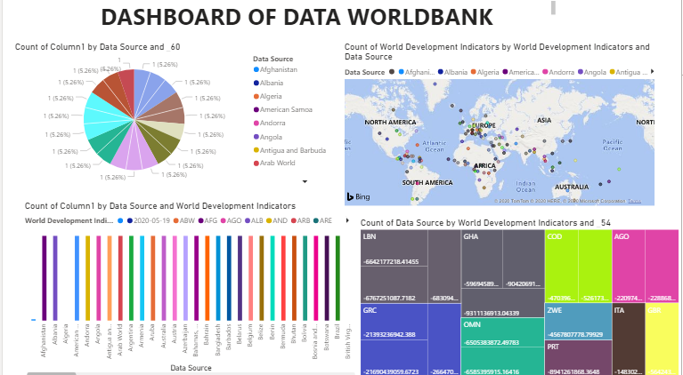

Figure 1 Dashboard overview

## Visualizations

The visualizations are done with the help of BI power tool and to perform this analysis, use of various fields, values and data is considered.

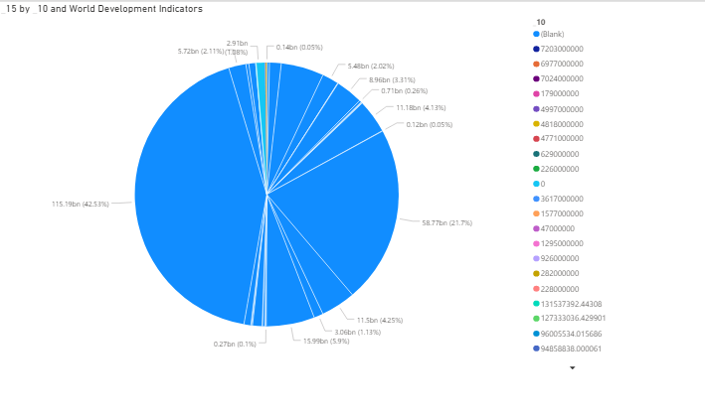

Figure 2Analysis of world development indicators

In the pie chart shown above, the development indicators are analyzed based on the values taken for analysis. It shows the development status in different fields and domains. Different color codes show the indicators and through this the data is analyzed in the pie chart. The fields selected for this analysis is world development indicators and values like _15 and _10 (Pandey, 2019).

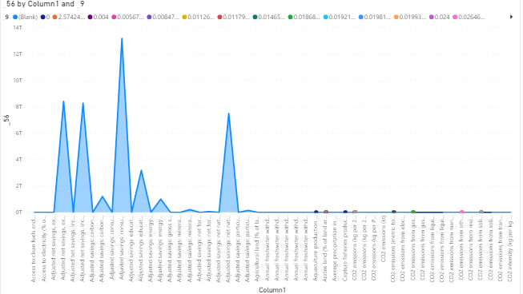

Figure 3 Analysis based on various values

In the graph shown in above image focus is put on various points which are analyzed in this. The points include the annual precipitation rate, Co2 emission rate different fields like soil, gas, liquids etc., adjusted net savings of several things like income, minerals, energy etc (Ram, Zhang, &Koronios, 2016).

.

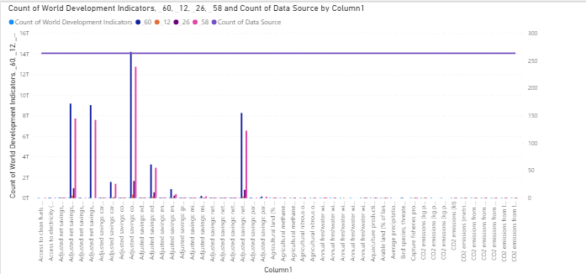

Figure 4Analysis based on data sources and world development indicators

In the above graph count of data sources is compared and analyzed with count of development indicators. The analysis is based on the column values annual precipitation rate, Co2 emission rate different fields like soil, gas, liquids etc., adjusted net savings of several things like income, minerals, energy etc. which is analyzed with data sources available and used (Laxmi, & Pranathi, 2015).

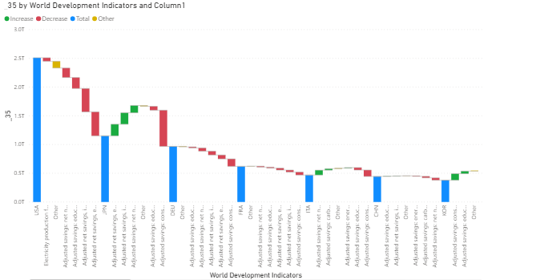

Figure 5 Analysis based on development indicators

In the image shown above analysis is done on the world development indicators values which is compared with other indicators usage like annual precipitation rate, Co2 emission rate different fields like soil, gas, liquids etc., adjusted net savings of several things like income, minerals, energy etc. These are categorized further fields like ITA, OEU and based on this analysis the usage is depicted (Goel, 2020).

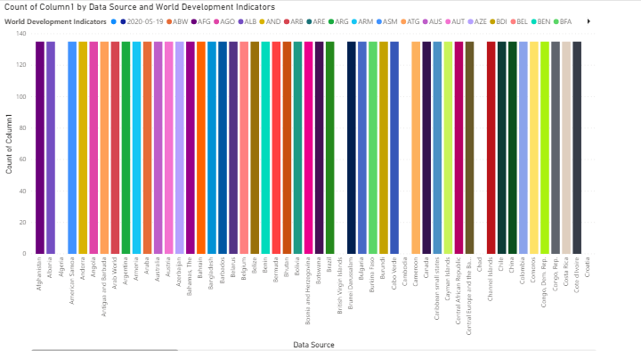

Figure 6 Analysis of several data sources used by various countries

In the graph depicted above the data sources are analyzed based on the development indicators of various countries. The countries are shown in different color codes like the purple color shows Afghanistan and their development is analyzed through the count mentioned in the graph.

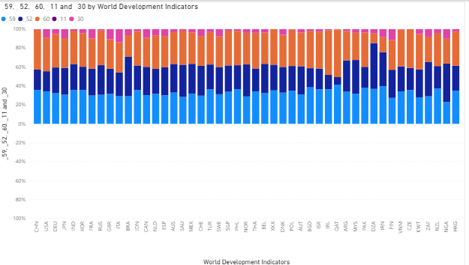

Figure 7Analysis of countries based on their development

The mentioned graph depicts the country wise development according to the percentage. The development is differentiated on the basis of colors based on their country values. Development range of 0 to 40% is shown between the light blue colors of all the countries but they vary based on their development. And like this all the country development analysis is done (Goel, 2020).

## Findings and Implication

From the above data analysis and visualizations, the world development is analyzed based on various fields and countries. In some graphs their development is shown and in some graph their resource utilization based on various factors is displayed (Ram, Zhang, &Koronios, 2016).

# BI trends in Development

As per the above visualizations concluded on the Data World Bank dataset in the development sectorit can be surelydepicted that business intelligence is required everywhere and in all domains as the technology is also evolving and the data usage requirements have also changed. To manage such huge amounts of data in an organizations and to analyze it, business intelligence knowledge is must (Ram, Zhang, &Koronios, 2016).

This development domain has observed a lot of variants and ups and downs in the previous years with the competitor’s approaching and challenging each other at every stage. But to endure in market all the sectors needto make primaryalterations. Development sector need to accept the changes and timely modifications to change their forthcoming time. Because of this Business Intelligence is required to analyze these things and to predict the future benefits and returns. Various things can be rectified as per the analysis as it helps in business continuity too.

Business Intelligence is a crucial for competitive benefit and is a set of concepts, practices, procedures, technologiesand architectures that alter raw information into significant and valuable information for business purposes. Business analytics and Intelligence will be important in associating the explosive development in data sources. Data sources are quicklyrising both externally and inside the organization. With this each and every modestbusiness is being capable to create decisions earlier than competitors is a thoughtful competitive edge and deprived of this, no singlebusiness will run successfully (Padghan, 2020).

# Conclusion

Business Intelligence (BI) tools, skills, demands and methods are growing across the world. Competitive burdens in equallyestablished and developed markets through the region are lashing investments in decision backup to increasefunctioningvisions and efficacy of a business. Extensiveacceptance of data analytics in field of development has focusedattention in visualization abilities and real-time analytics. Lastly, quicklyaltering data confidentiality regulations and laws have forced organizations to execute more severe information governance abilities and procedures.

The dataset chosen for this valuation is from world data bank. Through this valuation numerous data visualization ideas, its effect on the industry and in what way the industry is functioning etc. is acknowledged. The analysis is based on the main domain selected that is development. This report delivers valuable visualizations generated with the support of the selected dataset on both the selected domains. This data is the important factor for several businesses related with technology or with any domain analytics. Interactive data analysis, Performance monitoring, prognostic analysis is measured as few of the main business trends that can be originated from evaluating the above data set. With the interactive business dashboards several businesses can recognize the lucrative areas of the industry and can efficiently upsurge their revenue.

# References

*Augmented Analytics: The Future of Business Intelligence*. Sisense. (2020). Retrieved 27 May 2020, from https://www.sisense.com/whitepapers/augmented-analytics-the-future-of-business-intelligence/.

Goel, P. (2020). *How Business Intelligence is Changing the Future of Business*. DATAVERSITY. Retrieved 27 May 2020, from https://www.dataversity.net/how-business-intelligence-is-changing-the-future-of-business/.

Laxmi, P., & Pranathi, P. (2015). *Impact of Big Data Analytics on Business Intelligence-Scope of Predictive Analytics* [Ebook]. Retrieved 26 May 2020, from https://inpressco.com/wp-content/uploads/2015/03/Paper49856-860.pdf.

*Overview*. World Bank. (2020). Retrieved 26 May 2020, from https://www.worldbank.org/en/topic/environment/overview.

Padghan, V. (2020). *Power BI Tutorial | Data Visualization Using Microsoft Power BI*. Edureka. Retrieved 27 May 2020, from https://www.edureka.co/blog/power-bi-tutorial/.

Pandey, P. (2019). *Data Visualization with Power BI*. DataCamp Community. Retrieved 26 May 2020, from https://www.datacamp.com/community/tutorials/data-visualisation-powerbi.

Ram, J., Zhang, C., &Koronios, A. (2016). *The implications of Big Data analytics on Business Intelligence* [Ebook]. Retrieved 26 May 2020, from https://core.ac.uk/download/pdf/82671315.pdf.