Dissertation

**Title: THE USE OF LEAN MANUFACTURING PRACTICES TO IMPROVE MANAGEMENT OF MUNICIPAL WASTES IN THE STATE OF KUWAIT**

# Abstract

The following dissertation is based on the topic “The use of lean manufacturing practices to improve management of municipal wastes in the state of Kuwait” and is a considered case taken for the state of Kuwait, and the following report focuses on the lean manufacturing practices and questions relevant to it. As proper waste management and reduction practices are becoming difficult in different countries and geographical regions are facing difficulty in managing these tons of waste, effective solutions need to be researched and implemented in order to solve this problem. This report has majorly focused on the same problem, and in the further report, the issues have been discussed along with some impactful researched tools and technologies that have also been recommended for the reduction and management of waste in the state of Kuwait. In the following report, a major focus on the selection of articles for effective literature review has been provided along with different sections in the report, such as the use of specific methodology and the gathering of articles for secondary research. The major findings from the literature reviews, suggestions for technologies and advanced methodology for the management of waste in the context of lean practices in manufacturing have been provided. The dissertation has been written and performed on the basis of a literature review and secondary research. The aim of the report is to study the present scenario of the Kuwait manufacturing firms and then analyze it according to the fundamental objective of Lean Manufacturing, which aims to maximize productivity and decrease waste.

In the following report, a major focus on the selection of articles for effective literature review has been provided along with different sections in the report, such as the use of specific methodology and the gathering of articles for secondary research. The major findings from the literature reviews, suggestions for technologies and advanced methodology for the management of waste in the context of lean practices in manufacturing have been provided. The dissertation has been written and performed on the basis of a literature review and secondary research. The results obtained have been represented in the discussion section of the report.

From the findings, the engineering tools and technologies have been majorly identified that directly impact the engineering practices in the manufacturing section in different industries, which is beneficial for future research and management of waste similarly. The report contains suggestions for the implication of lean manufacturing practices based on the analysis from the state of Kuwait.

Contents

Abstract 1

List of figures 6

List of tables 7

List of abbreviations 8

Declaration 9

Acknowledgement 10

Chapter 1: Introduction 11

Background information 11

Research aim and objectives 12

Aim 12

Objectives 12

Research questions 12

Research block diagram 13

Chapter overview 14

Chapter 1 14

Chapter 2 14

Chapter 3 14

Chapter 4 14

Chapter 6 15

Chapter 6 15

Chapter 2: Literature review 16

Introduction 16

Review of the literature 16

Managing waste using sustainable/lean management 16

Zero waste manufacturing integration with sustainable construction waste management 17

Current practices/Generation based on technology 18

Demand side management implementation strategy 19

Management and valorization of industrial spent catalyst waste in the setting of sustainable practice 19

Issue of solid waste in the construction industry 20

Current state-of-the-art solution 21

Conclusion 22

Chapter 3: Research methodology 23

Research philosophy 23

Research approach 23

Methodological choice 24

Data collection 24

Data analysis 25

Time horizon 25

Chapter 4: Results 26

Findings from SAGE journal 26

Findings from MDPI 30

Chapter 5: Discussion 34

Different kinds of waste 34

Reducing the waste 35

Process/tools/technology/method used 36

Considerations 40

Chapter 6: Conclusion and recommendations 42

Conclusions 42

Future work 42

References 45

Appendix 51

Research plan 51

Project schedule 51

# List of figures

Figure 1: Research block diagram 13

Figure 2: Total amounts of municipal waste generated in different MENA countries 27

Figure 3: Plasma gasification technology procedure 28

Figure 4: Reasons for the collection of excess solid waste in the Egyptian context 30

Figure 5: Hierarchy of waste 32

Figure 6: Future technologies for e-waste management 33

Figure 7: Gantt chart 51

# List of tables

Table 1: Technologies, tools, and suggestions for deployment of waste management practices 36

Table 2: Project schedule 51

# List of abbreviations

LM: Lean Management

LCA: Life Cycle Assessment

IoT: Internet of Things

PLS-SEM: Partial Least Squares – Structural Equation Modelling

HWM: Hazard Waste Management

MHWM: Municipal Hazard Waste Management

EEE: Electronic and Electrical Equipment

# Declaration

I declare that this thesis is an original report of my research, has been written by me and has not been submitted for any previous degree. The experimental work is almost entirely my own work; the collaborative contributions have been indicated clearly and acknowledged. Due references have been provided on all supporting literature and resources.

I declare that this thesis was composed by myself, that the work contained herein is my own except where explicitly stated otherwise in the text, and that this work has not been submitted for any other degree or professional qualification.

Student Name:

Student ID:

# Acknowledgement

This research piece would not have been possible without the support of many people. Many thanks to my adviser, Laurence T. Strongarm, who read my numerous revisions and helped make some sense of the confusion. Also, thanks to my committee members, Joseph Green, G.L. Foreman, and Celia Barerra, who offered guidance and support.

Thanks to the University of Greenwich for awarding me a Dissertation Completion Fellowship and providing me with the financial means to complete this project. And finally, thanks to my parents and numerous friends who endured this long process with me, always offering support and love.

Thank you.

Student Name:

Student ID:

# Chapter 1: Introduction

## Background information

Lean manufacturing is a term you may have heard and been left wondering, "What is it?" Lean manufacturing, in its simplest form, is a production method based on the principle of maximizing output while minimizing waste. Lean is a way of thinking that seeks to maximize value creation while minimizing non-value-added activities. To achieve the goal of the greatest value with the least waste, the lean methodology emphasizes continuous experimentation. Within a lean organization, there is a close relationship between thought and action. A key principle of lean thinking is a relentless concentration on the needs of the customer. Lean manufacturing techniques improve productivity by cutting down on waste and increasing efficiency (Twi-global, 2022). Furthermore, incorporating lean manufacturing into wastewater management will provide a method for systematically decreasing industrial waste within a system while keeping quality and output within acceptable parameters. This city, known as Al Mutlaa, can be found in the western and northwestern parts of Kuwait, not far from the capital city. All nationalities are welcome in the city of Kuwait, as twelve distinct neighbourhoods are being developed.

The future city of Al Mutlaa features multiple zones, including a commercial hub, a city centre, and two district hubs. Moreover, this new approach to production based on lean principles makes it possible for cities to improve their waste management. It was in Kuwait where a production ethos and method were pioneered that would later be adopted by businesses elsewhere. Lean manufacturing is a method of production that aims to reduce waste and boost efficiency while prioritizing the needs of the customer. On the other hand, LM's key benefits are its capacity to cut down on lead times and waste (A N Alenezi, 2021). This study's goal is to define the nature of lean manufacturing in suburban and rural settings. For obvious reasons, this location was chosen for this purpose, and critical data was collected here. Most of these issues stem from ineffective management of resources, a lack of effective change management tools, an improper location, and an undesirable aesthetic design. Many companies are striving to achieve zero waste, which means they recycle or compost 100% of their rubbish from "manufacturing and municipal operations." We'll refer to this drive as the "Zero Waste" program. No matter how fantastic your aspirations may be, there is a right time and location to pursue them (Abu-Qdais, Al-Ghazo and Al-Ghazo, 2022). To observe how things ought to be organized, one need only go to nature, where organisms live, die, and decay to refill the soil for fresh growth (Hanstedt, 2022; S M Alotaibi and Alotaibi, 2016). Combining and maintaining a balance between production and maintenance planning has been shown to reduce manufacturing costs while providing the best possible solution for municipalities by cutting down on surplus stock, personnel, and raw materials while still meeting all of their production needs, and that’s what this thesis aims to do.

## Research aim and objectives

### Aim

This research aims to study the present scenario of the Kuwait manufacturing firms and then analyze them. And according to developing guidelines for good planning that adheres to quality standards, as well as standardizing work, reducing waste, and eliminating machine failures as it is observable that the manufacturing of good lead to so much waste that destructively affects the environment. Waste in production is reduced as a fundamental objective of Lean Manufacturing, which aims to maximize customer value. Lean manufacturing techniques were implemented to reduce waste, the main cause of inefficiency in the production chain, and to provide an overview of the production facility and the productive system. The purpose is to provide a holistic picture of the local government so that it can improve its operations and attract more customers, bring out the best plan to deal with this lean manufacturing water in Kuwait, and enhance the waste management policies so that they can provide a suitable environment.

### Objectives

* To maximize value for its customers while minimizing production waste.
* To provide a holistic picture of the local government so that it can improve its operations.
* To inspire confidence in the viability of the municipal government.
* Utilizing lean manufacturing techniques to enhance Kuwait's waste-management infrastructure.

## Research questions

* How can lean manufacturing techniques be applied to better handle waste collection in Kuwait's cities?
* To what extent do lean manufacturing methods pay off?
* When it comes to municipal organizations, how does lean manufacturing help reduce waste?

## Research block diagram

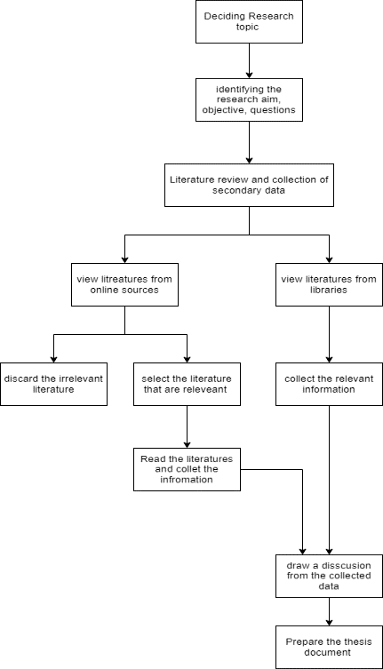

Figure 1: Research block diagram

This is the system block diagram that will provide the information of the workflow of this research as the first and foremost task is a selection of the topic to make this research specific, and then as the topic is selected, then identifying the aim, objective and the research questions to make our research valid towards the end and then the main works start where the collection of data in which for this research the secondary data is required so to different online and offline resources are used to collect the information and then after the data collection need to analyze out of it, discussion over the collected information so that at the end of this same conclusion can be made to make this thesis valid as to answer the research question.

## Chapter overview

### Chapter 1

This chapter will give you information about the background of the research that why this topic is selected for the research, and little information about the topic. And then defines the research aim, objective, and the research questions of this research so that towards the end proves the validity of this research and the system flow diagram to give you a brief idea about the procedure that is going to be followed to conduct this research.

### Chapter 2

This is the literature review chapter that contains and expresses the thoughts and views of the different authors and researchers that have performed similar research on lean manufacturing practices for waste management. Here several articles, literature, and the research paper are used for this literature review chapter.

### Chapter 3

Methodology chapter this chapter describes the research methodologies used and the data collection procedure, and the information on all the physical steps carried out to make this research successful. This chapter contains information about the research approach, methodology, data collection strategy, data collection, and others.

### Chapter 4

This chapter is one of the important parts of this thesis which contains the major findings of this research with a proper explanation and the facts of this research. This chapter is the result of this whole research and contains the major information.

### Chapter 6

This is the discussion chapter in which all the major findings from the secondary research are compared with each other and discuss which method is the best one to use. The discussion chapters contribute to the main weightage of the research report.

### Chapter 6

The conclusion chapter contains the gist of this whole document; it contains all the information in a summarized manner about every chapter. And this contains the information that this research is valid, whether it answers all the research questions or not.

# Chapter 2: Literature review

## Introduction

This section depicts a literature survey in which a variety of articles are reviewed and searched as per the topic's relevancy. There is a total of around 30 to 35 pieces of literature included in this dissertation regarding lean manufacturing practices that helps in managing the waste of municipalities in Kuwait states. There are different articles, journals, PDFs, and books reviewed as per the topic needed and selected only relevant journal articles from after the year 2016. This section describes what different authors have described in their literature regarding new methods and techniques used for waste management and lean manufacturing. This section also explains various works of literature relevant to the topic that helps in identifying how the different methods can be applied for the management of municipal waste and how lean manufacturing processes are used by industries as follows.

## Review of the literature

The study explains that waste management strategies which include established traditional methods with high protection of the environment and stability. Sustainable management will help in managing industrial, manufacturing, domestic, and other solid waste with treatment schemes of water pollutants.

### Managing waste using sustainable/lean management

According to Gollakota, Gautam, and Shu (2020), the waste management strategy should be used by manufacturers, which helps in analyzing the movement of pollutants and examining the impact of toxicity. The long-term management of municipal solid waste needs cleaner production using different bioresources. However, the challenges faced due to increasing industrialization and the continuously growing population are major factors for generating waste. A waste management system is developed for countries like Kuwait, Qatar, UAE, Oman, etc., that analyses the waste percentage using material flow analysis (Al-Adwani, 2021). This analysis shows that 65% of organic waste is collected, and the other 35% was from packaging waste which could be treated through electrochemical treatment. Further, a life cycle assessment (LCA) method is used as an application in waste management which has the purpose of building a system that provides an opportunity cost from the generated waste. The system expansion with a functional unit has been built, which helps in recycling and reusing the waste. The circular economy is also suggested in this literature which is applied to controlling the waste in alignment with LCA. However, environmental factors are creating issues for expanding the system. The LCA waste treatment is proposed for promoting waste management in context with opportunity cost (Aleisa and Heijungs, 2022). Also, Boom-Cárcamo E. and Peñabaena-Niebles (2002) have described that environmental issues are directly linked to waste generation, leading to different challenges globally. Industrial activities create a large amount of environmental pollution, which becomes riskier. The idea of sustainable management is implemented here for more consumption and production of waste and its residue with the use of production chains. For implementing a productive chain, there is a big need to collaborate with different markets and industries that use waste as raw material and provide economic benefits. There are many challenges faced by the current market to improve economic factors by reducing the emission of infecting particles and waste reduction (Abushaikha, Salhieh and Towers, 2018).

### Zero waste manufacturing integration with sustainable construction waste management

According to Kerdlap, Low, and Ramakrishna (2019), evolving the manufacturing technologies and their systems which help in eliminating the entire waste from the value chain of waste, are advances to zero waste manufacturing. The challenges have been faced due to labour shortage and land scarcity that affects the entire chain of manufacturing. The waste collection and its measurement are evaluated by the integration of collaborative platforms and IoT applications that will support the manufacturing processes (Kargar, Pourmehdi and Paydar, 2020). The IoT applications of IoT help in connecting the different manufacturing companies and their stakeholders to the value chain of waste, so the method of zero waste manufacturing is proposed, which assists in managing the business and growing the rate of the waste. Further, the construction industry also produces a large amount of construction waste that impacts the cities and their people with some negative impacts on the environment. Poor construction is considered a big challenge for the construction industry as it creates other impacts on society and increases health issues in humans also (Musa Mohammed). The partial least squares-structural equation modelling (PLS-SEM) is proposed by the author’s hypotheses for analyzing the impact of construction waste and managing them with zero waste.

Thus, the review looks at the prime effect of strategy-related features on the connection between the production of waste and economic development and misuse reduction of products. To economically limit development waste, the waste management strategy is used as the main tool, which is the board methodology (Abu-Qdais, Al-Ghazo and Al-Ghazo, 2022). This strategy has a connection to general well-being and natural destruction. Subsequently, it is basic to investigate how assets and produced waste are figured out and how to construct a reasonable waste administration framework. Because of expanded development exercises, produced products are moved around the world and bring waste. Thus, in the event that they are not dealt with as expected, they have adverse results for the common situation (Hussein et al. 2022).

### Current practices/Generation based on technology

Recently manufacturing processes are growing rapidly with the use of the latest tools and technology, which has also improved many financial routines of various sectors. But there only, financial growth is not enough for manufacturing industries as well as manufacturers. With the rising assumptions on corporate presentation and their process of straightforward ideas, the organizations perceive the requirement to follow up on practical aspects and find new aggressive assembling modes. Firms should obey ecological guidelines to deal with the exhaustion of normal assets at a supportable rate. Moreover, they are obliged to advance the gathering system, manufacturing, and reduction of waste and accomplish determined improvement (Touriki et al., 2021). In the words of Xu and Yang (2022), the waste of municipal should be collected and treated by the corporation of municipalities that includes the municipal sewage into their network and treat the garbage and do the waste operations. The hazardous waste management (HWM) scheme is used to hold the waste materials, and if they do not succeed in that process, then it might have a serious impact on both human health and the environment. Renewable energy systems and smart grid techniques are applied for managing and treating garbage and solid waste. IoT-based smart sensors can also integrate with smart grids that will help in data collection of total waste generation and collection for recycling and reuse. The IoT devices are used for creating smart trashcans for waste disposal that help in gathering the data for further implementation. This paper describes the Municipal hazardous waste management (MHWM-IoT) techniques to collect garbage and recycle them with disposal. Informal treatment, improper trash assortment, and moral worries are the central concerns affecting a strong waste organization (Ottoni, Dias and Xavier, 2020). Strong waste supervision is affected by informal treatment, wasteful trash assortment, and moral worries. Soil collapse, water contamination, soil corruption, and air-dirtying are a portion of the results of this interaction (Wijewickrama, Chileshe, Rameezdeen, and Ochoa, 2020). Thus, while examining risky waste, discussing the loss from urban areas and towns is also necessary, such as waste of electronic items, industrial material, and clinical waste. It is important to assortment, group, handles, bundle, store, transport, and circulation of waste materials for explicit treatment; that is a kind of dangerous waste, and it is called a material stream is known as risky waste reusing. As per the words of Gollakota, Gautam, and Shu (2020), electronic waste is used by many industries in different countries like Kuwait, Oman, Iraq, etc., which also influences the economic condition of the country. Electronic and electrical equipment (EEE) tools provide many recycling facilities to manufacturers, which results in effective e-waste management. However, the huge amount of electronic waste is dangerous for the ecosystem as well as countries. So there is a strong need for strategy implementation of e-waste management for nations (Mantzaras and Voudrias, 2017).

### Demand side management implementation strategy

Munir et al. (2019) pointed out that the increase in Kuwait's internal fuel consumption has created a lot of bane and anguish. About 46% of the country's energy usage is for the generation of electricity. The rising consumption of fuel has made Kuwait one of the world's most CO2 and electricity-consuming countries. The government provides consumers with a subsidy of 6% of the electricity production cost (Panchal, Singh and Diwan, 2021). This is one of the key reasons why the country's electricity consumption is high. Reducing consumption can help reduce both CO2 emissions and per capita electricity consumption. In addition to supporting the country's economy, the saved fossil fuel can also be exported to other countries. Demand-side management is a widely used tool to reduce electricity consumption. In order to transform municipal solid waste into worth for the circular economy, gasification of plasma can be a promising technology. Unfortunately, its current state is mainly limited to pilot or lab-scale operations (Alasseri et al., 2017). There are still many challenges that need to be resolved in order to commercialize this process successfully. This study aims to provide a comprehensive analysis of the current status of this technology and its potential to transform waste into value.

### Management and valorization of industrial spent catalyst waste in the setting of sustainable practice

According to Majed Al-Salem et al. (2019), managing industrial solid waste is vital to developing and developed countries' waste management strategies. It is responsible for collecting, transporting, and disposing of hazardous waste. This article reviews the various practices utilized in the industrialized world when managing industrial spent catalysts. It also aims to develop a strategy for addressing the challenges of industrial waste. Managing industrial solid waste is vital to developing and developed countries' waste management strategies. It is responsible for collecting, transporting, and disposing of hazardous waste. This article reviews the various practices utilized in the industrialized world when managing industrial spent catalysts. It also aims to develop a strategy for addressing the challenges of industrial waste. It draws parallels between the current practices of European countries and those of Kuwait, which relies solely on landfilling for its industrial waste management (Amaro et al., 2019). It also provides a comprehensive analysis of the regulations related to managing industrial waste in Kuwait. Although there are currently no regulations in the country that regulate the activities of the waste management industry, the government of Kuwait must take the necessary steps to establish a framework for the development of dedicated sectors that are focused on the valorization of chemicals and metals. There is a gap in the regulations governing industrial waste management in Kuwait (Amaro et al., 2019). This issue is critical to address in order to generate a sustainable practice & decrease the environmental impact of the country's landfill sites. One of the essential steps that can be taken to improve the efficiency of the waste management industry in Kuwait is to regulate the activities of specific industries.

### Issue of solid waste in the construction industry

Wang et al. (2022) stated that the goal of cleaner production is to reduce the use of energy, water, & materials, as well as the emissions of greenhouse gases and pollutants. It can also help manage the waste flow and improve operations' efficiency. Various technologies can help attain this goal. The use of graphical methods is a branch of engineering that can help improve the productivity of the process. This approach has been used in various ways for a long time. The handbooks published by Perry's Chemical Engineering and Southard's Mechanical Engineering are some of the most famous examples of this type of engineering. Through the use of mathematical programming, which is a branch of engineering, researchers can develop complex models and improve the efficiency of the process (Slutzman et al., 2022). Unfortunately, many of the problems encountered in the design and implementation of process integration systems are caused by the lack of freedom and options. This is why the researchers must be able to develop practical concepts that can lead to efficient system designs. One of the most critical factors that can be considered when developing process integration systems is the availability of graphical methods. These methods can help improve the efficiency of the process by making it easier to implement & show the growth of the process. They can also help developers make informed decisions and solve complex problems. The use of graphical methods has recently been widely used in developing various process integration tools (Daoud et al., 2020). One of these is the Waste Trading Pinch Analysis, a powerful tool that can help improve the efficiency of the process. New developments in the field of process integration can also help pave the way for hybrid approaches. These methods can help improve the design and implementation of process integration systems. The literature also helps in identifying the lean manufacturing methods that eliminate the challenges of research.

## Current state-of-the-art solution

As the topic shows, Kuwait has faced many challenges in managing municipal waste that also impacts its economic and environmental conditions. The current state of art describes the solution which has been selected for solving the waste management issues and their impacts.

The current state-of-the-art solution is an integrated smart green technique based on IOT, which helps in filling the gap between traditional approaches. The IoT-based smart sensors are used in this method that helps in managing municipal waste and other kinds of waste. Today manufacturing companies are very concerned about the environment as well as human health. Thus the industries are moving towards the green concept to reduce the impact of industrial and other wastes on the environment.

The green and lean practices are integrated with the smart management system of manufacturing which also includes the IoT devices connected to the system. The integration of these new concepts with technology helps manufacturers in managing their resources with more efficiency. Including IoT devices, the storage capacity and performance can be controlled and analyzed. This solution will provide results in higher performance and minimum wastage using the recycling process, which gives 95.09% efficiency (Xu and Yang, 2022). The issue of waste management can be minimized using the integrated smart green technique based on IoT devices which can also improve the production rate in manufacturing industries in Kuwait. The author has also explained the concept of reverse logistics, which focuses on the reuse and recycles the waste materials collected from different areas. The method of lean manufacturing also improves transportation facilities using a reverse logistic method-based supply chain that will be based on green technology. So the concept is linked together, and it can be beneficial for further implementation. The management can result in higher efficiency by reducing the impact of the emission of different gases. The research gap can be filled using the concept of lean methods of green technology, and it will effectively manage the wastage produced by industries and domestic sectors (Kaviani et al., 2020).

## Conclusion

This section helps in analyzing the different opinions and ideas of authors that are critically analyzed in the above literature section. There are different categories of articles, journals, and PDFs are included after reviewing them as per research needs. The lean manufacturing processes with benefits for industries are also described as including several waste management methods and techniques. The main purpose of this study is to evaluate the methods and their limitations for the future implementation of lean manufacturing processes in managing municipal waste in Kuwait. The state-of-the-art solution is also described, which helps in identifying how current methods/techniques provide better results in waste management.

# Chapter 3: Research methodology

The research onion framework is a diagram that was produced by Saunders. It is meant to represent the many different aspects of a study that need to be taken into consideration and organized for a successful design to be made. To put it another way, the research onion is a guide for developing an exhaustive research procedure. Because of the freedom it offers in selecting where to concentrate our efforts, we decided to go with this particular framework for this particular study. The many stages of the research are broken down into their respective sections later on in this chapter (Aesanetwork, 2020).

## Research philosophy

This research method would aid in investigating the most common approach that will be picked in this particular research doings, which is essential for effectively carrying out the entire research effort. Experts all over the world make use of a diverse assortment of research approaches to properly carry out market research that is tailored to the specific needs and requirements of the work. Furthermore, the objective of this research is to demonstrate that the implementation of lean manufacturing and water management will make it possible for businesses in Kuwait to contribute to the development of a sustainable chain in society because it is believed that lean management will enable businesses to increase their profits while maintaining a strong emphasis on the satisfaction of their customers (Sahay, 2022).

## Research approach

It would appear that the inductive research strategy, as well as the deductive research technique, are the two most well-known types of research procedures that are likely to be utilized the most. As a result, this technique of inductive research helps in the expansion of frequent theories, with a host of new consequences, by assisting in the gathering of pertinent information. This is in contrast to a "deductive research approach," which emphasises primarily obtaining substantial results from existing ideas. Inductive research differs from deductive research in that it helps in the development of numerous theories. This research has the research question and the objects that give a direction or motive to the research, and it allows the answering of the questions and it allows the answering of the objectives that were defined at the beginning of this research. Here is the objective of using the detective approach: because this research has the research question and the objects that give a direction or motive to the research (Hyde, 2000). The approach used for deductive research investigates a previously established phenomenon or theory and governs whether or not that theory relates to a set of predetermined conditions. It has been alleged that "the deductive approach follows the road of logic most closely," & this opinion has been corroborated. The line of said begins with philosophy and eventually results in a new hypothesis (BRM, 2022). This hypothesis is tested by putting it up against observations, which can either lead to a validation of the hypothesis or lead to rejection of the hypothesis. This research approach is connected with the inductive research approach as it aims to confirm or reject the hypothesis. The process of inductive reasoning begins with specific observations of the world and then progresses towards larger generalizations and concepts that are more abstract. When conducting research by means of an inductive strategy, which includes an opening with a topic, a researcher has an affinity, as he moves onward in his investigation, to create empirical simplifications & to find preliminary links (BRM, 2022).

## Methodological choice

The choice of methodology will always depend on the interpretation and methodological perspective of the researcher and their interaction with the practice and the practitioner, and there are no easy guidelines to follow to make educational breakthroughs. In addition, as all of us are aware, conducting a successful study calls for careful planning and carrying it out (Bhosale, 2022). Although many causes and variables contribute to the successful completion of a research project, selecting the most appropriate research practice is one of the most challenging and unclear decisions (Greener, 2018).

### Data collection

The data collection technique will help to describe the method that was occupied with gathering information that is related to the study purposes that are being addressed by the particular investigation. As a result of this, the method for collecting data helps outline the methods as well as complete approaches that are utilized in meeting relevant knowledge along with significant information that was also reliant on the final assessment that will be carried out while the investigation activity is being carried out. Internet research papers, articles, and journals are the primary sources for the acquisition of secondary data's basic information. All of the preliminary information that is necessary for this study may be found here. And to do that, both offline and online resources, such as Google Scholar, various kinds of literature, journals, and books that can be found at the library, as well as different research papers, are used (Boslaugh, 2022).

### Data analysis

Because the data that was obtained in the phase before this one enables us to do the analysis and then derive the results. This knowledge is relevant to the strategy for the structure of a sustainable project. In light of the data and the information at hand, a study that is exhaustive and well-informed might be anticipated. In light of this, the research endeavour would make use of a method in addition to a strategy by this approach. Secondary data will be collected to provide examples of how principles of lean manufacturing can be used to improve waste management in municipal settings within the state of Kuwait (Thomas, 2006). It would be beneficial to examine the application of lean manufacturing principles to improve the management of municipal garbage in the state of Kuwait if secondary data were included alongside the information. Collecting secondary data and information would involve using websites on the internet (Boslaugh, 2022).

## Time horizon

In the research study, there are principally two distinct varieties of the horizon: longitudinal and cross-sectional. And after observing and studying both horizons and checking the research requirement, it is observed that this research needs a cross-sectional time horizon where the researcher will read about the various time snapshots and collect information like the past scenario, present scenario, and then future predictions. This was discovered after observing and studying both horizons and checking the research requirement. It will provide a broad range for this research and be able to comprehend the differences between the various historical eras. Additionally, it will enable the researcher to bring out the best results by learning from the events of the past and considering the possibilities of the future (Sahay, 2022).

# Chapter 4: Results

## Findings from SAGE journal

From the SAGE journal articles, the first article provided different ways for waste management, which is generated within several industries and filtered according to the type of organization. The methods and regulations for the governance of different methods and processes are also included. The graph represents the different types of industrial solid waste generated in Kuwait, and along with it, some processes to manage and mitigate these wastes are described. The main waste considered here is the Spent Catalyst, which gears up a total of 4% of the approximate waste. Different methods to remove spelt catalysts have been described, such as the Hydrometallurgical and liquid-liquid extraction process, solvent and liquid–soil extraction, metal leaching, soda roasting, thermal cracking, Biotechnological processes, etc. It is also stated that the Kuwait IWM does not have proper governance measures to reduce municipal waste, and thus, regulations are required for industrial waste management for the development of sustainable practices in Kuwait (Majed Al-Salem et al., 2019).

In the next article, the application and experimental benefits of the lean six sigma DMAIC approach in an XYZ organization in Kuwait, which faced 22 per cent waste generation during metal sheets insulation for fabrication of ducts. The lean method has been induced to reduce waste by almost 50 per cent on average, and the results were concluded. From the final conclusion, the successful implementation of the lean six sigma DMAIC approach in fabrication was deployed, and waste was reduced up to an extent where benefits in different phases after applying six sigma were verified, such as increased feedback, strict monitoring, lesser material usage and reduction in waste generation (Hassan, Hamdan, Khourshed and Smew, 2018).

In the next article, the case study of the Sultanate of Oman is discussed, which majorly is facing waste management in the region; no other waste management method than dumping the waste into landfills seems a solution in there. For the following, the identification of waste-to-energy technology has been researched, and the conclusion states the relevant theoretical results. The method used in the research was the Analytical Hierarchy Process (AHP), and it was concluded that the most effective method for waste conversion is the anaerobic digestion, along with two other effective methods- fermentation and incineration processes, which are powerful but not as much as compared to the anaerobic digestion. The following method has the capacity to convert waste that is solid in nature, as well as waste consisting of 30 per cent moisture. This method has been used for maximum result declaration and waste reduction and is recommended in the following article for Oman (Qazi, Abushammala, and Azam, 2018).

Another article from the same journal states that poor waste management and the continuous increase in solid waste generated in the Middle East–North Africa region are increasing, creating exposure to efficient waste management issues. In this following article, different methods to waste disposal, waste management practices, and challenges to it are covered. The following article uses relevance of information accounted from the year 2014 to the year 2021, with a set of recommendations provided in order to deploy composting solutions as a strategy to waste reduction. In this article, several composting techniques were stated along with their advantages and disadvantages of each, which included composting techniques such as Aerated static pile composting, In-vessel composting, Onsite composting, Naturally aerated windrow composting, and Vermicomposting. It also represented the tons of waste generated in the region in different countries, represented below (Hussein, Uren, Rekik, and Hammami, 2021).

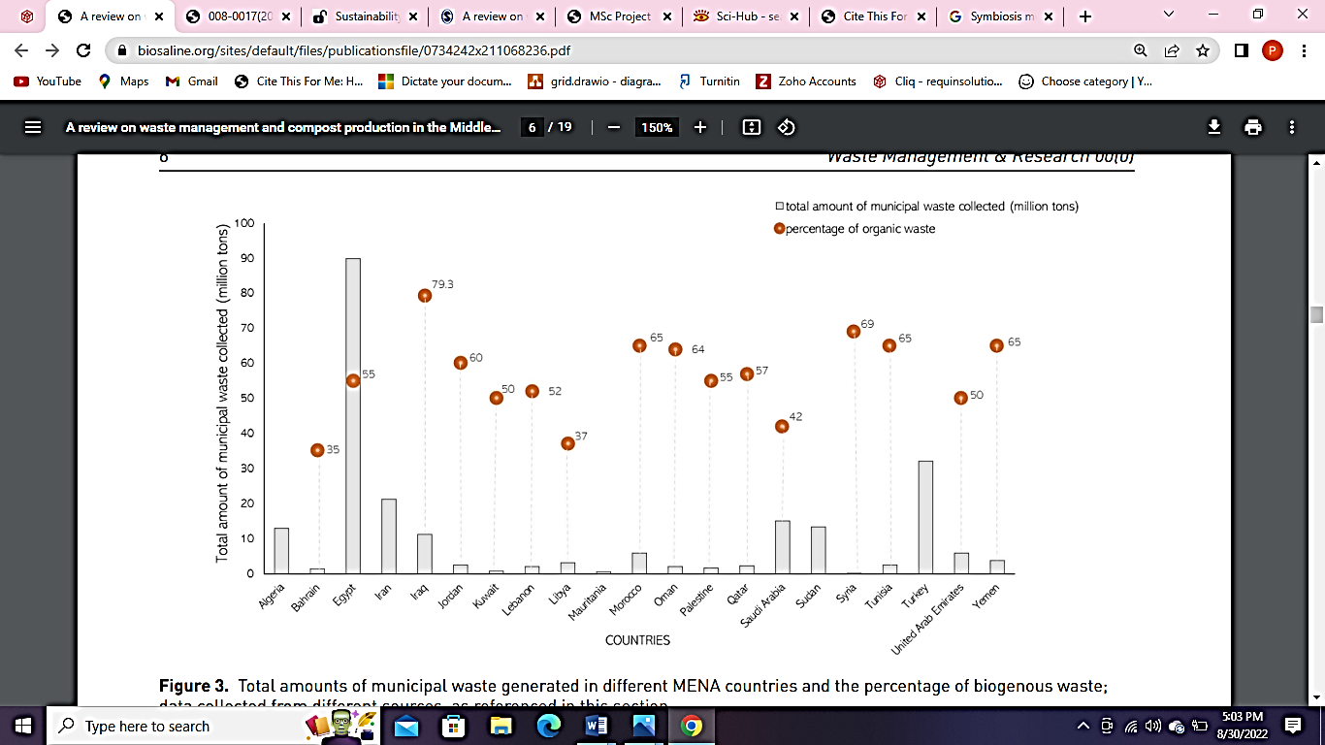

Figure 2: Total amounts of municipal waste generated in different MENA countries

In the next article, some tools and technologies are evaluated in order to leverage the amount of waste generated in different forms, such as greenhouse gases, water waste, energy and material pollution, etc. Methods and tools to reduce numerous wastes have been described, such as heat recovery for a reduction in heat emissions from petrochemical industries, mass integration of heat, an advanced integration of energy in order to reduce the consumption and usage, chemical engineering improvement for the development of a more clear production, control over the supply chain, inventories and transportation to reduce supply management wastage, graphical methods for the analysis of carbon dioxide emission control, etc. the conclusion states the graphical representations in order to develop cleaner production in several industries is not just a theory, but the practical application of it will be a major benefit to manage waste (Wang et al., 2022). In the next article, the information based on the conversion of solid municipal waste was described, where the technology used was Plasma gasification. In the article, it is stated that the method is quite effective even if it has numerous limitations and risks as well, but this is due to the gaps in proper acknowledgement of this technology. The procedure of plasma gasification is represented in the article through a diagram, and further, the challenges are suggested, such as operational costs, excess use of heat, lack of processing and understanding knowledge, the requirement to sort waste, etc. In the conclusion section, the following process has been effectively suggested, aligned with proper knowledge, and gathered requirements so that the process can be used effectively. The diagram below represents the procedure of plasma gasification, which has been taken from the following journal article (Munir et al., 2019).

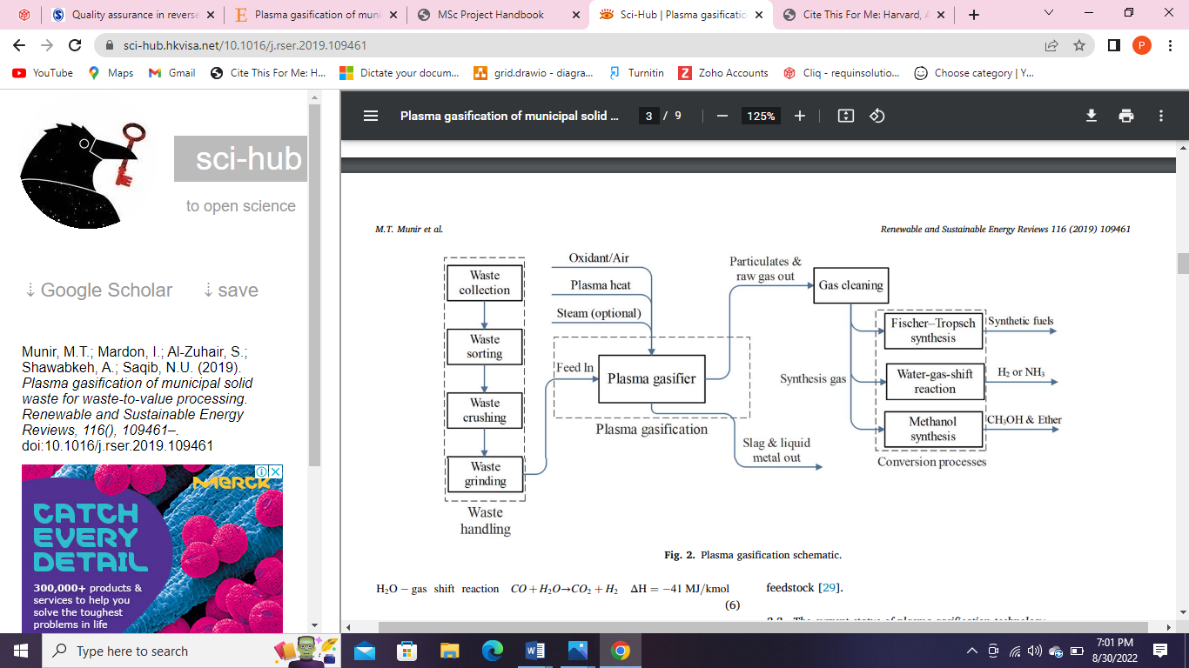

Figure 3: Plasma gasification technology procedure

In another article, the reverse logistics in the construction supply chain have been studied thoroughly, and so, the quality assurance has been focused on the management of waste that occurs during the supply and logistics part of the construction industry. The use of secondary analysis has been done the reason that fewer pieces of research have been focused on this topic since, and so the literature review has been presented. From the findings, it was stated that there are numerous reasons for lack of quality, resulting in exceeded waste, such as the lack of post-EoL operations, lack of knowledge, information, awareness as well as policies, inadequate knowledge about the use of advanced technology, proper flow of information in the supply, etc. Also, the paper further defines the challenges during the conformance of requirements into different phases, and some technologies have been presented to maintain the QA. These include- material passport, sensor-based online technology, remote sensors approaching, hydro cyclone classification, aerodynamic screening, near-infrared (NIR) technology program, image-based sensing devices, Aggregate shaping devices, hydraulic machines for separation of bricks and old mortar, etc. The paper concluded these recommendations as a beneficial technological trend shaping the future of waste in logistics (Wijewickrama, Chileshe, Rameezdeen, and Ochoa, 2020).

When moving with the research, the case study of the Egyptian construction industry has been described where solid waste has been considered a huge problem as the solid waste management (SW) practices are lesser as compared to the amount of waste generated. Several reasons have been identified for the ineffective SWM in the Egyptian region, along with a classification of waste of different types have also been described such as agricultural, construction, industrial, demolition, municipal, health care, slurry, sludge, drainages, and other hazardous wastes. To solve different SWM problems in the Egyptian context, several methods and suggestions were provided in the article, such as the adoption of waste management practices and policies, enforcement of laws and regulations, public awareness, Research and development, investment of people, practices, and efforts for increasing the SWM management capacity, etc. The article states the beneficial use of these steps in the future to be adopted for a better SWM scenario. The below figure represents the reasons behind the gathering of Solid waste (Daoud, Othman, Robinson, and Bayyati, 2020).

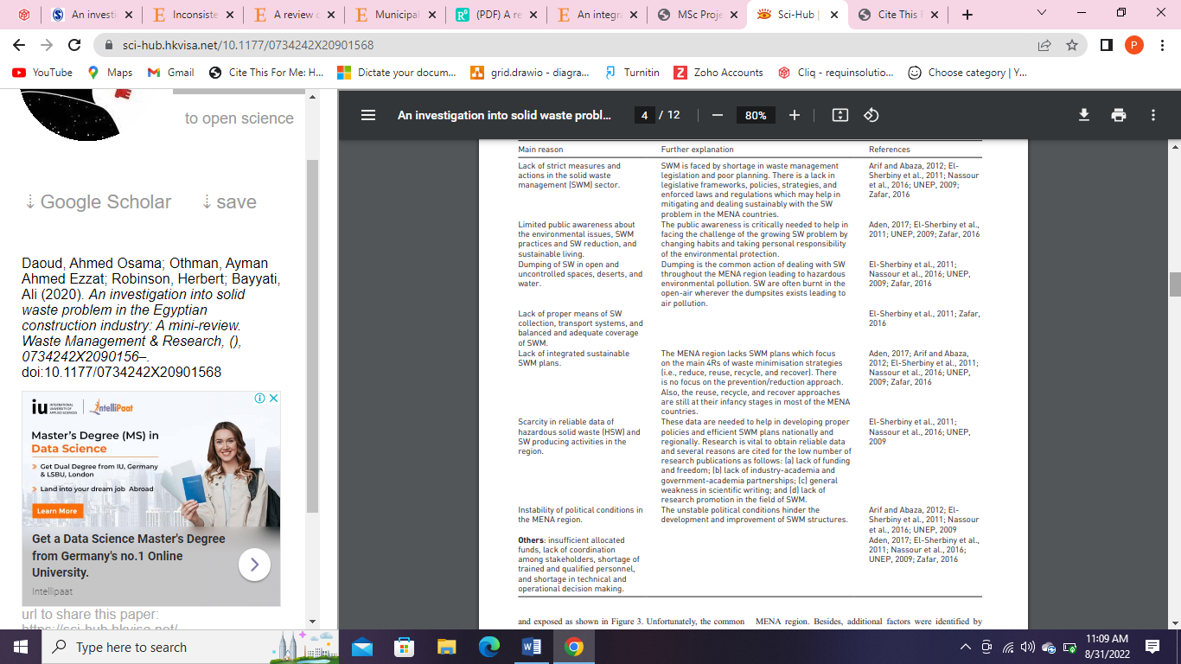

Figure 4: Reasons for the collection of excess solid waste in the Egyptian context

## Findings from MDPI

The next articles were gathered from MDPI, wherein the first article stated that the construction industry, on a global basis, faces issues during successful waste management, which indirectly relies upon poor practices of policy-related factors that govern the lessening of waste generation and management of construction accordingly. In the following article, the case study of Malaysia was reflected in relevance to the construction industry, and the method of Structural Equation Modelling (SEM) was used to analyze the survey results, which were conducted in the Malaysian construction industry. From the results, it was described that the relation between the effective imposition of policy-management and policy-related factors is an effective method for the reduction and management of the waste generated in the industry and for that purpose, it was also finalized that the implementation of policy-related factors does not have any severe effect on the waste generation in the industry, which needs to be focused (Mohammed et al., 2022).

In another article, the use of lean principles is described in the maintenance operations industry, specifically for the waste which is generated in a water treatment plant. The article states that this method is used for cost-cutting and eliminating wastes generated, where the water treatment plant is used as a case study. In this experimental article, the results were analyzed and gathered using several methods, such as 5S audit scores, MTBF, reliability, and MTTR. Some methods were described in the article, such as Worth Stream Mapping (VSM), Mean Time Between Failures (MTBF), 5’S Policy, Mean Time To Repair (MTTR), etc. After the results were analyzed successfully, it was concluded that effectiveness and waste reduction are possible by the application of lean principle tools such as 5’S in the management system in the water filtration stations. The lean principles have been qualified for the maintenance of the operations and quality as well as reducing the number of waste management failures (ALMOMANI and ALMUTAIRI, 2021).

From the Elsevier journals, the first journal states zero waste manufacturing, where different ideas of manufacturing methodology in several different sectors are selected as the main aim of the article. The term zero waste manufacturing is described as the future trend as well as a crucial element for effective waste management. For ZWM, different ideas have been suggested, such as the recycling of generated waste, sustainable manufacturing, improvement in the foundry, machinery equipment, etc. In the article, different types of waste have been covered in order to provide information on how effective waste management methods can be applied to these waste types, such as plastics/polymers, electronic/electric waste (such as wasted PCBs), ceramic waste, glass, machinery scrap, tires, metal formation waste, foundry waste, machinery dispersed elements, etc. The representation of waste hierarchy has been described in the graphic below (Singh, Ramakrishna, and Gupta, 2017).

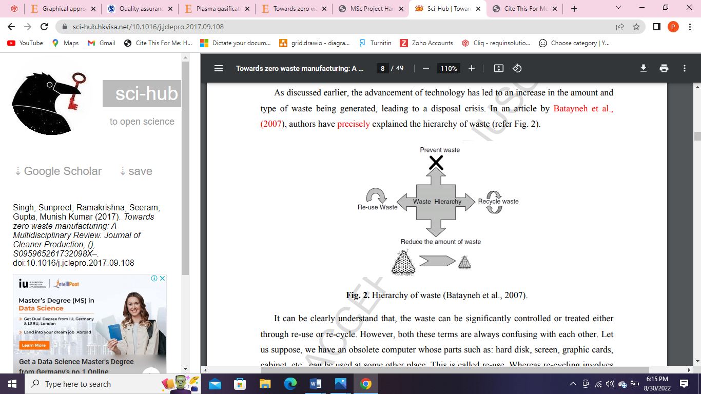

Figure 5: Hierarchy of waste

Another article stated that technology has a crucial role in developing our life, but electronic waste or e-waste is considered an issue that is rapidly increasing with fewer possible solution d control e-waste. Inconsistencies have developed for e-waste management. The amount of e-waste gathered in different regions, and countries have been represented graphically, where most of the e-waste is produced in Asia, with 18.2 Million Tons of electronic waste. Different categories of waste generated in several electronic types of equipment have been considered, and further implementations to manage this e-waste have been suggested. To control this e-waste generation and reduce its amount, several steps have been recommended, such as the role of government, consumers, the responsibility of the producers, pre-treatment of the waste, extraction and separation of metallic wastes, lifecycle assessment of the materials and the product, multi-criteria analysis, as well as future of e-waste management using advanced technologies such as green absorption and photocatalysts, etc. (Gollakota, Gautam and Shu, 2020).

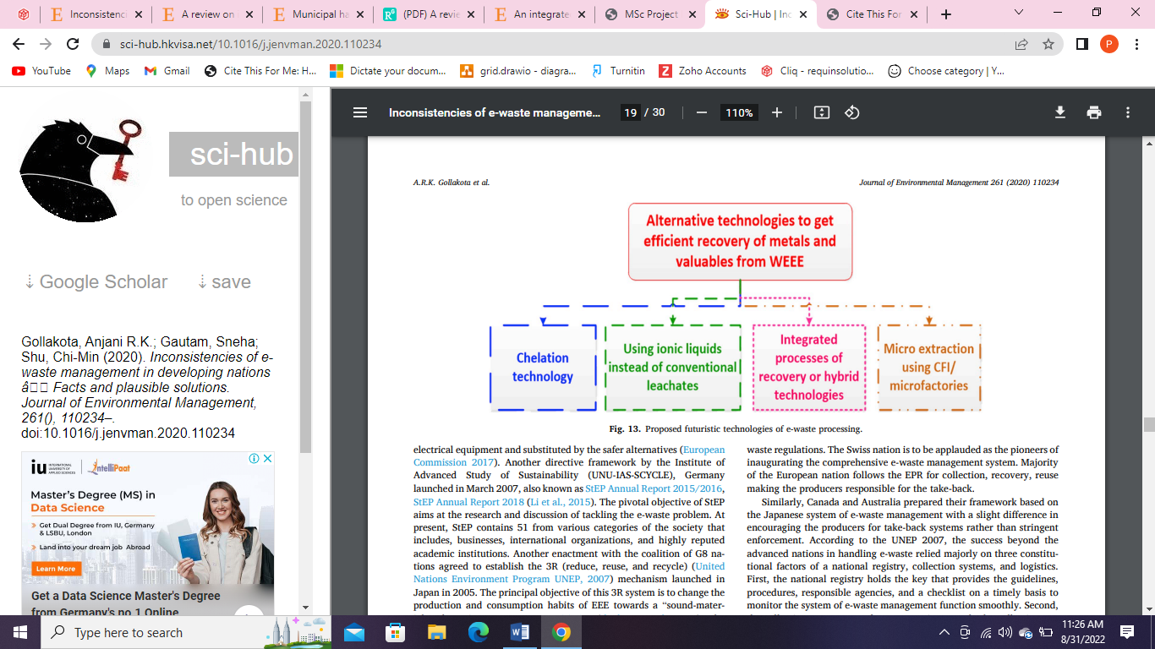

Figure 6: Future technologies for e-waste management

In another article, it has been described that the manufacturers in several industries are facing issues in manufacturing due to other reasons as well as in combination to maintain the green manufacturing practice. They ought to find a green, lean, and sustainable procedure to follow up with the waste management practices in the future aspect. Different terms related to this topic have been described in briefs, such as smart manufacturing, resilient manufacturing, green manufacturing, SGRL paradigm, and lean manufacturing. The literature review has been carried out to study these terms further for waste management, and it was stated that some combination of SGRL manufacturing practices could be combined in order to manage the processes of manufacturing, along with some limitations and gaps identified in the research study focused on this topic. The limitations need to be researched and studied in the future, and it must be considered that these SGRL manufacturing practices are considered effective waste management manufacturing practices (Touriki et al., 2021).

# Chapter 5: Discussion

## Different kinds of waste

From the above findings, several elements and aspects relevant to lean manufacturing practices to improve the management of municipal wastes in the state of Kuwait have been described, and the spotlight of this whole findings depends upon the secondary research which has been conducted in order to deploy efficient solutions in the state of Kuwait. Different industries and many more regions have been discovered in this dissertation where examples of case studies have been studied thoroughly, and the most impactful industry for the gathering of waste globally has been considered as the construction industry, As different types of wastes are generated from different products and elements, almost every sector and industry has some amount of contribution in the waste collection, and its inefficient management practice followed up (Abu-Qdais, Al-Ghazo and Al-Ghazo, 2022). Due to this reason, many regions and geographical areas are today suffering due to millions of tons of waste that are continuously piling up, and effective management of it can not be found. To understand the management of these wastes, different types of waste have been identified in this report, summarized below.

* Spent Catalyst
* Fabrication waste
* Solid waste
* Waste consisting moisture
* greenhouse gases
* Water waste
* Energy Pollution
* Material pollution
* Carbon dioxide emissions
* Agricultural waste
* Construction waste
* Industrial waste
* Demolition waste
* Municipal waste
* Health care waste
* Slurry waste
* Sludge waste
* Drainages waste
* Other hazardous wastes
* Waste generated in a water treatment plant
* plastics/polymers
* Electronic/electric waste (such as wasted PCBs)
* Ceramic waste
* Glass
* Machinery scrap
* Tires
* Metal formation waste
* Foundry waste
* Machinery dispersed elements (Panchal, Singh and Diwan, 2021)

## Reducing the waste

All these wastes were identified during the secondary research, where different articles were gathered and analyzed, and these outcomes were derived. In this report, different regions and case studies have been evaluated, and all the types of waste were identified in several industrial categories and products. On the other hand, there are numerous ways to reduce the amount of these wastes as well as proper treatment practices have been deployed in order to mitigate the generation of waste (Ottoni, Dias and Xavier, 2020). Also, several tools and technologies were identified and suggested, but along with it, several gaps and information lack have been observed in the path of research and development for the management of waste. Some of the waste reduction and management strategies do not work efficiently due to numerous reasons. These reasons can include lack of post-EoL operations, lack of knowledge, inadequate information, lack of awareness as well as ineffective waste management policies, inadequate knowledge about the use of advanced technology, the improper flow of information within the industry, etc. Several reasons have been described in these findings stating the numerous reasons for the gathering of waste (Abushaikha, Salhieh and Towers, 2018). These reasons include:

* Industrial waste management does not have proper governance measures to reduce municipal waste.
* Lack of quality products results in less waste generation.
* Resulting in exceeded waste due to improper manufacturing and bad quality raw materials.
* Lack of post-EoL operations.
* Lack of knowledge regarding waste management.
* Lack of Information to waste management practices and policies.
* Awareness of waste management policies.
* Inadequate knowledge about the use of advanced technology.
* Proper flow of information in the supply chains.
* Challenges during conformance of requirement.
* Poor practices of policy-related factors.
* Less governing of the waste generation.
* Improper Management of construction.
* Inconsistencies in managing e-waste.

## Process/tools/technology/method used

From the findings and the conducted research on the topic, the information and acknowledgement gathered from the dissertation revolves around the lean manufacturing practices to improve the management of municipal wastes globally in every geographical reason as every region faces a lack of proper waste management practices, but most probably and focused in the state of Kuwait. To effectively manage different types of waste in the following region and to reduce the amount from creating huge piles of waste which is useless and the only solution is to dump it in a landfill, several technologies have been suggested in order to maintain the process (Mantzaras and Voudrias, 2017). These tools and technologies, along with other suggestions, have been described below.

Table 1: Technologies, tools, and suggestions for deployment of waste management practices

|  |  |
| --- | --- |
| Name of the process/ tool/ technology/ method | Description |
| The hydrometallurgical process, the liquid-liquid extraction process, solvent and liquid–soil extraction, metal leaching, soda roasting, thermal cracking, and Biotechnological processes. | For the removal of spent catalysts, which has the capacity to catalyze and affect other waste and imply chemical processes over it; separation of liquids, soil and liquids, metals, gaseous and poisonous substances, heat and thermal substances. |
| Lean six sigma DMAIC approach. | For the management of waste generated during metal sheets insulation for fabrication of ducts. |
| Waste-to-energy technology (anaerobic digestion, fermentation, and incineration processes). | For the conversion of different types of waste into developing fuel and energy resources by fermenting the waste and processing it into energy-like substances. |
| Aerated static pile composting, In-vessel composting, Onsite composting, Naturally aerated windrow composting, and Vermicomposting. | Composting procedure for the waste to be converted into the soil, by addition of nutrients rich materials from the waste which decays into and formation of humus rich soil is deployed. |
| Heat recovery for a reduction in heat emissions from petrochemical industries, mass integration of heat, and advanced integration of energy in order to reduce consumption and usage. | For controlling and reducing the emissions from different industries, which results in the release of harmful chemicals into the air through pollution and gas emissions. |
| Chemical engineering improvement for the development of a more clear production. | Improving the processes of chemical engineering to reduce the usage of waste substances and deploy renewable methods to control chemical industry waste. |
| Control over the supply chain, inventories, and transportation to reduce supply management wastage. | Management of pollution and waste generated during supply chain management, inventory management, and transportation logistics that result in fuel wastage and air pollution emissions. |
| Graphical methods for the analysis of carbon dioxide emission control. | For the management of pollution generated due to transport and other logistics processes. |
| Plasma gasification. | For the conversion of solid municipal waste, the conversion of waste materials by application of excess heat and converting it into a gas that contains oxygen and hydrogen. |
| Material passport creation. | For the identification of specified materials that have to be transported. |
| Sensor-based online technology and remote Sensors are approaching. | To identify and allow products and materials that need to be transported and sense materials that can increase waste so that it can be stopped. |
| Hydro cyclone classification. | For the separation of slurry and heavy/solid components from the water using the centrifugal processes. |
| Aerodynamic screening. | For the identification of gases that are released due to a specific motion or movement, such as in vehicles. |
| Near-infrared (NIR) technology program. | Identification of materials without coming into contact with that material and identifying the properties they consist of. |
| Image-based sensing devices. | Image-based sensors will have the capacity to differentiate different types of waste and separate them so that the procedure for conversion and transformation of waste can be implemented successfully. |
| Aggregate shaping devices. | Aggregate shaping devices are effective in compressing and shaping waste materials into different materials, such as concrete mixes for road development and construction, that can be mixed along with other elements, such as cement. |
| Hydraulic machines for the separation of bricks and old mortar. | The construction industry faces issues during the separation of waste materials during reconstruction projects, where the use of hydraulic machines has the capability to separate old waste materials from a specific element. |
| Adoption of waste management practices and policies, enforcement of laws and regulations. | Adopting waste management practices by applying laws will allow individuals to forcefully clear waste starting from the first phase of the process. |
| Public awareness, investment of people, practices, and efforts for increasing the SWM management capacity. | The aware public of an initiative to reduce waste will help the future generation understand the impacts of waste generation and reduction altogether. |
| Implementation of policy-related factors. | Policy-related factors will enable the government to keep track of the national waste management issue and regulate it accordingly. |
| Research and development. | Research and development in the field of waste management with the aim of finding suitable options and advanced tools and technologies for the conversion of waste. |
| Application of lean principle tools such as 5’S in the management system. | For the proper management of the manufacturing processes and implementing a waste reduction in every phase of manufacturing. |
| Recycling of generated waste. | Recycling of the waste materials to reuse it again, such as recycling jute and plastic. |
| Sustainable manufacturing. | To manufacture products with good quality using renewable resources and eliminate single-use and bad-quality resources. |
| Improvement in the foundry and machinery equipment. | For the improvement of the manufacturing process, reduce the number of resources required so that the waste generation is automatically reduced. |
| Smart manufacturing, Resilient manufacturing, Green manufacturing, SGRL paradigm. | By implementing the use of advanced tools and technologies. |
| Lean manufacturing. | By minimising waste and residue and replacing them with greater and more efficient productivity. |

## Considerations

Along with suggesting the tools and technologies such as lean manufacturing practices for the management of municipal wastes in the state of Kuwait, the other considerations also have to be considered in order to understand the importance and carry out requirement analysis before the deployment of any of the methods or technology (Kaviani et al., 2020). We understand that the addition of advanced technologies has efficiently benefited several industries in the reduction and transformation of waste, but the gaps, limitations, as well as challenges with several of these methods, need to be determined. The implementation of proper research and development for each method deployed will be great exposure to understanding the pros and cons of each technology. Several limitations of these technologies have also been identified in this dissertation aligned with different technologies (Kargar, Pourmehdi and Paydar, 2020). They can be described and re-identified as gaps in proper acknowledgement of different advanced technologies, the difficulties in carrying out the procedure of plasma gasification, excess operational costs of new technical and automotive machinery, excess use of heat for waste transformation, lack of processing and understanding knowledge about the usage for a specific technology, the requirement to sort several types of waste, implementation of policy-related factors having almost no effect on individuals, research gaps in SGRL manufacturing practices, etc., are all the contributors of limited and improper deployed practices that could have reduced waste up to a large extent. On the other hand, it is noted that other countries and regions are facing the same issues regarding the effective management of waste and inefficient deployment of waste management practices (Al-Adwani, 2021). Different regions of the middle and middle eastern countries, such as Egypt and Asia pacific regions, are gathering huge loads of waste, where a journal stated 18.2 million tons of waste were generated in Asia, with European countries gathering 12.8 million tons of waste. These factors are important while deploying waste management practices as these continuously increasing numbers are creating problems. The regions such as Kenya, Kuwait, Yemen, United Arab Emirates, etc., are all states facing waste management issues (Gordon, 2005).

In the state of Kuwait, the topic focused on the continuous increase in the amount of waste which is creating huge problems for the individuals in the region. One of the main and major factors of this waste generated and collected with no management facility is the manufacturing practices that are currently being used in the manufacturing industry (Slutzman et al., 2022). In the research, it was seen that the manufacturers face difficulties in complying with efficient practices for waste management and reducing the waste generated during the manufacturing of different products. From the following results and findings, it can be said that the implementation of several steps, such as deploying lean manufacturing practices, along with green manufacturing, Smart manufacturing, Resilient manufacturing, and the SGRL paradigm, can be an effective method to do so. With the help of green and lean manufacturing practices, the removal of non-renewable resources used for manufacturing can be done with ease. As the research on these technologies still holds a very lower rank when compared to the amount of focus it holds, it is required that the big idea needs more focus and attention to manage waste effectively in the state of Kuwait in almost every industry and sector (Mknorthamerica, 2017).

# Chapter 6: Conclusion and recommendations

## Conclusions

One of the many potential benefits of eliminating waste within any town is a potential increase in municipal profits, which is just one of the many potential benefits of reducing waste levels. Your profits will go up if you spend less money, make more efficient use of your time and resources, and purchase less unnecessary inventory. If the city were to get rid of these eight wastes, it would be able to provide its citizens with higher-quality goods in a more timely and cost-effective manner, which would lead to a rise in the level of satisfaction felt by consumers. The elimination of waste has the potential to have a beneficial impact on the financial status of an organization. The use of lean approaches can cut the number of problems down to an acceptable level. The reason for this is that many people assume that the ultimate goal of implementing lean principles in a municipality is to improve service quality by minimizing potential sources of customer dissatisfaction. This is the reason why this is the case. Productivity, waste reduction, and financial gains are all possible outcomes that can result from using lean manufacturing practices. Despite the fact that much research on waste management has been carried out in Kuwait and elsewhere, the results of these studies have never been implemented in the country and instead stay relegated to the pages of academic journals. The major objective of the city is to put into action policies that, collectively, will result in a reduction in the quantity of waste produced across the nation. In addition, implementing a lean manufacturing strategy right from the start of each production line is the most efficient way to cut down on manufacturing costs as well as waste. This is because lean manufacturing is based on the idea that there is less waste when there is less waste. Sorting the various kinds of rubbish into their respective piles for expedited, specialized treatment will result in the production of manure that is friendly to the environment. In the event that any waste remains after production has been halted, it is imperative that it be disposed of in a manner that does not put marine life or the environment at risk.

## Future work

The treatment and management of waste in manufacturing facilities might potentially benefit from the application of other technologies. Because of the need for severe policies surrounding waste management and the application of the lean manufacturing technique in all Kuwait companies, involvement from the government is essential. The current predicament begs for extreme actions to be taken. Regular audits, in addition to other improvements, can assist manufacturers in reducing the amount of waste they produce. Some examples of these technologies are lean manufacturing, software that optimizes product design, intelligent tools and machines, and many others.

"Lean Manufacturing" (LM) was once exclusively utilized by one sort of firm in Kuwait, but now it is extensively employed by many various types of manufacturers all over the world. To accomplish this objective, lean manufacturing places a strong emphasis on getting rid of all possible sources of waste and establishing a culture in which there is a focus on continual development. However, the most significant benefits of LM are its capacity to cut down on lead times as well as the amount of waste produced (Twi-global, 2022). The goal of this research is to have a better understanding of how lean manufacturing practices are implemented in suburban and rural settings. The researcher has offered a comprehensive analysis of the study question, the research objects, and each process in the several chapters, in addition to discussions of the literature evaluation, methodologies, and outcomes. Based on reviews of relevant literature and other secondary sources addressing the current situation of garbage management in Kuwait, this report has been compiled. This problem needs to be addressed since manufacturing companies generate a significant amount of wastewater but do not have an efficient management system in place for dealing with it. The development of guidelines for efficient planning that are in line with quality standards, as well as the reduction of waste and elimination of machine failures, are some of the goals of this study. Norms for work, the reduction of waste, and the elimination of machine failures are also among the study's objectives.

As a result, utilizing lean manufacturing processes is the approach that appears to have the most promise. Studies have found that Kuwait does not currently have a plan in place for the management of solid waste, and inquiries into lean manufacturing are still ongoing. On the other hand, in Kuwait, there is not a single meaningful step taken to address manufacturing waste. The authors of this paper propose a solution in the shape of leaner manufacturing procedures. This phrase is spoken rather frequently because the primary purpose of lean manufacturing is to cut down on waste throughout the manufacturing process to increase the amount of money that can be placed toward delighting customers. Lean manufacturing techniques were used to eliminate waste, which is the primary cause of inefficiency in the production chain and to provide an overview of the production facility and the productive system. More output, greater efficiency, and less waste are just three of the numerous benefits that may be realized through the use of lean manufacturing practices, which can be implemented in Kuwait or anywhere else. Consequently, there are plenty of positive aspects to consider: The quality of the item has been improved: And companies can reallocate time and resources formerly spent on other tasks to the enhancement of products and the maintenance of high-quality standards when they streamline their business operations. It is critically recommended that the local government develop and implement new waste management policies as soon as possible to be able to adequately deal with the enormous amount of trash that has accumulated. Some of the recommendations are made that need to be looked after by the municipal of Kuwait to reduce waste as researches are not enough to reduce the waste; they need to make a change. And the companies themselves think of this sustainable approach that allows them to earn profit and fame without harming nature.

# References

A N Alenezi, T., 2021. Lean Design Management In Kuwait During Covid-19. [online] Available at: <https://www.researchgate.net/publication/351061632_Lean_Design_Management_In_Kuwait_During_Covid-19> [Accessed 30 August 2022].

Abu-Qdais, H., Al-Ghazo, M. and Al-Ghazo, E., 2022. Statistical analysis and characteristics of hospital medical waste under novel Coronavirus outbreak. *Global Journal of Environmental Science and Management (GJESM)*,.

Abushaikha, I., Salhieh, L. and Towers, N., 2018. Improving distribution and business performance through lean warehousing. *International Journal of Retail &amp; Distribution Management*, 46(8), pp.780-800.

Aesanetwork, 2020. *Blog 132-Research Onion: A Systematic Approach to Designing Research Methodology | | Welcome to AESA*. [online] Aesanetwork.org. Available at: <https://www.aesanetwork.org/research-onion-a-systematic-approach-to-designing-research-methodology/> [Accessed 30 August 2022].

Al-Adwani, M., 2021. Development of a BIM and LEAN construction process protocol for the construction industry in Kuwait: from a client perspective. *University of Salford*,.

Alasseri, R., Tripathi, A., Rao, T. J., and Sreekanth, K. J. (2017). A review on implementation strategies for demand side management (DSM) in Kuwait through incentive-based demand response programs. *Renewable and Sustainable Energy Reviews*, 77, 617-635.

Aleisa, E. and Heijungs, R., 2022. Leveraging life cycle assessment to better promote the circular economy: a first step using the concept of opportunity cost. *Sustainability*, 14(6), p.3451.

ALMOMANI, H. and ALMUTAIRI, N., 2021. Using Lean Principles in Water Maintenance Operations with Application to Water Treatment Plant. *International Journal of Environmental Science*, [online] 6. Available at: <https://www.iaras.org/iaras/filedownloads/ijes/2021/008-0017(2021).pdf>.

Amaro, P., Alves, A. C., and Sousa, R. M. (2019). Lean thinking: a transversal and global management philosophy to achieve sustainability benefits. *Poor Engineering for Global Development*, 1-31.

Bhosale, U., 2022. *How to Choose Best Research Methodology for Your Study - Enago Academy*. [online] *Enago Academy*. Available at: <https://www.enago.com/academy/choose-best-research-methodology/> [Accessed 30 August 2022].

Boom-Cárcamo, E. and Peñabaena-Niebles, R., 2022. Analysis of the Development of Industrial Symbiosis in Emerging and Frontier Market Countries: Barriers and Drivers. *Sustainability*, 14(7), p.4223.

Boslaugh, S., 2022. An Introduction to Secondary Data Analysis. [online] Available at: <https://cyfar.org/sites/default/files/Boslaugh,%202007.pdf> [Accessed 30 August 2022].

BRM, 2022. *Deductive Approach (Deductive Reasoning) - Research-Methodology*. [online] *Research-Methodology*. Available at: <https://research-methodology.net/research-methodology/research-approach/deductive-approach-2/> [Accessed 30 August 2022].

BRM, 2022. *Inductive Approach (Inductive Reasoning) - Research-Methodology*. [online] *Research-Methodology*. Available at: <https://research-methodology.net/research-methodology/research-approach/inductive-approach-2/> [Accessed 30 August 2022].

Daoud, A., Othman, A., Robinson, H. and Bayyati, A., 2020. An investigation into solid waste problem in the Egyptian construction industry: A mini-review. *Waste Management & Research*, [online] pp.1-12. Available at: <https://journals.sagepub.com/doi/abs/10.1177/0734242X20901568> [Accessed 31 August 2022].

Gollakota, A., Gautam, S. and Shu, C., 2020. Inconsistencies of e-waste management in developing nations – Facts and plausible solutions. *Journal of Environmental Management*, [online] 261, p.110234. Available at: <https://www.sciencedirect.com/science/article/pii/S0301479720301699https://www.sciencedirect.com/science/article/pii/S0301479720301699> [Accessed 31 August 2022]. Greener, S., 2018.

Gordon, L., 2005. *Technologies to reduce production costs*. [online] Americanmachinist.com. Available at: <https://www.americanmachinist.com/archive/features/article/21894934/technologies-to-reduce-production-costs> [Accessed 31 August 2022].

Hanstedt, J., 2022. *5 Best Practices for Implementing Lean Manufacturing*. [online] Mcl.bz. Available at: <https://www.mcl.bz/blog/5-best-practices-for-implementing-lean-manufacturing> [Accessed 30 August 2022].

Hassan, N., Hamdan, L., Khourshed, N. and Smew, W., 2018. Utilization Improvement of Insulation Material Using Lean Six Sigma in Duct Manufacturing Company in Kuwait. *Proceedings of the International Conference on Industrial Engineering and Operations Management*, [online] pp.27-29. Available at: <http://ieomsociety.org/dc2018/papers/206.pdf> [Accessed 30 August 2022].

Hussein, L., Uren, C., Rekik, F. and Hammami, Z., 2021. A review on waste management and compost production in the Middle East–North Africa region. *Waste Management &amp; Research: The Journal for a Sustainable Circular Economy*, [online] 40(8), pp.1110-1128. Available at: <https://www.biosaline.org/sites/default/files/publicationsfile/0734242x211068236.pdf> [Accessed 30 August 2022].

Hyde, K., 2000. Recognising deductive processes in qualitative research. *Qualitative Market Research: An International Journal*, 3(2), pp.82-90.

Kargar, S., Pourmehdi, M. and Paydar, M., 2020. Reverse logistics network design for medical waste management in the epidemic outbreak of the novel coronavirus (COVID-19). *Science of The Total Environment,* 746, p.141183.

Kaviani, M., Tavana, M., Kumar, A., Michnik, J., Niknam, R. and Campos, E., 2020. An integrated framework for evaluating the barriers to successful implementation of reverse logistics in the automotive industry. *Journal of Cleaner Production*, 272, p.122714.

Majed Al-Salem, S., Constantinou, A., Leeke, G., Hafeez, S., Safdar, T., Karam, H., Al-Qassimi, M., Al-Dhafeeri, A., Manos, G. and Arena, U., 2019. A review of the valorization and management of industrial spent catalyst waste in the context of sustainable practice: The case of the State of Kuwait in parallel to European industry. *Waste Management &amp; Research*, [online] 37(11), pp.1127-1141. Available at: <https://journals.sag 22.

Mantzaras, G. and Voudrias, E., 2017. An optimization model for collection, haul, transfer, treatment and disposal of infectious medical waste: Application to a Greek region. *Waste Management*, 69, pp.518-534.

Mknorthamerica, 2017. *The Benefits of Lean Manufacturing: Why and How to Go Lean*. [online] Mknorthamerica.com. Available at: <https://www.mknorthamerica.com/Blog/benefits-lean-manufacturing/#:~:text=Lean%20manufacturing%20improves%20efficiency%2C%20reduces,would%20have%20previously%20been%20wasted.> [Accessed 31 August 2022].

Mohammed, M., Shafiq, N., Al-Mekhlafi, A., Rashed, E., Khalil, M., Zawawi, N., Muhammad, A. and Sadis, A., 2022. The Mediating Role of Policy-Related Factors in the Relationship between Practice of Waste Generation and Sustainable Construction Waste Minimisation: PLS-SEM. *Sustainability*, [online] 14(2), p.656. Available at: <https://www.mdpi.com/2071-1050/14/2/656/htm> [Accessed 30 August 2022].

Munir, M., Mardon, I., Al-Zuhair, S., Shawabkeh, A. and Saqib, N., 2019. Plasma gasification of municipal solid waste for waste-to-value processing. *Renewable and Sustainable Energy Reviews*, [online] 116, p.109461. Available at: <https://www.sciencedirect.com/science/article/abs/pii/S1364032119306690> [Accessed 31 August 2022].

Ottoni, M., Dias, P. and Xavier, L.H., 2020. A circular approach to the e-waste valorization through urban mining in Rio de Janeiro, Brazil. *Journal of Cleaner Production*, 261, p.120990.

Panchal, R., Singh, A. and Diwan, H., 2021. Economic potential of recycling e-waste in India and its impact on import of materials. *Resources Policy*, 74, p.102264.

Qazi, W., Abushammala, M. and Azam, M., 2018. Multi-criteria decision analysis of waste-to-energy technologies for municipal solid waste management in Sultanate of Oman. *Waste Management &amp; Research: The Journal for a Sustainable Circular Economy*, [online] 36(7), pp.594-605. Available at: <https://journals.sagepub.com/doi/full/10.1177/0734242X18777800>.

S M Alotaibi, A. and Alotaibi, J., 2016. An Analytical assessment of Lean Manufacturing Strategies and Methodologies Applied to Kuwait Oil Company (KOC). [online] Available at: <http://dl6.globalstf.org/index.php/jet/article/view/1560> [Accessed 30 August 2022].

Sahay, A., 2022. Peeling Saunders’s Research Onion. [online] Available at: <https://www.researchgate.net/profile/Arunaditya-Sahay/publication/309488459_Peeling_Saunder's_Research_Onion/links/5813283508aedc7d89609ea8/Peeling-Saunders-Research-Onion.pdf> [Accessed 30 August 2022].

Singh, S., Ramakrishna, S. and Gupta, M., 2017. Towards zero waste manufacturing: A multidisciplinary review. *Journal of Cleaner Production*, [online] 168, pp.1230-1243. Available at: <https://www.sciencedirect.com/science/article/abs/pii/S095965261732098X> [Accessed 30 August 2022].

Slutzman, J., Bockius, H., Gordon, I., Greene, H., Hsu, S., Huang, Y., Lam, M., Roberts, T. and Thiel, C., 2022. Waste audits in healthcare: A systematic review and description of best practices. *Waste Management &amp; Research: The Journal for a Sustainable Circular Economy*, pp.0734242X2211015.

Thomas, D., 2006. A General Inductive Approach for Analyzing Qualitative Evaluation Data. *American Journal of Evaluation*, 27(2), pp.237-246.

Touriki, F., Benkhati, I., Kamble, S., Belhadi, A. and El fezazi, S., 2021. An integrated smart, green, resilient, and lean manufacturing framework: A literature review and future research directions. *Journal of Cleaner Production*, [online] 319, p.128691. Available at: <https://www.sciencedirect.com/science/article/abs/pii/S0959652621028912> [Accessed 31 August 2022].

Twi-global, 2022. *What is Lean Manufacturing and the 5 Principles Used?*. [online] *Twi-global.com.* Available at: <https://www.twi-global.com/technical-knowledge/faqs/faq-what-is-lean-manufacturing> [Accessed 30 August 2022].

Wang, B., Zhang, S., Guo, L., Klemeš, J. and Varbanov, P., 2022. Graphical approaches for cleaner production and sustainability in process systems. *Journal of Cleaner Production*, [online] 366, p.132790. Available at: <https://www.sciencedirect.com/science/article/abs/pii/S0959652622023861> [Accessed 30 August 2022].

Wijewickrama, M., Chileshe, N., Rameezdeen, R. and Ochoa, J., 2020. Quality assurance in reverse logistics supply chain of demolition waste: A systematic literature review. *Waste Management & Research*, [online] pp.1-22. Available at: <https://journals.sagepub.com/doi/figure/10.1177/0734242X20967717?> [Accessed 31 August 2022].

Xu, X. and Yang, Y., 2022. Municipal hazardous waste management with reverse logistics exploration. Energy Reports, 8, pp.4649-4660.

Zhang, Z., Malik, M., Khan, A., Ali, N., Malik, S. and Bilal, M., 2022. Environmental impacts of hazardous waste, and management strategies to reconcile circular economy and eco-sustainability. *Science of The Total Environment*, 807, p.150856.

# Appendix

## Research plan

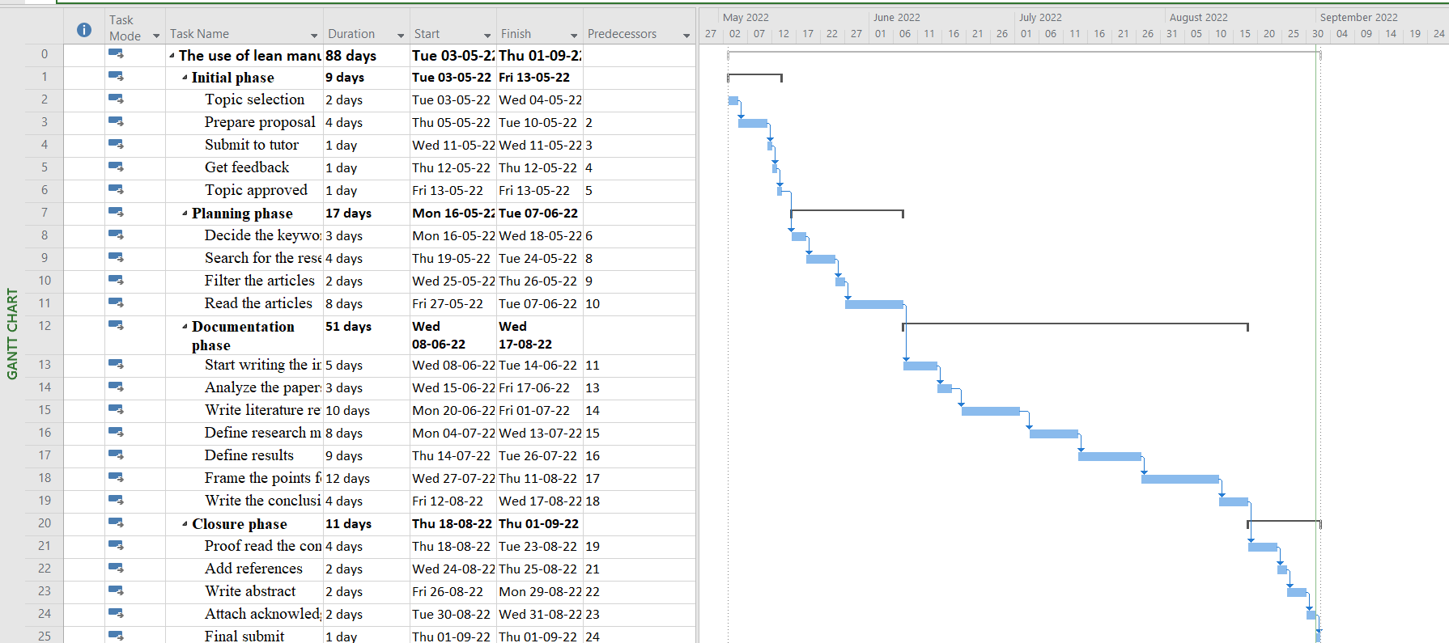

Figure 7: Gantt chart

## Project schedule

Table 2: Project schedule

|  |  |  |  |
| --- | --- | --- | --- |
| Task Name | Duration | Start | Finish |
| The use of lean manufacturing practices to improve management of municipal wastes in the state of Kuwait | **88 days** | **Tue 03-05-22** | **Thu 01-09-22** |
| Initial phase | **9 days** | **Tue 03-05-22** | **Fri 13-05-22** |
| Topic selection | 2 days | Tue 03-05-22 | Wed 04-05-22 |
| Prepare proposal | 4 days | Thu 05-05-22 | Tue 10-05-22 |
| Submit to tutor | 1 day | Wed 11-05-22 | Wed 11-05-22 |
| Get feedback | 1 day | Thu 12-05-22 | Thu 12-05-22 |
| Topic approved | 1 day | Fri 13-05-22 | Fri 13-05-22 |
| Planning phase | **17 days** | **Mon 16-05-22** | **Tue 07-06-22** |
| Decide the keywords | 3 days | Mon 16-05-22 | Wed 18-05-22 |
| Search for the research articles | 4 days | Thu 19-05-22 | Tue 24-05-22 |
| Filter the articles | 2 days | Wed 25-05-22 | Thu 26-05-22 |
| Read the articles | 8 days | Fri 27-05-22 | Tue 07-06-22 |
| Documentation phase | **51 days** | **Wed 08-06-22** | **Wed 17-08-22** |
| Start writing the introduction | 5 days | Wed 08-06-22 | Tue 14-06-22 |
| Analyze the papers | 3 days | Wed 15-06-22 | Fri 17-06-22 |
| Write literature review | 10 days | Mon 20-06-22 | Fri 01-07-22 |
| Define research methodology | 8 days | Mon 04-07-22 | Wed 13-07-22 |
| Define results | 9 days | Thu 14-07-22 | Tue 26-07-22 |
| Frame the points for discussion | 12 days | Wed 27-07-22 | Thu 11-08-22 |
| Write the conclusion and future work | 4 days | Fri 12-08-22 | Wed 17-08-22 |
| Closure phase | **11 days** | **Thu 18-08-22** | **Thu 01-09-22** |
| Proof read the content | 4 days | Thu 18-08-22 | Tue 23-08-22 |
| Add references | 2 days | Wed 24-08-22 | Thu 25-08-22 |
| Write abstract | 2 days | Fri 26-08-22 | Mon 29-08-22 |
| Attach acknowledgement and declaration | 2 days | Tue 30-08-22 | Wed 31-08-22 |
| Final submit | 1 day | Thu 01-09-22 | Thu 01-09-22 |