Bank Stability Analysis Project Report

Instructions

This section summarizes the predictive analysis conducted on the Bank Stability Dataset, focusing on the effectiveness of various machine learning models in predicting whether a bank is likely to go defunct or remain stable.

Dataset Overview

* **Total Entries:** 5,000
* **Key Features:**
  + Capital Adequacy Ratio
  + Non-Performing Loans Ratio
  + Liquidity Coverage Ratio
  + Return on Assets
  + Loan to Deposit Ratio
  + Net Interest Margin
  + Operational Efficiency Ratio
* **Target Variable:** Went Defunct (Yes/No)

Data Cleaning

* **Handling Missing Values:**
  + Fill missing values in numerical columns with median values.
* **Removing Duplicates:**
  + Eliminate any duplicate rows identified in the dataset.
* **Outlier Detection:**
  + Use the Z-Score method to detect outliers and remove them from the dataset.

Key Insights

1. **Financial Metrics Analysis**

* **Key Financial Metrics:**
  + **Capital Adequacy Ratio (CAR):**
    - **Mean:** 10.78%
    - **Observation:** Defunct banks typically have CAR values below 10%, indicating insufficient capital to absorb losses.
  + **Non-Performing Loans (NPL) Ratio:**
    - **Mean:** 2.6%
    - **Observation:** Defunct banks often exceed an NPL ratio of 15%, highlighting poor asset quality.
  + **Liquidity Coverage Ratio:**
    - **Mean:** 75.72%
    - **Observation:** Stable banks maintain liquidity ratios above 25%, while defunct banks frequently fall below 20%.
  + **Return on Assets (ROA):**
    - **Mean:** 2.6%
    - **Observation:** Stable banks exhibit positive ROA values, while defunct banks may show negative values.
  + **Loan-to-Deposit Ratio (LDR):**
    - **Mean:** 75.72%
    - **Observation:** Stable banks typically maintain LDRs between 70% and 80%, while defunct banks often exceed 90%.
  + **Net Interest Margin (NIM):**
    - **Mean:** Not explicitly provided, but stable banks generally have a consistent and healthy NIM.
  + **Operational Efficiency Ratio:**
    - **Mean:** Not explicitly provided, but stable banks maintain lower operational efficiency ratios compared to defunct banks.

1. **Stability Thresholds**

* **Identified Thresholds for Key Metrics:**
  + **Capital Adequacy Ratio (CAR):**
    - **Threshold:** Below 10% indicates a strong risk of instability.
  + **Non-Performing Loans (NPL):**
    - **Threshold:** Ratios over 15% are highly correlated with bank failure.
  + **Liquidity Coverage Ratio:**
    - **Threshold:** Ratios below 20% suggest higher failure rates.
  + **Loan-to-Deposit Ratio (LDR):**
    - **Threshold:** Ratios exceeding 90% indicate over-leveraging and financial stress.

3. **Temporal Trends**

* **Trends Over Time:**
  + **Post-2010 Improvements:**
    - There is a noticeable improvement in bank stability metrics post-2010, aligning with the implementation of stricter regulatory standards.
    - Average CAR and liquidity ratios have shown consistent growth, reflecting prudent financial practices.
  + **Decline in Defunct Banks:**
    - The number of defunct banks has decreased significantly post-2010, suggesting that regulatory compliance has positively impacted bank stability.
    - Defunct banks exhibited a progressive decline in CAR and liquidity in the years leading to their failure.

Distribution of Key Financial Metrics

1. **Histograms:**
   * Visualizations of key metrics such as Capital Adequacy Ratio (CAR), Non-Performing Loans (NPL), Liquidity Coverage Ratio, and Loan-to-Deposit Ratio.
   * **Highlight:**
     + The distribution of CAR shows that most stable banks have values above 12%, while defunct banks frequently fall below 10%.
     + NPL ratios for defunct banks are skewed to the right, indicating a higher frequency of loans in default.
2. **Correlation Heatmap**

* **Heatmap Visualization:**
  + A correlation heatmap was created to visualize the relationships between financial metrics.
  + **Highlight:**
    - Strong negative correlation between CAR and NPL (r = -0.75), indicating that as CAR decreases, NPL tends to increase.
    - Positive correlation between LDR and NPL, suggesting that higher loan-to-deposit ratios may lead to increased risk of non-performing loans.

1. **Box Plots for Stability Comparison**

* **Box Plots:**
  + Box plots were used to compare the distributions of CAR, NPL, and Liquidity Ratios between defunct and stable banks.
  + **Highlight:**
    - Defunct banks consistently show lower median CAR and Liquidity Ratios compared to stable banks.
    - The interquartile range (IQR) for NPL is significantly higher for defunct banks, indicating greater variability in loan performance.

1. **Scatter Plots**

* **Scatter Plot of CAR vs. NPL:**
  + A scatter plot visualizing the relationship between CAR and NPL ratios.
  + **Highlight:**
    - The plot reveals a clear trend where banks with lower CAR tend to have higher NPL ratios, reinforcing the importance of maintaining adequate capital.
* **Scatter Plot of LDR vs. Liquidity Ratio:**
  + This plot shows the relationship between LDR and Liquidity Ratio.
  + **Highlight:**
    - Banks with LDR above 90% often have lower liquidity ratios, indicating potential over-leveraging and financial stress.

1. **Performance by Region**

* **Bar Charts:**
  + Bar charts were created to compare the average CAR, NPL, and Liquidity Ratios across different regions.
  + **Highlight:**
    - Certain regions exhibit significantly higher average CAR and lower NPL ratios, indicating better overall bank performance and stability.

Recommendations for Stakeholders

* **Regular Monitoring:** Banks should continuously monitor their financial metrics to ensure they remain within safe thresholds.
* **Predictive Tools:** Implement predictive analytics tools to identify early warning signs of financial instability, allowing for timely interventions.
* **Regulatory Compliance:**Align operations with regulatory standards to enhance resilience and stability.

Model Performance Evaluation

* **Models Evaluated:**
  + Random Forest Classifier
  + Logistic Regression
  + Decision Tree Classifier
  + Gradient Boosting Classifier
  + XGBoost Classifier
* **Overall Accuracy:**
  + The models achieved high accuracy rates, with the best-performing models reaching an accuracy of 99% to 100%.
* **Key Metrics for XGBoost Classifier:**
  + **Accuracy:** 100%
  + **Precision:** 100% for both classes
  + **Recall:** 99% for class '1' (defunct)
  + **F1-Score:** 99%

Insights from Classification Reports

* **Precision and Recall:**
  + The models demonstrated excellent precision and recall, indicating that they are effective in correctly identifying both stable and defunct banks.
  + The high precision for class '0' (non-defunct) suggests that the models are reliable in predicting banks that are stable.
* **F1-Score:**
  + The F1-scores close to 1.00 indicate a strong balance between precision and recall, confirming the models' robustness in classification tasks.
* **Confusion Matrix Analysis**
  + confusion matrices reveal that the models have very few misclassifications:
  + For example, in the XGBoost model, only 1 bank was incorrectly classified as defunct while it was stable.
  + This low number of false positives and false negatives highlights the models' effectiveness in distinguishing between stable and defunct banks.

Model Deployment

This project introduces a dynamic, user-friendly Streamlit application designed to transform the way financial professionals evaluate and predict bank stability. By leveraging advanced machine learning techniques and an intuitive interface, the app enables users to:



Upload And Explore

Quickly explore financial data with features like summary statistics, missing value analysis, and heatmaps for correlation insights.

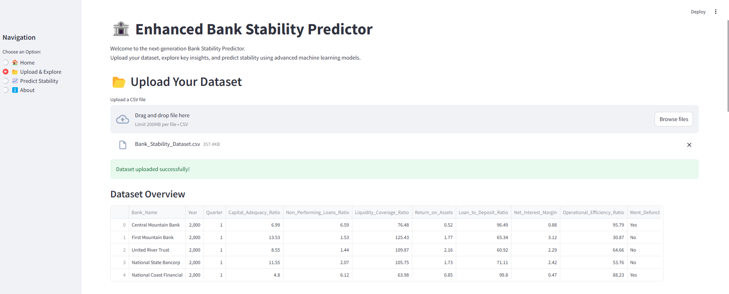

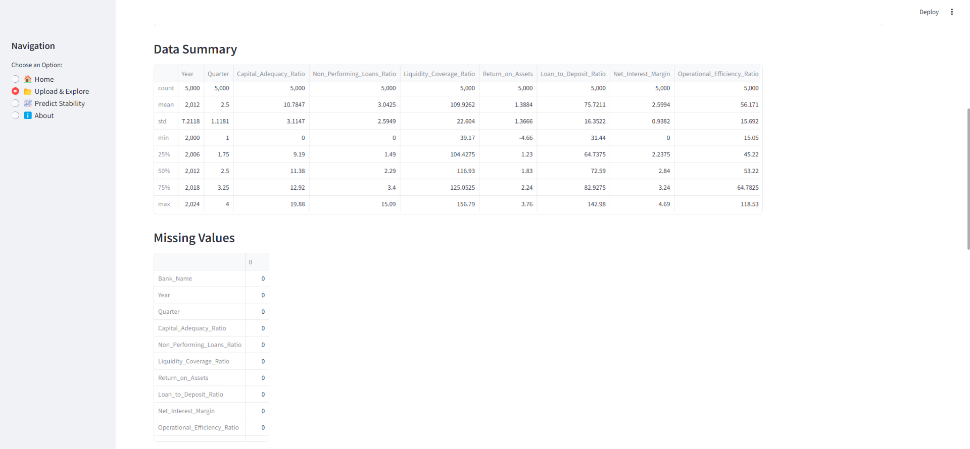

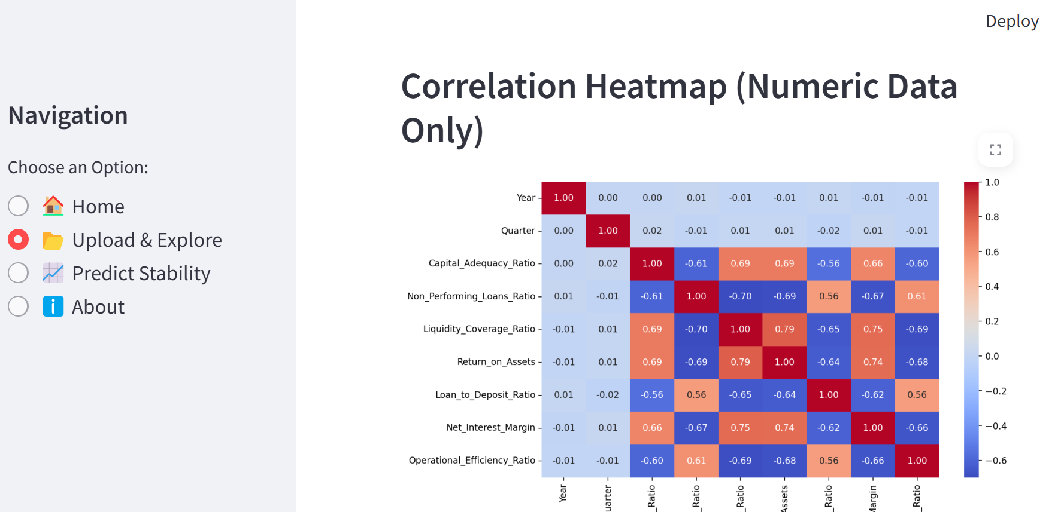

Predict Bank Stability: Train an XGBoost classifier and make real-time predictions with custom inputs for informed decision-making

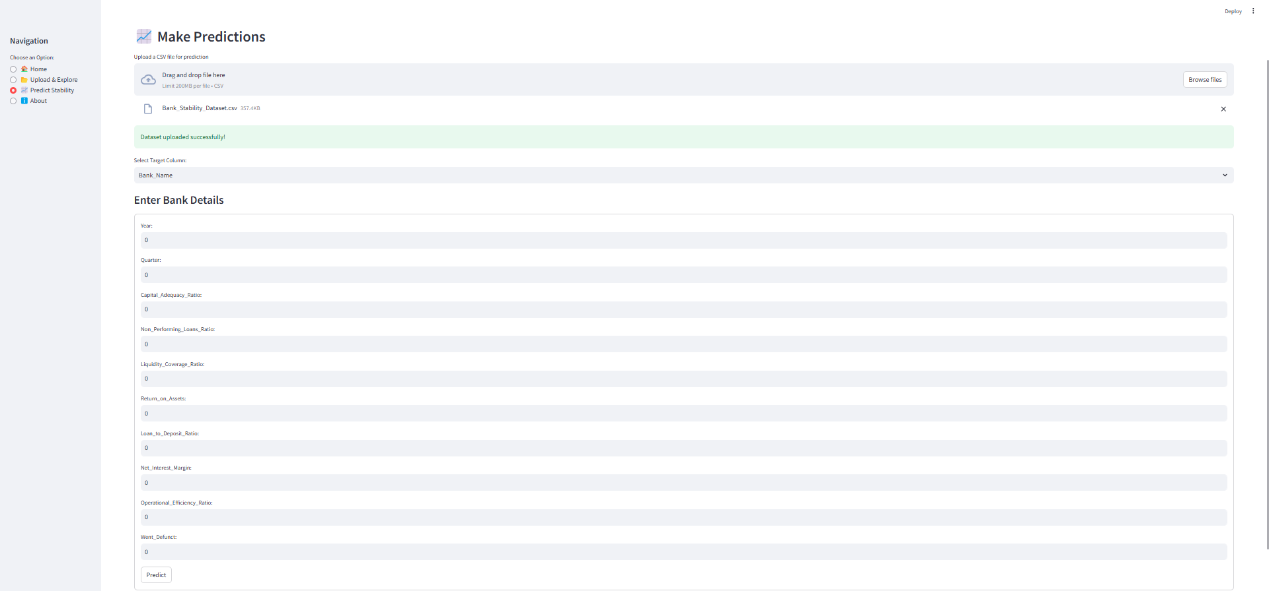

Make Prediction



About:

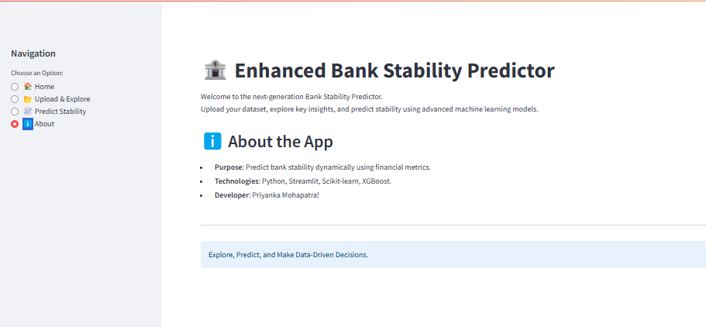

Dashboard

The dashboard created for the Bank Stability Analysis project serves as a visual representation of key financial metrics and insights related to bank stability. It provides stakeholders with an interactive tool to monitor and analyse the health of banks based on various financial indicators.



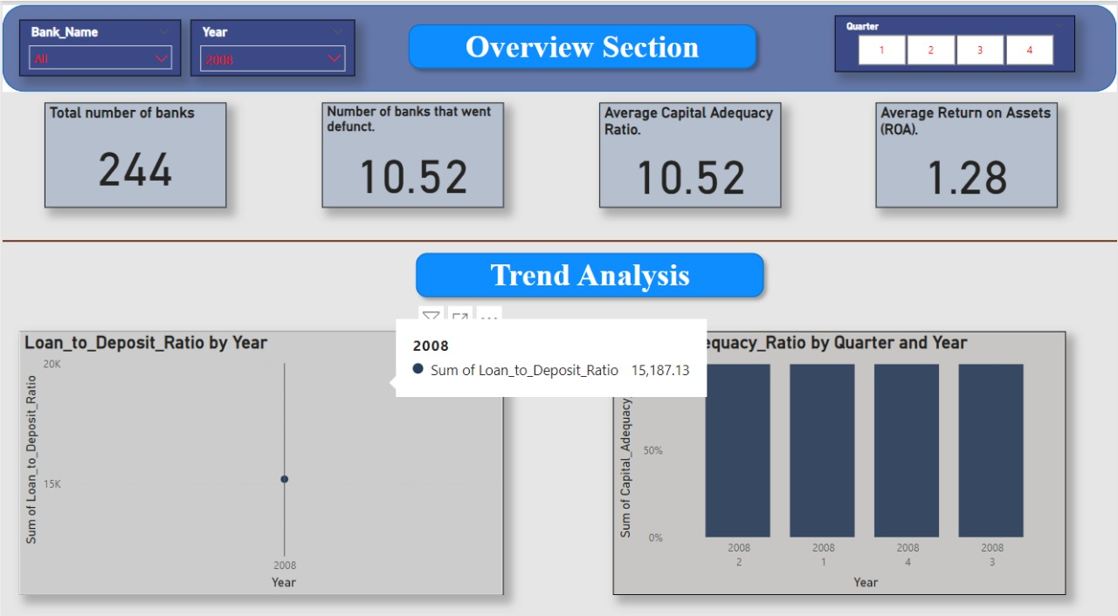

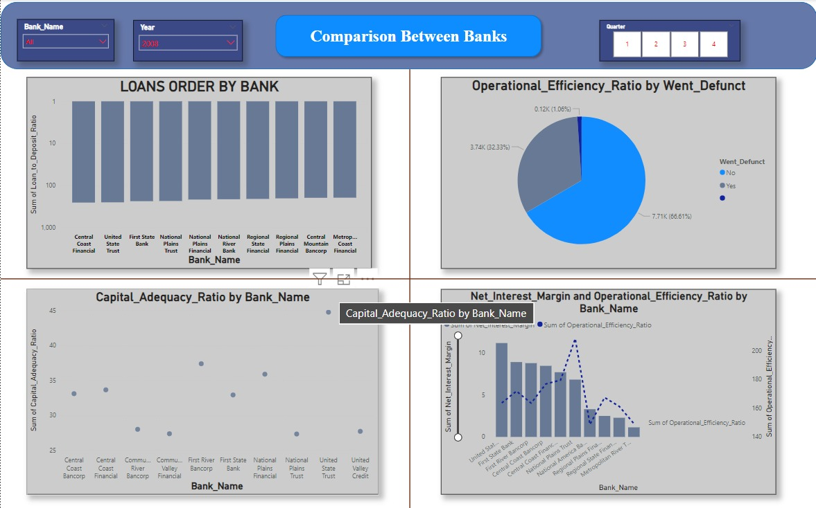

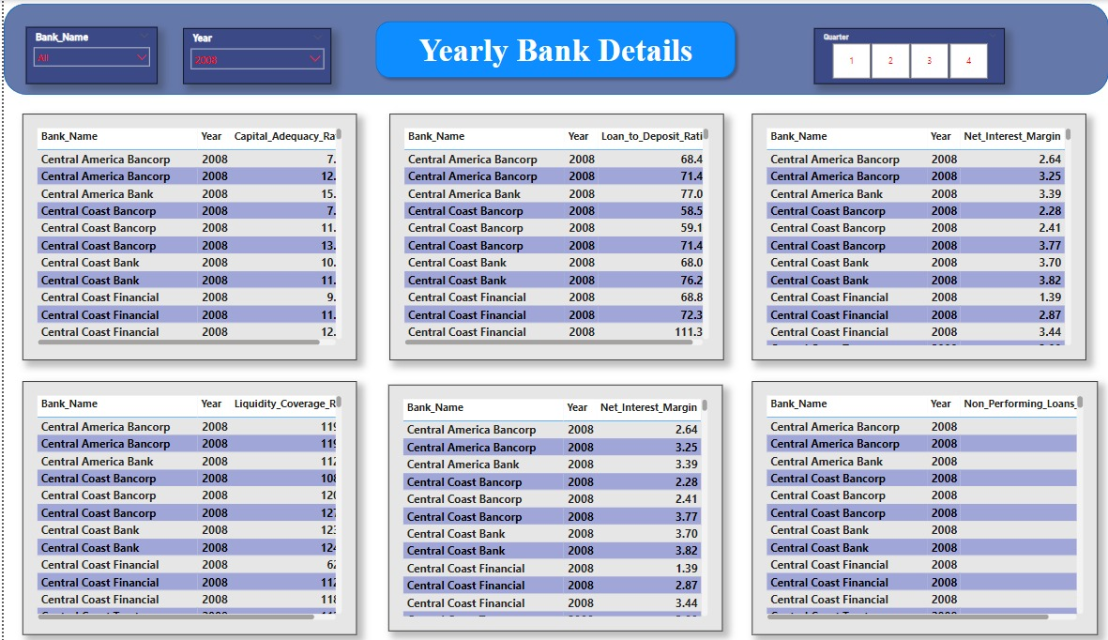

Conclusion

The Bank Stability Analysis project underscores the critical importance of financial health in the banking sector. By leveraging data-driven insights and predictive modelling, stakeholders can better understand the dynamics of bank stability and implement effective measures to safeguard against potential failures.