**AWS Task-1**

**Task Description:**

Create a windows Vm machine in AWS and connect with RDP open CMD in windows share the about system info.

**Step 1:**

* Create ec2 instance with windows server.

**Output:**

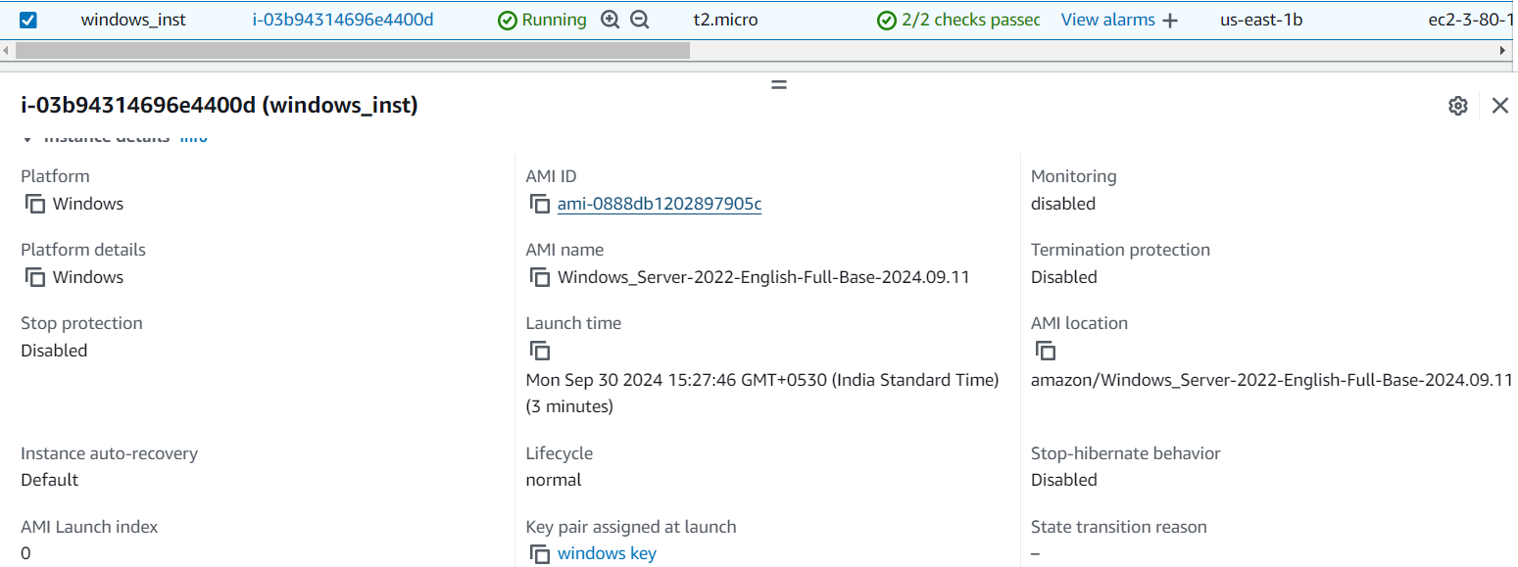

**Step 2:**

* Connect with RDP client and decrypt the password.

**Output:**

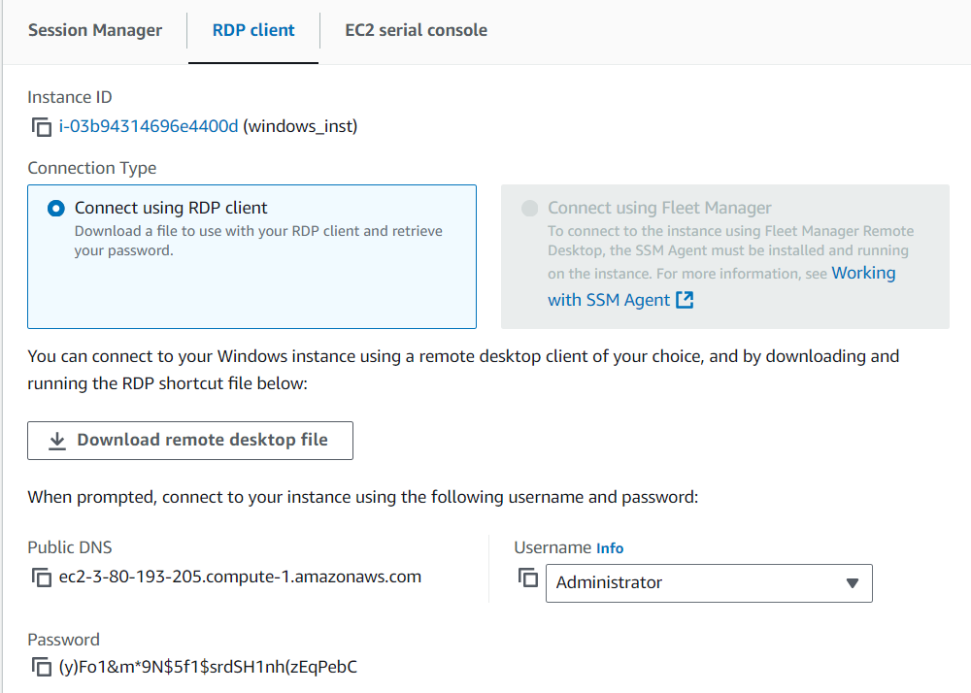

**Step 3:**

* From local machine, open windows Remote Desktop Connection and enter the password to login.

**Output:**

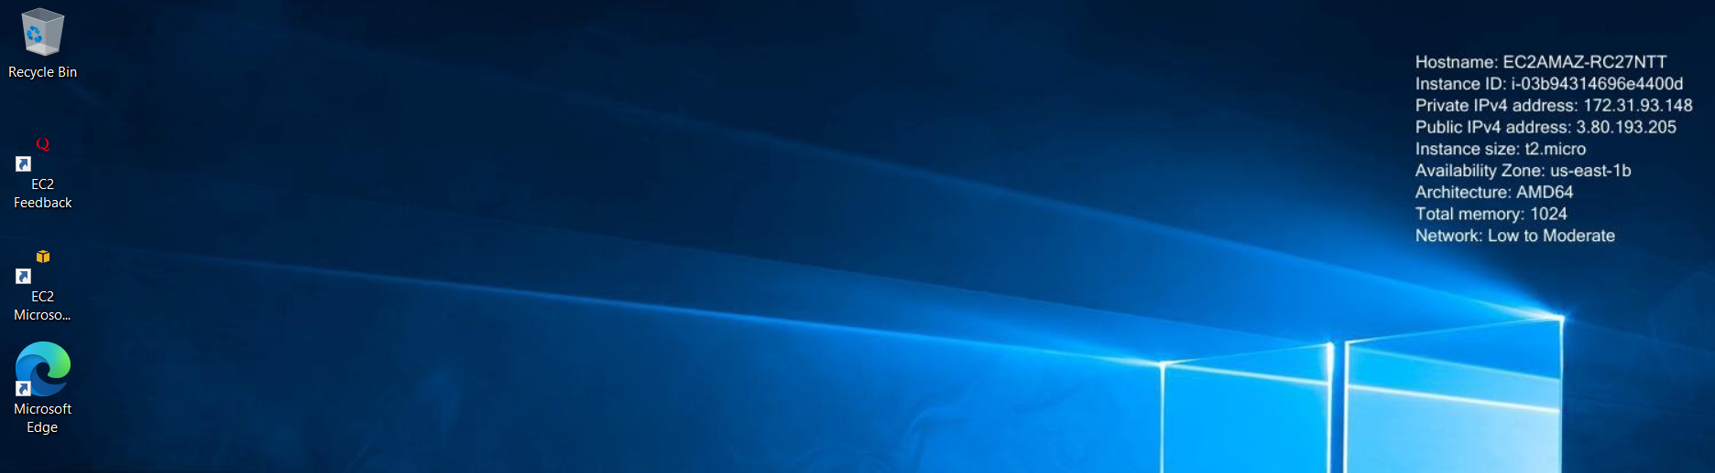

**Step 4:**

* Open CMD and retrieve system info with a command - **systeminfo**

**Output:**

