**AWS Task-2**

**Task Description:**

Set up a VPC with an Internet gateway, create a public subnet with 256 IP addresses, a private subnet with 256 IP addresses, make a route table connecting the Internet gateway and the subnets, and launch a Linux EC2 instance by using the above VPC and public subnet.

**Steps:**

1. **Create VPC**

Vpc name – test_vpc

IPv4 CIDR – 10.0.0.0/23

1. **Create internet gateway**

Igw name – test_igw

Go to test_igw’s action and attach with test_vpc

1. **Create public subnet**

Pub subnet name – pub_subnet

Availability zone – us-east-1a

IPv4 subnet CIDR block – 10.0.0.0/24

Enable auto assign public IPv4 addresses

1. **Create private subnet.**

Pvt subnet name – pvt_subnet

Availability zone – us-east-1b

IPv4 subnet CIDR block – 10.0.1.0/24

1. **Create Route Table for Public subnet:**

Route table name – pub_rt

From this route table create a route to the internet gateway (test_igw)

Port – 0.0.0.0/0

Click subnet association and associate this route table to the public subnet (pub_sub)

1. **Create Route Table for Pvt subnet:**

Route table name – pvt_rt

Click subnet association and associate this route table to the private subnet (pvt_sub)

**Output:**

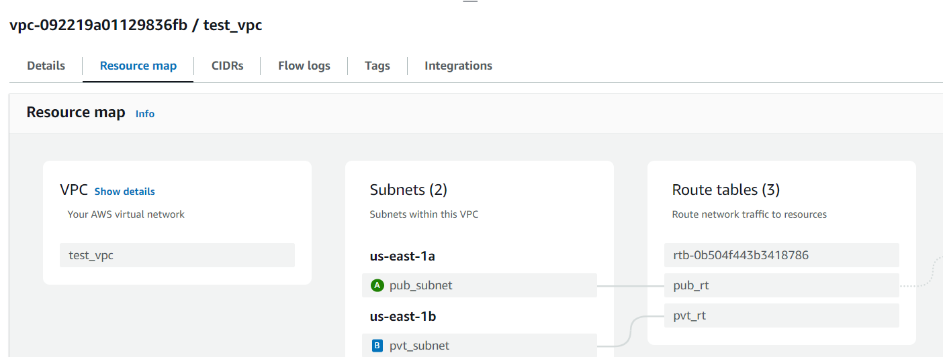

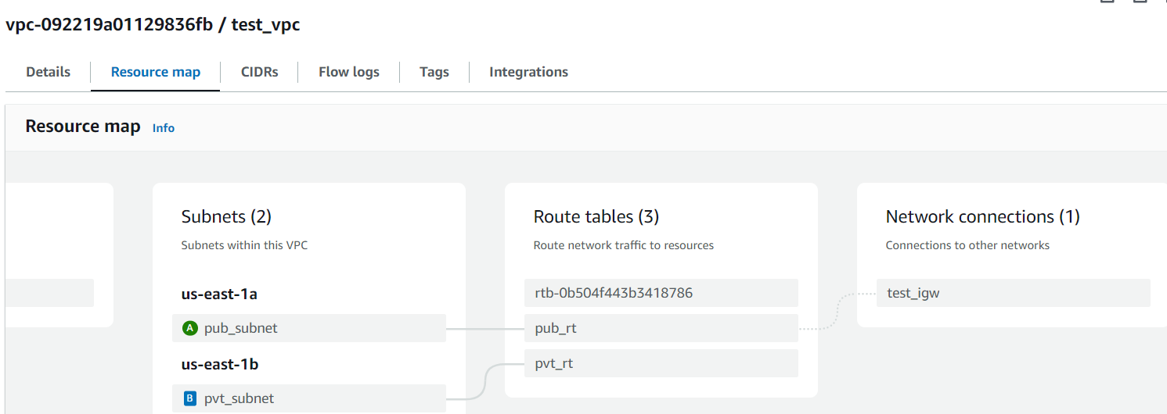

1. **Launch a Linux EC2 instance in a public subnet:**

Launch an instance with created vpc and public subnet.

**Output:**

