**AWS Task-3**

**Task Description:**

1. Create a S3 bucket, with no public access and upload files to the bucket & view the logs using cloudwatch for the uploaded files.

**Step 1- Create an s3 bucket:**

* Bucket name – jiyabuck
* Enable Block all public access
* Create bucket

**Output:**

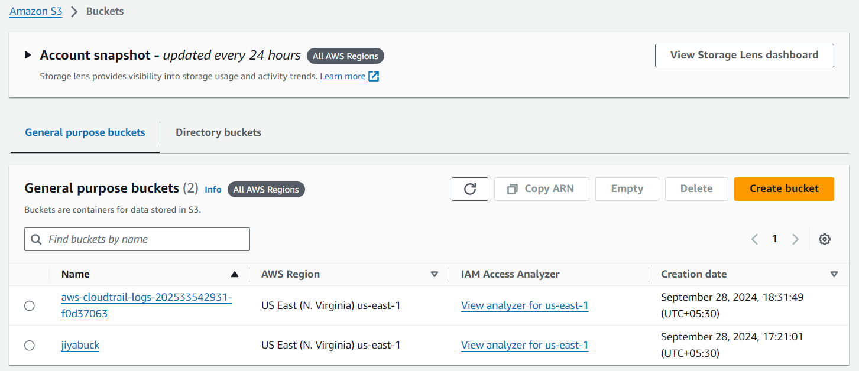

**Step 2 – Upload files to the bucket:**

* Select files and upload to the created bucket.

**Output:**

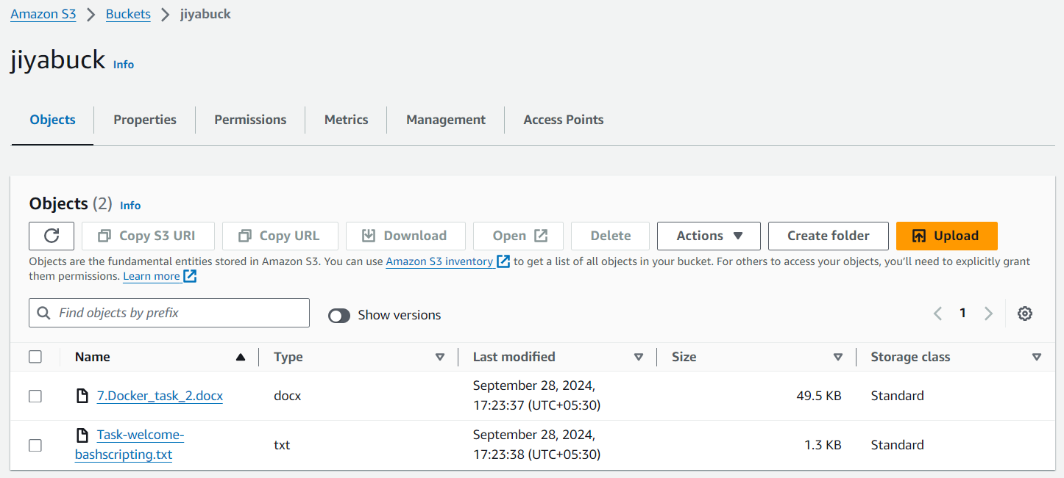

**Step 3 – Create CloudTrial:**

* Trial name – test_trial
* Bucket name – jiyabuck
* Log file SSE-KMS encryption – Disabled
* Cloudwatch logs – Enabled
* Create new IAM Role – s3_cloudtrial
* Select Management event
* API Activity – Read & Write
* Create trial

**Output:**

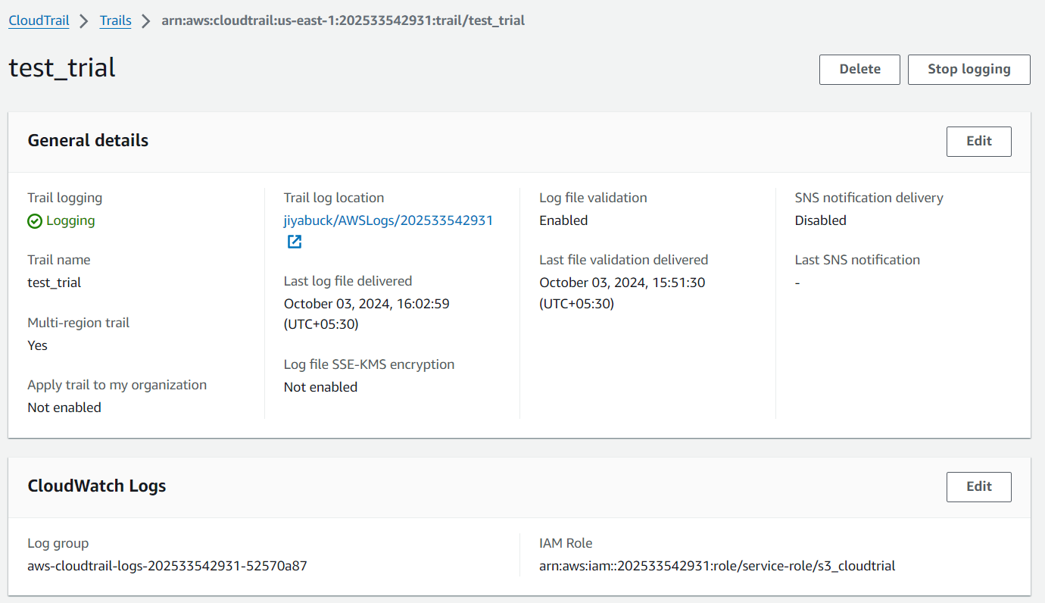

**Step 4 – View logs in cloudwatch:**

* Go to cloudwatch >> log groups >> Log stream
* We can see the logs here.

**Output:**

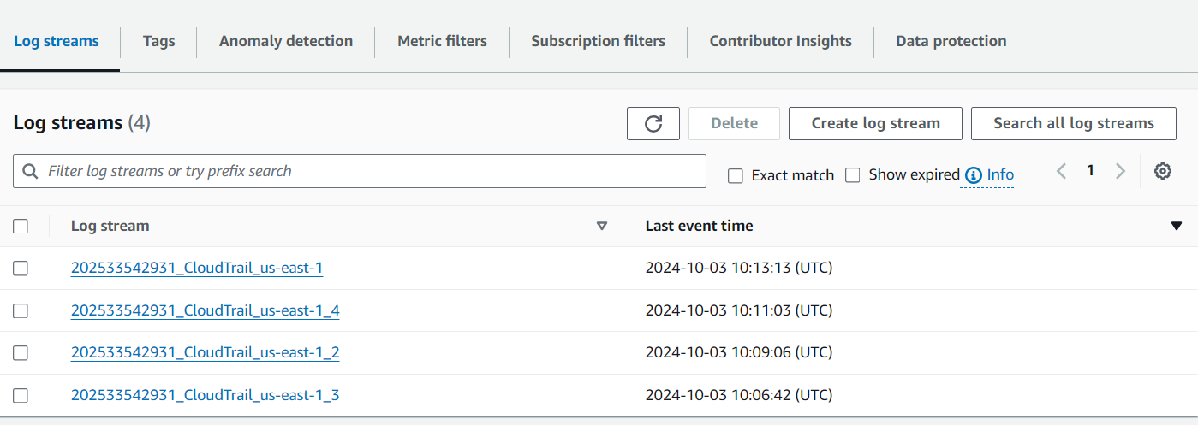

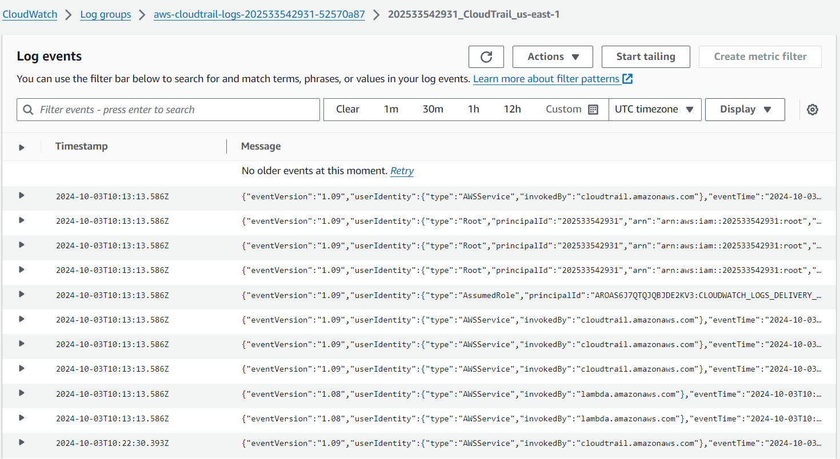

**Task 2**

**Launch two ec2-instances and connect it to a application load balancer, where the output traffic from the server must be an load balancer IP address**

**Step 1 – Create 2 ec2 instances:**

* Launch instance
* Both instances should be in same vpc. (Select vpc – test_vpc)
* In security groups allow Http port
* Create 2 instances.
* Install web server in both the instances. (nginx)

**Output:**

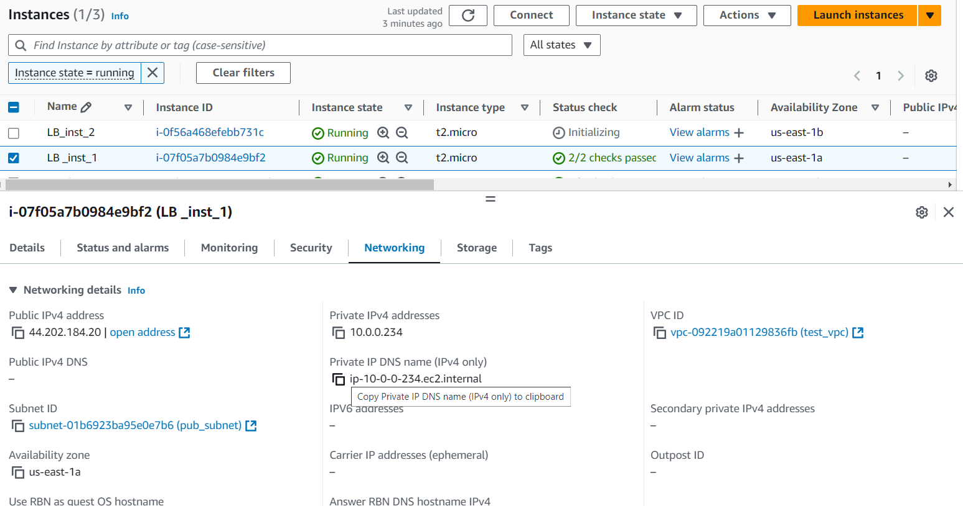

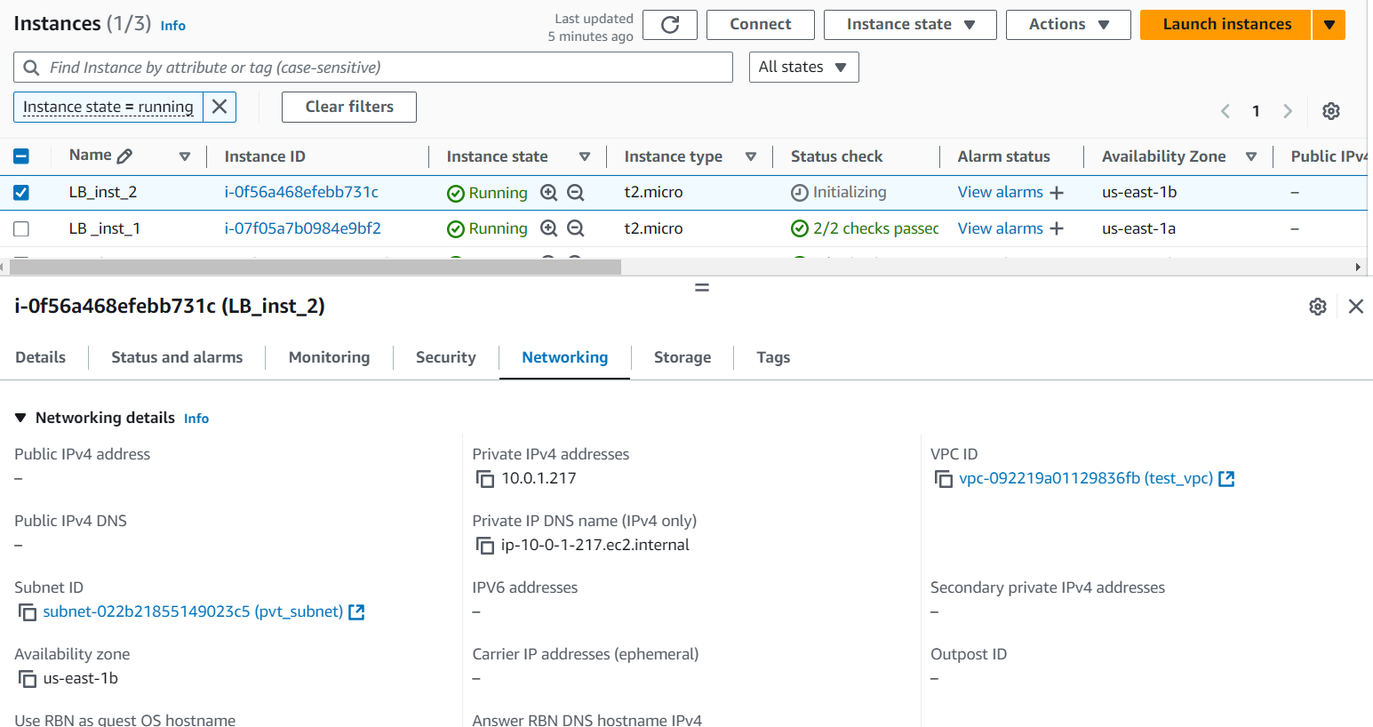

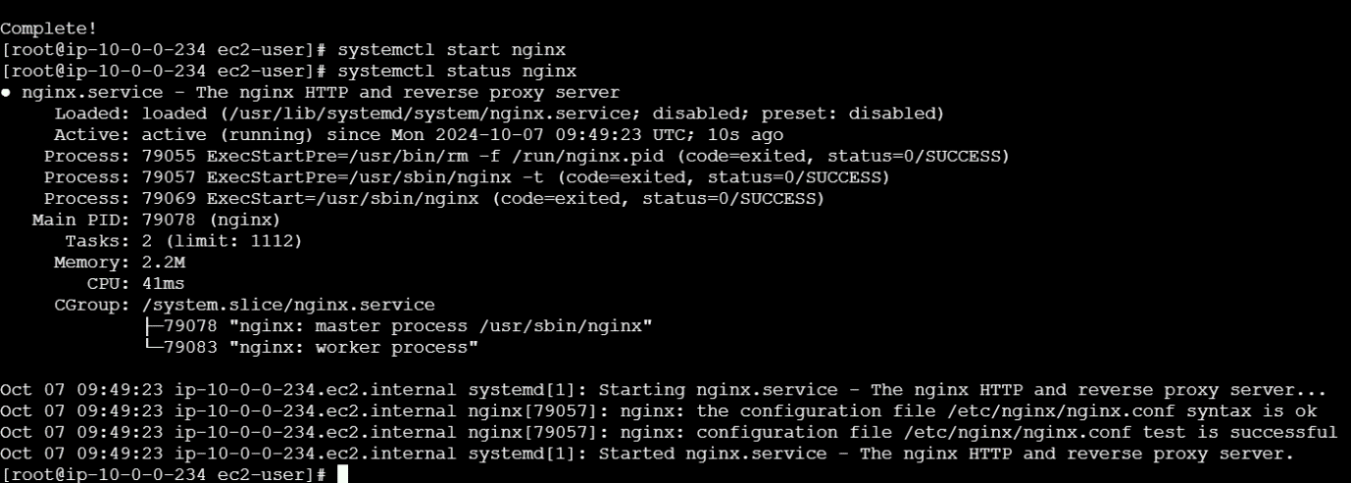

**Step 2 – Create Target Group:**

* Create target group for Http
* Choose instance
* Target group name – httptg
* Select port no – 80
* Select Vpc – testvpc
* Health check path - /
* Select both instances
* Create target group

**Output:**

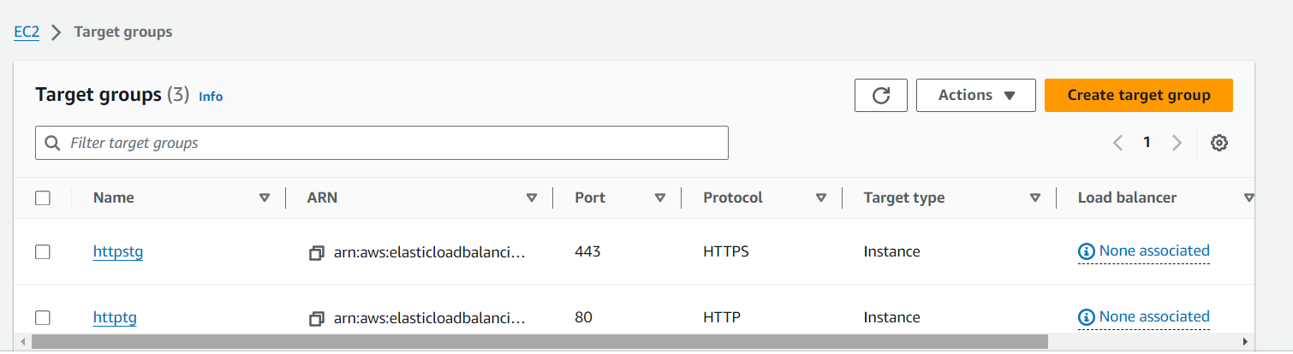

**Step 3 – Create an Application Load Balancer:**

* Select application load balancer
* LB name – tasklb
* Select Internet-facing & IPv4
* In network mapping select vpc, subnets & availability zones
* In security groups allow Http port
* In listeners and routing add target group for Http:80
* Create load balancer

**Output:**

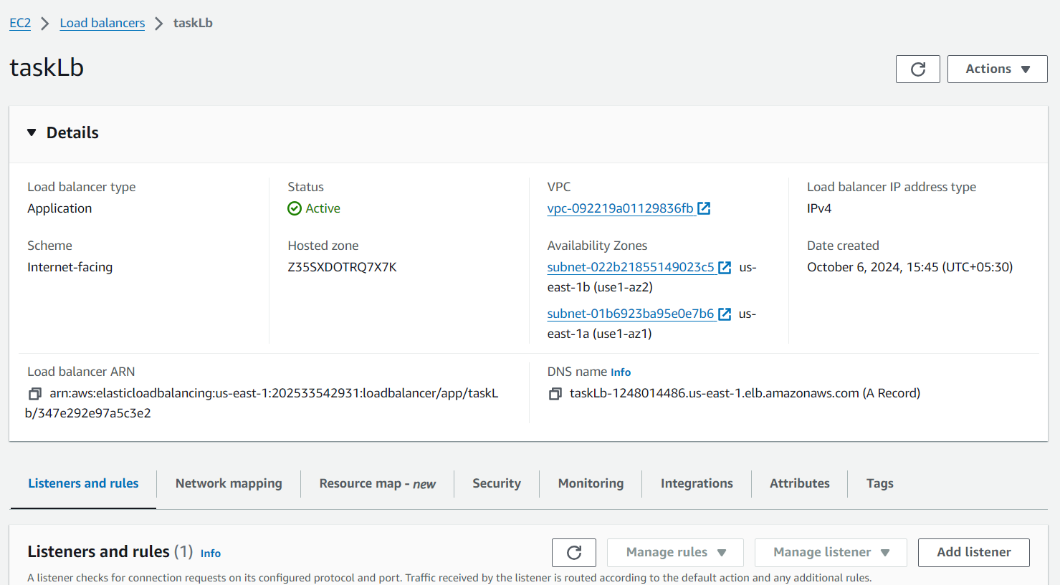

**Result:**

* Copy the DNS name in load balancer and hit it in the website.

