**AWS Task-4**

**Task Description:**

Launch an EC2 instance (Linux and Windows) along with a web server. Then, create an EBS volume of 5 GB, attach it to an EC2 machine (Linux and Windows), and take a snapshot. Finally, create an EBS volume using the taken snapshot.

**Step 1 – Install Linux instance with web server:**

* Launch instance (Name – linux_inst)
* Install httpd web server
* yum update
* yum install httpd -y
* systemctl start httpd
* systemctl enable httpd
* systemctl status httpd

**Output:**

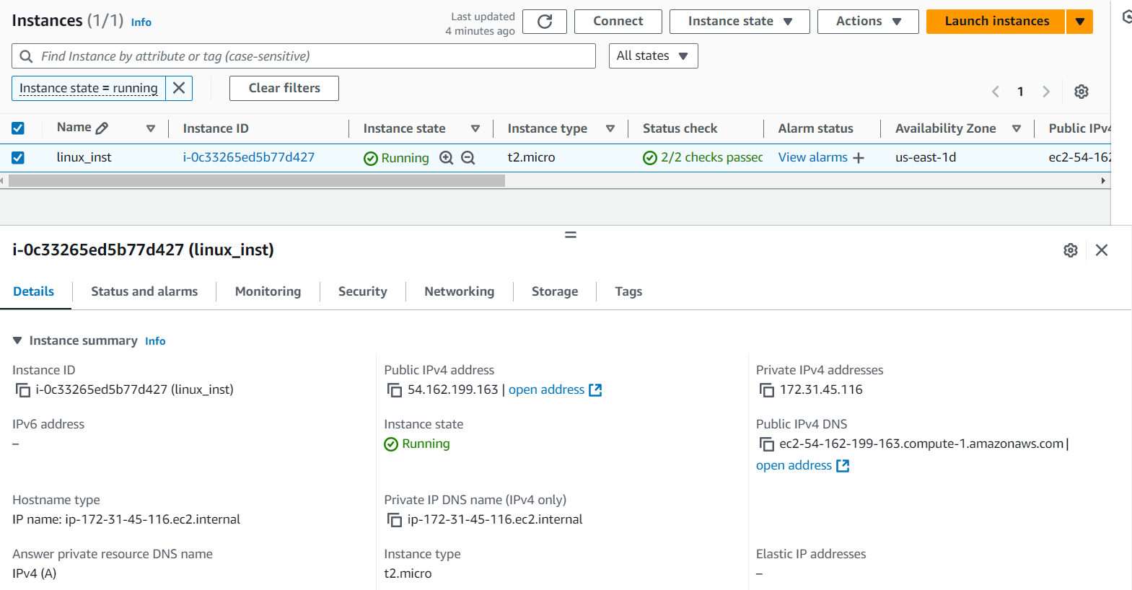

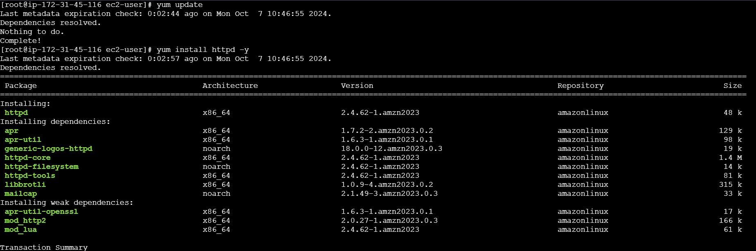

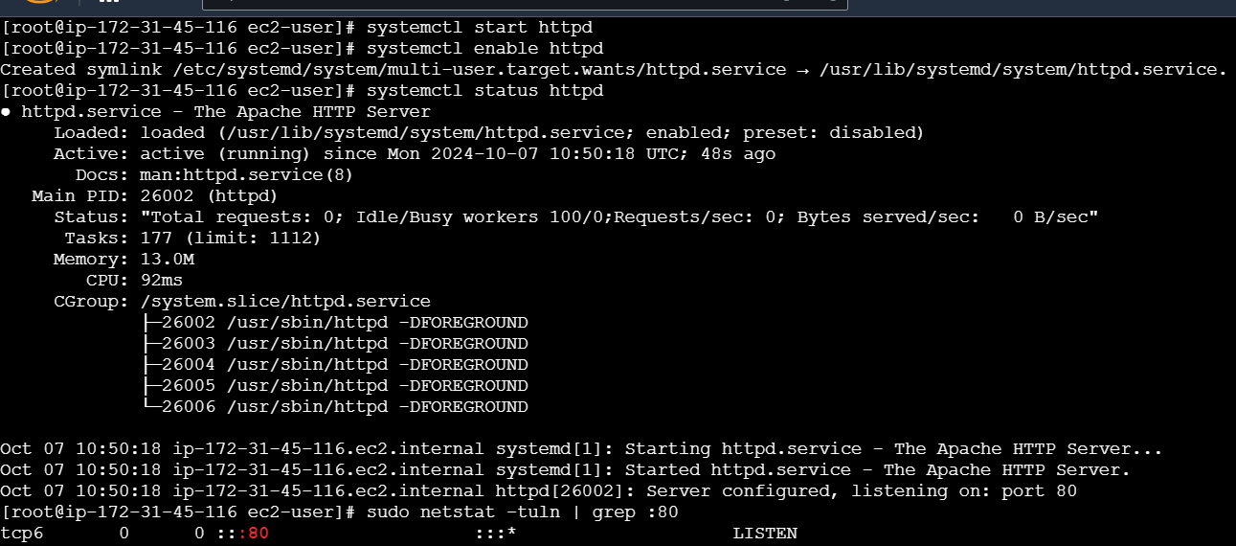



**Step 2 – Install windows instance with web server:**

* Select windows os and launch instance.
* Login windows instance using RDP client
* Open server manager
* Add Roles and Features
* In features select web server (IIS) role and install
* Open a browser and access the public ip - http://54.162.125.148/

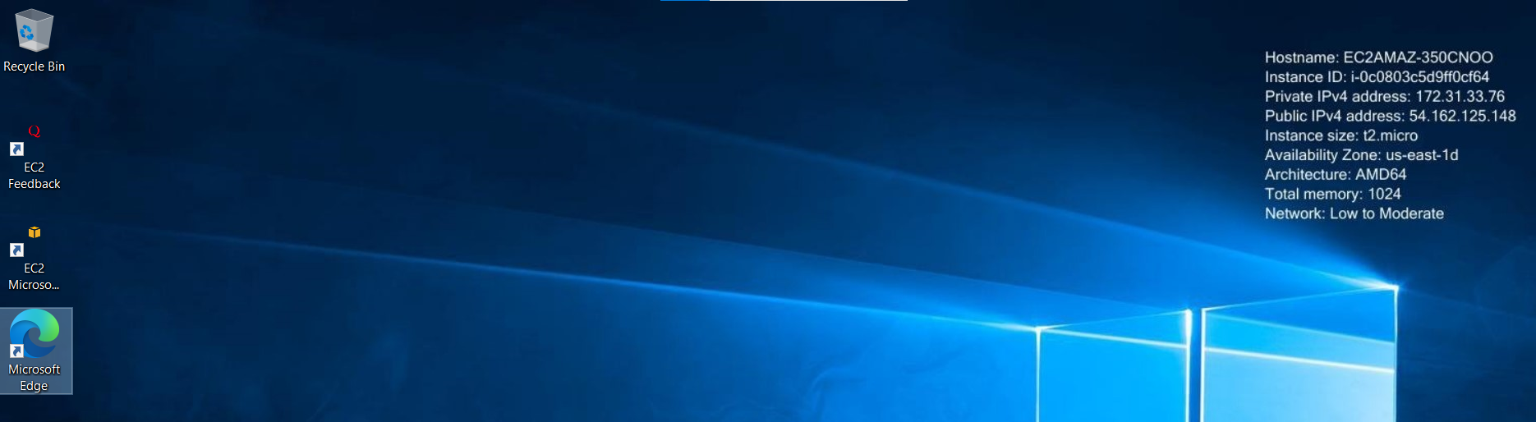

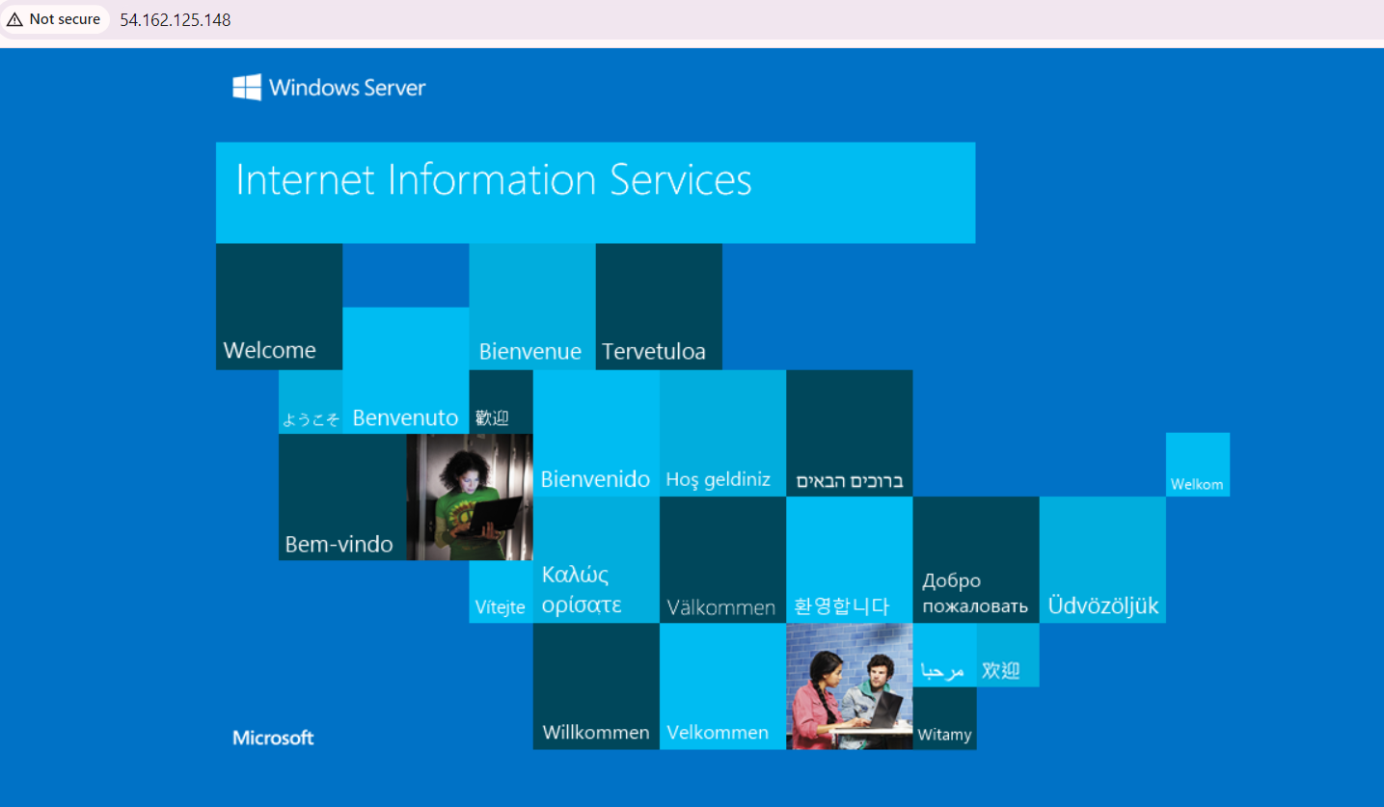

**Step 3 – Create EBS Volume & attach it to Linux instance:**

* Volume type – General purpose SSD (gp3)
* Size – 5 GB
* Name – task_vol
* Create volume
* Go to Volume actions
* Select instance – linux_inst
* Device name - /dev/sdb
* Attach volume
* Launch instance
* Scan disks – **lsblk**
* Make file system – **mkfs.xfs /dev/xvdb**
* Creating directory – **mkdir /task**
* Mount the volume – **mount /dev/xvdb /task**
* List the info about the mounted filesystems – **df -hT**

**Output:**

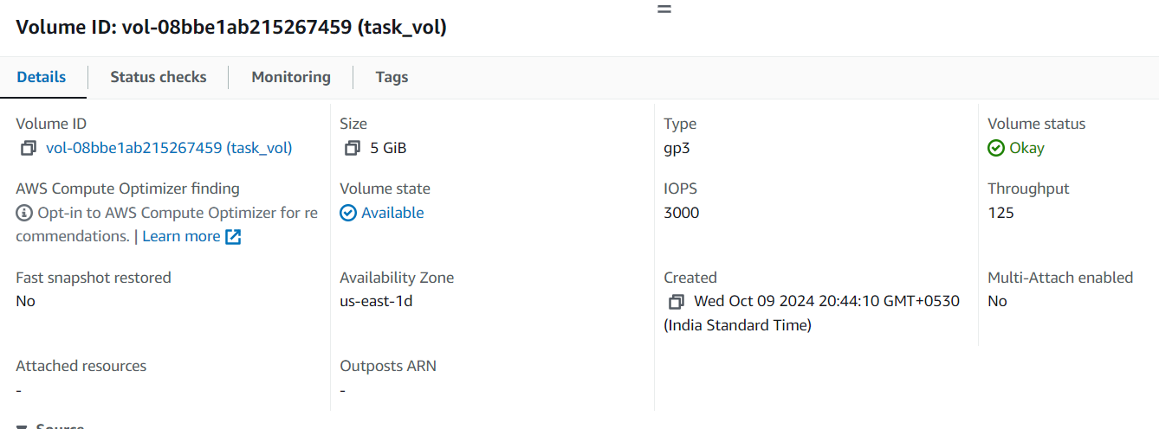

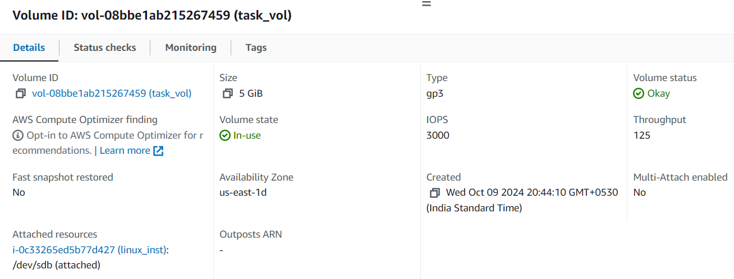

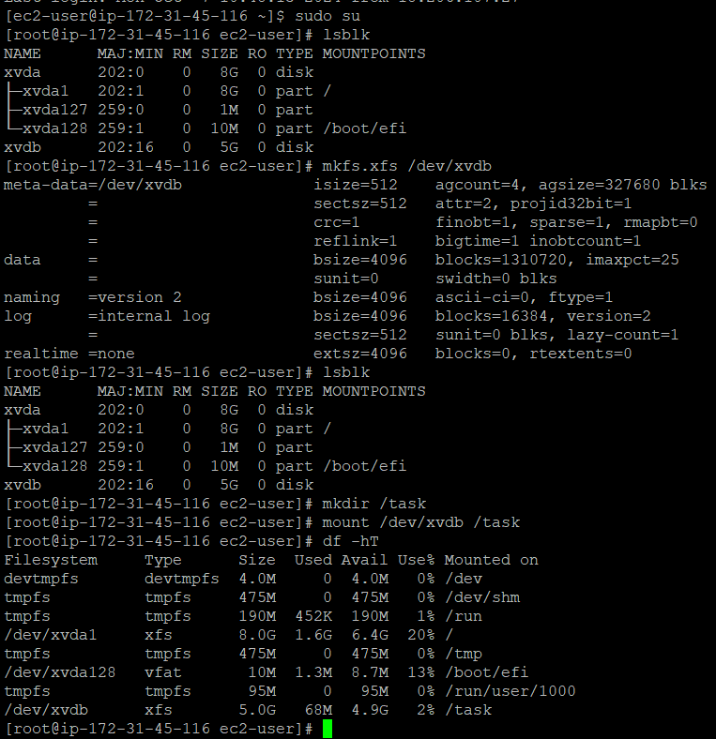

**Step 4 – Create EBS Volume & attach it to windows instance:**

* Volume type – General purpose SSD (gp3)
* Size – 5 GB
* Name – windows_vol
* Create volume
* Go to Volume actions
* Select instance – windows_task
* Device name - xvdb
* Attach volume
* Open RDP client and decrypt the password
* Login windows instance
* Open Disk Management
* Make disk 1 online
* Initialize disk 1
* Create new simple volume
* Finish

**Output:**

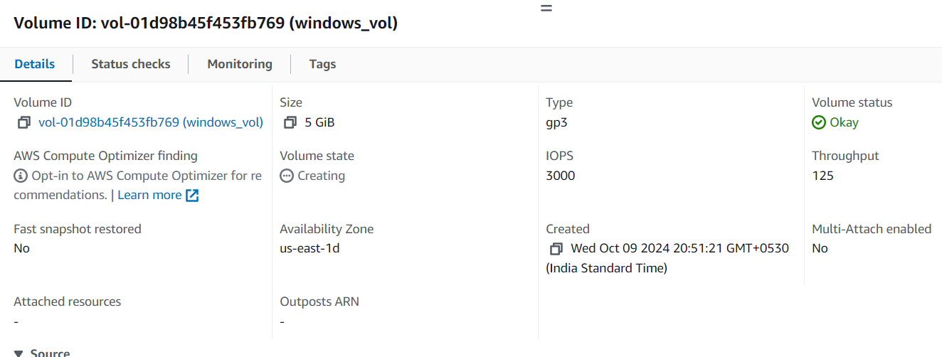

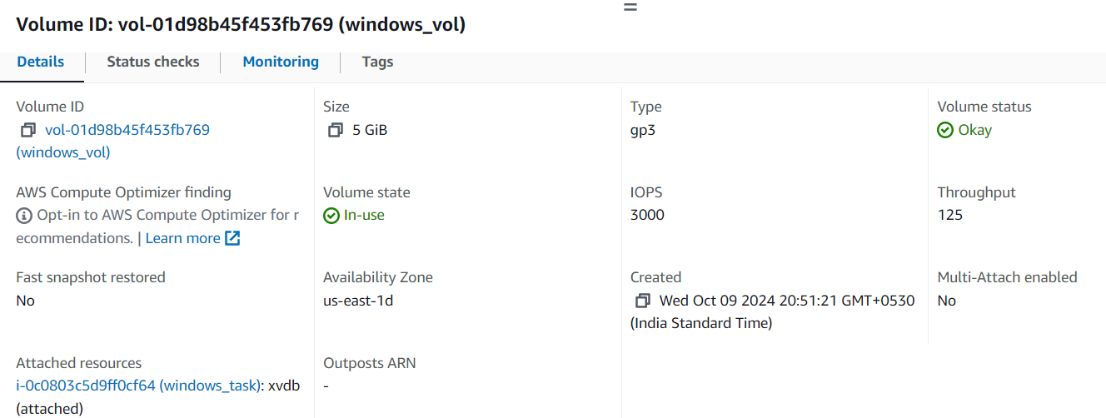

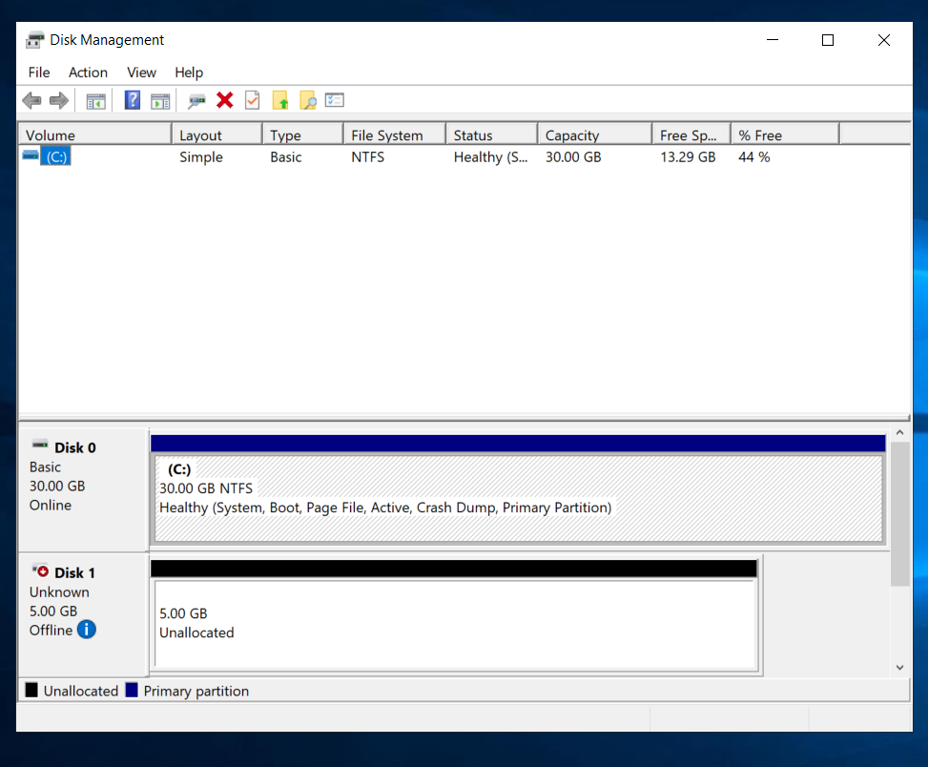

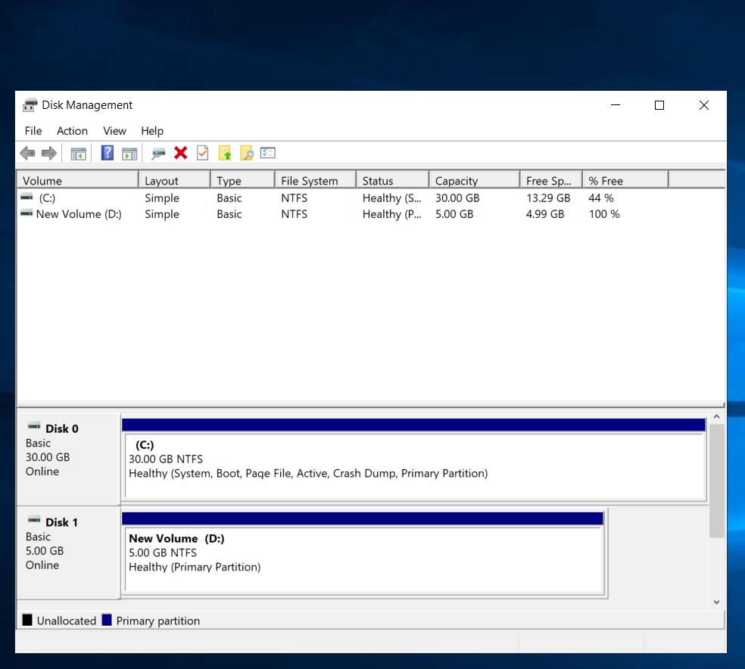

**Step 5 – Create Snapshot:**

* Resource type - volume
* Volume id – linux_snap, windows_vol
* Add snapshot description
* Snapshot name **–** linux_snap, windows_snap
* Create snapshot

**Output:**

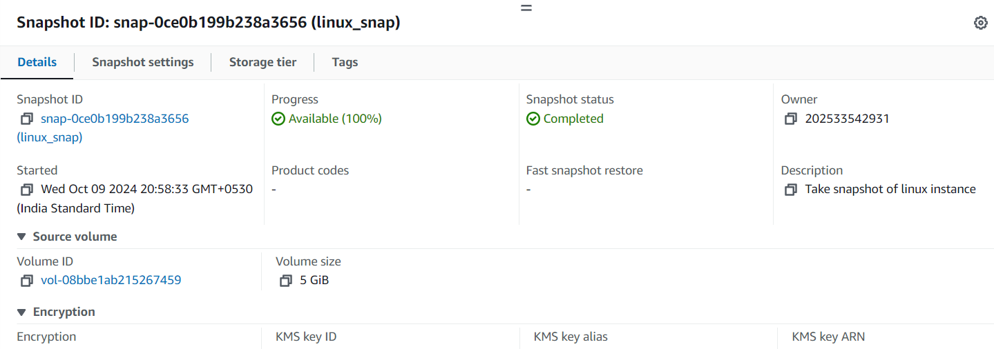

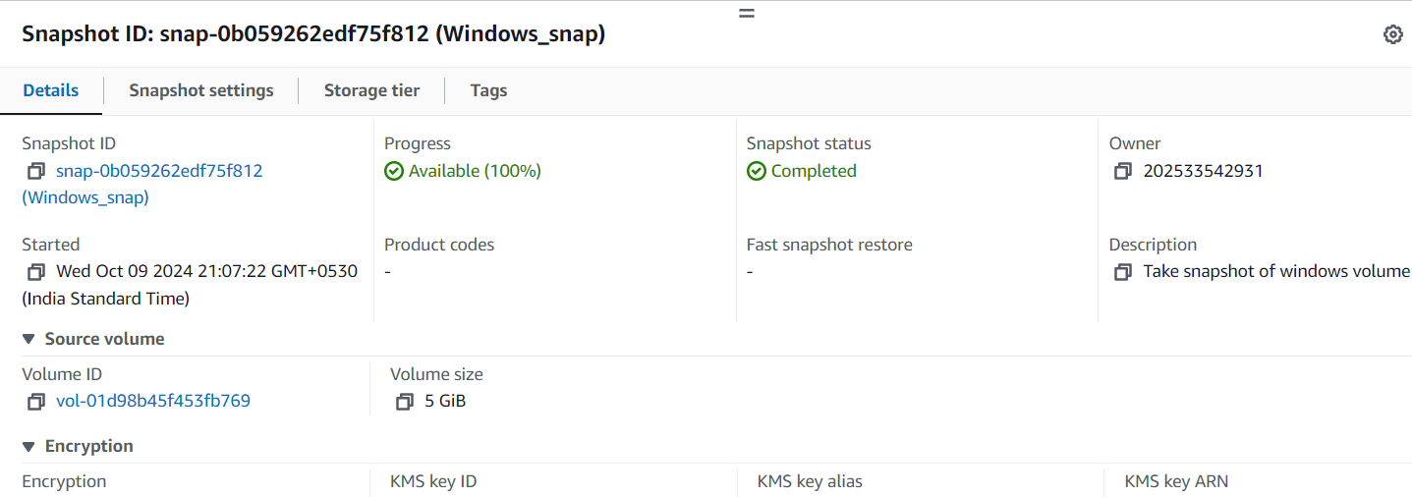

**Step 6 – Create Volume from Snapshot:**

* Select snapshots (linux_snap, windows_snap)
* Go to actions
* Create volume from snapshots
* Volume type – General purpose SSD (gp3)
* Size – 5 GB
* Availability Zone – us-east-1d
* Volume Name – linux_snap_vol, windows_snap_vol
* Create volume

**Output:**

