**Task:**

Create a custom docker image for nginx and deploy it using docker compose, where the volume bind mount should be at /var/opt/nginx location. Push the created custom docker image to your docker-hub.

**Step 1:**

1. Create a directory – **mkdir nginx**
2. Switch to the directory – **cd nginx**
3. Create and write the code in dockerfile – **vi Dockerfile**
4. Create and write the code in nginx.conf file – **vi nginx.conf**
5. Build docker image – **docker build -t dockerhubname/custom-nginx .**
6. Login to docker hub – **docker login**

Enter user name & password

**Output:**

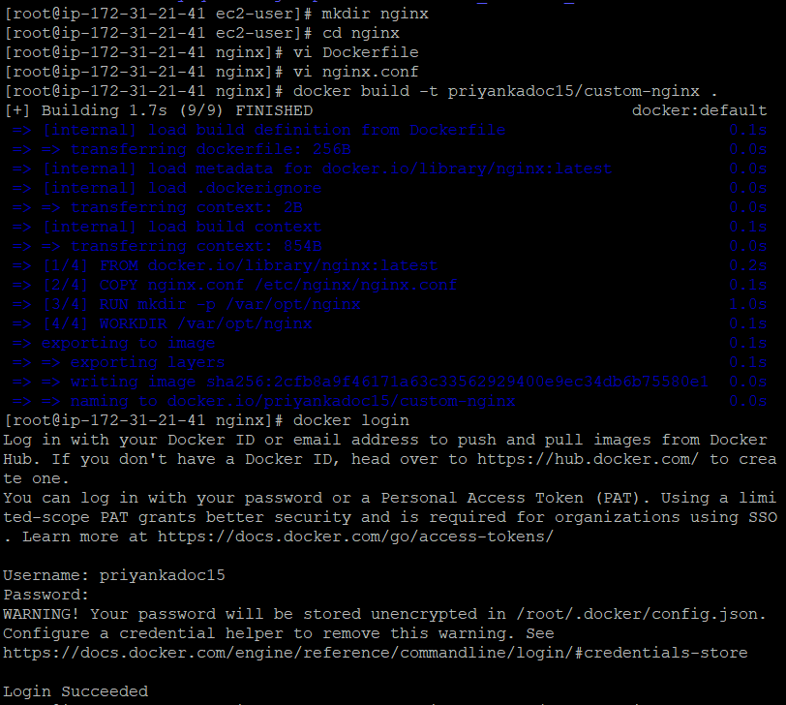

**Step 2:**

Push custom-nginx image to docker hub – **docker push dockerhubname/custom-nginx**

**Output:**

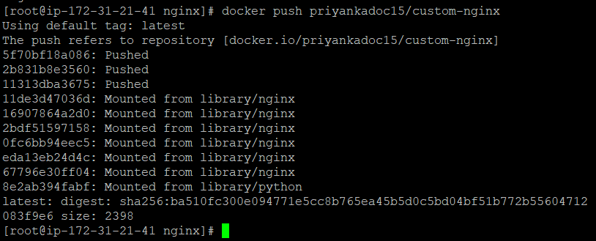

**Step 3:**

* Create a docker-compose.yml file to deploy custom NGINX container with a volume bind mount at /var/opt/nginx location – **vi docker-compose.yml**
* Create a directory to hold a volume data – **mkdir nginx-data**

**Output:**



**Step 4:**

Start the NGINX service using Docker Compose - **docker-compose up -d**

**Output:**

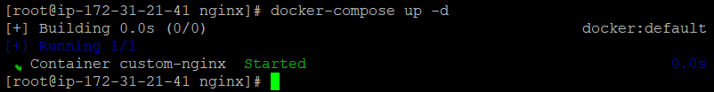

**Final output:**

