**Task:**

Launch jenkins and explore creating projects and users.

**Step 1:**

Launch Jenkins in ec2 instance with following commands:

* sudo yum update –y
* sudo wget -O /etc/yum.repos.d/jenkins.repo \https://pkg.jenkins.io/redhat-stable/jenkins.repo
* sudo rpm --import https://pkg.jenkins.io/redhat-stable/jenkins.io-2023.key
* sudo yum upgrade
* sudo dnf install java-17-amazon-corretto -y
* sudo yum install jenkins -y
* sudo systemctl enable jenkins
* sudo systemctl start jenkins
* sudo systemctl status Jenkins

**Step 2:**

**Creating users:**

Go to Jenkins dashboard

Manage Jenkins

Users

Create users

Fill the following details and we can create the users

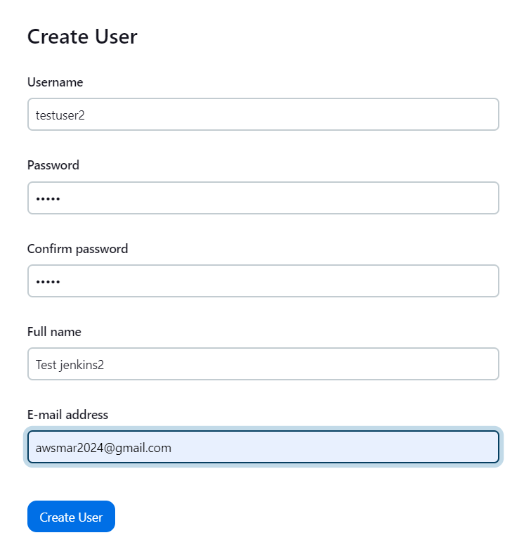

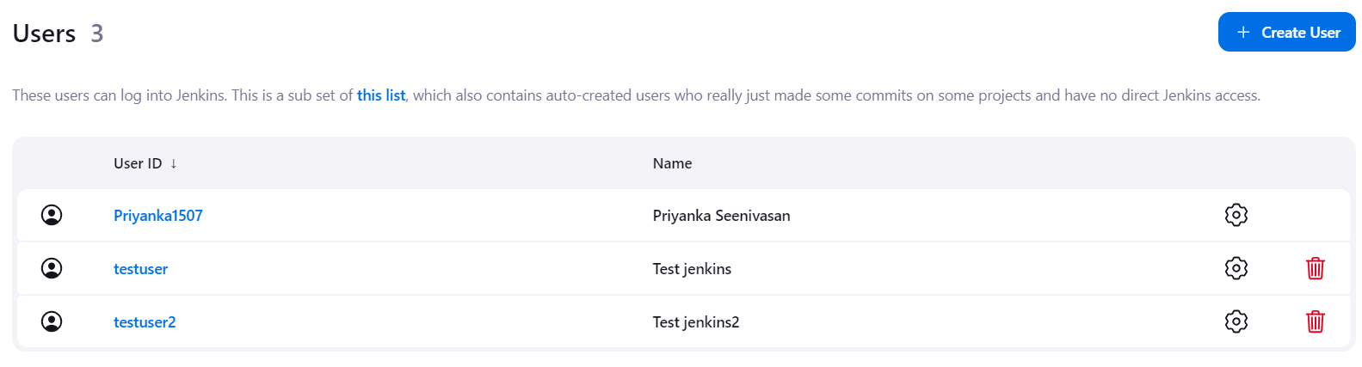

**Step 3:**

**Creating Projects:**

Go to Jenkins dashboard

New time

Enter an item name

Pipeline

Select or define pipeline script

Save and apply

Build this project

**Output:**

